**Documentation**

**Name: Krithivas Swaminathan**

**Krithivas@gmail.com**

**ScreenShots**

GZIP Utility

GZIP of a text file commands.txt in Desktop

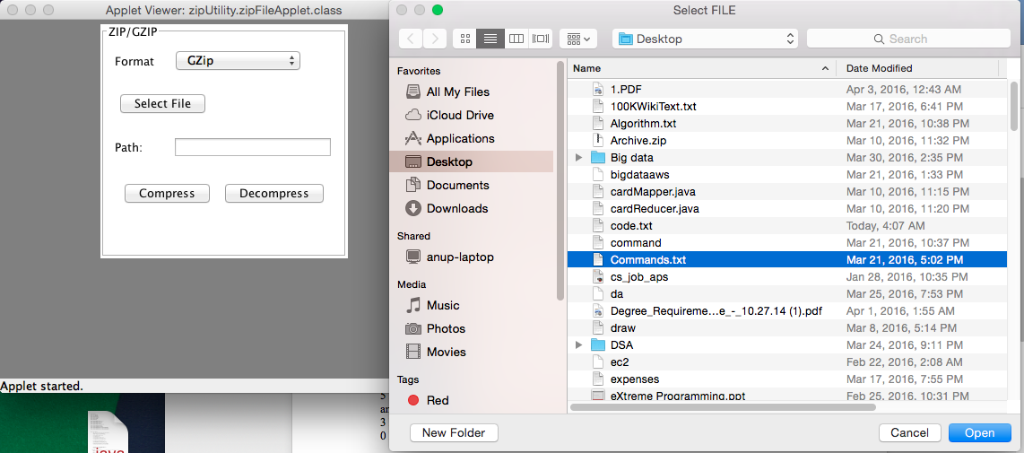

**Click on Compress to generate the .gz file in the desktop**

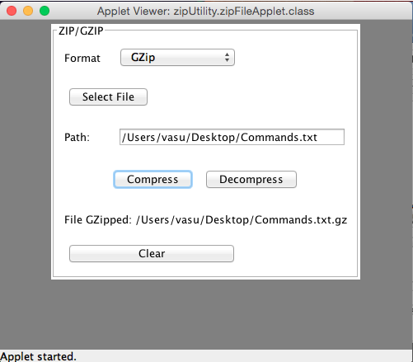

**Output file generated in desktop**



**Select the .gz file from the desktop and Click on Decompress to generate the .txt file back.**

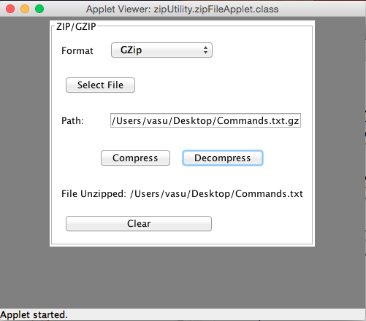

**Error Handling**

Selecting a non GZIP file while decompression shows the below error

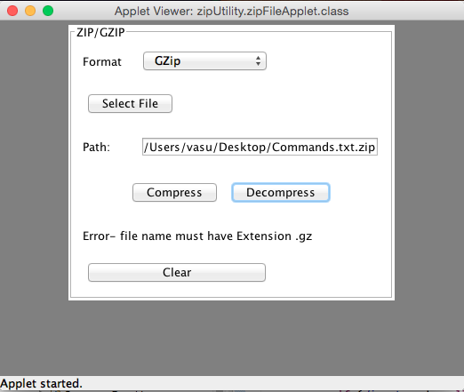

ZIP UTILITY

ZIP of a text file commands.txt in Desktop

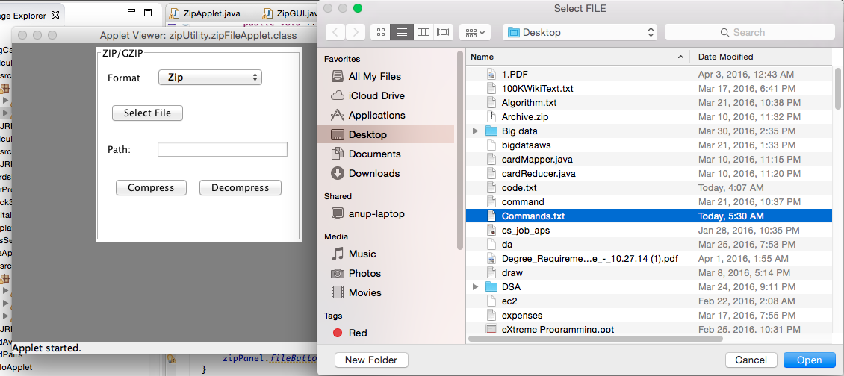

**Click on Compress to generate the .zip file in the desktop** 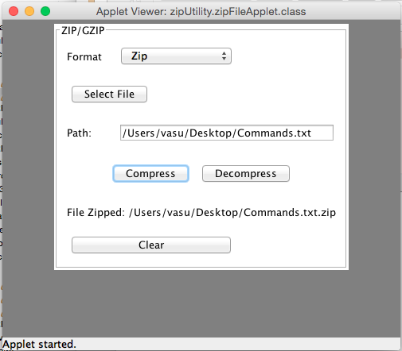

**Output file generated in the desktop**



**Select the .zip file from the desktop and Click on Decompress to generate the .txt file back.**

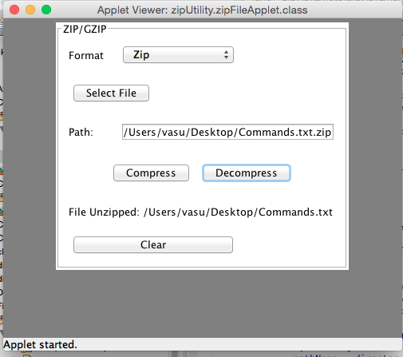

**Error Handling**

Selecting a non ZIP file while decompression shows the below error

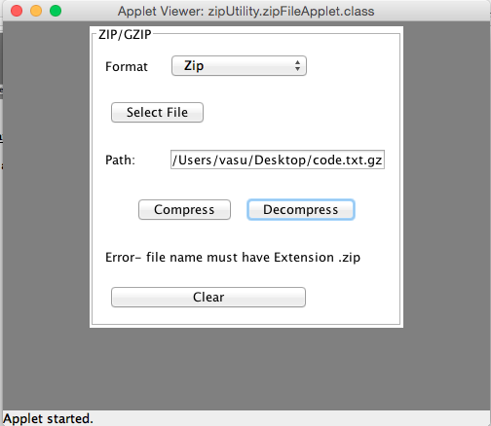

**Communication Diagram**

Exit

Start

Executes Compression Logic

Creates GUI

**compressionLogic**

**zipPanel**

**zipFileApplet**