**Library Management System**

**Name: Krithivas Swaminathan**

**Email:Krithivas@gmail.com**

**Project Planning Document**

**Use Case for Van Houten Library Management System**

**Scenario**: Library Management Utility with added Functionality.

**Level**: User Goal.

**Primary Actor**: User who wants to use Library Management Functionalities.

**Pre-Conditions**:

* User has access to the MySQL Database
* User Runs the applet

**Main Success Scenario**:

* User runs the applet. Applet gets displayed.
* User performs All Library Management Functions successfully.

**Post-Conditions**:

* User is able to remove and modify the previously inserted entries to the table.

**Basic Flow**:

* **User clicks on Add Book Button**

The ID, title, author of the book is taken from the user and inserted into the database through the MySQL connection.

* **User clicks on Delete Book Button**

The ID of the book is taken from the user and deleted from the database through the MySQL connection.

* **User Clicks on Search Book Button**

The ID of the book is taken from the user and the details of the book is returned from the database through the MySQL connection.

* **User Clicks on List All Books Button**

All the Books present in the database are shown to the user through the MYSQL connection established.

* **User Clicks on Lend Book Button**

The ID of the book is taken from the user and the status of the book is marked as ‘Lent’

* **User Clicks on Return Book Button**

The ID of the book is taken from the user and the status of the book is marked back to ‘Available’

* **User Clicks on List Rented Books Button**

All the Books with book status “Lent” in the database are shown to the user through the MYSQL connection present.

* **User Clicks on List Available Books Button**

All the Books with book status “Lent” in the database are shown to the user through the MYSQL connection present.

* **User Clicks on Exit Button**

User exits the Applet

**sScreenshots**

Initial Database Connection.

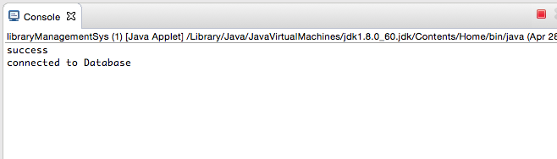

**Library Management Applet**

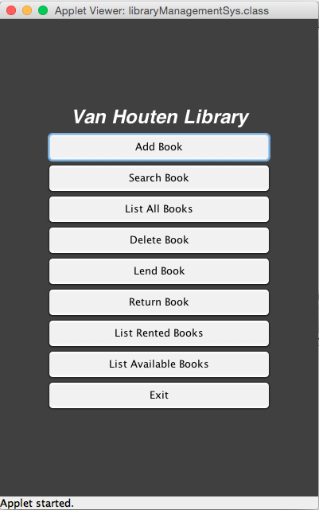

Initial MYSQL Database Setup Running in the Backend shown using PHPmyAdmin.

**Database**: library, **Table**: books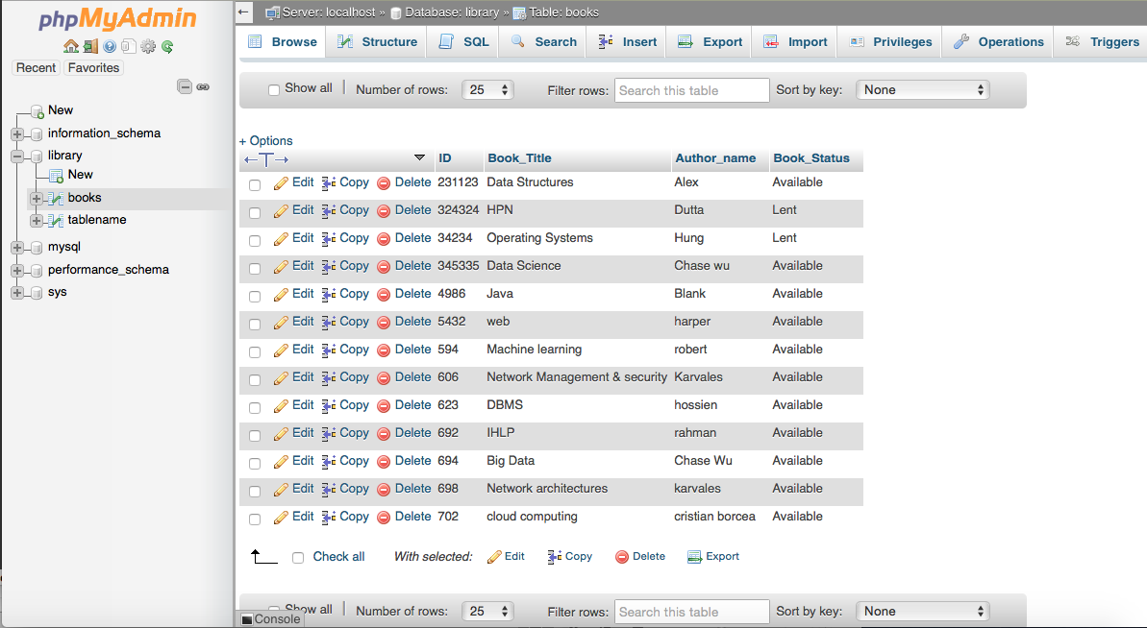

**ADD Book Functionality**

**Adding a book to the Library database Book id:721, Book Title: R Programming, Author name: David**

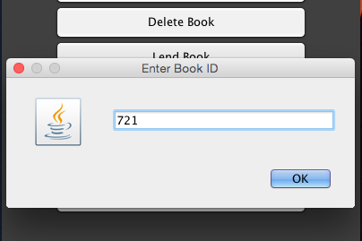

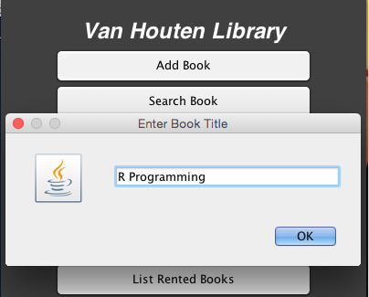

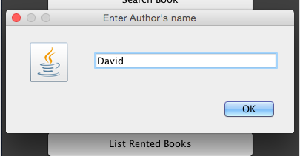

Shows the Library Database with the added Book.

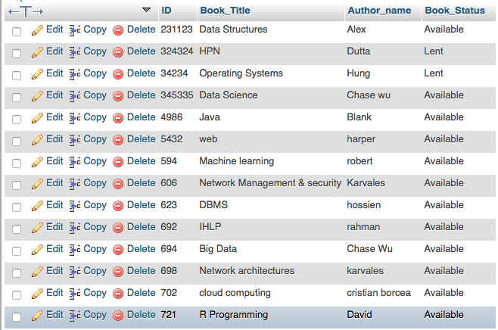

**Exceptions handled for Add Book Functionality**

**Scenario 1**

**Adding a book already added in the Database throws the below error**

Adding Book ID 721, throws the exception🡪 🡪 Book already available in the DB

 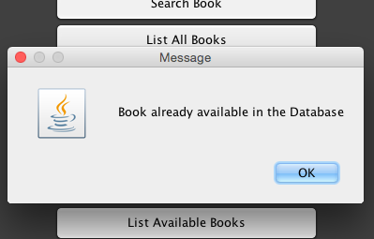

**Scenario 2**

Adding empty entries for either id/author name/ title will return the below dialog box

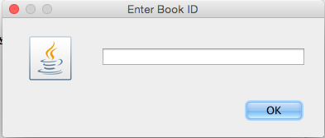 **🡪🡪**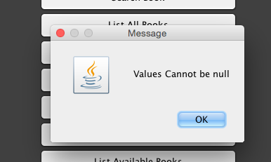

**Search Book Functionality**

Searching Book with ID 606

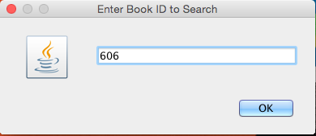

Returns the information regarding the book from the Database

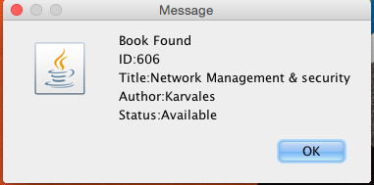

**Exceptions Handled for Search Book Functionality**

Searching for a Book id not available in the database 🡪 Returns the below error

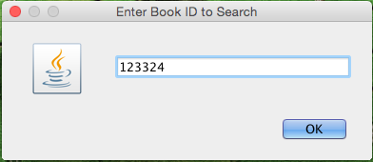 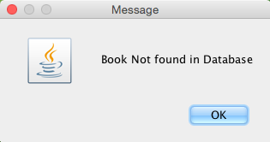

**List all Books**

**Clicking on the List All Books Button Displays all the Books present in the Database**

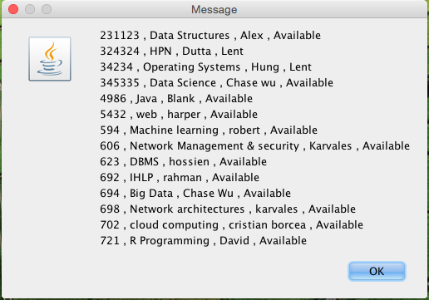

**Console Log for List All Books**

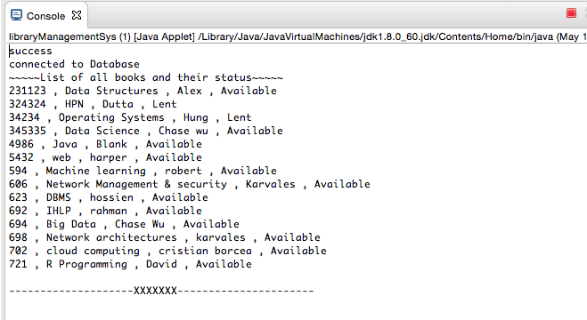

**Delete Book Functionality**

**Enter the book id to delete the book from the database**

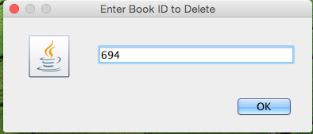

**The details of the deleted book are displayed**

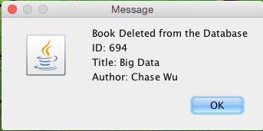

**Table after deletion of Book id 694**

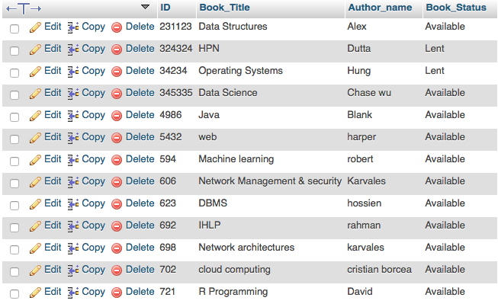

**Exceptions handled for Delete Book Functionality**

**Deleting a Book not available in the database 🡪 🡪 Displays the below error message**

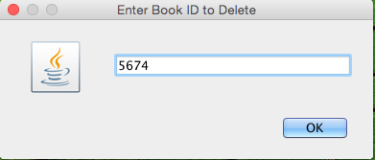 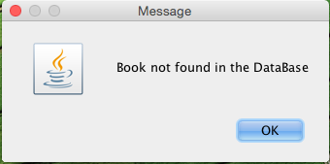

**Lend Book Functionality**

**User wants to Lend a Book *Book id: 4986, Title: Java, Author name: Blank***

**Clicks on Lend Book Button. Enter Book id: 4986🡪 🡪Status of the Book Lent is Shown**

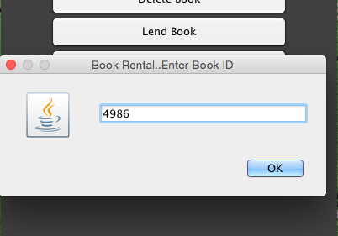 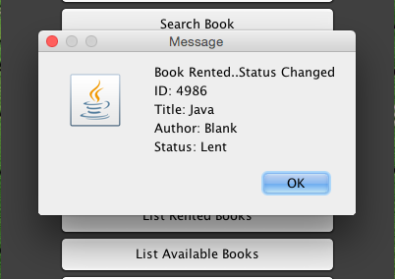

**Database showing the Status of the Book ‘Java’ marked as ‘Lent’**

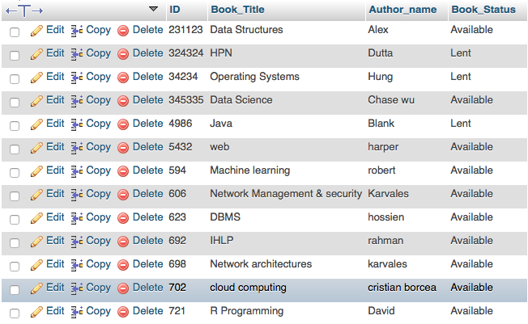

**Exceptions Handled for Lend Book Functionality**

**Scenario 1**

**User wants to Lend a Book already rented by someone else.**

**User wants to Lend the Book with *Book id: 34234, Book Title: Operating Systems,***

***Book Status: Lent***

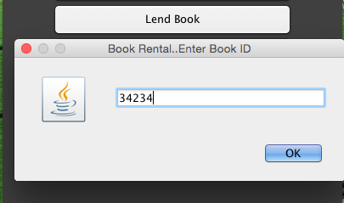

**The Below Error Message Dialog is displayed.**

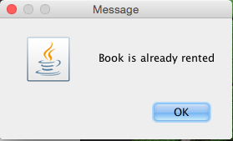

**Scenario 2**

**Lending a book not available in the Database 🡪 🡪 DISPLAYS THE BELOW ERROR**

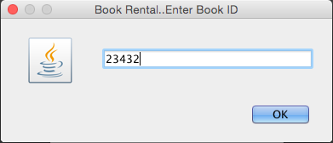 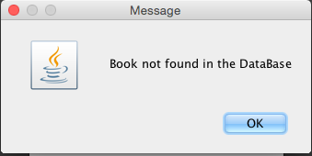

**Return Book Functionality**

**User wants to return a Book** (***Book id: 4986, Title: Java, Author name: Blank*) previously borrowed**

**Clicks on Return Book Button.**

**Enters Book id: 4986 🡪 🡪 Details of the Book Returned is displayed**

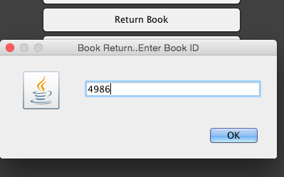 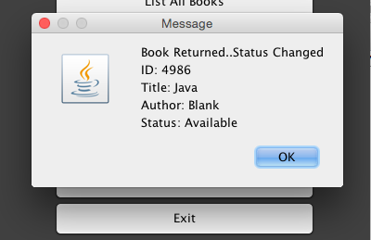

**Database showing the Status of the Book ‘Java’ marked back to ‘Available’**

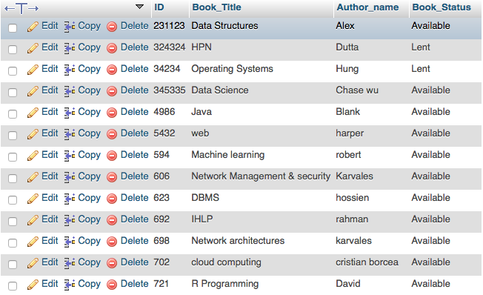

**Exceptions Handled for Return Book Functionality**

**Scenario 1**

**User wants to Return a Book that is already available in the Library Database**

**User wants to Return the Book with Book id: 623, Book Title: DBMS, Book Status: Available.**

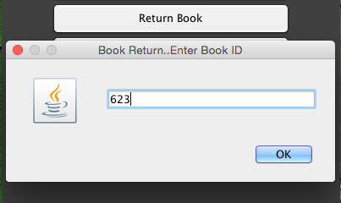

**The Below Error Message Dialog is displayed.**

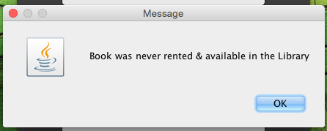

**Scenario 2**

**Returning a book not available in the DB🡪 🡪 DISPLAYS THE BELOW ERROR**

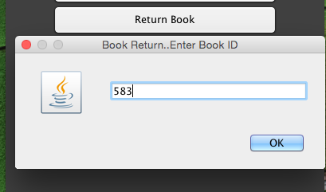 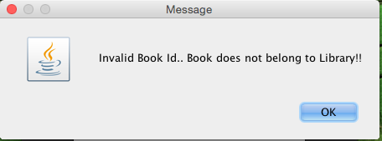

**List Rented Books Functionality**

**Clicking List Rented Books Button Displays the List of Lent books in the Database**

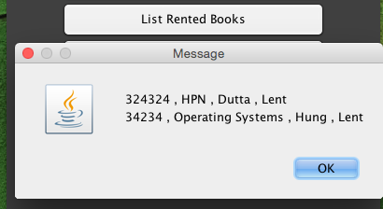

**Console Log**

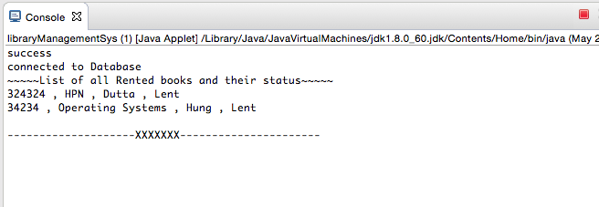

**List Available Books Functionality**

**Clicking List Available Books Button Displays the List of Available books in the Library.**

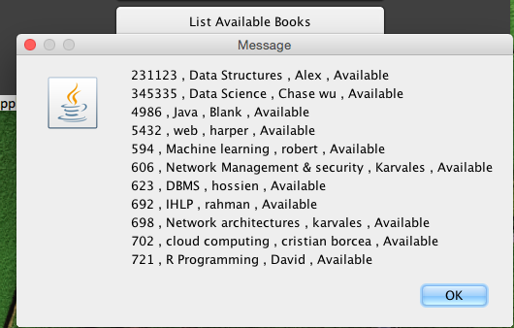

**Console Log**

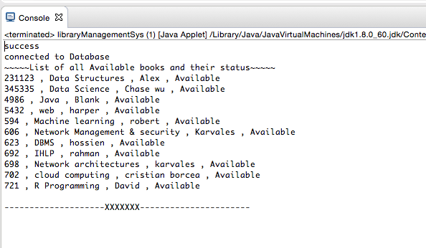

**Communication Diagram**

**Initializes Buttons and JPanel**

**Connection Terminated**

**Exit pressed**

Exit

libManagementSys

Return Books

Init()

**ListAll Books Pressed**

**Return Books pressed**

**List Rented Books pressed**

List Rented Books

**Waits for ActionListener.**

**Displays the Applet**

**Establishes database connection**

**Add Books Pressed**

**List Available books pressed**

**Lend Books pressed**

**Delete Books pressed**

**Search Books Pressed**

Search Books

Add Book

ListAll Books

Delete Books

Lend Books

List Available Books