https://880c339ac87519ae77.gradio.live/
https://colab.research.google.com/drive/11iJpOJ9SK9wSbhEoUds2OrODJ9yC8MOR#scrollTo=0b9572a1

User Input: We're trying to deploy the Billing service to the PT environment, but the deployment job in XLR is stuck and hasn't progressed in over an hour. Other environments deployed fine earlier today. There's no error in the job log, it just isn't moving forward. What should we check?
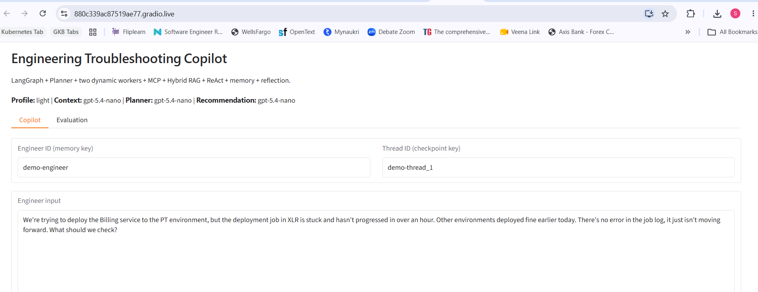

Clarification requested by the agent: In the PT Billing XLR deployment job, what is the most recent stage/step name shown as “last updated” (e.g., waiting for approval/lock, image pull, rollout, health checks), and what timestamp does it show for that last update?
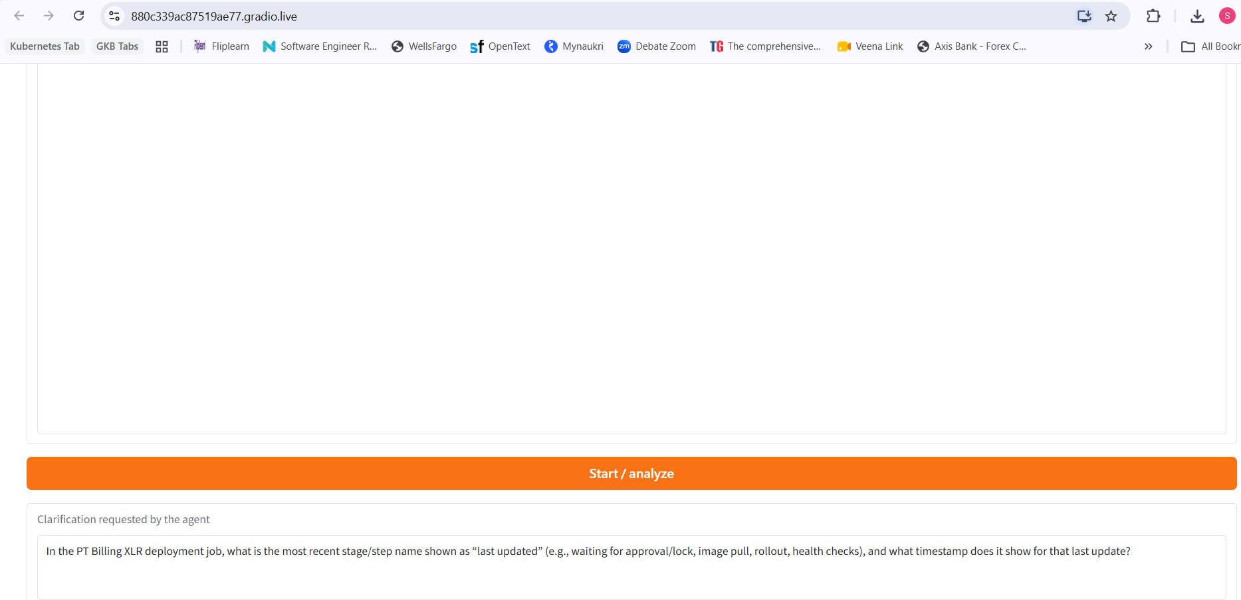

Engineer response: The XLR job is currently sitting at the pre-deployment validation step — it executed successfully and then just stopped advancing, no error shown. It's in a waiting/paused state, not actively executing anything (no CPU/log activity, no new log lines in the last 45+ minutes).
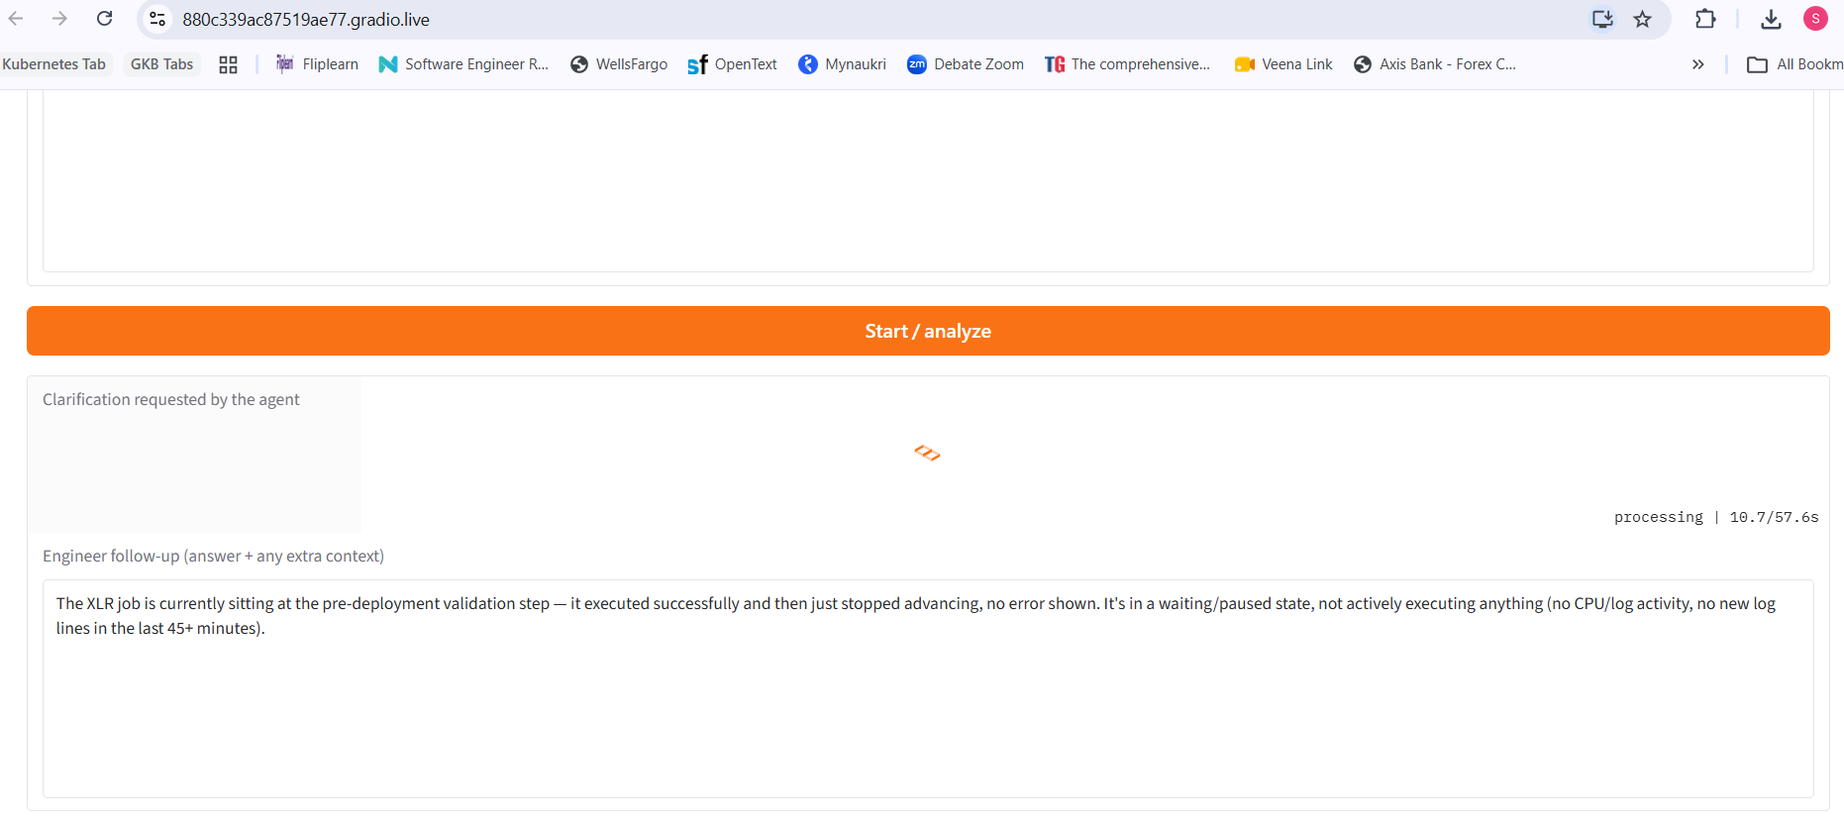
Recommendation by the agent:
{
"possible_issue_category": "deployment_order_issue",
"next_steps": [
"In XLR, open the Billing deployment job for PT and capture the last *completed* validation sub-check and timestamp (or the step the job history says is incomplete). If XLR shows “paused/waiting pre-deployment validation” with no errors, treat the pre-deployment validation phase as potentially waiting on prerequisites rather than failing—your goal is to identify the exact prerequisite that is gating advancement.",
"Run the runbook’s pre-deployment validation checklist specifically against the PT environment inputs: confirm required artifacts/credentials/secrets/certificates are present and accessible, confirm dependency readiness, and verify server health/network reachability/DNS/LB membership and baseline application health before deployment begins.",
"Do NOT re-run any database/DML changes or other already-completed steps; if XLR indicates only an EAR/app-copy/target-related step is incomplete, resume from the documented incomplete step after validating the target readiness that corresponds to the last completed item.",
"Check whether the PT validation gate depends on an external readiness condition (e.g., target directory/host health, dependency service health, or reachability of a required target). The internal prior pattern is “job stopped after a connection timeout to one target server” even when the overall job was otherwise reported successful; validate the exact target that corresponds to the last gating condition."
],
"diagnostic_path": [
"Record the XLR job’s state details (exact waiting reason/locked resource/approval flag if shown) and the timestamp of the last log/activity line.",
"Identify which pre-deployment validation sub-check is the current blocker (artifacts/credentials/certificates/secrets/access/dependency readiness; server health/network reachability/DNS/LB membership; baseline app health).",
"Validate PT targets and dependencies corresponding to that sub-check (health, DNS resolution, network reachability, LB membership, service dependencies).",
"Resume deployment from the documented incomplete step (do not re-run already completed database changes)."
],
"source_traces": [
"runbook::pre-deployment-validation::chunk-0000",
"triage::record-0000::chunk-0001"
],
"citations": [
{
"source_id": "runbook::pre-deployment-validation::chunk-0000",
"quote": "Confirm required artifacts, credentials, certificates, secrets, access and dependency readiness. Validate server health, network reachability, DNS resolution, load-balancer membership, service dependencies and the baseline application health state before deployment begins."
},
{
"source_id": "triage::record-0000::chunk-0001",
"quote": "The ticket says DML is complete and the EAR step is incomplete. That matches the job history."
},
{
"source_id": "triage::record-0000::chunk-0001",
"quote": "The next action is to validate the target server and resume from the documented incomplete step, not rerun the completed database change."
}
],
"acceptable_alternatives": [
"If XLR exposes an explicit manual resume/override or “retry validation” for the current blocker, use it only after you validate the specific dependency/target readiness gating the step (credentials/secrets/certificates, dependency readiness, or network/reachability)."
],
"should_not_repeat_the_below_action": [],
"clarification_questions": [
"What exact sub-state does XLR show for the PT Billing job (e.g., “waiting for approval”, “validation: dependency readiness”, “target server validation”), and what timestamp/log line is the last activity before it went quiet?",
"Which pre-deployment validation items are configured for this deployment template (and are any of them PT-specific like certificate/secret names, dependency endpoints, or target groups/load balancers)?"
],
"clarification_questions_required": false,
"confidence": "medium"
}

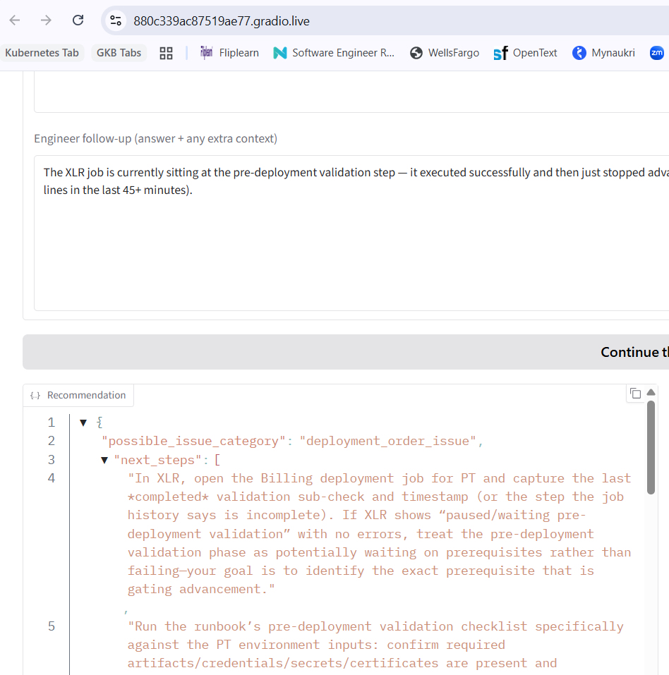

LLM Context:
{
"current_problem": "Billing service deployment to PT via the XLR deployment job is stuck: the job is paused/waiting at the pre-deployment validation step and has not advanced for over an hour (no errors in logs; no CPU/log activity; no new log lines for 45+ minutes). Earlier, other environments deployed successfully today.",
"environment": "PT environment; XLR deployment system/job",
"application": "Billing service",
"issue_category": "Deployment stuck at pre-deployment validation (hang/paused state)",
"conversation_summary": "The engineer is deploying the Billing service to PT. The XLR deployment job previously succeeded through validation but then stopped advancing at the pre-deployment validation step. The job appears paused/waiting with no errors and no log activity for 45+ minutes to over an hour, while other environments deployed earlier without issue. The engineer asks what to check next.",
"actions_already_attempted": [],
"people_mentioned": [],
"information_gaps": [
"What exact status/state does XLR show (e.g., “waiting for approval”, “stuck in validation”, “queued”, “resource lock”) and what timestamps/IDs are associated with the last log entry?",
"Which pre-deployment validation checks are running/expected (e.g., schema checks, connectivity/health checks, secrets/config validation, database migrations, artifact verification)?",
"Is there any dependency on shared infrastructure in PT (deployments, feature flags, maintenance windows, capacity, namespaces/service accounts) that could block validations?",
"Is there an approval gate, webhook callback, or external system that the validation step waits on (and whether it’s healthy/unreachable)?",
"Are there any recent changes to PT environment configuration or the Billing service version/artifact being deployed?",
"Does XLR provide a retry/resume/override option for validation, or does it require manual intervention when paused?",
"Are there correlated platform alerts (or other jobs) affecting PT at the same time? (No alerts mentioned yet.)"
],
"user_questions": [
"What should we check when an XLR deployment job is stuck at the pre-deployment validation step with no errors and no log activity?",
"How do we determine what the validation step is waiting on when it is in a paused/waiting state?",
"Is there a standard way to resume/retry or bypass validation in XLR without risking inconsistent deployment? "
],
"retrieval_queries": [
"XLR deployment job stuck at pre-deployment validation waiting paused no logs",
"PT environment Billing service deployment validation step hang troubleshooting checklist",
"XLR job state machine pre-deployment validation step what does it wait for (approvals/webhooks/resources)"
],
"durable_memory_facts": []
}

Recalled memory:
[
{
"id": 10,
"engineer_id": "demo-engineer",
"fact": "In the Billing deployment to PT, the XLR deployment job is stuck (no progress for over an hour) with no errors in the job log, while other environments deployed successfully earlier the same day.",
"person": null,
"team": null,
"topic": "Billing service PT deployment stuck in XLR",
"importance": "medium",
"source_turn": 3,
"source_text": "TURN 1:\nCustomerService deployed successfully to Prod and the deployment job reported success, but the application health check is now failing. The app logs show repeated connection timeouts when trying to reach the database layer. Nothing else was changed in this release. What's the next step?\n\n---\n\nTURN 2:\nCustomerService connects to cassandra-customerprofile.prod.internal:9042. The\nconnection reaches the cluster (DNS resolves fine, no network-level timeout),\nbut fails during the TLS handshake. Relevant log line:\n\n2026-09-26 03:14:22 ERROR [cluster1-nio-worker-3] com.datastax.driver.core.Connection\n - Error connecting to /10.42.6.18:9042 (SSLHandshakeException: PKIX path\n building failed: unable to find valid certification path to requested target)\n\nThis release also upgraded the Cassandra driver from 4.15 to 4.17. I haven't\nchecked yet whether the truststore was updated as part of this release.\n\n---\n\nTURN 3:\nWe're trying to deploy the Billing service to the PT environment, but the deployment job in XLR is stuck and hasn't progressed in over an hour. Other environments deployed fine earlier today. There's no error in the job log, it just isn't moving forward. What should we check?",
"created_at": "2026-09-26 10:53:49"
},
{
"id": 8,
"engineer_id": "demo-engineer",
"fact": "CustomerService production deployment reported success, but after deployment the app health check started failing due to repeated connection timeouts to the database layer; logs show Cassandra TLS handshake failing with SSLHandshakeException: PKIX path building failed: unable to find valid certification path to requested target.",
"person": null,
"team": "CustomerService/Platform (unspecified)",
"topic": "CustomerService -> Cassandra TLS handshake/PKIX failure after deployment",
"importance": "high",
"source_turn": 3,
"source_text": "TURN 1:\nCustomerService deployed successfully to Prod and the deployment job reported success, but the application health check is now failing. The app logs show repeated connection timeouts when trying to reach the database layer. Nothing else was changed in this release. What's the next step?\n\n---\n\nTURN 2:\nCustomerService connects to cassandra-customerprofile.prod.internal:9042. The\nconnection reaches the cluster (DNS resolves fine, no network-level timeout),\nbut fails during the TLS handshake. Relevant log line:\n\n2026-09-26 03:14:22 ERROR [cluster1-nio-worker-3] com.datastax.driver.core.Connection\n - Error connecting to /10.42.6.18:9042 (SSLHandshakeException: PKIX path\n building failed: unable to find valid certification path to requested target)\n\nThis release also upgraded the Cassandra driver from 4.15 to 4.17. I haven't\nchecked yet whether the truststore was updated as part of this release.\n\n---\n\nTURN 3:\nWe're trying to deploy the Billing service to the PT environment, but the deployment job in XLR is stuck and hasn't progressed in over an hour. Other environments deployed fine earlier today. There's no error in the job log, it just isn't moving forward. What should we check?",
"created_at": "2026-09-26 10:53:49"
},
{
"id": 7,
"engineer_id": "demo-engineer",
"fact": "The release that triggered the incident upgraded the Cassandra driver from 4.15 to 4.17; truststore updates were not yet confirmed.",
"person": null,
"team": null,
"topic": "Driver upgrade (4.15 -> 4.17) possibly impacted TLS trust configuration",
"importance": "high",
"source_turn": 2,
"source_text": "TURN 1:\nCustomerService deployed successfully to Prod and the deployment job reported success, but the application health check is now failing. The app logs show repeated connection timeouts when trying to reach the database layer. Nothing else was changed in this release. What's the next step?\n\n---\n\nTURN 2:\nCustomerService connects to cassandra-customerprofile.prod.internal:9042. The\nconnection reaches the cluster (DNS resolves fine, no network-level timeout),\nbut fails during the TLS handshake. Relevant log line:\n\n2026-09-26 03:14:22 ERROR [cluster1-nio-worker-3] com.datastax.driver.core.Connection\n - Error connecting to /10.42.6.18:9042 (SSLHandshakeException: PKIX path\n building failed: unable to find valid certification path to requested target)\n\nThis release also upgraded the Cassandra driver from 4.15 to 4.17. I haven't\nchecked yet whether the truststore was updated as part of this release.",
"created_at": "2026-09-26 10:42:38"
},
{
"id": 6,
"engineer_id": "demo-engineer",
"fact": "CustomerService deployment to Prod reported success, but health checks began failing due to Cassandra connectivity issues: SSLHandshakeException with `PKIX path building failed: unable to find valid certification path to requested target` when connecting to cassandra-customerprofile.prod.internal:9042.",
"person": null,
"team": null,
"topic": "Prod incident - Cassandra TLS PKIX failure after CustomerService deployment",
"importance": "high",
"source_turn": 2,
"source_text": "TURN 1:\nCustomerService deployed successfully to Prod and the deployment job reported success, but the application health check is now failing. The app logs show repeated connection timeouts when trying to reach the database layer. Nothing else was changed in this release. What's the next step?\n\n---\n\nTURN 2:\nCustomerService connects to cassandra-customerprofile.prod.internal:9042. The\nconnection reaches the cluster (DNS resolves fine, no network-level timeout),\nbut fails during the TLS handshake. Relevant log line:\n\n2026-09-26 03:14:22 ERROR [cluster1-nio-worker-3] com.datastax.driver.core.Connection\n - Error connecting to /10.42.6.18:9042 (SSLHandshakeException: PKIX path\n building failed: unable to find valid certification path to requested target)\n\nThis release also upgraded the Cassandra driver from 4.15 to 4.17. I haven't\nchecked yet whether the truststore was updated as part of this release.",
"created_at": "2026-09-26 10:42:38"
},
{
"id": 9,
"engineer_id": "demo-engineer",
"fact": "CustomerService release upgraded the Cassandra driver from 4.15 to 4.17, and truststore update status has not yet been verified.",
"person": null,
"team": null,
"topic": "Cassandra driver upgrade 4.15 -> 4.17 and truststore unknown",
"importance": "high",
"source_turn": 3,
"source_text": "TURN 1:\nCustomerService deployed successfully to Prod and the deployment job reported success, but the application health check is now failing. The app logs show repeated connection timeouts when trying to reach the database layer. Nothing else was changed in this release. What's the next step?\n\n---\n\nTURN 2:\nCustomerService connects to cassandra-customerprofile.prod.internal:9042. The\nconnection reaches the cluster (DNS resolves fine, no network-level timeout),\nbut fails during the TLS handshake. Relevant log line:\n\n2026-09-26 03:14:22 ERROR [cluster1-nio-worker-3] com.datastax.driver.core.Connection\n - Error connecting to /10.42.6.18:9042 (SSLHandshakeException: PKIX path\n building failed: unable to find valid certification path to requested target)\n\nThis release also upgraded the Cassandra driver from 4.15 to 4.17. I haven't\nchecked yet whether the truststore was updated as part of this release.\n\n---\n\nTURN 3:\nWe're trying to deploy the Billing service to the PT environment, but the deployment job in XLR is stuck and hasn't progressed in over an hour. Other environments deployed fine earlier today. There's no error in the job log, it just isn't moving forward. What should we check?",
"created_at": "2026-09-26 10:53:49"
}
]

Planner research plan:
{
"selected_workers": [
{
"role": "internal_knowledge",
"objective": "Find runbooks/previous incident/JIRA details for XLR deployment jobs stuck at 'pre-deployment validation'—including the meaning of job states, what checks run during validation, and standard resume/override actions.",
"queries": [
"XLR deployment job paused waiting pre-deployment validation troubleshooting",
"pre-deployment validation step XLR deployment what to check",
"deployment stuck at pre-deployment validation XLR resume retry override"
]
},
{
"role": "external_research",
"objective": "Check public/vendor documentation for XLR deployment job behavior/state machine, especially what the pre-deployment validation step waits on and any known issues/required manual interventions.",
"queries": [
"XLR deployment system pre-deployment validation stuck waiting documentation",
"XLR deployment job paused waiting for validation state machine",
"XLR deployment validation step what does it perform (artifact checks health checks approvals)"
]
}
],
"rationale": "The problem is an XLR deployment job hanging at a specific step with no log activity; resolving it fastest typically requires (1) internal runbook guidance on how XLR represents 'paused/waiting' and what validation checks/blockers are expected, plus any known PT/environment dependencies, and (2) potentially version/vendor-specific documentation for the validation step semantics and any documented resume/bypass mechanisms. This two-pronged approach avoids guessing and keeps research minimal."
}

ReAct Observations:
[
{
"worker_role": "internal_knowledge",
"ok": true,
"evidence_count": 2,
"queries": [
"XLR deployment job stuck no progress no errors PT troubleshooting",
"deployment job not progressing no errors XLR wait for approval lock rollout health checks",
"Billing service PT environment XLR deployment stuck runbook"
]
},
{
"worker_role": "external_research",
"ok": true,
"evidence_count": 0,
"queries": [
"XLR deployment job stuck no progress no errors documentation"
]
},
{
"worker_role": "internal_knowledge",
"ok": true,
"evidence_count": 3,
"queries": [
"XLR deployment job paused waiting pre-deployment validation troubleshooting",
"pre-deployment validation step XLR deployment what to check",
"deployment stuck at pre-deployment validation XLR resume retry override"
]
},
{
"worker_role": "external_research",
"ok": true,
"evidence_count": 0,
"queries": [
"XLR deployment system pre-deployment validation stuck waiting documentation"
]
}
]

Runtime telemetry:
{
"turn_number": 2,
"llm_calls": 8,
"input_tokens": 29662,
"output_tokens": 2941,
"total_tokens": 32603,
"llm_latency_seconds": 18.771,
"mcp_calls": 4,
"workers_used": [
"external_research",
"internal_knowledge"
],
"react_steps": 1,
"clarifications": 1,
"revisions": 1,
"memory_hits": 5
}

- Input Guard: accepted engineer input as turn 1
- Context Understanding Agent: understand_context() -> LLM1 -> QueryContext
- Memory Recall: 5 relevant stored fact(s) found
- Planner: plan_research() -> LLM2 -> ResearchPlan
- Planner selected 2 worker role(s)
- Dynamic Worker: internal_knowledge -> MCP -> success
- Dynamic Worker: external_research -> MCP -> success
- ReAct step 1: clarification required
- Clarification received: routing back to LLM1 context understanding
- Context Understanding Agent: understand_context() -> LLM1 -> QueryContext
- Memory Recall: 5 relevant stored fact(s) found
- Planner: plan_research() -> LLM2 -> ResearchPlan
- Planner selected 2 worker role(s)
- Dynamic Worker: internal_knowledge -> MCP -> success
- Dynamic Worker: external_research -> MCP -> success
- ReAct step 1: clarification required
- Recommendation Agent: recommend() -> LLM3 -> Recommendation
- Critic: REVISE
- Output Guard: final citation/provenance validation
- Memory Write: attempted to store 0 durable fact(s); saved 0

Evaluation Metrics:
{
"cases_run": 12,
"category_accuracy": 0.167,
"avg_next_action_coverage": 0.25,
"avg_source_coverage": 0.167,
"no_repeat_rate": 0.917,
"clarification_accuracy": 0.917,
"worker_selection_accuracy": 0.25,
"worker_execution_success": 1,
"memory_match_rate": 1,
"case_pass_rate": 0,
"retrieval_source_hit_rate": 0.833,
"retrieval_source_recall": 0.611,
"retrieval_source_mrr": 0.519,
"llm_judge_enabled": false,
"avg_latency_seconds": 49.337,
"total_input_tokens": 118462,
"total_output_tokens": 19721,
"total_tokens": 138183,
"avg_mcp_calls": 2.667,
"avg_llm_calls": 4.5,
"avg_react_steps": 1,
"avg_memory_hits": 0.25,
"avg_web_calls": 1.333,
"avg_revisions": 0.417,
"avg_evidence_count": 6.5,
"llm_judge_model": null
}

