**NON-LINEAR GROUND RESPONSE ANALYSIS OF MANGALORE AND BANGLORE SITES**

**A Project Report**

***Submitted by***

**KRITI SINGH**

**RUSHIL GOYAL**

**SUMIT NAGAR**

**BACHELOR OF TECHNOLOGY**

**CIVIL ENGINEERING DEPARTMENT**

**NATIONAL INSTITUTE OF TECHNOLOGY SURATHKAL**



**FACULTY SUPERVISOR**

**PROF. D. Venkat Reddy**

CIVIL ENGINEERING DEPARTMENT

NATIONAL INSTITUTE OF TECHNOLOGY KARNATAKA

**NATIONAL INSTITUTE OF TECHNOLOGY KARNATAKA**



**CIVIL ENGINEERING DEPARTMENT**

**CERTIFICATE**

*This is to certify that the dissertation entitled “****Non-linear ground response analysis of mangalore and banglore sites****”**is submitted by* ***KRITI SINGH*** *of 2010-2014 batch- B-Tech-Civil Engineering, National Institute of Technology, Surathkal to the Department of Civil Engineering, National Institute of Technology, Karnataka. It is a record of the major project work done by her under my guidance.*

Date: **Prof. D. Venkat Reddy**

*Civil Engineering Department*

*National Institute of Technology Karnataka*

*Shrinivasnagar, D.K. 575025*

**ABSTRACT**

Seismic codes are the guidelines which are mainly followed for earthquake resistant design of new building and retrofitting the existing structures. Studies carried out by many researchers have shown that Indian standard in current status do not provide a measurable seismic hazard for each region in India but lumps large parts of the country into unstructured regions of equal seismic hazard. In Indian standard code the RESPONSE SPECTRUM proposed is based on the zonation factor where the zonation map of India is classified into four zones having four seismic design coefficient only and even though India has a wide variety of diverse geology and geotechnical material properties, the IS seismic code groups geotechnical materials into three categories i.e. hard, medium and soft. Also recent studies showed that micro level hazard values are lesser or more than seismic hazard values given in Indian code and thus the three site classes defined in Indian code is insufficient to account the soil distribution to account earthquake geotechnical hazards. Many International standards are available which consider the shear wave velocity of subsoil as deciding factor to categorize the subsurface material which also accounts the local soil effect, which is missing in the present Indian standard code whereas IS code uses N values which are not clearly defined compared to modern seismic code. Therefore an attempt is made in this project to conduct a site specific ground motion analysis covering several regions in Peninsular India by studying the local seismicity and local site conditions.

Comparing IS Code with International building code (IBC) and Eurocode, IBC (2009) has six site classes to account site effect for different soil classifications similarly Eurocode the site subsoil is classified into different group types namely A, B, C, D, E, S1 and S2 which clearly shows the consideration of the wide range of geotechnical variations adopted in international codal provisions. The main objective of this study is to evaluate site specific design spectrum considering site specific soil profiles from different parts of Peninsular India and compare with an Indian Standard Earthquake code of “Criteria for earthquake resistant design of structures” (IS-1893-2002). Representative ground motions for different region will be selected and soil profiles with measured standard penetration test N values will be collected. These two data will be used for detailed site response study. Nonlinear site response study will be carried using “DEEPSOIL” and the response spectrum and other response parameters at ground surface will be estimated. Site effects are directly dependent on the local site conditions, the use of site coefficients of a similar site considering different earthquake record will be helping to generalize design spectrum. Finally this study also developed the normalized design spectra for different site condition similar to the standard code provision. These results may be useful to update current India response spectra.

**ACKNOWLEDGEMENT**

I would like to place on record my deep sense of gratitude to Dr. D. Venkat Reddy, Professor, Dept. of Civil Engineering, National Institute of Technology Karnataka for his generous guidance, insightful comments, constant monitoring, useful suggestions and moral support during every stage of this endeavor.

KRITI SINGH

NITK, SURATHKAL

**TABLE OF CONTENTS**

1. Abstract3
2. Acknowledgement4
3. Table of Contents 5
4. List of Tables and Figures 7
5. Chapter-1 : Introduction8  1.1) General Background8  
    1.2) Need for study8
6. Chapter-2 : Literature Review10  
   2.1) Introduction10  
   2.2) Site Response and its Terminology 11  
   2.3) Geology Information of India11  
   2.4) Seismic Site Classification13  
   2.5) Standard Penetration Test14  
   2.6) Scaling of Ground Motion14  
   2.6.1) Different Scaling Techniques15  
   2.7) Co-relation between SPT N and Shear Modulus16  
   2.8) Site Response Study17  
   2.8.1) Site-specific ground response analysis for Bhuj earthquake18  
   2.8.2) Site-specific ground response analysis for Bangalore region19  
   2.8.3) Site-specific ground response analysis for Delhi region20  
   2.8.4) Site-specific ground response analysis for Chennai region20  
   2.8.5) Site-specific ground response analysis for Dehradun region20  
   2.8.6) Site-specific ground response analysis for Kolkata region21  
   2.8.7) Site-specific ground response analysis for Mumbai region21  
   2.8.8) Site-specific ground response analysis for Kochi region22  
   2.9) The Soil Profile23  
   2.10) Response Spectrum24  
   2.10.1) Historical background24  
   2.10.2) Computation of Response spectra (Linear Acceleration) 24
7. Chapter-3 : Methodology25  
   3.1) Plan of Work25  
   3.2) Peninsular India Tectonics and its Seismicity26  
   3.3)Methodology for Ground Motion Selection and Scaling For Site Response Studies28  
   3.3.1) Scaling of acceleration time history with a scale factor for site response studies28  
   3.4) Methodology for Site Response Analysis29  
   3.5) Methodology for developing Elastic Response Spectrum31
8. Chapter-4 : Dynamic Properties of Soil33  
   4.1) Introduction33  
   4.2) Selection of Material Property Curves34  
   4.2.1) Sand35  
   4.2.2) Clay36  
   4.2.3) Gravel38
9. Chapter-5 : Correlations415.1) Introduction415.2) Existing Correlations between SPT N and Gmax41  
   5.3) N-SPT vs. Unit Weight Correlations41
10. Chapter-6: Site Response Studies and Results46  
    6.1) Introduction46  
    6.2) Need for Study47  
    6.3) Selection of Ground Motions47  
    6.4) Site Response Analysis50  
    6.4.1) Nonlinear Site Response Using Deep Soil50  
    6.5) Response Spectra at Ground Surface54  
    6.6) Average Response Spectra At Ground Surface57
11. Chapter-7 : Summary and Conclusion59
12. References61

LIST OF TABLES AND FIGURES

1. Table 2.1: Site classification system given in modern seismic codes with Indian Standards 13
2. Table 2.2: Correlations selected from literature 17
3. Fig 1.1: Damped single-degree-freedom (SDF) system31
4. Fig 4.1: Variation of shear modulus with shear strain for sands (seed and Idriss, 1970) 35
5. Fig 4.2: Variation of damping ratio with shear strain for sands (seed and idriss, 1970) 36
6. Fig4.3: Variation of shear modulus with shear strain for clay with different Plasticity Index (Vucetic and Dobry, 1991) 37
7. Fig4.4: Variation of damping ratio with shear strain for clay with different Plasticity Index (Vucetic and Dobry, 1991) 38
8. Fig4.5: Variation of shear modulus with shear strain for gravels (Rollins, 1998 and Seed, 1986) 39
9. Fig4.6: Variation of damping ratio with shear strain for gravels (Rollins, 1998 and Seed, 1986) 39
10. Table 5.1: Correlations selected from literature44
11. Table 5.2: N vs. Unit Weight Correlations for Cohesion less Soil45
12. Table 5.3: N vs. Unit Weight Correlations for Cohesive Soil45

13) Table 6.1: Details of selected ground motions for site response studies No. 47

14) Fig 6.1 (a-d): Selected ground motions for Site response study (Note: X-axis represent time in second, Y-axis represent acceleration in g) 48

15) Table 6.3.1: Table of PGA values corresponding to Bangalore Profile49

16) Table 6.3.2: Table of PGA values corresponding to Mangalore Profile49

17)Fig 6.5.1: Input bedrock motion corresponding to ground motion CAN02-5155

18) Fig 6.5.2: Surface motion corresponding to bedrock motion given in Fig 7.2 for Bangalore profile56

19) Fig 6.5.3: Comparison of response spectrum at the base and the surface for Bangalore site57

20) Fig 6.6.1: Response spectrum at the surface of Bangalore site for all 12 input motions. 58

21) Fig 6.6.2: Response spectrum at the surface of Mangalore site for 5 input motions representing PGA < .1g58

**CHAPTER-1**

**INTRODUCTION**

* 1. **GENERAL BACKGROUND**

It has long been recognized that the intensity of ground shaking during earthquakes and the associated damage to structures are significantly influenced by local geologic and soil conditions. Unconsolidated sediments are found to amplify ground motion during earthquakes and are hence more prone to earthquake damage than ground with hard strata. Modern cities built on soft sediments are especially vulnerable to damage caused by amplified ground motions. Damages and loss of lives caused due to earthquake occurrence are known as Seismic Hazards. Even though seismic zonation based on past earthquake distribution has been practiced in many of the developing countries like India. It is well known that earthquake motion is dependent on the soil deposit characteristics and consequently much research has already been done on this topic in order to predict the earthquake hazard at a site and possibly its specific response spectra. Furthermore, in most of seismic design codes the effect of local surface soil conditions is qualitatively considered through the soil condition related dynamic response coefficient, but still on this point more research is required for a more reliable quantitative estimation of ground motion characteristics and structural response at a given site. Available IS code for seismic design (IS 1893: 2002) divides the country into different zones based on the occurrence of events. The design Spectrum which is developed in IS code is based on Zonation factors. But event such as 1993 Killari, 1997 Jabalpur and 2001 Bhuj earthquakes which had occurred in so called stable regions of Indian subcontinent raised the question on the true seismicity defined by Indian standard code. In present form of IS code, local geology has not been given appropriate attention. The basic Objective of Seismic code is to provide a guarantee a minimum level of seismic safety in all constructions. Seismic codes are becoming popular in last few years due to frequent earthquakes around the world. Site effects represent seismic ground response characteristics and are inevitably reflected in seismic code provisions. The main approach in earthquake resistant design is the development of the response spectrum considering site specific subsoil and then finding the horizontal acceleration that is acting on the structure .However it is convenient for design to have smooth response spectra; however, in the real world response spectra come in a large variety of sizes and shapes.

* 1. **NEED FOR STUDY**

Engineers and seismologists have long recognized the importance of response spectra as a means of characterizing ground motions produced by earthquakes and their effects on structures. Since the concept of a response spectrum was introduced by Biot (1932, 1933) and extended by Housner (1941) to engineering applications, it has widely used for purposes of recognizing the significant characteristics of acceleration records and providing a simple way of evaluating the response of structures to strong ground shaking. The first step in any earthquake resistant design is the development of the response spectrum considering site specific subsoil and then finding the horizontal acceleration that is acting on the structure. Hence, there is need for updating and modifying the code in order to avoid the damage of structures and casualties. Many countries’ seismic codes serve for disaster management planning during earthquakes. In Indian seismic code, seismic hazard factors were grouped as four zones with respective zonation factors based macro level study. Many recent studies show that micro level hazard values are lesser or more than seismic hazard values in the Indian code. India has diverse geology and subsurface lithology. Three site classes defined in Indian seismic code are insufficient to account soil distributions in India to account earthquake geotechnical hazards. Few definitions given for soil classification in Indian seismic code does not match with Indian soil classification standard. Modern seismic codes used shear wave velocity as a prime factor to group the soils, but Indian code uses only N values. These N values are not also clearly defined when compared to modern seismic codes. In Indian standard code the design spectrum proposed is based on the zonation factor where the zonation map of India is classified into four zones having four seismic design coefficient only and even though India has a wide variety of diverse geology and geotechnical material properties, the IS seismic code groups geotechnical materials into three categories i.e. hard, medium and soft. Also recent studies showed that micro level hazard values are lesser or more than seismic hazard values given in Indian code and thus the three site classes defined in Indian code is insufficient to account the soil distribution to account earthquake geotechnical hazards. The current earthquake design spectra are based mainly on response spectra from recording stations located on alluvium deposits. A limited number of studies have shown that shape and the magnitude of response spectra for stations located on rock deposits are different from those located on alluvium deposits (Moraz-1976). Many International standards are available which consider the shear wave velocity of subsoil as deciding factor to categorize the subsurface material which also accounts the local soil effect, which is missing in the present Indian standard code whereas IS code uses N values which are not clearly defined compared to modern seismic code. In general, achievement of adequate earthquake-resistant design of structures and consequent minimization of losses and damages from devastating earthquakes require a reliable ground motion prediction either through the use of special earthquake maps and seismic provisions or, more specifically, from site-specific investigations.

Therefore an attempt is made in this project to conduct a site specific ground motion analysis covering Bangalore and Mangalore regions in Peninsular India by studying the local seismicity and local site conditions.

**CHAPTER-2**

**LITERATURE RIVIEW**

**2.1 INTRODUCTION**

Seismic codes are becoming popular in last few years due to frequent earthquakes around the world. Site effects represent seismic ground response characteristics and are inevitably reflected in seismic code provisions. It is known that each soil types responds in a different way when it is subjected to earthquake ground motion and also for sites located at same epicentral distance there may be a drastic change in the ground motion. As seismic waves travels through each soil type there will be change in amplitude and frequency, this change in behavior is due to geotechnical and geophysical properties of soil. The geotechnical properties have been influenced by many parameters and local site condition. The study of local site effect on seismic ground motions is an important feature of geotechnical earthquake engineering.

The selection of appropriate design spectra according to soil categories and seismic intensity is the simplest way to account for site effects both for engineering projects and for general purposes like microzonation study. Recent modern seismic codes in America, Europe, Japan and worldwide (IBC 2009, UBC 97, NEHRP and EC8) have produced numerous valuable data and have incorporated the site effects based on most important experimental and theoretical results. The accurate soil categorization is introduced based on a better description of soil profiles using standard geotechnical parameters like plasticity index (PI), undrained shear strength (Su) and average shear wave velocity (SWV) values. The design of an earthquake resistant structure mainly in urban centers is very important as the populations of the occupants in the building are increasing every year. The Indian seismic code IS 1893 (BIS, 2002) is the standard prescribed by Bureau of Indian Standards (BIS). This standard gives seismicity of locations in India with other factors to calculate forces for design of earthquake resistant structures. The site sub soil classification in the Indian Standard is based on the soil classification considering the grain size distribution and the SPT N value.Many International standards are available which consider the shear wave velocity of subsoil as deciding factor to categorize the subsurface material which also accounts the local soil effect, which is missing in the present Indian standard code whereas IS code uses N values which are not clearly defined compared to modern seismic code.

**2.2 SITE RESPONSE AND ITS TERMINOLOGY**

**Earthquake** is a vibration of the earth's surface usually triggered by the release of stored strain energy in the earth crust along fault lines. This release causes movement in masses of rock and resulting shock waves.

**Site response** analysis is the process of determining the response of soil deposit to the motion of the bedrock immediately beneath it.

**Shear modulus** is the ratio of shear stress to shear strain.

**Intraplate earthquake** is an earthquake that occurs within a plate, as opposed to those occurring at a plate boundary.

**Earthquake Intensity** is the qualitative assessment of earthquake, based on how strong earthquake feels to the observer, qualitative assessment of the kinds of damage done by an earthquake, depends on distance to earthquake & strength of earthquake. It is usually determined from the intensity of shaking and damage from the earthquake.

**Earthquake Magnitude** is the quantitative estimate of earthquakes related to energy release. Quantitative measurement of the amount of energy released by an earthquakedepends on the size of the fault that breaks and determined from Seismic Records.

**2.3 GEOLOGY INFORMATION OF INDIA**

This section gives the summary of Indian geology which highlights diverse distribution of surface materials. Surface materials play a very important role in modifying the seismic waves from seismic bedrock and cause damage to structure and/or to fail surface materials. India is not only diverse in geography, people and culture, but also in Geology and soil deposits. Geology contains rocks covering almost the entire spectrum of the Geological Time Scale. Different regions in India contain rock of all types belonging to different geologic periods. Some of the rocks are badly deformed and transmuted while others are recently deposited alluvium that has yet to undergo diagenesis. Generally India can be naturally divided into three geological provinces namely, the Himalayas, the Indo-Gangetic Plain and the Indian Shield. Geologically India can be divided as 20 geological provinces and detailed geological reports with maps are published by in Geological Survey of India (GSI).The southern boundary of the Himalayas is defined as Siwalik range which contains sediments deposited by ancient Himalayan Rivers. The lesser Himalaya lies in between Main Boundary Thrust (MBT) and Main Central Thrust (MCT) and consist of mostly Paleozoic sedimentary rocks. The Great Himalaya which is the most northerly sub-province comprises of crystalline metamorphic and igneous rocks. The Indo-Gangetic region consists of the vast alluvial plains. The sagging of the basement in this part is attributed to the collision of the Indian and the Eurasian plates. The Indo-Gangetic region is filled with sediments flowing from the Himalayas and parts of the peninsular shield region. The thickness of the alluvial deposits in the Indo-Gangetic Plains is of the order of 1.5-6 km. This conceals the solid nature of its basement.The peninsular shield consists of complex system of folds and faults in the basement rock, attributed to the intense tectonic activity during its evolution. This region contains majority of the rock formations and stratigraphical units in India. The rocks of the oldest Archean era known as Dharwars occupy more than half of the India shield. This discussion gives an overview of rock and geological deposits in India and detailed geological reports with maps can be accessed in Geological Survey of India. Here it can be clearly seen that geologically rock type and surface deposit are not uniform in India. Thus the properties of soil and rock layers above bed rock (geotechnical materials) are very important to represent seismic effects.

**2.4 SEISMIC SITE CLASSIFICATION**

Wide spread destructions caused by many earthquakes because of site specific amplification of ground motion, even at locations far away (100-300 km) from the epicenter (Ansal, 2004). The recent 2001 Gujarat-Bhuj, 1999 Chamoli and 2011 Sikkim earthquakes in India are some of the examples, with notable damage at a distance of 250 km from the epicenter. These failures are the result of the effect of soil condition on ground motion that translates to higher amplitude, which also modifies the spectral content and duration of ground motion (Anbazhagan and Sitharam, 2009a). Site specific ground response analysis aims in determining these effects by considering local soil conditions. Seismic codes describe the site effects by simplest way in the form of elastic response spectra considering soil categories and seismic intensity. Seismic identities are evaluated with respect to regional parameters. Soil categories are taken into account by means of seismic site characterization.

**Table 2.1: Site classification system given in modern seismic codes with Indian Standards**

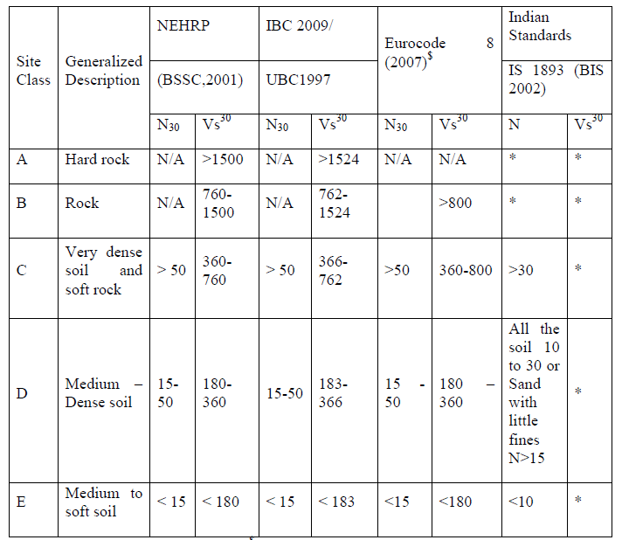

N/A-Not applicable, * Not mention, $The site classes B, C, D and E in this table correspond to site classes A, B, C and D as per Eurocode 8

Seismic site characterization is a process of classifying region/site based on average soil properties. Ground classification of individual sites based on soil boring or shear wave velocity is a more direct indicator of the local site effects. Studies on site effects require knowledge about shear stiffness of the soil column, expressed in terms of shear wave velocity (SWV) (Borcherdt, 1994). The site classes are defined in terms of SWV up to a depth of 30 m, denoted by *Vs30*. If measurement of SWV up to 30 m is not feasible then standard penetration test (SPT) N values and undrained shear strength (Su) could be used (Borcherdt, 1994). SWV can be directly measured in field tests or can be estimated from existing correlations between SPT blow-counts (SPT-N) and SWV (Hasancebi and Ulusay, 2006).

In the initial stage of seismic site classification, surface geology was used for site classification, but later it was proved that considering the geological units as the only criteria for seismic site characterization is not appropriate (Ansal, 2004). Seismic site characteristics are inevitably incorporated in modern seismic code provisions in many countries. Table 2.1 shows the summary of the site classes adopted in National Earthquake Hazards Reduction Program (NEHRP) (BSSC, 2001), International Building Code (IBC, 2009) or Uniform Building Code (UBC, 1997) and Eurocode 8 (2007).

In this study, the site classification using SPT-N is considered. The equivalent shear stiffness values of soil based on SPT-N [*N30*] over 30m depth can be calculated by

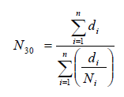

The international standards like NEHRP, IBC and Eurocode are using average soil shear wave velocity and SPT N up to 30 m, as the criteria for site classification. But using 30 m approach for site classification system in all the region is not appropriate (Anbazhagan et al 2010a; 2010b; 2010c). It can be also noted here that Indian code does not given any information on depth for site classifications and soil categories given in Indian code poorly matches with the modern seismic codes of IBC and Eurocode (see Table 2.1). Soil grouping i.e. site class based on SPT N value in IS 1893 (BIS 2002) is very vague. Approximate matching of Indian code soil classification for arriving design spectrum with international standards is given in Table 2.1.

**2.5 STANDARD PENETRATION TEST**

The Standard Penetration Test (SPT) is one of the oldest and most common in situ tests used for soil exploration in soil mechanics and foundation engineering, because of the simplicity of the equipment and test procedures. Standard Penetration Test N values become very important in earthquake geotechnical engineering because of a good correlation with an index of soil liquefaction and also provide the basis for site response and microzonation studies. Many researchers have published site specific response parameters using the SPT data. This test is quite crude and depends on many factors due to the test procedure and some equipment used in the test. Most of the shear modulus correlations are developed using the measured SPT N values.

**2.6 SCALING OF GROUND MOTION**

Scaling of earthquake ground motions is the modification of acceleration time series when we require events with high amplitudes or for the unavailability of rare events. Scaling involves multiplication of the accelerograms by a scale factor that makes the acceleration time series scale up or down by the scale factor applied which is generally referred as a linear scaling method and scaling also refers to the multiplication of the accelerograms by a scale factor that makes their peak vales of response spectrum match the target spectrum at the preferable fundamental period of the structure or over a period of interest for the structure as specified by various codal provisions which is generally termed as spectral matching method. Studies done by various researchers have been discussed here.

**2.6.1 DIFFERENT SCALING TECHNIQUES**

The various Scaling procedure discussed are Scaling on the basis of strong motion parameters, Scaling by Wavelets or Fourier transform and Scaling on the basis of Seismological parameters. Scaling on the basis of strong motion parameters, there are various methodology followed which has its advantage and disadvantage which is discussed below. The techniques followed are Scaling to Peak ground parameters (PGA and PGV), Scaling to Arias Intensity, Scaling to Root mean square acceleration, Scaling to Spectrum Intensity, Scaling to Iv index, Scaling to Spectral Acceleration and Scaling in Time axis.

The majority of the scaling technique is based on strong motion parameters. It is a common practice to follow the scaling of ground motion to a PGA value. However Scaling to a PGA will generally produce a reasonable match with the response spectrum at a short period, since response of short period structure (typically less than 0.5 Sec) is proportional to the acceleration valve and mid moderate period (0.5 to 3 sec) to velocity region and period greater than 3 sec is proportional to displacement region. Hence to reflect the dependency on the acceleration and velocity, scaling can be done to the PGA on the short period range and to the PGV for the moderate- long period range. Although scaling to PGV at moderate period range is just an improvement over using only the value of PGA for the complete range period ( Nau and Hall 1984). Since the peak ground motion values do not characterize satisfactorily the intensity of the ground motion, the Arias Intensity has been proposed as scaling parameter by Arias (1969) and Housner and Jennings (1977). However it does not constitute a great advantage over the use of Peak ground motions since it provides only minor reductions in scatter within limited ranges of frequency and also it is quite unusual to produce AI as a part of the output of a hazard study. Similar problems were reported in scaling to RMS (root-mean-square) acceleration and arms are very unlikely to be a part of the output from a seismic hazard study. Scaling to the Spectrum Intensity also was not a best option since scaling to SI is based on the assumption that the seismic energy imparted by the scaled records is equal to that implied by the design spectrum. In Scaling to the Iv index developed by Fahjan *et al*. (2008) because the previous methods of scaling did not satisfactorily take into account the duration of the ground motion, however this scaling factor includes only two of the basic ground motion parameters peak ground velocity and duration of strong shaking and theses two parameters are rarely available from seismic hazard studies. Scaling to Sa at the natural period of the structure is fundamental to code approaches. For the dynamic analysis most of the seismic design codes do not provide targets of records in terms of strong-motion parameters. When matching of real records is included, it is generally specified with regard to the ordinates of the acceleration response spectrum in the code. Bommer and Ruggeri (2002) summaries in their work the guidelines in current seismic design codes for the use of time histories in dynamic analysis. Finally the scaling in time axis changes the duration of the record and the frequency content over the entire spectrum. Another important issue of this type of scaling is that the relation between duration and number of cycles is lost if scaling is applied to the time axis. Scaling on the time axis should be used carefully to avoid unintended consequences.

The procedure followed in scaling by wavelets or Fourier transform is that, the amplitude of a recorded time history can be modified in a way that the response spectrum matches the target spectrum. This modification is usually called spectrum matching. Applying the Fourier Transform or wavelets theory one can perform this modification. There are various computer programs like RASCAL, developed by Silva and Lee (1987) which modifies the records in the frequency domain by the Fourier Transform, RSPMATCH is another computer program developed by Abrahamson (1993), modifies the records in the time domain by adding wavelets to the reference time history. The last methodology as motioned is scaling on the basis of Seismological parameters however has hardly been addressed in any technical literature.

In the analysis of Peninsular India, the method of linear scaling to match PGA is being adopted and the selection of the PGA is based on the PGA contour map developed by NDMA and Nath and Thimbajan in their works for developing Probabilistic Seismic Hazard map of India. However it is stated that the accelerograms should be scaled in terms of amplitude which does not change the shape of the response spectrum, but adjust the peak ground motion parameters, the spectral ordinates and the energy content. However the influence of the amplitude scaling on duration like bracketed and uniform duration for a given acceleration threshold will generally increase if the amplitude is increasing, Nevertheless scaling on the time axis modifies frequency content over the entire spectrum of real ground motion records as stated by Kramer (1996). As a consequence, it is very unlikely to yield realistic when scaling in time is performed and this approach will alter the duration without changing the number of cycles of motion. Therefore, this type of scaling is generally discouraged.

**2.7 CORRELATION BETWEEN SPT N AND SHEAR MODULUS**

Site response analysis is carried out by using correlation between SPT N and shear modulus.The existing correlations were developed by Imai and Yoshimura (1970), Ohba and Toriumi (1970), Ohta et al. (1972), Ohsaki and Iwasaki (1973), Hara et al. (1974), Imai and Tonouchi (1982), Seed et al. (1983); Seed et al. (1986) and Anbazhagan and Sitharam (2010). Table 2.7.1 gives summary of available SPT N versus Gmax correlations along with modified correlation by Kramer (1996) and new correlation by Anbazhagan et al., (2012). Kramer (1996) has modified correlation developed by Imai and Tonouchi (1982) for sandy soil by replacing measured N values with energy corrected N values [N60].

**Table 2.2 Correlations selected from literature**

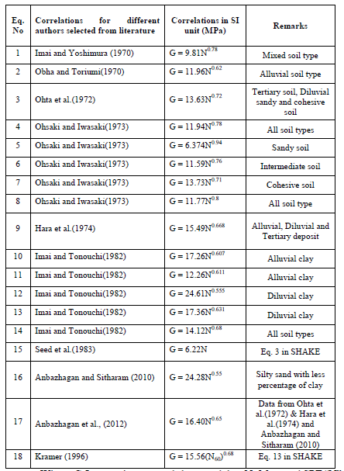

Where, G-Low strain measured shear modulus; N- Measured SPT “N” value.

**2.8 SITE RESPONSE STUDY**

Massive damages due to repeated earthquake are evidenced in our daily life since ancient times when compared to any other natural hazard. It is always believed that the occurrence of earthquake can never be controlled and until today there is no science to predict accurately the location, magnitude and time of earthquake occurrence well in advance. Earthquake induced damages and loss of lives can be minimized if all earthquakes related hazards are known for the expected future earthquake in the region. Such damages are not directly due to earthquakes but due to induced effects such as site effects which can cause more havoc in the form of liquefaction, landslides and ground shaking. The presence of local available geology at any site can modify the bedrock ground motions obtained from seismic hazard. As a result, it will cause a complete change in the ground motion characteristics such as duration of motion, frequency content and amplitude at surface level in comparison to bedrock. Thus the scenario will get completely changed as compared to the seismic hazard obtained at bedrock. These modified motions so called as surface motions are the actual ground motions which are responsible for the phenomena such as liquefaction, ground shaking and landslides. Also, these ground motions provide inputs for the seismically safe design of buildings and other infrastructures. Thus, these effects due local soil should be addressed completely while performing the seismic studies for any urban centre. Site specific ground response analysis aims in determining the effect of local soil conditions i.e. amplification of seismic waves. A site specific response study has been carried out by various researchers for different parts of India. In the year 2004 site response was conducted for Bhuj earthquake in the region of Gujarat by Govindraju and Sitharam, 2009 for Bangalore region by Anbazhagan and Sitharam, 2004 for Delhi region by Iyengar and Ghosh followed by Rao, Neelema and Satyam, Hanumanth Rao, Ramana for Delhi region in 2005, Suganthi, Boominathan in 2006 carried out site response studies for Chennai region in the year 2006, and UmaMaheshwari.et.al. (2008), Mahajan.et.al (2007) for Dehradun, Govindraju (2008) for Kolkata, Anbazhagan (2010) for Lucknow and Phanikanth carried out site response studies for Mumbai in 2011. Some of these site response studies have been discussed here in brief.

**2.8.1 Site-specific ground response analysis for Bhuj earthquake**

A case study on ground response analysis of a site in Ahmadabad city during the Bhuj earthquake was conducted by Govindraju et.al. (2004). Steps to be followed in conducting a meaningful site amplification study are explained. Difficulties/uncertainties in choosing an input ground motion are discussed and the various methods currently available for site amplification study are summarized.In the absence of natural motions, artificial motions can be generated using the concept of ‘spectrum compatible time histories’. For this problem several procedures are available such as time domain, frequency domain generation, empirical Green’s function technique, ARMA modeling, etc.The frequency content describes clearly how the amplitude of ground motion is distributed among different frequencies.The frequency content of a ground motion is obtained by transforming the ground motion from time domain to a frequency domain through a Fourier transform.The variation of energy released with time during Bhuj earthquake for a specific component is plotted. The strong ground motion zone with time has also been plotted. The duration of the strong motion is taken corresponding to the points at which 5% and 95% energy has been recorded.The effect of local soil conditions on ground response during earthquake has been evaluated using widely used computer program SHAKE 91 based on equivalent linear analysis.The spectral accelerations at the ground surface for no damping and 5% damping is plotted. A review of various aspects of site-specific ground response analysis including its engineering importance, difficulties involved in conducting a complete ground response study and also the justification for widely used one-dimensional ground response analysis is highlighted.In this paper, the ground response studies at a site in Ahmadabad City along with observations of geotechnical aspects such as ground cracking, sand volcanoes and liquefaction of soils associated with the Bhuj earthquake are discussed. Large settlements which amplify the damage are attributed to amplification of the ground and the near resonance condition. An attempt has been made to understand the reasons for the failure of multi-storeyed buildings founded on soft alluvial deposits in Ahmadabad. Soil exploration data of a site very close to Sabarmati River was collected from an agency in Ahmadabad. Soil conditions around the Bhuj area have been detailed using a tabular column giving index properties of the soil from Bhuj.Using the soil exploration data of a site very close to Sabarmati river belt in Ahmadabad, the seismic response of the selected site considering the ground as one dimensional layered elastic system was analyzed using SHAKE91. The program requires the input of dynamic properties of soil such as shear modulus or shear wave velocity. In order to evaluate the dynamic properties of soil for the selected soil profile data, empirical equations recommended by Japan Road Association (JRA) were used (Shannon, 1992) Also, Finite Element Analysis was carried out for different configurations of multi-storey building frames for evaluating their natural frequencies and is compared with the predominant frequency of the layered soil system.

**2.8.2 Site-specific ground response analysis for Bangalore region**

Anbazhagan and Sitharam (2008) performed the site response analysis for Bangalore region using shear wave velocity (SWV) profiles for the entire 220 km2 area of Bangalore city. The SWV profiles were obtained by conducting large number of seismic refraction survey all around Bangalore using Multichannel Analysis of Surface Waves (MASW). Obtained SWV profiles for top 30 m for Bangalore as per Anbazhagan and Sitharam (2008) shows that most of the city area composed of soft soil and stiff soil (Seismic site class D and C). One–dimensional site response analyses by equivalent linear approach using SHAKE (Schnabel *et al.* 1972) showed that the amplification factor for Bangalore was found as varying from 2 to 4.

**2.8.3 Site-specific ground response analysis for Delhi region**

G. V. Ramana conducted a site response studies for the regions of Delhi to determine the site amplification. Difficulties/uncertainties in choosing an “input ground motion” are discussed. Seismic hazard analyses (probabilistic or deterministic) are used to predict bedrock motions at the location of the site. Seismic hazard analyses rely on empirical attenuation relationships to predict bedrock motion parameters. Ground response problem becomes one of determining response of soil deposit to the motion of the underlying bedrock.

The current practice and recommendations have also been discussed that includes the mention about the inadequacy of the “seismic coefficient” method. Even to use the “simplified approach”, one requires the magnitude *M* of the earthquake and*amax*, the peak ground acceleration at the site, which is an end product of site specific ground response analysis.

**2.8.4 Site-specific ground response analysis for Chennai region**

Boominathan *et al*. (2008) performed the ground response analyses for Chennai city using SHAKE91. A total of 38 SWV profile for the entire city of Chennai were obtained from MASW tests. In the absence of recorded bedrock motions at Chennai, the recorded ground motion during 1952, Taft Kern earthquake with a PGA of 0.185 g was considered for the site response analyses. Based on the analysis, Boominathan *et al.* (2008) reported that the amplification factor of 4, 4.5 and 5.5 for rock sites, sand sites and clay sites for Chennai. Borehole details at Mogappair site in Chennai show the presence of silty clay in the top 6 m followed by dense sand of 7 m thickness underlain by soft to hard clay of 14 m thickness. N-SPT variation with depth for this location shows the presence of soft soil in the top 13m followed by dense soil and hard rock from 13 m to 30 m depth. Thus based on this study, it can be observed that the presence of soft soil even in thickness of 13 m can cause an amplification of 4.5 to 5.5 in the input bedrock motion.

**2.8.5 Site-specific ground response analysis for Dehradun region**

Kamal and Mundepi (2007) used Nakamura technique (Nakamura, 1979) to study the site effects for Dehradun. Based on horizontal to vertical spectra ratio recorded at 45 locations throughout the Dehradun, Kamal and Mundepi (2007) found the variation in the predominant frequency for the entire Dehradun. Also based on the analyses, an amplification factor ranging between 2 and 3 was determined for the area of Dehradun. Mahajan *et al*. (2007) based on 50 MASW tests conducted at Dehradun city found that the entire area is composed of soft soil, stiff soil and dense soil. Based on the lithological details obtained from Tube well borings at Dehradun by Mahajan *et al.* (2007), the top 9 m is composed of clay followed by coarse sand and clay till a depth 23 m below ground level. Further a layer of clay mixed with boulders of lime was found beyond 23 m depth in layers of 4 m underlain by compact gravels. Thus, based on the combined study from Mahajan *et al.* (2007) and Kamal and Mundepi (2007), it can be said that the presence of soft, stiff soil were found to cause amplification of 2-3 in the bed rock motion for Dehradun.

**2.8.6 Site-specific ground response analysis for Kolkata region**

Govindraju and Bhattacharya (2008) performed the site response analysis based on equivalent linear approach for the city of Kolkata. More than 100 boreholes collected from various agencies were collected to understand the subsoil lithology variation for the city of Kolkata. Representative boreholes presented by Govindraju and Bhattacharya (2008) indicate the presence of silty clay, silty sand and sand mixed with mica. Based on N-SPT variation from these boreholes, it can be said that for majority of locations the top 15 m is composed of soft soil followed by followed by stiff soil below 15 m till a depth of 30 m. Ground response analysis for these soil columns by Govindraju and Bhattacharya (2008) using recorded data from 5 standard earthquakes showed an amplification factor for such soil deposits of soft and stiff soils were in the range of 4.4 to 4.8.

**2.8.7 Site-specific ground response analysis for Mumbai region**

Phanikanth.et.al. (2011) showed the effect of local soil sites in modifying ground response by performing one dimensional equivalent linear ground response analysis for some of the typical Mumbai soil sites.Three different sitesMangalwadi site, Walkeshwar site, BJ Marg near Pandharichawl site is considered in this study and the soil profile is up to Bed Rock. Four ground motions having variations in MHA, bracketed duration and frequency content have been considered. The typical amplifications of ground accelerations considering 4 strong ground motions with wide variation of low to high MHA, frequency contents and durations are obtained. Equivalent linear ground response analysis using computer based program namely DEEPSOIL is used.Field borehole data of some typical sites of Mumbai are considered for the analysis. A set of material curves have been defined in DEEPSOIL for modulus reduction curves and damping ratio curves for different soils.Earthquake characteristics of these motions like Pre-Dominant period, mean period, bracketed duration, significant duration are derived using seismic signal program. Thus for a given time history at the bedrock location and by knowing the dynamic soil characteristics i.e., shear wave velocity profile with depth, modulus reduction and damping curves, the ground motions amplifications are obtained by performing ground response analysis in this paper.The frequencies obtained for these soil sites have been compared with the fundamental frequency based on closed form solutions. It can be observed that the results are in good agreement with the closed form solutions (Kramer 2005).A Comparison table between the calculated frequencies and those obtained by using DEEPSOIL for various soil sites has also been presented Response Spectrum is developed using Seismo Signal computer Program.Acceleration v/s time, Strain v/s time, (τ/σv) v/s time histories at ground level (GL) have also been discussed. The effect of soil layers on ground amplifications is also attempted in the present study. The acceleration response spectrum at ground level for different input motions are evaluated for al1 site locations and the results are plotted. Damping ratio is considered as 5% for generating the response spectrum. The variation of maximum horizontal acceleration along the depth is presented.

**2.8.8 Site-specific ground response analysis for Kochi region**

Singh.et.al. (2012) undertook studies on site specific response studies on a site specific response and its relationship with the geological formation in Kochi city, where they used to about 924 records of ambient noise vibration The ambient noise records were obtained from varied geological setup such as beach sectors, islands, backwater zones, laterites and charnockite formations in order to conduct site response studies at varied local soil conditions. The studies showed that the ground motion amplification had a spatial variability having specific range of resonance frequency for typical soft soil to compacted rocky sites. Their contribution towards detailed seismic microzonation map represented five classes of resonance frequency and three classes of site amplification. In order to estimate site response parameter I-SESAME (version 1.0) software developed under European Project SESAME 2000-2004 was used for processing of micro tremor data. These site response parameters were used to prepare seismic microzonation map for the Kochi city. They concluded that the whole distribution pattern of resonance frequency and site amplification showed that soft soils with thick sedimentary columns in and around the coastal belt and backwater zones are invariably associated with low resonance frequency and likely to amplify ground motion greatly that may result in relatively more damage and on the other hand, the eastern portion of the study region covered with charnockite and laterite exhibit high resonance frequency and may not amplify ground motion much. In such areas, damage will be limited but strong amplification is anticipated in scattered sites having undulation in topography and in basement. Seismic Microzones I, II and III identified from the microzonation map have different site response characteristics in terms of resonance frequency and site amplification. Seismic Microzone I indicates high frequency sites (stable areas) in which generally low level site amplification occur but likely to generate high amplification of ground motion at limited sites; Seismic Microzone II is a medium frequency sites (moderately unstable) in which moderate to high amplification of ground motion likely to occur while Seismic Microzone III is a low frequency sites (unstable areas) and is likely to produce high to very high amplification of ground motion. The characteristic site period in Microzone III is estimated to be highest whereas it is comparatively low to very low in Microzones II and I, respectively.

**2.9 THE SOIL PROFILE**

Rock or soil material, derived by geologic processes, is subject to physical and chemical changes brought about by the climate and other factors prevalent at the location of the soil. The soil profile is a natural succession of zones or strata below the ground surface. It may extend to various depths, and each stratum may have various thicknesses. The upper layer of the profile is typically rich inorganic plant and animal residues mixed with a given mineral-based soil. Soil layers below the topsoil can usually be distinguished by a contrast in color and degree of weathering. The physical properties of each layer usuallydiffer from each other. Topsoil is seldom usedfor construction. Deeper layers will havevarying suitability, depending on theirproperties and location. It is important torelate engineering properties to individual soillayers in order for the data to be meaningful.If data from several layers of varying strengthare averaged, the result can be misleadingand meaningless. The most common method of obtaining some information concerning relative density orthe stiffness of in-situ soil consists of counting the number of blows of a drop weightrequired to drive the sampling spoon a specified distance into the ground. This dynamicsounding procedure is called the *standard penetration test* (SPT). The standard penetration test (SPT) is an in-situ dynamic penetration test designed to provide information on the geotechnical engineeringproperties of soil.The main purpose of the test is to provide an indication of the relative density of granular deposits, such as sands and gravels from which it is virtually impossible to obtain undisturbed samples. The great merit of the test and the main reason for its widespread use is that it is simple and inexpensive. The soil strength parameters which can be inferred are approximate, but may give a useful guide in ground conditions where it may not be possible to obtain borehole samples of adequate quality like gravels, sands, silts, clay containing sand or gravel and weak rock. Values from SPT tests, which constitute the most common in-situ geotechnical test, are commonly used to characterize soil deposits. As discussed above the presence of local available geology at any site can modify the bedrock ground motionsand amplify the motion when it finally reaches the ground surface it is important to study the geological nature of the site of interest by collecting the soil profile data by conducting Standard penetration test up to bed rock and classifying the different layers with corresponding N values. An attempt is made to collect bore hole details for Peninsular India through various sources and agencies so that the final Design spectrum which is developed is site specific spectra.

**2.10 RESPONSE SPECTRUM**

**2.10.1 Historical background**

The concept of response spectra was first incorporated into the United States building codes in the late 1950’s by means of the coefficient *C* in the lateral force equation. It is over the decades, response spectra have been playing an increasing role in the development of earthquake design criteria. The response spectrum method (RSM) was introduced in 1932 in the doctoral dissertation of Maurice Anthony Biot at Caltechfor the use in the analysis and design of earthquake-resistant structures. It is an approach to finding earthquake response of structures using waves or vibrational mode shapes that is in early1930`s Professor Theodore von Karman and his student Maurice Biot were studying the theoretical dynamics problem of how to estimate the maximum response of oscillators to transient excitation, and proposed what is now called the RSM, the Response spectrum method in earthquake engineering. These ideas were first described in 1930, and were further developed the following 10 yr. As per Biot the two main reasons to study spectral distribution is important for two main reason, the peak of spectral shape reveals certain characteristics frequencies of the soil at the given location and the second reason was that by applying the preceding theorem, the maximum effect of earthquakes on building will be easily evaluated (M.D. Trifunac 2006). The RSM remained in the academic sphere of research for almost 40 years, gaining engineering acceptance during the early 1970s. There were two main reasons for this. First, the computation of response to earthquake ground motion led to “certain rather formidable difficulties” (Housner, 1947), and, second, there were only a few well recorded accelerograms that could be used for response studies. This started to change in 1960s with arrival of digital computers and with commercial availability of strong motion accelerographs. Trifunac in his work in 2003 showed that before the digital computer age, the computation of response was time consuming, and the results were unreliable. By the late 1960s and early 1970s, the digitization of analog accelerograph records and the digital computation of ground motion and of the response spectra were developed completely and tested for accuracy. Then, in 1971, with the occurrence of the San Fernando, California, earthquake, the modern era of RSM was launched. This earthquake was recorded by 241 accelerographs. Combining the data from the San Fernando earthquake with all previous strong-motion records, Lee in 2005launched the first comprehensive empirical scaling analyses of response spectral amplitudes.

**2.10.2 Computation of Response spectra (Linear Acceleration).**

To develop elastic response spectra from ground motion recordings for complex loading time histories, the closed-form solutions become impossible to obtain and therefore we must resort to numerical methods. All numerical methods compute solution at discrete time steps and are based on some assumption regarding the solution over a given time interval. The choice of a suitable time step is critical. It is important to understand Accuracy and Stability of numerical methods. An accurate numerical solution is close to the exact solution of the differential equation. The stability refers to the largest time step that can be used without solutionbecoming unbounded due to accumulation of errors. For the dynamic response time history which is given, the maximum of the calculated gives the peak response of the SDOF corresponding to its natural frequency and damping ratio. A plot of the same for various natural periods and damping ratios gives the elastic response spectrum for the input acceleration time history (input ground motion). The above process of obtaining the elastic response spectrum was achieved through SeismoSignalν 4.3.0. In Seismosignal, the spectra is computed by means of time-integration of the equation of motion (linear acceleration method) of a series of single-degree-of-freedom systems, from which the peak acceleration response is then obtained and plotted in period vs. acceleration (or pseudo-acceleration, J.W.Baker and C.A.Cornell ,2005) graphs, known as response spectra. Hence for the computation of spectral values linear acceleration method is adopted in this case. The procedure for developing response spectrum from linear acceleration method is summarized in chapter 3.

**CHAPTER-3**

**METHODOLOGY**

**3.1 PLAN OF WORK**

The work has been planned and executed in the way represented in the following steps

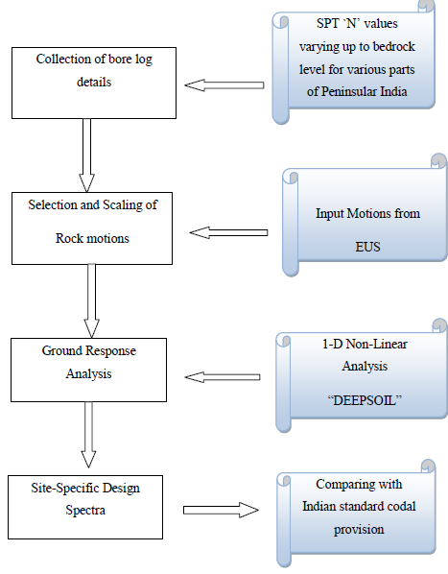

**Brief Description of sequence of steps carried out for the Project:**

The initial problem to be solved by geotechnical Engineers in the regions where earthquake hazards exist is to estimate the Site –Specific Dynamic Response of the layered soil deposit. The complete dynamic site characterization is based on the results of geophysical as well as geotechnical investigations and laboratory testing, one or more soil profiles must be selected for the region selected or site of interest. The first step carried out in the project work is to collect the soil profile data having SPT `N’ values varying up to bed rock level for various regions throughout Peninsular India. The proceeding step involving in the selection of rock motions, where in appropriate rock motions are selected which represent the design rock motion for the site and this selection of Motion was selected from Eastern United States having the same seismotectonic features as that of Peninsular India and the selected input motions is been scaled linearly as per the procedure given by Yasin Fahjan (2010). Selecting the rock motions and Soil profiles for the selected regions a nonlinear analysis in carried out using a computer based program called “DEEPSOIL”. A nonlinear analysis is usually performed by using a discrete model such as finite element as lumped mass models, and performing time domain step-by-step integration of equation of motion. The effect of local soil conditions on ground response during earthquake is evaluated by performing analysis using DEEPSOIL for the selected region providing the appropriate rock motions selected as per the PGA Contour maps proposed by NDMA and Nath and Thimbajan and arriving at the response spectrum at ground level. The final objective is to arrive at the Site specific Response Spectra for the Peninsular India and Proposing new Site coefficients based on this study carried out. Response spectrum is a practical means of characterizing ground motions and their effects on structures. The Response Spectrum provides a convenient means to summarize the peak responses of all possible linear SDOF system to a particular component of ground motions.

**3.2 PENINSULAR INDIA TECTONICS AND ITS SEISMICITY**

Peninsular India which is the stable continental region (SCR) known for its less active seismicity with the past occurrences of moderate earthquakes with relatively lesser activity, the region was earlier considered to be tectonically stable and as a zone of safety with no expectancy of any devastating earthquakes. The seismicity being quite diffused in the shield region, the traditional concept of stability over a past few decades has been proved the other way with occurrences of some major earthquakes that turned out to be very devastating M.Yanger Walling et .al (2009).The Geological survey of India (GSI.2000) developed a detailed seismotectonic Atlas of India projecting the fault map and dividing India into three zones based on geology and tectonic setup; the Himalayan region, the Gangetic region and the Peninsular Region( Kayal 2008). Although concentration of earthquake in India being very high along the Himalayan and Gangetic plains the seismic activity in Peninsular India (PI) which is believed to be relatively stable, has caused much concern over few decades. This landmass is far away from the highly active Himalayan collision zone; however various tectonic structures in PI, the Cambay and Kutch region are very active region (Raghukanth 2010).

Peninsular India has relatively experienced around 400 earthquake of magnitude greater than 3 in a period of 600 years (Rao and Rao 1984). It is generally held that seismic activity is more frequent at the intersection of the Dharwar, Aravali and Singh bhum protocontinents which together constitute Peninsular India (Iyengar and Raghukanth 2004). These three Protocontinents are separated by rifts. The earthquakes in peninsular India can be classified into rift and non rift events. The 1967 Koyna earthquake and 1993 Killari earthquake are examples of non rift events, whereas the 1997 Jabalpur and 2001 Kutch earthquakes are rift events. The most striking feature in the geological map of PI is the Son-Narmada-Tapti (SONATA) rift zone, which is an ENE–WSW trending zone and runs across the Indian shield from west coast to east coast. This rift zone, about 1,600 km long, separates the northern and southern blocks of the Indian shield and is a region of moderate seismic activity with infrequent earthquakes. In southern India, sporadic and low-level seismicity is observed along the old shear zones. The faults associated with the Godavari graben, namely, the Kaddam fault and the Gundlakamma fault near Ongole on the coast, which trends NW–SE, are regarded as the moderately active faults in PI. These faults separate the Singh bhum and Dharwarprotocontinents. Another prominent rift zone in PI is the Kutch rift, located at the northwest margin of the Indian shield. The structural trend of the Kutch rift basin is controlled by a number of E–W faults. Among these faults, the Allah Band and the Kutch mainland fault are active and have produced damaging earthquakes in the past. Based on the occurrence of earthquakes, it has been felt that the hazard in peninsular India is less severe than in the Himalayan region, but the damage caused due to intraplate events is very high.

The events are also felt over a much larger area than Himalayan earthquakes (Singh *et al.* 2004; Kayal 2008). The historical earthquakes from the Peninsular region are the 1764 Mahabaleshwar (M: 6) (Kumar, 1998), 1819 Kutch (M: 8.3), 1846 Damooh Hill, near Jabalpur (Imax: VIor M: 6.5+), 1848 Mount Abu (M: 6.0+), 1900 Coimbatore (M: 6.0+), 1927 Son-Valley (Ms: 6.5) (Gahalaut et al., 2007) and1938 Satpura (M: 6.3) (Rao et al., 2002; Mall et al., 2005), 1969 Bhadrachalam (mb: 5.3) and 1970 Broach (mb: 5.3). The devastating earthquakes like the 1967 Koyna (Ms: 6.5), 1993 Latur (mb: 6.3), 1997 Jabalpur (mb: 6.0) and 2001 Bhuj (Mw: 7.6). Hence the Vulnerability of the Peninsular India to Earthquake hazards cannot be written off as completely safe from seismic hazard. A point to be noted for the Peninsular India is that despite the occurrences of earthquake with magnitude 6 or slightly higher, the damages or causalities are very large suggesting that people are not accustomed to the regular ground shaking as in the Himalayan and strict building codes are not been followed. Though the damage is largely caused by the local geology much of the damages can be curbed to a certain extent with proper site response studies for every different regions of India.

**3.3 METHODOLOGY FOR GROUND MOTION SELECTION AND SCALING FOR SITE RESPONSE STUDIES**

➢ Selection of Input motion of PGA greater than 0.05g recorded at rock Site.

➢ 6 Ground Motions Finalized based on similar seismotectonics of Eastern United States.

➢ Scaling of Input Motion Linearly (Time Domain) using scale factor 2, 3and 4.

* Grouping of finalized 12 motions based on PGA contour map proposed by NDMA and Nath and Thimbajan.

Real strong motion accelerograms contain a wealth of information about the nature of ground shaking and carry all the ground motion characteristic amplitude ,frequency and energy content , duration and phase characteristics and reflect all the factors that influence accelerograms (characteristics of source ,path, and site) .As soil thickness dynamic properties, shear modules and damping curves play very important role in site amplification and shaping of response and design spectrum, Input ground motion acceleration time histories play vital role in the output spectral signature . Even though stable continental region (SCR) of peninsular India (PI) has experienced more than 12 earthquakes of magnitude above 6, very limited acceleration time history are available for site response study. These are several earthquakes records for intraplate region in rest of the world having similar seismotectonic characteristics as of peninsular India is been selected for this site response studies.

**3.3.1 Scaling of acceleration time history with a scale factor for site response studies**

Surface geology plays an important role in altering the observed seismic motion and thereby its damage potential and therefore Site response studies becomes important for any site considered. For developing Design Spectrum for different parts of Peninsular India considering Site specific ground response studies, acceleration time history was selected from eastern united states since the geological features of EUS being explored to be matched with Peninsular India and mainly due to the unavailability of input motions recorded in South India. Ground motion recorded at different sites will significantly vary due to several factors and for the response studies done in peninsular India the input motions recorded at bedrock is being selected having PGA greater than 0.02g and six acceleration time histories is being finalized for the analysis, however the site response studies needs a good number of time histories the selected six time histories is being scaled using scale factors. There are various scaling techniques followed throughout by various engineers and researchers for building analysis one among them being the linear scaling is been adopted in this work as presented by Yasin M Frajan for a simple reason of being Linear scaling maintains the relation between those record properties that scale Linearly( Sa, PGA), however other techniques of scaling followed demands for the target spectrum for scaling and as in this work for developing design spectrum for Peninsular India not depending upon target spectrum instead choosing the required PGA to be scaled up from the PGA contour maps developed by National Disaster management Authority (NDMA) and PGA contour map by Nath and Thimbajan.

**3.4 METHODOLOGY FOR SITE RESPONSE ANALYSIS**

➢ Collecting bore log data from various parts of PI with recorded SPT values for varying layers of soil upto bed rock depth.

➢ Selection of suitable EQ ground motion acceleration time history.

➢ Sealing of selected intraplate input motion for 3 scale factors 2, 3 and 4.

➢ Carrying out site response analysis using deep soil considering selected ground motion and soil properties.

➢ Estimate shear modules for the soil type using the correlation between SPTN and G.

Steps involved in ground response analyses to develop site-specific response spectra at a soil site are briefly summarized below

**Characterization of site conditions**. Based on results of field and laboratory investigation programs, one or more idealized soil profiles are developed for the site. Site characterization includes development of dynamic soil properties (e.g., shear modulus and soil damping and their variations with shearing strain) for each soil layer present at the site.

**b. Selection of rock motion**. Appropriate rock motions (either natural or synthetic acceleration time histories) are selected or developed to represent the design rock motion for the site. If natural time histories are used, a suite of time-histories that have ground motion characteristics (e.g., peak ground motion parameters, response spectral content, and duration of strong shaking) generally similar to characteristics estimated for the design rock motions are selected. The response spectra for the selected rock motions should, in aggregate, approximately fit or reasonably envelop the design rock spectrum developed for the site. Natural time-histories may be scaled by a factor to improve the match to the design rock spectrum. If synthetic time-histories (i.e., recorded time-histories modified to achieve a match to a smooth response spectrum) are used, their spectra should approximately fit the design rock spectrum. The duration of shaking should also be reasonable. It is desirable that more than one synthetic time-history be used. Preferably, rock motions are assigned at a hypothetical rock outcrop at the site, rather than directly at the base of the soil profile. This is because the knowledge of rock motions is based on recordings at rock outcrops; and unless the rock is rigid, the motions at the base of the soil profile will differ from those of the outcrop.

**c. Ground response analyses and development of ground surface response spectra**. Using the rock time-histories as input motions, ground response analyses are conducted for the modeled soil profile(s) to compute ground motions at the ground surface. Nonlinear soil response is approximated by either equivalent linear analysis methods (e.g., SHAKE (Schnabel, Seed, and Lysmer 1972), or nonlinear analysis methods (e.g., DEEPSOIL (Hashash and Park, 2001). Parametric analyses should be made to incorporate uncertainties in dynamic soil properties. Analyses are generally made for best-estimate (average), upper-bound and lower-bound soil properties. Response spectra of the ground surface motions are calculated for the various analyses made. These response spectra can then be statistically analyzed and/or interpreted in some manner to develop design response spectra of surface motions. The time-histories obtained from the site response analyses can be used as representative time-histories of surface motions. Because the response spectra of the input rock time-histories may not closely match the rock design response spectrum (particularly when natural time-histories are used), it may be desirable to obtain “site amplification ratios” from the ground response analyses rather than using the response spectra of calculated surface motions directly. Site amplification ratios are ratios of the response spectra of the ground surface motions computed from the ground response analyses divided by the response spectra of the corresponding input rock motions. Statistical analyses can be made on the amplification ratios or some other method used to obtain design amplification ratios. The estimated response spectrum at the ground surface is then obtained by multiplying the site amplification ratios by the design rock response spectrum over the entire period range. A design response spectrum is then developed by further smoothing the estimated ground surface response spectrum as required. The time-histories from the ground response

analyses can be used directly to represent ground surface motions, or synthetic time-histories can be developed to match the design ground surface response spectrum.

**3.5 METHODOLOGY FOR DEVELOPING ELASTIC RESPONSE SPECTRUM**

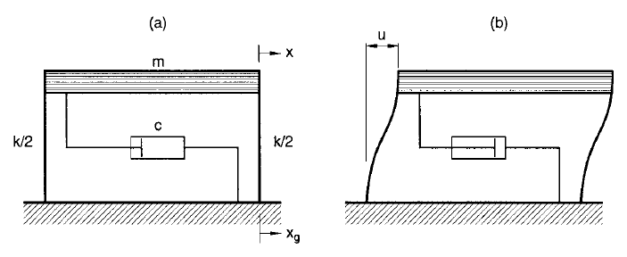 **Figure .1 Damped single-degree-freedom (SDF) system**

The equation of dynamic equilibrium for the single-degree-freedom (SDF) system, shown in above Figure 1 can be written as



1

where m is the mass, c the damping factor, k the stiffness, x the horizontal displacement

of mass, xg the horizontal ground displacement, and the overdot denotes differentiation with

respect to time. Equation (1) may be rewritten as

2

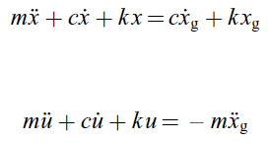

3

in which, u=x*−*xg =displacement of mass with respect to ground, or the deformation of SDF

system.

Either the Equations (2) and (3) can be used to compute the response of the SDF system. While,

Equation (2) makes use of the velocity and displacement histories, Equation (3) makes use

of the acceleration history. Since the acceleration, velocity and displacement histories may not

be compatible with one another, the results obtained from the solution of Equation (2) can

be different than those obtained from the solution of Equation (3). For flexible (long-period)

systems, Equation (2) should be used (with initial conditions displacement and velocity at t = 0 are zero), because the response of such systems is controlled by ground velocity and displacement, whereas for stiff (short-period) systems, Equation (3) should be used because the response of such systems is controlled by ground acceleration.

A system is considered sti_ or exible depending on whether its natural frequency $ω$

is large or small compared to the frequency of ground motion. For a purely sinusoidal ground

motion, the frequency of ground motion can be obtained from the relationship

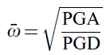

4

Earthquake ground motions are not sinusoidal | they contain many different frequencies. For

such motions, Equation (4) provides a simple measure of the ground motion frequency with

which the system frequency can be compared to determine whether the system is stiff or

flexible

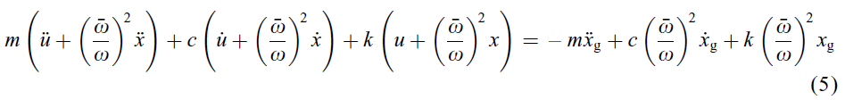

Equation (5) converges to Equation (2) for very flexible systems and Equation (3) for very

stiff systems. Dividing throughout by m and substituting,

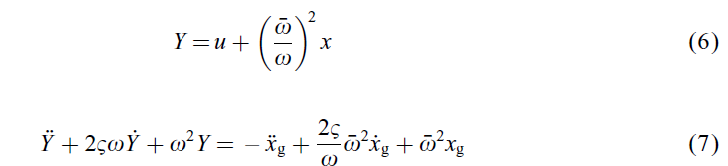

For given values $δ$& and T, Equation (7) is first solved for Y using initial conditions (Y (0) = Y_(0) = 0). Deformation u is obtained next using the following expression, derived from Equation (6) and the relationship x=u + xg:

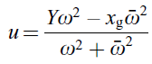

The spectral deformation SD is the maximum value of the deformation at any time, i.e.



**CHAPTER-4**

**DYNAMIC PROPERTIES OF SOIL**

**4.1 INTRODUCTION**

Site amplification of seismic energy due to soil conditions and damage to build environment was amply demonstrated by many earthquakes during the last century. The wide spread destruction caused by Guerrero earthquake (1985) in Mexico city, Spitak earthquake (1988) in Leninakan, Loma Prieta earthquake (1989) in San Francisco Bay area, Kobe earthquake (1995), Kocaeli earthquake (1999) in Adapazari are important examples of site specific amplification of ground motion, even at location far away (100-300km) from the epicenter (Ansal, 2004). The recent 2001 Gujarat-Bhuj earthquake in India is another example, with notable damage at a distance of 250km from the epicenter (Sitharam et. al 2001, and Govindraju et. al 2004). These failures resulted from the effect of soil condition on the ground motion that translates to higher amplitude; it also modifies the spectral content and duration of ground motion.

Stiffness of soil deposits, represented by shear modulus, is an important property for evaluating the dynamic responses of soil structures at different sites. Seismic waves are filtered as they pass through soil layers, from bedrock to surface, change frequencies and amplitudes and these modifications result in different ground motion characteristics. This process can transfer large accelerations to structures causing large destruction, particularly when the resulting seismic wave frequency matches with the resonant frequencies of the structures. Therefore, the effects of earthquakes in buildings and earthworks depend on the shear moduli of soil strata underlying the affected sites. Shear modulus is calculated by using measured SPT N value which in turn used to find out the peak ground acceleration (PGA) and the response spectrum of the site.

Soil properties that influence wave propagation and other low-strain phenomena include stiffness, damping, Poisson’s ratio and density. Of these, stiffness and damping are the most important, the other have less influence. Local site conditions have an influence on amplitude, frequency content, and duration of strong ground motion. The extent of influence of this parameter depends on the geometry and material properties of the subsurface materials, on site topography, and on the characteristics of the input motion. The nature of local site effects can be illustrated by simple theoretical ground response analyses, by measurements of actual surface and subsurface motion at same site, and by measurements of ground surface motions from sites with different subsurface condition.

The nature and distribution of earthquake damage is strongly influenced by the response of soils to cyclic loading. This response is controlled in large part by the mechanical properties of the soil. Ground response analyses are used to evaluate dynamic stresses, strains and to determine the earthquake induced forces which may lead to instability of structures. Geotechnical earthquake engineering encompasses a wide range of problems involving many types of loading and many potential mechanisms of failure, and different soil properties influence the behavior of the soil for different problems. For many important problems, particularly those dominated by wave propagation effects, only low levels of strain are induced in the soil. The behavior of soils subjected to the dynamic loading is governed by what have come to popularly known as dynamic soil properties. Over the years, a number of techniques have been developed for ground response analysis. Although many of two and three-dimensional techniques are relatively straightforward extensions of corresponding one-

dimensional techniques, but one-dimensional equivalent linear (EQL) and nonlinear (NL) analysis are most commonly used to perform seismic site response analysis. The very basic problem to be solved by geotechnical engineers in regions where earthquake hazards exist is to estimate the site-specific dynamic response of a layered soil deposit. The problem is commonly referred to as site-specific response analysis or soil amplification study. This is generally the beginning point for most aseismic studies.

**4.2 SELECTION OF MATERIAL PROPERTY CURVES**

A ground response analysis consists of studying the behavior of a soil deposit subjected to an acceleration time history applied to a layer of the soil profile. Ground response analysis is used to predict the ground surface motions for evaluating the amplification potential and for developing the design response spectrum. In present study, one-dimensional ground response analysis using nonlinear model has been carried out using DEEPSOIL V5.1 software in which motion of object is given at rock layer in the system and motions can be computed in any other layer. The one-dimensional linear analysis to compute ground response using DEEPSOIL employs an iterative procedure in selection of shear modulus and damping ratio of soil properties. These properties can be defined by discrete points or by defining soil parameters that to be used in hyperbolic model in nonlinear analysis. The option of defining the soil curves using discrete points in DEEPSOIL is only applicable for equivalent linear analysis. In equivalent linear analysis shear modulus and damping ratio are defined as a function of strain. Although the equivalent linear approach is computationally convenient and provides reasonable results for many practical problems, it remains an approximation to the actual nonlinear process of seismic ground response. An alternative approach is to analyze the actual nonlinear response of soil deposit using direct numerical integration in the time domain. By integrating the equation of motion in small time steps, any linear or nonlinear stress strain model or advanced constitutive model can be used. At the beginning of each time step, the stress-strain relationship is referred to obtain the appropriate soil properties to be used in that time step. The different modulus curves used for the analysis are discussed in section (4.2.1), (4.2.2) (4.2.3).

**4.2.1 Sand**

Seed and Idriss, 1970, showed by investigations that modulus values of sands are strongly influenced by confining pressure, strain amplitude and void ratio but not significantly by variation in grain size characteristics. They found that in general, the shear modulus and confining pressure are related by Eq5.2.1.



Where, G is shear modulus, σm’ is mean effective confining pressure, K2 is a parameter dependent on void ration and strain amplitude.

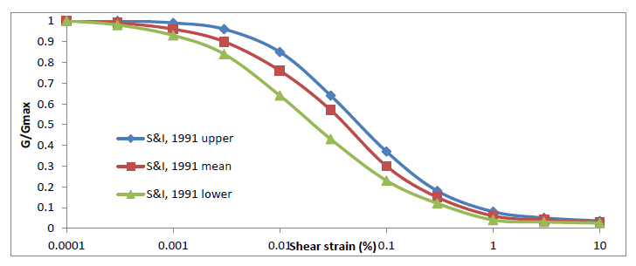

**Fig4.1. Variation of shear modulus with shear strain for sands (seed and Idriss, 1970)**

Ratio of modulus at shear strain ϒ to modulus at shear strain 10-4% was plotted against shear strain to obtain a band of results (Fig 5.1). They further suggested that close approximation to modulus vs. shear strain relationship for any sand can be obtained by determining low strain modulus using wave propagation techniques and reducing this value for other strain levels in accordance with the average curve in Fig 4.1.

Hardin and Drnevich, 1970, studied the factors influencing variation of damping ration in sands and understood that the main factor affecting variation of damping ratio with shear strain is effective vertical confining pressure. Seed and Idriss presented results of previous investigations for various confining pressures and suggested that average curve is likely to provide values of damping ratio with sufficient accuracy for many practical purposes (Fig4.2).

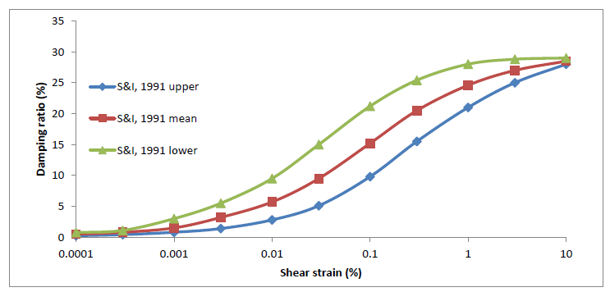

**Fig4.2. Variation of damping ratio with shear strain for sands (seed and idriss, 1970)**

**4.2.2 Clay**

Accurate determination of the shear moduli of saturated clays is enormously complicated by the large effect of strain amplitude and sample disturbance on modulus values. In situ measurements eliminate the problems raised by sample disturbance, but to date no technique has been developed for inducing large scaled amplitudes in natural deposits and thus moduli can only be determined at very low strain levels. In the laboratory, on the other hand, samples may tested under a wide variety of strains, but for test specimens from natural deposits, the moduli determined will inevitably be influenced by the effects of sample disturbance (Seed and Idriss, 1970). Previous experimental studies have shown that dynamic properties of clays vary in more complicated ways than sands and the effects of parameters such as time duration, over consolidation and saturation are more pronounced (Kokusho, 1982). Vucetic and Dobry, 1991, presented a parametric study showing the influence of the plasticity index on the seismic response of clay sites excited by the accelerations recorded on rock in Mexico City during the 1985 earthquake. The curves for different PI are shown in Fig 4.3 and 4.4.

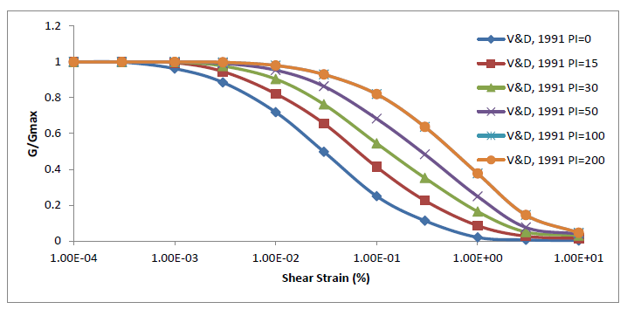

**Fig4.3. Variation of shear modulus with shear strain for clay with different Plasticity Index (Vucetic and Dobry, 1991)**

Based on the review of a number of available cyclic loading results, they concluded that the plasticity index (PI) is the main factor controlling the locations of the modulus reduction curve G/Gmax versus γc (cyclic shear strain) and material damping ratio curve *λ* versus γc, for a wide variety of saturated soils ranging from clays to sands. As the PI goes up, *G/Gmax*increases and *λ* is reduced, i.e., higher plasticity soils generally exhibit a more linear cyclic stress-strain response. This is true for both normally and over consolidated soils. A similar conclusion is also valid for normally consolidated clays for the rate of degradation of the secant modulus *G* with the number of straining cycles, which is reduced at larger PI.

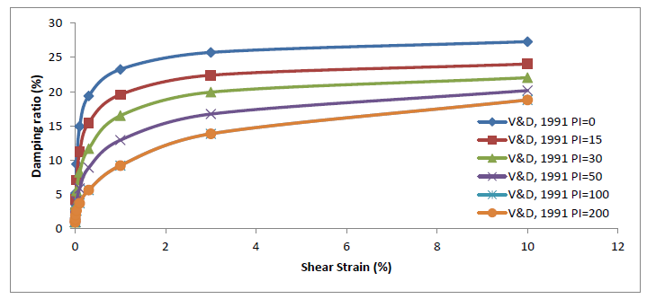

**Fig4.4. Variation of damping ratio with shear strain for clay with different Plasticity Index (Vucetic and Dobry, 1991)**

**4.2.3 Gravel**

Probably because of the large diameter of test specimens required (about 12 in.), there have been virtually no laboratory studies of the shear moduli and damping ratios for gravelly soils. It has long been recognized, however, that shear wave velocities are significantly higher in gravels than in sands. Seed et al performed comprehensive series of tests on 12-in. diameter samples of several different types of gravel in the University of California Rock fill Testing Facility. Tests were performed on isotropically-consolidated samples of gravelly soils under undrained cyclic loading conditions. In this investigation the shear moduli and damping characteristics of the soils were determined from the hysteretic stress-strain relationships determined by cyclic undrained triaxial tests. For each loading cycle, a hysteresis loop was plotted. The equivalent modulus was obtained from the secant modulus, which represented the average modulus of the loop. The equivalent damping ratio at shear strains was determined from the area inside the hysteresis loop using standard procedures (Seed and Idriss, 1970). Since the hysteresis loops are a function of the maximum strain applied, both the equivalent modulus and the equivalent damping ratio are strain-dependent.

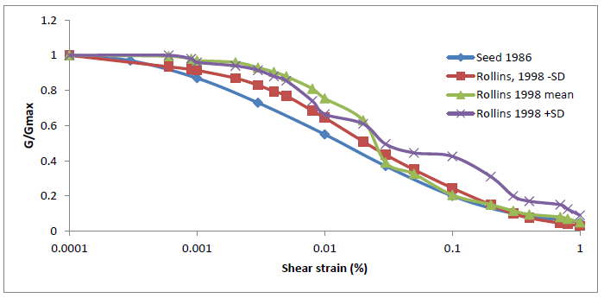

**Fig4.5. Variation of shear modulus with shear strain for gravels (Rollins, 1998 and Seed, 1986)**

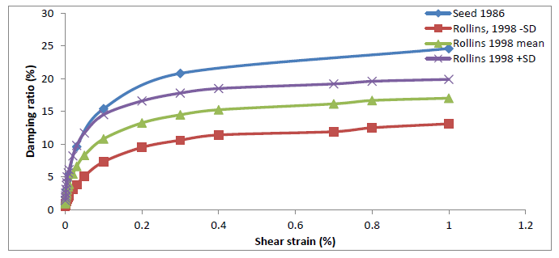

**Fig4.6. Variation of damping ratio with shear strain for gravels (Rollins, 1998 and Seed, 1986)**

They concluded that for most practical purposes, the dynamic shear moduli of granular soils (sands and gravels) can conveniently be expressed by the relationship eq5.2.1. Values of the modulus coefficient *K2*for gravels are generally greater than those for sands by factors ranging from about 1.35-2.5.The curves used for analysis in present study are presented in Fig 5.6 and 5.7.

Over the years, the shear wave velocity has been measured in a number of gravelly soil profiles, primarily in connection with liquefaction investigations and seismic assessments of earth- and rock-fill dams. Almost no data was available for gravels until Seed et al. (1984, 1986) published results from large diameter (=300 mm) cyclic triaxial shear tests on four rock-fill dam materials. Results available from at least 15 investigations (including this one) where cyclic shear tests were performed on gravels to determine shear modulus and damping relationships are presented in literature (Iida et al. 1984; Seed et al. 1986; Shamoto et al. 1986; Hatanaka et al. 1988; Hynes 1988; Shibuya et al. 1990; Goto et al. 1992, 1994; Yasuda and Matsumoto 1993, 1994; Kokusho and Tanaka 1994; Konno et al. 1994; Souto et al. 1994; Hatanaka and Uchida 1995). Rollins (1998) summarized the available data, presented best-fit curves for shear modulus and damping relationships, and review factors which affect these parameters.

Rollins concluded that best-fit hyperbolic curve can be used to define the mean normalized shear modulus, G/Gmax, versus cyclic shear strain, γ, curve for gravels based on data from 15 investigators mentioned above. The mean curve for gravels is closer to the curve for sand determined by Seed and Idriss (1970) than the curve for gravels reported by Seed et al. (1986). Analyses performed on 980 data points from 15 investigations indicate that the G/Gmax versus γ curve is essentially independent of sample disturbance, fines content (range 0-9%), gravel content, and relative density. It is, however, moderately dependent on the confining pressure. As the confining pressure increases, the curve moves closer to the upper range of the data. A best-fit hyperbolic curve can be used to define the mean damping ratio, *D,* versus cyclic shear strain, γ, relationship based on data from eight investigations. The range of data for gravels determined in this study falls toward the bottom of the curve for sand and gravel defined by Seed et. al (1986).

**CHAPTER-5**

**CORRELATIONS**

**5.1 INTRODUCTION**

Site response analysis requires dynamic/shear moduli of subsurface layers. A low strain shear modulus plays a fundamental role in geotechnical earthquake engineering to estimate the hazard parameters for site response studies. Shear modulus are usually obtained from measured shear wave velocity and density or from SPT N values using correlation between SPT N and shear modulus. Many shear modulus correlations between N and shear modulus (Gmax) are available in the literature, but selected few correlations are repeatedly used to obtain site response parameters. Site response analysis is carried by using one-dimensional and Nonlinear (DEEPSOIL V5.1) analysis. Anbazhagan et al. (2012) presented detailed review of the available fifteen Gmax correlations with SPT N and a proposal of new correlation applicable to any region.

Shear modulus is one of the important site parameters which affect site response studies along with depth of bedrock and type of sand or clay (Hwang and Chen Sam Lee, 1991). Shear modulus are usually obtained from measured shear wave velocity and density or from standard penetration test (SPT) N values using correlation between SPT N and shear modulus (G). Soil stiffness in the form of SPT N value is a useful parameter and widely used to estimate amplification of seismic waves. The soil with varying soil types and their physical properties has a major influence in the distribution of earthquake forces which is induced due to earthquake. These parameters have a major influence in the calculation of seismic site response. Site response analyses are used to predict surface motion for development of response spectra which gives primary aid for design engineers for safety

evaluation of structures and also it gives potential for liquefaction hazards. Therefore, it is very important that the selected parameters (i.e. in this case shear modulus) are carefully accessed to find out site response.

**5.2. EXISTING CORRELATIONS BETWEEN SPT N and Gmax**

Many regression equations of SPT N versus shear wave velocity are available in the literature for different soils by many researchers. Among these correlations few were developed considering corrected SPT N and shear wave velocities. But few regression equations are available for SPT N versus shear modulus when compared to SPT N versus shear wave velocity relation. Summary of SPT N versus shear modulus correlation in original form and converted in SI units is presented in Table 5.1.

Imai and Yoshimura [17] presented the very first correlation based on downhole shear wave velocity measurements in various soil layers. Here authors calculated shear modulus by assuming a unit weight of 1.7 t/m3 (16.67 kN/m3 or 1.7 g/cm3) and high-lighted that their correlation is valid for different soil types (see Eq. (1) in Table 5.1), provided that the small changes are needed in the numerical value of Poisson’s ratio.In the same year Ohba and Toriumi [27] have also given a correlation based on their experimental study at Osaka. The authors have estimated the shear wave velocity by manipulation of measured Rayleigh wave velocities and have assumed a unit weight of 1.7 t/m3 (see Eq. (2) in Table 5.1).

Ohta et al. [29] have presented the correlation between SPT N versus shear modulus using 100 sets of data from 18 locations (see Eq. (3) in Table 6.1). Data are derived from Tertiary soil, Diluvial sandy and cohesive soil, and Alluvial sandy and cohesive soil. The authors observed that the sandy soil possessed a little lower shear modulus than the cohesive soils for the same values of N, but the difference was not so definitive.

Ohsaki and Iwasaki [28] presented a summary of all the above equations and proposed new correlations from well shooting and SPTs. The authors and Evaluation Committee collected these data jointly on High Rise Building Structures. The authors developed this correlation by considering the SPT N value of 0.5 instead of zero, also by considering the different soil category and soil types. These data sets contain the data from Tertiary soil, Diluvial sandy soil, Diluvial cohesive soil, Alluvial Sandy soil and Alluvial cohesive soil. Correlations were developed based on soil category (Tertiary, Diluvial and Alluvial) and soil type (Sandy, intermediate and cohesive). The authors have observed that based on soil categories there was no appreciable difference between the coefficients of correlation. The correlation considering all the data sets is given in Eq. (4) in Table 5.1 and correlation for each soil type is given in Eqns. (5)–(7) in Table 6.1. The authors have highlighted that among the above correlations, the correlation obtained for cohesive soils (Eq. (7)) is well correlated and correlation for intermediate soils (Eq. (6)) is fairly correlated since soils of too much variety are incorporated in this category. In order to use a correlation regardless of soil type and geological age, authors rounded up Eq. (4) as given in Eq. (8) (see Table 5.1).

The rounded correlation (Eq. (8)) and correlation for sandy soil (Eq. (5)) match closely for the values of N above 40, which may be due to a large number of data sets for sandy soil than cohesive soil. The correlation considering all the data sets (Eq. (4)) is in between the Eq. (5) and Eqs. (6) and (7). Cohesive data sets are clustered in between SPT N value of 2 and 20, and the N value of less than 2 is found only in cohesive soils.

Hara et al. [16] have developed a correlation using the data set of 25 sites, which consisted of 15 Alluvial deposits, 9 Diluvial deposits and 1 Tertiary deposit. Cohesive soil data were only considered to develop correlation between G max and SPT N value. Shear wave velocity was measured by the well-shooting test, and the developed correlation is Eq. (9) in Table 5.1. Imai and Tonouchi [18] developed correlations between SPT N with shear wave velocity and shear modulus and presented them in the Second European Symposium on Penetration Testing. The authors have accumulated the above data in the year 1967, which contains 400 boreholes data throughout Japan. They have measured S wave and P wave velocity separately, considering average N values for single velocity layer and have presented the correlation for different soil geological categories and soil types. The N values of less than 1 and above 50 are substituted for the number of blows required to achieve a penetration depth of 30 cm from the actual amount of penetration achieved in blows. Data set includes alluvial peat, clay, sand and gravel, diluvial clay, sand and gravel, Tertiary clay and sand, Fill clay and sand, and Special soil of loam and Sirasu. A large number of data are from alluvial clay and sand, diluvial clay and sand. Eqs. (10)–(14) in Table 6.1 give the correlation developed for different soil types with a number of data sets considered along with their range N values.

The correlation for alluvial clay (Eq. (10)) is comparable with the correlation for all the soil types (Eq. (14)) up to the SPT N value of 40. The alluvial sand correlation (Eq. (11)) is not comparable with the correlation for all the soil types (Eq. (14)) for any N value.

Seed et al. [34] developed a correlation based on their previous studies. The correlation is available, but other information regarding the number of points, data sets and soil types is missing. Coauthor Arango (personal e-mail communication, October 2009) has also confirmed that the above details are not available. The correlation presented by Seed et al. [34] is given by Eq. (15). Review shows that Eqs. (1) and (2) were developed by assuming uniform density. Remaining equations were developed assuming SPT N values less than 1 and extrapolating SPT N values more than 50 using shear wave velocity measured by well shooting.

**Table 5.1 Correlations selected from literature**

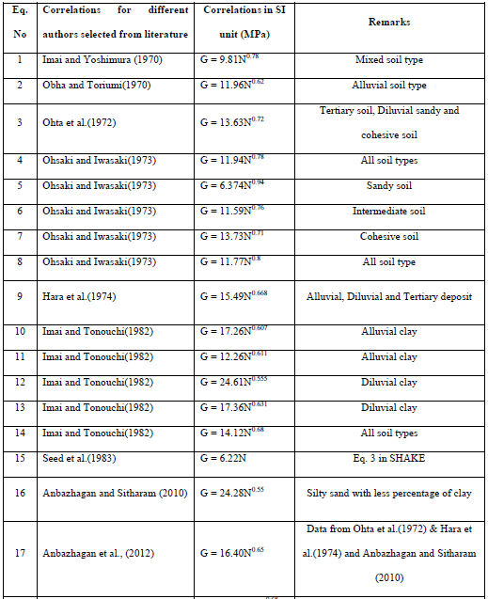

These studies were carried out in Japan except by Seed et al. [34]. Recently, Anbazhagan and Sitharam [5] developed a correlation between measured SPT N and shear modulus values using data generated for seismic microzonation study of Bangalore, India.

**5.3: N –SPT vs. Unit Weight Correlations**

In order to find seismic site response, analyses is done in DEEPSOIL V5.1. For the analysis in DEEPSOIL V5.1, the properties like thickness, unit weight, and maximum shear modulus (Gmax), damping ratio and selecting modulus curve for respective soil type have to be defined. The unit weight correlation for cohesionless and cohesive soil is as given in table 5.2 and 5.3respectively.

**Table 5.2: N vs. Unit Weight Correlations for Cohesion less Soil**

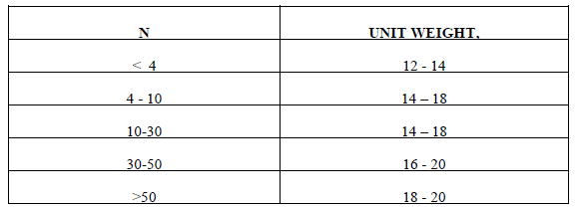

**Table 5.3: N vs. Unit Weight Correlations for Cohesive Soil**

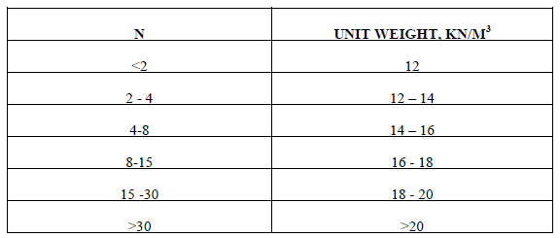

**CHAPTER-6**

**SITE RESPONSE STUDIES AND RESULTS**

**6.1 INTRODUCTION**

The presence of local available geology at any site can modify the bedrock ground motions obtained from seismic hazard. As a result, it will cause a complete change in the ground motion characteristics such as duration of motion, frequency content and amplitude at surface level in comparison to bedrock. Thus the scenario will get completely changed as compared to the seismic hazard obtained at bedrock. These modified motions so called as surface motions are the actual ground motions which are responsible for the various disasters. Also, these ground motions provide inputs for the seismically safe design of buildings and other infrastructures. Thus, these effects due local soil should be addressed completely while performing the site response studies for any region. Understanding the role of local geology can be divided into two parts. Firstly, the available subsurface geology should be explored by performing large number of field tests for the region under study. This is called as site classification. Large numbers of field test are desired so that the complex nature of subsoil lithology can be understood accurately. With the available shallow depth lithology in terms of various *in-situ* soil properties along with the determination of dynamic properties of each sub layer, the influence of these soil layers upon the input bedrock motion should be studies. The response of different subsoil layers at any site with respect to the input bedrock motion is called as site response study and is the second step in understanding the role of local geology. The effectiveness of site response study is solely depended upon the accuracy in predicting the local site effects or site response studies. Since these effects can cause many fold rise in the amplitude of bedrock motion along with other modifications which results in most of the surface induced damages, these should be addressed accurately.

Indian sub-continent is experiencing earthquake damages since 1200 AD even though very limited attempts have been made to estimate seismic hazard parameters on regional scale. Understanding the local geology for site response studies is always a challenging task since the subsoil geology can vary from simple to very complex in nature. Thus, capturing these subsurface features always consists of many approximations. Collected subsurface lithology and seismic site classification for Peninsular India based on both the collected subsoil reports have been presented in Chapter 4. In the present work, an attempt has been done to understand the response of local geology of entire peninsular India with studies conducted and response at the surface of soil deposit depends mainly on the frequency contents of the bedrock motion and the geometry and material properties of the soil layers above the bedrock. These parameters are needed to be quantified directly or indirectly and accounted in the seismic design or codal provisions. The selection of appropriate elastic response/design spectra according to the soil categories and seismic intensity is the simplest way to account for site effects both for engineering projects and for general purposes like microzonation study (Pitilakis, 2004). Recent modern seismic codes in America, Europe, Japan and worldwide (IBC 2009, UBC 97, NEHRP and EC8) have produced numerous valuable data and have incorporated the site effects based on the most important experimental and theoretical results. But Indian seismic code (BIS 1893, 2002) does not have proper provisions for seismic site classification. Hence in this study it is proposed to develop a new site classification system for Indian shallow soil deposits considering representative earthquake time histories at free field condition and rock, in-situ measured soil properties and shear modulus and damping curves. The proposed site classification scheme also will be validated by comparing with existing site classification and design spectrum in standards.

**6.2 NEED FOR THE STUDY**

The role of local geology upon the input ground motion has been discussed in detail in the last section. It is the local site effect which is responsible for the majority of the damages occurred due to an earthquake and not the bedrock motion (Anbazhagan *et al.,* 2010). Classical examples where the role of local soil have been observed on a massive scale include 2001 Bhuj earthquake (Mw=7.7) in India, 2001 Bhuj earthquake caused excessive ground shaking in the entire Gujarat and caused excessive damage to the state. Peninsular India has experienced a considerable number of earthquakes which has caused damages to the state. This clearly states the presence of local soil can cause damage from moderate to catastrophic even if the earthquake is of small to moderate size. Thus, these local site effects should be determined effectively in order to minimize the induced effects during an earthquake. Site specific ground motion studies aims at addressing these effects considering local subsoil conditions. Many researchers have attempted to estimate the local site effects.

**6.3 SELECTION OF GROUND MOTIONS**

Similar to the subsoil data at the site of interest, the bedrock motion at the site is also a pre-requisite of site response analysis. Real strong motion accelerograms contain a wealth of information about the nature of ground shaking and carry all the ground motion characteristic amplitude ,frequency and energy content , duration and phase characteristics and reflect all the factors that influence accelerograms (characteristics of source ,path, and site). As soil thickness dynamic properties, shear modules and damping curves play very important role in site amplification and shaping of response and design spectrum, Input ground motion acceleration time histories play vital role in the output spectral signature. Even though stable continental region (SCR) of peninsular India (PI) has experienced earthquakes of magnitude above 6, very limited acceleration time history are available for site response study. These are several earthquakes records for intraplate region in rest of the world having similar seismotechtonic characteristics as of peninsular India is been selected for this site response studies. The characteristics of base motion which controls the response of soil column are the frequency content, amplitude and duration on the input motion. These three characteristics affect the local soil condition during an earthquake. Considering some standard ground motions for the analysis which have been recorded in other parts of the world may not be appropriate. Also, selection of one ground motion based on the seismic hazard analysis may also not be effective as one ground motion may not reflect the bedrock motion completely in terms of frequency content, duration and amplitude. In the present work, for conducting the site response analysis no recorded ground motion for peninsular India was available of required PGA level. In absence of recorded bedrock motion at Peninsular India, ground motions recorded during various earthquakes in the intraplate regions across eastern United States have been selected.

**Table 6.1: Details of selected ground motions for site response studies No.**

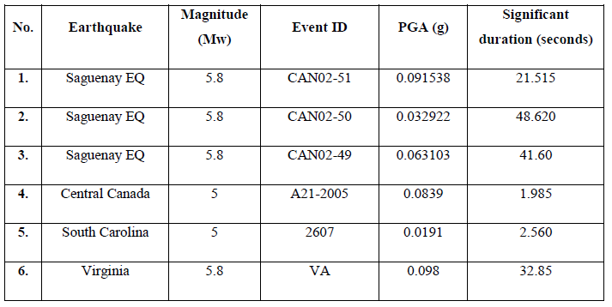

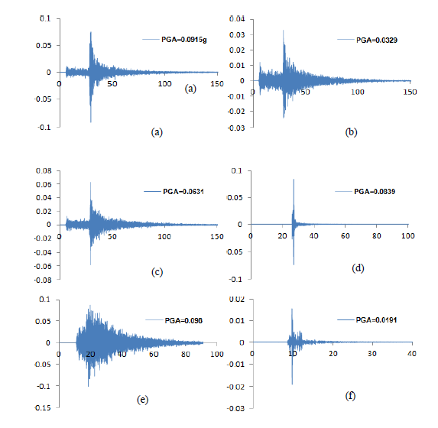

**Fig 6.1 (a-d): Selected ground motions for Site response study (Note: X-axis represent time in second, Y-axis represent acceleration in g).**

For an analysis of each soil profile the selected input motions are as discussed in section 6.3 and these input motions are been linearly scaled by scale factor (SF) 2,3 and 4 as shown in the table above.

**Table 6.3.1 Table of PGA values corresponding to Bangalore Profile** 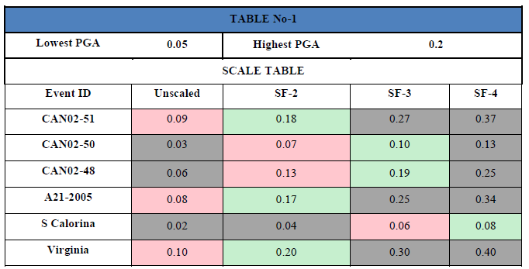

**Table 6.3.2 Table of PGA values corresponding to Mangalore Profile**

|  |  |  |  |  |
| --- | --- | --- | --- | --- |
| **Lowest PGA** | **0.05** | **Highest PGA** | **0.1** | |
| **SCALE TABLE** | | | | |
| **PGA** | **Unscaled** | **SF-2** | **SF-3** | **SF-4** |
| **CAN02-51** | 0.09 | **0.18** | **0.27** | **0.37** |
| **CAN02-50** | **0.03** | 0.07 | 0.1 | **0.13** |
| **CAN02-48** | 0.06 | **0.13** | **0.19** | **0.25** |
| **A21-2005** | 0.08 | **0.17** | **0.25** | **0.34** |
| **S Calorina** | **0.02** | **0.04** | 0.06 | 0.08 |
| **Virginia** | 0.1 | **0.2** | **0.3** | **0.4** |

**6.4 SITE RESPONSE ANALYSIS**

Different types of soil layers available above the bed rock alter the bedrock motion in different ways. A softer soil layer will amplify the bedrock motion more in comparison to stiffer or hard soil. Soil characteristics which controls the local site effects are shear wave velocity of the soil layer, its density and depth of water table. In general the soils density and shear wave velocity decreases towards the ground surface, the wave propagation velocity will also decreases and thus soil will amplify more. Many researchers have developed correlations between relative amplification for any site based on collected geotechnical parameters from field testing. Relative amplification can be defined as amplification with respect to reference site.

The simulation of nonlinear behavior of soil under cyclic loading can be attempted by different approaches. These are:

I. Linear approach

II. Equivalent linear approach

III. Nonlinear approach

Linear approach consists of approximating the nonlinear soil behavior by linear behavior for each soil layer. Transfer function for each layer is determined using and the Fourier series at the bottom by the layer is multiplied by the transfer function which will yield the Fourier series at the top of soil layer. Approximating the nonlinear soil behavior by the linear approach is not accurate and thus this method has limited applications for microzonation studies.

The stress-strain behavior of soil is nonlinear which indicates the shear modulus and damping of the soil as a function of the level of strain. Equivalent linear approach approximate the nonlinear shear modulus and damping behavior of soil using secant shear modulus and viscous damping (Seed and Idriss, 1970; Hardin and Drnevich, 1972; Hashash and Park, 2001). Performing the site response based on equivalent linear approach is suitable for shallow depths only since for deeper depths, the soil column will behave nonlinear and this effect cannot be captured by equivalent linear approach. Different researchers have developed different programs for nonlinear site response using hyperbolic function. Lee and Finn (1978) developed seismic site response program using hyperbolic function. This program was further extended using modified hyperbolic function by Matasovic (1993), Matasovic and Vucetic (1995). DEEPSOIL (Hashash and Park, 2001) and D_MOD_2 (Matasovic, 2006) nonlinear site response codes were developed where the nonlinear strain-strain behavior of soil was modeled considering hysteresis spring connected to lumped mass.

**6.4.1 Nonlinear Site Response Using Deep Soil**

Seed and Idriss (1970) highlighted that for most of the cohesionless soil the modulus degradation and damping curves obtained from equivalent linear approach follow a narrow range. Also the effect of confining pressure on modulus degradation and damping curves based on data from Seed and Idriss (1970) is high (Hashash and Park, 2001). However, Hashash and Park (2001) based on experimental data from Laird and Stokoe (1993) showed that the effect of confining pressure of modulus degradation and damping curve is minimal. For deeper depths the confining pressure is more and based on equivalent approach, the shear modulus is reducing at much faster rate compared to what was observed from experimental results. This highlights the limitation for equivalent linear approach in comparison to nonlinear soil response for site response of deeper basins. Secondly the equivalent linear approach is unable to capture the entire strain-strain behavior of soil due to large number of loading cycles and excess pore pressure generation (Hashash and Park, 2001). Since, the depth of soil column has not been limited to 30 m as highlighted earlier; following the above limitations of equivalent approach, the nonlinear approach for site response using DEEPSOIL V3.7 (Hashash *et al*. 2009) has been used for site response studies for Peninsular India in the present work.

DEEPSOIL was developed to understand the nonlinear soil response for Mississippi embayment where the overburden thickness varies from 100 m to even 1000 m (Hashash and Park, 2001) composing of silt, sand and clay. The available depth of overburden and the types of soil available beneath the ground surface of Mississippi are similar to those observed in Lucknow. The basic equation of motion used as the reference equation for DEEPSOIL (Hashash and Park, 2001) is given as



Where, [*M*], [*C*], [*K*] are the mass matrix, damping matrix and stiffness matrix respectively of the single degree freedom system, system; are the nodal relative acceleration, relative nodal velocity and nodal relative displacement respectively. Again, is the

acceleration at the bottom of the soil column while [*I*] is the unit vector. Matrixes [*M*], [*C*] and [*K*] resemble the soil properties to be used in the analysis. Such properties can be determined from the constitutive model of the soil type. Constitutive model uses the backbone curve to model the modulus degradation and damping behavior of soil based on hyperbolic function (Hashash and Park, 2001). However, this form of hyperbolic function model cannot captures the effect of confining pressure on strain dependency to modulus degradation and damping for soils available at deeper depths (Hashash and Park, 2001). Matasovic, (1993) proposed the backbone curve which relates the initial shear stress with initial shear strain and initial shear modulus as given below;

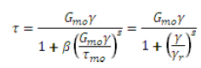

Where, is the shear stress, Gmo is initial shear modulus, is the shear stress at 1 % strain, is the shear strain, is the reference shear strain which is a material constant, and s are the regression coefficients obtained from best fit of backbone curve (Matasovic, 1993; Hardin and Drenvich, 1972; Hashash and Park, 2001) with the modulus and damping curve of soil. Based on experimental results, Hardin and Drenvich, (1972) showed that the reference strain which is a material constant in equation 7.2, is a function of confining pressure for clean sands and not has a constant value for a material. However this reference strain can be used as the normalizing strain to capture the dependency of confining strain of modulus degradation and damping values (Hardin and Drenvich, 1972; Hashash and Park, 2001). Based on the above findings by Hardin and Drenvich (1972), Shibata and Soelarno (1975) considered the reference strain as proportional to (where is the total vertical stress) to capture the effect to confining pressure in the above model. The value of regression coefficients were taken as . Hashash and Park (2001) proposed a new form of reference strain to incorporate the dependency of confining pressure in the hyperbolic model as given below;

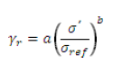

Where a and b are the regression parameters giving best fit curve, and are the effective vertical stress and the reference confining of 0.18 MPa respectively. Comparison between the modulus degradation curve based on equation 7.3 and the experimental data shows a good matching till a confining pressure of 10000 kPa or till a depth of 1000 m with ground water table at the surface (Hashash and Park, 2001). Hyperbolic function given by Matasovic (1993) can capture the damping variation with strains for strains higher than 10-4. Using the equation 7.3 can help to capture the effect of confining pressure upon damping. But for small strains, the present form of reference strain may yield zero damping for strains lesser than 10-4 which is an idealistic condition. Matasovic (1993) showed that for small strains, the damping matrix [*C*] as given in equation 7.1 is independent of strains and only is a function of stiffness of the soil layer as given in the equation below;



Where [C] is the damping matrix at small strains, [K] is the stiffness matrix, is the equivalent damping ratio and is the angular frequency. It is clear that the above equation does not capture the effect on confining pressure on damping ratio for small strains. Thus Hashash and Park (2001) based on experimental data from Laird and Stokoe (1993) proposed a relation between equivalent damping ratio and the confining pressure as given below (Hashash and Park, 2001);



Where is the equivalent damping ratio, c and d are the material properties and is the vertical effective stress. The equation 7.4 was modified by Hashash and Park (2001) in order to account for the change in with depth in the damping matrix [*C*], as given below;

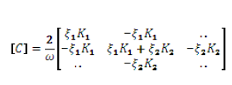

The above equation was given for a soil system with n number of layers. Suffixes 1 and 2 indicate the parameters for layer 1 and 2 from ground level, is the angular frequency, K resembles the stiff of each soil layer, denotes the equivalent ratio obtained from equation 7.5 for each soil layer. Thus the total damping will be equal to the damping obtained from equation 7.3 for higher strains and the damping obtained from equation 7.6. Hashash and Park (2001) showed the capability of total damping based on the two equations with the experimental data by Laird and Stokoe (1993). The basic equation of motion given in equation 7.1 was solved by Hashash and Park (2001) using the Newmark (1959) -method and a computer code DEEPSOIL was developed to study the response of soil condition considering the effect of confining pressure upon the material properties. All the soil layers were modeled as the mass, nonlinear spring dashpot system. Each of the soil layers can be modeled as either linear elastic material or pressure dependent nonlinear material. The base of the soil column can be represented either as infinite stiff or visco-elastic half space (Hashash and Park, 2001). The program can be successfully used for any number of soil layers and for any depth. This program can be used to perform both the equivalent and nonlinear soil response analysis. The updated version of this software; DEEPSOIL v 5.1 has been used in this work to conduct the nonlinear site response analysis for shallow sites of Peninsular India.

**6.5 RESPONSE SPECTRA AT GROUND SURFACE**

The acceleration-time histories at various depths are obtained as a result of ground response analysis and these motions can be characterized by the corresponding response spectra. The ground surface response spectra for all the profiles were plotted with 5% critical damping value that obtained from DEEPSOIL analysis. In order to perform the nonlinear analysis in DEEPSOIL, the soil column has to be created. Other information’s such as soil type, depth of water table, density of soil at various depths are required as input parameters for DEEPSOIL. The modulus reduction (G/Gmax) and damping ratio curve have been selected separately. These include 1) G/Gmax and damping curves for sandy soil as per Seed & Idriss, 1991 (Mean Limit) 2) G/Gmax and average damping curve as per Vucetic & Dobry, 1991for clay; and 3) G/Gmax and damping curves for bedrock by Schnabel (1973).

The following are the soil profile of MG Road in Bangalore and Mangalore region.

|  |  |  |  |  |  |
| --- | --- | --- | --- | --- | --- |
|  |  |  |  |  |  |
| **MG Road** | | **No of Layers** | **17** |  | **GWL = NIL**  BORELOG DETAILS OF MG ROAD BANGALORE |
| **Drilled upto 30 m** |  |  |  |  |  |
| **Layer No** | **Layer Name** | **Thickness** | **SPT** | **Unit Weight** | **Shear Modulus** |
| **1** | **Silty sand** | **1.5** | **7** | **18** | **70803.15403** |
| **2** | **Silty Sand** | **2** | **15** | **15** | **107671.0318** |
| **3** | **Silty Sand** | **1** | **12** |  | **95235.39068** |
| **4** | **Silty Sand** | **2** | **19** |  | **122620.5227** |
| **5** | **Silty Sand** | **1** | **17** |  | **115344.1543** |
| **6** | **Silty Sand** | **1.5** | **34** |  | **168873.7264** |
| **7** | **Silty Sand** | **1.5** | **40** |  | **184663.7615** |
| **8** | **Silty Sand** | **2** | **33** |  | **166123.6059** |
| **9** | **Silty Sand** | **1.5** | **57** | **15** | **224377.7832** |
| **10** | **Silty Sand** | **1.5** | **45** | **15** | **197022.3818** |
| **11** | **Silty Sand** | **1.5** | **45** | **15** | **197022.3818** |
| **12** | **Silty Sand** | **1.5** | **47** |  | **201791.3307** |
| **13** | **Silty Sand** | **1.5** | **53** |  | **215576.0007** |
| **14** | **Silty Sand** | **1.5** | **62** |  | **234997.9705** |
| **15** | **Silty Sand** | **1.5** | **62** |  | **234997.9705** |
| **16** | **Silty Sand** | **5** | **66** |  | **243219.1951** |
| **17** | **Soft Rock** | **2** | **100** | **20** | **305667.09** |
|  | **Total Thickness** | **30** |  |  |  |

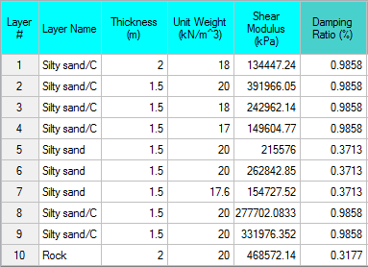

BORELOG DETAILS OF MANGALORE

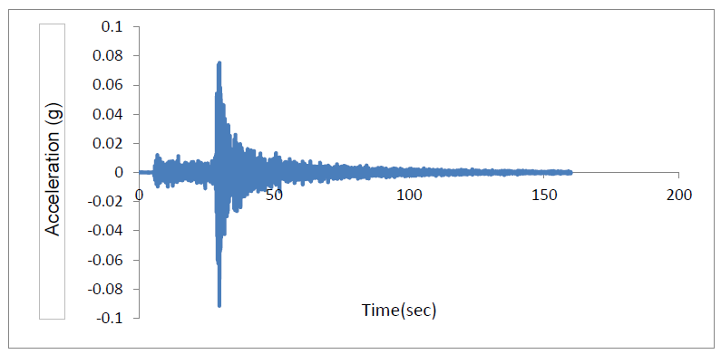**Fig 6.5.1: Input bedrock motion corresponding to ground motion CAN02-51**

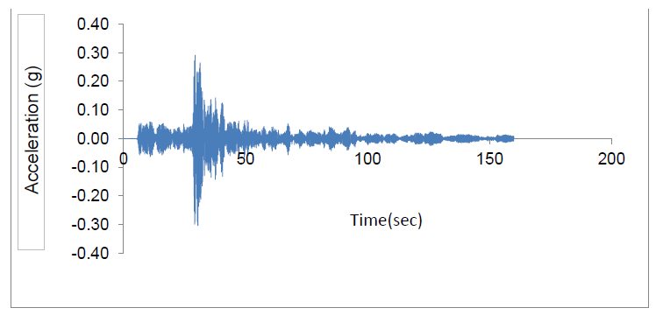**Fig 6.5.2: Surface motion corresponding to bedrock motion given in Fig 7.2 for Bangalore profile**

All the analyses have been performed using rigid half space with frequency domain The PGA range considered for the study varies from 0.02 g to 0.1 g. The duration of input motion ranges from 2 seconds to 48.62 seconds as given in Table 7.3. A typical acceleration time history at bedrock level for event ID CAN02-51 of PGA 0.09g as an input and the obtained surface ground motion after the analysis for Bangalore is shown in the above figures. Fig 6.5.1 shows the PGA of 0.09g at 29.68 seconds at the base of soil column. This base motion has been amplified to 0.284 g at 30.195 seconds when it reaches to the surface as given in Fig 7.4. Thus, based on this analysis it can be said that an amplification factor of 3.15 has been obtained for BH- 1 for ground motion CAN02-51. Similarly all the 12 ground motions have been applied to this soil column. Such analyses will provide series of amplification factors for this soil column.

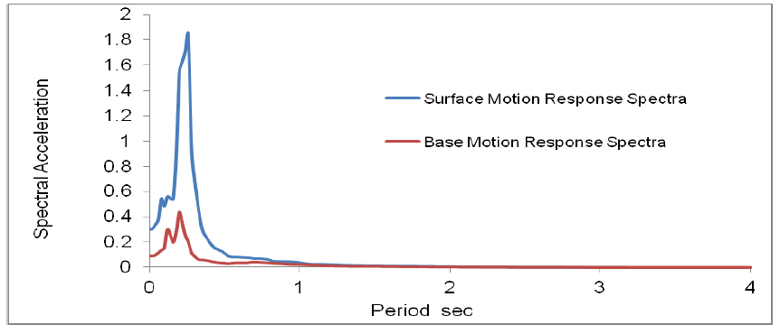

**Fig 6.5.3: Comparison of response spectrum at the base and the surface for Bangalore site.**

The comparison of response spectra due to base motion with the surface response spectra has been presented in Fig 7.2. It can be observed from the Fig 7.2 that for base motion a peak spectral acceleration of 0.44 g has been obtained at 0.2 seconds. However after site response analysis the corresponding surface motion as given in Fig 7.3 shows peak spectral acceleration of 1.85 g at 0.26 seconds. Thus, there is a complete change in the amplitude of spectral.

**6.6 AVERAGE RESPONSE SPECTRA AT GROUND SURFACE**

For developing average response spectra at ground surface for a soil column, the input motions are selected from table 6.3.1 and table 6.3.2 based on the soil column from which region is been selected. For the Bangalore region there are 12 input motions while for Mangalore region 8 input motions are used for analysis. These input motions peninsular regions are selected based on the minimum and maximum PGA value of that corresponding region given in the PGA contour map published by NDMA and Nath and Thimbajan. An average response spectrum is developed for a typical soil column for Bangalore as well as Mangalore region.

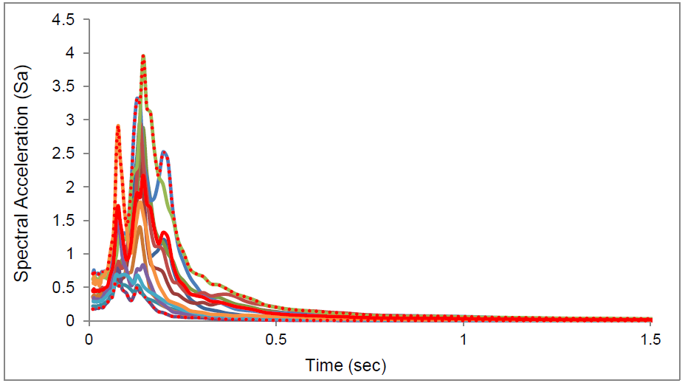

**Fig 6.6.1: Response spectrum at the surface of Bangalore site for all 12 input motions.**

**Fig 6.6.2: Response spectrum at the surface of Mangalore site for 5 input motions representing PGA < .1g**

**Fig 6.6.3: Response spectrum at the surface of Mangalore site for 3 input motions representing PGA > .1g**

**CHAPTER-7**

**SUMMARY AND CONCLUSION**

Present work consists of performing the site response studies for Peninsular India. Subsoil lithology has been collected based on geotechnical information. Detailed discussion on the subsoil lithology can be found in chapter 4. The frequency content, duration and amplitude of ground motions are the three important factors which govern the site response in any location. In absence of recorded ground motions at bedrock level for Peninsular India available, 6 ground motions at bedrock level which were recorded during various earthquakes in intraplate region across eastern United States have been considered as regional ground motions due to similarities in seismotectonic features. These motions have been selected and linearly scaled with scale factor 2, 3 and 4 such that a wide range of amplitude, duration and frequency contents can be covered. Among the various site response approaches, nonlinear site response analysis has been considered for the study. Detailed discussions about various nonlinear models available have been presented. The effect of confining pressure upon the modulus degradation and damping which was not been considered in earlier nonlinear models was discussed. Discussion shows that only DEEPSOIL is the model where the effect of confining pressure upon the modulus reduction and damping for entire range of strains has been considered. Thus, the updated version of DEEPSOIL (V5.1) has been used in the present study. The main objective of this study is to evaluate site specific design spectrum considering site specific soil profiles from different parts (Bangalore and Mangalore) of Peninsular India Most importantly, the single response spectrum for all the sites is inappropriate and doesn’t depict the actual soil condition. A further work on these lines is currently underway.

**REFERENCES**

1. Abrahamson, N. A. and Silva, W. J., 1997. Empirical response spectral attenuation relations for shallow crustal earthquakes. Seismol. Res. Lett. Vol. 68, pp. 94-127.

2. Anbazhagan P, Sitharam TG, Aditya P. Correlation between low strain shear modulus and standard penetration test ‘N’ values. In: Proceedings of the fifth international conference on recent advances in geotechnical earthquake engineering and soil dynamics, 2010, p. 10.

3. Anbazhagan, P, Neaz Sheikh and Hing-Ho Tsang (2010a), “Seismic Site Classification Practice in Australia, China and India: Suitability” Proceedings of International Conference on Materials, Mechanics and Management (IMMM 2010), Kerala, India, Vol.1; pp.189-197.

4. Anbazhagan, P., Abhishek Kumar and Sitharam, T.G. (2010b) “Site Response Deep Sites in Indo-Gangetic Plain for Different Historic Earthquakes,” Proceedings of Fifth International Conference on Recent Advances in Geotechnical Earthquake Engineering and Soil Dynamics, San Diego, California. Paper No. 3.21b: P-12.

5. Anbazhagan, P. and Sitharam, T. G. (2010c) “Relationship between Low Strain Shear Modulus and Standard Penetration Test 'N' Values” ASTM Geotechnical Testing Journal, 33 (2); 150-164.

6. Ansal, A (ed) (2004), “Recent Advances in Earthquake Geotechnical Engineering and Microzonation,” Kluwer Academic Publishers. Printed in the Netherlands.

7. ASCE 7 (2002), “Minimum Design Loads for Buildings and Other Structures, Reston”, VA: American Society of Civil Engineers.

8. Baker, J. W., and Cornell, A. C. (2006). “Spectral shape, epsilon and record selection,”

9. Boominathan A, Dodagoudar R, Suganthi A, Uma Maheshwari R (2007) “Seismic hazard assessment considering local site effects for microzonation studies of Chennai city” In: Proceedings of the workshop on microzonation, IISc Bangalore, vol 1, pp 94–104

10. Borcherdt, R.D. (1994), “Estimates of site-dependent response spectra for design (methodology and justification),” Earthquake Spectra, 10(4), 617-653.

11. Boominathan A (2011) “Seismic Hazard Assessment for the proposed 2x500 Mw Fast Breeder Reactor- 1x2, Kalpakkam” Draft Report, A, IIT Madras, June 2011.

12. Biot MA. Vibrations of buildings during earthquake. Transientoscillations in elastic system Chapter II. PhD thesis no. 259, Aeronautics Department, California Institute of Technology, California,Pasadena, 1932.

13. Biot MS. Theory of elastic systems vibrating under transient impulsewith an application to earthquake-proof buildings. ProcNatlAcadSci 1933;19(2):262–8.

14. BIS, 1962. "IS 1893–1962: Indian standard recommendations for earthquake resistant design of structures". Bureau of Indian Standards, New Delhi.

15. BIS, 1966. "IS 1893–1966: Indian standard criteria for earthquake resistant design of structures". Bureau of Indian Standards, New Delhi.

16. BIS, 1970. "IS 1893–1970: Indian standard criteria for earthquake resistant design of structures". Bureau of Indian Standards, New Delhi.

17. BIS, 1984. "IS 1893–1984: Indian standard criteria for earthquake resistant design of structures". Bureau of Indian Standards, New Delhi.

18. BIS, 2002. "IS 1893–2002 (Part 1): Indian standard criteria for earthquake resistant design of structures, Part 1 — general provisions and buildings". Bureau of Indian Standards, New Delhi.

19. Chopra, A.K. (2001). Dynamics of Structures: Theory and Applications to Eq. Eng., 2nd Ed.,

20. Chapter 3 – Commentary, NEHRP, 2000, 17-33.

21. Dorby, R. and Vucetic, M. “Dynamic properties and seismic response of soft clay deposits.” Proceedings of International Symposium on Geotechnical Engineering of Soft Soils, Vol. 2, Mexico City, Mexico, August, 1987, 51-87

22. Dong-soo Kim , Jong Ku Yoon, “ Development of new site classification system for the regions of shallow bedrock in korea”,J of Earthquake engineering, Vol. 10, No. 3 (2006) :331-358.

23. Earthquake Engineering & Structural Dynamics, Vol. 35, No. 9, pp. 1077-1095.

24. Electric Power Research Institute (EPRI). 1993. Guidelines for Site Specific Ground Motions. Palo Alto, California. November. TR-102293.

25. Freeman, S.A, (2007). Response Spectra as a useful Design and Analysis Tool for Practicing Structural Engineers, ISET Journal of Earthquake Technology, 44(1), (in press).

26. GovindaRaju L, Ramana GV, HanumantaRao C, Sitharam TG (2004) “Site specific ground response analysis” CurrSci 87(10):1354–1362.

27. Ghasemi, H., Zare, M., Sinaeian, F., “ Smooth spectra of horizontal and vertical ground motions for Iran”, ISET Journal of Earthquake Technology, 500,Vol. 46, No. 1

28. GSI 2000 Seismotectonic atlas of India and its environs; Geological Survey of India.

29. Hashash, Y.M.A, Groholski, D.R., Phillips, C. A., Park, D, Musgrove, M. (2012) “DEEPSOIL 5.1, User Manual and Tutorial.” 107 p.

30. Housner, G.W. (1947), “Characteristics of Strong Motion Earthquakes,” Bull. Seism. Soc.Amer., Vol. 37, No.1, pp. 19–31.

31. Housner GW,” Behavior of structures during earthquakes”. J EngMechDiv ASCE 1959;85(EM 4):109–29.

32. ICC (International Code Council) (2003), “International Building Code (IBC) 2003”, Country Club Hills, IL: Building Officials and Code.

33. Idriss, I. M., and Sun, J. I. (1992), "User's Manual for SHAKE91", Center for Geotechnical Modeling, Department of Civil and Environmental Engineering, Univ. of California, Davis, CA, USA,pp 12 .

34. Imai T, Yoshimura Y. Elastic wave velocity and soil properties in soft soil.

Tsuchito-Kiso 1970;18(1):17–22. [in Japanese].

35. Imai T, Tonouchi K. Correlation of N-value with S-wave velocity and shear

modulus. In: Proceedings of the 2nd European symposium on penetration testing; 1982. p. 57–72.

36. Iyengar RN, Raghukanth STG,“Attenuation of strong ground motion in peninsular India”Seismol Res Lett 2004;75:530–40.

37. Kramer, S.L., Geotechnical Earthquake Engineering, Pearson Education, Inc., 1996, 254-307.

38. Lee, V.W. (2002), “Empirical Scaling of Strong Earthquake Ground Motion-Part I:Attenuation and Scaling of Response Spectra,” Indian Society of Earthquake TechnologyJournal, Vol.39, No.4, pp. 219–254.

39. Lee, V.W. (2007), Empirical Scaling and Regression Methods for Earthquake Strong-Motion Response Spectra – A Review, Indian Society of Earthquake Technology journal,44(1), (in press).

40. MihailoD.Trifunac, “ Earthquake response spectra for performance based design- A critical review”, soil dynamics and earthquake engineering (2012),doi:10.1016.

41. Mohraz, B., W. J. Hall, and N. M. Newmark (1972), “ A study of vertical and horizontal earthquake spectra”, AEC Report WASH-1255, Nathan M. Newmark Consulting Engineering Services, Urbana, Illinois.

42. Mohraz B, “A study of earthquake response spectra for different geological conditions”, Bull SeismolSoc Am 1976;66:915–35.

43. Nath S K and Thingbaijam KKS. Peak ground motion predictions in India: an appraisal for rock sites. Journal of Seismology 2011; 15: 295-315.

44. Nau, J., and Hall, W. (1984). “Scaling methods for earthquake response spectra,” J. of Str. Eng.(ASCE), Vol. 110, No. 91-109

45. NDMA. Development of probabilistic seismic hazard map of India. Technical report by National Disaster Management Authority 2010, Govt. of India.

46. Newmark, N.M., Hall, W.J., Earthquake Spectra and Design, Earthquake Engineering Research Institute, 1982.

47. Newmark, N.M., Blume, J.A., and Kapur, K.K. (1973). “Seismic Design Criteria for Nuclear Power Plants,” J. of the Power Division, ASCE, Vol. 99, pp. 287–303.

48. Ohsaki Y, Iwasaki R. On dynamic shear moduli and Poisson’s ratio of soil

deposits. Soils and Foundations 1973;13(4):61–73.

49. Ohta T, Hara A, Niwa M, Sakano T. Elastic moduli of soil deposits estimated by

N-values. In: Proceedings of the 7th annual conference. The Japanese Society

of Soil Mechanics and Foundation Engineering; 1972. p. 265–8.

50. Ohta Y, Goto N. Estimation of S-wave velocity in terms of characteristic

indices of soil. Butsuri-Tanko 1976;29(4):34–41 [in Japanese].

51. Raghukanth STG, Sreelatha S, Dash SK (2008) ,”Ground motion estimation at Guwahati city for anMw 8.1 earthquake in the Shillong plateau”, Tectonophysics 448(1–4):98–114.

52. RaghuKanth,S.T.G., Iyengar, R.N., 2006." Seismic hazard estimation for Mumbai city".Curr. Sci. 91(11), 1486-1494.

53. Rajiv Ranjan (2005),” Site response analysis of Dehradun city”. M. S. Thesis submitted to the international institute for geoinformation science and earth observation, India.

54. Schnabel, P. B., Lysmer, J. and Seed, H. Bolton, (1972), “SHAKE: A Computer Program for Earthquake Response Analysis of Horizontally Layered Sites,” Earthquake Engineering Research Center, University of California, Berkeley: Report No. UCB/EERC-72/12: 102.

55. Seed, H. B., and Idriss, I. M., (1970), “Soil Moduli and Damping Factors for Dynamic Response Analyses,” Earthquake Engineering Research Center, University of California, Berkeley, California, Rep. No. EERC-70/10.

56. Sitharam, T. G. and Anbazhagan, P. (2007), “Seismic Hazard Analysis for the Bangalore Region, Nat.Hazards”, Vol. 40, pp 261–278.

57. Sitharam, T.G., and GovindaRaju, L. (2004),“Geotechnical Aspects and Ground Response Studies in Bhuj Earthquake, India”,International Journal of Geotechnical and Geological Engineering, Kluwer publishers, Vol. 22, pp 439-455.

58. Seed HB, Idriss IM, Arango I. Evaluation of liquefaction potential using field

performance data. Journal of Geotechnical Engineering 1983;109(3):458–82.

59. Seed HB, Tokimatsu K, Harder LF, Chung RM. The influence of SPT procedures

in soil liquefaction resistance evaluations. Journal of Geotechnical Engineering,

ASCE 1985;111(12):1425–45.

60. Seed HB, Wong TR, Idriss IM, Tokimatsu K. Moduli and damping factors for dynamic analyses of cohesionless soils. Journal of Geotechnical Engineering

1986;112(11):1016–32.

61. Trifunac, M.D, (2003) 70th Anniversary of Biot Spectrum, 23rd Annual ISET Lecture, Indian Society of Earthquake Technology Journal, Paper 431, Vol. 40, No. 1, pp. 19–50.

62. Uma Maheswari, R. (2005), “Development of Site–specific Design Response Spectra for Chennai City,” M.E. Thesis, Anna University, Chennai.

63. USGS (2006), “Susceptibility Map of the San Francisco Bay Area”, open File Report 00-444, URL: http://geomaps.wr.usgs.gov/sfgeo/.

64. Vucetic, M. and Dobry, R. (1991). ”Effect of Soil Plasticity on Cyclic Response.” J. Geotech. Engrg., 117(1), 89–107.

65. Y. M. Fahjan(2008), “Selection And Scaling Of Real Earthquake Accelerograms,” Vol. 19, No.3