DEPLOY NGINX USING YAML
Create this folder structure:
day15-kubernetes/
nnn deployment.yaml
nnn service.yaml
nnn README.md
nnn evidence/

Step 1 — Create `deployment.yaml`
apiVersion: apps/v1
kind: Deployment
metadata:
name: nginx-deployment
labels:
app: nginx
spec:
replicas: 2
selector:
matchLabels:
app: nginx
template:
metadata:
labels:
app: nginx
spec:
containers:
- name: nginx
image: nginx:1.27
ports:
- containerPort: 80

Step 2 — Create `service.yaml`
apiVersion: v1
kind: Service
metadata:
name: nginx-service
spec:
type: NodePort
selector:
app: nginx
ports:
- port: 80
targetPort: 80
nodePort: 30080

Step 3 — Apply the manifests
- kubectl apply -f deployment.yaml
- kubectl apply -f service.yaml
- kubectl get deployments
- kubectl get pods -o wide
- kubectl get services
Expected result: the Deployment should become available, two Pods should reach `Running`, and the Service should show
NodePort `30080`. Image tags and cluster setup may affect the time required.

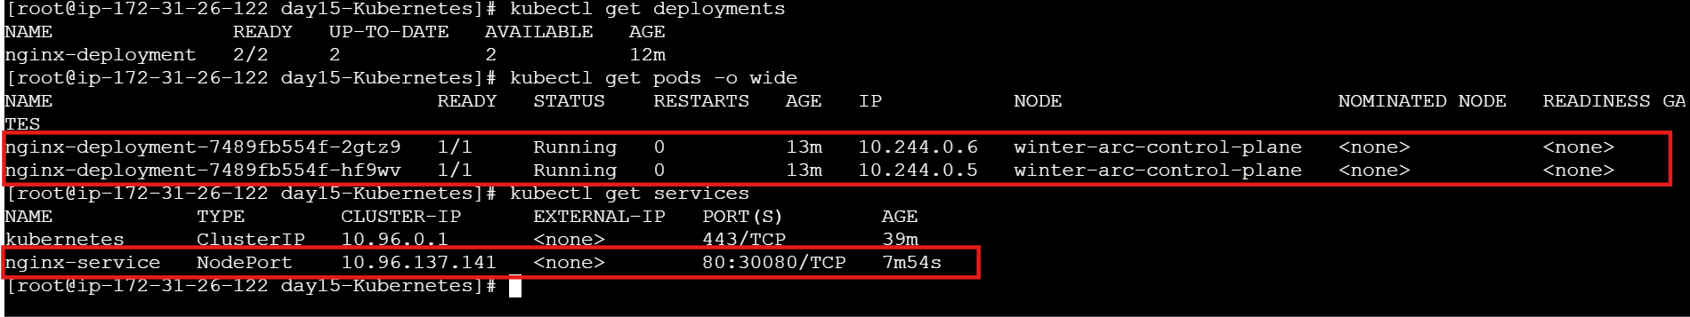

Step 4 — Inspect the resources
- kubectl describe deployment nginx-deployment
- kubectl describe service nginx-service
- kubectl get events --sort-by=.metadata.creationTimestamp
- kubectl logs deployment/nginx-deployment
- If `kubectl logs deployment/nginx-deployment` is unsupported by your kubectl version or returns an ambiguity error, list the Pods with
- `kubectl get pods` and run `kubectl logs `.

Inspect the resources
- kubectl describe deployment nginx-deployment

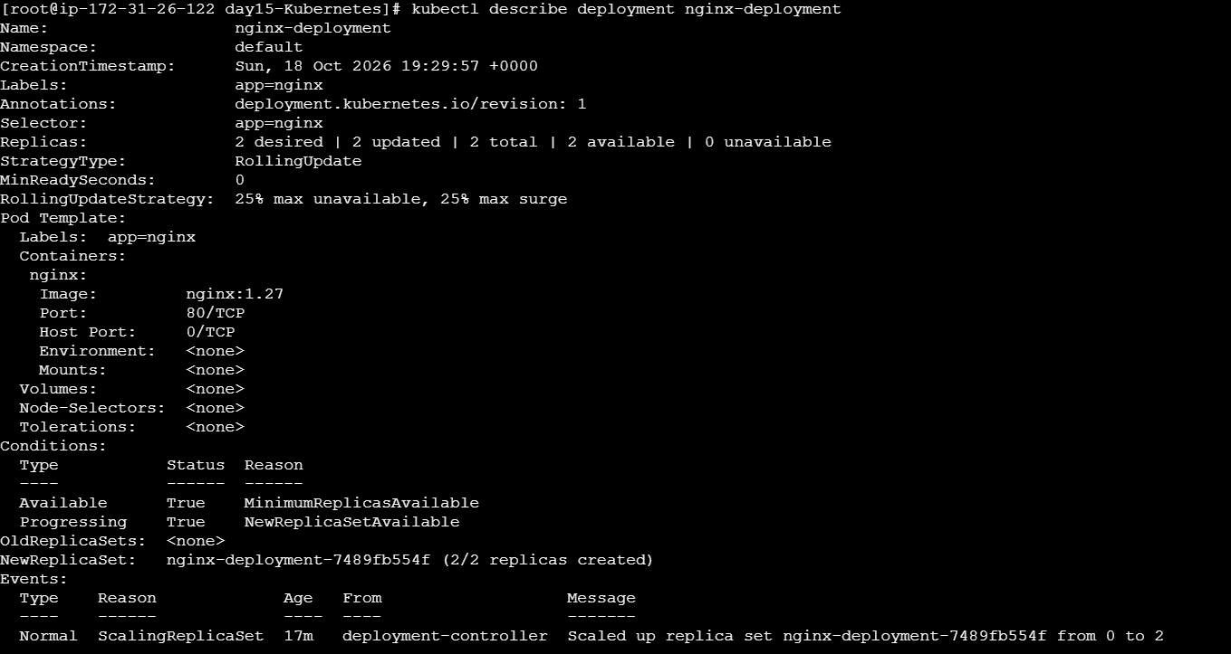

- kubectl describe service nginx-service

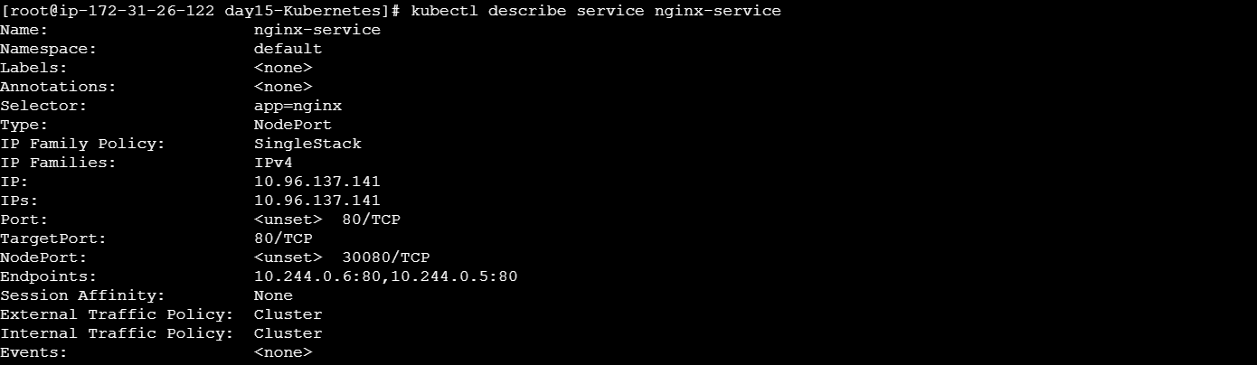

- kubectl get events --sort-by=.metadata.creationTimestamp

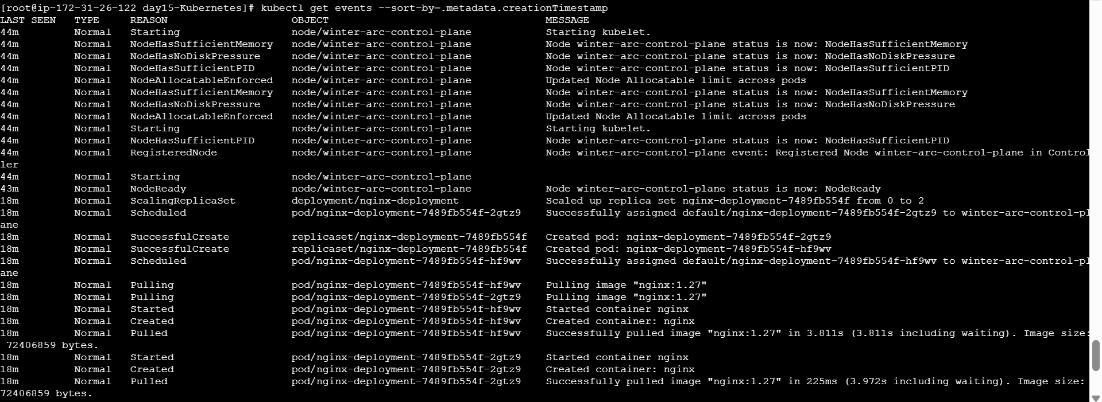

- kubectl logs deployment/nginx-deployment

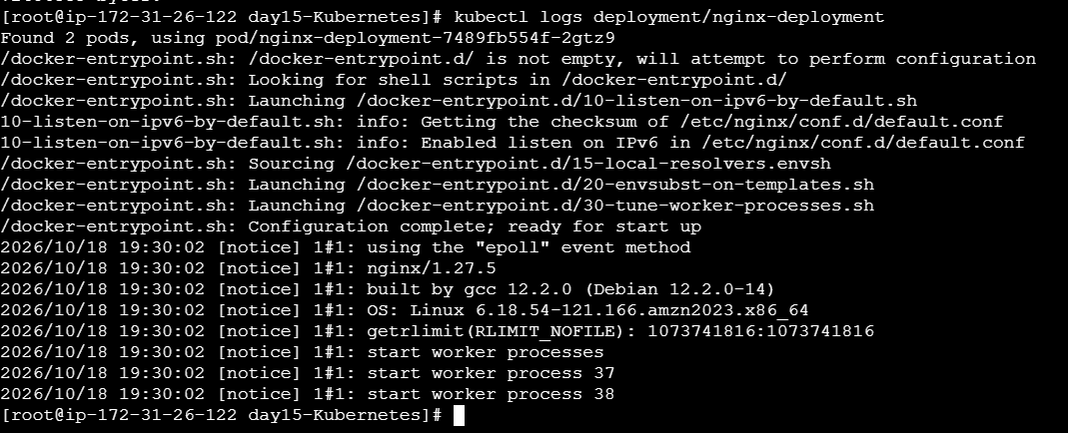

If `kubectl logs deployment/nginx-deployment` is unsupported by your kubectl version or returns an ambiguity error, list the Pods with
`kubectl get pods` and run `kubectl logs `.

SCALE AND VERIFY
Step 5 — Scale the application to three replicas

- kubectl scale deployment nginx-deployment --replicas=3
- kubectl get deployment nginx-deployment
- kubectl get pods
Confirm that three Pods are running or ready. The Deployment declares the desired replica count; Kubernetes attempts to maintain it.

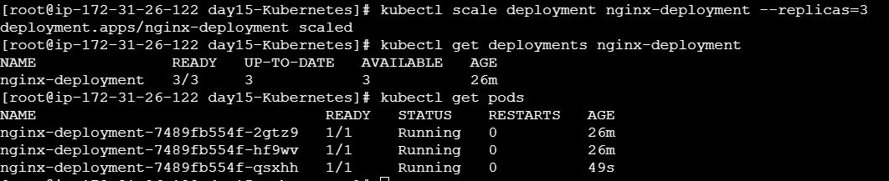

Test access
• Try opening http://localhost:30080 if your local Kubernetes setup exposes NodePort through localhost.
• If that address does not work in your environment, use port-forwarding as a reliable local test:
kubectl port-forward service/nginx-service 8080:80
# In another terminal, test:
curl http://localhost:8080
Stop port-forwarding with Ctrl+C after testing. Save a screenshot of the Nginx welcome page or successful curl output.

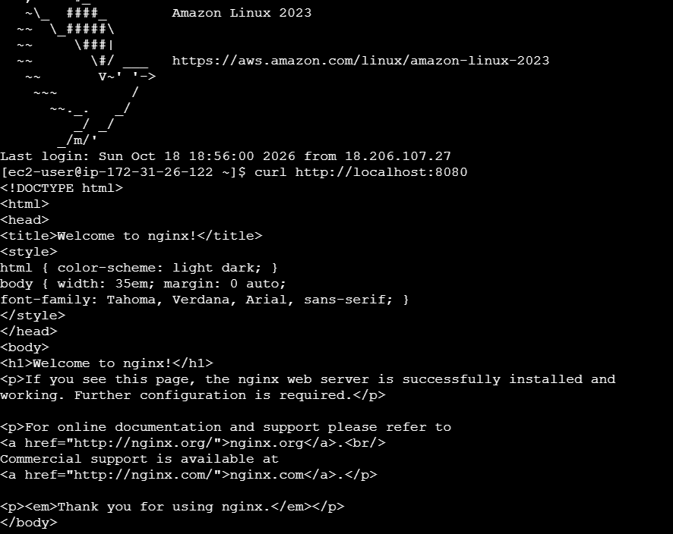

Step 7 — Demonstrate self-healing (optional)

- kubectl get pods
- kubectl delete pod <one-nginx-pod-name>
- kubectl get pods -w
Watch Kubernetes create a replacement Pod because the Deployment is maintaining the desired replica count. Press Ctrl+C to stop watching.

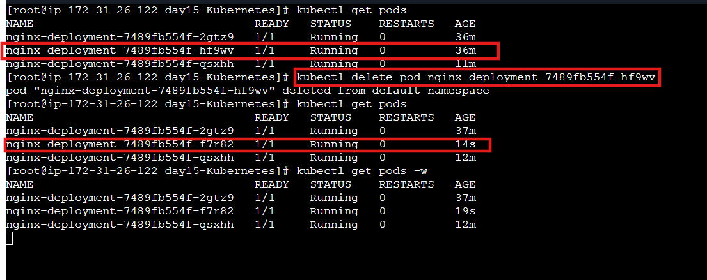

TROUBLESHOOTING | PROBLEM CHECK / FIX
kubectl cannot connect to server | Confirm Docker Desktop or kind cluster is running; check `kubectl config current-context`.
Pod is Pending Run | `kubectl describe pod ` and inspect Events and node availability.
Pod is ImagePullBackOff | Check the image name/tag and internet access; inspect the Pod events.
Pod is CrashLoopBackOff | Use `kubectl logs ` and `kubectl describe pod `.
Service has no endpoints | Check that Service selector labels match the Pod labels: `kubectl get pods --show-labels`.
Port 30080 does not open | Try `kubectl port-forward service/nginx-service 8080:80` and browse localhost:8080.

