RUN A CONTROLLED RELEASE
Step 1 — Find your existing Deployment
- kubectl config current-context
- kubectl get deployments
- kubectl get pods
- kubectl get rs
The commands below use nginx-deployment and container nginx as examples. Replace them if your resources have different names.

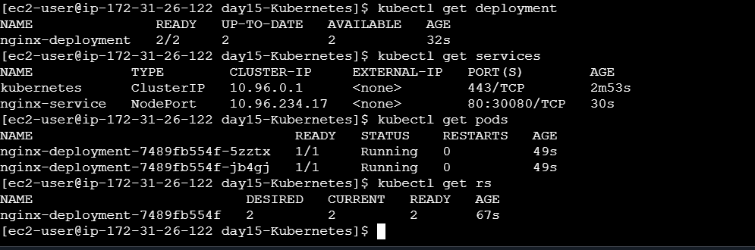

Step 2 — Inspect the rollout strategy
kubectl describe deployment nginx-deployment
kubectl get deployment nginx-deployment -o yaml
Find the strategy settings. If maxSurge or maxUnavailable are not specified, Kubernetes uses the defaults for RollingUpdate.
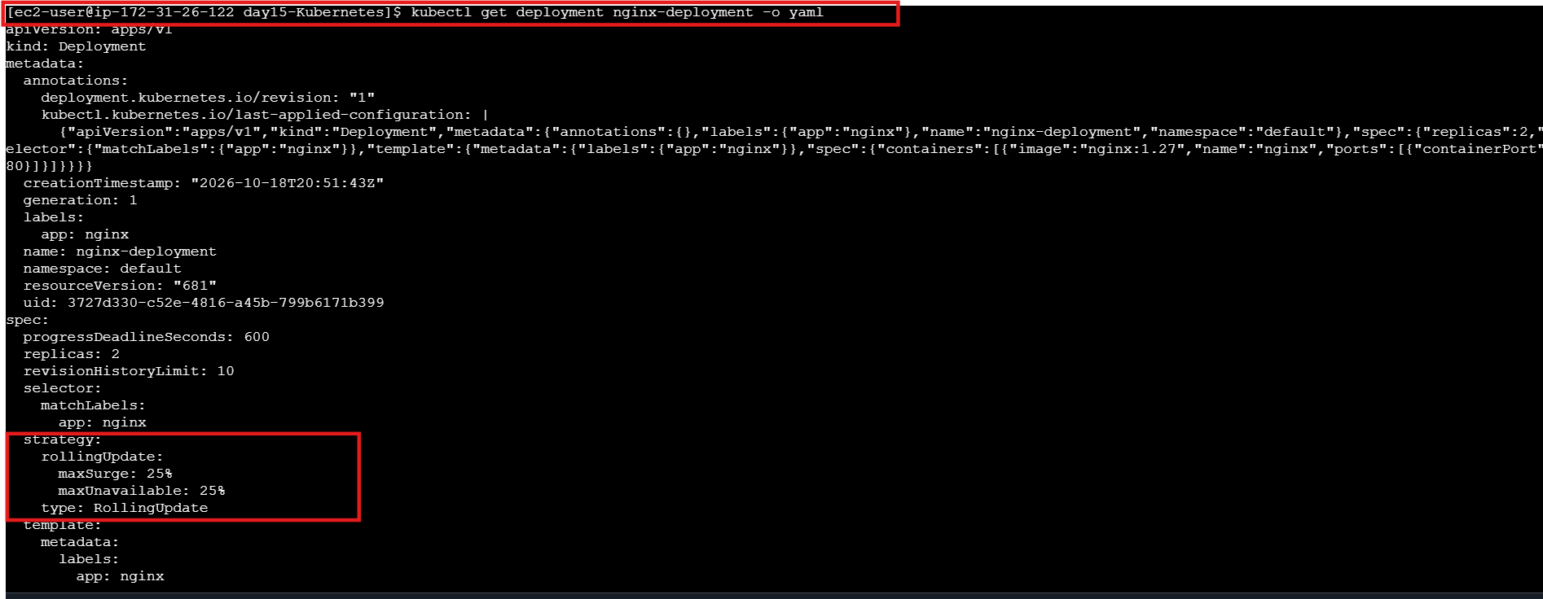

Step 3 — Annotate and update the image
- kubectl annotate deployment/nginx-deployment \
kubernetes.io/change-cause="Day 16: update Nginx for rollout practice"
- kubectl set image deployment/nginx-deployment \
nginx=nginx:1.28
- kubectl rollout status deployment/nginx-deployment
- kubectl rollout history deployment/nginx-deployment
- kubectl get rs,pods -o wide

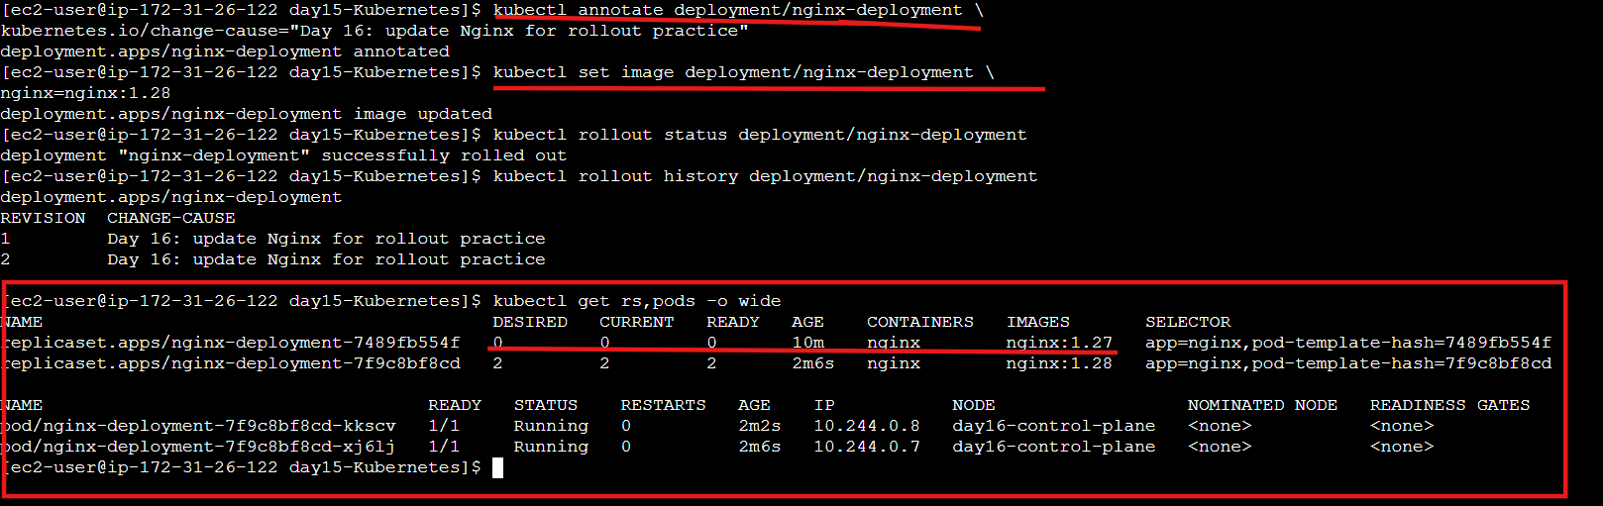

BREAK A RELEASE & ROLL BACK
Step 5 — Save the known-good revision

- kubectl rollout history deployment/nginx-deployment
- kubectl get deployment nginx-deployment \
-o jsonpath='{.spec.template.spec.containers[0].image}'; echo

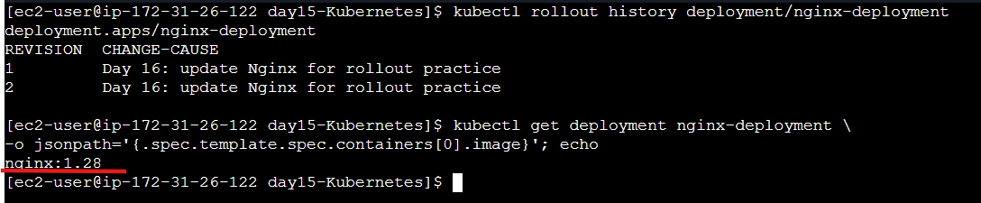

Step 6 — Trigger a temporary failed rollout
- kubectl set image deployment/nginx-deployment \
nginx=nginx:1.99-broken
- kubectl get pods -w
Wait briefly for new Pods to show a pull failure, then press Ctrl+C. Old healthy Pods may remain available while the new ReplicaSet fails to
become ready.

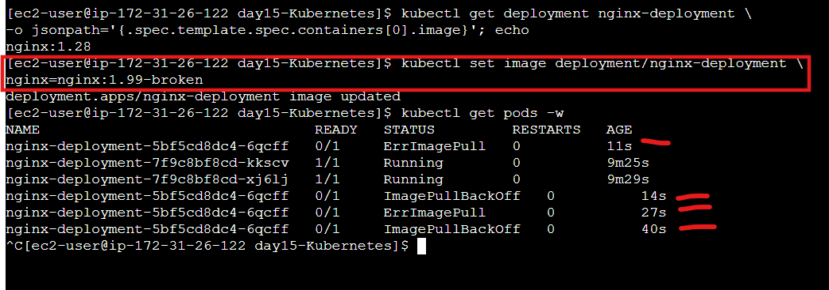

Step 7 — Diagnose the failure
kubectl get pods
kubectl describe pod POD_NAME
kubectl get events --sort-by=.metadata.creationTimestamp
kubectl rollout history deployment/nginx-deployment
Replace POD_NAME with a Pod from the failed rollout. Find the image-pull error in Events and explain why the new version could not start.

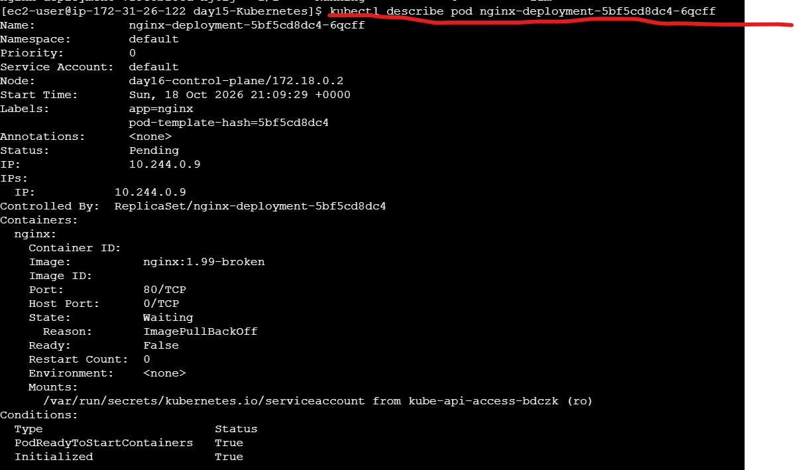
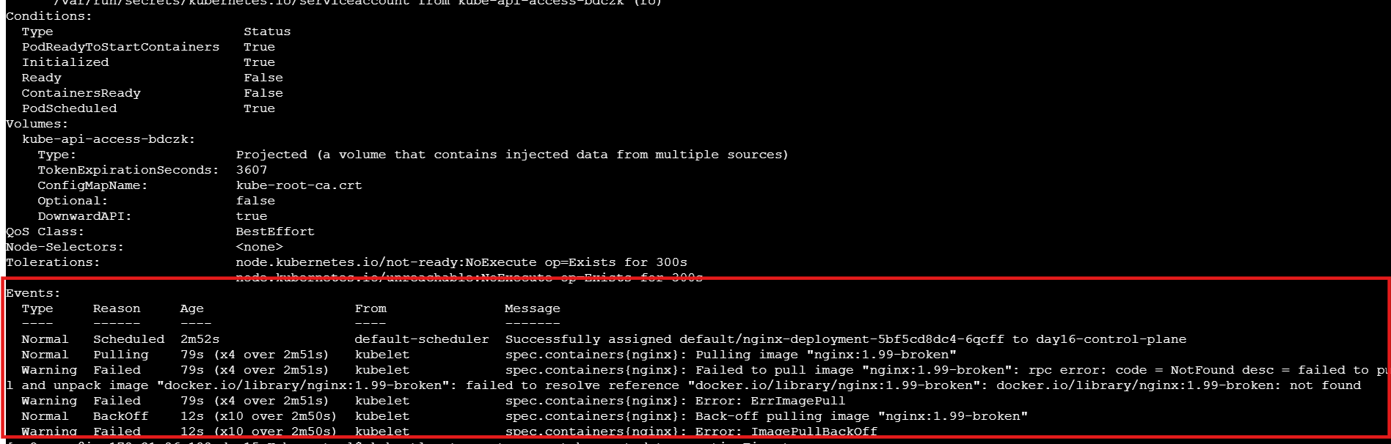

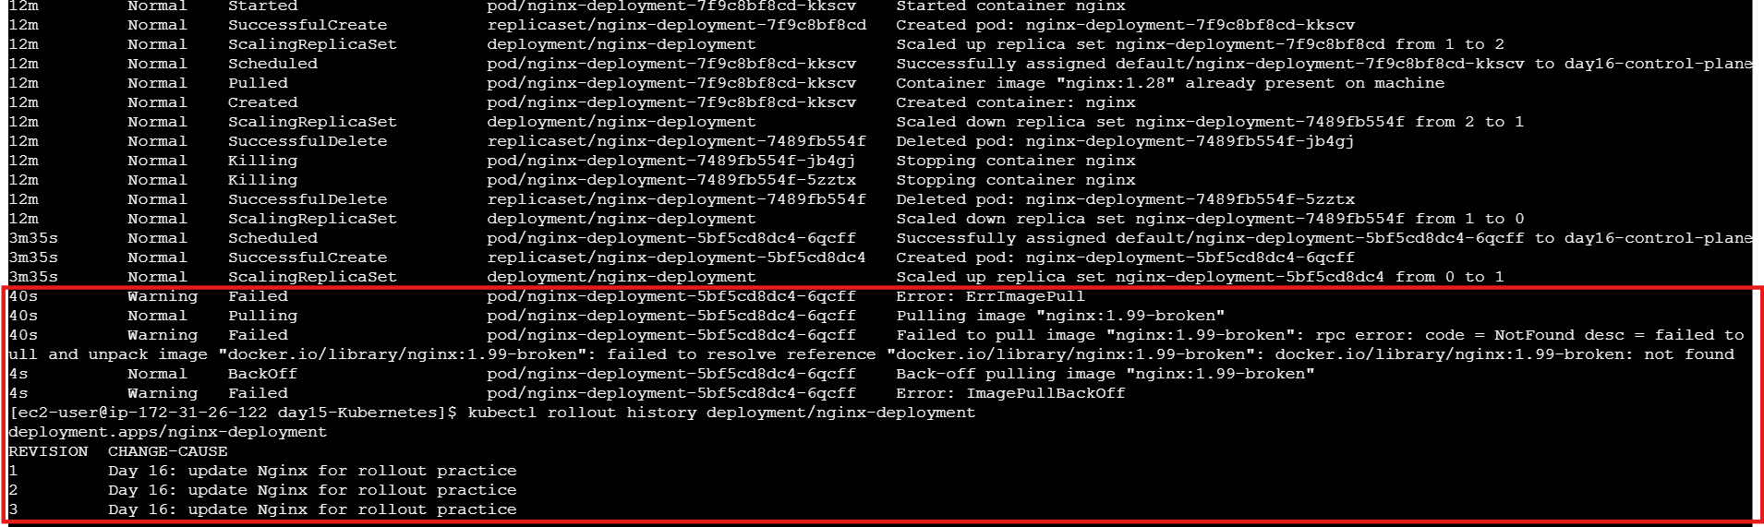

Step 8 — Roll back
kubectl rollout undo deployment/nginx-deployment
kubectl rollout status deployment/nginx-deployment
kubectl rollout history deployment/nginx-deployment
kubectl get deployment nginx-deployment -o wide
kubectl get pods

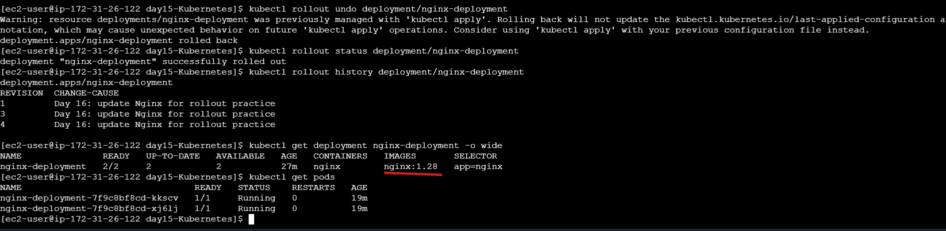

TROUBLESHOOTING & SUBMISSION | PROBLEM CHECK / FIX
Rollout status never completes | Inspect Pods and run kubectl describe pod POD_NAME; read Events for image or readiness errors.
ImagePullBackOff | Confirm the image name/tag. Here, the invalid tag is intentional; roll back after collecting evidence.
History does not show the expected note | Check that change-cause annotation was applied before the image update. Inspect history again.
Wrong Deployment/container name | Use kubectl get deployments and kubectl describe deployment DEPLOYMENT_NAME.
Rollback seems not to work | Inspect current image and Pods, wait for rollout status, and check the selected revision.
No previous revision exists | Make a successful Pod-template change first; history records revisions after template changes.

