02 / CREATE THE SERVICE & TEST DNS
Step 1 — Check your current cluster
- kubectl config current-context
- kubectl get nodes
- kubectl get deployments
- kubectl get services

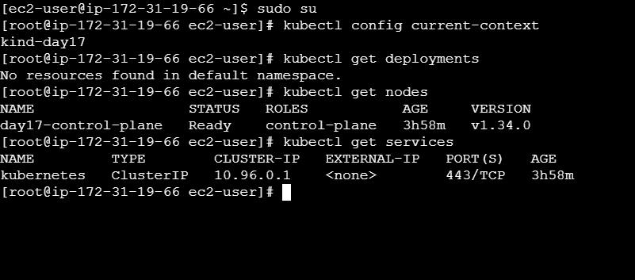

Step 2 — Create a three-replica test workload
kubectl create deployment hello --replicas=3 \
--image=registry.k8s.io/e2e-test-images/agnhost:2.39 \
-- /agnhost netexec --http-port=8080
kubectl get deployment hello
kubectl get pods -l app=hello --show-labels

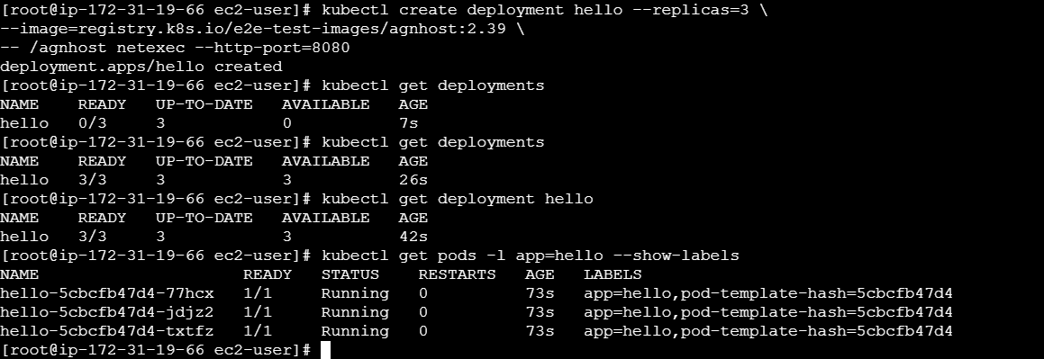

Step 3 — Create a ClusterIP Service
kubectl expose deployment hello --name=hello \
--type=ClusterIP --port=80 --target-port=8080
kubectl get svc hello -o wide
kubectl describe svc hello
kubectl get endpointslices \
-l kubernetes.io/service-name=hello

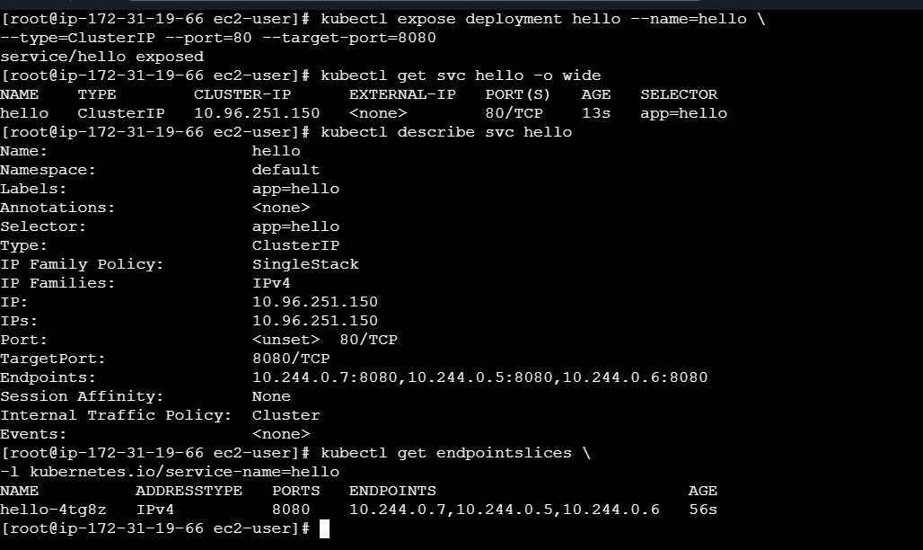

Manifest alternative — svc-clusterip.yaml
apiVersion: v1
kind: Service
metadata:
name: hello
spec:
type: ClusterIP
selector:
app: hello
ports:
- port: 80
targetPort: 8080
Use either kubectl expose or the manifest—not both. If using the manifest, apply it with kubectl apply -f svc-clusterip.yaml.
Step 4 — Call the Service by name
kubectl run tmp --rm -it --image=busybox:1.36 \
--restart=Never -- sh
Inside the temporary shell:
nslookup hello
nslookup hello.default.svc.cluster.local
for i in 1 2 3 4 5 6; do
wget -qO- http://hello/hostname
echo
done
exit
Expected: requests return backend hostnames. With three Ready replicas, repeated requests should reach more than one backend over the series;
exact order is not guaranteed.
If DNS resolves but requests fail, check targetPort, Pod readiness and EndpointSlices before changing unrelated settings.

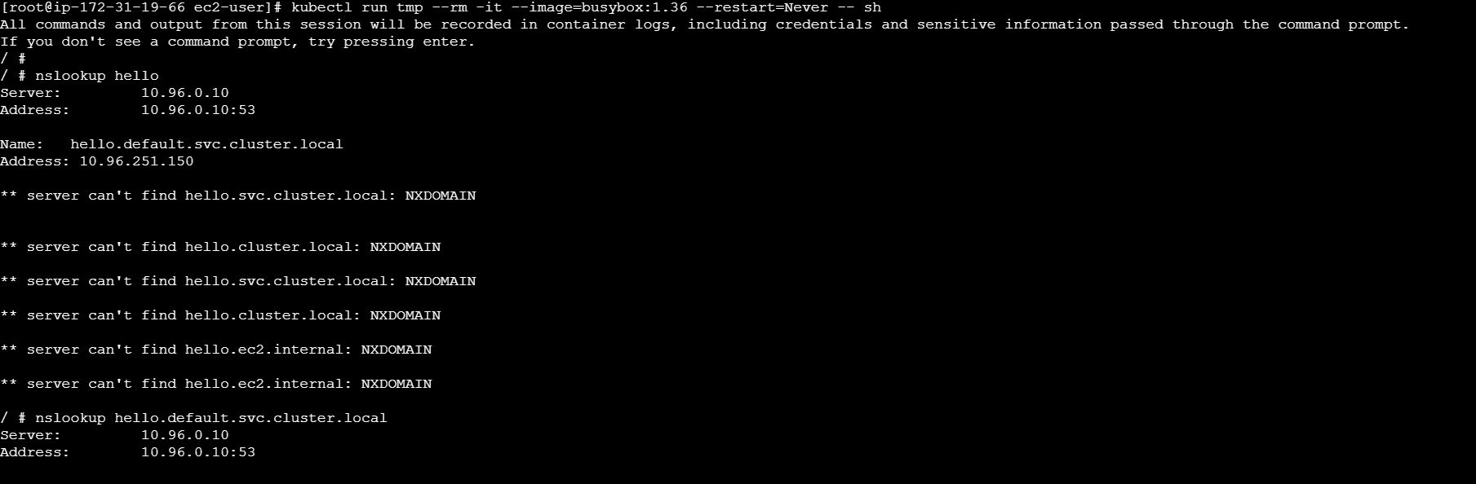
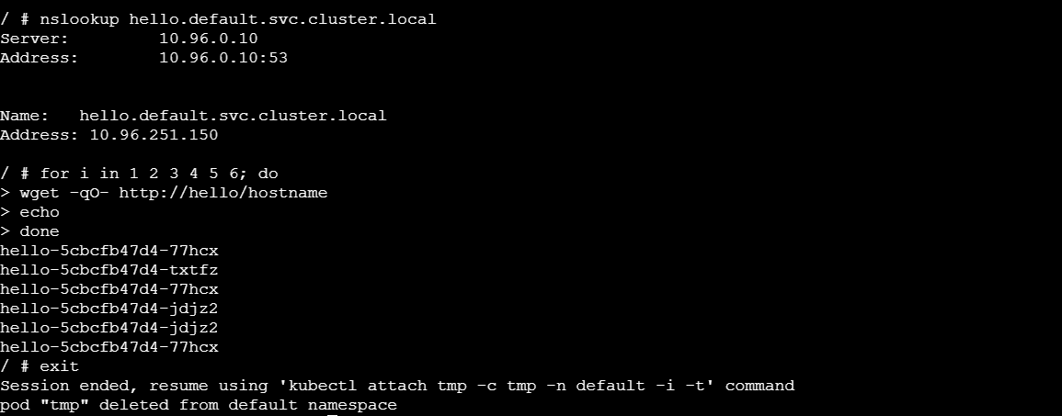

Step 5 — Observe backend endpoints
kubectl get endpointslices \
-l kubernetes.io/service-name=hello -o wide
kubectl get pods -l app=hello -o wide
Record the backend addresses and confirm they correspond to Ready Pods selected by the Service.
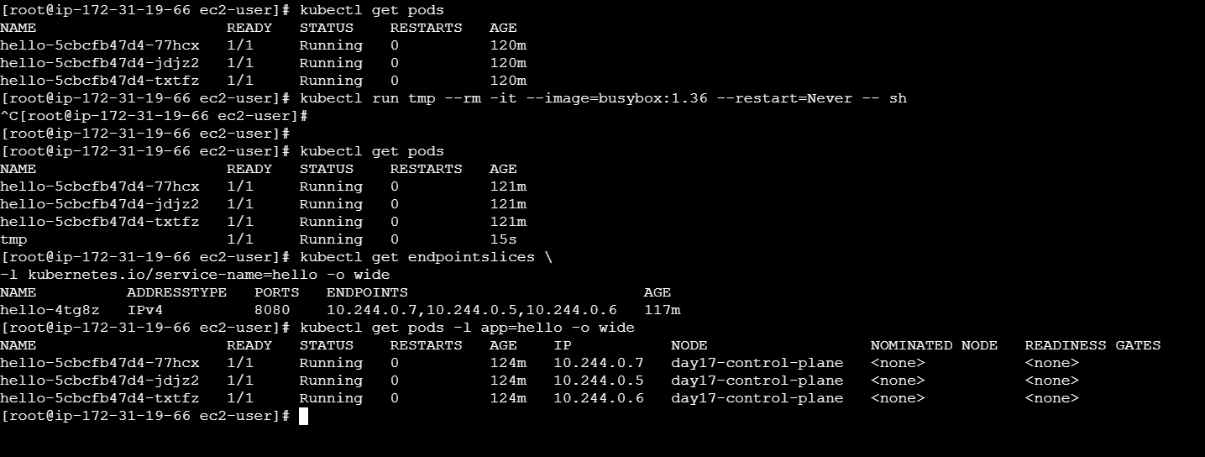

Step 6 — Delete one backend Pod and observe replacement
kubectl get pods -l app=hello
kubectl delete pod POD_NAME
kubectl get pods -l app=hello -w
Replace POD_NAME with one Pod from this workload. Wait for a replacement, then press Ctrl+C.
kubectl get endpointslices \
-l kubernetes.io/service-name=hello -o wide
kubectl get pods -l app=hello
Capture evidence that the endpoint set changes and the workload returns to three Ready replicas.

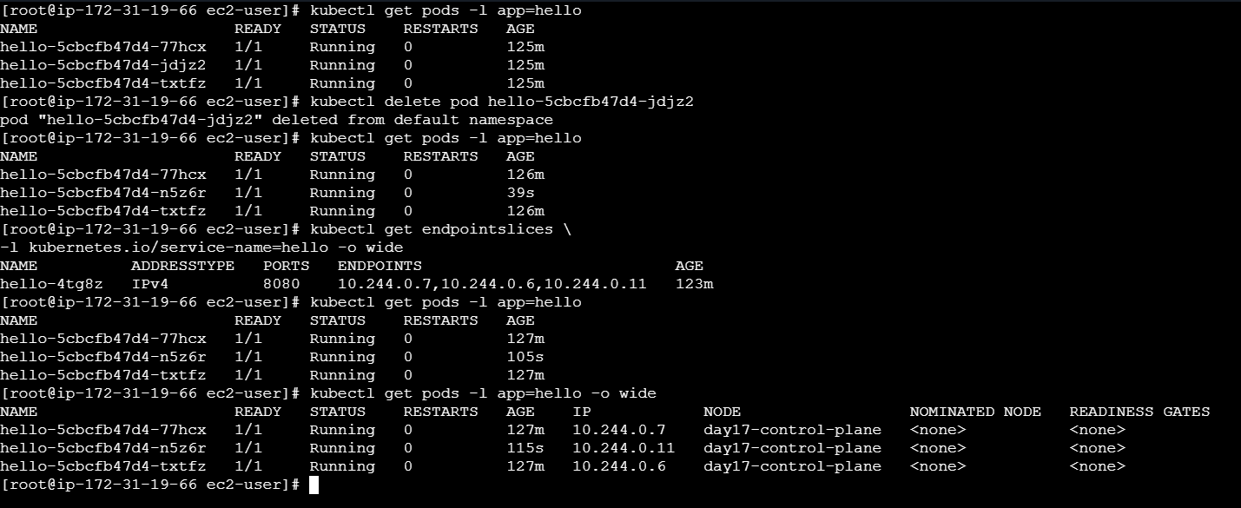

Step 7 — Break the selector
kubectl patch service hello \
-p '{"spec":{"selector":{"app":"hellow"}}}'
kubectl describe service hello
kubectl get endpointslices \
-l kubernetes.io/service-name=hello
Expected: the selector no longer matches app=hello Pods, so backend endpoints become empty. DNS may still resolve because the Service exists,but requests cannot reach an application backend.

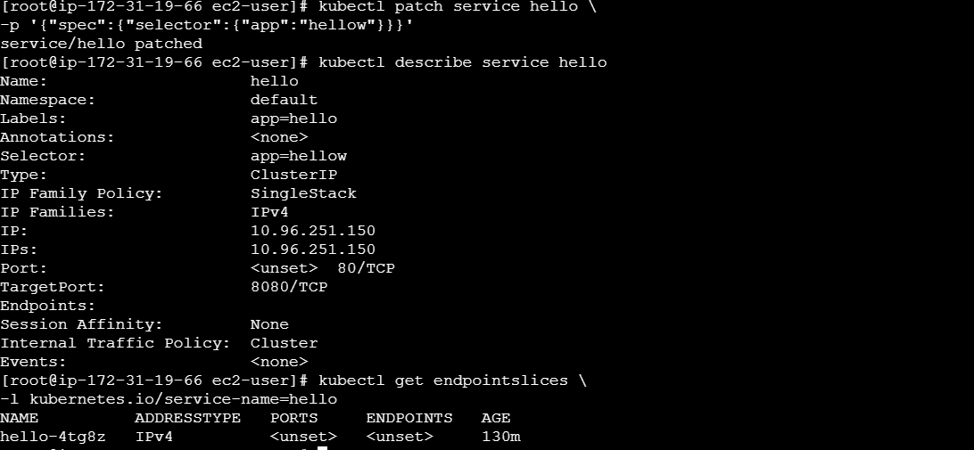

Step 8 — Fix and verify
kubectl patch service hello \
-p '{"spec":{"selector":{"app":"hello"}}}'
kubectl get endpointslices \
-l kubernetes.io/service-name=hello -o wide
kubectl describe service hello
Run the BusyBox request loop again and confirm requests succeed

