3. Task A — Create isolated namespaces
Create the two namespaces and verify them:
kubectl create namespace dev
kubectl create namespace prod
kubectl get namespaces
If a namespace already exists, inspect it instead of deleting it.
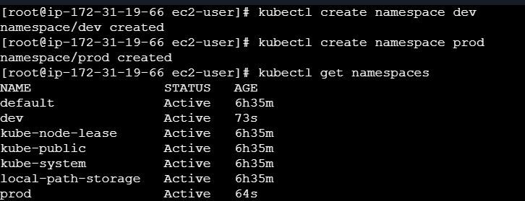

4. Task B — Create different ConfigMaps
Save the following as configmap-dev.yaml. Create configmap-prod.yaml similarly, but use APP_ENV: prod and Hello
from PROD in the page.
apiVersion: v1
kind: ConfigMap
metadata:
name: site
data:
APP_ENV: dev
index.html: |
<h1>Hello from DEV</h1>
<p>Winter Arc · Day 4</p>
kubectl apply -f configmap-dev.yaml -n dev
kubectl apply -f configmap-prod.yaml -n prod
kubectl get configmap site -n dev
kubectl get configmap site -n prod

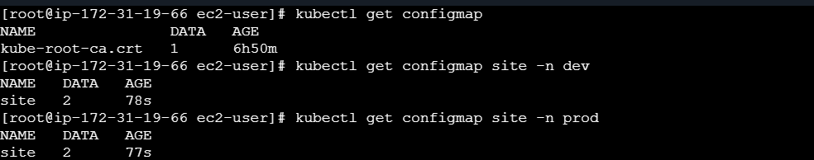

5. Task C — Create lab-only Secrets
Use dummy values only. Never commit real passwords, tokens, or production secrets to GitHub.
kubectl create secret generic db-secret \
--from-literal=password=dev-pass -n dev
kubectl create secret generic db-secret \
--from-literal=password=prod-pass -n prod
kubectl get secret db-secret -n dev
kubectl get secret db-secret -n prod

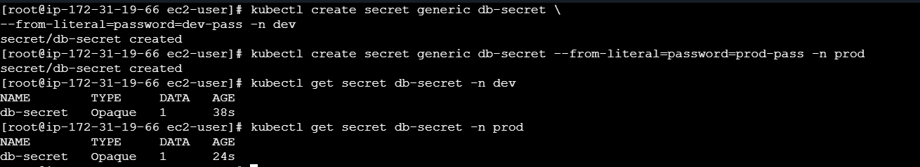

6. Task D — Configure the same workload in both namespaces
Save as deployment.yaml. The ConfigMap provides APP_ENV and the Nginx page; the Secret provides DB_PASSWORD
as an environment variable.
apiVersion: apps/v1
kind: Deployment
metadata:
name: web
spec:
replicas: 1
selector:
matchLabels:
app: web
template:
metadata:
labels:
app: web
spec:
containers:
- name: nginx
image: nginx:1.27
ports:
- containerPort: 80
env:
- name: APP_ENV
valueFrom:
configMapKeyRef:
name: site
key: APP_ENV
- name: DB_PASSWORD
valueFrom:
secretKeyRef:
name: db-secret
key: password
volumeMounts:
- name: html
mountPath: /usr/share/nginx/html
volumes:
- name: html
configMap:
name: site
- kubectl apply -f deployment.yaml -n dev
- kubectl apply -f deployment.yaml -n prod
- kubectl get pods -n dev
- kubectl get pods -n prod

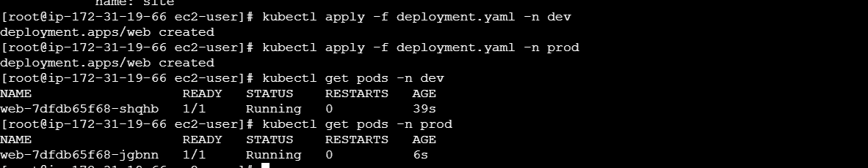

7. Task E — Verify each environment
Run each port-forward command in a separate terminal and keep it running:
kubectl port-forward -n dev deploy/web 8081:80
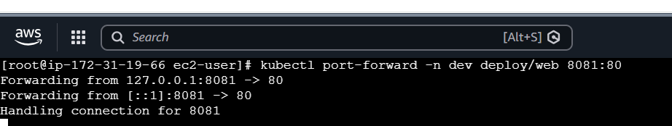

kubectl port-forward -n prod deploy/web 8082:80

From another terminal, check both pages and environment variables:
curl http://localhost:8081
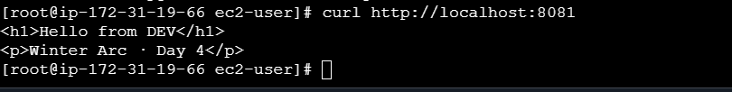

curl http://localhost:8082
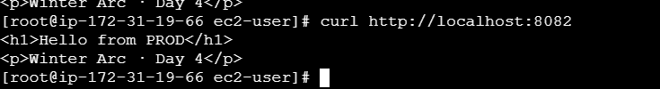

kubectl exec -n dev deploy/web -- printenv APP_ENV
kubectl exec -n dev deploy/web -- printenv DB_PASSWORD
kubectl exec -n prod deploy/web -- printenv APP_ENV
kubectl exec -n prod deploy/web -- printenv DB_PASSWORD
Expected: the dev page says Hello from DEV and APP_ENV=dev; prod says Hello from PROD and APP_ENV=prod. Do not
show DB_PASSWORD values in public screenshots or your README.
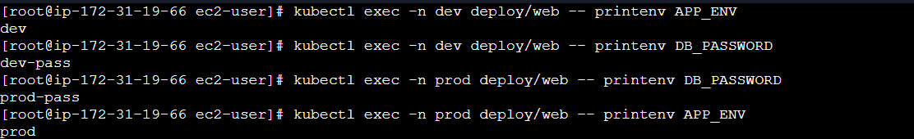

8. Task F — Update configuration and observe
Edit the dev ConfigMap and change its page text and APP_ENV:
kubectl edit configmap site -n dev
Check the page again after a short delay. Mounted ConfigMap files usually update after a short delay (often around a minute),
but environment variables are set when the container starts. Restart the Deployment to load a changed APP_ENV:
kubectl rollout restart deployment/web -n dev
kubectl rollout status deployment/web -n dev
kubectl exec -n dev deploy/web -- printenv APP_ENV
Note: ConfigMap volumes mounted with subPath do not receive automatic updates. This assignment mounts the ConfigMap as a directory.

