Task A — inspect your cluster
Run and save the output. Do not assume your StorageClass name; verify it first.
- kubectl get storageclass
- kubectl get pv
- kubectl get pvc -A
- kubectl describe storageclass standard
If your default StorageClass is not named standard, update the manifest below to use the name your cluster reports.

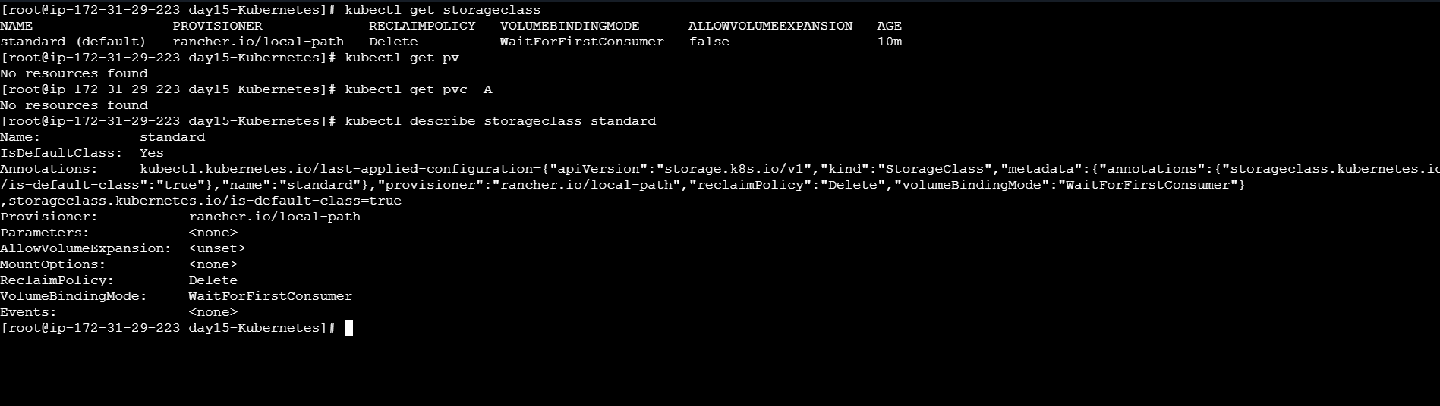

4. Task B — create a lab namespace and dummy Secret
Use a dummy lab password only. Never commit real credentials or show password values in public screenshots.
kubectl create namespace day19-storage
kubectl create secret generic pg-secret \
--from-literal=POSTGRES_PASSWORD=WinterArcLab123! \
-n day19-storage
5. Task C — create the Headless Service
Save as pg-headless.yaml. The StatefulSet uses this Service for stable network identity.
apiVersion: v1
kind: Service
metadata:
name: pg-headless
namespace: day19-storage
spec:
clusterIP: None
selector:
app: pg
ports:
- name: postgres
port: 5432
targetPort: 5432
- kubectl apply -f pg-headless.yaml
- kubectl get svc -n day19-storage

6. Task D — create PostgreSQL StatefulSet
Save as postgres-statefulset.yaml. Notice the volumeClaimTemplates section: it creates a PVC for the StatefulSet Pod. The
database stores its files under the mounted data directory.
apiVersion: apps/v1
kind: StatefulSet
metadata:
DevOps Winter Arc — 90 Days | Day 19 Page 2
name: pg
namespace: day19-storage
spec:
serviceName: pg-headless
replicas: 1
selector:
matchLabels:
app: pg
template:
metadata:
labels:
app: pg
spec:
containers:
- name: postgres
image: postgres:16-alpine
ports:
- containerPort: 5432
env:
- name: POSTGRES_DB
value: winterarc
- name: POSTGRES_USER
value: appuser
- name: POSTGRES_PASSWORD
valueFrom:
secretKeyRef:
name: pg-secret
key: POSTGRES_PASSWORD
volumeMounts:
- name: data
mountPath: /var/lib/postgresql/data
volumeClaimTemplates:
- metadata:
name: data
spec:
accessModes: ["ReadWriteOnce"]
storageClassName: standard
resources:
requests:
storage: 1Gi
- kubectl apply -f postgres-statefulset.yaml
- kubectl get statefulset,pods,pvc -n day19-storage

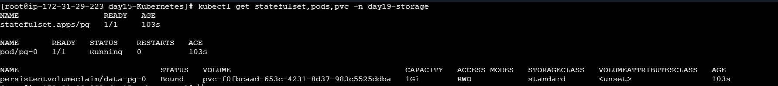

7. Task E — create a record and test persistence
Wait for pg-0 to become Ready and its PVC to become Bound. Open the database shell:
kubectl exec -it -n day19-storage pg-0 -- \
psql -U appuser -d winterarc

Inside psql, create a table and insert a test record:
CREATE TABLE lab_notes (id INT PRIMARY KEY, note TEXT);
INSERT INTO lab_notes VALUES (1, 'data-survives-pod-delete');
SELECT * FROM lab_notes;
\q

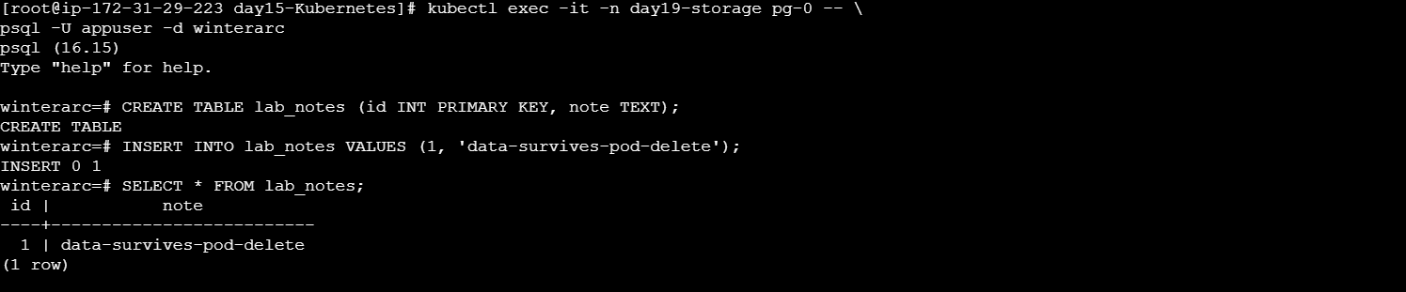

Now delete only the Pod and wait for its replacement:
- kubectl get pvc -n day19-storage
- kubectl delete pod pg-0 -n day19-storage
- kubectl get pods -n day19-storage -w

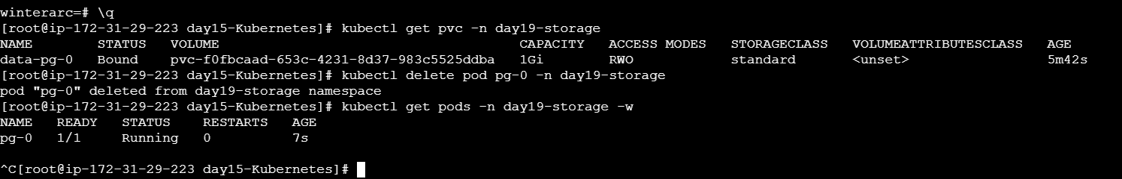

After the replacement Pod is Ready, query the table again:
- kubectl exec -n day19-storage pg-0 -- \
psql -U appuser -d winterarc -c \
- "SELECT * FROM lab_notes;"

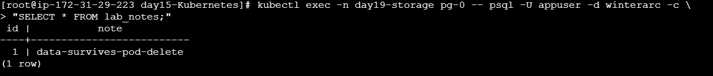

Success condition: the row data-survives-pod-delete still exists. Capture evidence of the Bound PVC, Pod recreation, and returned
row.
8. Task F — inspect the storage chain
kubectl get statefulset,pods,pvc,pv -n day19-storage

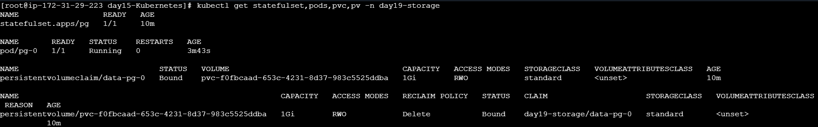

kubectl describe pvc data-pg-0 -n day19-storage
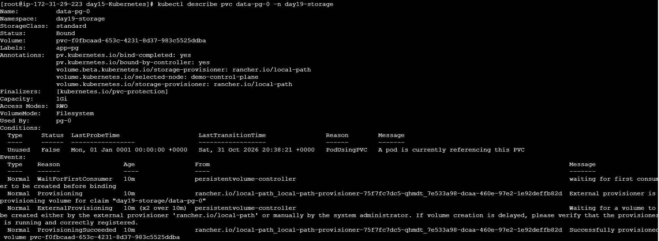

kubectl get events -n day19-storage --sort-by=.lastTimestamp
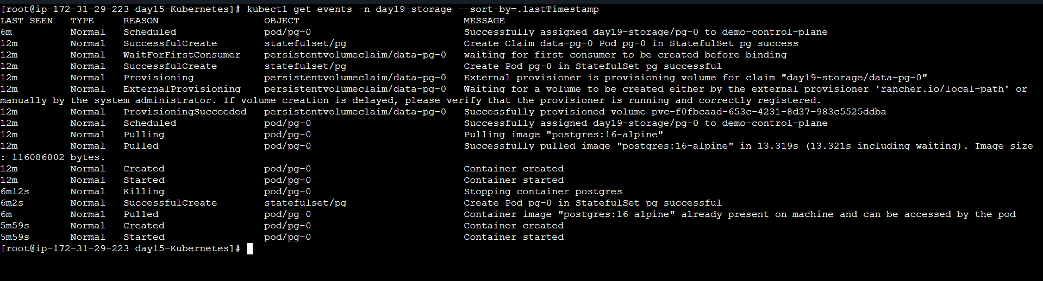

In your README, explain: StatefulSet Pod ® PVC ® PV ® storage provisioner / node path. Exact PV names and local paths
vary by cluster.
9. Break & diagnose
Inspect PVC Events and write down at least two reasons a claim could stay Pending. Examples include a missing/mismatched
StorageClass, provisioner issues, or unsatisfied storage requirements. Diagnose first; do not change settings blindly.
Quick troubleshooting
Symptom Check
PVC Pending Describe PVC; inspect Events and StorageClass/provisioner.
Pod not starting Describe pg-0; check Events and whether the PVC is Bound.
Postgres restarts Check logs and Secret key names.
Data seems missing Verify the same PVC is attached and query the correct database/table.
PVC remains after Pod
deletion
Expected: claims are normally retained when only the Pod is deleted.

