PROJECT REPORT
Trust-Aware Financial Research Assistant
Retrieval-Augmented Generation · Trust Layer · Human-in-the-Loop Validation

Type: AI Engineering Portfolio Project
Dataset: Infosys · TCS · Cognizant (Annual Reports, Earnings Calls, Financial News)
Stack: Python · ChromaDB · Ollama · LangGraph · Streamlit

1. Executive Summary
This project delivers a local-first financial research assistant that lets analysts, students, and investors query real company filings in plain English and receive answers that are explicitly grounded in source text, scored for confidence, and validated before being surfaced. It is not a generic chatbot — it is a purpose-built research tool with a Trust Layer that scores every answer on five measurable factors, detects contradictions and forward-looking language, and generates an Approve / Warn / Review decision for each response.
The system covers Infosys, TCS, and Cognizant across multiple fiscal years, supporting six output modes from a single chat window: natural language Q&A with trust scoring, multi-company comparison, knowledge graph visualization, human-in-the-loop review, multi-year trend dashboards, and full analyst report generation. Everything runs locally by default using Ollama and a free embedding model, with OpenAI available as a one-toggle alternative.

Financial professionals and students spend hours reading through hundreds of pages of annual reports just to find one revenue figure or compare two companies across years. This project was built to fix that — to make financial research faster and more reliable without a Bloomberg terminal or an expensive data subscription. The people who benefit most are equity research analysts who need to cross-reference multiple filings quickly, finance students working directly with real company data, small advisory firms doing early-stage due diligence, and independent investors who want to verify what companies actually report rather than rely on media summaries.
What separates this from any other “chat with your PDFs” tool is accountability. Every answer carries a confidence score broken down by five measurable factors, a direct citation to the source page, and a human review flag when the evidence is thin. In financial research, acting on a wrong number has real consequences — so the system treats answer trustworthiness as a first-class feature, not an afterthought. That is the difference between a demo and something you can actually use to make decisions.

2. System Architecture
The pipeline is organized into six discrete layers, each with a single responsibility:

Layer | File | Responsibility
Document Ingestion | document_processor.py | Load PDFs/TXTs, extract text, resolve company name from folder structure, extract fiscal year from document content (500-line scan) with filename fallback
Vector Store | vector_store.py | Chunk text, embed with SentenceTransformer or OpenAI, persist in ChromaDB; execute company+year-filtered similarity search
RAG Business Logic | rag_pipeline.py | Six feature functions: Q&A, comparisons, knowledge graph data, ratios, reports, ingest CLI
Trust Validation | trust_engine.py | Five-factor confidence scoring, citation validation, contradiction detection, forward-looking language detection, per-sentence claim verification
Workflow Routing | langgraph_flow.py | 4-node LangGraph workflow classify→route→trust→response; plain-Python fallback if LangGraph unavailable
User Interface | dashboard.py | Streamlit single-window app: Chat, Knowledge Graph, HITL Queue, Dashboard, Report tabs
Human Review Queue | hitl_queue.py | JSON-backed persistent queue: Approve, Edit, Reject, Need More Evidence; timestamped for audit

Document folder structure: documents / ➨SourceType➩ / ➨CompanyName➩ / file.pdf — company name comes from the immediate parent folder, source type from the grandparent folder, filenames can be anything.

3. Key Features

3.1 Chat Interface with Trust Scoring
The chat tab is the primary interface. Every question is classified by LangGraph and routed to the right feature. Responses include the answer text, the source document and page, and a full trust card showing the confidence score, band, and decision. All supporting detail — citations, chunk previews, validation breakdown, HITL action — is available as expandable panels beneath each response.

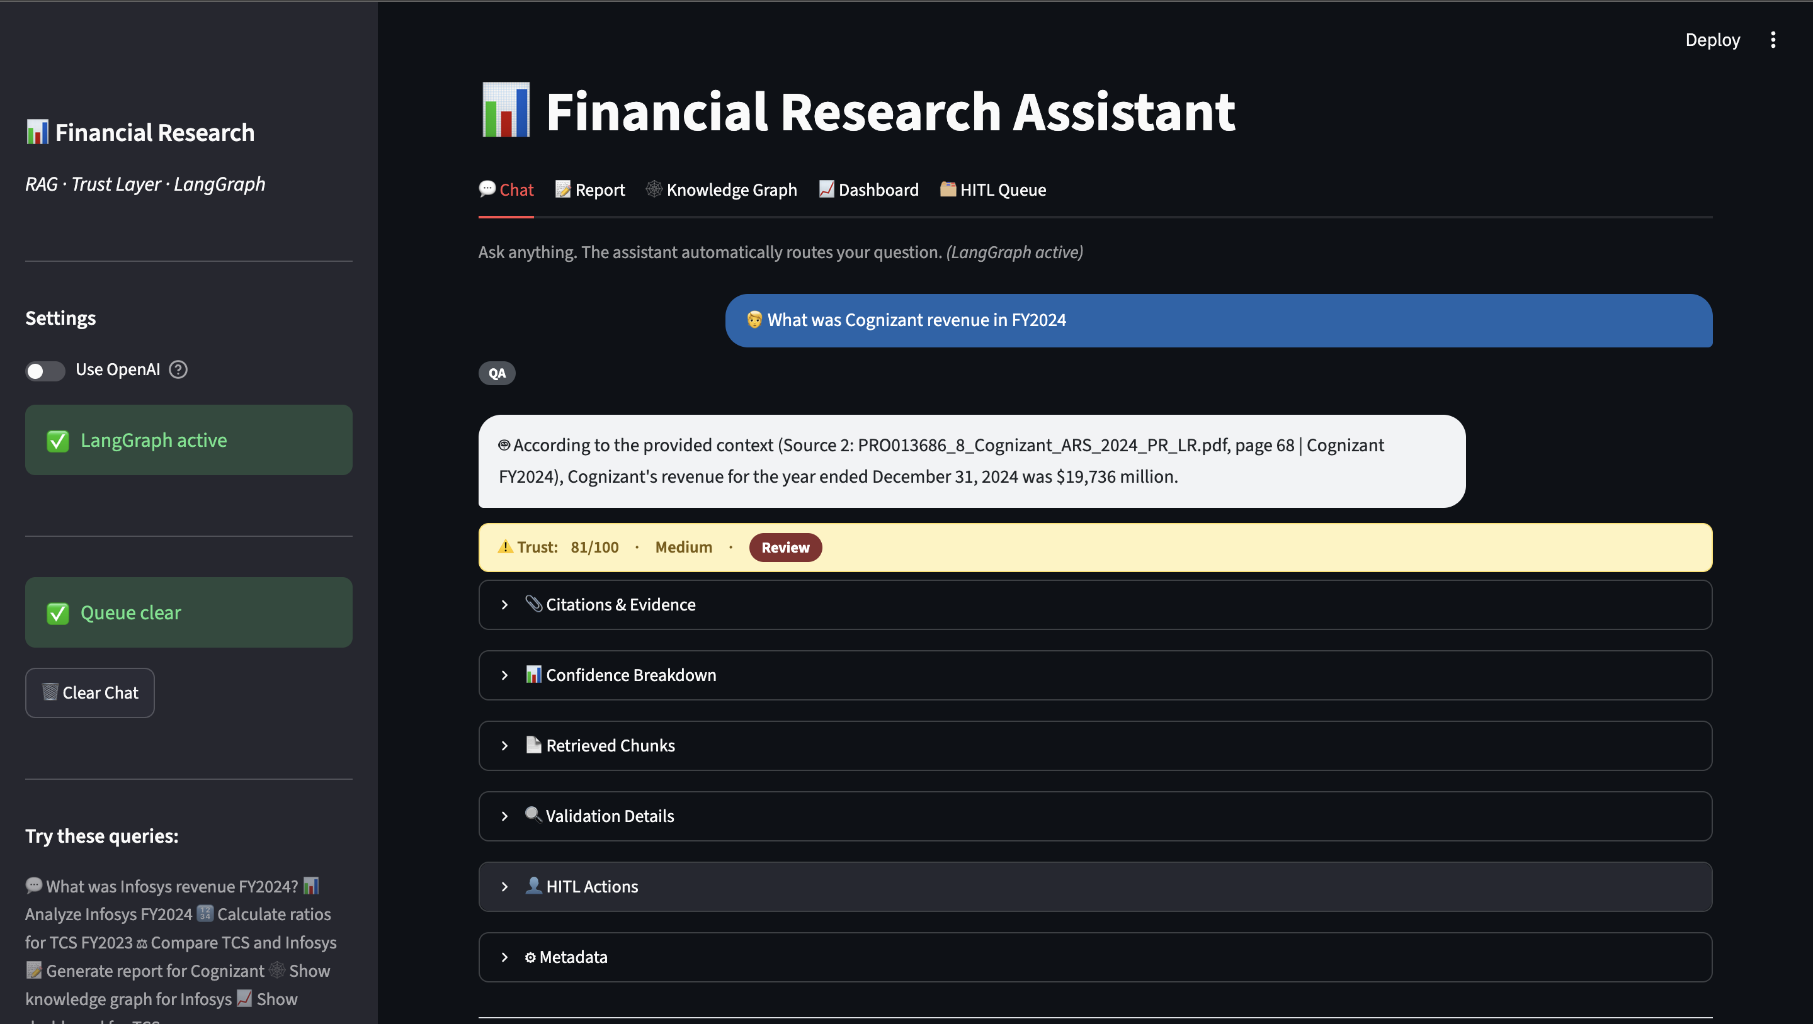
Figure 1 — Chat interface showing a Cognizant FY2024 revenue query answered with source citation to page 68 of the annual report and Trust Score 81/100 (Medium · Review).

3.2 Multi-Company Comparison
Asking "Compare TCS and Infosys for FY2025" fires parallel retrieval for each company across the same set of financial dimensions — revenue, profitability, growth, business outlook — and returns a structured side-by-side comparison with confidence scores per dimension. Each company's data is retrieved with a strict company + fiscal year filter to prevent cross-contamination between filings.

3.3 Knowledge Graph
For any company and fiscal year, six targeted queries extract the company's business segments, products, services, risks, growth opportunities, and management themes. These are rendered as an interactive network graph with color-coded node types. The graph gives a visual overview of the company's structure and strategic priorities that would otherwise require reading dozens of pages.

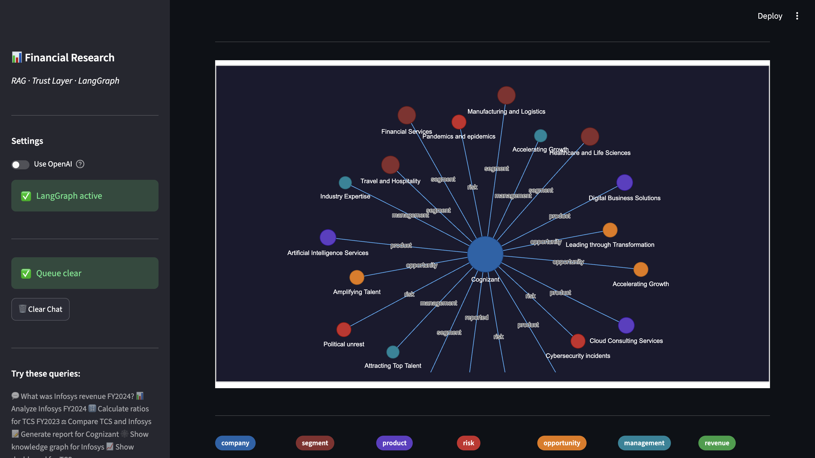
Figure 2 — Knowledge graph for Cognizant FY2024 showing segments (dark red), products (purple), risks (red), opportunities (orange), and management themes (teal) extracted from the annual report.

3.4 Human-in-the-Loop Review Queue
Low-confidence answers do not get silently displayed. They are routed to a persistent review queue where a human reviewer can Approve, Edit, Reject, or request more evidence. Every decision is timestamped and stored for audit. This queue is also reachable directly from any chat response via the HITL Actions panel, regardless of confidence score, so reviewers can flag any answer manually.

3.5 Analytics Dashboard
The dashboard auto-discovers all fiscal years present in the vector store for the selected company and plots four trend charts: Revenue (USD billions), Operating Margin (%), Net Income (USD billions), and Total Headcount. Years with no available data are explicitly captioned rather than silently dropped. The system handles mixed-currency reporting — Infosys reports in Indian Rupees, which is automatically converted to a USD-equivalent for chart display while original figures remain in the Raw Data tab.

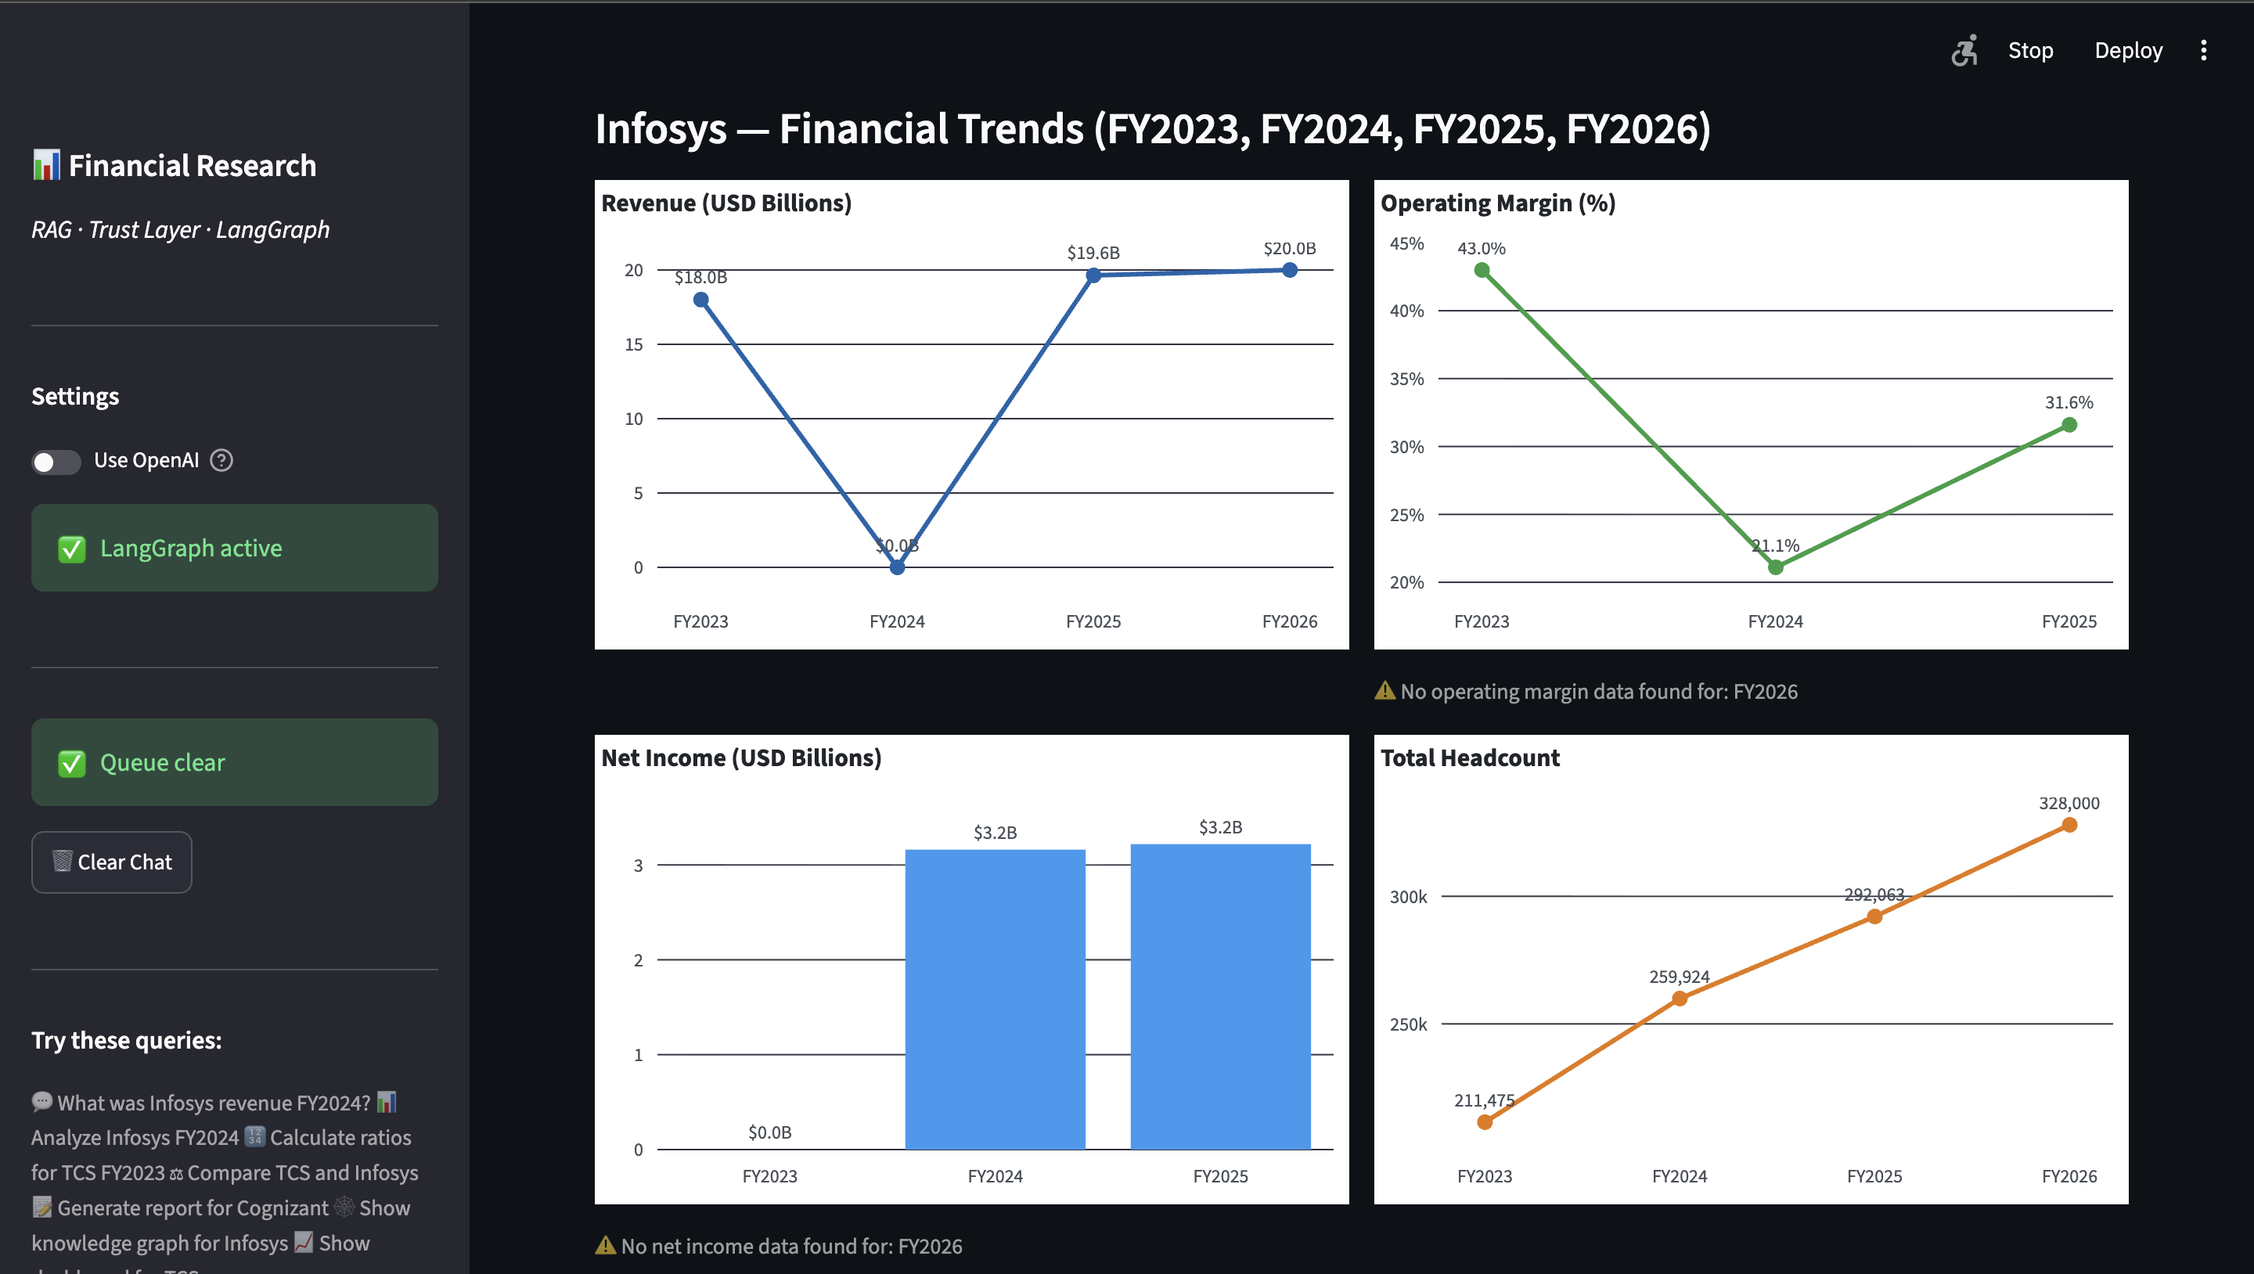
Figure 3 — Analytics dashboard for Infosys across FY2023–FY2026. Revenue grew from $18.0B to $20.0B. Headcount grew steadily from 211,475 to 328,000. Missing data years are explicitly flagged.

3.6 Analyst Report Generation
Asking "Generate report for Cognizant" fires six section-specific retrieval queries — Executive Summary, Business Overview, Financial Performance, Operational Highlights, Risks & Challenges, Analyst Verdict — and assembles them into a structured markdown report with per-section confidence scores. The report can be downloaded directly from the Report tab.

4. Trust Scoring
Every answer is scored out of 100 across five independently-weighted factors:

Factor | Max | What It Measures
Source Quality | 25 | Proportion of retrieved chunks from primary sources (annual reports, earnings calls)
Retrieval Relevance | 21* | Mean cosine similarity between query embedding and chunk embeddings. *Calibrated to all-MiniLM-L6-v2’s real range of 0.55–0.65 on financial text
Citation Completeness | 20 | Every retrieved chunk has a matching citation; metadata (company, year, page) agrees between citation and chunk
Cross-Source Agreement | 15 | All retrieved chunks agree on company name and fiscal year — detects mixed-year data contamination
Calculation Validation | 15 | Dollar/rupee/percent figures in the generated answer appear in the source chunk texts

Scores of 85+ are Approved automatically. Scores of 70–84 produce a Warn. Below 70, or whenever contradictions, citation failures, or forward-looking language are detected, the answer is routed to the HITL queue regardless of numeric score.

5. Technology Choices
Decision | Chosen | Why
Vector store | ChromaDB | Stores text + vectors + metadata together; supports $and filtering by company AND fiscal year simultaneously. FAISS does not support server-side metadata filtering.
LLM (local) | Ollama / llama3 | Free, private, no per-token cost. Documents never leave the machine.
LLM (cloud) | OpenAI GPT-4o | One-toggle upgrade for higher answer quality when needed.
Embeddings | all-MiniLM-L6-v2 | Free, local, ~80MB, no API key required. Runs on CPU to avoid GPU memory instability.
Workflow | LangGraph | Forces typed state across all routing nodes. Identical plain-Python fallback included.
UI | Streamlit | Single-process architecture — no separate API server. UI and backend share the same Python runtime.
Graph | NetworkX + PyVis | On-demand, ephemeral graph of ~20–30 nodes. No persistent graph database or infrastructure needed.

6. Results & Validation
The following results were produced from the live running system against the ingested dataset (3 companies, 4 fiscal years, 23,826 chunks). All figures below can be verified by running the same queries against the application.

6.1 Q&A Results
Query | Answer Produced | Source | Trust Score
What was Cognizant revenue in FY2024? | $19,736 million | PRO013686_8_Cognizant_ARS_2024_PR_LR.pdf, page 68 | 81/100 · Medium
What was Cognizant revenue in FY2025? | $21,108 million | 2025_Annual_Report_Final.pdf, page 71 | 81/100 · Medium
What was Infosys revenue in FY2024? | ₹153,670 crore | infosys-ar-24.pdf, page 272 | 95/100 · High ✔ Approve

Cognizant FY2024 ($19,736 million) is verifiable against Cognizant’s Form 10-K, year ended December 31, 2024, Consolidated Statements of Operations. Infosys FY2024 (₹153,670 crore) is verifiable against the Infosys Annual Report FY2024, Consolidated Statement of Profit and Loss.

6.2 Dashboard Results (Infosys FY2023–FY2026)
- Revenue: $18.0B (FY2023) → $19.6B (FY2025) → $20.0B (FY2026) — consistent upward trend
- Operating Margin: 43.0% (FY2023) → 21.1% (FY2024) → 31.6% (FY2025) — sharp dip in FY2024, recovering
- Headcount: 211,475 (FY2023) → 259,924 (FY2024) → 292,063 (FY2025) → 328,000 (FY2026) — steady growth
- FY2026 Net Income: explicitly flagged as no data found rather than showing $0 or extrapolating

6.3 Knowledge Graph Results (Cognizant FY2024)
- Segments: Financial Services, Healthcare and Life Sciences, Manufacturing and Logistics, Travel and Hospitality
- Products: Digital Business Solutions, Artificial Intelligence Services, Cloud Consulting Services
- Risks: Cybersecurity incidents, Pandemics and epidemics, Political unrest
- Management themes: Accelerating Growth, Amplifying Talent, Leading through Transformation, Industry Expertise

6.4 Verification Instructions
- 1. Start Ollama: ollama serve (separate terminal)
- 2. Ingest: rm -rf chroma_db/ then python rag_pipeline.py --ingest --docs_folder ./documents
- 3. Run: streamlit run dashboard.py
- 4. Chat tab: type the queries from Section 6.1 — answers and source citations should match exactly
- 5. Dashboard tab: select Infosys — FY2023, FY2024, FY2025, FY2026 auto-detected, all four charts populate
- 6. Knowledge Graph tab: type Cognizant, FY2024, click Build Graph — 15–20 nodes matching Section 6.3 labels

7. How the Trust Layer Works
The Trust Layer operates entirely on data already assembled during retrieval — it never re-opens the original PDFs, re-runs similarity search, or calls the LLM a second time. Everything is a fast, deterministic computation on the answer_package dict.
Retrieval quality validation
At query time, ChromaDB computes a cosine similarity score between the query embedding and each retrieved chunk embedding. This score is stored in the answer_package. The Trust Layer reads it back and converts it to a tiered confidence score using a curve calibrated to this embedding model’s real-world range on financial text.
Citation validation
The Trust Layer cross-checks the citations list against the retrieved_chunks list — a pure dict-to-dict comparison in memory. It verifies that every chunk has a matching citation and that company name, fiscal year, and page number agree between both.
Calculation validation
Dollar, rupee, and percentage figures are extracted from the generated answer text using a regex pattern, then checked against chunk texts using digit-core matching — stripping all non-digit characters from both sides before comparing. This handles the common case where “$19,736 million” in the answer corresponds to “19,736” in the source chunk, since PDF table extraction strips currency symbols and line-wraps units.

8. Technology Stack
Category | Technology
UI & Backend | Streamlit
Vector Database | ChromaDB
Local Embeddings | SentenceTransformers — all-MiniLM-L6-v2
Cloud Embeddings (optional) | OpenAI text-embedding-3-small
Local LLM | Ollama — llama3
Cloud LLM (optional) | OpenAI GPT-4o
ML Backend | PyTorch (CPU mode)
Agentic Workflow | LangGraph
PDF Extraction | PyMuPDF (fitz)
Charting | Plotly
Graph Visualization | NetworkX + PyVis
HTTP Client | requests (Ollama API)
Not Used | FastAPI, Flask, Docker, SQL, Neo4j, FAISS

9. Known Limitations
- Company alias matching is exact — ‘TCS’ and ‘Tata Consultancy Services’ are treated as different companies.
- Trust score weights are heuristic, not derived from a labeled evaluation dataset.
- INR→USD conversion uses a fixed ~83 rate for chart display. Not a live exchange rate.
- Adding a new document requires deleting chroma_db/ and re-ingesting the full corpus.

Appendix — Answer Package Schema
Every RAG query produces an answer_package dict. Its structure is frozen by project_contract.json. See sample_answer_package.json and sample_trust_card.json for a real computed example using Cognizant FY2024 data (96/100 · High · Approve).
answer_package fields
- question — raw user query
- answer — LLM-generated answer text
- retrieved_chunks — list of dicts: chunk_id, text, company_name, fiscal_year, source_type, file_name, page_number, similarity_score
- citations — list of dicts: chunk_id, file_name, page_number, company_name, fiscal_year
- metadata — model_used, retrieval_top_k, pipeline_version, timestamp, total_chunks_in_store, embedding_model
trust_card fields
- confidence_score — int 0–100
- confidence_band — High | Medium | Low
- confidence_breakdown — per-factor dict with score, max, reason
- validation_results — citations, financials, contradictions, forward_looking
- per_claim_validation — sentence-level breakdown with support_rate
- issues — flat list of all human-readable validation warnings
- decision — { action: Approve | Warn | Review, reason }
- rag_output — the original answer_package embedded verbatim

