A Minor Project II report on
NeoNote
Submitted in partial fulfillment of the requirements for the degree of
Bachelor of Engineering in Software Engineering at Pokhara University

By
Anil B.K
Kriti Adhikari
Subash Banstola

Department of Research and Development
GANDAKI COLLEGE OF ENGINEERING AND SCIENCE
Lamachaur, Kaski, Nepal
(April 30, 2024)

A Minor Project II report on
NeoNote
Submitted in partial fulfillment of the requirements for the degree of
Bachelor of Engineering in Software Engineering at Pokhara University

By
Anil B.K
Kriti Adhikari
Subash Banstola

Supervisor

Supervisor Name

Department of Research and Development
GANDAKI COLLEGE OF ENGINEERING AND SCIENCE
Lamachaur, Kaski, Nepal

Acknowledgement
We would like to extend our heartfelt gratitude to our project supervisor Er. Tara Bahadur Thapa for her invaluable guidance and continuous support throughout the development of NeoNote. We are equally thankful to the principal Dr. Bishwo Udhir Poudel Gharti and vice principal Mr. Ashok Raj Parajuli for providing us with this opportunity to apply our learning in a real-world project. Our sincere appreciation also goes to the entire team of supervisors who helped us overcome various challenges during the development process. A special thanks to our Project Head Er Santosh Panth for his constant motivation and leadership, which greatly inspired us throughout the project journey.
We are also immensely grateful to our friends and peers who stood by us during the past few months—sharing ideas, solving problems, and contributing their efforts to enhance the project. Their collaborative spirit and encouragement were crucial in shaping NeoNote into a fully functional application with note-taking, diary, task management, and collaboration features. The entire team is truly thankful to everyone who directly or indirectly contributed to the successful completion of this project.

Anil B.k

Kriti Adhikari

Subash Banstola

ABSTRACT
NeoNote is a comprehensive platform independent app developed to address the need for efficient task management, note-taking, and project organization. The project aims to simplify the complexities of everyday planning by providing a unified platform that combines intuitive note-taking capabilities with robust task-tracking tools. Built using Flutter for the frontend, Django for the backend, and PostgreSQL for database management, the system ensures seamless functionality, scalability, and secure data handling. The methodology involves creating an interactive interface that enables users to create, organize, and edit notes while managing tasks through features like customizable templates, real-time collaboration, and multi-device synchronization. Initial testing highlights smooth user interactions, reliable performance, and a responsive design. The system’s effectiveness is evaluated through internal performance metrics and user trials, ensuring its suitability for both individual and collaborative use cases. NeoNote concludes by offering a versatile, efficient, and user-centric solution that empowers individuals and teams to optimize their productivity and achieve their goals.
Keywords: Platform Independent app, task management, note-taking, project organization, productivity, Flutter, Django, PostgreSQL, scalable, performance optimization.

TABLE OF CONTENTS
APPROVAL CERTIFICATE.............................................................................................i
ABSTRACT……………………………………………………………………………...ii

Chapter 1 INTRODUCTION…………………………………………………………….1
- BACKGROUND…………………………………………………………………1
- PROBLEM STATEMENTS……………………………………………………..1
- OBJECTIVES……………………………………………………………………2
- IMPLICATIONS…………………………………………………………………2

Chapter 2 LITERATURE REVIEW……………………………………………………..3

Chapter 3 TOOLS AND METHODOLOGY…………………………………………….4
- REQUIRED TOOLS……………………………………………………………..4
- DESIGN………………………………………………………………………….4
3.2.1 USE CASE DIAGRAM …………………………………………………...4
3.2.2 ENTITY RELATIONSHIP DIAGRAM…………………………………...7
3.2.3 SYSTEM SEQUENCE DIAGRAM ………………………………………8
3.2.4 DESIGN CLASS DIAGRAM ……………………………………………..9
3.2.5 INTERACTION DIAGRAM …………………………………………….10
3.3 APPROACH ……………………………………………………………………10

Chapter 4 FINDINGS, RESULTS AND ANALYSIS …………………………………11
4.1 TEST CASE REPORT / RESULT ……………………………………….11
4.2 KEY OUTPUT …………………………………………………………...12
4.3 ANALYSIS ………………………………………………………………12
Chapter 5 CONCLUSION AND RECOMMENDATION …………………………….13
5.1 CONCLUSION …………………………………………………………..13
5.2 RECOMMENDATION …………………………………………………..13

BIBLIOGRAPHY………………………………………………………………………14

LIST OF TABLES
TABLE 1: COMPARISON TABLE…………………………………………………….3
TABLE 2: TEST CASES……………………………………………………………….11

LIST OF FIGURES
FIGURE 1: USE CASE DIAGRAM.……………………………………………………..5
FIGURE 2: ENTITY-RELATIONSHIP DIAGRAM………………………………….....7
FIGURE 3: SYSTEM SEQUENCE DIAGRAM…………………………………………8
FIGURE 4: DESIGN CLASS DIAGRAM FOR PERSONAL SPACE .. ……………….9
FIGURE 5: DESIGN CLASS DIAGRAM FOR WORK SPACE ………………………9
FIGURE 6: INTERACTION DIAGRAM ………………………………………………10

Chapter 1
INTRODUCTION
- Background
NeoNote is platform independent app designed to streamline task management, note-taking, and project organization. The primary objective of this platform is to simplify and enhance users' productivity by providing an intuitive and feature-rich tool that integrates all essential productivity features in one place. NeoNote offers a flexible and user-friendly approach, allowing users to create, organize, and track their tasks and notes easily.. The app’s modular design makes it adaptable to users' unique needs, enabling them to personalize their workspace. NeoNote allows users to visually track task progress, helping them stay on top of their goals and effectively manage their time. The system also provides users with the flexibility to categorize and organize their notes and tasks in a way that suits their workflow. This comprehensive tool ensures users can maintain clarity, stays focused, and work more efficiently toward their objectives.
- Problem statement
NeoNote tackles everyday challenges like keeping your data in sync across devices without any hiccups, scaling smoothly as more users and data come on board, keeping your information safe and secure, and making real-time collaboration easy with clear user permissions and editing controls.

- OBJECTIVE
This project will serve the following objectives:
- To create a platform where users can easily take, edit, and organize notes, tasks, and projects without any hassle.
- To provide a mechanism for project owners to invite other registered users (via email) to become members of their projects.
- To enable teams to collaborate by sharing tasks and workspaces seamlessly.
- To proactively notify users in real time about goals, and tasks for improved engagement.
- To offer time-zone-aware calendar UI for creating, viewing, and managing events with proper access controls.

- IMPLICATION
NeoNote simplifies task management, note-taking, and project organization, improving productivity and teamwork. Its features, like cross-device access and real-time collaboration, help users stay organized and focused. These projects empower individuals and teams to work smarter, save time, and achieve their goals efficiently.

Chapter 2
LITERATURE REVIEW
Several products like Trello, Google Keep, ClickUp, and Notion offer similar features, such as task management and note-taking. However, NeoNote uniquely combines these features with real-time collaboration, customizable templates, and multi-device sync, all in an intuitive, user-friendly platform. Unlike others, it is specifically designed to streamline both personal and collaborative project management.
Table 1: COMPARISON TABLE
Application  Features | Trello | Notion | Google Keep | ClickUp | NeoNote
Ease of use | MEDIUM | MEDIUM | HIGH | MEDIUM | HIGH
Task Management | HIGH | HIGH | MEDIUM | HIGH | HIGH
Note-Taking | LOW | HIGH | HIGH | MEDIUM | HIGH
Password Protection | YES | YES | YES | YES | YES
Team Management | YES | YES | NO | YES | YES
Real-Time Collaboration | YES | YES | YES | YES | YES

Chapter 3
TOOLS AND METHODOLOGY

3.1 REQUIRED TOOLS
Different tools used to develop our app:
- Flutter: Best for cross-platform deployment and creating visually rich, interactive apps.
- Django: For backend development, handling server-side logic and database management.
- MySQL/PostgreSQL: For managing the system's relational database, storing user data, notes, and tasks.
- Figma: For designing and prototyping the app's user interfaces.
- Draw.io: For creating system architecture diagrams and workflows.
- MS-Word: For writing and preparing reports.

3.2 Designs
3.2.1 Use-Case Diagram
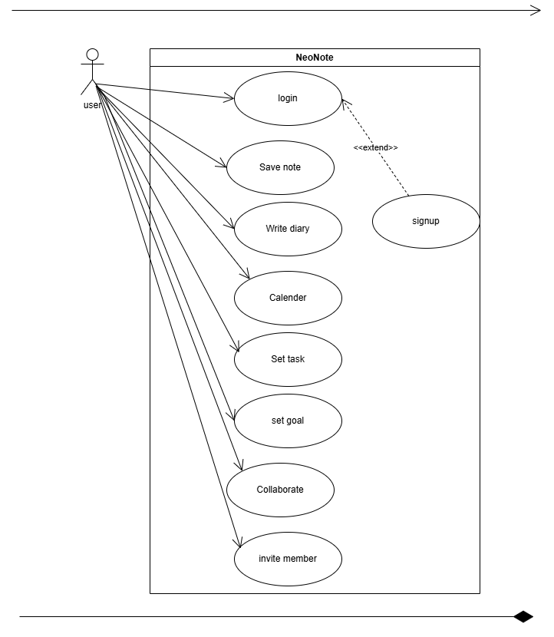
FIGURE 1: USE CASE DIAGRAM

USE CASE: NeoNote
Actors:
- User: A person who uses NeoNote for note-taking, task management, and project organization.
Use Cases:
- Login: Users and administrators can log in to the system using Firebase Authentication.
- Logout: Users and administrators can log out of the system at any time.
- Create Note: Users can create, edit, and save new notes.
- Organize Tasks: Users can add, edit, and delete tasks related to their notes and projects.
- View Notes/Tasks: Users can view their saved notes and tasks, organized by projects or categories.
- Set Reminders: Users can set reminders for tasks or notes to receive notifications at a specified time.
- Share projects: Users can share projects with other users for collaborative editing and viewing.
- Delete Note/Task: Users can delete any note or task they no longer need.

3.2.2 Entity Relation Diagram (EDR) 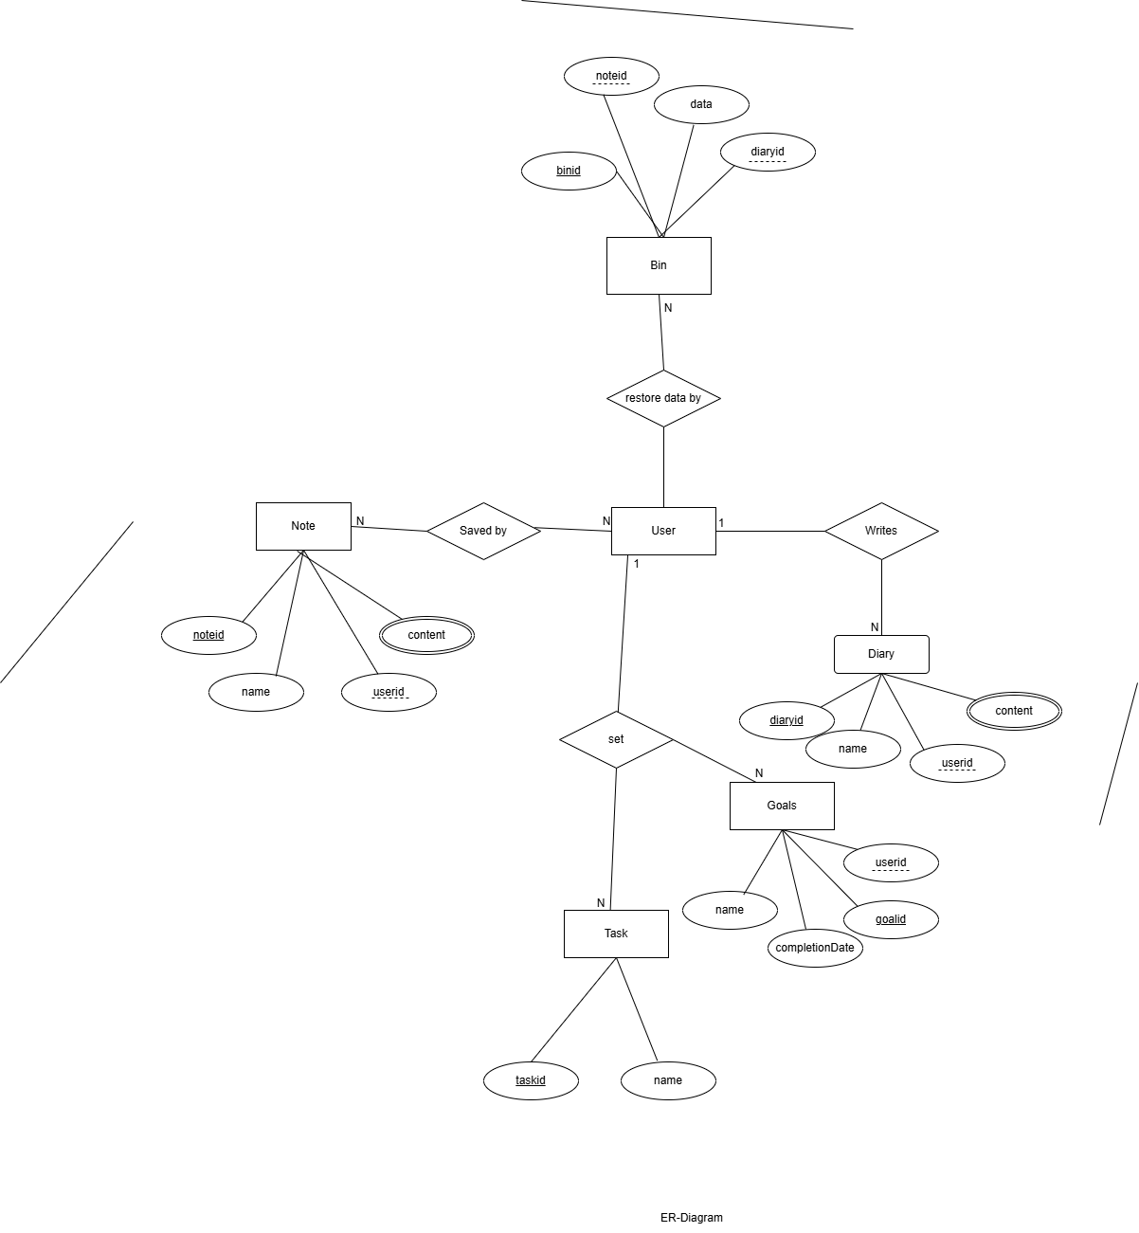

FIGURE 2: ENTITY RELATIONSHIP DIAGRAM

3.2.3 System Sequence Diagram (SSD)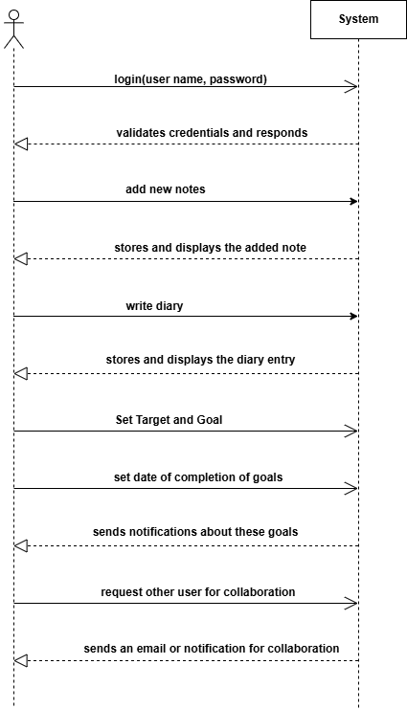
FIGURE 3: SYSTEM SEQUENCE DIAGRAM (SSD)

3.2.4 DESIGN CLASS DIAGRAM
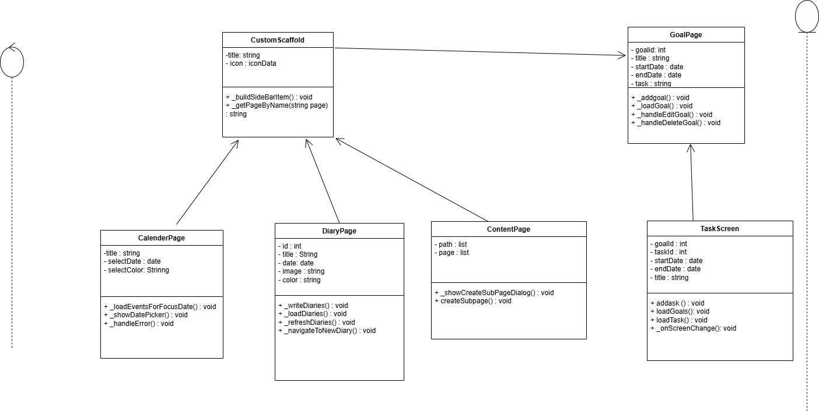
FIGURE 4 : DCD FOR PERSONAL SPACE

3.2.5 INTERACTION DIAGRAM
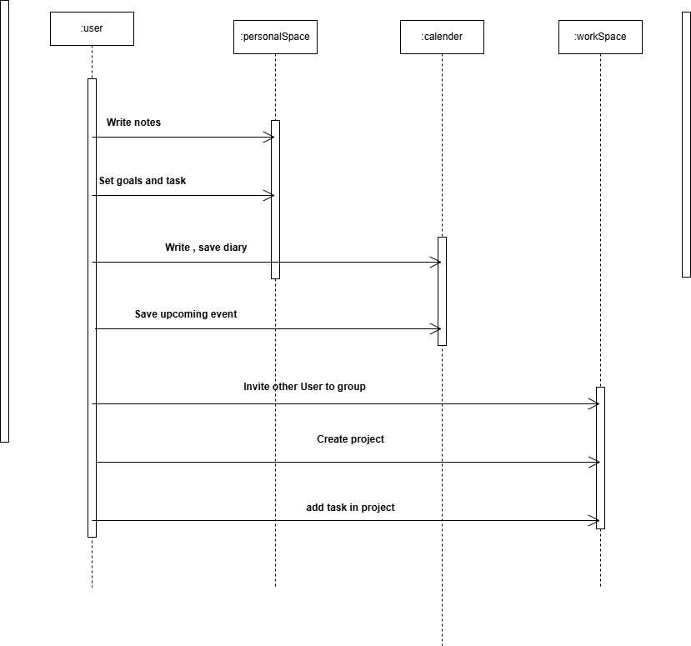
FIGURE 4: INTERACTION DIAGRAM
3.3 APPROACH
For the development of NeoNote, an Agile approach is used to ensure flexibility and continuous improvement throughout the project. This iterative approach allows for frequent updates, quick feedback loops, and the ability to adapt to changing user needs. Each sprint will focus on specific features, such as task management, note-taking, and real-time collaboration, ensuring that the app evolves efficiently while maintaining a user-centric focus. This methodology also supports frequent testing and refinement to guarantee optimal performance and user satisfaction .

CHAPTER 4
Findings, Results and Analysis

4.1 Test Case Report/ Result
Table 2: TEST CASE
S.N | TEST CASE | EXPECTED | OBSERVED | RESULT
1 | Authentication | Enter empty id and password | The id and password is empty. | Pass
2 | Authentication | Enter incorrect password | Password is incorrect. | Pass
3 | Check Invalid Password | Set password less than 8 character | The password is at least 8 characters. | Pass
4 | Authentication | Enter delete id and password of left user | This id does not exist. | Pass
5 | Ensure that users can create a new note successfully. | Create a New Note | The new note is saved and visible in the note list. | Pass
6 | Ensure changes made by one user are reflected instantly for another user. | Collaboration (task Editing) | Users see the changes immediately. | Pass
7 | Verify that users can create, edit, and delete tasks. | Task Management | The task is created, edited, and deleted successfully, with changes reflected in the app. | Pass

4.2 key output
- It provides an interface to take and organize notes.
- It includes a diary feature to record personal thoughts.
- It allows users to collaborate and share notes.
- It helps manage daily tasks and long-term goals.

  - ANALYSIS
Our project NeoNote is a note-taking and productivity application designed to help users manage personal diaries, tasks, goals, and collaborate through shared notes. It includes essential features like real-time note sharing, task tracking, and secure cloud storage. The app has undergone all required testing and produced the expected results. Working on NeoNote helped us gain practical experience in full-stack development, including frontend, backend, API development, and integration. The product is now ready for real-world use. We applied Black Box Testing to validate the application's functionality without accessing internal code. This approach focused on inputs, outputs, and expected behaviors based on user requirements.
Despite its strengths, NeoNote has a few limitations:
- Requires internet access to function.
- Manual support may be needed to maintain collaboration quality.

CHAPTER 5
CONCLUSION AND RECOMMENDATION
5.1 Conclusion
Developing NeoNote gave us valuable experience in building a system that blends functionality, usability, and collaboration. From UI design to backend and API integration, we explored new areas and overcame challenges with the help of online resources and developer communities.
We also recognized the importance of testing and quality assurance, focusing on meeting user requirements through structured testing rather than manual checks. Tools like GitHub, Trello, and Discord played a key role in helping us collaborate effectively.
NeoNote was proposed to enhance personal productivity and note-sharing, and we are confident that we have successfully brought our vision to life as a practical and reliable application.
5.2 RECOMMENDATION
NeoNote has reached the end of its development timeline, and we’ve successfully met our initial goals. However, there is still room for improvement. Based on our experience, we recommend the following enhancements:
- Implement cloud-based data storage and synchronization to ensure user data is automatically backed up, available across devices, and resilient to local failures.
- Create a Favorites section that lets users bookmark and quickly access their most-used notes, tasks, and projects.
- Add Templates functionality, allowing users to choose or create reusable templates for notes

Bibliography
Trello. (n.d.). Trello: Project Management and Collaboration Tool. Retrieved from https://trello.com
Notion. (n.d.). Notion: All-in-One Workspace for Notes, Tasks, and Collaboration. Retrieved from https://www.notion.so
Google Keep. (n.d.). Google Keep: Notes and Lists. Retrieved from https://keep.google.com
ClickUp. (n.d.). ClickUp: Project Management and Productivity Tool. Retrieved from https://www.clickup.com
Draw, Entity Relationship Diagram. Retrieved From Infinite Learnopidia: https://www.youtube.com/@infinitelearnopidia/
Nick, D. (2022). Creating Use case Diagram retrieved from
Youtube: https://www.wrike.com/blog/what-is-a-use-case/

APPENDICES

