**TRIBHUWAN UNIVERSITY**

**Institute of science and technology**

**A Final Year Project Proposal On**

**“ExpressTrack”**

A Courier Management System

**Submitted To:**

**Butwal Multiple Campus**

**Golpark, Butwal, Nepal**

***In partial fulfillment of the requirements For the Bachelors Of Science In***

***Computer Science And Information Technology***

**Submitted By:**

**Bishnu Giri (TU Roll No:27670/077)**

**Kriti Bhattarai (TU Roll No:27686/077)**

July, 2024

# **Table of Contents**

**1.** **Introduction** 1

**2.** **Problem Statement** 2

**3.** **Objectives** 3

**4.** **Methodology** 4

# **Introduction**

The primary objective of any courier agency is to ensure that parcels are delivered accurately and promptly to their intended recipients. Achieving this goal requires meticulous record-keeping of customer details, courier information, billing, payments, and tracking IDs. Handling these tasks manually can be not only time-consuming but also prone to errors. To enhance efficiency, reliability, and accuracy, a computerized courier management system (CMS) is indispensable for contemporary courier services.

A logistics courier management system is an online application designed to automate many processes within the load office. It focuses on managing and implementing the exercises and strategies of a courier agency. This system helps reduce human effort and errors associated with traditional practices by tracking all relevant data and displaying descriptions of couriers and customers. This not only speeds up the delivery process but also increases customer satisfaction by providing the ability for recipients to accept or reject couriers.

A CMS is responsible for scheduling order deliveries, assigning them to couriers, overseeing operations while couriers are in the field, and suggesting strategic improvements for future planning. Depending on the size and complexity of a business, a courier management system may also include aspects of vehicle oversight, fuel management, and courier expense approval.

Overall, a CMS offers a solution to many problems faced by courier agencies, allowing them to mail items to anyone in the world in a timely and efficient manner.

# **2.Problem Statement**

Courier agencies face the challenge of ensuring that packages are delivered accurately and on time to the correct recipients. Managing customer details, package information, billing, payments, and tracking manually is labor-intensive and prone to errors, leading to delays and dissatisfied customers.

Manual processes often result in data entry mistakes, miscommunication, and difficulties in tracking packages. These issues can harm the agency’s reputation and decrease customer loyalty due to delays and lack of transparency.

A computerized courier management system (CMS) addresses these challenges by automating the entire process, from recording customer information to managing billing and tracking packages. This system reduces human error, improves operational efficiency, and enhances service reliability, ultimately leading to higher customer satisfaction and trust.

# **3. Objectives**

This project focuses on **Courier Management**, which handles daily tasks like booking,loading, delivery, status checks, and branch management. Doing these tasks manually can be challenging and prone to mistakes. Therefore, it’s important to use computerized software to make the process easier and more efficient as technology becomes more important in everyday life.

The objectives of Courier Management System are:

1. To improve accuracy by reducing human errors in order processing and delivery management.
2. To enhance customer experience by providing real-time tracking, notifications, and easy access to support.
3. To streamline branch management by integrating and coordinating activities across multiple locations.
4. To facilitate better decision-making with detailed reports and analytics on performance and operations.
5. To increase flexibility in handling different types of deliveries and adjusting to changing demands.
6. To support scalability by accommodating growth and adapting to increased delivery volumes.
7. To ensure data security by protecting sensitive information with robust security measures.

# **4.Methodology**

For our project we have selected Agile Development Model because it provides a flexible and iterative approach to development that aligns well with our needs. Agile emphasizes continuous engagement with stakeholders, allowing us to gather regular feedback and make necessary adjustments throughout the project. This iterative process helps ensure that the system evolves based on real user needs and changes in requirements.

The Agile methodology also promotes collaboration among team members, which is crucial for addressing issues quickly and efficiently. By breaking the project into manageable iterations, we can deliver functional parts of the system incrementally, ensuring that each phase adds value and improves the overall product. This approach minimizes risk and allows for ongoing refinement, which is essential for creating a high-quality, user-centric courier management system like ExpressTrack.

**Fig: Agile Development Model**

## Requirement Identification

1. **Literature Review**

The courier system in Nepal is mostly traditional way of paperwork and done manually. The trend of online businesses is increasing so a reliable digital way of carrying courier is a must in current scenario. There is no proper way of storing data of courier and customers. Most of the literature review was taken from documents on operation of the courier companies and some other policy books policy.[1] As a way of managing its activities manually, Courier services rely on various journals to record its transaction. The registration of personal records, all registered packages in a journal an amount paid. For example, any package that was to be delivered by the department is recorded in the package registration journal. Considering the work involved in recording these transactions; issuing receipts and generating statistical reports was time consuming. The people sometimes forget to record some data due to the pressure from the waiting queue, which may affect the accuracy of the information and the decision to be made.[2]

Due to the growing scope of 2-commerce and demand for on-time delivery, most of the company in Nepal rely on courier delivery providers in order to outsource their delivery products as soon as possible. The delivery companies assist business owner in growing their businesses nationally and internationally.[3] COVID-19 and a 120-day national lockdown (March 24th - July 22nd) plus a second 22-day lockdown in Kathmandu valley (Aug 19th -Sept 10th) caused disruptions to national and international transport systems, affecting the ability of government and humanitarian workers to respond. Online stores are confused about providing service due to lack of clear guidelines from the government regarding ecommerce. They deliver to a very limited number of places, and also only at certain times. This has made life difficult for both sellers and buyers.[4]

As courier service nature is to expand day to day, every courier service solution is a web-based on which is quite easy to access without any installation overheads. Non- web-based solutions are not available because there are not feasible and does not satisfy the purpose of expansion. With a web-based system user or branch operator can be a person who has a basic knowledge of browser and computer. But with in-house software, it will be hard to deal with installations, maintenance any kind of unexpected mees-up.[5]

We have also reviewed www.dhl.com from where DHL is a German logistics company providing courier; package delivery and express mail service, which is a division of the German logistics firm. The company group delivers over 1.6 billion parcels.[6]

1. **Requirement Analysis**

The Courier Management System in Nepal involves analyzing both functional and non-functional requirements to ensure the system meets the needs of its users effectively.

**Functional Requirements**

**User Registration**: Allow customers, couriers, and admins to create accounts.

**Parcel Creation:** Allow customers to create a new parcel entry with details such as sender, recipient, weight and dimensions.

**Parcel Tracking**: Enable customers to track the status and location of their parcels in real-time.

**Delivery Scheduling**: Provide estimated delivery times and allow customers to choose preferred delivery windows.

**Status Notifications**: Send SMS/email notifications to customers about parcel status updates (e.g., picked up, in transit, delivered).

**Payment Gateway Integration**: Integrate with payment gateways to allow customers to pay for shipping fees online.

**Help Desk**: Provide a help desk or support ticket system for customers to raise issues or inquiries.

**Non-Functional Requirements**

**Performance:** The system should havefast response and capable of handling many users.

**Maintainability**: The system should be designed for easy maintenance, allowing for updates and modifications without significant downtime or disruption to users.

**Security**: The system should protect data with encryption, strong authentication, and compliance with privacy regulations.

**Scalability**: The system should easily expand to handle more users and higher loads.

**Usability**: The platform should be user-friendly with an intuitive interface that is easy to navigate for both job seekers and employers.

**Feasibility Study**

A feasibility study is the first step in project design. It involves collecting information to assess whether the project is achievable and worthwhile. It looks at technical, economic, operational, and schedule aspects to determine if the project can be successfully completed and maintained.

**Technical Feasibility**

Technical feasibility refers to the assessment of whether a project or system can be effectively developed and implemented using existing technology and resources. Our project “ExpressTrack” is a technically feasible system as the tools and technology we are using (HTML, CSS, JavaScript, React, Django, MySQL) for the development of the project are easily available online with proper documentation and support.

**Economic Feasibility**

Economic feasibility examines whether a project is financially sound by comparing its costs with the potential benefits. It assesses if the project is practical and profitable. For the "ExpressTrack" project, it is economically viable due to the use of free development tools and software, which helps keep initial costs low. Additionally, the project has the potential for revenue through partnerships with recruiters and educational institutions, which could offer advertising and premium services. This approach helps ensure the project's long-term financial stability and profitability.

**Operational Feasibility**

Operational feasibility evaluates whether a project can be effectively integrated into the current operational environment and whether it will function smoothly after implementation. It involves assessing if the organization has the necessary resources, such as staff, technology, and materials, to support the project. The analysis also examines how well the project will align with existing processes and workflows, and its potential impact on operational efficiency.

**Schedule Feasibility**

Schedule feasibility checks if a project can be finished on time. It looks at whether the project can meet its deadlines, considering how long each task will take, if resources are available when needed, and any risks that might cause delays. The project is planned to be completed within a 12 week of timeframe, utilizing a agile development model. To assess schedule feasibility, project managers use various tools such as Gantt charts, PERT charts, and the Critical Path Method (CPM). For our project, we are using Gantt Chart. Given below is a Gantt Chart describing the schedule for ExpressTrack Project:

|  |  |  |  |  |  |  |  |  |  |  |  |  |
| --- | --- | --- | --- | --- | --- | --- | --- | --- | --- | --- | --- | --- |
| Key Activities | Duration (in weeks) Week starts from July | | | | | | | | | | | |
| **1st** | **2nd** | **3rd** | **4th** | **5th** | **6th** | **7th** | **8th** | **9th** | **10th** | **11th** | **12th** |
| Planning |  |  |  |  |  |  |  |  |  |  |  |  |
| Analysis & Design |  |  |  |  |  |  |  |  |  |  |  |  |
| Coding |  |  |  |  |  |  |  |  |  |  |  |  |
| Testing |  |  |  |  |  |  |  |  |  |  |  |  |
| Documentation |  |  |  |  |  |  |  |  |  |  |  |  |
| Presentation |  |  |  |  |  |  |  |  |  |  |  |  |

**Fig: Gantt chart of Work Schedule**

**High Level Design**

**Class Diagram**

A class diagram is a type of static structure diagram used in software engineering and object-oriented programming to describe the structure of a system by showing its classes, their attributes, methods, and the relationships among objects. It is a key component of the Unified Modeling Language (UML), which provides a standard way to visualize the design of a system.

In terms of ExpressTrack project, a class diagram can be used to model different entities involved in the system, such as login, customer, courier, courierCompany,shipment etc. It can also show how these entities interact with each other and what attributes and operations they have.

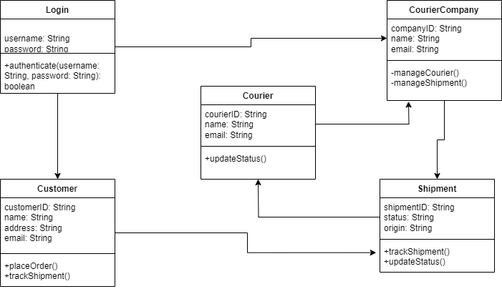

**Fig: Class Diagram for ExpressTrack**

**Activity Diagram**

An activity diagram is a type of UML (Unified Modeling Language) diagram that represents the flow of activities within a system. It illustrates the sequence of activities, decisions, and the flow of control from one activity to another.

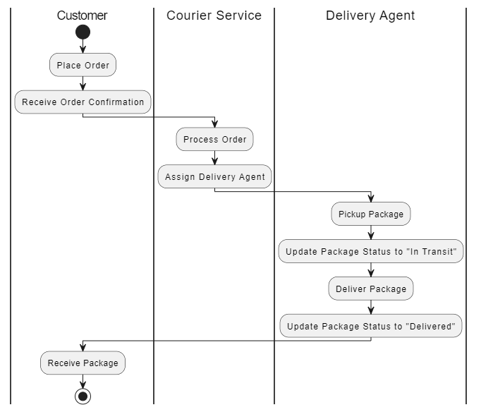

**Fig: Activity Diagram**

**Description Of Algorithms**

**Tools**

**Implementing Tools**

**Front End**

**1 Html**: HTML, or HyperText Markup Language, is the foundational language used to create and structure web pages by employing a set of tags and attributes that define elements such as headings, paragraphs, images, links, and multimedia, thereby enabling web browsers to display content in a formatted and organized manner.

**2 CSS**: CSS, or Cascading Style Sheets, is a stylesheet language used to control the presentation and layout of web pages by applying styles to HTML elements, such as colors, fonts, spacing, and positioning.

**3 JavaScript:** JavaScript is a versatile programming language that enables dynamic and interactive features on websites, allowing for the creation of responsive user interfaces, real-time updates, and complex functionalities in web applications.

**4 ReactJS:** ReactJS is a JavaScript library for building user interfaces, particularly single-page applications, by creating reusable UI components and managing the state of the application efficiently**.**

**Back End**