**Kidney Stone Detection Algorithm in Ultrasound Images Using Segmentation and Morphological Analysis**

**Kriti Gupta1, Pallavi Kaul2, Arashdeep Kaur3**

1,2,3Computer Science Dept., Amity School of Engineering and Technology, Amity University Uttar Pradesh

1. **Introduction**

This work proposes an image processing algorithm to accurately detect the presence of kidney stone in ultrasound images of kidneys. Kidney stone in an ultrasound image can be detected only by a specialist. With the help of proposed algorithm automated methods can be used during the process of detection of kidney stone. With the help of median filter speckle noise present in ultrasonic images may be eliminated from the original image, thus leading to accurate detection of kidney stone. With the combination of fuzzy c-means clustering and dilation/erosion the region where the stone is present is obtained.

1. **Proposed Algorithm**

In this work the input image is the ultrasound image of kidney stone in grayscale. The steps involved in the proposed algorithm are: noise removal which is then followed by detection of RoI (Region of Interest) and application of morphological techniques. The proposed algorithm can be presented by the following flowchart:

Noise Removal

Detection of Region of interest (RoI)

Dilation/Erosion

Figure 1: Block diagram of proposed method

The ultrasound image is considered to be better than MRI and X-Ray images during the detection of renal calculus because MRI and X-ray images emit a lot of radiations that can result in damaging bones of children and long exposure to radiations may result in damage to adults as well. The original ultrasound image of kidney is shown below in Figure 2.



Figure 2: Original Image

Image Pre-Processing: The first step involves noise removal with the help of different filtering techniques such as median filter and contrast intensification of the image. Ultrasonic images of kidneys contain speckle noise. This speckle noise can be removed by using median filter. The adjustment factors depend on gamma transformations with varying values of gamma. The plot of these gamma variations is as follows:

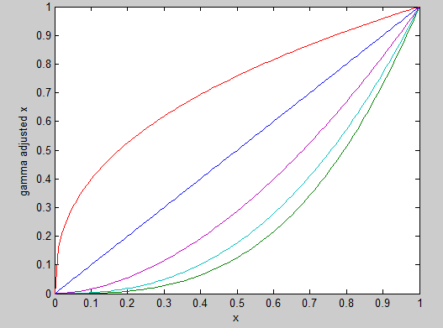

Figure 3: Plot of Intensity Variation

The image after applying median filter with varying adjustment factors is shown in figure 4.



Figure 4: Image After Median Filter and Intensity Adjustment

Segmentation refers to the detection of region of interest (RoI). The region where the stone is present is detected with the help of fcm clustering in this proposed algorithm. The image after applying segmentation method is as follows:



Figure 5: Segmented Image

Morphological analysis involves the dilation/erosion of the segmented image. This step helps in differentiating the ROI from the rest of the image using different pixel values. The final image after applying morphological techniques is given in figure 6.



Figure 6: Final Image

Figure 7 represents the edge of the stone using edge detection method.



Figure 7: Edge Detection of Stone

This algorithm has been applied to several ultrasonic images and the results obtained were of competent accuracy. The resultant image from the proposed algorithm detects the stone accurately in kidneys.

1. **Results and Discussion**

The algorithm was successfully implemented and positive results were obtained as seen in figure 6 and figure 7. On implementing this proposed algorithm, there were some variations in the exact position of the stone which could be rectified by varying the intensity adjustment of each ultrasound image of the stone. Out of 148 images, 137 images were those in which the stone was present. Thus, leading to an accuracy of 92.57%.

Figure 6 depicts the size of the stone in the kidney whereas Figure 7 depicts the shape of the stone. With this result the doctors can look for the appropriate treatment method which can result in the removal of stone from kidneys in an efficient manner.

1. **Conclusion**

The proposed methodology of detecting the presence of renal calculi has been done by pre-processing the ultrasonic image followed by its segmentation and finally performing morphological analysis on the resulting image. The resulting image helped in detecting the exact location of the stone and further the edge detection method was used to determine its shape and structure. The strategic combination of these three methods proved to be an accurate method that can be used in the process of detection of kidney stone. The accuracy of proposed algorithm is 92.5% which is competent enough as compared to previous algorithms done in this work.

1. **Acknowledgment**

We thank Dr. Pankaj Gupta of Gupta Nursing Home (Saharanpur, U.P.) to assist us with the proper knowledge of kidneys and kidney stones and Dr. Deepshikha Khanna of Balaji Diagnostic Center (Saharanpur, U.P.) to provide us with ultrasonic images of kidney stone.