Machine Learning-Based Buyer Segmentation and Investment Profiling for Real Estate Market Intelligence
Project Report | Unified Mentor / Parcl project brief
DATA DISCLAIMER: All numerical results in this report were generated from synthetic practice data, not actual Parcl customer records.

Abstract
This project demonstrates a machine-learning workflow for exploring real-estate buyer profiles using buyer type, geography, acquisition purpose, financing indicator, referral channel, age, and satisfaction. The workflow includes data cleaning, feature engineering, one-hot encoding, numerical scaling, exploratory checks, K-Means clustering, hierarchical clustering, and cluster evaluation with the Elbow Method and Silhouette Score. A Streamlit dashboard provides interactive summaries and filters. The supplied dataset is synthetic and results are for demonstration only.

1. Introduction and Problem Statement
Buyer behaviour can vary by acquisition purpose, geography, financing needs, and service satisfaction. A single marketing approach may not serve all customers equally. The project explores whether unsupervised machine learning can group similar buyer records and make the resulting patterns easier to review through an interactive dashboard.

2. Objectives
- Inspect and clean buyer records, missing values, and duplicate entries.
- Create age from date of birth and prepare categorical and numeric features.
- Use K-Means and hierarchical clustering to explore buyer groupings.
- Evaluate candidate cluster counts using inertia and Silhouette Score.
- Summarize cluster profiles and present key views in a Streamlit dashboard.
- Develop cautious recommendations that can be validated using real business data.

3. Dataset and Data Preparation
The synthetic CSV contained 604 rows before cleaning. Four exact duplicate rows were detected; after deduplication by row and client ID, 600 unique client records remained. The dataset contains fields for client_id, client_type, gender, country, region, date_of_birth, acquisition_purpose, loan_applied, referral_channel, and satisfaction_score. Missing categorical values were imputed with the most frequent value and missing numeric values with the median. The client ID was excluded from model inputs.
After one-hot encoding categorical features and scaling numeric features, the model matrix contained 41 features.

4. Methodology

4.1 Data cleaning and feature engineering
Exact duplicates and duplicate client IDs were removed. Date of birth was parsed and age calculated using 27 October 2026 as the analysis reference date. Invalid ages were treated as missing.

4.2 Encoding and scaling
Categorical features were one-hot encoded; age and satisfaction score were imputed with the median and standardized.

4.3 Cluster selection
K-Means models for k=2 through k=7 were evaluated using inertia and silhouette score. These metrics are decision aids; business interpretability and data quality must also be considered.

4.4 Model comparison
K-Means was compared with agglomerative hierarchical clustering using the same prepared features and selected cluster count.

4.5 Dashboard
The Streamlit app provides filters for country, region, acquisition purpose, and client type, plus buyer distribution, financing, satisfaction, geographic summaries, and segment profiles.

5. Results (Synthetic Practice Data)
The highest silhouette score among the tested K-Means candidates occurred at k=2, with a score of 0.112. The hierarchical clustering silhouette score at the same k was 0.078. Both scores are relatively low, suggesting that the synthetic buyer groups are not strongly separated in the selected feature space. Therefore, the selected k is a reproducible starting point, not proof of naturally distinct market segments.
Cleaning summary: 604 original rows; 4 exact duplicate rows; 600 records after deduplication.
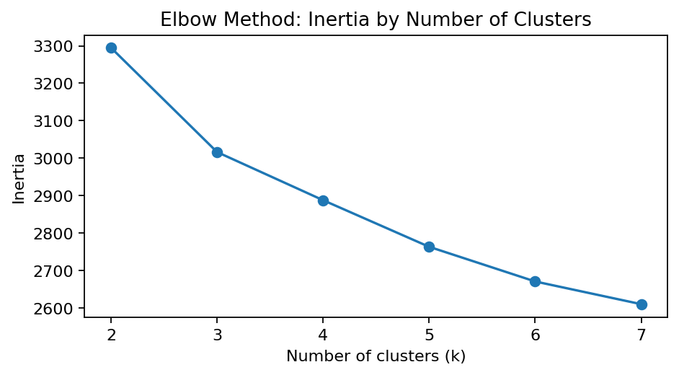
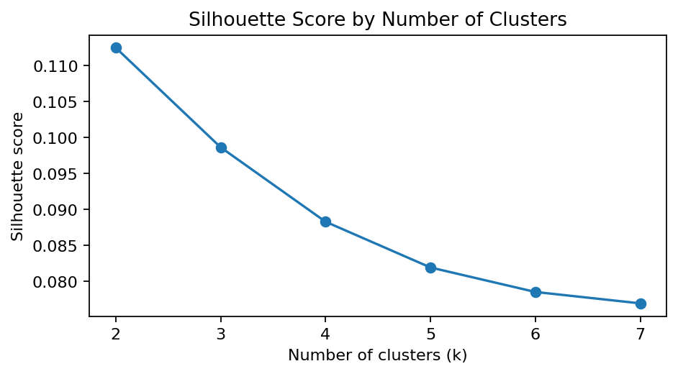

5.1 Cluster profiles
Cluster | Buyers | Median age | Investment share | Loan share | Avg satisfaction
0 | 390 | 40.0 | 53.3% | 49.5% | 4.34/5
1 | 210 | 40.5 | 59.5% | 48.1% | 2.79/5
Cluster IDs are arbitrary. The synthetic run produced two clusters, but the average satisfaction values differ more than some of the demographic and financing measures. This pattern should not be treated as a verified customer insight until it is re-tested on authorized company data.

6. Dashboard Features
- Segmentation overview: buyer counts by acquisition purpose and client type.
- Investor behaviour: loan application share and satisfaction by acquisition purpose.
- Geographic analysis: country and region distribution.
- Segment insights: adjustable K-Means cluster count, cluster profile table, silhouette score, and CSV export.
- User controls: country, region, acquisition purpose, and client-type filters.

7. Business Recommendations
- Use cluster profiles to tailor relevant property information and communication, rather than assuming all buyers share the same needs.
- If financing patterns differ in real data, make financing information and eligibility guidance easy to access.
- Review referral channels and satisfaction by segment before changing marketing budgets.
- Investigate lower satisfaction scores to identify service friction; do not infer the cause from clustering alone.
- Validate any campaign or service recommendations with controlled tests and measurable business outcomes.

8. Limitations and Ethical Considerations
The data are synthetic and do not represent actual Parcl customers or company performance. Available features do not include property prices, income, budgets, transaction values, or realized returns. Clustering is exploratory and does not establish causation. Demographic attributes should be handled responsibly and must not be used to justify unfair or discriminatory treatment. Final results must be recalculated on authorized, representative data before submission.

9. Conclusion
The project starter demonstrates a complete analytical workflow from data cleaning through clustering and dashboarding. On the synthetic dataset, the tested clustering solutions show limited separation, so segment labels should be interpreted cautiously. The final business conclusions should be updated after running the same workflow on the actual dataset supplied or approved by the organization.

Appendix: Files and Reproducibility
Included files: notebook, synthetic CSV, Streamlit app, requirements.txt, cleaned segment output, cluster profile, cluster evaluation table, and README. Run the notebook from top to bottom, then launch the dashboard with 'streamlit run app.py' after installing requirements.

