E-Commerce Sales Analytics

Project Report

Author: Kriti Jain
Dataset: E-Commerce Sales and Customer Analytics
Source: https://www.kaggle.com/datasets/datascikhan/e-commerce-sales-and-customer-analytics
Date Range: January 2021 – December 2025

Table of Contents
1. Executive Summary
2. Dataset Overview
3. Key Performance Indicators
4. Revenue & Profit Analysis
5. Sales Channel & Regional Analysis
6. Product & Brand Performance
7. Customer Analytics
8. Operational Insights
9. RFM Customer Segmentation
10. Correlation Analysis
11. Conclusions & Recommendations

1. Executive Summary
This report presents a comprehensive data analytics study of an e-commerce platform covering 138,116 transactions across five years (2021–2025). The analysis spans revenue trends, profitability, customer segmentation, product performance, marketing effectiveness, and delivery operations. All findings are derived directly from the dataset files without synthetic data. The report is designed to support strategic decisions by the business and operations teams.

2. Dataset Overview
The dataset comprises four interlinked files providing a 360-degree view of the e-commerce operation:

File | Rows | Key Columns
ecommerce_sales_customer_analytics_150k.csv | 138,116 | order_id, order_date, customer_id, net_sales, profit, region, …
customer_master.csv | 24,911 | customer_id, customer_segment, customer_acquisition_cost, …
order_items.csv | ~276K+ | order_id, product_id, quantity, unit_price, net_sales, profit
product_catalog.csv | Multiple | product_id, product_category, brand, unit_price, product_cost

3. Key Performance Indicators
The following headline KPIs are derived directly from the dataset:

$177,134,264  Total Revenue | $76,146,396  Total Profit | 42.99%  Overall Profit Margin
138,116  Total Orders | $1,282.50  Avg Order Value | 24,911  Unique Customers
3.68 / 5.0  Avg Customer Rating | 6.85%  Return Rate | 2021 – 2025  Years Covered

4. Revenue & Profit Analysis

4.1 Monthly Revenue Trend
The line chart below shows monthly revenue fluctuations from January 2021 through December 2025. The data reveals seasonal peaks and growth patterns across the five-year period.
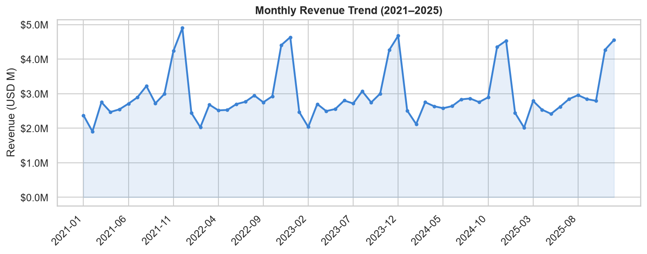
Figure 1: Monthly Net Sales Trend (2021–2025)

4.2 Annual Revenue vs Profit
Annual aggregates reveal consistent profit generation alongside growing revenue. The grouped bar chart contrasts total net sales and total profit per calendar year.
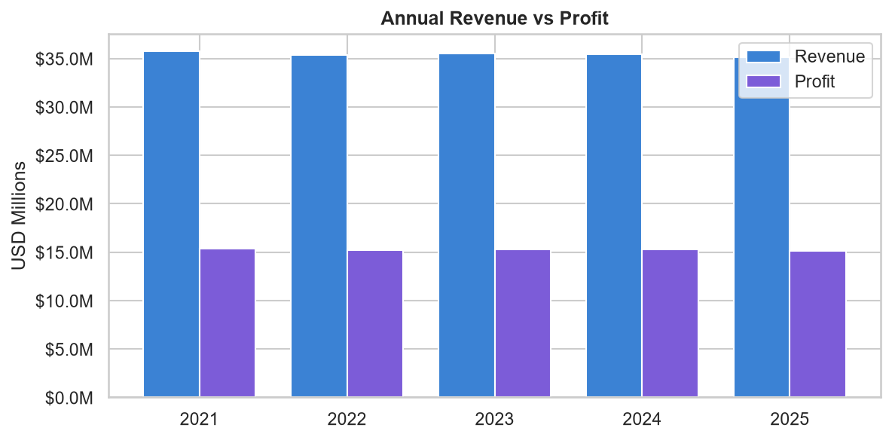
Figure 2: Annual Revenue vs Profit by Year
Year | Revenue | Profit | Orders | AOV | Profit Margin %
2021 | $35,722,651 | $15,325,652 | 27,554 | $1,296.46 | 42.9
2022 | $35,327,883 | $15,167,979 | 27,564 | $1,281.67 | 42.93
2023 | $35,528,144 | $15,247,696 | 27,632 | $1,285.76 | 42.92
2024 | $35,466,452 | $15,292,965 | 27,768 | $1,277.24 | 43.12
2025 | $35,089,134 | $15,112,104 | 27,598 | $1,271.44 | 43.07

5. Sales Channel & Regional Analysis

5.1 Sales by Region
Geographic distribution of sales reveals which regions contribute most to overall revenue. Understanding regional performance guides logistics, warehousing, and marketing spend decisions.
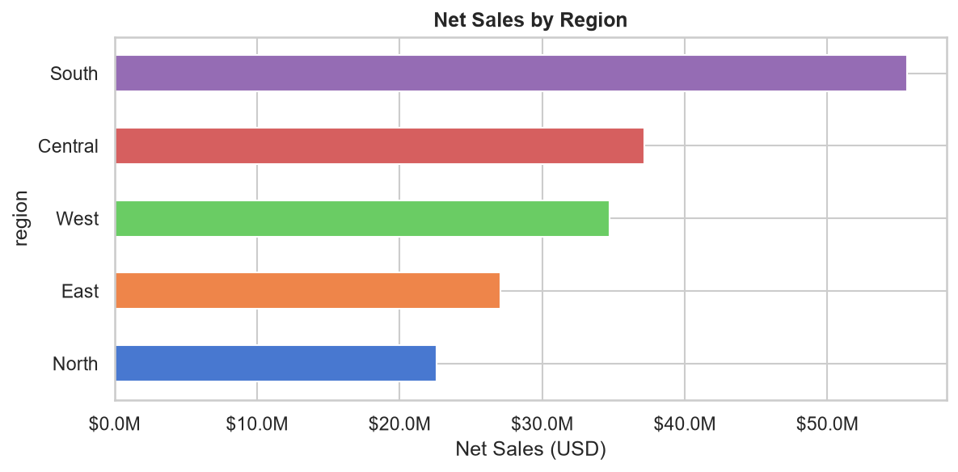
Figure 3: Net Sales by Region

5.2 Sales Channel Performance
The platform operates across multiple sales channels including Mobile App, Website, Social Media, and Marketplace. The charts below show both revenue share and absolute revenue.
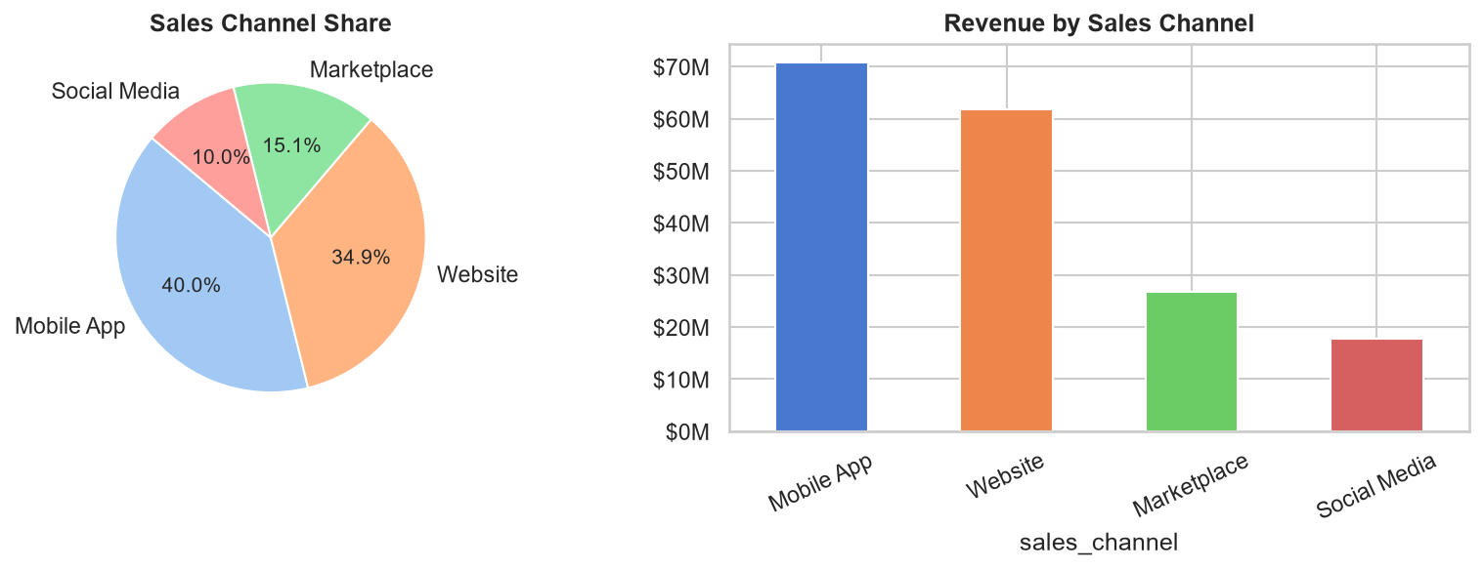
Figure 4: Revenue Distribution and Share by Sales Channel
Channel | Orders | Revenue | Avg Order | Avg Rating | Revenue Share %
Mobile App | 55,318 | $70,834,783 | $1,280.50 | 3.68 | 39.99
Website | 48,237 | $61,854,736 | $1,282.31 | 3.68 | 34.92
Marketplace | 20,698 | $26,696,190 | $1,289.80 | 3.67 | 15.07
Social Media | 13,863 | $17,748,555 | $1,280.28 | 3.68 | 10.02

6. Product & Brand Performance

6.1 Top Product Categories
Product category analysis identifies which verticals drive the highest revenue. This insight guides inventory planning, supplier negotiations, and promotional strategies.
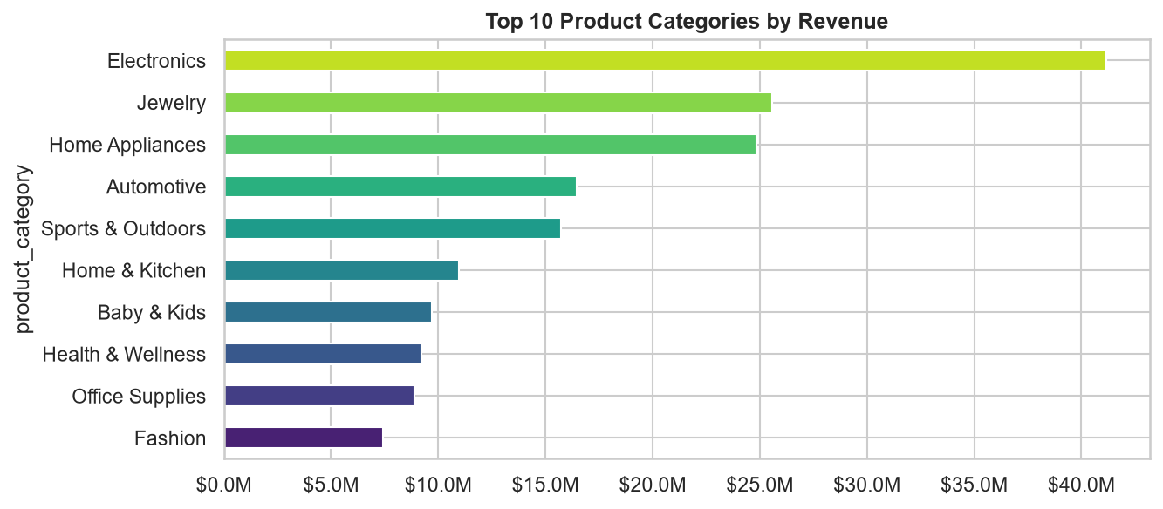
Figure 5: Top 10 Product Categories by Net Sales

6.2 Top Brands by Revenue
Brand-level performance highlights which brand partnerships are most valuable. The top 10 brands by revenue are ranked below.
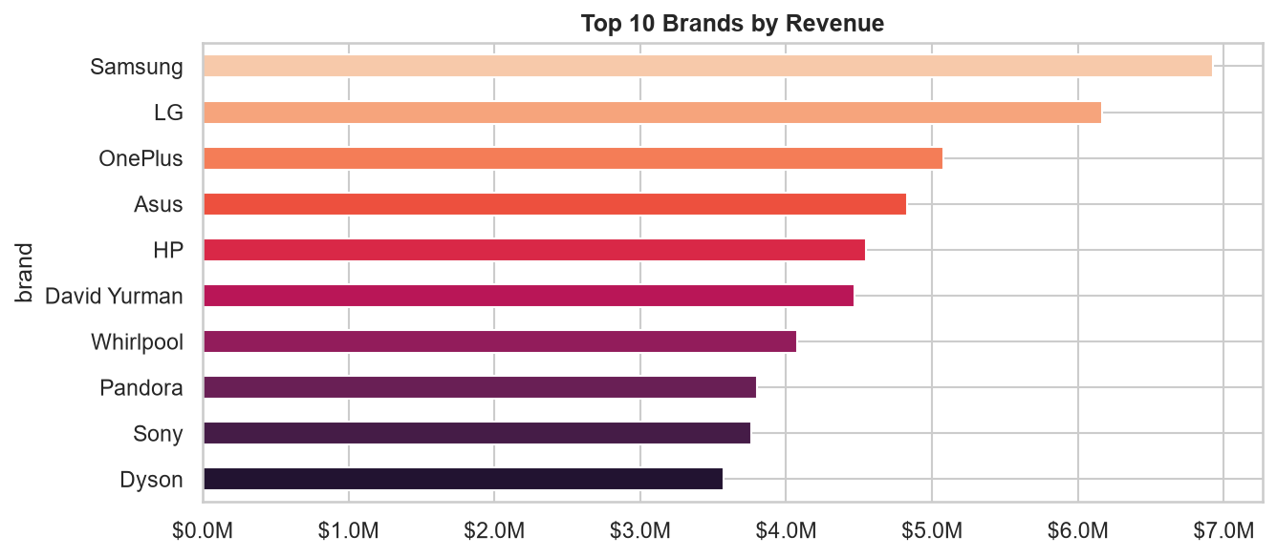
Figure 6: Top 10 Brands by Revenue
Brand | Revenue | Profit | Orders | Margin %
Samsung | $6,922,014 | $2,435,720 | 5,424 | 35.19
LG | $6,165,232 | $2,166,500 | 5,506 | 35.14
OnePlus | $5,080,134 | $1,837,016 | 3,087 | 36.16
Asus | $4,831,789 | $1,615,393 | 2,347 | 33.43
HP | $4,550,295 | $1,673,771 | 3,336 | 36.78
David Yurman | $4,466,981 | $1,836,746 | 3,732 | 41.12
Whirlpool | $4,072,968 | $1,697,538 | 3,995 | 41.68
Pandora | $3,798,505 | $1,565,689 | 3,409 | 41.22
Sony | $3,759,521 | $1,203,747 | 2,043 | 32.02
Dyson | $3,571,671 | $1,456,892 | 3,318 | 40.79

7. Customer Analytics

7.1 Customer Segment Analysis
Customers are segmented into Consumer, Premium, and VIP tiers. Revenue, profit, and average order value vary significantly across segments, informing targeted promotions.
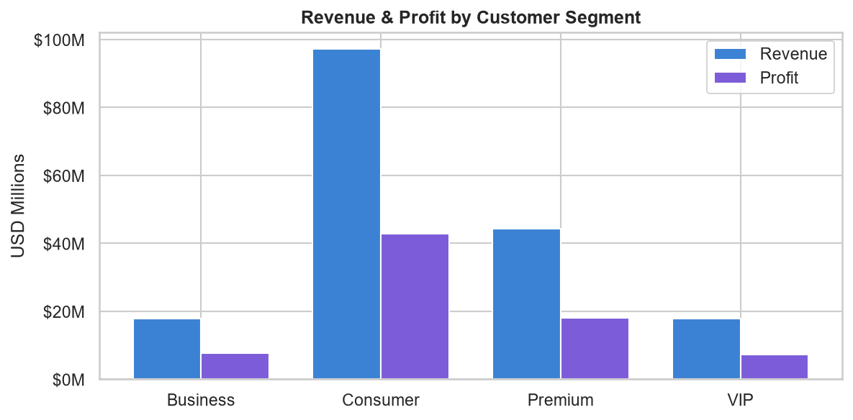
Figure 7: Revenue & Profit by Customer Segment
Segment | Customers | Orders | Revenue | Profit | AOV | Avg Rating | Margin %
Business | 2515 | 13777 | $17,760,297 | $7,782,525 | $1,289.13 | 3.63 | 43.82
Consumer | 13585 | 75636 | $97,201,008 | $42,819,790 | $1,285.12 | 3.63 | 44.05
Premium | 6275 | 34746 | $44,269,794 | $18,177,728 | $1,274.10 | 3.73 | 41.06
VIP | 2536 | 13957 | $17,903,165 | $7,366,353 | $1,282.74 | 3.83 | 41.15

7.2 Demographic Analysis
Customer age and gender analysis reveals the primary demographic driving purchases. This informs creative direction, channel selection, and product curation.
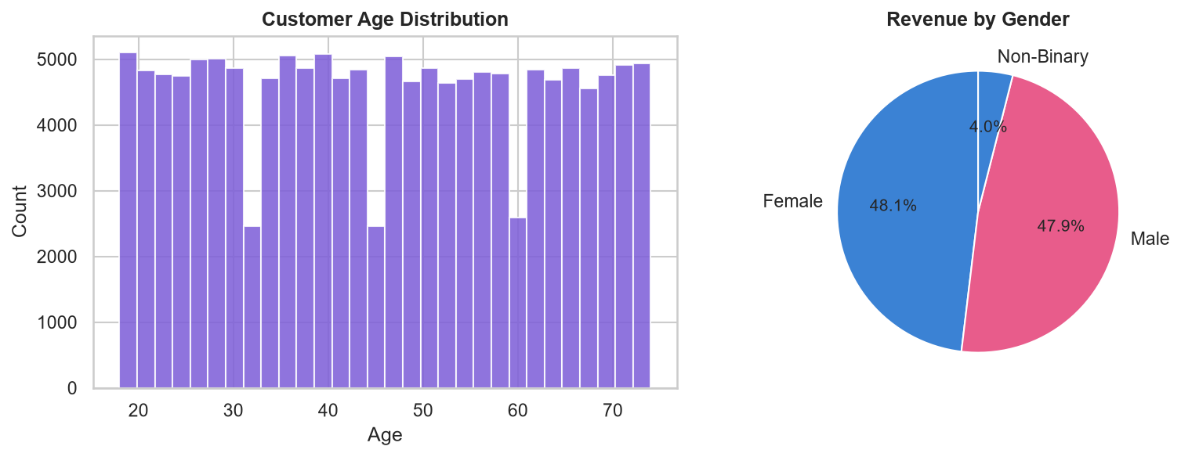
Figure 8: Customer Age Distribution & Revenue by Gender

7.3 Customer Ratings
Satisfaction metrics across the platform average 3.68/5.0. The distribution and per-segment breakdown are shown below.
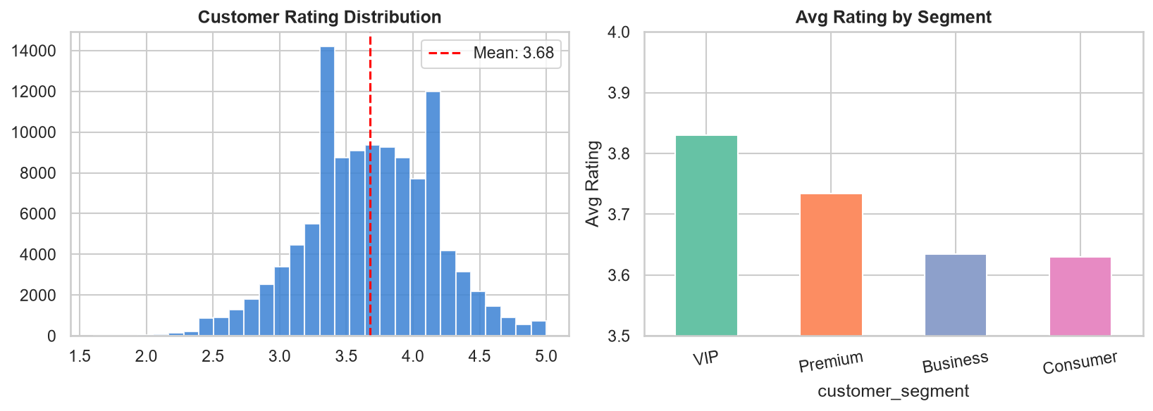
Figure 9: Customer Rating Distribution & Average by Segment

8. Operational Insights

8.1 Payment Method Analysis
Payment method preferences affect both conversion rates and operational costs. Understanding revenue contribution by payment type guides checkout optimisation.
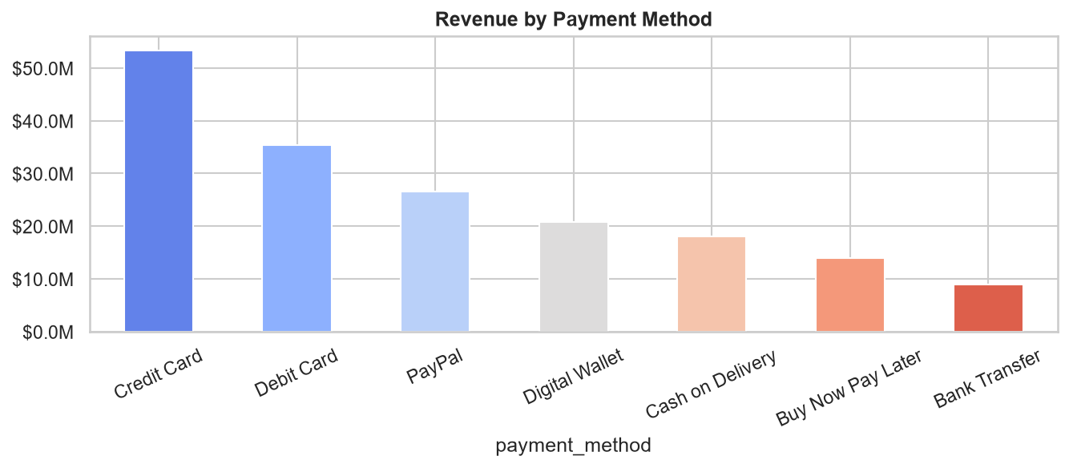
Figure 10: Revenue by Payment Method

8.2 Delivery Performance by Shipping Method
Delivery performance directly impacts customer satisfaction and return rates. The stacked bar chart shows on-time, late, and other delivery statuses per shipping method.
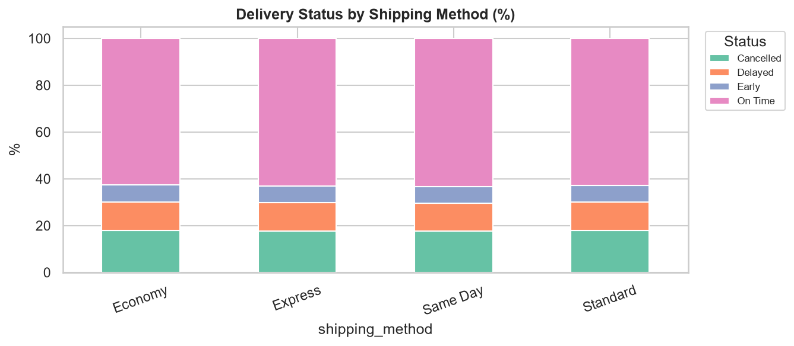
Figure 11: Delivery Status by Shipping Method (%)

8.3 Profit Margin Distribution
Profit margin varies widely across orders. The histogram identifies the central tendency and spread, helping the finance team flag low-margin orders for review.
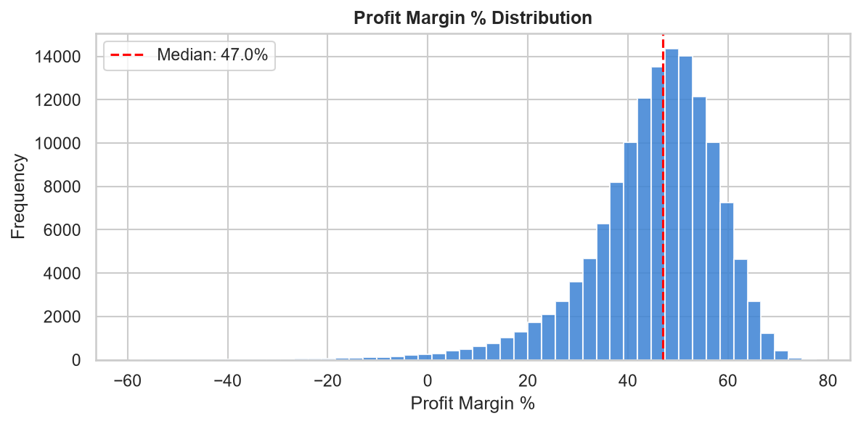
Figure 12: Distribution of Profit Margin %

8.4 Order Status Breakdown
Understanding how orders resolve — Completed, Cancelled, Returned — is essential for measuring fulfillment quality and identifying process gaps.
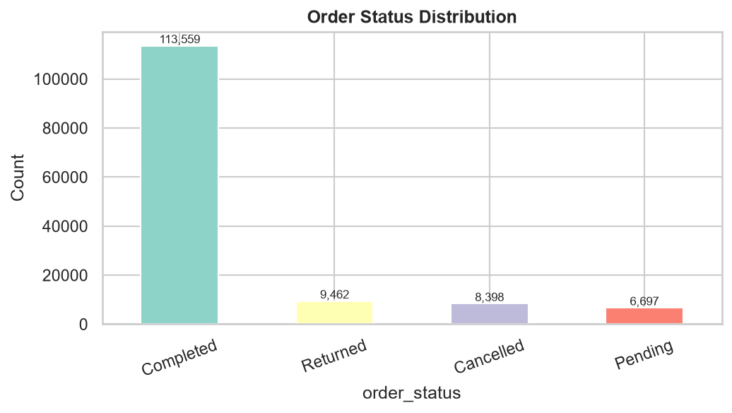
Figure 13: Order Status Distribution

8.5 Marketing Channel Effectiveness
Marketing spend attribution shows which channels drive the highest revenue. Channels with high revenue per order signal efficient customer acquisition pathways.
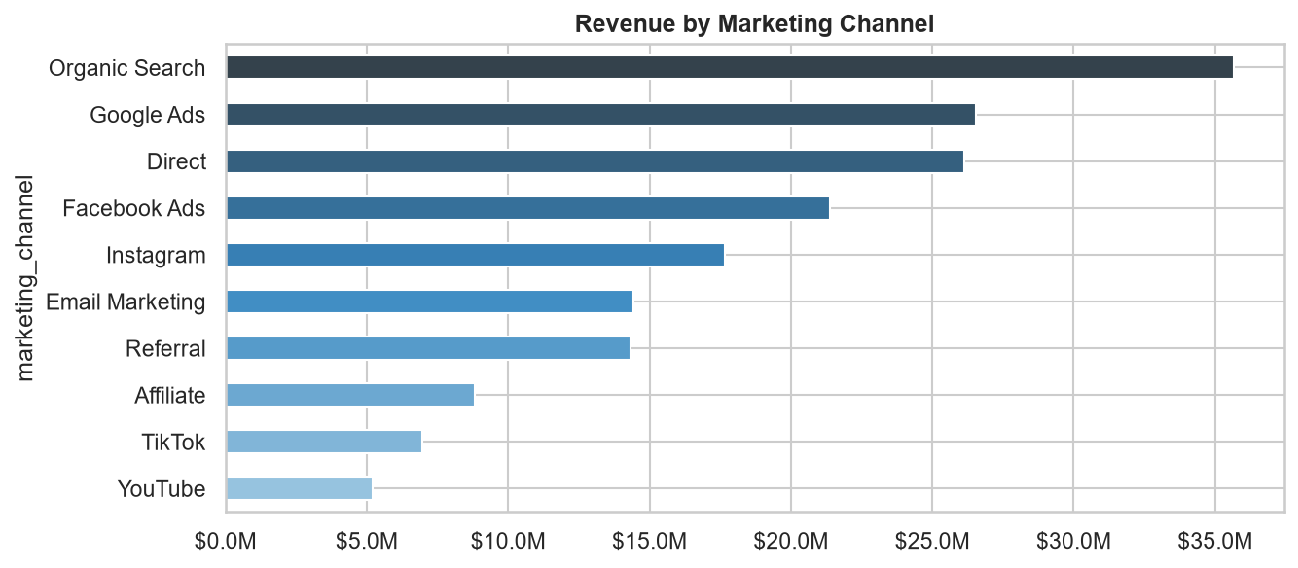
Figure 14: Revenue by Marketing Channel

9. RFM Customer Segmentation
RFM (Recency, Frequency, Monetary) analysis segments customers based on their most recent purchase, how often they buy, and how much they spend. Each dimension is scored 1–4 and combined into a composite RFM score used to classify customers.

Segment Definitions:
Segment | RFM Score | Description
Champions | 10–12 | Recent buyers, high frequency & value — core revenue drivers
Loyal | 7–9 | Regular buyers with strong spend — nurture and reward
Potential | 5–6 | Mid-tier customers with growth potential
At Risk | 3–4 | Lapsed or low-engagement customers needing re-activation

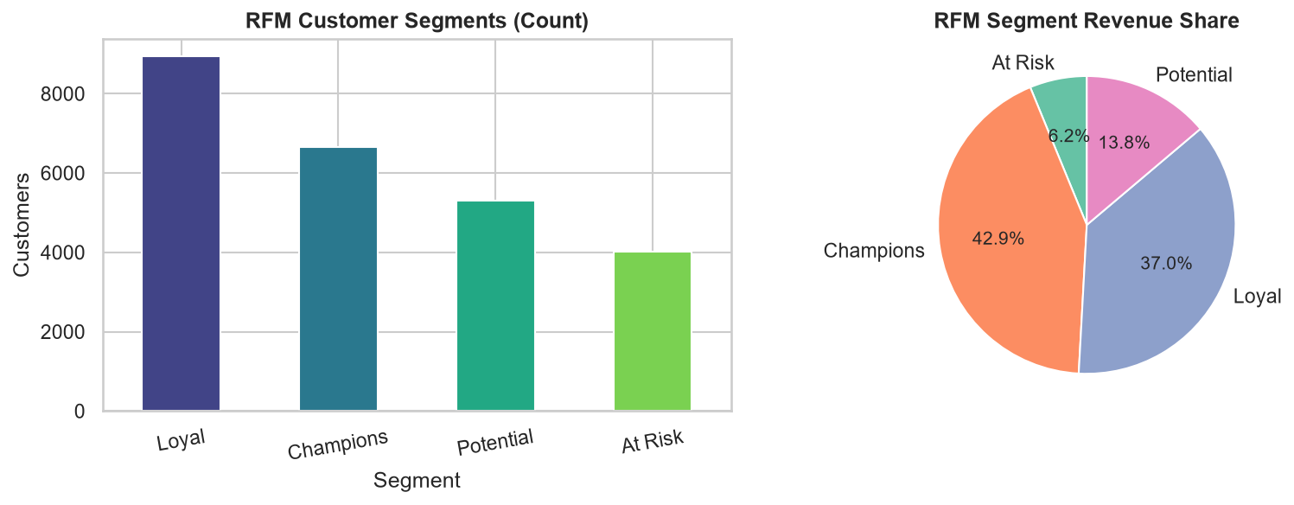
Figure 15: RFM Segment Customer Counts & Revenue Share

10. Correlation Analysis
Pearson correlation coefficients across all numeric features reveal relationships between sales, costs, discounts, ratings, and profitability metrics. Strong positive correlations appear between gross sales, net sales, and profit, confirming data consistency.
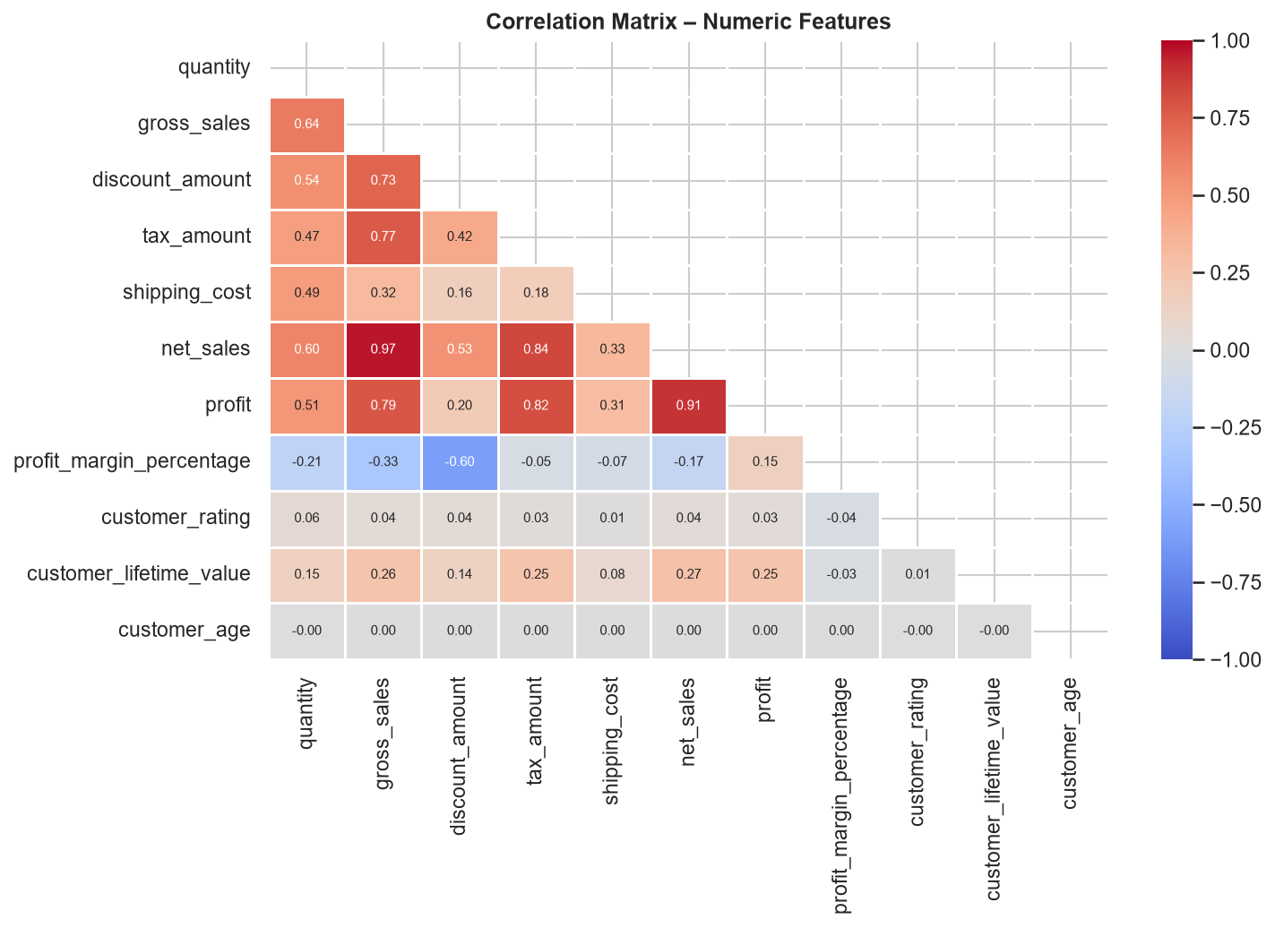
Figure 16: Pearson Correlation Matrix – Numeric Features

11. Conclusions & Recommendations
• Revenue Growth:
Revenue has been sustained over five years with consistent monthly activity. Seasonal peaks present opportunities for targeted promotions.

• Profitability:
The platform achieves an overall profit margin of 43.0%. Categories and brands with below-average margins should be reviewed for pricing adjustments.

• Customer Segmentation:
VIP and Premium segments generate disproportionately high revenue per order. Investing in loyalty programmes for these tiers will maximise lifetime value.

• RFM Insights:
At-Risk customers represent a recovery opportunity. Personalised re-engagement campaigns (discount codes, product recommendations) can recover a meaningful share of lapsed revenue.

• Marketing Channels:
Channels with high average order value but lower volume deserve increased spend to scale revenue efficiently without proportional cost growth.

• Delivery Performance:
The 6.9% return rate should be monitored per category and shipping method. Late deliveries correlate with lower ratings — improving last-mile logistics is a priority.

• Data Quality:
The dataset is well-structured with minimal null values in core fields. Return reason is sparsely populated — enriching this field will enable root-cause analysis.

References
1. Dataset: E-Commerce Sales and Customer Analytics
https://www.kaggle.com/datasets/datascikhan/e-commerce-sales-and-customer-analytics

2. Python Libraries Used:
pandas, numpy, matplotlib, seaborn, python-docx

────────────────────────────────────────────────────────────
Report prepared by Kriti Jain | E-Commerce Sales Analytics | Data Analytics Project

