MediAssist AI
Intelligent Healthcare Guidance Chatbot
Comprehensive Project Documentation Report
Prepared for local-first development, testing, and deployment using only free/open-source tools.
Generated on: 14 May 2026, 01:30 PM
Medical Disclaimer: This chatbot is not a licensed medical professional. Consult a doctor for emergencies or accurate diagnosis.

Executive Summary
MediAssist AI is a local-first healthcare guidance chatbot built with free and open-source tools. The system is designed to help users describe symptoms in natural language, receive general healthcare guidance, review uploaded health reports, explore non-prescription supportive medicine suggestions, and find nearby hospitals, doctors, and pharmacies. The project combines a modern React frontend with a Python FastAPI backend and a Retrieval-Augmented Generation (RAG) pipeline powered by FAISS, Sentence Transformers, and an Groq API-hosted local language model.
The main aim of the project is to create a healthcare support assistant that remains lightweight enough to run on a normal laptop, while still demonstrating modern AI architecture, safe design practices, real-world usability, and a beginner-friendly codebase.

Project Goals
- Accept symptom descriptions in natural language.
- Retrieve relevant healthcare context using RAG before answering.
- Explain possible conditions in simple language.
- Provide safe general OTC/common-support suggestions only.
- Detect emergency warning patterns such as chest pain or breathing difficulty.
- Allow PDF upload for report summarization.
- Use OpenStreetMap-powered nearby healthcare search.
- Provide a premium-looking user interface suitable for a modern healthcare product demo.
- Use only free and open-source tooling.

Problem Statement
Healthcare information is often fragmented across generic search engines, static informational websites, hospital directories, and clinical PDF reports. Many users need a single interface where they can ask symptom-based questions, review a health document, and decide whether they need nearby medical care. A plain conversational chatbot without retrieval may hallucinate or respond too generically. Therefore, this project uses Retrieval-Augmented Generation to ground answers in a healthcare knowledge base before generating a response.

What the System Does
- Symptom checker: Users can type messages like 'I have fever, headache, and sore throat'.
- Possible condition hints: The assistant identifies likely conditions from retrieved context.
- Severity labeling: Responses are categorized as Mild, Moderate, or Serious.
- Precautions and self-care advice: The assistant suggests hydration, rest, monitoring, and similar general precautions.
- OTC support guidance: Only general non-dangerous, label-based medicine suggestions are allowed.
- Emergency escalation: The assistant explicitly warns users to seek immediate medical attention when severe symptoms are detected.
- PDF summarization: Users can upload a health-related PDF and get a text summary.
- Nearby doctor/hospital finder: Uses geolocation and OpenStreetMap/Overpass API to list nearby facilities.
- Persistent settings and history: The system stores chat history and model settings locally.

Why Use LLMs in This Project
Large Language Models (LLMs) are useful in this project because healthcare users typically describe their symptoms in natural, conversational language rather than structured forms. A traditional rule-based system can recognize a fixed symptom list, but it struggles with free-form input, paraphrased descriptions, incomplete context, or follow-up questions. An LLM can interpret natural language, maintain conversational continuity, synthesize retrieved medical context, and return a readable explanation.
However, LLMs alone are not enough for trustworthy healthcare guidance. A pure model-only chatbot may produce unsupported or hallucinated answers. That is why this system does not rely on a general LLM alone; it combines a local LLM with a RAG retrieval layer and rule-based medical guardrails.

Why Use a Local Open-Source LLM
- Cost control: Running a local open-source model avoids paid API usage.
- Offline/local-first capability: The assistant can function locally without depending on proprietary cloud inference.
- Privacy improvement: Sensitive symptom descriptions can remain on the user’s machine or local network environment.
- Educational value: The project demonstrates how modern LLM systems can be built end-to-end with open tools.
- Customization: Local models can be swapped or tuned later.
- Compliance with the project requirement: The user explicitly requested only free/open-source tools.
The default intended model path is Groq API with a lightweight model such as TinyLlama.

Why Retrieval-Augmented Generation (RAG) Was Chosen
RAG is used to improve answer grounding. Instead of asking the model to answer purely from memorized parameters, the system first retrieves the most relevant healthcare text chunks from a local knowledge base. Those chunks are then passed to the LLM along with the user query. This produces more context-aware and evidence-backed answers.
- Improves reliability compared to model-only answering.
- Allows domain customization using healthcare-specific text sources.
- Makes it easier to update the knowledge base without retraining the model.
- Supports source citation in the UI.
- Works well because embeddings + FAISS are relatively lightweight for a small knowledge base.

Core Architecture
Layer | Technology | Purpose
Frontend | React + Vite + Tailwind CSS + Framer Motion | User interface, animations, chat, upload, nearby care, settings
Backend | FastAPI | REST API endpoints and application orchestration
RAG Retrieval | LangChain + FAISS | Document chunking, embeddings, similarity search
Embeddings | Sentence Transformers / all-MiniLM-L6-v2 | Vector representation of text chunks
Local LLM | Ollama + TinyLlama/Phi/Gemma/FLAN-T5 path | Conversational answer generation
PDF Handling | PyPDF | Extract text from uploaded health reports
Nearby Search | OpenStreetMap Overpass API | Locate nearby hospitals, clinics, doctors, pharmacies
Persistence | JSON files | Chat history and settings storage

Backend Design

Module/File | Responsibility
app/main.py | FastAPI app setup and route registration
app/models.py | Pydantic request/response schemas
app/config.py | Default settings, file paths, runtime initialization
app/services/chat_service.py | Chat orchestration, prompt building, history, safe fallback
app/services/rag_service.py | Load knowledge data, split chunks, embed text, FAISS retrieval
app/services/location_service.py | Nearby healthcare search using Overpass API
app/services/report_service.py | PDF text extraction and report summarization
app/utils/medical_guardrails.py | Emergency keyword detection, severity inference, safe OTC suggestions
app/utils/storage.py | Local JSON read/write helpers

Generative AI & RAG Pipeline Architecture
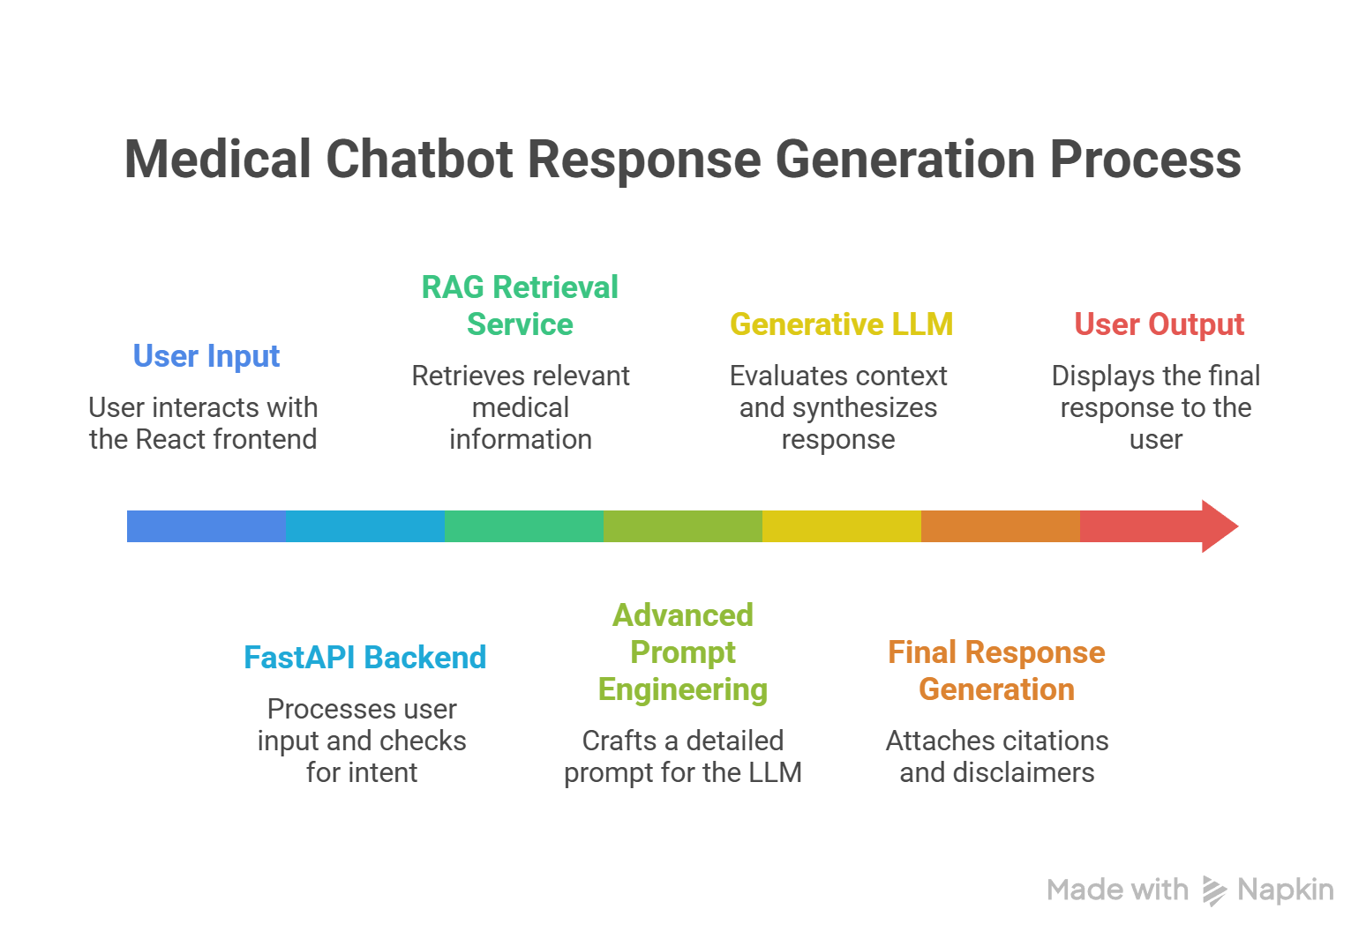
Workflow:
- Healthcare documents are loaded from CSV and optional text files.
- The content is split into chunks using RecursiveCharacterTextSplitter.
- Each chunk is converted into embeddings using all-MiniLM-L6-v2.
- Embeddings are stored in a FAISS vector index.
- When the user asks a question, the system performs similarity search over the indexed chunks.
- Top-k relevant chunks are selected as context.
- Advanced Prompt Engineering: The system dynamically constructs a rich context prompt injecting retrieved medical documents, conversational memory (history), and safety guardrails. This ensures the Generative AI model remains context-aware and hallucination-free.
- Generative LLM Inference: The Groq API executes state-of-the-art open-source LLMs (like Llama 3.1 8B or 70B) to perform natural language generation (NLG), synthesizing complex medical context into highly conversational, human-like responses.
- If the model is unavailable, a deterministic fallback answer is returned using rule-based safety logic.

Medical Safety Design
Healthcare applications must be especially careful about safety, scope, and overconfidence. This system explicitly avoids positioning itself as a diagnostic authority and instead acts as a guidance assistant.
- Mandatory disclaimer is included in responses and health endpoint text.
- Emergency keywords such as chest pain, breathing difficulty, stroke signs, seizures, or fainting trigger urgent warnings.
- Only general OTC/common-support suggestions are allowed.
- No dangerous prescriptions, opioids, antibiotics, or steroid recommendations are provided.
- Users are encouraged to consult a doctor for severe, worsening, or unclear symptoms.
- The report summarization feature avoids pretending to interpret clinical values as a doctor.

13. Datasets and Knowledge Sources
The system is structured to support real public healthcare sources. Because the user requested a storage-efficient local build, the current repository includes a compact sample healthcare dataset. The architecture is intentionally prepared so larger real datasets can be added later when storage allows.

API Endpoints
Source | Role in Project | Status in Current Build
OpenStreetMap / Overpass | Nearby care discovery | Actively used
Local healthcare_knowledge.csv | Small sample retrieval knowledge base | Actively used

Why the System Uses FastAPI
- FastAPI is free and open-source.
- It provides automatic request validation through Pydantic models.
- It is beginner-friendly yet production-capable.
- It offers fast development speed for AI APIs.
- Interactive API docs are available through Swagger/OpenAPI support.

Why FAISS and Sentence Transformers Were Chosen
FAISS is a highly popular open-source similarity search library that is efficient for vector retrieval tasks. Sentence Transformers provides high-quality text embeddings with small and practical models such as all-MiniLM-L6-v2, which is well suited to low-storage and local-laptop constraints.
- Small embedding model footprint compared to many alternatives.
- Good semantic retrieval quality for short healthcare text chunks.
- Fast enough for local development and experimentation.
- Straightforward integration with LangChain.

Why Groq Was Chosen
Groq was chosen to power the LLM inference because it offers unparalleled speed using Language Processing Units (LPUs). This allows the application to run state-of-the-art open-source models (like Llama 3.1 70B) instantly without requiring expensive local hardware or GPUs.
- Blazing fast inference speeds for real-time chat.
- Access to the latest open-source models (Llama 3.1, Mixtral, Gemma 2).
- Integrates seamlessly with LangChain via langchain-groq.
- No local hardware limitations, enabling access to 70B+ parameter models.

Current Limitations
- The current repository uses a compact sample healthcare knowledge base rather than full MedQuAD ingestion.
- Clinical report analysis is text-summary based and does not perform specialist-grade lab interpretation.
- Nearby search quality depends on OpenStreetMap data coverage.
- If the Groq API key is missing or fails, the backend catches the error and gracefully informs the user.
- The current setup does not include user authentication or encrypted long-term health record storage.
- This assistant is not a substitute for professional diagnosis.

Testing and Verification Performed
- Frontend dependency installation and production build validation with Vite.
- Backend dependency installation and Python compile validation.
- Health endpoint verification on the FastAPI backend.
- Settings and history endpoint verification.
- Nearby healthcare search testing path enabled through the frontend and API.
- UI iteration and multiple layout corrections on the landing page and chat workspace.

Future Enhancements
- Add a real ingestion script for MedQuAD and disease-symptom datasets.
- Support structured CSV/PDF ingestion pipelines from more healthcare documents.
- Migrate to newer LangChain provider packages such as langchain-ollama and langchain-huggingface.
- Add authentication and role-based access for clinician or patient modes.
- Improve PDF lab result extraction and abnormal-value highlighting.
- Add maps and specialist filtering in nearby search.
- Add multilingual support for wider accessibility.
- Add unit tests and integration tests for chat, upload, and retrieval flows.

Conclusion
MediAssist AI demonstrates how a meaningful healthcare guidance assistant can be built using only free/open-source tools. Its value comes from combining a high-speed open-source LLM via Groq with retrieval, structured safeguards, practical document handling, and real-world nearby-care lookup. The project is intentionally designed to be understandable, extendable, and feasible for student or portfolio use while still reflecting modern AI application architecture.
In summary, this project is a sophisticated Generative AI application. It demonstrates the powerful synergy of Large Language Models (LLMs), semantic embeddings, and Retrieval-Augmented Generation (RAG) to solve real-world problems in the healthcare domain, proving that advanced GenAI capabilities can be harnessed safely and effectively.

