CHASE

CHASE

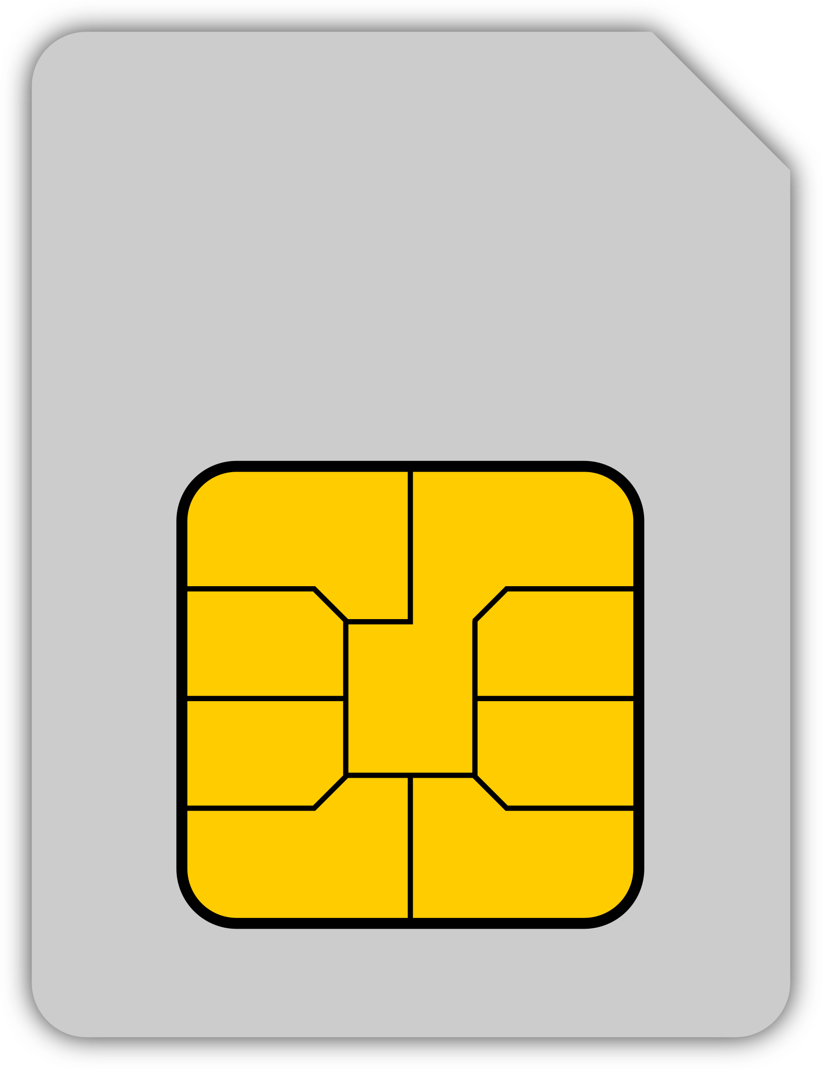

4568 9274 4689 8672

DEBIT CARD

VISA