**ABSTRACT 1**

**Project Title:** **HerBuddy – AI Driven Period Companion and Story Hub**

**Domain: HealthCare**

**Team Name: Synovate**

**Team Members details:**

|  |  |  |  |  |  |
| --- | --- | --- | --- | --- | --- |
| **Role** | **Name** | **USN (College Reg no.)** | **College Name** | **Email id** | **Phone no.** |
| Team Member 1 | Kritika | 1SI23CI065 | SIT | prasadkritika43@gmail.com | 8050575747 |
| Team Member 2 | Chandushree R | 1SI23CS035 | SIT | chandushree6438@gmail.com | 9663426747 |
| Team Member 3 | Shravya G S | 1SI23CS209 | SIT | shravyags06@gmail.com | 7829797673 |
| Team Member 4 | Avani A U | 1SI23CS026 | SIT | avaniau.2005@gmail.com | 9148103966 |

**PROBLEM STATEMENT**

Menstrual health is often surrounded by stigma and misinformation, leaving individuals without a reliable and safe space to ask sensitive questions or share personal experiences. This lack of accessible and accurate information can lead to misconceptions, poor menstrual hygiene practices, and delayed medical intervention. Additionally, existing online communities lack proper moderation, exposing users to harmful content and harassment.

**PROBLEM DESCRIPTION**

Menstrual irregularities are a common issue among women and can be an early warning sign of Polycystic Ovary Disorder (PCOD). Many women remain undiagnosed due to a lack of awareness, financial constraints, or difficulty accessing healthcare services. Misinformation and societal stigma further contribute to confusion and delayed medical intervention. Beyond physical symptoms, PCOD can lead to emotional distress, anxiety, mood swings, and even depression. However, mental health support and awareness surrounding the psychological effects of PCOD remain limited.

Early detection is essential in preventing complications such as infertility, insulin resistance, and metabolic disorders, yet many women lack reliable tools to track menstrual irregularities and recognize warning signs. Without proper monitoring and timely medical guidance, managing PCOD becomes challenging. There is a growing need for accessible, affordable, and user-friendly solutions that empower women to take control of their reproductive health, receive timely interventions, and manage PCOD effectively through lifestyle modifications and medical support.

**PROPOSED SOLUTION**

Use Case Diagram

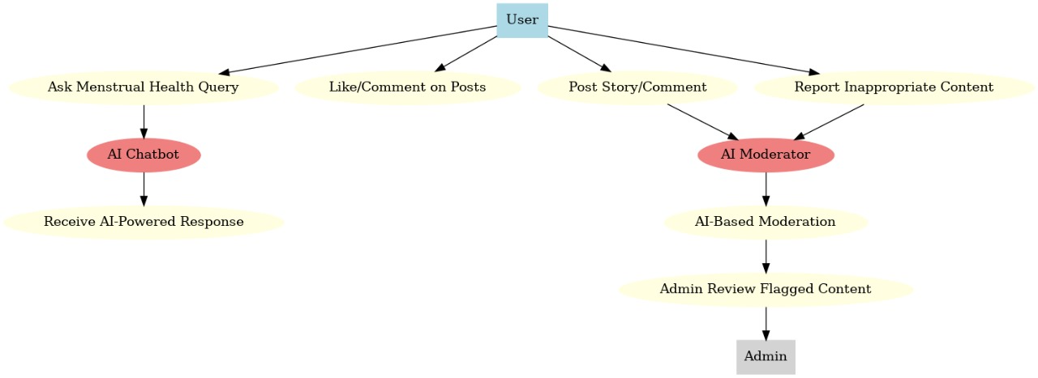

The platform will consist of two core components:

1. AI Chatbot:

Built using OpenAI’s GPT-3.5/4 API or Dialogflow to handle a variety of period-related queries.

Provides real-time, fact-based responses and myth-busting information

Personalized recommendations and suggestions for pain management, hygiene, and lifestyle improvements.

2. Community Platform:

Allows users to anonymously share their experiences and seek support.

Provides a space for open, stigma-free conversations about menstruation and reproductive health.

Users can engage with other stories while maintaining complete anonymity.

AI-Based Moderation System:

Utilizes Perspective API or a custom NLP model to detect toxic, harmful, or inappropriate content.

Automatically flags or removes inappropriate comments to maintain a respectful environment.

Community-based reporting and moderation as a secondary safety mechanism.

AI Models:

OpenAI API for chatbot responses.

Perspective API or custom sentiment/toxicity detection model for content moderation.

**TECHNOLOGY STACK**

Frontend:

* HTML, CSS, JavaScript - for a simple, responsive UI
* Bootstrap , Tailwind CSS - for styling and layout

Backend:

* Flask (Python) , Node.js with Express (for handling API requests)
* SQLite , Firebase Realtime Database (for storing user posts and chatbot interactions)

AI Chatbot:

* OpenAI API (GPT-4) , Dialogflow (for answering period-related queries)

AI-Based Moderation System:

* Perspective API , OpenAI Moderation API (for detecting harmful content in posts and comments)

**APPLICATIONS**

1. **AI Chatbot for Menstrual Queries**  
   Provides quick, reliable answers about menstrual health, PCOS, pregnancy, and hygiene. It also educates users about hormonal changes and irregular cycles.
2. **Menstrual Health Education**  
   Spreads awareness about menstrual health, busting myths and promoting culturally sensitive knowledge.
3. **Safe Space for Story Sharing**  
   Allows users to anonymously share experiences and engage with others through comments and likes, fostering a supportive community.
4. **AI-Powered Content Moderation**  
   Automatically detects and filters inappropriate or harmful content to maintain a safe and respectful environment.
5. **Anomaly Detection and Health Alerts**  
   Identifies unusual patterns, such as missed periods or abnormal bleeding, and suggests seeking medical advice when necessary.
6. **Mental Health Support**  
   Connects users with similar experiences and provides resources to cope with emotional challenges
7. **Content Reporting and Admin Intervention**Enables users to report inappropriate content, ensuring admin review and prompt action.

**ABSTRACT 2**

**Project Title: eBallot - Ensuring Authenticity and Fairness**

**Domain: Open Innovation**

**Team Name: Synovate**

**Team Members details:**

|  |  |  |  |  |  |
| --- | --- | --- | --- | --- | --- |
| **Role** | **Name** | **USN (College Reg no.)** | **College Name** | **Email id** | **Phone no.** |
| Team Member 1 | Kritika | 1SI23CI065 | SIT | prasadkritika43@gmail.com | 8050575747 |
| Team Member 2 | Chandushree R | 1SI23CS035 | SIT | chandushree6438@gmail.com | 9663426747 |
| Team Member 3 | Shravya G S | 1SI23CS209 | SIT | shravyags06@gmail.com | 7829797673 |
| Team Member 4 | Avani A U | 1SI23CS026 | SIT | avaniau.2005@gmail.com | 9148103966 |

**PROBLEM STATEMENT**

Traditional voting systems often struggle with low voter turnout, high costs, and accessibility challenges, particularly for remote and overseas voters. Physical polling stations and paper-based processes add logistical and financial burdens while limiting convenience for many voters. A secure, transparent, and user-friendly online voting system can address these issues by increasing accessibility, reducing administrative costs, and ensuring election integrity. With strong security measures like encryption and authentication, online voting can provide a reliable and efficient alternative, encouraging greater participation in the democratic process.

**PROBLEM DESCRIPTION**

The traditional voting system requires individuals to be physically present in their registered constituencies, which creates significant challenges for those who cannot travel due to distance, physical limitations, or time constraints. This leads to reduced voter turnout and an inefficient electoral process. Additionally, existing online voting systems often lack robust security, making them vulnerable to fraud and identity theft.

Moreover, the current system contributes to a reduction in voter turnout due to logistical challenges like long queues, travel time, and a lack of flexibility for voters. This not only affects the inclusiveness of the electoral process but also undermines its effectiveness in representing the true voice of the people. Traditional voting systems also rely heavily on infrastructure and manpower, which can be resource intensive and vulnerable to human errors and fraud.

There is a lack of a secure and efficient remote voting system that can ensure both accessibility and integrity. While some online voting solutions exist, they often fall short in terms of security, leaving them vulnerable to identity theft, unauthorized access, and vote tampering

**Proposed solution:** The proposed solution is to develop a secure and accessible online voting system that allows eligible voters to cast their votes remotely, ensuring convenience, security, and transparency. This system addresses the limitations of traditional voting by leveraging modern technology to authenticate voters and enable secure vote submission.

**Key Features of the Solution**

**1. Online Voting Request:** Voters who cannot physically visit their constituencies can request access to vote online through the system by providing valid credentials.

**2. Multi-Factor Authentication:** The system ensures security through multi-layered authentication:

 • Unique Credentials: Each voter is assigned a unique voter ID and password.

 • Facial Recognition: Real-time facial recognition to prevent impersonation.

**3. Constituency-Specific Ballots:** Once authenticated, the system displays the relevant candidates based on the voter’s registered constituency to ensure accuracy.

**4. Vote Submission and Encryption:** Votes are securely encrypted during transmission and stored anonymously in the database.

**5. Monitoring and Fraud Prevention:** The system logs all activities securely and monitors for suspicious behavior, such as multiple login attempts or inconsistent facial data

**Case Diagram**

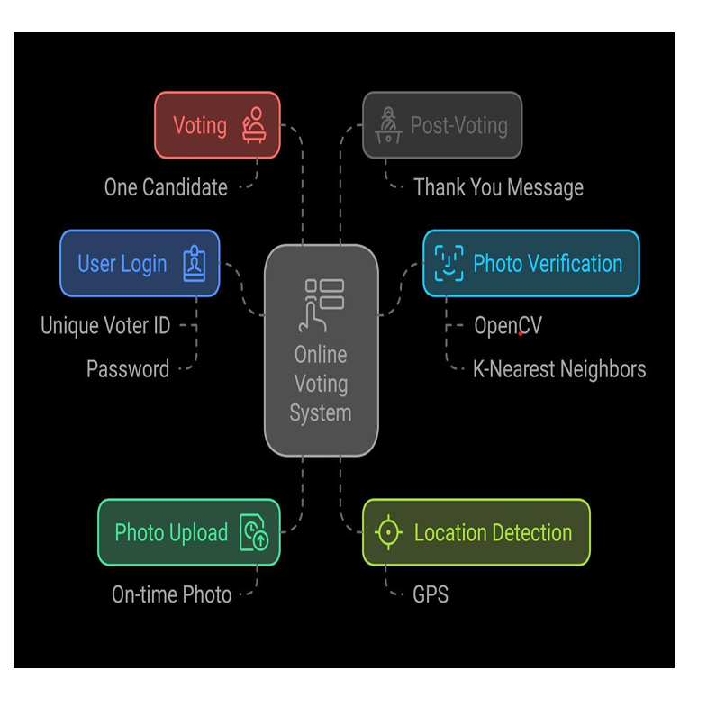

**TECHNOLOGY STACK**

**Frontend: HTML,CSS,JavaScript**

Fundamental technologies for creating and styling interactive and responsive web pages.

**Frameworks: React js**

A popular JavaScript library for building fast and reusable UI components

**Backend: node js with Express js**

A lightweight Node.js framework for building APIs and web applications. Techniques combining computer vision and machine learning to identify and detect facial recognition. Server-side interfaces to handle requests and exchange data between applications.

**Database: MongoDB**

A database designed for scalable and flexible data storage.

**Face recognition and detection:**

Open CV and K-nearest neighbour algorithm (ML)

**APPLICATIONS**

**1.Voting During Byelections:** Students studying outside their constituency and employees working elsewhere can vote remotely using the digital voting system,

**2.Extending Postal Voting Facility:** Currently, postal voting is available only to government employees on election duty. The digital voting system can bridge this gap, thereby preventing loss of votes from these groups.

**3.Pre-Election Facility for Differently-Abled Individuals:** The current system involves election officers visiting the homes of differently-abled individuals to collect their votes. The digital voting system can replace this process by enabling them to cast their votes securely from the comfort of their homes, saving resources and ensuring convenience.

**ABSTRACT 3**

**Project Title: EcoChamp – Gamify Waste, Beautify Earth!**

**Domain: Pollution and Waste Management**

**Team Name: Synovate**

**Team Members details:**

|  |  |  |  |  |  |
| --- | --- | --- | --- | --- | --- |
| **Role** | **Name** | **USN (College Reg no.)** | **College Name** | **Email id** | **Phone no.** |
| Team Member 1 | Kritika | 1SI23CI065 | SIT | prasadkritika43@gmail.com | 8050575747 |
| Team Member 2 | Chandushree R | 1SI23CS035 | SIT | chandushree6438@gmail.com | 9663426747 |
| Team Member 3 | Shravya G S | 1SI23CS209 | SIT | shravyags06@gmail.com | 7829797673 |
| Team Member 4 | Avani A U | 1SI23CS026 | SIT | avaniau.2005@gmail.com | 9148103966 |

**PROBLEM STATEMENT**

India faces a severe waste management crisis, with millions of tons of improperly discarded waste causing pollution and health hazards. Despite initiatives like Swachh Bharat Abhiyan, poor ground-level implementation and lack of citizen participation hinder progress. The absence of early education on waste segregation among children, who are the future custodians of the environment, further exacerbates the problem, leading to poor habits and worsening the situation.

**PROBLEM DESCRIPTION**

Inadequate Government Implementation: Despite initiatives like Swachh Bharat Abhiyan, inconsistent monitoring and lack of community engagement, especially in rural areas, hinder effective waste management.

Lack of Incentives for Waste Segregation: Government programs rarely offer meaningful rewards to encourage waste segregation, reducing motivation for sustainable practices.

Limited Environmental Awareness Among Children: Conventional education methods fail to engage children and instill sustainable habits, missing the opportunity to build environmental responsibility from an early age.

Negative Impact of Violent Games: Popular games promote aggression and lack moral lessons. A game that rewards children for positive actions like waste segregation can nurture environmental responsibility and instill moral values.

**Proposed Soltuion:** To address these pressing issues, we propose EcoChamp, an AI-powered educational game designed to teach children about pollution, waste segregation and disease prevention.

**Key features of the solution:**

Smart Waste Classification Using AI: Players drag and drop waste items into bins.

AI (using models like MobileNet or ResNet) identifies the waste type and provides real-time feedback. If a player makes an incorrect choice, the AI suggests the correct bin to promote learning.

Adaptive Difficulty through Reinforcement Learning: The game dynamically adjusts its difficulty level based on player performance. If a player excels, more complex waste items or time constraints are introduced. Struggling players are given simpler challenges and hints to boost confidence and learning.

Real-Time Government Initiative Simulation: The game simulates a system where points earned for correct waste segregation can be converted into real-world benefits.

This mirrors how government incentives or financial rewards could motivate people to segregate waste correctly in real life.

Gamified Incentives to Promote Real-World Impact: Players are awarded virtual rewards for learning and improving their segregation skills. These rewards could be linked to real-world incentives in collaboration with local authorities or schools.

**CASE DIAGRAM**

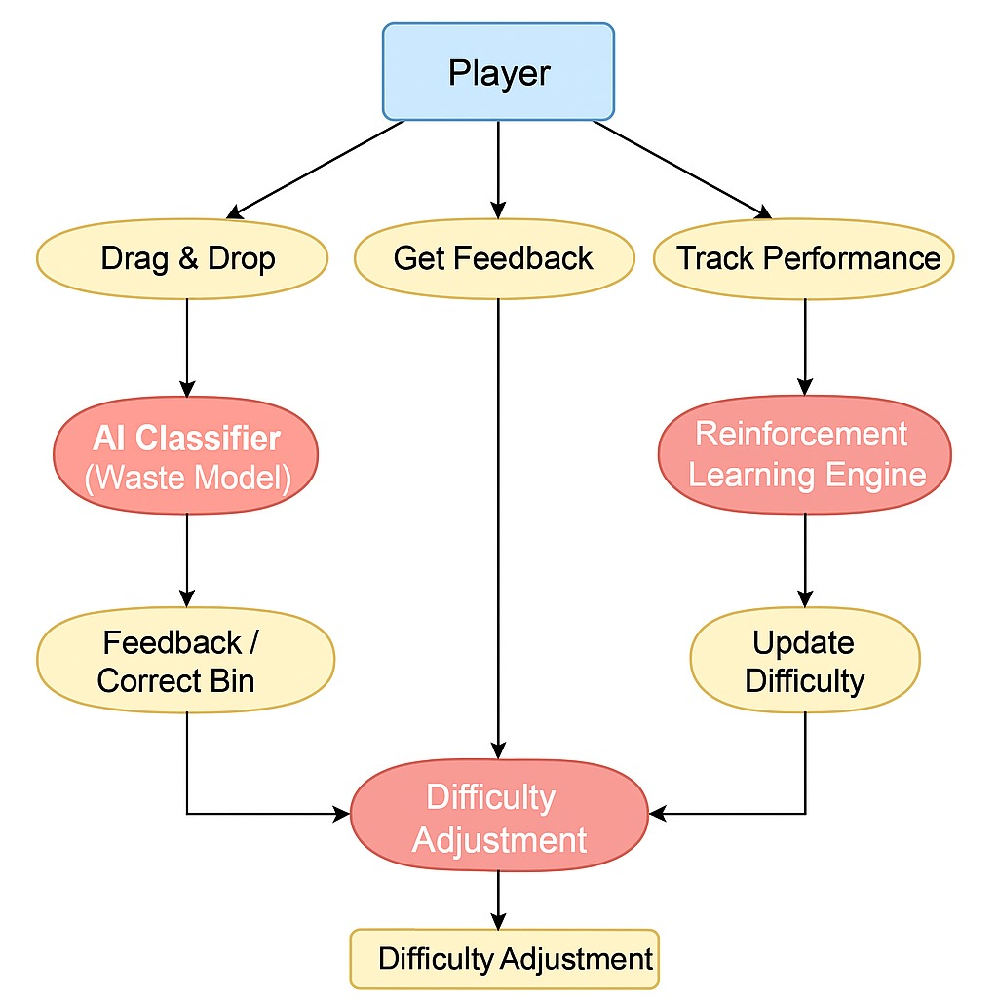

**TECHNOLOGY STACK**

**Frontend**

* HTML5, CSS3, JavaScript – Core technologies for building and styling interactive web pages.
* Canvas API (optional) – A JavaScript feature for rendering graphics and animations directly in the browser.

**Backend**

* Flask (Python) – A lightweight and flexible web framework for handling server-side logic and API interactions.
* SQLite – A self-contained, file-based database suitable for lightweight and efficient data storage.

**AI Model**

* MobileNet (Pre-trained Model with TensorFlow/Keras) – A deep learning model optimized for image classification and real-time processing.

**Dataset**

* TrashNet Dataset – A labeled dataset for training AI models to classify and recognize different types of waste.

**Reinforcement Learning (RL) Model**

* Q-Learning (Basic Version with Python) – A reinforcement learning algorithm used to optimize decision-making in AI-based waste classification.

**APPLICATIONS**

1. Environmental Education in Schools:

Teach children waste segregation and recycling through interactive gameplay.

2. Instill lifelong habits of responsible waste management.

Behavioral Change through Gamification:

3. Encourage positive habits by rewarding players for correct actions.

Promote eco-friendly practices in a fun and engaging way.

4. Community Awareness Campaigns:

Use the game as part of awareness drives to educate communities.

5. Involve local authorities to promote waste segregation practices.

Incentive-Based Learning for Children:

6. Link game rewards to real-world incentives to motivate children.

Encourage children to adopt sustainable practices beyond the game.

Government Implementation for Real-World Impact:

The government can adopt this idea in real life by offering cash rewards or incentives for proper waste segregation.

This approach can motivate communities to actively participate in sustainable waste management