MODULE-7:
Hands on 1
Create a Spring Web Project using Maven
Follow steps below to create a project:
- Go to https://start.spring.io/
- Change Group as “com.cognizant”
- Change Artifact Id as “spring-learn”
- Select Spring Boot DevTools and Spring Web
- Create and download the project as zip
- Extract the zip in root folder to Eclipse Workspace
- Build the project using ‘mvn clean package -Dhttp.proxyHost=proxy.cognizant.com -Dhttp.proxyPort=6050 -Dhttps.proxyHost=proxy.cognizant.com -Dhttps.proxyPort=6050 -Dhttp.proxyUser=123456’ command in command line
- Import the project in Eclipse "File > Import > Maven > Existing Maven Projects > Click Browse and select extracted folder > Finish"
- Include logs to verify if main() method of SpringLearnApplication.
- Run the SpringLearnApplication class.
SOLUTION:
SpringLearnApplication.java
package com.cognizant.springlearn;

import org.slf4j.Logger;
import org.slf4j.LoggerFactory;
import org.springframework.boot.SpringApplication;
import org.springframework.boot.autoconfigure.SpringBootApplication;

@SpringBootApplication
public class SpringLearnApplication {
private static final Logger LOGGER = LoggerFactory.getLogger(SpringLearnApplication.class);
public static void main(String[] args) {
LOGGER.info("Inside main method: Starting SpringLearnApplication...");
SpringApplication.run(SpringLearnApplication.class, args);
LOGGER.info("SpringLearnApplication started successfully.");
}
}
Result:
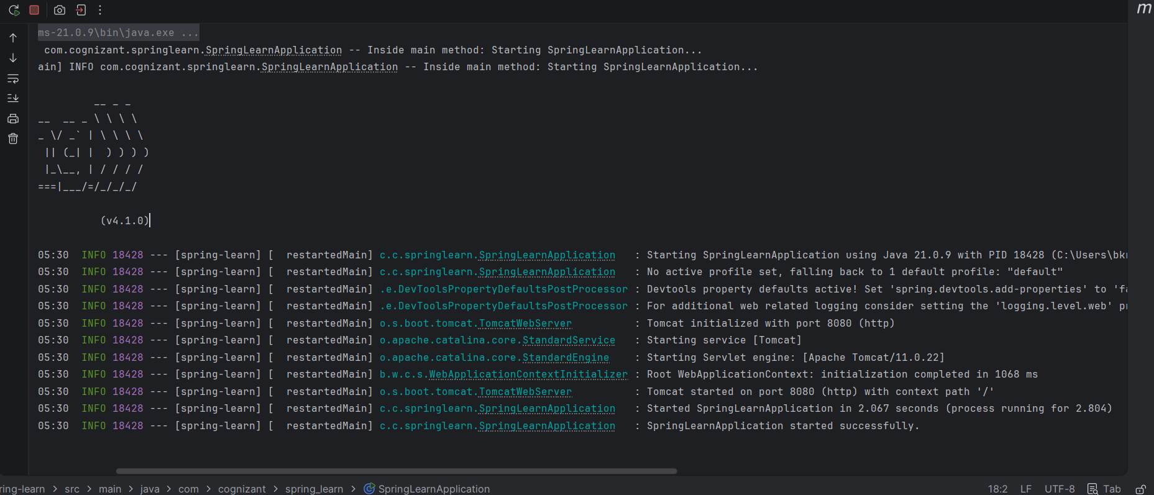
Hands on 4
Spring Core – Load Country from Spring Configuration XML
An airlines website is going to support booking on four countries. There will be a drop down on the home page of this website to select the respective country. It is also important to store the two-character ISO code of each country.
Code | Name
US | United States
DE | Germany
IN | India
JP | Japan
Above data has to be stored in spring configuration file. Write a program to read this configuration file and display the details.
Steps to implement
- Pick any one of your choice country to configure in Spring XML configuration named country.xml.
- Create a bean tag in spring configuration for country and set the property and values
<bean id="country" class="com.cognizant.springlearn.Country">
<property name="code" value="IN" />
<property name="name" value="India" />
</bean>
- Create Country class with following aspects:
  - Instance variables for code and name
  - Implement empty parameter constructor with inclusion of debug log within the constructor with log message as “Inside Country Constructor.”
  - Generate getters and setters with inclusion of debug with relevant message within each setter and getter method.
  - Generate toString() method
- Create a method displayCountry() in SpringLearnApplication.java, which will read the country bean from spring configuration file and display the country details. ClassPathXmlApplicationContext, ApplicationContext and context.getBean(“beanId”, Country.class). Refer sample code for displayCountry() method below.
ApplicationContext context = new ClassPathXmlApplicationContext("country.xml");
Country country = (Country) context.getBean("country", Country.class);
LOGGER.debug("Country : {}", country.toString());

- Invoke displayCountry() method in main() method of SpringLearnApplication.java.
- Execute main() method and check the logs to find out which constructors and methods were invoked.
SOLUTION:
country.xml:
<?xml version="1.0" encoding="UTF-8"?>
<beans xmlns="http://www.springframework.org/schema/beans"
xmlns:xsi="http://www.w3.org/2001/XMLSchema-instance"
xsi:schemaLocation="http://www.springframework.org/schema/beans
http://www.springframework.org/schema/beans/spring-beans.xsd">

<bean id="country" class="com.cognizant.spring_learn.Country">
<property name="code" value="IN" />
<property name="name" value="India" />
</bean>

</beans>
Country.java
package com.cognizant.spring_learn;

import org.slf4j.Logger;
import org.slf4j.LoggerFactory;

public class Country {

private static final Logger LOGGER = LoggerFactory.getLogger(Country.class);
private String code;
private String name;

public Country() {
LOGGER.debug("Inside Country Constructor.");
}

public String getCode() {
LOGGER.debug("Inside getCode getter method.");
return code;
}

public void setCode(String code) {
LOGGER.debug("Inside setCode setter method with value: {}", code);
this.code = code;
}

public String getName() {
LOGGER.debug("Inside getName getter method.");
return name;
}

public void setName(String name) {
LOGGER.debug("Inside setName setter method with value: {}", name);
this.name = name;
}

@Override
public String toString() {
return "Country [code=" + code + ", name=" + name + "]";
}
}
SpringLearnApplication.java
package com.cognizant.spring_learn;

import org.slf4j.Logger;
import org.slf4j.LoggerFactory;
import org.springframework.boot.CommandLineRunner;
import org.springframework.boot.SpringApplication;
import org.springframework.boot.autoconfigure.SpringBootApplication;
import org.springframework.context.ApplicationContext;
import org.springframework.context.annotation.Bean;
import org.springframework.context.support.ClassPathXmlApplicationContext;

@SpringBootApplication
public class SpringLearnApplication {

private static final Logger LOGGER = LoggerFactory.getLogger(SpringLearnApplication.class);

public static void main(String[] args) {
SpringApplication.run(SpringLearnApplication.class, args);
}

@Bean
public CommandLineRunner demo() {
return args -> {
displayCountry();
};
}

public static void displayCountry() {
ApplicationContext context = new ClassPathXmlApplicationContext("country.xml");
Country country = context.getBean("country", Country.class);
LOGGER.debug("Country : {}", country.toString());
}
}
application.properties
server.port=8085
logging.level.com.cognizant.spring_learn=DEBUG
RESULT:
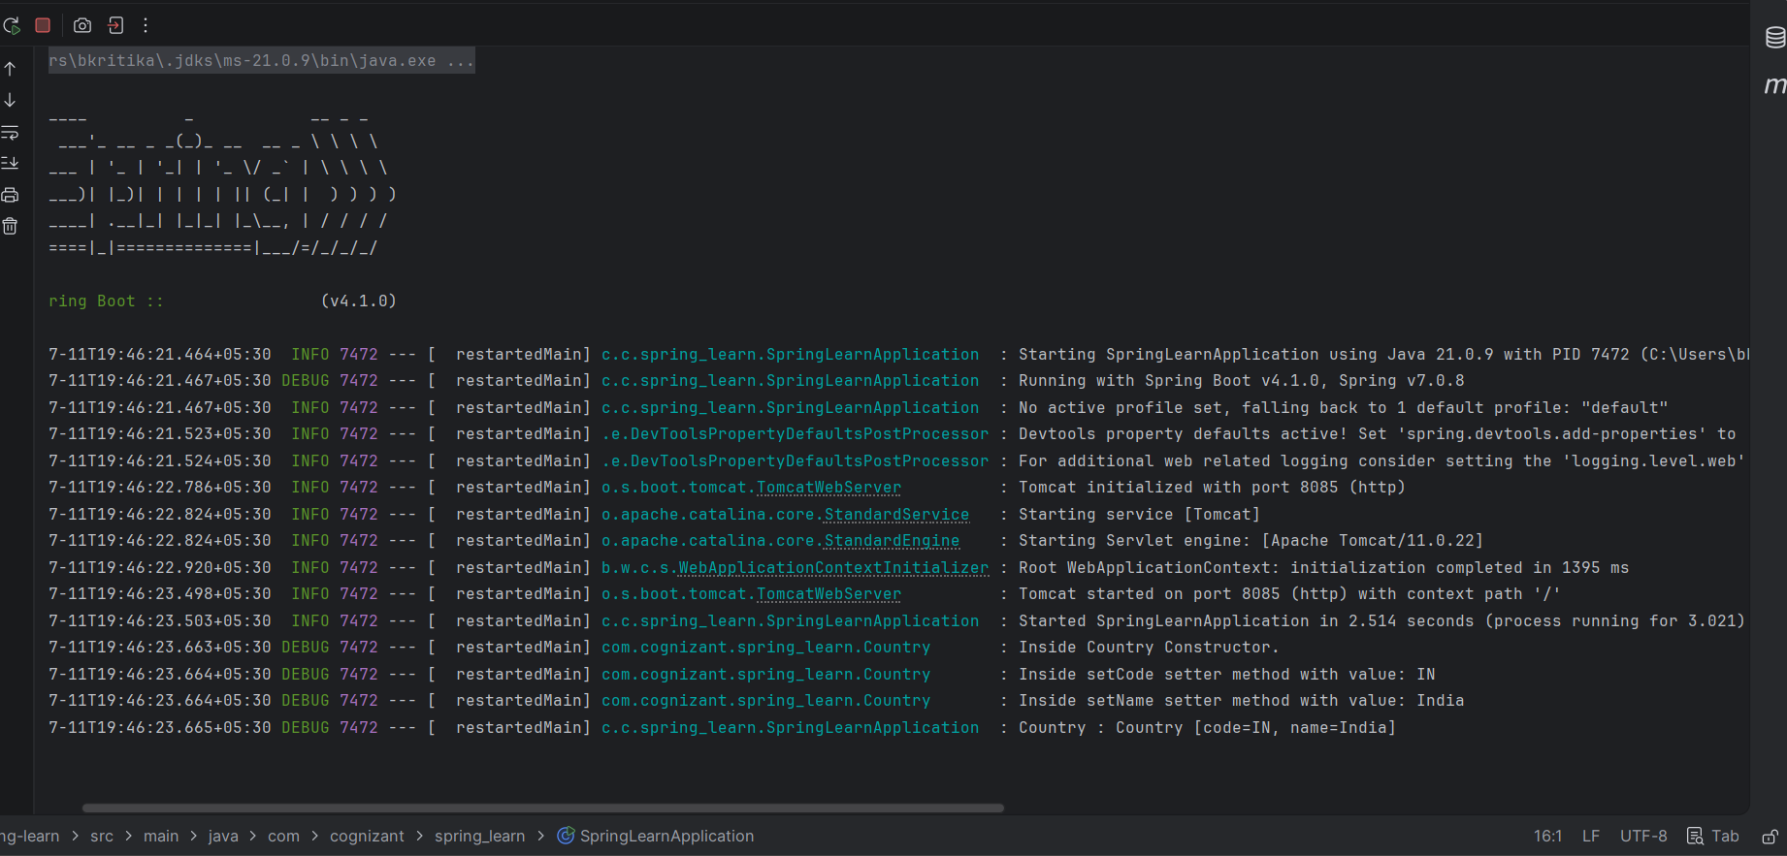
Hello World RESTful Web Service
Write a REST service in the spring learn application created earlier, that returns the text "Hello World!!" using Spring Web Framework. Refer details below:
Method: GET
URL: /hello
Controller: com.cognizant.spring-learn.controller.HelloController
Method Signature: public String sayHello()
Method Implementation: return hard coded string "Hello World!!"
Sample Request: http://localhost:8083/hello
Sample Response: Hello World!!
IMPORTANT NOTE: Don't forget to include start and end log in the sayHello() method.
Try the URL http://localhost:8083/hello in both chrome browser and postman.
SME to explain the following aspects:
- In network tab of developer tools show the HTTP header details received
- In postman click on "Headers" tab to view the HTTP header details received
SOLUTION:
HelloController.java
package com.cognizant.spring_learn.controller;

import org.slf4j.Logger;
import org.slf4j.LoggerFactory;
import org.springframework.web.bind.annotation.GetMapping;
import org.springframework.web.bind.annotation.RestController;

@RestController
public class HelloController {

private static final Logger LOGGER = LoggerFactory.getLogger(HelloController.class);

@GetMapping("/hello")
public String sayHello() {
LOGGER.info("Start of sayHello() method execution");
String message = "Hello World!!";
LOGGER.info("End of sayHello() method execution");
return message;
}
}
RESULT:
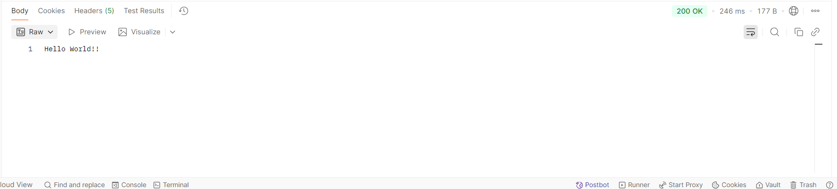
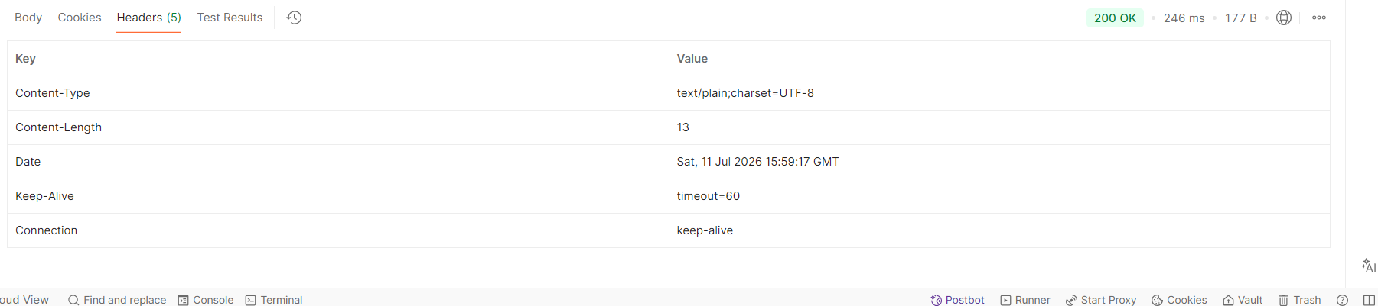
REST - Country Web Service
Write a REST service that returns India country details in the earlier created spring learn application.
URL: /country
Controller: com.cognizant.spring-learn.controller.CountryController
Method Annotation: @RequestMapping
Method Name: getCountryIndia()
Method Implementation: Load India bean from spring xml configuration and return
Sample Request: http://localhost:8083/country
Sample Response:
{
"code": "IN",
"name": "India"
}
SME to explain the following aspects:
- What happens in the controller method?
- How the bean is converted into JSON reponse?
- In network tab of developer tools show the HTTP header details received
- In postman click on "Headers" tab to view the HTTP header details received
SOLUTION:
package com.cognizant.spring_learn.controller;

import com.cognizant.spring_learn.Country;
import org.springframework.context.ApplicationContext;
import org.springframework.context.support.ClassPathXmlApplicationContext;
import org.springframework.web.bind.annotation.RequestMapping;
import org.springframework.web.bind.annotation.RequestMethod;
import org.springframework.web.bind.annotation.RestController;

@RestController
public class CountryController {

@RequestMapping(value = "/country", method = RequestMethod.GET)
public Country getCountryIndia() {
ApplicationContext context = new ClassPathXmlApplicationContext("country.xml");
return context.getBean("country", Country.class);
}
}
country.xml
<bean id="country" class="com.cognizant.spring_learn.Country">
<property name="code" value="IN" />
<property name="name" value="India" />
</bean>
RESULT:
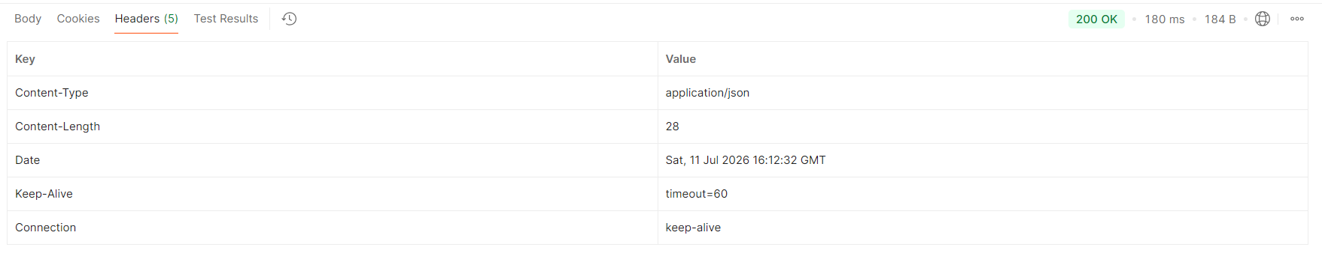REST - Get country based on country code
Write a REST service that returns a specific country based on country code. The country code should be case insensitive.
Controller: com.cognizant.spring-learn.controller.CountryController
Method Annotation: @GetMapping("/countries/{code}")
Method Name: getCountry(String code)
Method Implemetation: Invoke countryService.getCountry(code)
Service Method: com.cognizant.spring-learn.service.CountryService.getCountry(String code)
Service Method Implementation:
- Get the country code using @PathVariable
- Get country list from country.xml
- Iterate through the country list
- Make a case insensitive matching of country code and return the country.
- Lambda expression can also be used instead of iterating the country list
Sample Request: http://localhost:8083/country/in
Sample Response:
{
"code": "IN",
"name": "India"
}
country.xml:
<?xml version="1.0" encoding="UTF-8"?>
<beans xmlns="http://www.springframework.org/schema/beans"
xmlns:xsi="http://www.w3.org/2001/XMLSchema-instance"
xsi:schemaLocation="http://www.springframework.org/schema/beans
http://www.springframework.org/schema/beans/spring-beans.xsd">

<bean id="in" class="com.cognizant.spring_learn.Country">
<property name="code" value="IN" />
<property name="name" value="India" />
</bean>

<bean id="us" class="com.cognizant.spring_learn.Country">
<property name="code" value="US" />
<property name="name" value="United States" />
</bean>

</beans>
CountryService.java
package com.cognizant.spring_learn.service;

import com.cognizant.spring_learn.Country;
import org.springframework.context.ApplicationContext;
import org.springframework.context.support.ClassPathXmlApplicationContext;
import org.springframework.stereotype.Service;

import java.util.Collection;

@Service
public class CountryService {

public Country getCountry(String code) {
ApplicationContext context = new ClassPathXmlApplicationContext("country.xml");
Collection<Country> countries = context.getBeansOfType(Country.class).values();

return countries.stream()
.filter(country -> country.getCode().equalsIgnoreCase(code))
.findFirst()
.orElse(null);
}
}
CountryController.java
package com.cognizant.spring_learn.controller;

import com.cognizant.spring_learn.Country;
import com.cognizant.spring_learn.service.CountryService;
import org.springframework.beans.factory.annotation.Autowired;
import org.springframework.web.bind.annotation.GetMapping;
import org.springframework.web.bind.annotation.PathVariable;
import org.springframework.web.bind.annotation.RequestMapping;
import org.springframework.web.bind.annotation.RequestMethod;
import org.springframework.web.bind.annotation.RestController;

@RestController
public class CountryController {

@Autowired
private CountryService countryService;

@RequestMapping(value = "/country", method = RequestMethod.GET)
public Country getCountryIndia() {
return countryService.getCountry("IN");
}

@GetMapping("/countries/{code}")
public Country getCountry(@PathVariable String code) {
return countryService.getCountry(code);
}
}
SpringLearnApplication.java:
package com.cognizant.spring_learn;

import org.slf4j.Logger;
import org.slf4j.LoggerFactory;
import org.springframework.boot.CommandLineRunner;
import org.springframework.boot.SpringApplication;
import org.springframework.boot.autoconfigure.SpringBootApplication;
import org.springframework.context.ApplicationContext;
import org.springframework.context.annotation.Bean;
import org.springframework.context.support.ClassPathXmlApplicationContext;

@SpringBootApplication
public class SpringLearnApplication {

private static final Logger LOGGER = LoggerFactory.getLogger(SpringLearnApplication.class);

public static void main(String[] args) {
SpringApplication.run(SpringLearnApplication.class, args);
}

@Bean
public CommandLineRunner demo() {
return args -> {
displayCountry();
};
}

public static void displayCountry() {
ApplicationContext context = new ClassPathXmlApplicationContext("country.xml");
Country country = context.getBean("in", Country.class);
LOGGER.debug("Country : {}", country.toString());
}
}
RESULT:
