Exercise 1: Setting Up JUnit Scenario: You need to set up JUnit in your Java project to start writing unit tests. Steps: 1. Create a new Java project in your IDE (e.g., IntelliJ IDEA, Eclipse). 2. Add JUnit dependency to your project. If you are using Maven, add the following to your pom.xml: junit junit 4.13.2 test 3. Create a new test class in your project.
SOLUTION:
import org.junit.Test;
import static org.junit.Assert.assertEquals;

public class MyFirstTest {

@Test
public void testAddition() {
int sum = 2 + 2;
assertEquals(4, sum);
}
}
RESULT:
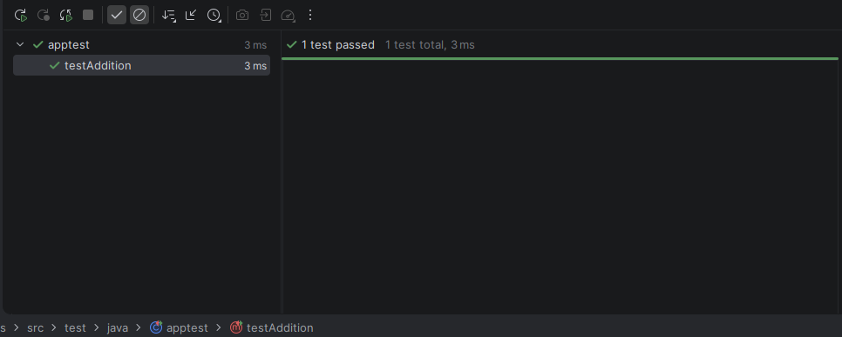
Exercise 3: Assertions in JUnit Scenario: You need to use different assertions in JUnit to validate your test results. Steps: 1. Write tests using various JUnit assertions. Solution Code: public class AssertionsTest { @Test public void testAssertions() { // Assert equals assertEquals(5, 2 + 3); // Assert true assertTrue(5 > 3); // Assert false assertFalse(5 < 3); // Assert null assertNull(null); // Assert not null assertNotNull(new Object()); } }

SOLUTION:
import org.junit.Test;
import static org.junit.Assert.*;

public class AssertionsTest {
@Test
public void testAssertions() {

assertEquals(5, 2 + 3);

assertTrue(5 > 3);

assertFalse(5 < 3);

assertNull(null);

assertNotNull(new Object());
}
}
RESULT:
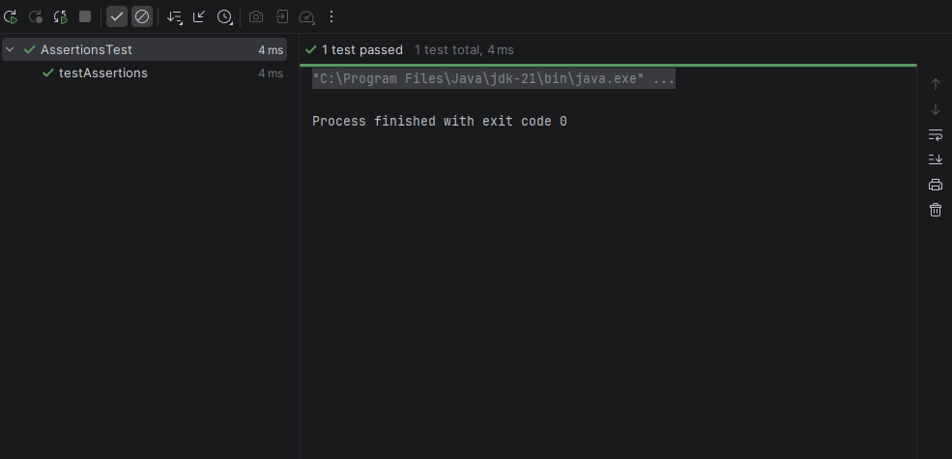
Exercise 4: Arrange-Act-Assert (AAA) Pattern, Test Fixtures, Setup and Teardown Methods in JUnit Scenario: You need to organize your tests using the Arrange-Act-Assert (AAA) pattern and use setup and teardown methods. Steps: 1. Write tests using the AAA pattern. 2. Use @Before and @After annotations for setup and teardown methods.
Solution:
import org.junit.After;
import org.junit.Before;
import org.junit.Test;
import java.util.ArrayList;
import java.util.List;
import static org.junit.Assert.*;

public class LifecycleAndAAATest {
private List<String> shoppingList;

public void setUp() {
shoppingList = new ArrayList<>();
System.out.println("Setup: Created a fresh shopping list.");
}

public void testAddItem() {
String item = "Apples";
shoppingList.add(item);
assertEquals(1, shoppingList.size());
assertTrue(shoppingList.contains("Apples"));
System.out.println("Test: Verified adding an item works.");
}
public void tearDown() {
shoppingList.clear();
System.out.println("Teardown: Cleared the list data.");
}
}
RESULT:
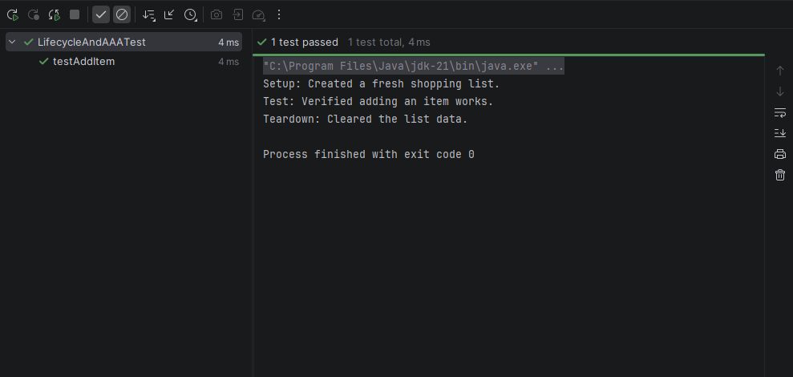
Exercise 1: Mocking and Stubbing Scenario: You need to test a service that depends on an external API. Use Mockito to mock the external API and stub its methods. Steps: 1. Create a mock object for the external API. 2. Stub the methods to return predefined values. 3. Write a test case that uses the mock object. Solution Code: import static org.mockito.Mockito.*; import org.junit.jupiter.api.Test; import org.mockito.Mockito; public class MyServiceTest { @Test public void testExternalApi() { ExternalApi mockApi = Mockito.mock(ExternalApi.class); when(mockApi.getData()).thenReturn("Mock Data"); MyService service = new MyService(mockApi); String result = service.fetchData(); assertEquals("Mock Data", result); } }
SOLUTION:
public interface ExternalApi {
String getData();
}
public class MyService {
private ExternalApi api;

public MyService(ExternalApi api) {
this.api = api;
}

public String fetchData() {
return api.getData();
}
}
import static org.junit.jupiter.api.Assertions.assertEquals;
import static org.mockito.Mockito.*;

import org.junit.jupiter.api.Test;
import org.mockito.Mockito;

public class MyServiceTest {
public void testExternalApi() {
ExternalApi mockApi = Mockito.mock(ExternalApi.class);
when(mockApi.getData()).thenReturn("Mock Data"); .
MyService service = new MyService(mockApi);
String result = service.fetchData();
assertEquals("Mock Data", result);
}
}
RESULT:
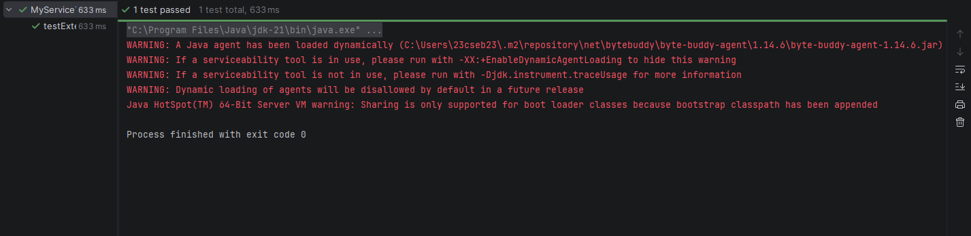
Exercise 2: Verifying Interactions Scenario: You need to ensure that a method is called with specific arguments. Steps: 1. Create a mock object. 2. Call the method with specific arguments. 3. Verify the interaction. Solution Code: import static org.mockito.Mockito.*; import org.junit.jupiter.api.Test; import org.mockito.Mockito; public class MyServiceTest { @Test public void testVerifyInteraction() { ExternalApi mockApi = Mockito.mock(ExternalApi.class); MyService service = new MyService(mockApi); service.fetchData(); verify(mockApi).getData(); } }
SOLUTION:
public interface ExternalApi {
String getData();
}
public class MyService {
private ExternalApi api;

public MyService(ExternalApi api) {
this.api = api;
}

public String fetchData() {
return api.getData();
}
}
import static org.mockito.Mockito.*;

import org.junit.Test;
import org.mockito.Mockito;

public class MyServiceTest {
public void testVerifyInteraction() {
ExternalApi mockApi = Mockito.mock(ExternalApi.class);
MyService service = new MyService(mockApi);
service.fetchData();
verify(mockApi).getData();
}
}
Result:
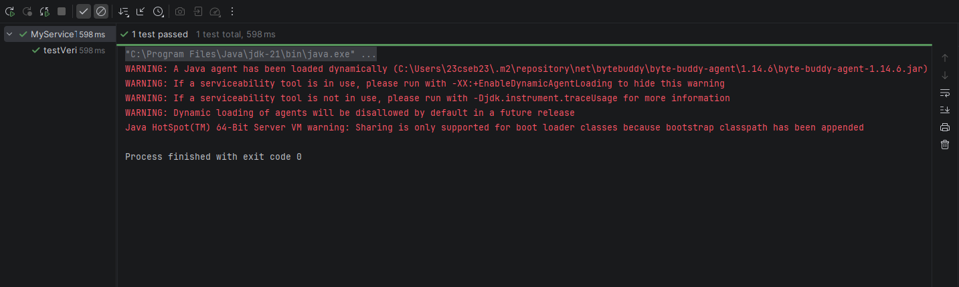
Exercise 1: Logging Error Messages and Warning Levels Task: Write a Java application that demonstrates logging error messages and warning levels using SLF4J. Step-by-Step Solution: 1. Add SLF4J and Logback dependencies to your `pom.xml` file: org.slf4j slf4j-api 1.7.30 ch.qos.logback logback-classic 1.2.3 2. Create a Java class that uses SLF4J for logging: import org.slf4j.Logger; import org.slf4j.LoggerFactory; public class LoggingExample { private static final Logger logger = LoggerFactory.getLogger(LoggingExample.class); public static void main(String[] args) { logger.error("This is an error message"); logger.warn("This is a warning message"); } }
SOLUTION:
import org.slf4j.Logger;
import org.slf4j.LoggerFactory;

public class LoggingExample {
private static final Logger logger = LoggerFactory.getLogger(LoggingExample.class);

public static void main(String[] args) {
logger.error("This is an error message");
logger.warn("This is a warning message");
}
}
RESULT:
