Exercise 1: Control Structures

Scenario 1: The bank wants to apply a discount to loan interest rates for customers above 60 years old.
  - Question: Write a PL/SQL block that loops through all customers, checks their age, and if they are above 60, apply a 1% discount to their current loan interest rates.
Scenario 2: A customer can be promoted to VIP status based on their balance.
  - Question: Write a PL/SQL block that iterates through all customers and sets a flag IsVIP to TRUE for those with a balance over $10,000.
Scenario 3: The bank wants to send reminders to customers whose loans are due within the next 30 days.
  - Question: Write a PL/SQL block that fetches all loans due in the next 30 days and prints a reminder message for each customer.
SOLUTION:

CREATE TABLE Customers (
CustomerID INT PRIMARY KEY,
CustomerName VARCHAR2(50),
Age INT,
Balance NUMBER,
IsVIP VARCHAR2(10) DEFAULT 'FALSE'
);

CREATE TABLE Loans (
LoanID INT PRIMARY KEY,
CustomerID INT,
InterestRate NUMBER,
DueDate DATE
);

INSERT INTO Customers VALUES (1, 'Alice Jones', 65, 12000, 'FALSE');
INSERT INTO Customers VALUES (2, 'Bob Smith', 45, 5000, 'FALSE');
INSERT INTO Loans VALUES (101, 1, 5.5, SYSDATE + 15);
INSERT INTO Loans VALUES (102, 2, 4.0, SYSDATE + 45);

BEGIN

FOR r_cust IN (
SELECT l.LoanID, l.InterestRate
FROM Loans l
JOIN Customers c ON l.CustomerID = c.CustomerID
WHERE c.Age > 60
) LOOP
UPDATE Loans
SET InterestRate = r_cust.InterestRate - 1
WHERE LoanID = r_cust.LoanID;
END LOOP;

FOR r_cust IN (SELECT CustomerID FROM Customers WHERE Balance > 10000) LOOP
UPDATE Customers
SET IsVIP = 'TRUE'
WHERE CustomerID = r_cust.CustomerID;
END LOOP;

FOR r_loan IN (
SELECT c.CustomerName, l.LoanID, l.DueDate
FROM Loans l
JOIN Customers c ON l.CustomerID = c.CustomerID
WHERE l.DueDate BETWEEN SYSDATE AND (SYSDATE + 30)
) LOOP
DBMS_OUTPUT.PUT_LINE('Reminder: Loan ' || r_loan.LoanID || ' for ' || r_loan.CustomerName || ' is due on ' || TO_CHAR(r_loan.DueDate, 'YYYY-MM-DD'));
END LOOP;

COMMIT;
END;
/
Output:
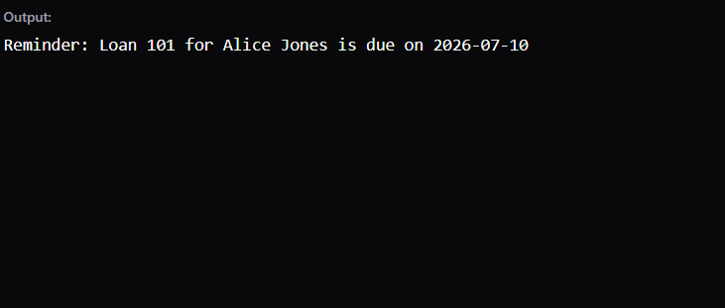
Exercise 3: Stored Procedures

Scenario 1: The bank needs to process monthly interest for all savings accounts.
  - Question: Write a stored procedure ProcessMonthlyInterest that calculates and updates the balance of all savings accounts by applying an interest rate of 1% to the current balance.

Scenario 2: The bank wants to implement a bonus scheme for employees based on their performance.
  - Question: Write a stored procedure UpdateEmployeeBonus that updates the salary of employees in a given department by adding a bonus percentage passed as a parameter.

Scenario 3: Customers should be able to transfer funds between their accounts.
  - Question: Write a stored procedure TransferFunds that transfers a specified amount from one account to another, checking that the source account has sufficient balance before making the transfer.

SOLUTION:

CREATE TABLE Accounts (
AccountID INT PRIMARY KEY,
AccountType VARCHAR2(20),
Balance NUMBER
);

CREATE TABLE Employees (
EmployeeID INT PRIMARY KEY,
Department VARCHAR2(50),
Salary NUMBER
);

INSERT INTO Accounts VALUES (1, 'Savings', 5000);
INSERT INTO Accounts VALUES (2, 'Checking', 2000);
INSERT INTO Accounts VALUES (3, 'Savings', 10000);

INSERT INTO Employees VALUES (101, 'HR', 4000);
INSERT INTO Employees VALUES (102, 'IT', 6000);
INSERT INTO Employees VALUES (103, 'IT', 6500);

CREATE OR REPLACE PROCEDURE ProcessMonthlyInterest AS
BEGIN
UPDATE Accounts
SET Balance = Balance * 1.01
WHERE AccountType = 'Savings';

DBMS_OUTPUT.PUT_LINE('Scenario 1: Monthly interest applied to all savings accounts.');
END;
/

CREATE OR REPLACE PROCEDURE UpdateEmployeeBonus (
p_Department IN VARCHAR2,
p_BonusPercent IN NUMBER
) AS
BEGIN
UPDATE Employees
SET Salary = Salary * (1 + (p_BonusPercent / 100))
WHERE Department = p_Department;

DBMS_OUTPUT.PUT_LINE('Scenario 2: Bonus applied to department ' || p_Department);
END;
/

CREATE OR REPLACE PROCEDURE TransferFunds (
p_SourceAccount IN INT,
p_DestAccount IN INT,
p_Amount IN NUMBER
) AS
v_Balance NUMBER;
BEGIN

SELECT Balance INTO v_Balance FROM Accounts WHERE AccountID = p_SourceAccount;

IF v_Balance >= p_Amount THEN

UPDATE Accounts SET Balance = Balance - p_Amount WHERE AccountID = p_SourceAccount;

UPDATE Accounts SET Balance = Balance + p_Amount WHERE AccountID = p_DestAccount;

DBMS_OUTPUT.PUT_LINE('Scenario 3: Successfully transferred $' || p_Amount || ' from Account ' || p_SourceAccount || ' to ' || p_DestAccount);
ELSE
DBMS_OUTPUT.PUT_LINE('Scenario 3: Transfer Failed. Insufficient balance in Account ' || p_SourceAccount);
END IF;
EXCEPTION
WHEN NO_DATA_FOUND THEN
DBMS_OUTPUT.PUT_LINE('Scenario 3: Transfer Failed. One or both account IDs do not exist.');
END;
/

BEGIN
DBMS_OUTPUT.PUT_LINE('--- RUNNING STORED PROCEDURES ---');

ProcessMonthlyInterest;

UpdateEmployeeBonus('IT', 5);

TransferFunds(1, 2, 500);

COMMIT;
END;
/
RESULT:
