Exercise 1: Implementing the Singleton Pattern
Scenario:
You need to ensure that a logging utility class in your application has only one instance throughout the application lifecycle to ensure consistent logging.
Steps:
- Create a New Java Project:
  - Create a new Java project named SingletonPatternExample.
- Define a Singleton Class:
  - Create a class named Logger that has a private static instance of itself.
  - Ensure the constructor of Logger is private.
  - Provide a public static method to get the instance of the Logger class.
- Implement the Singleton Pattern:
  - Write code to ensure that the Logger class follows the Singleton design pattern.
- Test the Singleton Implementation:
  - Create a test class to verify that only one instance of Logger is created and used across the application.
Solution:
public class Logger{
private static Logger instance=new Logger();
private Logger(){
}
public static Logger getInstance(){
return instance;
}
}
public class Main{
public static void main(String[] args){
Logger log1= Logger.getInstance();
Logger log2=Logger.getInstance();
System.out.println(log1==log2);
}}

RESULT:
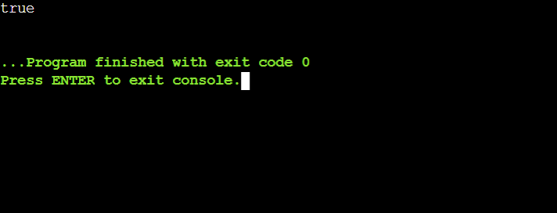
Exercise 2: Implementing the Factory Method Pattern
Scenario:
You are developing a document management system that needs to create different types of documents (e.g., Word, PDF, Excel). Use the Factory Method Pattern to achieve this.
Steps:
- Create a New Java Project:
  - Create a new Java project named FactoryMethodPatternExample.
- Define Document Classes:
  - Create interfaces or abstract classes for different document types such as WordDocument, PdfDocument, and ExcelDocument.
- Create Concrete Document Classes:
  - Implement concrete classes for each document type that implements or extends the above interfaces or abstract classes.
- Implement the Factory Method:
  - Create an abstract class DocumentFactory with a method createDocument().
  - Create concrete factory classes for each document type that extends DocumentFactory and implements the createDocument() method.
- Test the Factory Method Implementation:
  - Create a test class to demonstrate the creation of different document types using the factory method.
SOLUTION:
public abstract class Document{
public abstract void getDocument();
}
public class wordDocument extends Document{
public void getDocument(){
System.out.println( "created worddocument");
}
}
public class PdfDocument extends Document{
public void getDocument(){
System.out.println(" created pdfdocument");
}
}
public class ExcelDocument extends Document{
public void getDocument(){
System.out.println("created excelDocument");
}
}
public abstract class DocumentFactory{
public abstract Document createDocument();
}
public class wordFactory extends DocumentFactory{
public Document createDocument(){
return new wordDocument();
}
}
public class pdfFactory extends DocumentFactory{
public Document createDocument(){
return new PdfDocument();
}
}
public class excelFactory extends DocumentFactory{
public Document createDocument(){
return new ExcelDocument();
}
}
public class Main{
public static void main(String[] args)
{
DocumentFactory doc=new wordFactory();
Document word=doc.createDocument();
word.getDocument();
}
}
RESULT:
