REVENUE SCIENCE — PROOF OF CONCEPT
Revenue Quality & Leakage Recovery
Problem Statement, Root-Cause Analysis, and a Working Proof-of-Concept Solution

Prepared by Kritika
mahnakritika3@gmail.com · August 2026
A revenue leakage in low-density, e-commerce-driven shipments is a structural, quantifiable, and fixable problem. This document lays out the problem, traces it to its root causes, and proposes a working, data-driven solution — with a proof-of-concept built end to end to demonstrate the approach.
Independent analysis, not affiliated with or endorsed by FedEx. Built entirely on public information — no proprietary, confidential, or internal FedEx data was used anywhere in this document.

1. Executive Summary
Shipments that are low-density — bulky relative to their weight, like apparel and home goods — are systematically billed below their true cost-to-serve. This is not a one-off billing error; it is a structural gap between how rate cards are set (on average density assumptions, negotiated once and rarely revisited) and how the shipment mix actually behaves (fast-moving, e-commerce-driven, and increasingly weighted toward light, bulky goods). The gap is real, measurable, and — based on public industry signals — actively being worked on by carriers right now.
This document lays out the problem end to end: a formal problem statement (5W), a root-cause analysis (5 Whys and a fishbone diagram), and a proposed solution — a three-stage analytical engine (Detect → Target → Forecast) that finds the leakage, decides which accounts to act on and how, and forecasts the recovery. The approach is demonstrated with a working proof-of-concept: a full Python pipeline run on a synthetic but realistic dataset, calibrated to publicly disclosed industry facts. No proprietary or confidential data was used anywhere in this analysis.

2. Problem Statement
Revenue leakage and yield erosion: a meaningful share of shipments — especially low-density, “light & bulky” e-commerce packages — are billed below their true cost-to-serve and below target margin. The gap is driven by static rate structures that don't adjust as fast as the underlying package-density mix shifts, and it is largest in exactly the categories e-commerce has grown fastest: apparel, home goods, and similar bulky-but-light goods.
 | Framing
What | Shipments — especially low-density e-commerce packages — are billed below true cost-to-serve and target margin.
Who | Pricing and revenue teams own the fix; Sales and Finance feel the downstream impact; SME and e-commerce accounts are most exposed.
When | A structural, ongoing issue — acute since the e-commerce boom, now more urgent given recent dimensional-weight rule changes and shifting parcel volume mix.
Where | Concentrated in low-density product categories (apparel, home goods) and in SME / e-commerce-heavy accounts.
Why | Static rate cards and periodic reviews can't track fast-moving package-density mix, so pricing lags reality instead of continuously correcting for it.

3. Why This Matters Now
Four public data points, taken together, point at the same underlying problem: revenue quality in low-density, e-commerce-driven shipments is under active pressure across the parcel industry.

Dimensional-weight rules have been tightened
Carriers now round every fractional inch UP on all three package dimensions — a direct lever to capture more revenue from light, bulky e-commerce packages, up from a more forgiving rounding standard.
Source: shipping-industry trade press (ShipperHQ, PARCEL Industry, 3PL Center)

Competitors moved in lockstep
UPS rolled out a nearly identical dimensional-rounding change around the same time — evidence this is an industry-wide revenue-quality tactic, not a FedEx-only move.
Source: shipping-industry trade press (ShipperHQ, PARCEL Industry, 3PL Center)

“Revenue quality” is the watchword
Q4 FY26 package yield was reported up 11% year over year, with company commentary attributing the large majority of that gain to base price increases rather than fuel surcharges or volume growth — a deliberate, disciplined pricing stance.
Source: FedEx Q4 FY26 earnings coverage (multiple financial outlets)

Low-margin volume is being deliberately traded for margin
Ground Economy volume was reported down roughly 5% in the quarter — a signal that low-margin volume is being traded for margin quality, not chased at any cost.
Source: FedEx Q4 FY26 earnings coverage (multiple financial outlets)

4. Root-Cause Analysis

4.1 The Five Whys
Tracing the problem back through five iterations of “why” surfaces the structural root cause:
- Why 1 — Why is revenue quality eroding in e-commerce / low-density shipments? Because many shipments are billed below their true, correctly-measured cost-to-serve.
- Why 2 — Why are they billed below true cost? Because billable weight is set by static, negotiated rate terms — not continuously reconciled against actual package density.
- Why 3 — Why aren't rates reconciled continuously? Because there's no scalable analytics process that monitors account-level density and margin drift and triggers action.
- Why 4 — Why is there no such process? Because pricing analytics today is largely retrospective — periodic rate reviews and contract audits — not a standing statistical monitoring system.
- Why 5 — Why is it retrospective, not continuous? Because closing that gap requires building a dedicated capability: a revenue science function that combines shipment-level modeling, elasticity analysis, and forecasting into a repeatable, proactive process. This is precisely the capability the proposed solution builds.

4.2 Fishbone (Ishikawa) Diagram
Five contributing categories converge on the same effect — none of them fixable by a one-time rate change alone.
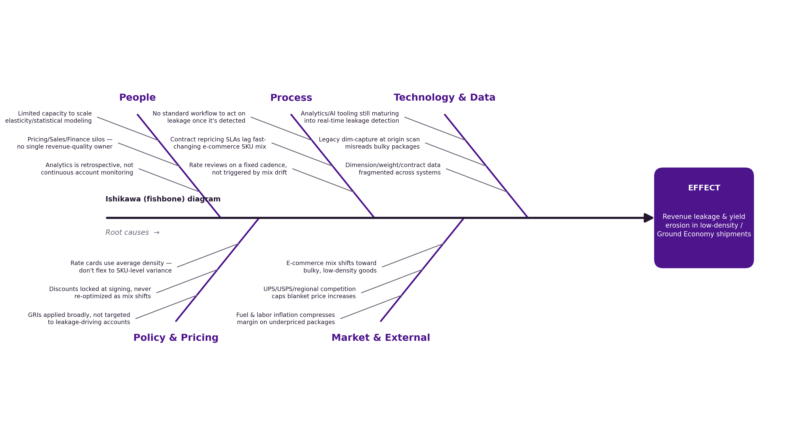
Figure 1. Root causes of revenue leakage, grouped into People, Process, Technology & Data, Policy & Pricing, and Market & External categories, all converging on the same effect.

5. Proposed Solution: A Revenue Quality & Leakage Recovery Engine
The proposed solution is a three-stage analytical pipeline — Detect, Target, Forecast — that turns shipment-level data into an account-level action list, not just a report. Each stage is designed to close one link in the root-cause chain above.

5.1 Detect
Recompute the correct dimensional-weight revenue for every shipment from its length, width, and height, and compare it to what was actually billed.
- Applies the published domestic dimensional-weight divisor (139 in³/lb)
- Models both the legacy and the current, tightened rounding rule, so the shift itself is visible in the data
- Flags the dollar gap, shipment by shipment, rather than waiting for a periodic audit

5.2 Target
Roll shipment-level findings up to the account level; score every account on a blended margin-gap and leakage-share risk score, and size two concrete levers.
- A composite risk score ranks every account, concentrating attention on the ones that are both under-margin and leaking revenue — not just one or the other
- Segment-level price elasticity (e.g., SME vs. mid-market vs. enterprise) sizes how much room there is to correct pricing without triggering churn
- Two levers per account: a no-risk billing correction (Lever A), and a capped, elasticity-aware repricing recommendation (Lever B), each sized independently

5.3 Forecast
Project the leakage trend forward, and model the revenue-quality recovery curve as both levers ramp in over a multi-month rollout.
- A trend baseline (“do nothing”) is compared against an intervention scenario
- The intervention scenario uses a realistic ramp curve (partial capture in month one, building toward full run-rate) rather than assuming an unrealistic overnight fix
- The output is a monthly recovery curve leadership can use for planning, not a single static number

5.4 Data & Transparency
The proof-of-concept below runs on a synthetic dataset — 60,000 shipments across 900 accounts over a 13-month window — generated to mirror publicly disclosed facts: the published dimensional-weight divisor, the industry-reported dimensional-rounding rule change, and public earnings commentary on base yield and revenue quality. No proprietary or confidential shipment, billing, or customer data was used anywhere in this analysis. Every modeling assumption — the cost curve, price elasticity by segment, and the leakage-probability model — is clearly labeled as an illustrative assumption in the underlying code, not a claim about any carrier's actual internal economics. The purpose of the proof-of-concept is to demonstrate the method; validating it against real shipment and billing data is the natural next step (see Section 8).

6. Results from the Proof-of-Concept

6.1 Headline metrics
Metric | Value | Detail
Leakage identified (sample) | $72.1K | 5.4% of sample revenue
Leak $ / shipment, current rule | $1.32 | +46.2% vs. the prior, looser rounding rule
Tier-1 “act now” accounts | 135 | 35.7% of total leakage dollars, from 15% of accounts
Annualized recovery potential | $69.6K | Levers A + B combined, at sample scale
6-month forecast recovery | $12.6K | Cumulative, under a realistic phased rollout

6.2 Where the leakage concentrates
Leakage is concentrated in exactly the categories a dimensional-weight billing gap would predict — low-density, bulky goods.
Category | Leakage ($) | % of category revenue
Home & Bulky | $54,652 | 11.9%
Apparel / Soft Goods | $13,340 | 6.7%
Electronics | $2,071 | 1.4%
Health / Beauty | $1,546 | 2.9%
Industrial / B2B | $522 | 0.1%

6.3 Account prioritization
A composite risk score (blending margin gap and leakage share) ranks all 900 accounts into three action tiers.
Tier | Accounts | Leakage ($) | Recommended recovery ($)
Tier 1 — Act Now | 135 | $25,753 | $29,002
Tier 2 — Monitor | 225 | $25,830 | $25,830
Tier 3 — Healthy | 540 | $20,548 | $20,548

6.4 Sample worklist (top accounts)
The output of the model is a ranked, actionable worklist — not just a summary chart. A sample of the top accounts by recommended recovery:
Account | Segment | Leakage ($) | Sugg. price Δ | Recovery ($)
A100172 | SME | $1,001 | +2.7% | $1,038
A100620 | Mid-Market | $914 | +4.5% | $1,020
A100469 | SME | $921 | +2.5% | $957
A100809 | Enterprise | $800 | +6.3% | $934
A100802 | Mid-Market | $836 | +3.1% | $883
Read this row: account A100172 (SME, Home & Bulky) is under-billed by roughly $1,000 in the sample window. A capped 2.7% price move — sized to this account's own price elasticity — plus the dimensional-weight billing correction recovers essentially all of it, net of modeled volume risk.

7. Forecast & Business Case
Under a “do nothing” baseline, monthly leakage continues to trend upward as e-commerce mix shifts further toward low-density goods. Under the proposed intervention — billing correction plus targeted, elasticity-capped repricing, ramped in over six months — monthly leakage is projected to fall by roughly 44% by month six, worth a cumulative $12.6K in this sample window.
At real-world shipment volumes — many millions of packages a day for a major parcel carrier — this sample is a rounding error. That is by design: the purpose of the proof-of-concept is to prove the method (Detect → Target → Forecast) on a small, fully transparent dataset, not to size the real opportunity. The right next step is validating this pipeline against real shipment and billing data, where the same logic would surface the actual dollar opportunity at scale.

8. From POC to Production: Implementation Roadmap
Phase | Timeline | Focus
1. Validate | Days 0–30 | Replace synthetic data with a sampled extract of real shipment/billing records; recalibrate cost and elasticity assumptions with Finance and Pricing stakeholders.
2. Integrate | Days 30–90 | Connect to the actual rating/billing systems; stand up account scorecards refreshed on a rolling basis instead of quarterly.
3. Pilot | Days 90–180 | Automate the billing-correction lever end to end; pilot the targeted-repricing lever with an approved account cohort, tracking churn against forecast.
4. Scale | Ongoing | Expand to additional segments and products; document the method fully so it can be run and extended by others, not re-run as a one-off exercise.

9. Key Takeaways & Recommendations
- The problem is structural, not seasonal. Static rate cards and periodic reviews can't track fast-moving package-density mix, so low-density shipments are billed below true cost-to-serve — and the gap compounds with every rate change.
- The method — Detect, Target, Forecast — is fully demonstrated end to end: shipment-level leakage detection, composite account risk scoring, and a forecast that fits a linear trend to the leakage baseline and layers a modeled (not fitted) intervention ramp on top — all built and run in this proof-of-concept.
- The output is a worklist, not just a chart: a ranked, account-level list with two concrete levers and a capped, elasticity-aware price recommendation per account — something a team can act on directly.
- The fix is inherently cross-functional. The fishbone analysis spans people, process, technology, policy, and market causes — closing the gap touches Pricing, Sales, Finance, and Operations together, not one team in isolation.
- The recommended next step is validation on real data: a phased rollout — validate, integrate, pilot, scale — turns this proof-of-concept into a production capability.

Appendix: Methodology, Assumptions & Data Sources
This proof-of-concept uses a synthetic, illustrative dataset (60,000 shipments across 900 accounts, spanning a 13-month window) generated to mirror publicly disclosed facts. No proprietary, confidential, or customer data was used anywhere in this analysis. All figures in this document are directional, meant to demonstrate an analytical method that could be applied to real shipment and billing data — not to represent any carrier's actual financial results.

Public facts the dataset is calibrated to
- The published domestic dimensional-weight divisor (139 in³/lb) used by major US parcel carriers.
- The industry-reported dimensional-weight rounding rule change (rounding every fractional inch up on all three dimensions), reported across shipping-industry trade press.
- Public earnings-call commentary on base-yield-led revenue quality and shifting low-margin parcel volume.

Modeling assumptions (clearly labeled, not claims about real economics)
- Cost-to-serve curve: a fixed handling/space cost plus a per-pound linehaul cost that scales with shipping zone.
- Price elasticity by segment: illustrative values within the general range reported in parcel-industry pricing literature (roughly -0.2 to -0.7), more elastic for smaller accounts and less elastic for larger ones.
- Leakage probability: a function of how large the gap is between a shipment's actual and correctly-measured billable weight, and how long it has been since an account's rate terms were last reviewed.

