SQL ANALYSIS
1️⃣ Create Table
CREATE TABLE incidents (
incident_id INT,
category VARCHAR(50),
priority VARCHAR(10),
resolution_time_hours FLOAT,
root_cause VARCHAR(50),
customer_impact VARCHAR(5),
agent_id INT
);

2️⃣ SQL Queries (WITH PROBLEM ANALYSIS)
1️⃣ Top Issues
SELECT category, COUNT(*) FROM incidents
GROUP BY category
ORDER BY COUNT(*) DESC;
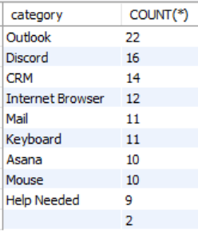

2️⃣ Average Resolution Time
SELECT priority, AVG(resolution_time_hours)
FROM incidents
GROUP BY priority;
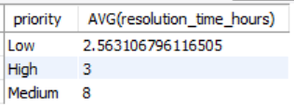
3️⃣ AGENT PERFORMANCE RANKING (RANK)
Which agents are resolving tickets fastest?
SELECT
agent_id,
AVG(resolution_time_hours) AS avg_resolution_time,
RANK() OVER (ORDER BY AVG(resolution_time_hours)) AS performance_rank
FROM incidents
GROUP BY agent_id;
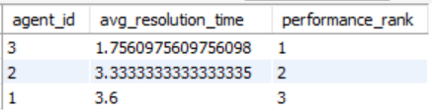

4️⃣ HIGH PRIORITY TREND BY CATEGORY
Which category generates the most high-priority incidents?
SELECT
category,
COUNT(*) AS high_priority_count
FROM incidents
WHERE priority = 'High'
GROUP BY category
ORDER BY high_priority_count DESC;

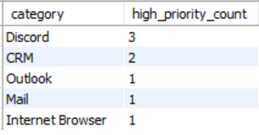

5️⃣ ESCALATION RISK IDENTIFICATION
Which incidents are at risk of escalation due to very high resolution time?
SELECT *
FROM incidents
WHERE resolution_time_hours >
(SELECT AVG(resolution_time_hours) + 2*STDDEV(resolution_time_hours)
FROM incidents);
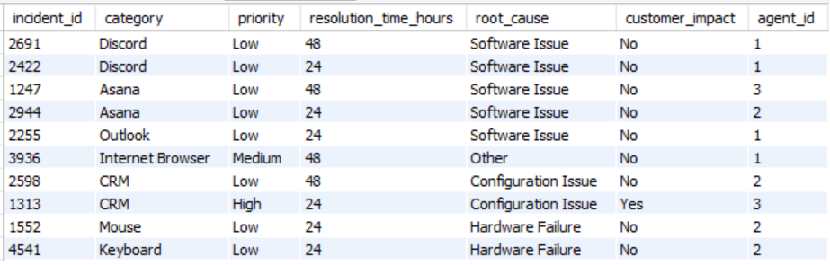

6️⃣ CATEGORY CONTRIBUTION PERCENTAGE
What percentage of total incidents comes from each category?
SELECT
category,
COUNT(*) AS category_count,
ROUND(
COUNT(*) * 100.0 / SUM(COUNT(*)) OVER (), 2) AS percentage_contribution
FROM incidents
GROUP BY category;
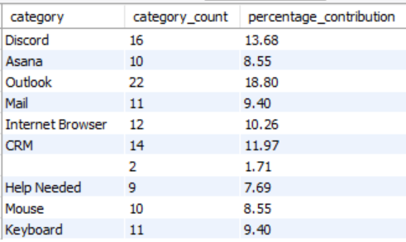
7️⃣ CUSTOMER IMPACT ANALYSIS (CASE + WINDOW)
Which category has the highest customer impact rate?
SELECT
category,
COUNT(*) AS total_incidents,
SUM(CASE WHEN customer_impact = 'Yes' THEN 1 ELSE 0 END) AS impacted_incidents,
ROUND(
SUM(CASE WHEN customer_impact = 'Yes' THEN 1 ELSE 0 END)*100.0/COUNT(*), 2 ) AS impact_percentage
FROM incidents
GROUP BY category;
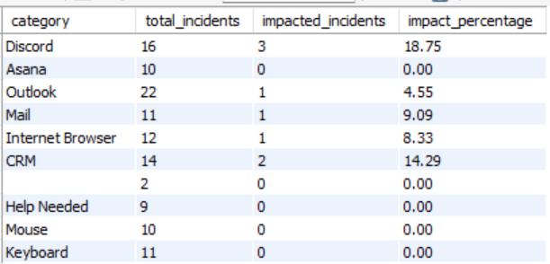

8️⃣ BOTTLENECK INCIDENT IDENTIFICATION
Which incidents are taking unusually long time compared to overall average resolution time?
SELECT
incident_id,
category,
priority,
resolution_time_hours
FROM incidents
WHERE resolution_time_hours >
(SELECT AVG(resolution_time_hours) FROM incidents)
ORDER BY resolution_time_hours DESC;
