
A Technology Stack Guide
on
“ShopAssist-AI: An Agentic RAG Customer-Support and Inventory Assistant for an Online Clothing Store”
(Every tool, model, method and n8n node used in the project – what it is, why it was chosen and how it is used)

Course: Agentic AI for Business Automation
Capstone Project (Individual)
Submitted by
065087: Kritika Bhachawat
PGDM (Business Data Analytics), 2025–27
FORE School of Management, New Delhi
Date of Submission: 10th October 2026
Submitted to: Prof. Shiva Botchu

1. The stack at a glance
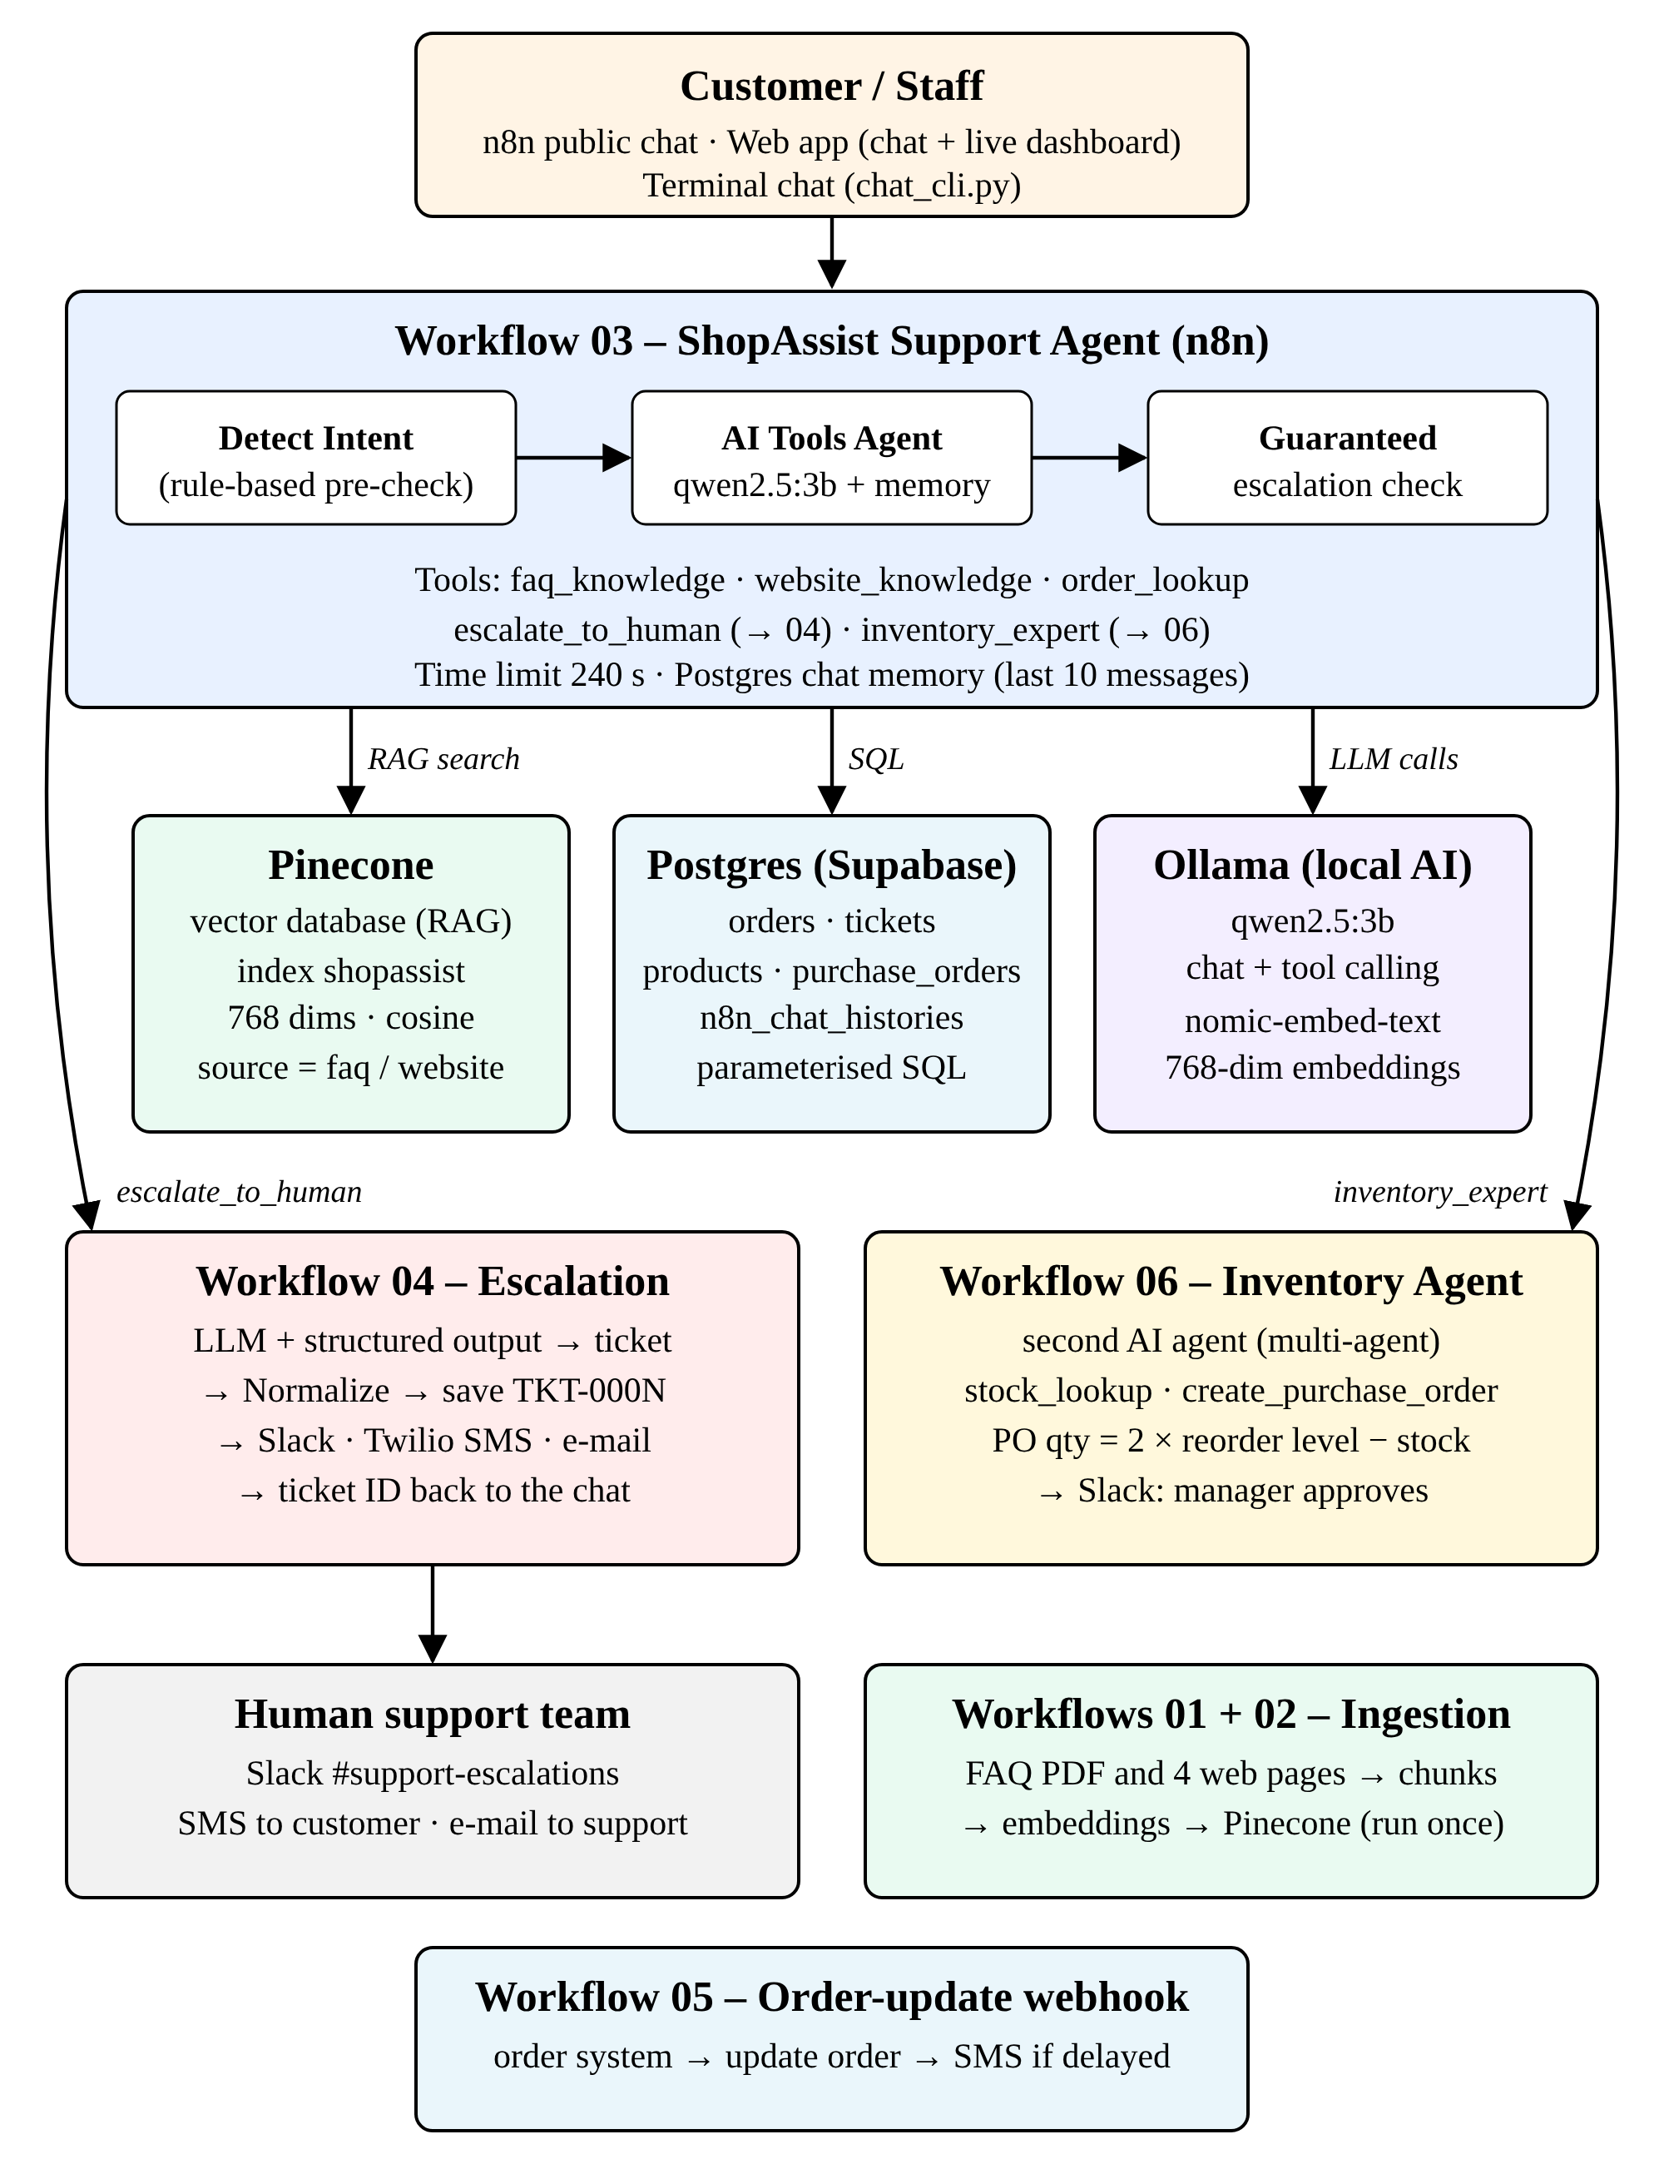
How the technologies fit together
Layer | Technology | Cost | Runs where
Automation & agents | n8n 2.x | Free (self-hosted) | Laptop, Docker
Language model | qwen2.5:3b via Ollama | Free | Laptop
Embedding model | nomic-embed-text via Ollama | Free | Laptop
Vector database | Pinecone | Free tier | Cloud
Relational database | PostgreSQL (Supabase) | Free tier | Cloud
Notifications | Slack, Twilio SMS, Gmail SMTP | Free / trial | Cloud
App & tooling | Python 3, HTML/CSS/JS, Docker, Git/GitHub | Free | Laptop

2. Core AI concepts used

2.1 Agentic AI and AI agents
Aspect | Details
What it is | An AI agent is an LLM that can decide which actions (tools) to take, observe the results and continue until the task is done, instead of only producing text.
Method | Reason → act (call a tool) → observe → answer. This is the ReAct pattern; n8n's Tools Agent implements it with native tool calling.
In ShopAssist | Two agents: the Support Agent (workflow 03, 5 tools, up to 8 steps) and the Inventory Agent (workflow 06, 2 tools, up to 4 steps).
Why | Customer questions vary; the agent chooses between the FAQ, website, order database, inventory expert and escalation itself.

2.2 Tool calling
Aspect | Details
What it is | The model returns a structured request such as order_lookup({"order_id_or_phone":"UT1002"}) instead of text. n8n runs the tool and gives the result back to the model.
In ShopAssist | Tools: faq_knowledge, website_knowledge, order_lookup, escalate_to_human, inventory_expert, stock_lookup, create_purchase_order.
How inputs are filled | n8n $fromAI(name, description, type, default) lets the model fill each tool parameter. Defaults keep a tool working if the model forgets a field.
Why it matters | The model needs tool-calling support, which is why qwen2.5 was chosen.

2.3 RAG – Retrieval-Augmented Generation
Aspect | Details
What it is | Before answering, search a knowledge base for the most relevant text and give it to the LLM, so the answer is based on the company's own documents, not on the model's memory.
Steps | 1) Load documents → 2) split into chunks → 3) turn chunks into vectors (embeddings) → 4) store in a vector database → 5) at question time embed the question, find the nearest chunks, answer from them.
In ShopAssist | Two knowledge bases in one Pinecone index, separated by metadata: source=faq (PDF) and source=website (4 scraped and summarized pages).
Agentic RAG | The agent decides which knowledge base to search (or none), instead of always searching everything.
Benefit | Fewer invented answers ("hallucinations"), easy updates (re-ingest a document, no retraining), and answers can name their source.

2.4 Embeddings and vector search
Aspect | Details
What it is | An embedding is a list of numbers (here 768) that represents the meaning of a text. Texts with similar meaning have vectors that point in similar directions.
Similarity | Cosine similarity measures the angle between two vectors (1 = same meaning). The Pinecone index uses the cosine metric.
Rule | The same embedding model must be used for storing and for searching, and the index dimension must match the model (768 for nomic-embed-text).
topK | The agent receives the 4 most similar chunks per search (topK = 4).

2.5 Chunking (text splitting)
Aspect | Details
What it is | Long documents are cut into smaller pieces so each vector represents one topic and fits the model's context.
Method | Recursive Character Text Splitter: it tries to split at paragraphs, then sentences, then words, so pieces stay readable.
Settings | Chunk size 1,000 characters, overlap 200: the overlap keeps a sentence that crosses a border searchable in both chunks.

2.6 Metadata filtering
Aspect | Details
What it is | Each vector carries labels (metadata). A search can be limited to vectors with certain labels.
In ShopAssist | source (faq / website), plus url and title for web pages. faq_knowledge filters source=faq; website_knowledge filters source=website.

2.7 Summarization before storing
Aspect | Details
What it is | Web pages are summarized by the LLM into factual bullets before they are embedded.
Why | Raw HTML text has menus and repetition. Summaries are shorter and cleaner, so retrieval is more precise and uses less context.
Settings | Basic LLM Chain, qwen2.5:3b, temperature 0 (factual, repeatable).

2.8 Structured output
Aspect | Details
What it is | Forcing the LLM to answer in a fixed JSON format defined by a JSON schema.
In ShopAssist | Workflow 04 turns an escalation into a ticket with fixed fields: customer_name, phone, order_id, issue_type, sentiment, priority, summary, suggested_action.
Methods | Structured Output Parser (schema) + Ollama JSON mode (format: json) + a Normalize step that fills gaps and clamps values to the allowed lists.

2.9 Conversation memory
Aspect | Details
What it is | The agent remembers earlier messages in the same chat session.
In ShopAssist | Postgres Chat Memory: table n8n_chat_histories, last 10 messages per session, so "and when will it arrive?" works after an order ID was given.

2.10 Multi-agent system
Aspect | Details
What it is | Several specialised agents work together; one agent calls another like a tool.
In ShopAssist | The Support Agent calls the Inventory Agent through the inventory_expert tool (n8n "Call n8n Workflow" tool). Each agent has its own prompt, tools and limits.
Why | Separation of concerns: customer service and procurement need different knowledge and permissions. Each agent stays small and reliable.

2.11 Human-in-the-loop
Aspect | Details
What it is | The AI hands over to a person for decisions it should not make alone.
In ShopAssist | Escalation tickets for angry customers and refunds above Rs 5,000; purchase orders are drafts that a manager approves in Slack.

2.12 Guardrails (deterministic rules around the AI)
Aspect | Details
What it is | Rules in normal code that check or correct what the AI does.
In ShopAssist | Detect Intent (pre-check notes and flags), guaranteed escalation, refund amount read from the database, Normalize Ticket, SQL-enforced PO quantity, tool input defaults, fallback replies, time limits, parameterised SQL.
Result | Evaluation went from 9 / 14 to 14 / 14.

2.13 Prompt engineering
Aspect | Details
What it is | Writing clear instructions (system prompt) that define the agent's role, rules and output style.
In ShopAssist | prompts/agent_system_prompt.md: answer only from tools, cite the source, ask for the order ID, escalation rules, refusal of off-topic questions, one-word message mapping. prompts/inventory_agent_prompt.md: stock and PO rules.
Lesson | Short, explicit notes added to the message (by Detect Intent) worked better for a 3B model than a longer system prompt.

3. Platforms and models

3.1 n8n (workflow automation platform)
Aspect | Details
What it is | An open-source, low-code workflow automation tool. Workflows are built from nodes on a canvas; it has native AI (LangChain-based) nodes.
Version / setup | n8n 2.x, self-hosted in Docker (container shopassist-n8n, http://localhost:5679, WEBHOOK_URL set so chat webhooks use the right port).
In ShopAssist | 6 workflows: 01 ingest PDF, 02 scrape + summarize, 03 support agent, 04 escalation, 05 order webhook, 06 inventory agent.
Why | Visual and explainable, many integrations (Slack, Twilio, Postgres, Pinecone), webhooks and a public chat built in; free when self-hosted.
Features used | Publishing (activation), sub-workflows, execution log, per-workflow time limits, credentials store, public REST API (used by the import and doctor scripts).

3.2 Ollama (local model runtime)
Aspect | Details
What it is | A free program that downloads and runs open-source LLMs on your own computer and serves them on http://localhost:11434.
Why chosen | Google Gemini returned "403 project denied" for the available keys. Ollama needs no key, costs nothing and keeps customer data on the laptop.
Connection | n8n credential "Ollama account": http://localhost:11434, or http://host.docker.internal:11434 from Docker.

3.3 qwen2.5:3b (chat / reasoning model)
Aspect | Details
What it is | An open-weights LLM from Alibaba's Qwen team, 3 billion parameters (about 2 GB), with native tool calling and JSON output.
Used for | Both agents' reasoning and answers, page summaries (02), ticket JSON (04).
Key settings | temperature 0.2 for the support agent, 0 for the Inventory Agent, summaries and tickets; numCtx 8192 (the default 2048 cut off the agent prompt); think: false; format: json for tickets.
Trade-off | Small enough for a laptop, but it can skip steps, so the guardrails were added. qwen2.5:7b or 14b would be more accurate but slower.

3.4 nomic-embed-text (embedding model)
Aspect | Details
What it is | An open embedding model from Nomic AI, served by Ollama; it produces 768-dimension vectors and supports long inputs.
Used for | Embedding the FAQ chunks, page summaries and every search question.

3.5 Pinecone (vector database)
Aspect | Details
What it is | A managed cloud database for vectors with fast similarity search and metadata filters.
Setup | Index shopassist, dimension 768, metric cosine, serverless free tier; created by scripts/setup_pinecone.py.
Used by | Workflows 01 and 02 (insert) and the two retrieval tools in workflow 03.

3.6 PostgreSQL on Supabase
Aspect | Details
What it is | PostgreSQL is an open-source relational (SQL) database; Supabase hosts it for free with a web dashboard.
Tables | orders, tickets (TKT-000N id generated by the database), products, purchase_orders (PO-000N), n8n_chat_histories.
Connection | Session pooler (host aws-…pooler.supabase.com, user postgres.<project>), SSL.
Safety | All queries are parameterised ($1, $2…); text from the model is never inserted into SQL directly.

3.7 Slack, Twilio and Gmail SMTP
Aspect | Details
Slack API | Bot posts escalation alerts to #support-escalations (04) and PO approval requests (06).
Twilio SMS | Texts the customer the ticket ID (04) and delay notices (05). Trial accounts send only to verified numbers.
Gmail SMTP | E-mails the full ticket to the support inbox (04), using an app password.
Resilience | All three are set to *continue on error*, so a missing credential or phone number never breaks the chat.

3.8 Docker
Aspect | Details
What it is | Runs applications in isolated containers.
In ShopAssist | n8n runs in Docker Compose; data lives in a volume, so containers can be recreated safely. scripts/fix_webhook_url.sh adds WEBHOOK_URL with an override file.

3.9 Python tooling
Aspect | Details
What it is | Small Python 3 scripts (standard library + pg8000 Postgres driver) that automate setup and testing.
Scripts | build_workflows.py (generates the workflow JSON), import_to_n8n.py (n8n API), setup_database.py, setup_pinecone.py, doctor.py and verify_setup.py (health checks), test_chat.py, chat_cli.py, evaluate.py, kpi_report.py.
Why | Repeatable setup ("infrastructure as code"): the whole system can be rebuilt with a few commands, and problems are diagnosed automatically.

3.10 Web app (front end)
Aspect | Details
Back end | app/server.py: Python standard-library HTTP server on port 8501; endpoints /api/chat (forwards to n8n), /api/kpis (database), /api/status (health).
Front end | app/index.html: plain HTML, CSS and JavaScript, no framework. Chat panel, one-tap chips, status lights, KPI cards and live tables refreshed every 10 s.

3.11 Git and GitHub
Aspect | Details
Used for | Version control and submission: all code, workflows, prompts, data, docs and screenshots are in the repository. Secrets stay in .env, which Git ignores.

4. Every n8n node used
Node (type) | Workflows | Purpose in ShopAssist
Manual Trigger | 01, 02 | Start ingestion by hand
HTTP Request | 01, 02 | Download the FAQ PDF, urls.txt and each web page
Code (JavaScript) | 01–04 | Fix MIME type, split URLs, Detect Intent rules, Needs-a-Ticket check, Normalize Ticket
HTML Extract | 02 | Pull readable body text out of web pages
Basic LLM Chain | 02, 04 | Summarize pages; build the ticket JSON
Default Data Loader | 01, 02 | Turn PDF / text into documents with metadata
Recursive Character Text Splitter | 01, 02 | Chunk 1,000 / overlap 200
Embeddings Ollama | 01–03 | nomic-embed-text vectors
Pinecone Vector Store | 01–03 | Insert vectors; retrieve as an agent tool with a metadata filter
Ollama Chat Model | 02, 03, 04, 06 | qwen2.5:3b for agents, summaries, tickets
Chat Trigger | 03 | Public hosted chat and chat webhook
AI Agent (Tools Agent) | 03, 06 | Reasoning and tool calling
Postgres Chat Memory | 03 | Conversation memory
Postgres Tool | 03, 06 | order_lookup, stock_lookup, create_purchase_order (agent tools)
Call n8n Workflow Tool | 03 | escalate_to_human → 04, inventory_expert → 06
Execute Workflow | 03 | Guaranteed escalation calls 04 directly
Execute Workflow Trigger | 04, 06 | Entry point of sub-workflows
Structured Output Parser | 04 | Ticket JSON schema
Postgres | 03, 04, 05 | Order details, save ticket, update order
IF | 03, 05 | Ticket missing? / order delayed?
Set (Edit Fields) | 02–04, 06 | Shape outputs (reply text, ticket ID, metadata)
Slack | 04, 06 | Escalation alert, PO approval
Twilio | 04, 05 | SMS to the customer
Send Email (SMTP) | 04 | E-mail to the support team
Webhook | 05 | Receive order status updates
Respond to Webhook | 05 | Return ok / not found to the caller

5. Parameters explained
Parameter | Value | What it controls | Why this value
temperature | 0.2 support agent / 0 elsewhere | Randomness of the model | Low = factual and repeatable
numCtx | 8192 | Context window (tokens the model can read) | Default 2048 cut off the system prompt and tool results
think | false | Reasoning mode on/off | qwen2.5 is not a thinking model; avoids errors
format | json (04) | Force JSON output | Valid ticket JSON
maxIterations | 8 (03) / 4 (06) | Max tool-call rounds of an agent | Stops loops; keeps answers fast
contextWindowLength | 10 | Messages kept in memory | Enough context, small prompt
topK | 4 | Chunks returned per search | Enough evidence without noise
chunkSize / overlap | 1000 / 200 | Text chunk length / shared part | One topic per chunk; no lost sentences
dimension / metric | 768 / cosine | Vector size / similarity measure | Must match nomic-embed-text
executionTimeout | 03: 240 s, 04/06: 150 s, 05: 60 s | Max run time of a workflow | A stuck run cannot block the local model

6. Why a local model? (comparison)
Criterion | Cloud LLM API (e.g. Gemini, GPT) | Local LLM (Ollama + qwen2.5:3b) – chosen
Cost | Pay per token after free quota | Free
Access | Needs an API key; Gemini returned 403 for the project | No key, no account
Privacy | Customer data leaves the company | Data stays on the laptop
Quality | Higher | Lower – compensated with guardrails
Speed | Fast, independent of laptop | 2–23 s per answer on a MacBook Air
Availability | Always on | Only while the laptop runs

7. Evaluation and KPI methods
- Automatic evaluation (evaluate.py): 14 questions covering RAG, SQL, combined, missing information, escalation, refusal, one-word inputs and inventory. Each answer is checked for required keywords (and forbidden ones, such as code). Result: 14 / 14, 10 s average.
- Human review of the answers, which found wrong details that keywords miss. Those were then fixed with rules.
- Business KPIs (kpi_report.py, dashboard): conversations, tickets by type and priority, share resolved without a human (≈ 82 %), low-stock products, purchase orders.
- Health checks (doctor.py): code version, .env, Ollama, database tables, Pinecone vector count, n8n workflows and credentials, stuck runs, recent errors.

8. Glossary
Term | Meaning
LLM | Large Language Model – an AI model that reads and writes text
Agent | An LLM that can call tools and act in several steps
Tool | A function the agent can call (database query, search, another workflow)
RAG | Retrieval-Augmented Generation – answer from retrieved documents
Embedding / vector | Numbers that represent the meaning of a text
Vector database | Database that finds the most similar vectors (Pinecone)
Chunk | A small piece of a document stored as one vector
Metadata | Labels stored with a vector (source, url, title)
Hallucination | A confident but invented answer
Guardrail | A rule in code that checks or corrects the AI
Webhook | A URL that another system calls to send data to n8n
Sub-workflow | A workflow called by another workflow
Human-in-the-loop | A person approves or handles what the AI should not decide
Token | A small piece of text (about ¾ of a word) the model processes

