UniPlanner Project Report – Figures

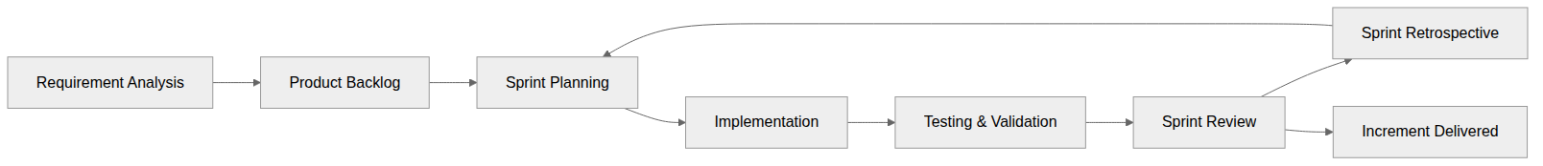
Figure 1.1: Agile Scrum Methodology

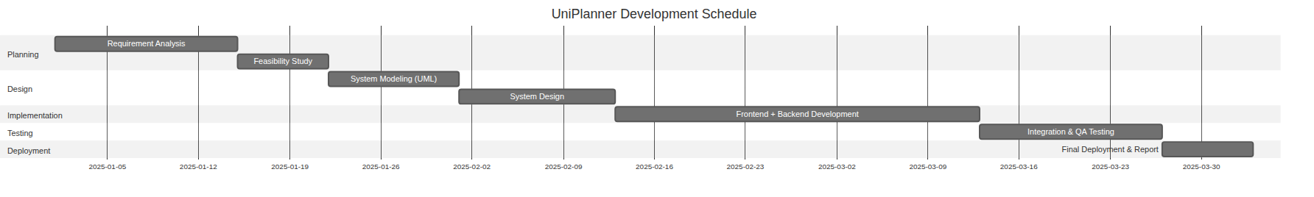
Figure 3.1: Gantt Chart of UniPlanner Development Schedule

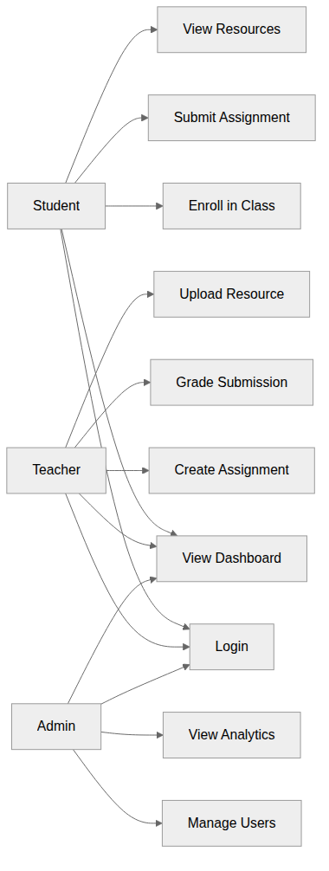
Figure 3.2: Use Case Diagram of UniPlanner

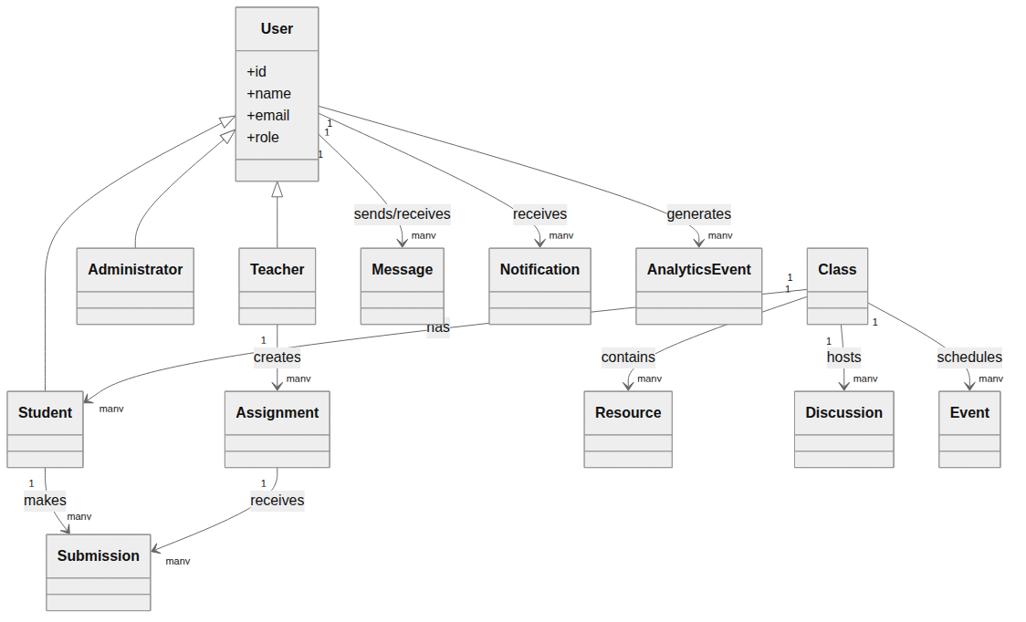
Figure 3.3: Class Diagram of UniPlanner

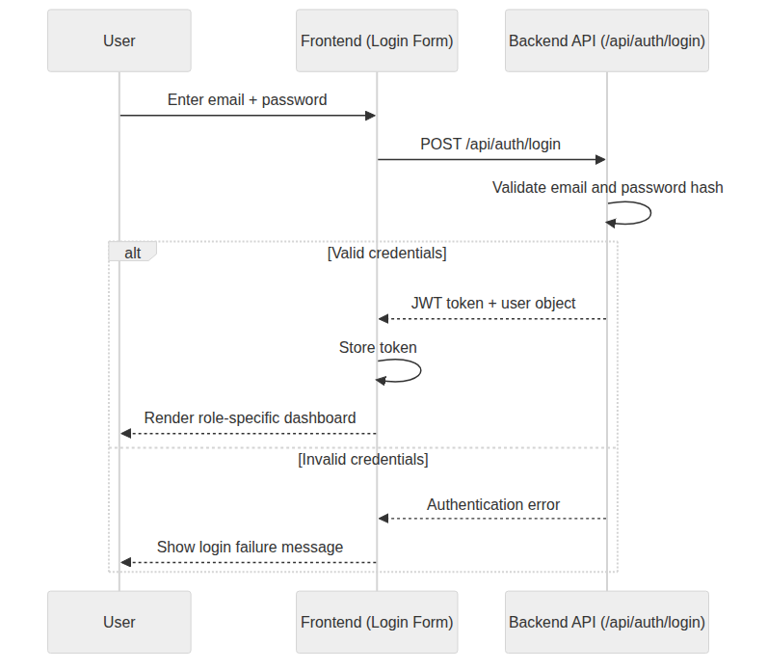
Figure 3.4: Sequence Diagram of Login and Dashboard Flow

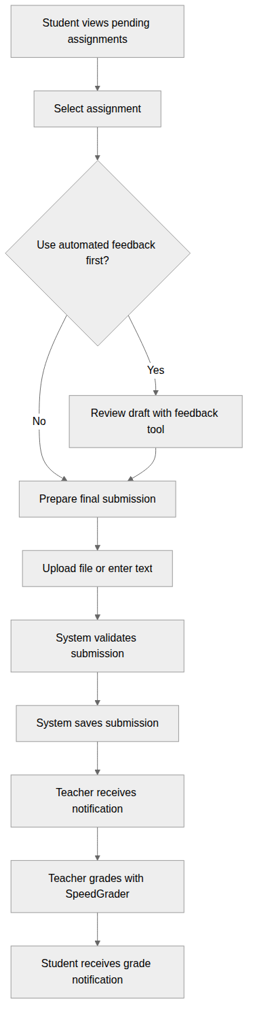
Figure 3.5: Activity Diagram of Assignment Submission Workflow

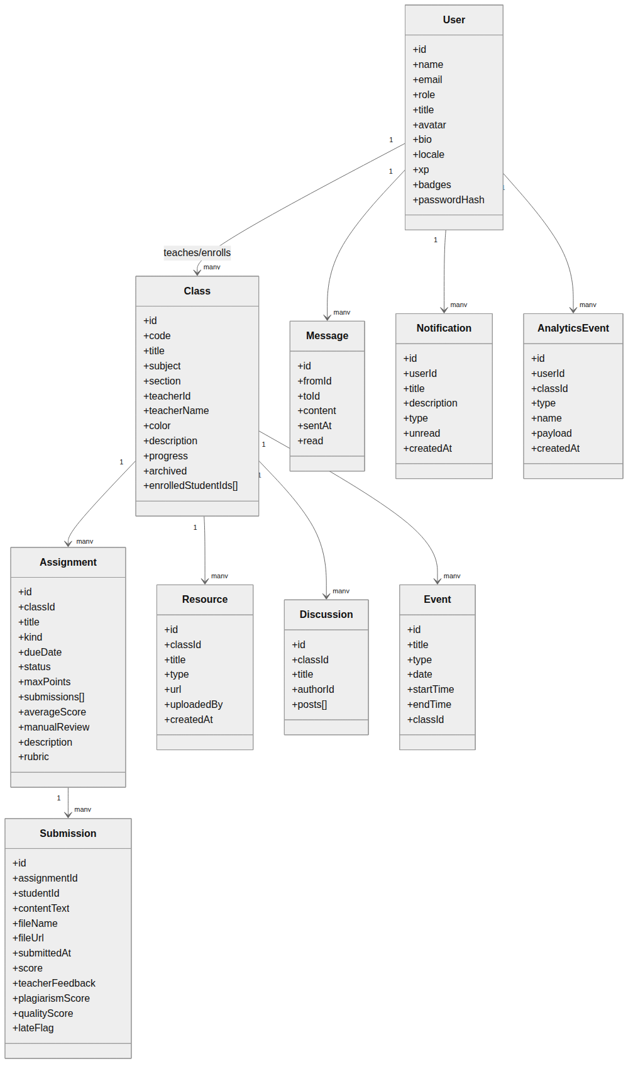
Figure 4.1: Refined Class Diagram of UniPlanner

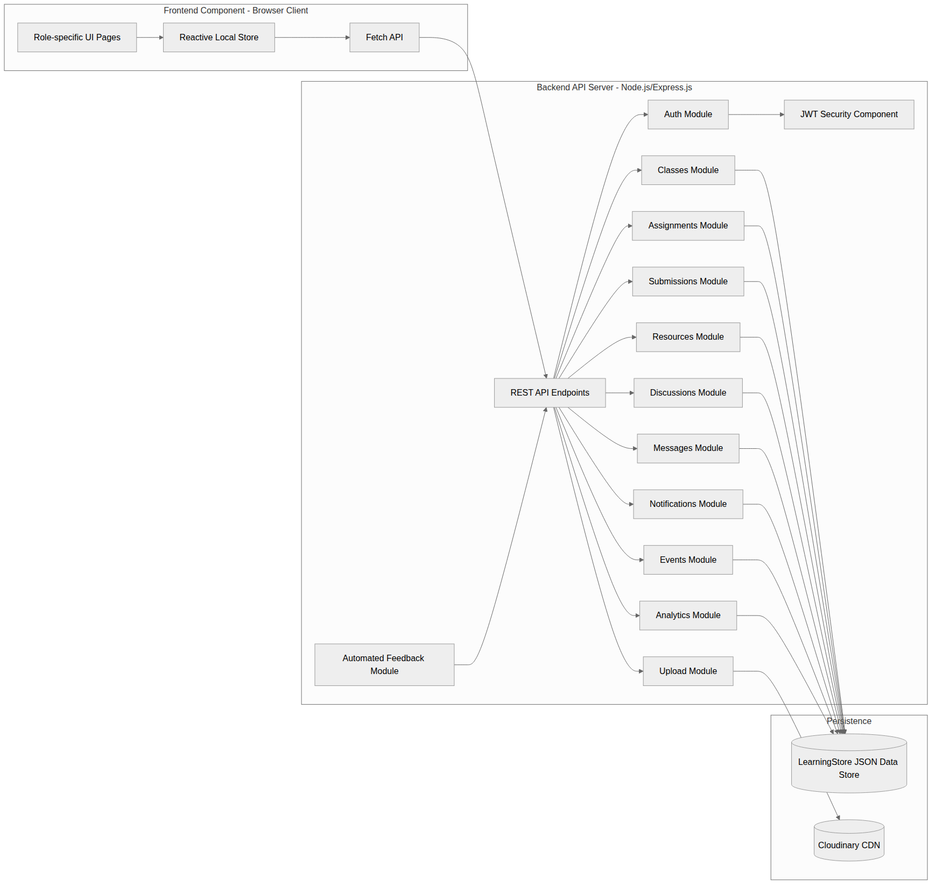
Figure 4.2: Component Diagram of UniPlanner

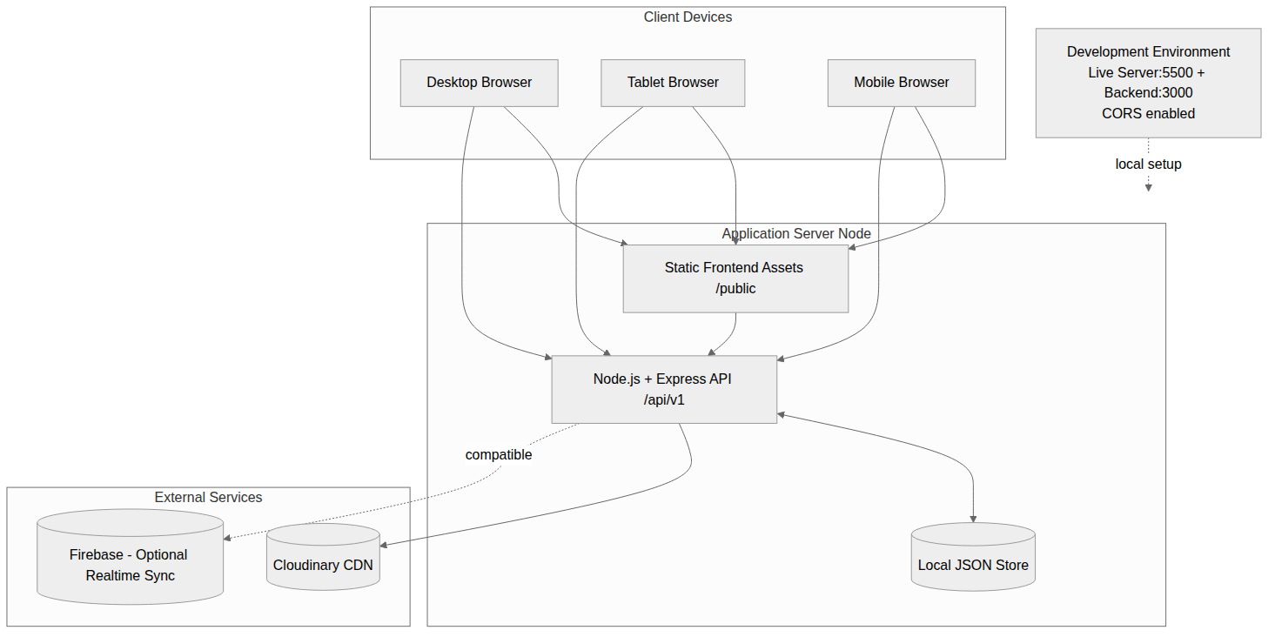
Figure 4.3: Deployment Diagram of UniPlanner

