SEASONAL AGRICULTURE
PERFORMANCE ANALYSIS
Yield, Profitability & Resource-Efficiency Patterns Across Kharif, Rabi & Zaid
VOIS AICTE Batch 2026–2027 — Major Project
Data Analytics Portfolio Project
Dataset: 4,000 farm records · 8 Indian states · 8 crops · 3 seasons
Tools: Python (Pandas, Seaborn, SciPy) · SQL · Jupyter Notebook

Executive Summary
This project analyzes 4,000 farm-level records across 8 Indian states, 8 crops, 3 irrigation methods and 3 cropping seasons — Kharif, Rabi and Zaid — to understand how seasonal conditions drive yield, cost, profitability and water-use efficiency. The goal is to support evidence-based seasonal planning: which crops, irrigation methods and regions perform reliably, and where losses concentrate.
The analysis shows that Zaid is the highest-risk season, with nearly two-thirds of farms operating at a loss, driven by low rainfall, high temperature and poor water efficiency. Crop choice matters more than season alone — Sugarcane and Chilli stay profitable in every season, while Wheat and Rice are loss-making on average regardless of conditions. Drip irrigation consistently outperforms Flood irrigation on water efficiency, with the gap widest exactly when water is scarcest.
4,000  Farm Records | 8  States Covered | 64.5%  Loss-Making Farms (Zaid) | 42.2%  Loss-Making Farms (Kharif)

1. Problem Statement & Objectives
Agricultural performance varies across seasons due to differences in rainfall, temperature, soil conditions, farming practices and market conditions. This project investigates how key performance indicators — yield, cost, revenue, profit, water efficiency and disease/pest risk — differ across the Kharif, Rabi and Zaid seasons, and identifies patterns that can support evidence-based seasonal agricultural planning.

Key Questions Investigated
- How does yield and profitability vary across seasons?
- What environmental conditions (rainfall, temperature, humidity) characterize each season?
- Which crops perform best and worst in each season?
- Does irrigation method effectiveness change by season?
- Are resource usage patterns (water, fertilizer) different across seasons?
- Are seasonal patterns consistent across states?
- What is driving the high proportion of loss-making farms?

2. Dataset & Methodology

Dataset Overview
The dataset covers 4,000 farm records spanning Andhra Pradesh, Gujarat, Karnataka, Madhya Pradesh, Maharashtra, Punjab, Tamil Nadu and Telangana, across 8 crops (Rice, Wheat, Maize, Cotton, Pulses, Groundnut, Chilli, Sugarcane) and 4 irrigation methods (Drip, Sprinkler, Flood, Rainfed). Each record captures environmental conditions (rainfall, temperature, humidity, sunlight, soil health), input usage (fertilizer, pesticide, NPK, seed quality), and financial and resource outcomes (yield, cost, revenue, profit, water use, disease/pest risk).

Data Cleaning & Feature Engineering
- Rainfall (48 missing), Soil Moisture (40 missing) and Yield (32 missing) — together under 1.5% of rows — were imputed using the season-wise median rather than a single global median, to avoid distorting seasonal comparisons.
- No duplicate records were found.
- Engineered features: Profit Margin % (Profit ÷ Revenue), Cost per Hectare, and an Is_Loss_Making flag (Profit_INR < 0).

Tools & Methods
- Python (Pandas, NumPy) for cleaning and feature engineering
- Seaborn / Matplotlib for exploratory visualization
- SciPy (one-way ANOVA) for statistical significance testing
- SQL (companion query set) for summary aggregation, ranking and window-function analysis, portable across MySQL/PostgreSQL/SQL Server

3. Season & Crop Distribution
Kharif is the most represented season (1,780 records), followed by Rabi (1,620) and Zaid (600) — reflecting Zaid's status as a shorter, more limited cropping window in practice. Rice and Wheat are the most-recorded crops, with Sugarcane the least represented.
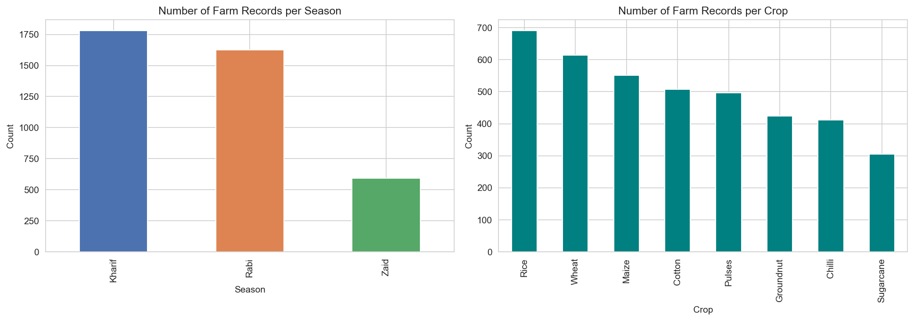
Figure 1. Number of farm records per season and per crop.

4. Environmental Conditions Across Seasons
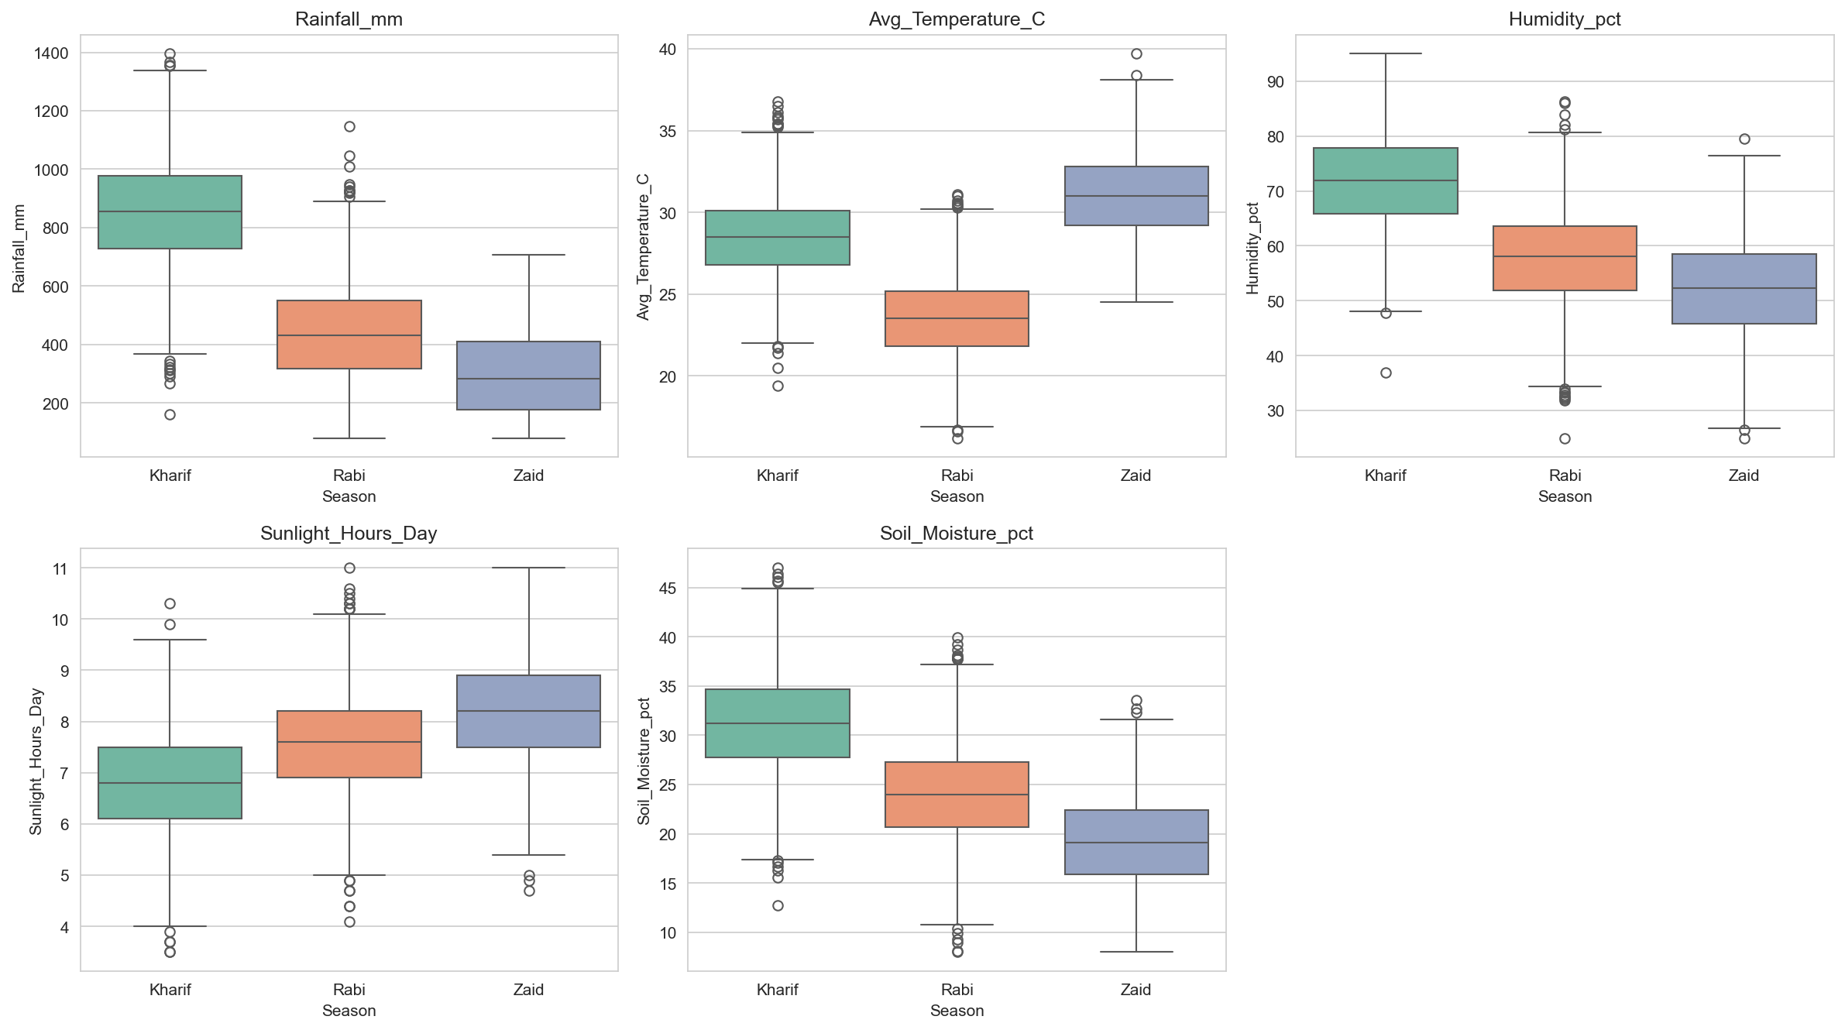
Figure 2. Distribution of rainfall, temperature, humidity, sunlight and soil moisture by season.
Kharif has the highest rainfall (monsoon season) and is warm and humid. Rabi is cooler and drier, typical of winter cropping. Zaid is the hottest season with the lowest rainfall, relying heavily on irrigation. This matches the expected agro-climatic definitions of these seasons in India.

5. Yield & Profitability Across Seasons
Season | Avg Yield (t/ha) | Avg Revenue (₹) | Avg Cost (₹) | Avg Profit (₹) | Loss-Making %
Kharif | 6.0 | 710,719 | 531,804 | 178,915 | 42.2%
Rabi | 5.0 | 601,526 | 513,837 | 87,689 | 51.1%
Zaid | 5.0 | 519,172 | 543,977 | −24,805 | 64.5%

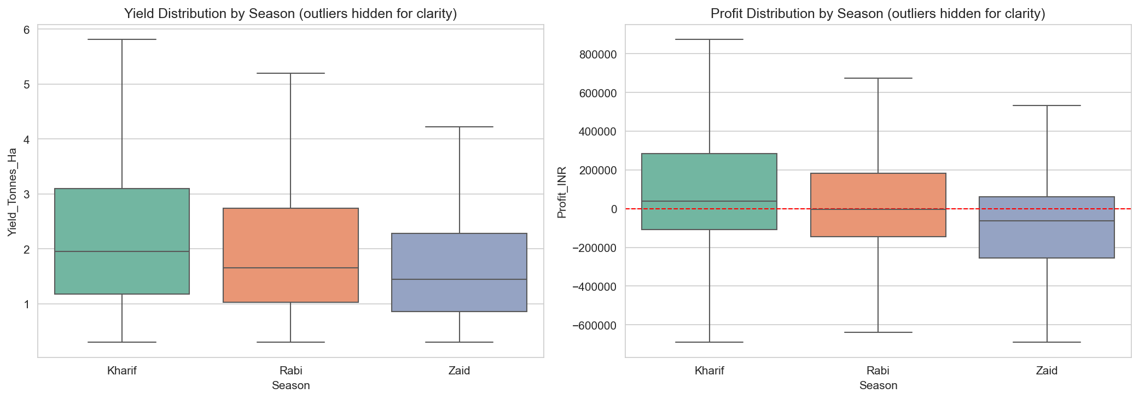
Figure 3. Yield and profit distributions by season (outliers hidden for clarity).
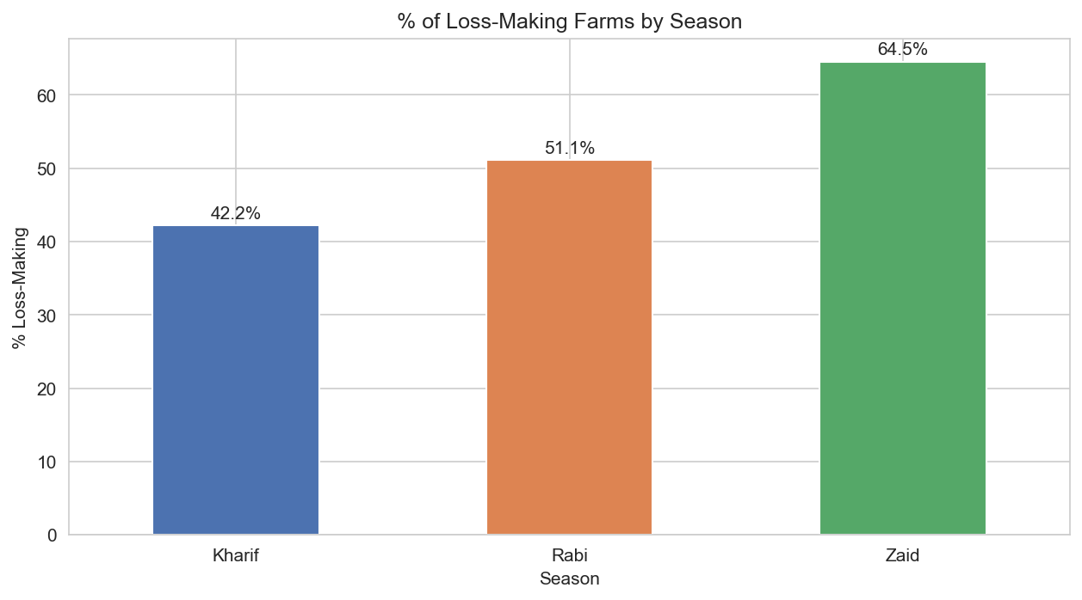
Figure 4. Percentage of loss-making farms by season.
Zaid has both the lowest median profit and the highest share of loss-making farms (64.5%, vs. 51.1% in Rabi and 42.2% in Kharif). This is consistent with its lower rainfall and heavier reliance on costly irrigation, while input costs such as fertilizer remain broadly similar across seasons — meaning Zaid farms pay similar costs for worse growing conditions.

6. Crop Performance by Season
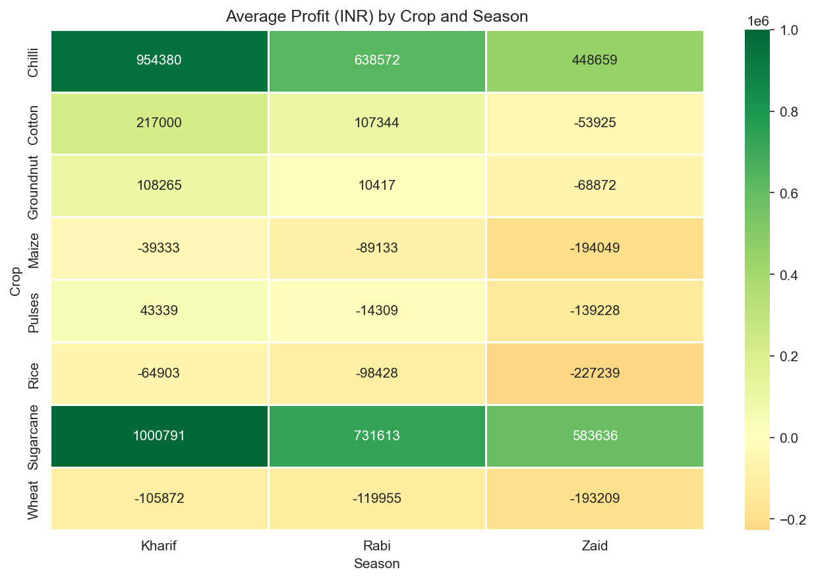
Figure 5. Average profit (INR) by crop and season.
Sugarcane and Chilli remain strongly profitable in all three seasons — Sugarcane in particular averages roughly ₹1,000,791 profit in Kharif, ₹731,613 in Rabi and ₹583,636 even in Zaid. Wheat and Rice are loss-making on average in every season, which points to a structural cost or pricing issue for these crops rather than a purely seasonal effect. Cotton, Groundnut and Pulses are only profitable in Kharif and/or Rabi, turning unprofitable specifically in Zaid — a clear case of crop-season mismatch.

7. Irrigation Method Effectiveness by Season
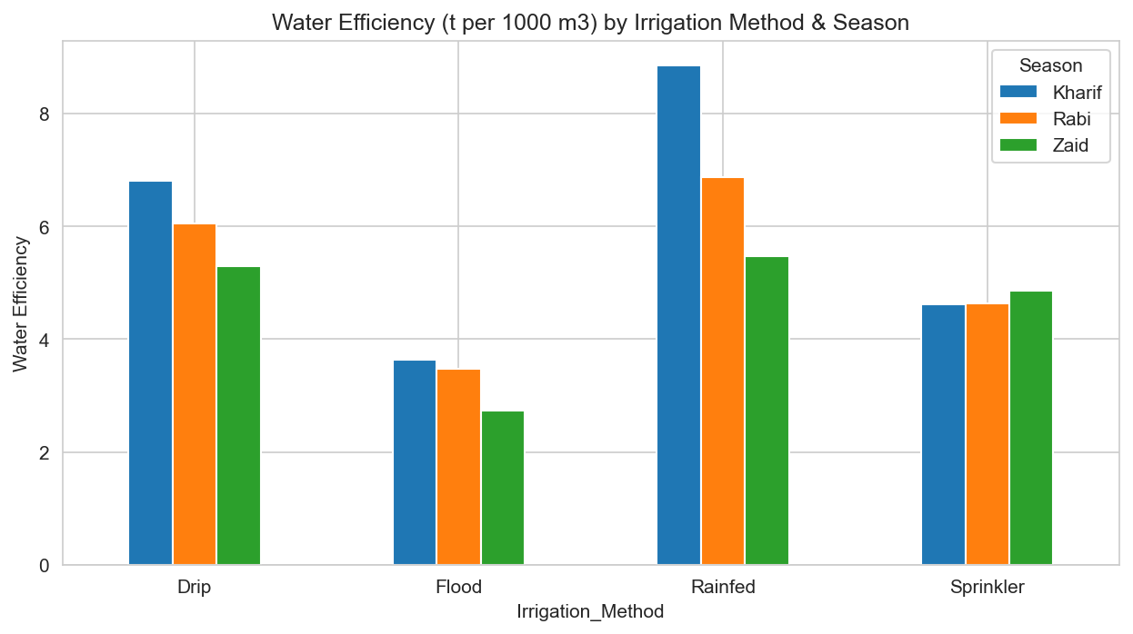
Figure 6. Water efficiency (tonnes per 1,000 m³) by irrigation method and season.
Rainfed and Drip irrigation post the highest water efficiency across all seasons, while Flood irrigation is consistently the least efficient method. The efficiency gap between methods widens in Zaid — exactly when water is scarcest and efficient use matters most — making irrigation method choice a high-leverage lever for improving Zaid-season outcomes.

8. Correlation Analysis
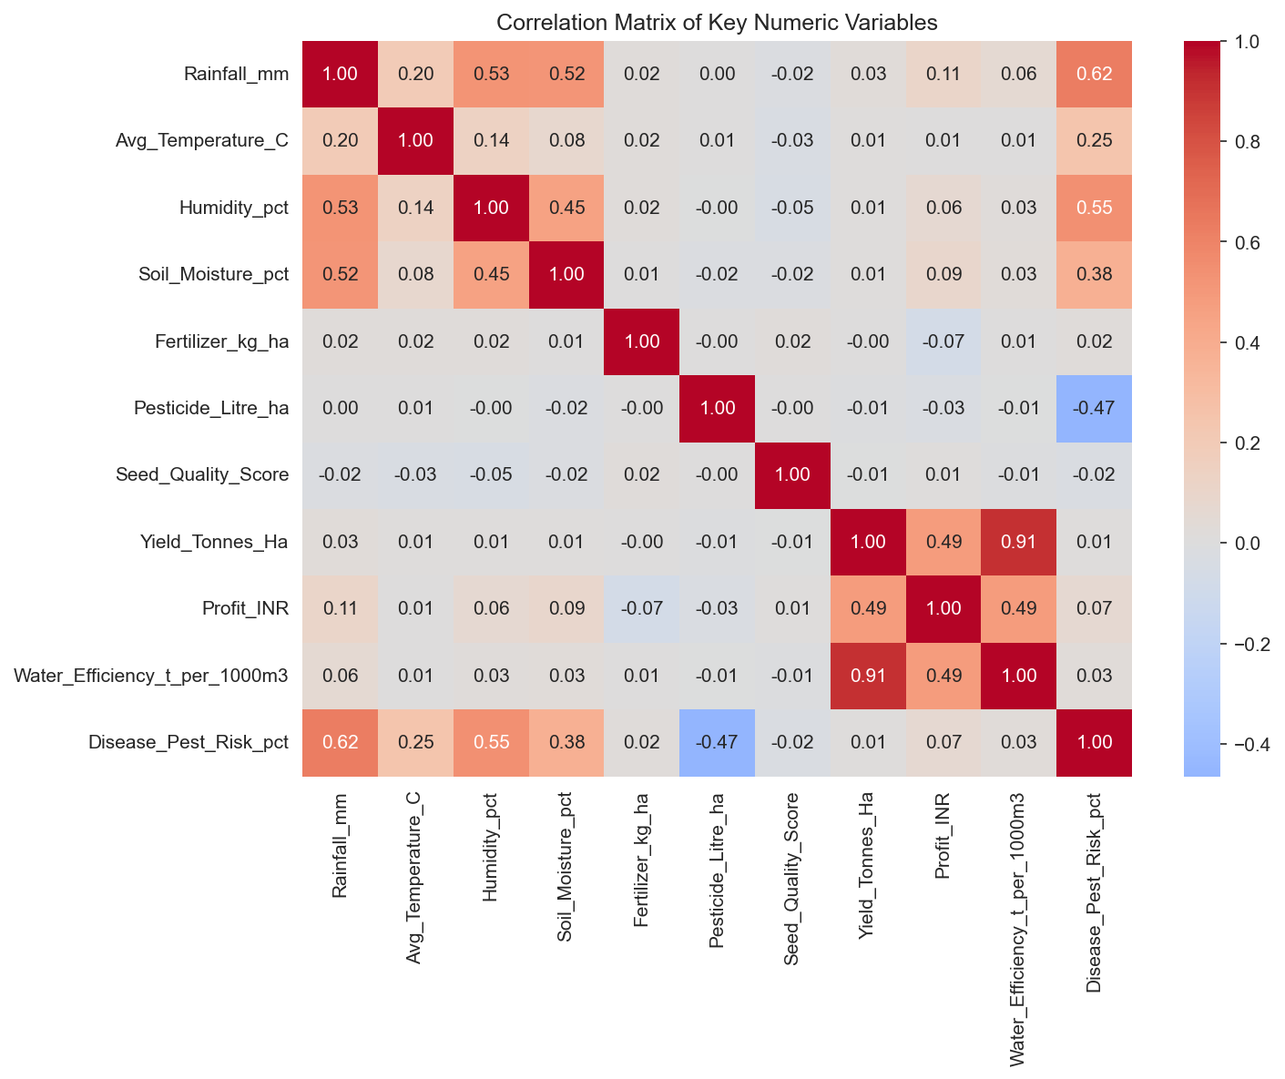
Figure 7. Correlation matrix of key numeric variables.
Yield and water efficiency are very strongly correlated (r = 0.91), and both correlate moderately with profit (r ≈ 0.49) — efficient water use and higher yield move together and both feed profitability. Rainfall, humidity and soil moisture are moderately correlated with each other (as expected physically) and each shows a moderate positive relationship with disease/pest risk (r = 0.62, 0.55 and 0.38 respectively), while pesticide use shows a moderate negative correlation with disease/pest risk (r = −0.47), consistent with pesticide application suppressing recorded risk. Fertilizer, seed quality and temperature show negligible direct correlation with profit.

9. Statistical Significance Test — Does Season Affect Yield?
A one-way ANOVA was run to test whether mean yield differs across Kharif, Rabi and Zaid.
Test | F-statistic | p-value | Result (α = 0.05)
ANOVA: Yield ~ Season | 1.554 | 0.212 | Not significant

With p = 0.212 (> 0.05), the test fails to reject the null hypothesis: mean yield does not differ significantly across seasons at the 95% confidence level. This is an important nuance — while profit and loss-rates clearly diverge by season (Sections 5–6), that gap is driven more by cost structure, water efficiency and pricing than by yield itself.
Note on the source notebook: the notebook's own Section 11 narrative states that "season has a statistically significant effect on yield," but the ANOVA cell immediately above it prints p = 0.212, which is not significant. This report follows the printed test output (not significant) rather than that summary line — worth correcting in the notebook before sharing it publicly.

10. State-wise Seasonal Consistency
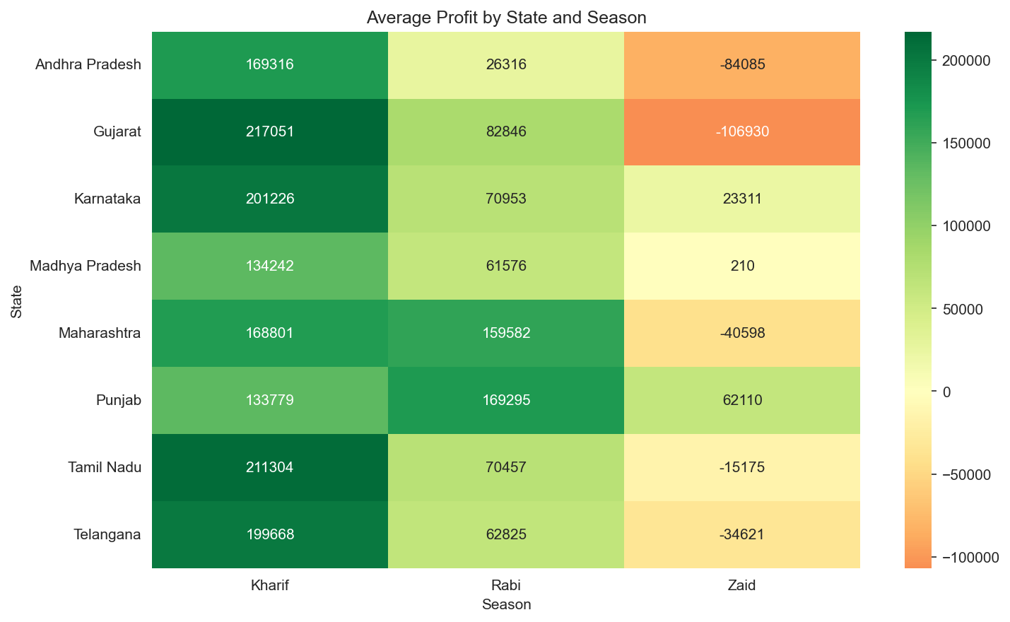
Figure 8. Average profit by state and season.
Every state follows the same seasonal ranking — Kharif > Rabi > Zaid — but the magnitude differs sharply. Gujarat, Karnataka, Tamil Nadu and Telangana post the strongest Kharif profits (₹199,000–₹217,000 average), while Punjab is the standout exception: it is the only state with a positive average profit in Zaid (₹62,110) and its Rabi profit (₹169,295) exceeds its own Kharif profit — likely reflecting Punjab's strong Rabi wheat infrastructure and irrigation base, even though Wheat is unprofitable on average nationally. Gujarat has the deepest Zaid losses (−₹106,930), making it the state most exposed to Zaid-season risk.

11. Key Insights
- Zaid is the highest-risk season: lowest rainfall, highest temperature, lowest water efficiency, and the highest share of loss-making farms (64.5% vs. 42.2% in Kharif).
- Crop-season mismatch drives losses: Wheat and Rice are loss-making in most seasons regardless of conditions, pointing to a cost-structure or pricing issue rather than a purely seasonal effect; Sugarcane and Chilli are resilient across all seasons.
- Drip and Rainfed irrigation outperform Flood irrigation on water efficiency in every season, with the gap widening in water-scarce Zaid — a clear lever for improving Zaid profitability.
- Disease/pest risk is highest in Kharif, consistent with humid monsoon conditions favoring pests and fungal disease, and tracks closely with rainfall and humidity.
- Season does not significantly affect yield on its own (ANOVA p = 0.212) — the seasonal profit gap is driven mainly by cost structure and water efficiency, not by yield differences.
- Punjab is a consistent outlier, the only state profitable in Zaid and stronger in Rabi than Kharif — a useful case study for what protects margins in the hardest season.

12. Recommendations
- Prioritize drip (or rainfed, where feasible) irrigation adoption for Zaid-season farming to offset water scarcity and lift water efficiency when it matters most.
- Re-evaluate the Zaid crop mix — shift acreage away from Cotton and Groundnut, which are only profitable in Kharif/Rabi, toward Sugarcane, Chilli or other Zaid-resilient crops.
- Investigate cost structures and pricing for Wheat and Rice, which are unprofitable in most seasons regardless of environmental conditions — this is a margin problem, not a weather problem.
- Strengthen pest and disease management support specifically ahead of and during Kharif season, given its higher humidity-linked risk.
- Use state-season profit patterns for region-specific advisories rather than a single national recommendation — study what makes Punjab's Zaid and Rabi performance an exception and whether that model transfers to Gujarat and Andhra Pradesh, the two hardest-hit states in Zaid.
- Correct the ANOVA interpretation in the source notebook (Section 11) before publishing, since the printed p-value (0.212) contradicts the written "statistically significant" claim.

13. Limitations & Next Steps
- Cross-sectional data — no year-over-year trend is captured, so it isn't possible to tell whether Zaid's losses are worsening, stable, or improving over time.
- Cost breakdown (labor, seed, fertilizer, irrigation infrastructure individually) isn't available, limiting how precisely the Wheat/Rice loss driver can be diagnosed.
- Next step: a regression or driver-analysis model isolating the individual contribution of irrigation method, crop choice and state to profit, to move from descriptive to predictive insight.
- Next step: incorporate market price volatility, since Market_Price_INR_Tonne is captured but not yet analyzed as a driver of the Wheat/Rice loss pattern.

Appendix: Analysis Assets
- Seasonal_Agriculture_Performance_Analysis.ipynb — full Python EDA notebook (cleaning, visualization, ANOVA test)
- cleaned_seasonal_agriculture.csv — cleaned dataset (4,000 rows × 31 columns) used for all analysis
- seasonal_agriculture_analysis.sql — companion SQL query set covering data-quality checks, seasonal summaries, crop/irrigation/state pivots, and window-function ranking of top/bottom-performing farms

