REPORT

BANK CUSTOMER CHURN ANALYSIS

Business Context & Problem Statement

Background
In the modern retail banking landscape, customer retention is a critical competitive advantage. Losing a customer is not simply the loss of a single transaction — it represents the loss of a long-term revenue stream, trust, and referral potential. The bank in this study operates across France, Spain, and Germany with a diverse customer base spanning different demographics, financial profiles, and engagement levels.

Traditional churn analysis is retrospective — it explains why a customer left after the fact. Modern banking demands an anticipatory approach: identifying customers who are likely to churn before they actually do. This enables:
- Proactive retention campaigns targeting high-risk segments
- Personalized offers designed to re-engage at-risk customers
- Targeted customer engagement based on individual risk profiles
- Significant reduction in wasted retention budgets on low-risk customers

Problem Statement
Despite having rich customer-level data, banks often lack the analytical infrastructure to convert raw data into actionable churn intelligence. Specifically, the challenges are:

Challenge | Business Impact
No accurate churn prediction models | Inability to identify at-risk customers early
Lack of quantitative churn risk scores | Retention budgets allocated inefficiently
No insight into churn drivers | Broad, untargeted campaigns with low ROI
Reactive rather than proactive actions | High customer acquisition costs replace preventable losses

Project Objectives
Primary Objectives
- Predict customer churn with high accuracy (>80% target)
- Generate churn probability scores (0-1) for every customer
- Identify and rank the key drivers of churn behaviour

Secondary Objectives
- Reduce false positives in churn detection to avoid misdirected retention spend
- Improve interpretability of ML models for business stakeholders
- Enable scenario-based churn risk analysis through a deployable application

Dataset Description

Column | Description
CustomerId | Unique identifier for each customer (dropped in modelling)
Surname | Customer last name (dropped — non-informative)
CreditScore | Numerical creditworthiness score
Geography | Country: France, Spain, or Germany
Gender | Male or Female
Age | Customer age in years
Tenure | Number of years the customer has been with the bank
Balance | Account balance at time of record
NumOfProducts | Number of bank products the customer holds
HasCrCard | Binary: 1 = has credit card, 0 = does not
IsActiveMember | Binary: 1 = active, 0 = inactive
EstimatedSalary | Customer's estimated annual salary
Exited | TARGET: 1 = churned, 0 = retained

2. Data Preprocessing & Feature Engineering

Data Quality Assessment
A thorough quality check was performed before any analysis:
- Missing values: None detected across all 14 columns
- Duplicate rows: None found
- Data types: Consistent — Year (int64), CreditScore (int64), Balance (float64), EstimatedSalary (float64), object columns for categorical

Outlier Detection & Treatment
Outlier analysis was conducted using the Interquartile Range (IQR) method on three key numerical features: Creditscore, Balance, and EstimatedSalary.
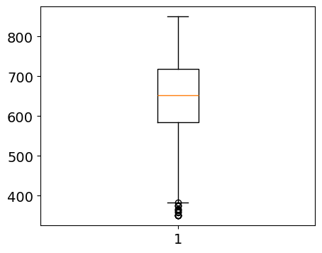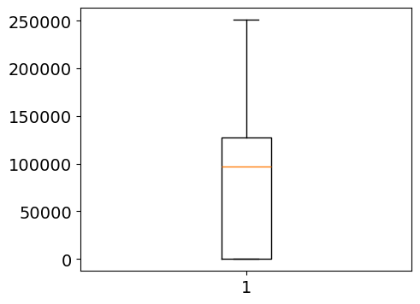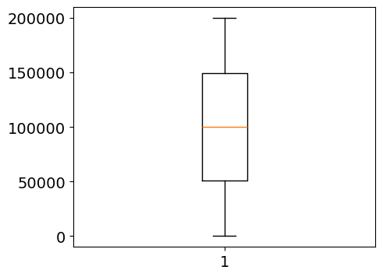
Feature | Min (After IQR) | Max (After IQR)
CreditScore | 383.0 | 919.0
Balance | -191469.06 | 319115.1
EstimatedSalary | -96605.77250000002 | 296990.7675
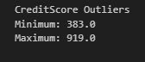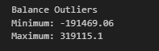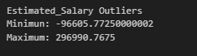

Categorical Encoding
- Geography: One-hot encoded (France = baseline, Germany_dummy and Spain_dummy created; first dropped to avoid multicollinearity)
- Gender: Label encoded (Male = 1, Female = 0)
- Binary columns (HasCrCard, IsActiveMember): Already in 0/1 format — no transformation required

Feature Engineering
The following derived features were constructed to enrich the model:
- Balance-to-Salary ratio: Measures financial weight of bank balance relative to income
- Product density indicator: Flags customers with unusually high product concentration
- Engagement-product interaction: NumOfProducts × IsActiveMember
- Age-tenure interaction: Captures loyalty relative to age
- Age groups: Binned into 18-25, 26-35, 36-45, 45-55, 56-65, 66-75, 76+ categories
- Tenure Group: Categorized 0-2 (New), 3-5 (Mid), 6-10 (Long)
- Male Spain interaction: Gender × geography product feature
- Male Germany interaction: Gender x geography_germany

Feature Scaling
StandardScaler was applied to all numerical features prior to model training. This ensures no single feature dominates due to magnitude differences (e.g., Balance in 100,000s vs. Tenure in 0-10).

3. Exploratory Data Analysis (EDA)

Target Variable Distribution
The dataset exhibits a class imbalance that is typical in churn problems:

Category | Count | Percentage
Retained (Exited = 0) | 7,963 | 79.63%
Churned (Exited = 1) | 2,037 | 20.37%
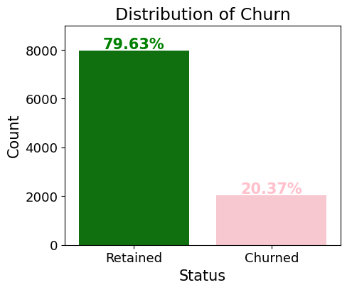
The 79.63% vs 20.37% split means a naive model predicting 'no churn' would achieve ~80% accuracy. This underscores the need for models evaluated on precision, recall, and F1-score rather than accuracy alone.

Geographic Distribution
Customer distribution across geographies is uneven, with France constituting the majority:
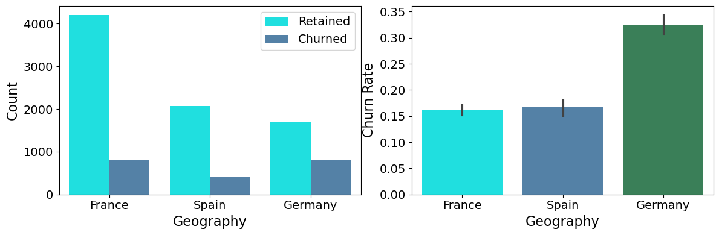
- France: ~5,014 customers (50.14%) — largest segment
- Germany: ~2,509 customers (25.09%)
- Spain: ~2,477 customers (24.77%)

However, the churn rate tells a starkly different story by geography. Germany exhibits a disproportionately high churn rate (~32%) compared to France and Spain (~16%). This geographic risk pattern is one of the strongest business signals in the dataset.

Gender-Wise Analysis
Gender | Churn Rate
Female | ~25%
Male | ~16%
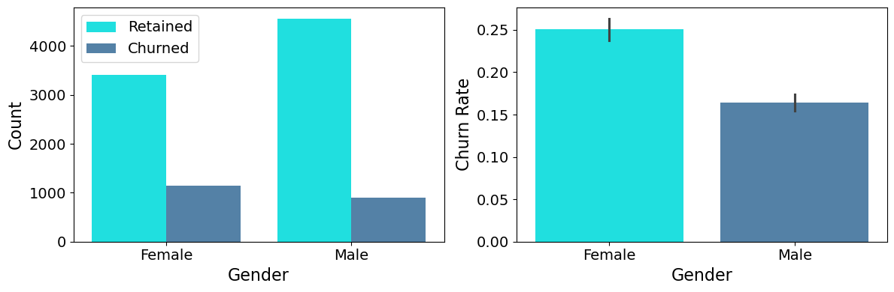
Female customers churn at a significantly higher rate than males. This gender gap suggests that the bank's products or service experience may not be adequately meeting the needs of female customers — a key strategic finding for targeted retention programs.

Age Distribution

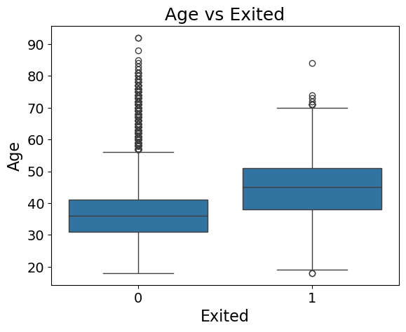
Age shows the most pronounced correlation with churn among all numerical features. Key observations:
- The core customer base is concentrated between ages 28-45
- Customers in the 40-60 age band exhibit substantially higher churn rates
- The Age vs. Exited box plot shows churned customers have a significantly higher median age (~45) compared to retained customers (~37)
- Older, potentially more financially established customers appear to be actively reconsidering their banking relationships

Product Usage Analysis
NumOfProducts | Count | Churn Rate (Approx.)
1 product | ~5,084 | ~27%
2 products | ~4,590 | ~7.6%
3 products | ~266 | ~82%
4 products | ~60 | ~100%
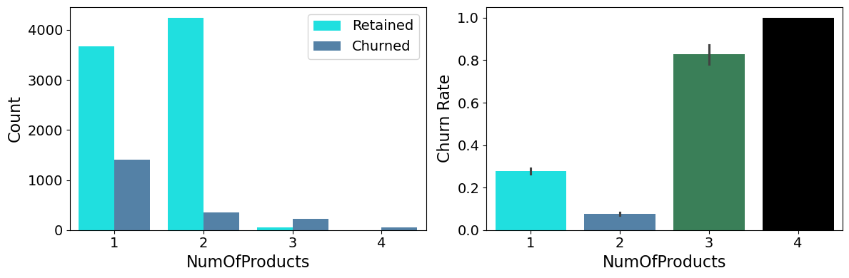
This is one of the most striking findings in the entire analysis. While customers with 2 products have the lowest churn rate, those with 3 or 4 products show extremely high churn rates approaching 100%. This non-linear pattern suggests product overload — customers may feel trapped or overextended, leading to dissatisfaction and exit.

Balance Distribution

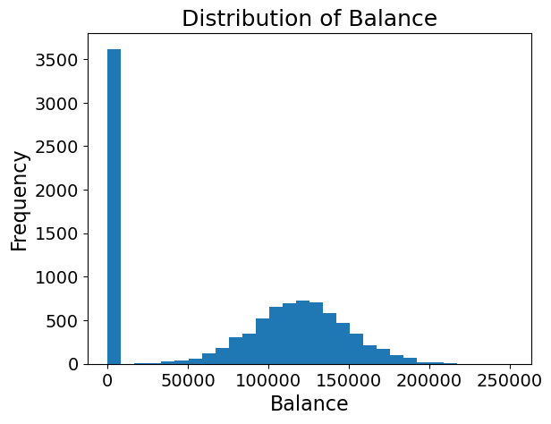
- The Balance variable shows a bimodal distribution. A substantial cluster of ~3,617 customers have a zero balance.
- The remaining customers' balances are approximately normally distributed with a mean around 76,485.

Credit Card & Activity Analysis

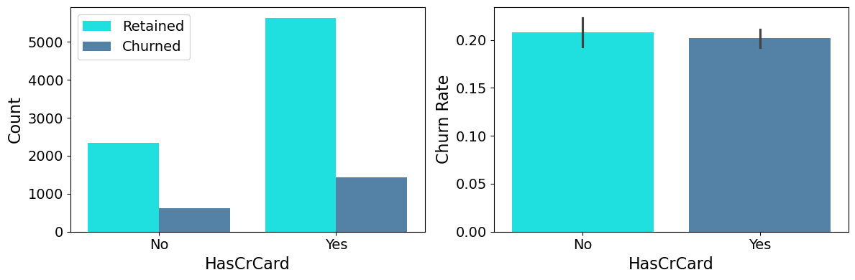
- HasCrCard: 7055 customers (~70.6%) hold a credit card — credit card ownership does NOT significantly differentiate churners from non-churners.
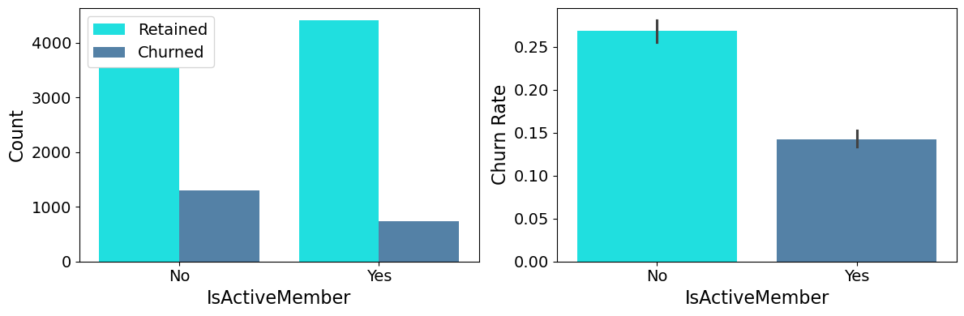
- IsActiveMember: The split is nearly equal (51.51% active vs 48.49% inactive) — however, inactive members churn at ~26.9% vs active members at ~14.3%

Correlation Analysis

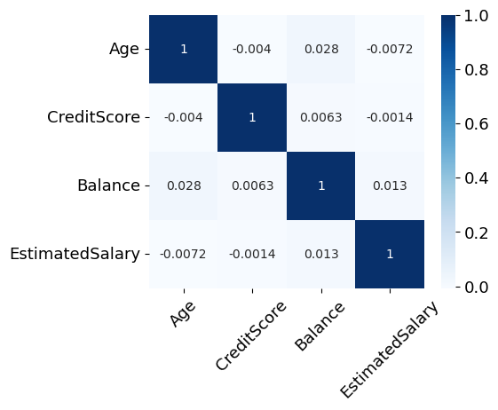
The Pearson correlation matrix among numerical features reveals:
- Age vs. CreditScore: -0.004 (virtually no correlation)
- Balance vs. EstimatedSalary: 0.013 (near-zero)
- Balance vs. CreditScore: 0.006 (negligible)
The near-zero correlations among numerical features confirm that multicollinearity is not a concern, and all features carry independent predictive information.

4.PREDICTIVE MODELING

Model Development Strategy
A systematic multi-model approach was adopted, progressing from interpretable baseline models to complex ensemble methods. This allows direct comparison of the accuracy-interpretability tradeoff .

Model | Category
Logistic Regression | Baseline — interpretability benchmark
Decision Tree | Tree-based — moderate complexity
K-Nearest Neighbours (KNN) | Distance-based classifier
Random Forest | Ensemble — bagging approach
Gradient Boosting | Ensemble — boosting approach (best performer)

Train-Test Split & Preprocessing
- 80/20 stratified train-test split (random_state=42 for reproducibility)
- Training set: ~8,000 samples | Test set: ~2,000 samples
- StandardScaler fitted on training data, applied to test data (no data leakage)
- Categorical encoding: Geography one-hot encoded, Gender label encoded

Model Results & Comparison

Model | Accuracy | Weighted F1
Logistic Regression | 81.1% | 0.77
Decision Tree | 78.40% | 0.79
KNN | 83.0% | 0.81
Random Forest (100 trees) | 86.65% | 0.85
Gradient Boosting (100 est.) | 86.75% | 0.86

Detailed Results — Random Forest
The Random Forest model delivered the best balance of performance and interpretability:

Metric | Class 0 (Retained) | Class 1 (Churned)
Precision | 0.88 | 0.76
Recall | 0.97 | 0.46
F1-Score | 0.92 | 0.58
Support | 1,607 | 393

Observation: The model is very good at identifying retained customers (recall 0.97) but shows lower recall for churners (0.46). This is a class imbalance effect — future iterations should incorporate SMOTE or class-weighted training to improve minority class recall.

Detailed Results — Gradient Boosting
Gradient Boosting achieved the highest overall accuracy of 86.75% with strong weighted F1 of 0.87, making it the recommended production model:

Metric | Class 0 (Retained) | Class 1 (Churned)
Precision | 0.88 | 0.75
Recall | 0.96 | 0.49
F1-Score | 0.92 | 0.59
Support | 1,607 | 393

Feature Importance & Churn Drivers

Feature importance analysis from the Random Forest model provides quantitative insight into which customer attributes most strongly drive churn predictions. This is critical for translating data science findings into actionable business strategy.
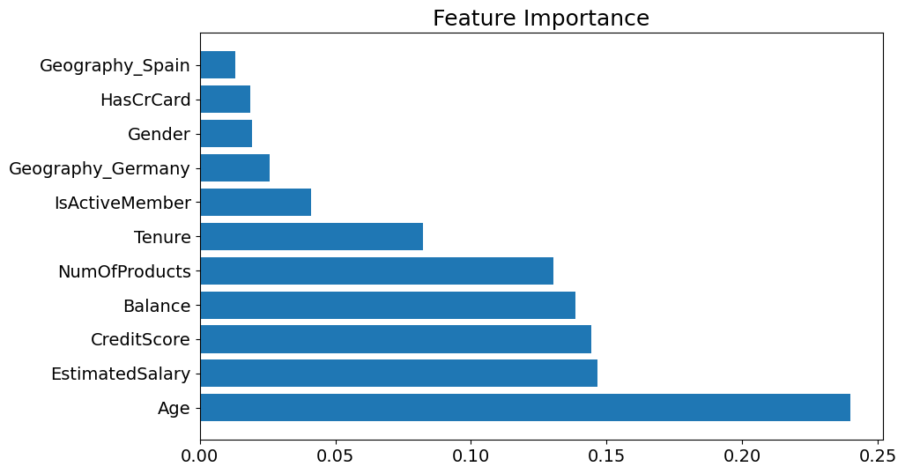

Rank | Feature | Importance Score
1 | Age | ~0.24
2 | EstimatedSalary | ~0.18
3 | CreditScore | ~0.15
4 | Balance | ~0.14
5 | NumOfProducts | ~0.13
6 | Tenure | ~0.06
7 | IsActiveMember | ~0.04
8 | Geography_Germany | ~0.03
9 | HasCrCard | ~0.01
10 | Geography Spain | ~0.005

Business Interpretation of Top Features
- Age (0.24): Older customers are disproportionately churning — potential dissatisfaction with digital-first banking or competitor offers targeting senior segments
- EstimatedSalary (0.18): Higher-income customers may have more options and lower switching costs — premium retention strategies needed
- CreditScore (0.15): Lower credit score customers may be churning due to declined services or unfavorable terms
- Balance (0.14): High-balance customers exhibit elevated churn — possibly seeking better interest rates elsewhere
- NumOfProducts (0.13): The non-linear effect (peak churn at 3-4 products) signals product overload and customer dissatisfaction

5. Churn Risk Segmentation

Based on EDA and model outputs, four distinct customer risk tiers can be defined for targeted intervention:

Risk Tier | Profile | Recommended Action
Critical (>70% prob) | Age 45-65, Germany, 3-4 products, inactive | Immediate personal outreach, dedicated relationship manager
High (50-70% prob) | Female, age 40-55, single product, high balance | Priority retention offers, product re-evaluation call
Medium (30-50% prob) | Age 35-45, low activity, credit card holder | Automated engagement campaign, product upsell opportunity
Low (<30% prob) | Young, active, 2 products, France/Spain | Standard loyalty program, periodic NPS survey

6. Business Recommendations

Immediate Actions
- Launch a dedicated Germany Customer Retention Initiative targeting the ~32% churn rate. Conduct qualitative customer interviews to uncover service gaps.: Germany Priority Program
- Design tailored products and communication strategies addressing the higher female churn rate (~25%). Consider focus groups and gender-specific journey mapping.: Female Customer Strategy
- Urgently audit customers with 3-4 products. Proactively offer product simplification consultations — these customers are nearly guaranteed to churn without intervention.: Product Rationalization
- Develop a dedicated program for customers aged 45-65 with personalized banking advisors, simplified digital interfaces, and age-appropriate product offerings.: Senior Customer Engagement

Model Deployment Recommendations
- Deploy Gradient Boosting as the production churn scoring engine (86.75% accuracy)
- Generate weekly churn probability scores for all active customers
- Integrate churn scores into CRM systems for relationship manager dashboards
- Implement the Streamlit web application for business analysts to run scenario-based risk assessments without requiring Python expertise
- Establish a quarterly model retraining cycle using updated customer data

Model Improvement Roadmap
- Apply SMOTE (Synthetic Minority Oversampling) to address the 80:20 class imbalance — this should significantly improve churner recall from the current ~0.46-0.49
- Implement XGBoost and LightGBM for comparison against Gradient Boosting
- Add SHAP (SHapley Additive exPlanations) value analysis for customer-level explainability
- Explore time-series features capturing account activity trends over rolling 3-6 month windows
- Implement threshold optimization — adjust the 0.5 classification threshold to optimize for business ROI rather than raw accuracy

Conclusion

This analysis successfully demonstrates that customer churn in the European Bank dataset is both predictable and explainable using machine learning. The Gradient Boosting model achieved 86.75% accuracy and identified Age, EstimatedSalary, CreditScore, Balance, and NumOfProducts as the primary drivers of churn.

The key business insight is clear: churn is not random. It follows identifiable patterns — older customers in Germany, inactive members, customers with product overload, and high-income individuals are statistically far more likely to leave. These are not uncontrollable losses; they are preventable with the right intelligence and intervention.

By deploying this predictive system, the bank can shift from a reactive, costly retention posture to a proactive, data-driven customer relationship strategy. The expected impact includes reduced annual churn rate, improved customer lifetime value, more efficient retention spending, and a measurable competitive advantage in customer loyalty.

Final Model Recommendation
- RECOMMENDED: Gradient Boosting Classifier (accuracy: 86.75%, F1: 0.87)
- BACKUP: Random Forest Classifier (accuracy: 86.5%, F1: 0.84)
- BASELINE REFERENCE: Logistic Regression for explainability-first use cases
- NEXT STEP: Address class imbalance with SMOTE for improved minority class recall

