🟦 Domain 1: Cloud Concepts & Technology

1. AWS Cloud Computing
- What it is: On-demand delivery of IT resources (compute, storage, database, etc.) via the internet.
- Global/Regional: Global (you choose regions to deploy resources).
- What it does: Eliminates need to buy, own, and maintain physical servers.
- Why needed: Scalability, cost-effectiveness, and speed of deployment.
- Pricing: Pay-as-you-go.
- Integrations: Works with all AWS services.
- Use: Anytime you want to reduce capital expense and increase agility.

2. AWS Global Infrastructure
- What it is: AWS is organized into regions, availability zones (AZs), and edge locations.
- Global/Regional: Global design; you choose regionally.
- What it does: Ensures high availability, fault tolerance, and low latency.
- Why needed: Reduces single point of failure and latency.
- Pricing: No cost to choose a region, but service prices vary by region.
- Integrations: All services are deployed within this structure.
- Limitations: Not all services available in all regions.
- Use: Select closest region to users for low latency.
- Avoid: Don't choose regions with limited-service availability for your use case.

3. Benefits of Cloud
- What it is: Key advantages of using cloud over traditional on-premise.
- Benefits:
  - Elasticity (scale in/out)
  - Agility (quick experimentation)
  - Cost-efficiency (pay only for what you use)
  - Global reach
  - High availability
- Use: To increase speed to market and optimize cost.

4. Cloud Deployment Models
Model | Description | Use When...
Public Cloud | AWS owns and operates resources. | You want zero maintenance.
Private Cloud | Resources are used exclusively by one organization. | You have strict compliance/security needs.
Hybrid Cloud | Mix of on-premise and cloud. | Gradually migrating to cloud or require both.

5. Cloud Service Models
Model | What You Manage | Example Services
IaaS (Infrastructure as a Service) | You manage OS, apps. AWS provides networking, servers | EC2, VPC, EBS
PaaS (Platform as a Service) | AWS manages OS, runtime. You manage app. | Elastic Beanstalk, Lambda
SaaS (Software as a Service) | AWS manages everything. You use the app. | Amazon Chime, WorkMail

Cloud Computing can be broadly divided into three types - Infrastructure as a Service (IaaS), Platform as a Service (PaaS), Software as a Service (SaaS).
Platform as a Service (PaaS) removes the need to manage underlying infrastructure (usually hardware and operating systems) and allows you to focus on the deployment and management of your applications. You don’t need to worry about resource procurement, capacity planning, software maintenance, patching, or any of the other undifferentiated heavy lifting involved in running your application.
Please review this overview of the types of cloud computing:
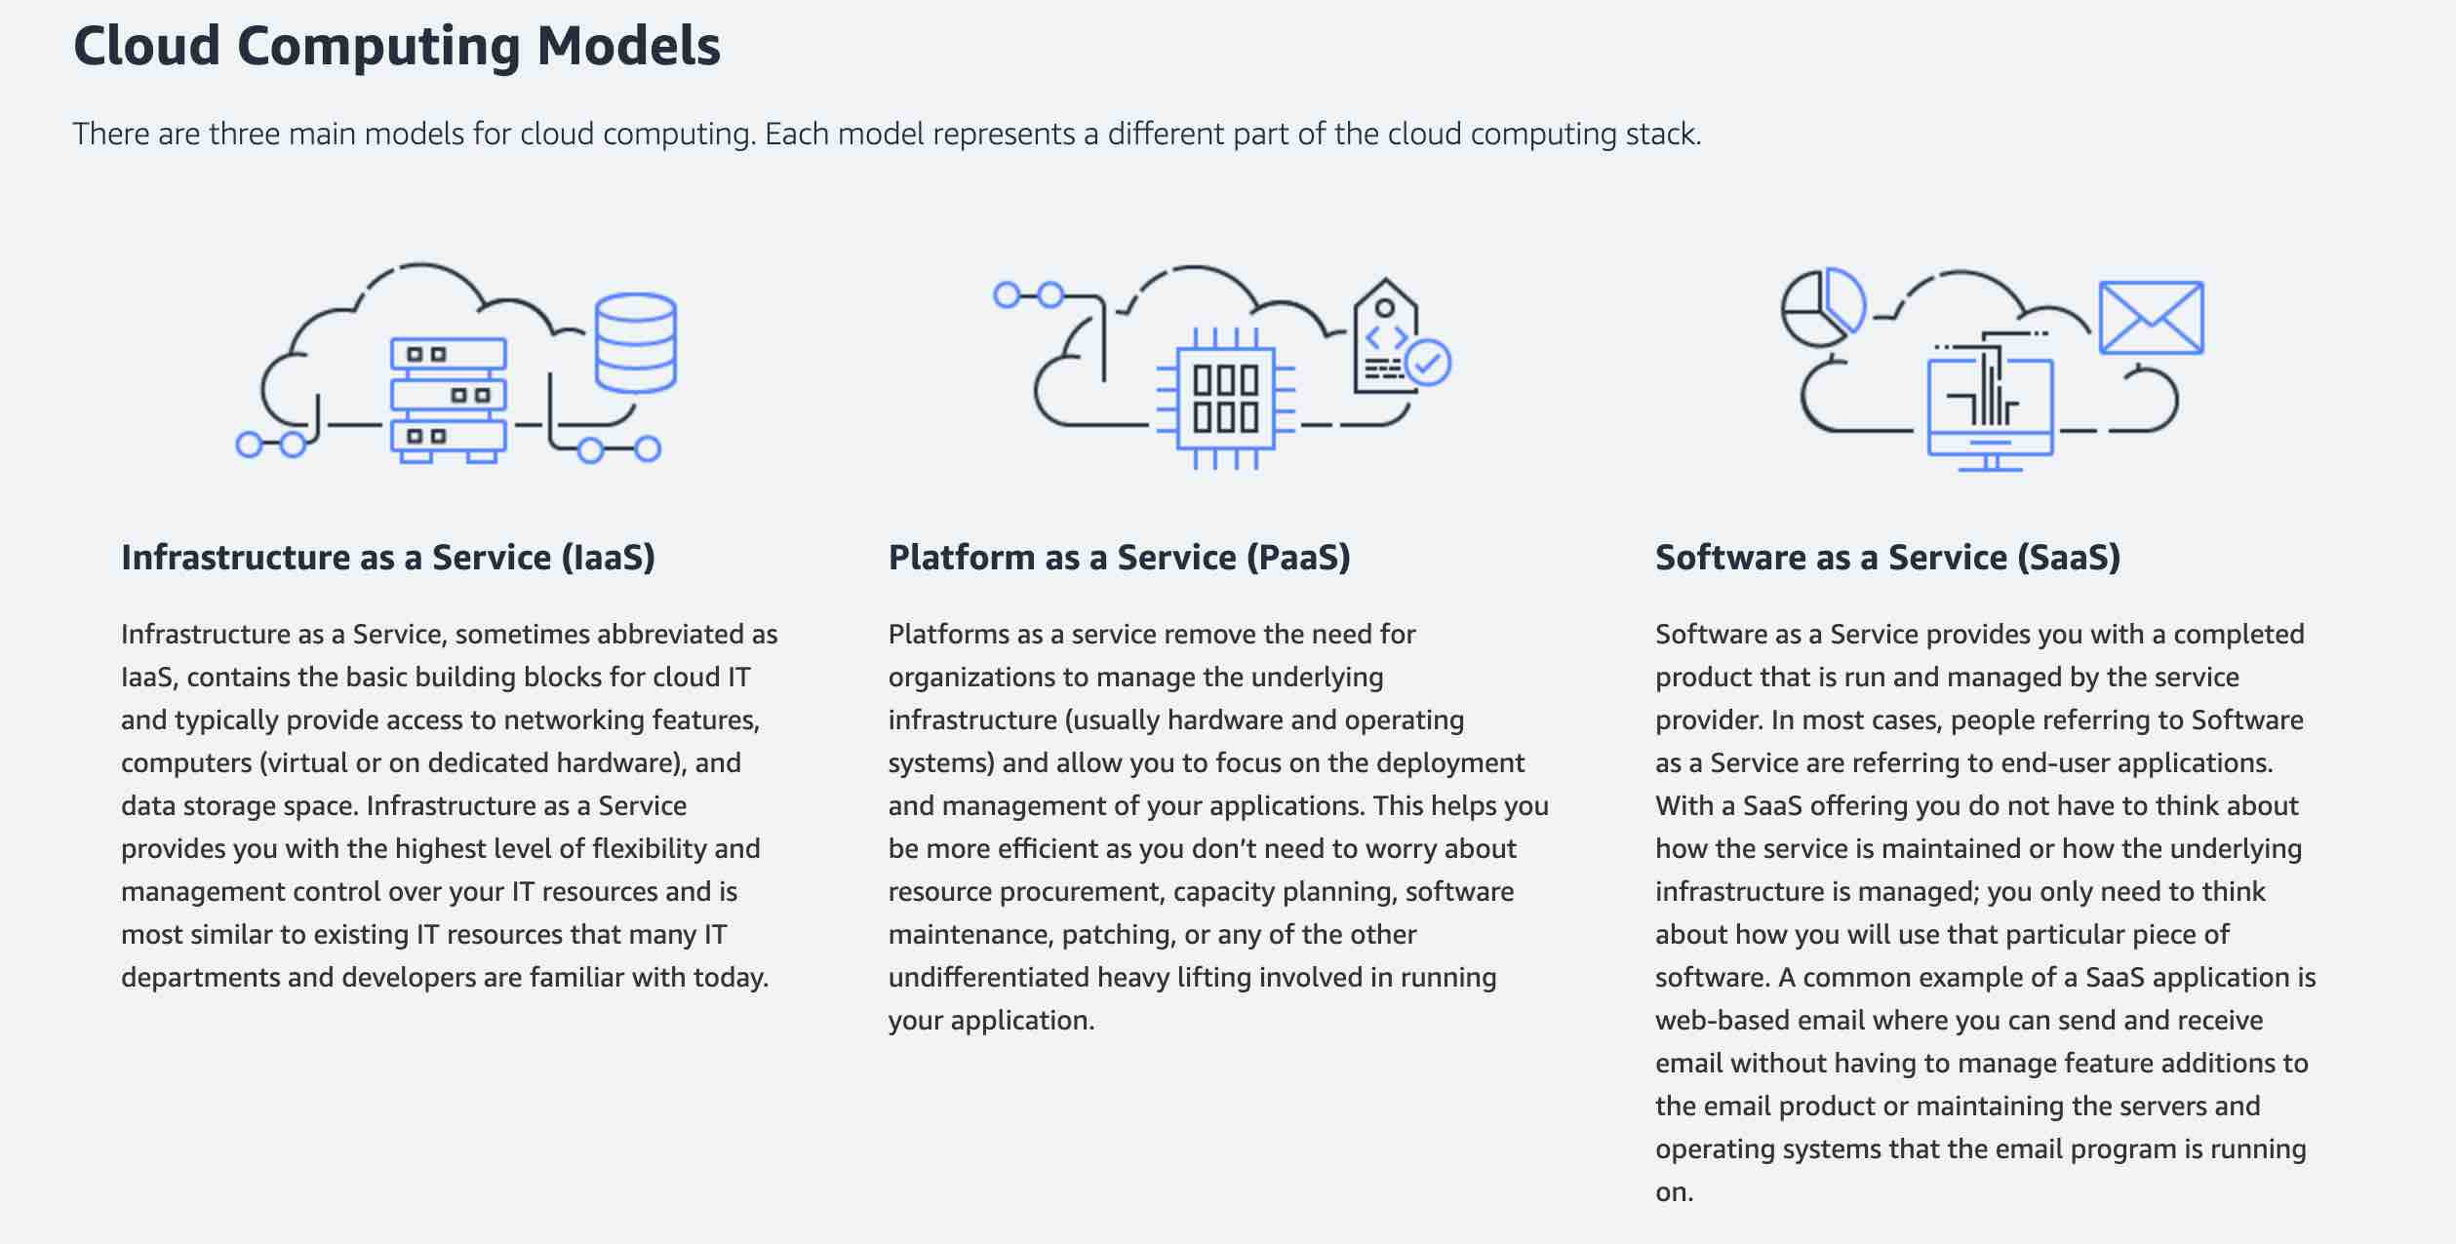
via - https://aws.amazon.com/types-of-cloud-computing/

🟦 Domain 2: Security and Compliance

1. AWS Shared Responsibility Model
- What it is: Security responsibilities are shared between AWS and the customer.
- Global/Regional: Global principle.
- What it does: Defines who secures what.
- Pricing: No cost — it’s a model, not a service.
- Integrations: Applies to all AWS services.
- Limitations: Customer must secure their own data, configurations, and credentials.
- Responsibility Split:
AWS (Security of the Cloud) | You (Security in the Cloud)
Hardware, global infrastructure | Customer data, user access, configurations
Networking, hypervisors | OS patches, firewall rules, IAM

2. AWS Identity and Access Management (IAM)
- What it is: Service to control access to AWS services and resources.
- Global/Regional: Global (not region-specific).
- What it does: Lets you create users, groups, roles, and permissions.
- Why needed: Secure user and service access control.
- Pricing: Free.
- Integrations: Works with all AWS services.
- Limitations: Complex policies can lead to misconfigurations.
- Use When: You need fine-grained access control.
- Avoid When: N/A – IAM is required for all access control.

3. IAM Policies
- What it is: JSON documents that define permissions.
- Types:
  - Identity-based (attach to users, groups, roles)
  - Resource-based (attach to resources like S3).
- Best Practice: Follow least privilege — only give required access.

4. IAM Roles
- What it is: Temporary credentials that AWS services or users can assume.
- Why needed: For services like EC2, Lambda to access S3, RDS, etc. without storing credentials.
- Example: EC2 instance role to access an S3 bucket.

5. IAM Users and Groups
- User: A person or app with long-term credentials.
- Group: Collection of users to assign common permissions.

6. AWS Organizations
- What it is: Service to manage multiple AWS accounts from a single location.
- Global/Regional: Global — it is managed from a single point for all regions.
- What it does:
    - Create and group multiple AWS accounts into a single Organization.
    - Apply Service Control Policies (SCPs) to control what actions services can perform, across accounts.
    - Consolidated billing for all member accounts.
    - Separate workloads (e.g., dev, test, prod) into isolated accounts for better security and cost tracking.

- Why needed: Easier multi-account governance and cost tracking.
  - Security isolation: Separate accounts for different environments (dev/test/prod).
  - Centralized billing: Easier cost tracking and discounts.
  - Governance: Apply restrictions and policies at scale.
  - Delegation: Teams can manage their accounts independently under shared controls.

- Key Components
Component | Explanation
Management Account | The main/root account that creates and manages the organization.  Has full administrative privileges.
Member Accounts | Other AWS accounts invited or created within the organization.  They are governed by the management account.
Organizational Units (OUs) | Logical groupings of accounts (e.g., one OU for prod, another for dev).  SCPs can be applied at OU level.
Service Control Policies (SCPs) | Guardrails that define maximum permissions for accounts or OUs.  Even if IAM allows it, an SCP can deny it.

- Pricing: Free. (No extra cost for using AWS Organizations. You pay only for resources consumed by individual accounts.)
- Integrations: Ties into IAM, consolidated billing.
Service | Integration
AWS IAM | Works with IAM. SCPs act as an upper boundary for IAM permissions.
AWS Billing | Consolidated billing. One bill for all accounts.
AWS Control Tower | Uses AWS Organizations under the hood to set up secure multi-account environments.
AWS SSO | Helps manage access across accounts in the organization.

- Use When: Managing multiple accounts (by teams, projects, environments).
    - You manage more than one AWS account.
    - You want central control over permissions, billing, and policies.
    - You want to apply governance controls across teams/environments.
    - You're setting up a secure, scalable cloud environment using AWS best practices.

- Limitations
Limitation | Details
SCPs don't grant permissions | They only restrict them. IAM policies are still required.
Hard to manage manually | In large orgs, managing SCPs and OUs manually becomes complex without automation (e.g., Control Tower).
Account limits | By default, 10 accounts per org; can be increased via support ticket.

- Avoid When: You only use one AWS account.
    - You don’t need centralized governance or consolidated billing.
    - You're working on a personal or small project.

**The AWS account must be able to operate as a standalone account. Only then it can be removed from AWS organizations
You can remove an account from your organization only if the account has the information that is required for it to operate as a standalone account. For each account that you want to make standalone, you must accept the AWS Customer Agreement, choose a support plan, provide and verify the required contact information, and provide a current payment method. AWS uses the payment method to charge for any billable (not AWS Free Tier) AWS activity that occurs while the account isn't attached to an organization.

7. AWS Artifact
AWS Artifact is your go-to, central resource for compliance-related information that matters to your organization. It provides on-demand access to AWS’ security and compliance reports and select online agreements. Reports available in AWS Artifact include our Service Organization Control (SOC) reports, Payment Card Industry (PCI) reports, and certifications from accreditation bodies across geographies and compliance verticals that validate the implementation and operating effectiveness of AWS security controls. It is not a service, it's a no-cost, self-service portal for on-demand access to AWS’ compliance reports.
- What it is: Portal to access compliance reports (like SOC 2, ISO, etc.)
- Global/Regional: Global.
- Use: When you need audit or compliance documentation for security certifications.

8. AWS Shield
- Standard:
  - Free, automatic DDoS protection.
  - Protects Route 53, CloudFront, ALB/ELB, etc.
- Advanced:
  - Paid subscription, includes 24/7 DDoS response team, higher levels of protection.
  - Protects CloudFront, ALB/ELB, Route 53, Global Accelerator, EC2.
  - Use Advanced when you're running high-availability, critical apps.

9. AWS WAF (Web Application Firewall)
- What it is: Protects web apps from common exploits (SQL injection, XSS).
- Global/Regional: Regional, but applied on CloudFront or ALB.
- Pricing: Pay per rule and request.
- Use: When you want custom firewall rules for your web apps.
- Avoid: If you don’t have web-facing components.

10. AWS Secrets Manager
- What it is: Manages and rotates credentials and secrets (DB passwords, API keys).
- Global/Regional: Regional.
- Pricing: Charged per secret and API call.
- Use: For sensitive secret storage with automatic rotation.
- Avoid: For simple config values (use Systems Manager Parameter Store instead).

11. AWS Key Management Service (KMS)
- What it is: helps you create, control, and manage cryptographic keys used to encrypt and decrypt your data.
Think of KMS as a vault that stores and protects the keys you use to lock (encrypt) and unlock (decrypt) data.
It’s what you use to perform encryption and decryption operations.
Types:
- AWS-managed keys – created and managed by AWS for services like S3, EBS, etc. Automatically rotated by AWS
- Customer-managed keys (CMKs) – you create and control these. U can enable automatic rotation (every year) or rotate manually.
- AWS-owned keys – used by AWS internally; not visible to customers.

- Global/Regional: Regional.
- Pricing: Pay per key and usage.
- Use: To encrypt S3, EBS, RDS, etc.
  - To encrypt sensitive data (e.g., personal data, payment info)
  - To meet compliance requirements
  - For data protection in services like S3, EBS, RDS, Lambda, Secrets Manager

- Avoid: If you're not handling sensitive data (to reduce cost).
- Recognizing KMS in Question Scenarios
If the question says... | You should think of...
“Encrypt data stored in S3/EBS/RDS” | AWS KMS
“Use your own encryption key” | AWS KMS with CMK
“Manage who can use the key” | AWS KMS with IAM or Key Policies
“Comply with data protection regulations (GDPR, HIPAA)” | AWS KMS
“Audit who used the key and when” | AWS KMS + CloudTrail
“Auto-rotate keys” | Customer-managed CMK in KMS
“Encryption integrated with AWS services” | AWS KMS

- Common Traps in Options
- Make sure you don’t confuse KMS with:
Wrong Option | Why It’s Incorrect
AWS Secrets Manager | It's for storing secrets, not general encryption
AWS IAM | Controls access, but doesn't encrypt data
AWS Shield | Protects against DDoS, not used for encryption
Amazon Macie | For discovering PII data, not encrypting it
S3 default encryption | Uses KMS under the hood, but you may still need to manage keys via KMS

- AWS Systems Manager
- AWS Systems Manager allows you to centralize operational data from multiple AWS services and automate tasks across your AWS resources. You can create logical groups of resources such as applications, different layers of an application stack, or production versus development environments.
- With AWS Systems Manager, you can select a resource group and view its recent API activity, resource configuration changes, related notifications, operational alerts, software inventory, and patch compliance status. You can also take action on each resource group depending on your operational needs. AWS Systems Manager provides a central place to view and manage your AWS resources, so you can have complete visibility and control over your operations.
- How AWS Systems Manager works:
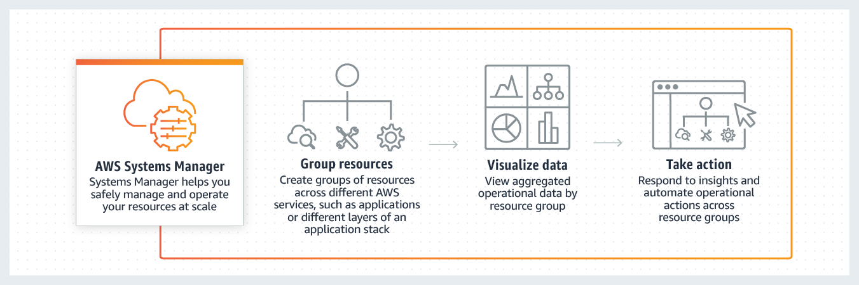
via - https://aws.amazon.com/systems-manager/

🟦 Domain 3: Cloud Technology and Services (Core AWS Services)

✅ COMPUTE SERVICES

1. Amazon EC2 (Elastic Compute Cloud)
- What it is: Virtual servers (instances) to run applications.
- Global/Regional: Regional.
- Why needed: For full control over compute environment.
- Pricing:
  - On-Demand (pay by second/hour),
  - Reserved (1–3 yr commitment),
  - Spot (cheap, interruptible),
  - Free Tier (750 hrs/month for t2.micro for 12 months).
- Integrations: Works with IAM, VPC, S3, RDS, etc.
- Use When: You need custom OS, software, scalability.
- Avoid When: You want serverless or managed services.

When using EC2 instances you are charged for the compute uptime of the instance based on the family and type you chose. You are also charged for the amount of data provisioned.
CORRECT: "Data storage" is a correct answer.
CORRECT: "Server uptime" is also a correct answer.
INCORRECT: "Basic monitoring" is incorrect. Basic monitoring is free for EC2, detailed monitoring is charged.
INCORRECT: "AMI" is incorrect. Amazon Machine Images (AMIs) are not chargeable. You can purchase chargeable AMIs via the marketplace but you are not charged for any you create.
INCORRECT: "Private IP address" is incorrect. You do not pay for private IP addresses.

2. Amazon EC2 Auto Scaling
- What it is: Automatically add/remove EC2 instances based on demand.
- Why needed: Maintain availability + reduce cost.
- Pricing: Free for Auto Scaling itself; pay for EC2 instances.
- Scaling Types:
  - Target tracking
  - Step scaling
  - Scheduled scaling
- Use When: Traffic is unpredictable.
- Avoid When: Using serverless or managed compute.
- Amazon EC2 Auto Scaling is configured within the EC2 console and can launch instances within a VPC across multiple AZs. It cannot launch resources into another AWS Region.

3. AWS Lambda
- What it is: Serverless function-as-a-service.
- Why needed: Run code without managing servers.
- Global/Regional: Regional.
- Pricing: Free up to 1M requests/month + 400,000 GB-seconds; pay-per-request after.
- Use When: Lightweight logic, event-driven tasks.
- Avoid When: Long-running processes (max 15 mins per invocation).

4. AWS Elastic Beanstalk
- What it is: PaaS to deploy web apps using EC2, ELB, RDS, etc.
- Why needed: Quick deployments with minimal infrastructure management.
- Global/Regional: Regional.
- Pricing: No extra charge, pay only for underlying resources (EC2, RDS).
- Use When: You want to deploy Java/.NET/PHP/Python apps quickly.
- Avoid When: You need fine-grained control over infrastructure.

5. AWS Fargate
- What it is: Serverless container compute engine for ECS/EKS.
- Why needed: Run containers without managing servers.
- Pricing: Pay for vCPU + memory usage.
- Use When: Running microservices in containers.
- Avoid When: You want cheaper, more tunable EC2-based container hosting.

6. Amazon Lightsail (Compute Services)
- What it is:
A simplified cloud platform offering preconfigured virtual servers (VPS) with bundled compute, storage, and networking.
- Who it's for:
Ideal for developers, small businesses, students, and startups needing a fast and easy way to deploy simple web apps, websites, or blogs.
- What it includes:
  - Virtual servers (Linux/Windows)
  - Static IP address
  - DNS management
  - SSH access
  - Automatic backups (snapshots)
  - Optional pre-installed stacks (WordPress, LAMP, Node.js, etc.)
- Pricing model:
  - Fixed monthly pricing
  - No need to manage individual AWS components (like EC2, EBS, VPC)
- Region availability:
Regional service – you choose where your VPS is hosted.
- Integrates with:
  - Amazon RDS
  - Amazon Route 53
  - Amazon CloudFront
  - Can export instance to EC2 when more flexibility is needed
- Limitations:
  - No auto scaling
  - Limited custom networking (no complex VPC setups)
  - Fewer configuration options than EC2
  - No granular IAM role assignment
- When to use:
✅ When you want a quick, easy, and low-cost way to host:
  - Websites
  - Web applications
  - Blogs
  - Development or testing environments
- When to avoid:
❌ When your project needs:
  - Complex networking/security setup
  - Auto scaling or high availability
  - Production-level workloads with full control
  - Deep integration with multiple AWS services

Amazon Lightsail is designed to be the easiest way to launch and manage a virtual private server (VPS) with AWS. Amazon Lightsail plans include everything you need to jumpstart your project – a virtual machine, SSD- based storage, data transfer, Domain Name System (DNS) management, and a static IP address – for a low, predictable price.
It is great for people with little cloud experience to launch quickly a popular IT solution ready to use immediately.

✅ STORAGE SERVICES

Data stored within an AWS region is not replicated outside of that region automatically. It is up to customers of AWS to determine whether they want to replicate their data to other regions. You must always consider compliance and network latency when making this decision.
CORRECT: "Data is not replicated outside of a region unless you configure it" is the correct answer.

6. Amazon S3 (Simple Storage Service)
- What it is: Scalable object storage (images, videos, logs, etc.).
- Global/Regional: Regional.
- Pricing: Pay per GB/month + requests.
- Classes: S3 Standard, Intelligent-Tiering, Glacier, Deep Archive.
- Use When: Store files, backups, logs, media.
- Avoid When: You need block storage or relational storage.

The Amazon Simple Storage Service (S3) offers virtually unlimited storage. The total volume of data and number of objects you can store are unlimited.
Individual Amazon S3 objects can range in size from a minimum of 0 bytes to a maximum of 5 terabytes. The largest object that can be uploaded in a single PUT is 5 gigabytes.

Amazon S3 Storage Classes – Full Comparison with Use Cases
Storage Class | What It Is | Use Case | Durability | Availability | Min Storage Duration | Retrieval Time | Retrieval Cost | AZ Redundancy | When to Use | When Not to Use
S3 Standard | Default class for frequently accessed data | Active content like websites, apps, mobile data | 99.999999999% (11 9s) | 99.99% | None | Immediate | No | ✅Yes | -Frequently accessed data  - Real-time apps and APIs  - Data that needs millisecond latency | - Data rarely accessed or intended for archiving
S3 Intelligent-Tiering | Automatically moves objects between access tiers based on usage | Data with unpredictable or changing access patterns | 99.999999999% | 99.9% – 99.99% | 30 days | Immediate | No | ✅Yes | - Ideal when access pattern is unknown or unpredictable  - Good for mixed-use data that may be frequently or infrequently accessed over time | - For objects smaller than 128 KB (not eligible for auto-tiering)  - When monitoring charges are not acceptable
S3 Standard-IA | Infrequent access with instant retrieval | Backups, DR, archived logs | 99.999999999% | 99.9% | 30 days | Immediate | ✅Yes | ✅Yes | - Infrequently accessed data with immediate retrieval needs  - Disaster recovery, backup data, old logs | - Frequently accessed data (higher cost than Standard)  - Short-lived data (penalty for <30-day storage)
S3 One Zone-IA | Infrequent access, stored in one AZ only | Re-creatable backups, thumbnails, or generated reports | 99.999999999% | 99.5% | 30 days | Immediate | ✅Yes | ❌No | - For cost-saving on non-critical data  - Good when you can re-create data if lost  - Temporary or derived assets | - When durability across multiple AZs is required  - Mission-critical or irreplaceable data
S3 Glacier Instant Retrieval | Archive storage with milliseconds access time | Medical images, news media archives, cold backups | 99.999999999% | 99.9% | 90 days | Milliseconds | ✅Yes | ✅Yes | - When archived data is needed quickly but infrequently  - Better than Standard-IA if retrieval is rare but must be instant | - When data is frequently used  - Data with a short retention period
S3 Glacier Flexible Retrieval | Archive storage with minutes to hours access time | Long-term backup, compliance archives, legacy content | 99.999999999% | 99.9% | 90 days | Minutes to hours | ✅Yes | ✅Yes | - Cost-effective long-term storage  - Good when retrieval time can be minutes or hours  - Alternative to tape storage | - Not for frequently accessed or real-time retrieval use cases
S3 Glacier Deep Archive | Cheapest long-term archival storage | Legal/compliance data, research data, audits | 99.999999999% | 99.9% | 180 days | 12 to 48 hours | ✅Yes | ✅Yes | - Data you almost never need to access  - Meets regulatory/retention requirements  - Cheaper than Glacier Flexible if retrieval is very rare | - Not suitable for data needed in hours or days  - Not for operational or app-serving data

📌 Amazon S3 Storage Classes – Summary with Cost
Storage Class | Use When... | Access Time | Availability | Cost (💲)
S3 Standard | Fast, frequent access | Milliseconds | 99.99% | 💰💰💰 (Highest)
S3 Intelligent-Tiering | Access pattern is unknown/changing | Milliseconds | 99.9–99.99% | 💰💰 (Auto-adjusts)
S3 Standard–IA | Infrequent, but immediate access needed | Milliseconds | 99.9% | 💰💰 (Lower than Standard)
S3 One Zone–IA | Infrequent access + can tolerate AZ failure | Milliseconds | 99.5% | 💰 (Lowest IA tier)
S3 Glacier Instant | Archival data, needs quick access | Milliseconds | 99.9% | 💰 (Lower than IA)
S3 Glacier Flexible | Long-term archive, can wait minutes–hours | Minutes to Hours | 99.99% | 💵 (Very Low)
S3 Glacier Deep Archive | Data needed rarely (compliance, legal) | 12–48 Hours | 99.99% | 💵 (Cheapest)

7. Amazon EBS (Elastic Block Store)
- What it is: Block storage for EC2.
- Global/Regional: Regional.
- Use When: You need persistent storage for EC2.
- Avoid When: You need file/object-based storage.

You can create a point-in-time snapshot of an Amazon EBS Elastic Volume and use it as a baseline for new volumes or data backup. If you make periodic snapshots of a volume, the snapshots are incremental—the new snapshot saves only the blocks that have changed since your last snapshot.
You can back up the data on your Amazon EBS Elastic Volumes to Amazon Simple Storage Service (Amazon S3) by taking point-in-time snapshots.

With EBS volumes you are charged for the amount of data provisioned (not consumed) per month. This means you can have empty space within a volume and you still pay for it. With provisioned IOPS volumes you are also charged for the amount you provision in IOPS
CORRECT: "The amount of data storage provisioned" is a correct answer.
CORRECT: "Provisioned IOPS" is also a correct answer.
INCORRECT: "The amount of data storage consumed" is incorrect as you pay for the amount provisioned.
INCORRECT: "Number of snapshots" is incorrect. You pay for the storage consumed by snapshots, not by the number of snapshots.
INCORRECT: "Inbound data transfer" is incorrect as you do not pay for data ingress.
References:
https://aws.amazon.com/ebs/pricing/
Save time with our exam-specific cheat sheets:
https://digitalcloud.training/certification-training/aws-certified-cloud-practitioner/aws-billing-and-pricing/

8. Amazon EFS (Elastic File System)
- What it is: Scalable network file system (like shared drive).
- Use When: You need a file system accessible by multiple EC2 instances.
- Avoid When: You only need object storage (use S3 instead).

EFS is a fully-managed service that makes it easy to set up and scale file storage in the Amazon Cloud. EFS uses the NFSv4.1 protocol. Can concurrently connect 1 to 1000s of EC2 instances, from multiple AZs.

Amazon Elastic File System (Amazon EFS) provides a simple, scalable, fully managed elastic NFS file system for use with AWS Cloud services and on-premises resources.
To access EFS file systems from on-premises, you must have an AWS Direct Connect or AWS VPN connection between your on-premises datacenter and your Amazon VPC. You mount an EFS file system on your on-premises Linux server using the standard Linux mount command for mounting a file system
How Amazon EFS Works:
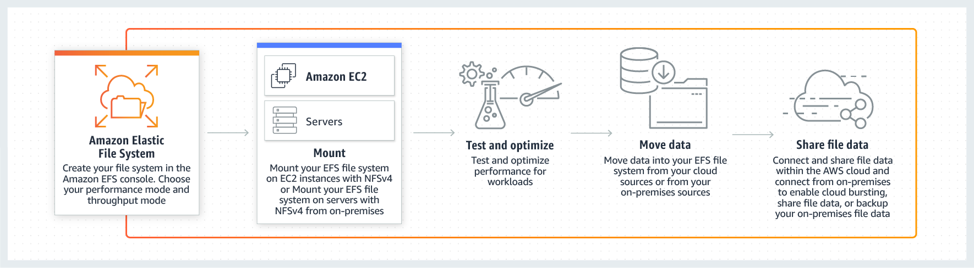

Amazon Elastic File System (Amazon EFS) provides a simple, scalable, elastic file system for Linux-based workloads for use with AWS Cloud services and on-premises resources. Amazon EBS snapshots cannot be stored on Amazon EFS.

9. 🟦 Amazon S3 Transfer Acceleration (S3TA)
What it is:
S3 Transfer Acceleration is a feature of Amazon S3 that speeds up uploads and downloads of large files to and from S3 over long distances by using Amazon CloudFront’s globally distributed edge locations.
As data arrives at an AWS Edge Location, data is routed to your Amazon S3 bucket over an optimized network path. S3 Transfer Acceleration is designed to optimize transfer speeds from across the world into S3 buckets. If you are uploading to a centralized bucket from geographically dispersed locations, or if you regularly transfer GBs or TBs of data across continents, you may save hours or days of data transfer time with S3 Transfer Acceleration.

Global/Regional:
✅ Global (it uses global CloudFront edge locations)

What it does:
- Accelerates data transfers to a specified S3 bucket using CloudFront edge locations.
- When a user uploads a file from far away (e.g., Asia to a US S3 bucket), the file is first routed to the nearest CloudFront edge location, then securely transmitted over the AWS backbone network to S3.
- Ideal for applications where latency is critical, or where users are spread across the globe.

Why it's needed:
- Uploading large files directly to S3 from distant locations can be slow and unreliable.
- S3TA reduces latency and improves throughput, especially for international users.

Pricing:
- Additional cost on top of S3 standard PUT/GET requests.
- Charged per GB uploaded/downloaded via acceleration endpoint.
- No charge if the acceleration feature is not used even when enabled.

How to enable:
- Can be enabled at bucket level.
- You use a special S3TA endpoint:
https://<bucketname>.s3-accelerate.amazonaws.com

Integrations:
- Works only with S3, but leverages CloudFront behind the scenes.
- Can be used with SDKs, CLI, and custom apps that upload/download objects.

Limitations:
- Not supported for all S3 operations (only PUT, GET, etc. — not list/delete).
- No benefit for users geographically close to the S3 bucket region.
- Slightly higher cost than standard S3 transfer.

When to use:
✅ Use when:
- You have global clients uploading to S3 buckets.
- You need to upload/download large objects over long distances.
- You're building a mobile or web app where file upload speed matters.
❌ Avoid when:
- Your users are already close to your S3 bucket region.
- You don’t need low-latency or faster uploads.
- You want to minimize cost and can tolerate some upload delay.
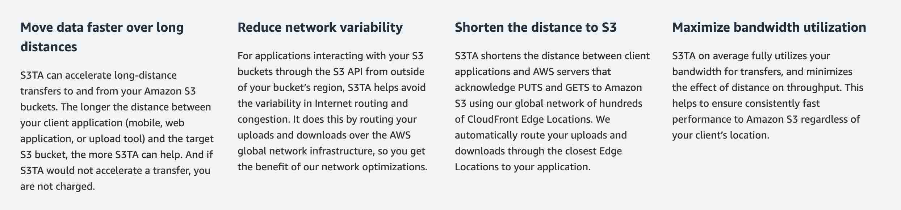

AWS DataSync
AWS DataSync is a secure online data transfer service that simplifies, automates, and accelerates copying terabytes of data to and from AWS storage services. Easily migrate or replicate large data sets without having to build custom solutions or oversee repetitive tasks. DataSync can copy data between Network File System (NFS) shares, or Server Message Block (SMB) shares, self-managed object storage, AWS Snowcone, Amazon Simple Storage Service (Amazon S3) buckets, Amazon Elastic File System (Amazon EFS) file systems, and Amazon FSx for Windows File Server file systems.
You can use AWS DataSync for ongoing transfers from on-premises systems into or out of AWS for processing. DataSync can help speed up your critical hybrid cloud storage workflows in industries that need to move active files into AWS quickly. This includes machine learning in life sciences, video production in media and entertainment, and big data analytics in financial services. AWS DataSync provides timely delivery to ensure dependent processes are not delayed. You can specify exclude filters, include filters, or both, to determine which files, folders, or objects get transferred each time your task runs.
AWS DataSync employs an AWS-designed transfer protocol—decoupled from the storage protocol—to accelerate data movement. The protocol performs optimizations on how, when, and what data is sent over the network. Network optimizations performed by DataSync include incremental transfers, in-line compression, and sparse file detection, as well as in-line data validation and encryption.
Data Transfer between on-premises and AWS using AWS DataSync:
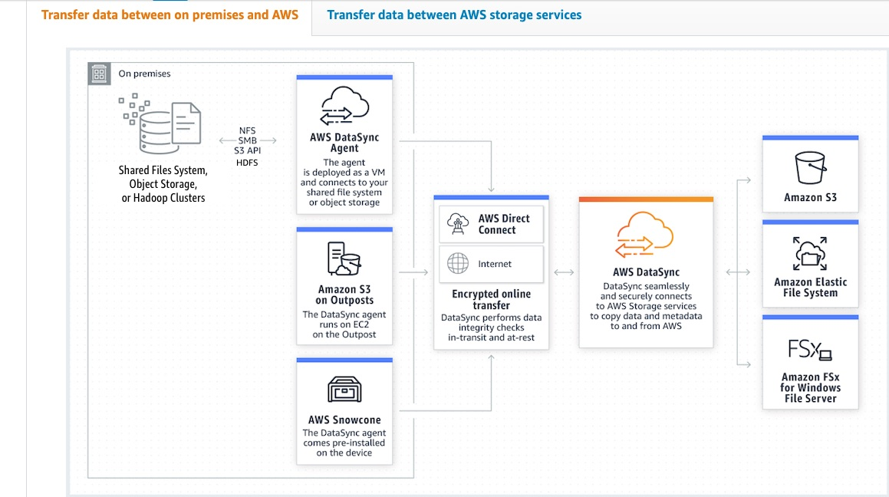
via - https://aws.amazon.com/datasync/

✅ DATABASE SERVICES

9. Amazon RDS (Relational Database Service)
- What it is: Managed relational DB service (MySQL, PostgreSQL, Oracle, SQL Server).
- Why needed: Removes DB admin tasks (patching, backups, etc.).
- Use When: You need reliable SQL DB with minimal ops.
- Avoid When: For complex joins/analytics (use Redshift), or small unstructured data (use DynamoDB).

10. Amazon Aurora
- What it is: High-performance, fully managed RDS engine (compatible with MySQL & PostgreSQL).
- Faster: Up to 5x MySQL, 3x PostgreSQL.
- Use When: Need enterprise-grade performance and availability.
- Avoid When: Cost is a major concern (Aurora is more expensive than RDS).

11. Amazon DynamoDB
- What it is: NoSQL key-value and document database.
- Why needed: Millisecond performance at scale.
- Global/Regional: Regional, with global table option.
- Pricing: On-demand or provisioned; charges per read/write capacity.
- Use When: You need fast, scalable NoSQL DB.
- Avoid When: You need complex queries or relational joins.
- Amazon DynamoDB stores items, not objects, based on key, value pairs.
- (Amazon S3 is an object-based storage system that stores objects that are comprised of key, value pairs.)

12. Amazon Redshift
- What it is: Fully managed data warehouse.
- Why needed: Run complex analytics on large datasets.
- Pricing: Pay per node/hour or on-demand.
- Use When: You need to run complex BI queries or use with tools like QuickSight, Tableau.
- Avoid When: Use case is simple transactions — use RDS or DynamoDB.

13. Amazon ElastiCache
- What it is: In-memory data store for caching (Redis or Memcached).
- Use: Improve app speed and reduce DB load.
- Use When: Caching, session storage, leaderboard, pub/sub.
- Avoid When: You don’t need low-latency access.

14. Amazon Athena
- What it is: Serverless query service to run SQL on S3 data.
- Why needed: Quickly analyze logs or CSV/Parquet files.
- Pricing: Pay per query (per TB scanned).
- Use When: Ad hoc analytics on S3 data.
- Avoid When: You need persistent DBs (use RDS/Redshift).

🌐 Networking Services

1. Amazon VPC (Virtual Private Cloud)
- What it is: A logically isolated network in AWS to launch your resources (like EC2) in.
- Global/Regional: Regional (you create VPCs per region).
- What it does:
  - Lets you define IP ranges using CIDR blocks (e.g., 10.0.0.0/16),
  - create subnets (Divide your VPC into subnets (public or private)),
  - configure route tables, internet gateways, NAT gateways and Security Groups to control traffic flow.
  - Deploy resources like EC2, RDS, etc., in specific subnets based on accessibility (internet-facing or private).
  - Enables communication between resources in the same VPC or across VPCs using VPC peering or Transit Gateway.
- A virtual private cloud (VPC) is a virtual network dedicated to your AWS account. A VPC spans all the Availability Zones in the region.
- CORRECT: "It spans all Availability Zones within a region" is the correct answer.
- INCORRECT: "It spans a single CIDR block" is incorrect. You can have multiple CIDR blocks in a VPC.
- INCORRECT: "It spans multiple subnets" is incorrect. A VPC spans AZs, subnets are created within AZs
- INCORRECT: "It spans all Availability Zones in all regions" is incorrect as it is within a single Region.

🌍 Region (e.g., us-east-1)
└── 🏢 Availability Zone (AZ-1) ┐
└── 🏢 Availability Zone (AZ-2) ├── All AZs are part of the Region
└── 🏢 Availability Zone (AZ-3) ┘

🔽
🛡️ VPC (in us-east-1 region) → spans across all 3 AZs

🔽
📦 Subnet-1 (in AZ-1) ─┐
📦 Subnet-2 (in AZ-2) ─┤ → All subnets are inside this VPC
📦 Subnet-3 (in AZ-3) ─┘

Understanding the Configuration Locations in the AWS Management Console:
1. VPC (Virtual Private Cloud) Section:
- In the VPC section, you configure:
  - VPCs (your private isolated networks)
  - Subnets (chunks of IP ranges inside a VPC, mapped to Availability Zones)
  - Route Tables, Internet Gateways, NAT Gateways
  - VPC Endpoints (to connect privately to AWS services like S3 or DynamoDB)
2. EC2 Section:
- You configure compute-related resources here:
  - EC2 Instances
  - EBS Volumes (Elastic Block Store = storage attached to EC2 instances)
  - Elastic Load Balancers (ELB) (for distributing traffic across instances)
⚠️ Even though EC2s, EBS, and ELBs are inside a VPC, you create them from the EC2 section, not the VPC section.
3. Amazon Route 53:
- You configure DNS records here:
  - Like pointing www.example.com to an EC2 or ELB
  - Also use Hosted Zones, Health Checks, etc.

🗺️ Hierarchy of AWS Networking: What’s inside what?
🌍 AWS Region (e.g., us-east-1)
└── 🏢 Availability Zones (e.g., us-east-1a, 1b, 1c)
└── 🛡️ VPC (Virtual Private Cloud – spans all AZs in region)
├── 📦 Subnets (Each in a single AZ)
│ └── 🖥️ EC2, ELB, EBS are launched inside subnets
└── 📡 VPC Endpoints, NAT Gateway, Route Tables, etc.
- A Region is a physical location with multiple AZs
- A VPC lives inside a Region and spans multiple AZs
- A Subnet is inside one Availability Zone
- EC2, ELB, EBS are deployed inside Subnets
- Route 53 is a global service — it can route across regions

🧠 Quick Notes:
- VPC and networking config: VPC Console
- Storage & Compute: EC2 Console
- DNS & domain-level routing: Route 53 Console

- Key Components
Component | Description
Subnets | Sub-networks inside VPC. Can be public (internet-facing) or private.
Internet Gateway | Allows internet access for public subnets.
NAT Gateway | Allows private subnet instances to access the internet (for updates, etc.).
Route Tables | Define how traffic is directed within the VPC.
Security Groups | Virtual firewalls attached to instances. Control inbound/outbound traffic.
Network ACLs | Optional stateless firewalls at the subnet level.

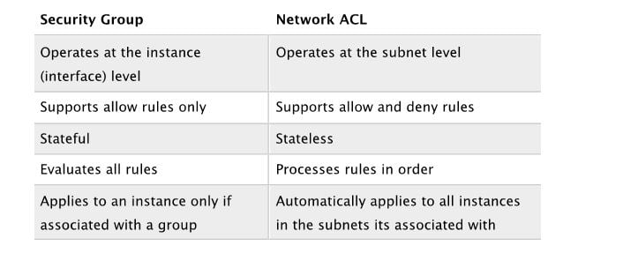

- Why needed: To control networking, security, and traffic flow for your AWS resources.
- Pricing: Free for basic VPC; you pay for NAT Gateway, traffic going out, etc.
- Integrates with: EC2, RDS, Load Balancers, Lambda (VPC access), etc.
Service | How It Integrates
EC2, RDS, Lambda | Deployed within VPC subnets.
Elastic Load Balancer (ELB) | Placed in public subnet; connects to instances in private subnets.
S3 & DynamoDB | Can be accessed privately using VPC endpoints (no internet required).
IAM | Used to control what VPC actions users/services can perform.

- Limitations: Max 5 VPCs per region by default (can request increase).
Limitation | Notes
No internet by default | Resources in a VPC need internet gateway or NAT to connect to internet.
Per-region scope | You can’t span a single VPC across regions.
Peering is non-transitive | If VPC A peers with B and B peers with C, A cannot talk to C unless directly peered.
IP range must not overlap | When peering VPCs, IP CIDR ranges must not overlap.

- Use when: You need private networking, security control, and traffic routing.
- Avoid when: For serverless apps with no networking setup (like simple Lambda + S3 usage). You're using fully managed services that do not require network configuration (e.g., S3, DynamoDB in default access mode). For very simple apps, AWS default VPC may be enough.

AWS VPC Connectivity — When to Use What?

🌐 1. Internet Gateway (IGW)
- Use When:
You want to allow resources in your public subnet (e.g., EC2 or Load Balancer) to access the internet.
- Example Use Case:
A web server running on EC2 that should be accessible from the public.
- Note:
Must attach IGW to your VPC and update the route table to send 0.0.0.0/0 traffic to IGW.

🔁 2. NAT Gateway
- Use When:
Instances in private subnets need to initiate connections to the internet (e.g., software updates, APIs), but should not be accessible from the internet.
- Example Use Case:
App server in private subnet downloading patches or hitting a public API.
- Note:
NAT Gateway lives in a public subnet and routes outbound traffic for private subnets.

🔗 3. VPC Peering
- Use When:
You need private communication between two VPCs in the same or different AWS accounts and limited network complexity.
- Example Use Case:
Two internal services in different VPCs (like a backend and DB layer in different teams) need to talk.
- Limitations:
  - Non-transitive: A↔B and B↔C does NOT mean A↔C
  - IP ranges must not overlap
  - Not ideal for large networks

🌐 4. Transit Gateway
- Use When:
You want to connect multiple VPCs and on-premises networks in a hub-and-spoke model at scale.
- Example Use Case:
Large enterprise with 10+ VPCs and VPN/Direct Connect needing centralized routing.
- Benefits over Peering:
  - Scalable
  - Transitive routing supported
  - Simplifies management vs multiple VPC peerings

AWS Transit Gateway connects virtual private clouds (VPC) and on-premises networks through a central hub. This simplifies your network and puts an end to complex peering relationships. It acts as a cloud router – each new connection is only made once. As you expand globally, inter-Region peering connects AWS Transit Gateways using the AWS global network. Your data is automatically encrypted and never travels over the public internet.
How AWS Transit Gateway can simplify your network:
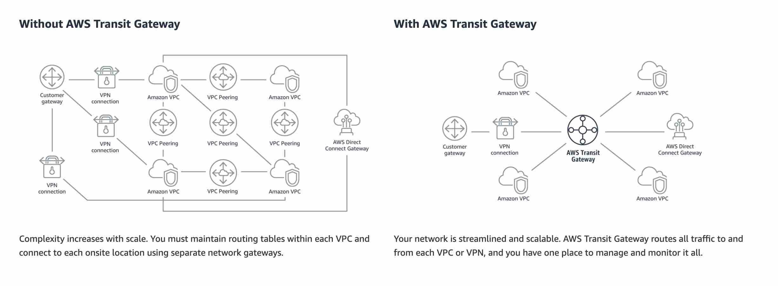

🌉 5. VPC Endpoints (Gateway / Interface)
- Use When:
You want to privately access AWS services (like S3, DynamoDB, SNS) from within your VPC without going through the internet.
- Example Use Case:
Lambda function in VPC accessing S3 via VPC endpoint for faster + secure communication.
- Types:
  - Gateway endpoints → S3, DynamoDB
  - Interface endpoints → All other services (use Elastic Network Interface)

** VPC Interface Endpoint
An interface endpoint is an elastic network interface (ENI) with a private IP address from the IP address range of your subnet that serves as an entry point for traffic destined to a supported service. Interface endpoints are powered by AWS PrivateLink, a technology that enables you to privately access services by using private IP addresses. AWS PrivateLink restricts all network traffic between your VPC and services to the Amazon network. You do not need an internet gateway, a Network Address Translation (NAT) device, or a virtual private gateway.
Exam Alert:
You may see a question around this concept in the exam. Just remember that only Amazon S3 and Amazon DynamoDB support VPC gateway endpoint. All other services that support VPC Endpoints use a VPC interface endpoint (note that Amazon S3 supports the VPC interface endpoint as well).
VPC Gateway Endpoint - A Gateway Endpoint is a gateway that you specify as a target for a route in your route table for traffic destined to a supported AWS service. The following AWS services are supported: Amazon S3, DynamoDB. You cannot use VPC Gateway Endpoint to privately connect your VPC to an Amazon SQS queue.

🌍 6. VPN Gateway (Site-to-Site VPN)
- Use When:
You want to connect your on-premises data center to your AWS VPC over an encrypted internet connection.
- Example Use Case:
A hybrid setup where your internal data center communicates with AWS services.
- Note:
Latency can vary since it goes over the internet.

🚄 7. AWS Direct Connect
- Use When:
You want a dedicated private network connection from your on-premises to AWS for low latency and high throughput.
- Example Use Case:
Enterprises with heavy data transfer needs or sensitive workloads (e.g., finance, health).
- Note:
More expensive than VPN but more consistent + secure.

✅ Summary Table
Connectivity Method | When to Use | Used For
Internet Gateway | Access from internet | Public EC2, ELB
NAT Gateway | Private → Internet | App servers, updates
VPC Peering | Small-scale VPC-to-VPC | 2–3 VPCs
Transit Gateway | Large multi-VPC network | Enterprises
VPC Endpoint | Private access to AWS service | S3, DynamoDB, SNS
VPN Gateway | On-prem to AWS (encrypted over internet) | Hybrid cloud
Direct Connect | High-speed private on-prem ↔ AWS | Secure, low-latency ops

** Understanding VPC Endpoints in AWS
When you want your resources inside a VPC (like EC2, Lambda) to privately access AWS services without going over the public internet, you use VPC Endpoints.
There are two types of VPC Endpoints:

1. Gateway Endpoint
- Definition:
A gateway endpoint is a target for a route in your VPC route table. It allows traffic to flow privately to AWS services using internal AWS networking — not the internet.
- Supported Services:
  - ✅ Amazon S3
  - ✅ Amazon DynamoDB
❗These are the only two AWS services that support Gateway Endpoints.
- Use Case Example:
Your EC2 instance in a private subnet needs to download a file from S3, without using NAT Gateway or Internet Gateway.
- Why limited to S3 and DynamoDB?
These two services are high-throughput, and a gateway-based solution is more cost-effective and scalable for them.

2. Interface Endpoint
- Definition:
An interface endpoint is an Elastic Network Interface (ENI) with a private IP from your VPC, connected to a service.
- Supported Services:
  - ✅ All other AWS services (e.g., SNS, SQS, KMS, Secrets Manager, CloudWatch, etc.)
  - ✅ Amazon S3 (yes, S3 supports both types)
  - ✅ Amazon DynamoDB (also supports both)
- Why use Interface Endpoints for S3/DynamoDB too?
Sometimes, you want fine-grained access, TLS encryption, CloudTrail logging, or private link access across accounts — all of which interface endpoints support.
- Example Use Case:
Lambda in a VPC accessing Secrets Manager using a private connection via interface endpoint.

💡 Summary to Remember for the Exam
VPC Endpoint Type | Supports | Example Services
Gateway Endpoint | ✅ Only S3 and DynamoDB | S3, DynamoDB
Interface Endpoint | ✅ All services including S3/DynamoDB | Secrets Manager, SNS, SQS, etc.

Network Access Control List (network ACL)
A Network Access Control List (network ACL) is an optional layer of security for your virtual private cloud (VPC) that acts as a firewall for controlling traffic in and out of one or more subnets (i.e. it works at the subnet level). A network ACL has separate inbound and outbound rules, and each rule can either allow or deny traffic.

A Network ACL (NACL) is a stateless firewall-like layer of security for your VPC subnets. It controls inbound and outbound traffic to and from one or more subnets based on rules (like IP address, protocol, and port number).

📍 Key Features:
Feature | Details
Stateless | Responses to allowed traffic must be explicitly allowed back.
Applied at | Subnet level
Default ACL | Each VPC comes with a default NACL that allows all traffic.
Custom ACLs | You can create custom NACLs and associate them with subnets.
Rules | Numbered list of allow or deny rules (from lowest to highest).
Evaluated in order | Rules are evaluated in order (lower number first).
Each subnet = 1 NACL | A subnet can be associated with only one NACL at a time.

🧠 How It's Different from Security Groups
Feature | Security Group | Network ACL
Level | Instance level | Subnet level
Stateful | Yes | No
Rules | Only allow rules | Allow and Deny rules
Return traffic | Automatically allowed | Must be explicitly allowed
Applies to | EC2 instances, ENIs | Entire subnet
Evaluation order | All rules are evaluated | Rules evaluated from lowest to highest

✅ Use Cases
- Restrict access to specific IP ranges (e.g., allow office IP, deny public).
- Deny traffic from known bad IP addresses (something SGs can’t do).
- Add an extra layer of security to public or private subnets.

🧾 Example: NACL Rules
Rule # | Type | Protocol | Port Range | Source | Allow/Deny
100 | HTTP | TCP | 80 | 0.0.0.0/0 | ALLOW
110 | HTTPS | TCP | 443 | 0.0.0.0/0 | ALLOW
120 | ALL Traffic | ALL | ALL | 203.0.113.0/24 | DENY
* | ALL Traffic | ALL | ALL | 0.0.0.0/0 | DENY
👉 In this example:
- HTTP and HTTPS are allowed from anywhere.
- A specific IP range is denied (maybe it's malicious).
- All other traffic is denied by default (rule *).

🔁 NACL vs Security Group — When to Use Which?
Scenario | Use NACL | Use SG
Block specific IPs (deny rules) | ✅ | ❌
Allow specific ports for a subnet | ✅ | ❌
Control traffic for individual instances | ❌ | ✅
Stateful filtering | ❌ | ✅
Add extra subnet-level security | ✅ | ✅

Network Access Control List (network ACL) Overview:
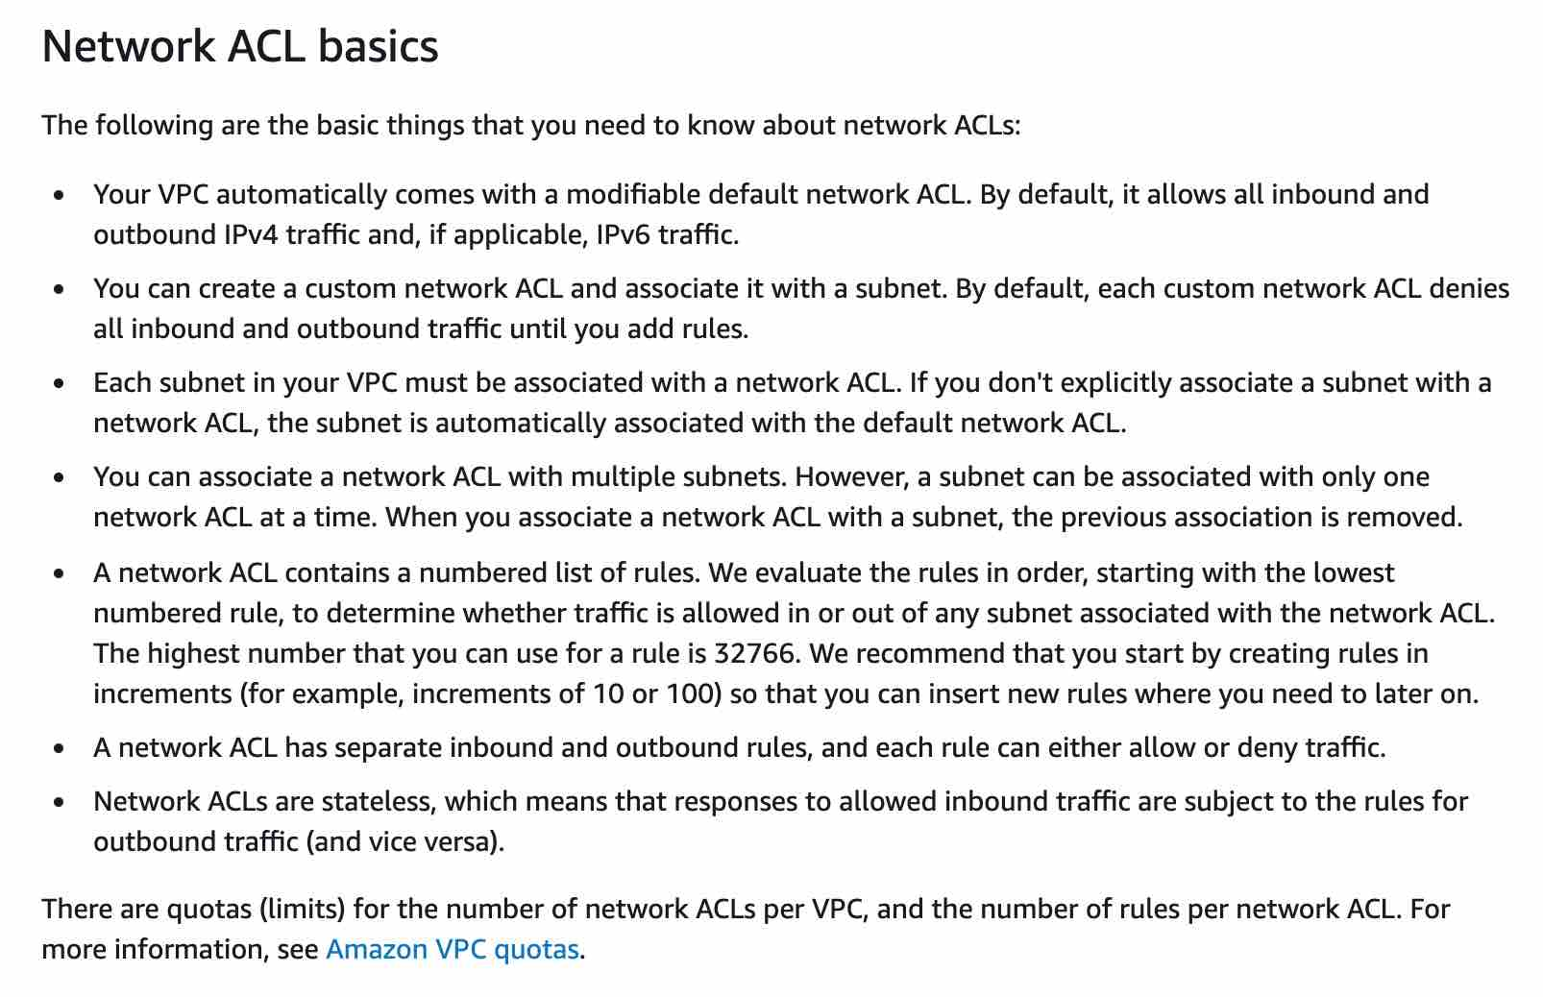
via - https://docs.aws.amazon.com/vpc/latest/userguide/vpc-network-acls.html

VPC Flow Logs - VPC Flow Logs is a feature that enables you to capture information about the IP traffic going to and from network interfaces in your VPC. Flow log data can be published to Amazon CloudWatch Logs or Amazon Simple Storage Service (Amazon S3). After you've created a flow log, you can retrieve and view its data in the chosen destination. However, it cannot deny traffic from a specific IP address.

2. Amazon CloudFront
Amazon CloudFront is a Content Delivery Network (CDN) service that securely delivers static and dynamic content (e.g., HTML, CSS, images, videos, APIs) to users with low latency and high transfer speed using AWS global edge locations.

🌍 Global or Regional?
- Global Service (with over 600+ edge locations worldwide)

⚙️ What it Does
- Distributes your content to edge locations near the user.
- Caches content closer to the viewer for faster delivery.
- Supports dynamic and static content.
- Works with HTTPS, SSL, signed URLs, and custom domain names.
- Can serve custom error pages and compress content automatically.

❓ Why Needed
- To reduce latency by serving content from the nearest AWS location.
- Offloads origin servers (like S3, EC2, ALB).
- Provides secure, scalable, and high-performance content delivery.
- Helps prevent DDoS attacks with AWS Shield Standard integration.

💲 Pricing
- Pay-as-you-go based on:
  - Data transferred out (per GB)
  - Number of HTTP/HTTPS requests
  - Regional data transfer prices vary
- Additional cost for:
  - Field-level encryption
  - Signed URLs/cookies
  - Real-time log streaming

🔗 Integrations
- Works with:
  - Amazon S3 (origin)
  - Elastic Load Balancers
  - Amazon EC2
  - AWS Lambda@Edge (to run code at edge locations)
  - AWS WAF (Web Application Firewall)
  - AWS Shield (for DDoS protection)
  - Route 53 for custom domains

⚠️ Limitations
- Does not cache everything by default — caching behavior must be configured.
- Real-time logs are not enabled by default — must configure separately.
- Latency for origin fetches can occur if content is not cached.
- Slight complexity in setting custom behaviors and cache invalidations.

🕐 When to Use
- When serving global content (e.g., website, media, APIs).
- For reducing latency of static/dynamic content.
- To improve load times of web apps & mobile apps.
- When you need secure delivery via HTTPS.
- To accelerate S3, EC2, or on-prem content delivery.

🚫 When Not to Use
- For purely internal/private applications not accessed globally.
- If you don’t need low-latency or don’t care about caching performance.
- If your application is only used within a VPC or private network.

3. AWS Global Accelerator
AWS Global Accelerator is a networking service that improves the availability, performance, and reliability of your applications by routing traffic through the AWS global network infrastructure.

Global/Regional:
✅ Global – built on the AWS global network backbone.

What it does:
- Provides you with static IP addresses that act as a fixed entry point to your application (even if it’s running in multiple AWS Regions).
- Uses Anycast IP routing to direct user traffic to the nearest AWS edge location.
- Routes the traffic over the AWS global network to the optimal endpoint in the target AWS Region.
- Improves performance and fault tolerance by rerouting traffic to healthy endpoints in case of failure.

Why it's needed:
- Public internet can be slow, unreliable, and unpredictable across geographies.
- Global Accelerator uses the high-speed AWS backbone network, ensuring consistent, low-latency connections.
- Helps with disaster recovery, multi-region redundancy, and global performance optimization.

Pricing:
- Charged based on:
  - Hourly charges for each accelerator.
  - Data transfer costs (per GB transferred through the accelerator).
- Additional cost compared to routing directly over the internet.

Integrations:
- Supports Elastic Load Balancers (ALB/NLB), EC2 instances, and Elastic IPs as endpoints.
- Can be used with multi-region applications, APIs, web apps, and gaming.

Limitations:
- No direct integration with S3 or Lambda.
- Adds extra cost for performance and availability benefits.
- Limited to TCP and UDP protocols.

When to use:
✅ Use when:
- You need fast and reliable performance for global users.
- You want static IP addresses for your global applications.
- You are deploying multi-region architectures with failover and routing control.
- You are building low-latency apps (e.g., video conferencing, gaming, financial services).
❌ Avoid when:
- Your application is limited to a single region with local traffic only.
- You want to minimize cost and performance is not a critical concern.

📊 Comparison Table: CloudFront vs S3TA vs Global Accelerator
Feature / Service | Amazon CloudFront | S3 Transfer Acceleration (S3TA) | AWS Global Accelerator
Purpose | Content Delivery Network (CDN) for web content (HTML, CSS, JS, images, videos) | Accelerates uploads and downloads to/from Amazon S3 buckets over long distances | Improves performance for global apps by routing traffic through AWS global network
Accelerates | Static & dynamic web content delivery | File uploads/downloads to S3 buckets | TCP/UDP traffic to applications (EC2, ALB, etc.)
How it works | Uses edge locations to cache and serve content closer to users | Uses CloudFront edge locations to speed up data transfer to S3 | Routes user traffic to optimal AWS endpoint using Anycast IPs
Supports Caching | ✅ Yes | ❌ No | ❌ No
Use Cases | Websites, video streaming, APIs, gaming | Fast file uploads/downloads to S3 from globally distributed clients | Global applications needing low latency and high availability
Integration | S3, EC2, ALB, Lambda@Edge, Route 53 | Only with Amazon S3 | EC2, ALB, Elastic IPs, Route 53
Charges | Based on data transfer out and HTTP/HTTPS requests | Based on the distance and amount of data transferred | Fixed hourly charge + data transfer premium
Security | Integrated with AWS Shield, WAF, SSL/TLS | Secure by using HTTPS | Integrated with AWS Shield, uses static Anycast IPs
Edge Locations | Used for caching and delivery | Used as acceleration points | Used to direct traffic via AWS network, not for caching
Traffic Direction | Region → Edge → User | Client → Edge → S3 Bucket | User → Edge → Optimal AWS Region

✅ When to Use Which:
Use This If You Need... | Use
Global low-latency for an application | AWS Global Accelerator
Uploading/downloading files faster to/from S3 | Amazon S3 Transfer Acceleration (S3TA)
Global app resilience & failover | AWS Global Accelerator
Just to speed up S3 transfers (not the app) | Amazon S3 Transfer Acceleration (S3TA)

4. Amazon Route 53
- What it is: A highly available and scalable Domain Name System (DNS) web service.
- Global/Regional: Global.
- What it does: Translates domain names to IP addresses, supports routing policies.
- Why needed: To register domains and manage DNS records.
- Pricing: Pay per hosted zone and DNS queries.
- Integrates with: CloudFront, Load Balancers, EC2, S3 (static hosting).
- Limitations: No built-in WAF or SSL (must be combined with other services).
- Use when: You want to route traffic to AWS apps or register domains.
- Avoid when: You're using third-party DNS providers and don’t need AWS DNS.
Amazon Route 53 features include domain registration, DNS, traffic flow, health checking, and failover. .Route 53 does not support DHCP, IP routing or caching.
CORRECT: "Domain registration" is the correct answer.
CORRECT: "Traffic flow" is the correct answer.
INCORRECT: "DHCP" is incorrect as explained above.
INCORRECT: "Caching" is incorrect as explained above.
INCORRECT: " IP Routing" is incorrect. The DNS features of Route 53 are called “routing policies”, however this is not traditional IP routing which is performed by routers. It is intelligent DNS that responds with different results based on certain factors such as latency, weight, or failover configuration.

5. Elastic Load Balancing (ELB)
- What it is: Automatically distributes incoming traffic across multiple targets (EC2, Lambda, etc.).
- Global/Regional: Regional.
- What it does: Ensures high availability and fault tolerance of apps.
- Why needed: Helps balance load and avoid failures.
- Pricing: Based on hours used and data processed.
- Integrates with: EC2, ECS, Lambda, Auto Scaling.
- Limitations: Cannot route globally (use Global Accelerator for that).
- Use when: You have multiple servers or services behind a single entry point.
- Avoid when: Your app is very simple (e.g., one Lambda function only).

🔄 Application Integration Services

1. Amazon SQS (Simple Queue Service)
- What it is: A fully managed message queuing service.
- Global/Regional: Regional.
- What it does: Stores and manages messages between services asynchronously.
- Why needed: Helps decouple services and ensure reliability.
- Pricing: Free for first 1 million requests/month, then pay-per-request.
  - Additional charges for data transfer, message retention, and encryption using KMS.
- Integrates with: Lambda (trigger), EC2, Step Functions, EventBridge.
- Limitations: Not real-time; max retention = 14 days.
- Use when: You need to queue tasks, decouple services, handle retries.
- Avoid when: You need real-time event delivery (use SNS or EventBridge).

🛠️ When to Use SQS
- Use Amazon SQS when:
- You want loose coupling between components.
- You want asynchronous communication.
- You need to buffer requests or handle high traffic spikes.
- You want to offload retry logic and prevent data loss.
- You need exact order delivery → Use FIFO Queue.

🛑 When NOT to Use SQS
- If you want publish/subscribe model → Use SNS.
- If you need event-driven processing with filtering → Use EventBridge.
- If you need stream processing (real-time data feed) → Use Amazon Kinesis.

🧠 Exam Tip: When is SQS the Answer?
Look for these clues:
- “Decouple components”
- “Queue messages”
- “Retry failed tasks”
- “Dead-letter queue (DLQ)”
- “Guarantee order of messages” → FIFO
- “Scale consumers independently from producers”
- “Batch processing” or “Message buffering”
- “Use case includes retrying failed API calls”

2. Amazon SNS (Simple Notification Service)
- What it is: A fully managed pub/sub messaging and mobile notification service. Allows you to send messages from a single source to multiple subscribers (like Lambda, SQS, email, SMS, HTTP).
- Global/Regional: Regional.
- What it does: Sends messages to multiple subscribers (email, Lambda, SQS, etc.).
SNS allows event producers (called "publishers") to send messages to a topic. The topic then delivers that message to all subscribed endpoints (like Lambda functions, SQS queues, or email addresses).
→ Supports fan-out pattern (one-to-many communication).
→ Also supports application-to-person notifications (e.g., mobile push or SMS).

- Why needed: Real-time notifications or broadcast messaging.
- Pricing: Free tier for 1 million publishes, then pay per request and delivery type.
- Integrates with: AWS Lambda (to process messages in real-time)
Amazon SQS (to queue messages for delayed processing)
HTTP/S endpoints (for webhooks)
Email & SMS (for user notifications)
CloudWatch Logs (for logging SNS events)

- Limitations: No message ordering (for FIFO, use Amazon SQS FIFO queues).
No message persistence (SNS does not store undelivered messages unless you use SQS).
Retries need to be configured (e.g., exponential backoff for delivery failures).
No built-in payload transformation (use Lambda if needed).

- Use when: You want to send the same message to many systems.
For real-time alerts (e.g., application errors, user actions).
In event-driven architectures.
When different subscribers need to take different actions based on a single event.
- Avoid when: You need message persistence or delayed processing (use SQS).
  - When you need message ordering or durability → use Amazon SQS.
  - For synchronous communication between services (consider API Gateway + Lambda).
  - When handling high-volume workflows with complex retries → consider Step Functions.

Reference architecture for building a decoupled order processing system using SNS and SQS
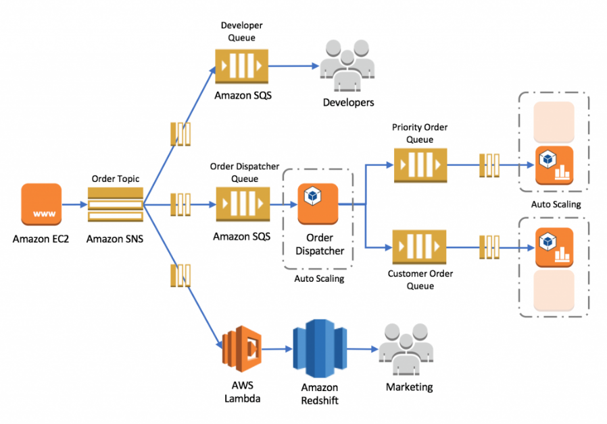

- 🛒 A Customer Places an Order
A user visits a web application running on an Amazon EC2 instance and places an order. The web app doesn’t handle the order processing itself. Instead, it wants to notify other systems that "Hey, an order was just placed!"

- 📢 EC2 Publishes the Order to Amazon SNS
The EC2 instance sends this order as a message to a service called Amazon SNS (Simple Notification Service), using a Topic named OrderTopic.
Think of SNS as a megaphone — once EC2 shouts a message into it, any subscriber listening to this topic gets a copy of the message.

- 📤 SNS Fans Out the Order Message to Multiple Subscribers
SNS sends the order message to three different destinations, all at the same time:
  - 📥 SQS Developer Queue — This queue collects messages for developers to review, debug, or test.
  - 📥 SQS Order Dispatcher Queue — This is where the main processing logic starts.
  - ⚡ AWS Lambda — This function is triggered automatically to store the order data in Amazon Redshift, which is later used by the Marketing team for analytics.

- 🧠 Order Dispatcher Picks Up the Order
An Order Dispatcher Service, running on EC2 (with Auto Scaling), reads messages from the Order Dispatcher Queue.
It checks the order details and asks:
“Is this a priority order or a regular customer order?”

- 🚦 Dispatcher Routes Orders to the Right Queues
Based on the order type:
  - 📥 Priority orders go to the Priority Order Queue
  - 📥 Regular customer orders go to the Customer Order Queue

- ⚙️ Auto-Scaling EC2 Workers Process the Orders
Two different EC2 Auto Scaling groups are running:
  - One group listens to the Priority Order Queue
  - Another listens to the Customer Order Queue
Each group processes the orders asynchronously — scaling in and out based on load, without waiting on other services.

- 📊 Real-Time Data Streaming to Amazon Redshift (via Lambda)
Meanwhile, the Lambda function triggered by SNS sends order information to Amazon Redshift.
This way, the Marketing team gets live data about new orders, enabling them to generate reports, track trends, or analyze performance.

✅ Why This Architecture Works So Well
- Services are loosely coupled (changes in one don’t break others).
- It’s highly scalable (Auto Scaling + SQS queues).
- It allows real-time analytics (Redshift).
- Failures in one part don’t block the whole system.
- Easy to add or remove subscribers to SNS.

3. Amazon EventBridge (formerly CloudWatch Events)
- What it is: A serverless event bus to connect applications using events.
- Global/Regional: Regional.
- What it does: Routes events from services to targets (Lambda, SQS, etc.).
- Why needed: Automates event-driven workflows.
- Pricing: Free for 100K events/month; pay per event beyond.
- Integrates with: AWS services, SaaS apps (like Zendesk, Datadog), Lambda, Step Functions.
- Limitations: Limited event retention; no payload transformation.
- Use when: You want to respond to AWS events or schedule tasks.
- Avoid when: You need strict ordering or durable message queues (use SQS).

4. AWS Step Functions
- What it is: A serverless function orchestrator to coordinate multiple AWS services.
- Global/Regional: Regional.
- What it does: Builds workflows using state machines.
- Why needed: Coordinates long-running processes or retries.
- Pricing: Pay per state transition.
- Integrates with: Lambda, SQS, SNS, ECS, DynamoDB, API Gateway.
- Limitations: State machine size and timeout limits apply.
- Use when: You need to manage workflows or service coordination.
- Avoid when: You need simple, lightweight single service invocation.

🏗️ Monitoring, Logging, and Observability

🏗️ Architecture Best Practices & High Availability Concepts

🔁 Scaling in AWS
What is Scaling?
Scaling is the process of adjusting compute capacity based on your application's demand. AWS offers two types of scaling:
1. Vertical Scaling (Scale Up/Down):
- Increase or decrease the size of the instance (e.g., from t2.micro to t2.large).
- Easy but has hardware limitations.
- Example: Upgrading an EC2 instance to get more CPU/RAM.
2. Horizontal Scaling (Scale Out/In):
- Add or remove multiple instances to handle load.
- Provides better fault tolerance and is preferred for stateless applications.
- Example: Auto Scaling Group adding more EC2 instances during high traffic.
📌 Services That Support Auto Scaling:
- Amazon EC2 – via Auto Scaling Groups.
- Amazon ECS (Fargate or EC2 launch types) – based on CPU/memory or queue length.
- DynamoDB – scales based on read/write throughput.
- Aurora Serverless – automatically scales the database capacity.
- Lambda – automatically scales by default (serverless).

✅ How AWS Achieves Fault Tolerance
What is Fault Tolerance?
Fault Tolerance is the ability of a system to remain operational even when components fail.
🔐 Key Concepts to Ensure Fault Tolerance:
- Availability Zones (AZs):
  - Multiple data centers in a region.
  - Services deployed across AZs can withstand failure of one zone.
  - Example: RDS Multi-AZ, ELB distributes traffic across instances in different AZs.
- Elastic Load Balancing (ELB):
  - Distributes incoming traffic across multiple targets (EC2, Lambda, containers).
  - Ensures if one instance fails, traffic is rerouted.
- Auto Scaling:
  - Automatically replaces unhealthy instances to maintain desired count.
  - Detects failure and recovers capacity.
- Amazon S3:
  - Designed for 99.999999999% (11 9s) durability.
  - Stores data redundantly across multiple AZs.
- Route 53 – DNS Failover:
  - Monitors endpoints and redirects traffic to healthy regions or endpoints.
- Multi-AZ & Multi-Region Deployments:
  - Used for Disaster Recovery or High Availability.
  - Example: Host app in us-east-1 and replicate it to us-west-2.

💡 When to Use:
Scenario | Recommended Feature
Traffic spike during sales | Auto Scaling
Need uptime if one server fails | Load Balancer
Protect from AZ failure | Multi-AZ RDS
Global user access & failover | Route 53 + Multi-Region
Handle failures in real-time queues | DLQ with SQS/Lambda

Fault tolerance is achieved by a scale up operation
A scale up operation is constrained to be running its processes on only one computer. In such systems, the only way to increase performance is to add more resources into one computer in the form of faster CPUs, memory or storage. Fault tolerance is not possible for such scaling operations since a single instance is prone to failure.

✅ AWS X-Ray
What it is:
AWS X-Ray is a distributed tracing service that helps developers analyze and debug applications, especially those built using microservices architecture. It lets you trace requests as they travel through the different services in your application.
Global or Regional:
Regional (You must enable and use X-Ray in each AWS Region where your application runs.)
What it does:
- Collects data about requests (called traces) from AWS services and your application code.
- Breaks traces into segments for each service and function involved.
- Generates a visual map of your service interactions, including latency, errors, and request flow.
- Helps detect bottlenecks, slow services, errors, and performance issues.
Why needed:
- In modern apps (especially microservices), it's difficult to pinpoint where an issue is occurring.
- X-Ray gives end-to-end visibility into the flow of requests, even across AWS services.
- Helps with performance tuning, root cause analysis, and understanding dependencies.
Pricing:
- Free tier: 100,000 traces and 1 million trace segments per month.
- Beyond free tier, you pay per trace recorded, scanned, and retrieved.
- Low cost, based on usage.
Integrates with:
- Amazon EC2
- AWS Lambda
- Amazon ECS / EKS
- Amazon API Gateway
- Elastic Beanstalk
- AWS SDKs (custom apps written in Java, Python, Node.js, etc.)
Limitations:
- Only captures data for requests that use HTTP, HTTPS, or AWS SDKs.
- Needs the X-Ray SDK to be added to your application code.
- Default retention of traces is 30 days.
- No application-level logging — only performance/tracing data.
When to use:
- You’re using microservices or serverless applications and want full visibility.
- Need to debug latency, performance bottlenecks, or trace errors.
- Want to monitor how requests travel through services (like API Gateway → Lambda → DynamoDB).
When not to use:
- In monolithic apps with simple flows — standard logs may be enough.
- If you only want CPU, memory, and infra-level monitoring — use CloudWatch.
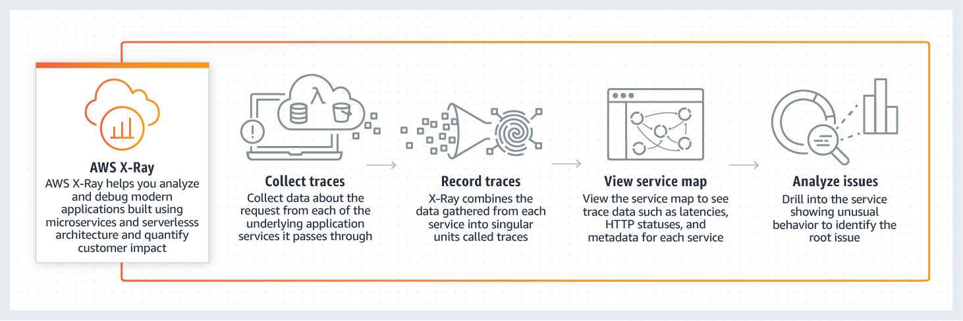

CLOUDWATCH
Amazon CloudWatch is a monitoring service for AWS cloud resources and the applications you run on AWS. You can use Amazon CloudWatch to collect and track metrics, collect and monitor log files, and set alarms. Amazon CloudWatch can monitor AWS resources such as Amazon Elastic Compute Cloud (Amazon EC2) instances, Amazon DynamoDB tables, and Amazon Amazon Relational Database Service (Amazon RDS) DB instances, as well as custom metrics generated by your applications and services, and any log files your applications generate.
You can use Amazon CloudWatch to gain system-wide visibility into resource utilization, application performance, and operational health. You can use these insights to react and keep your application running smoothly.
How Amazon CloudWatch works:
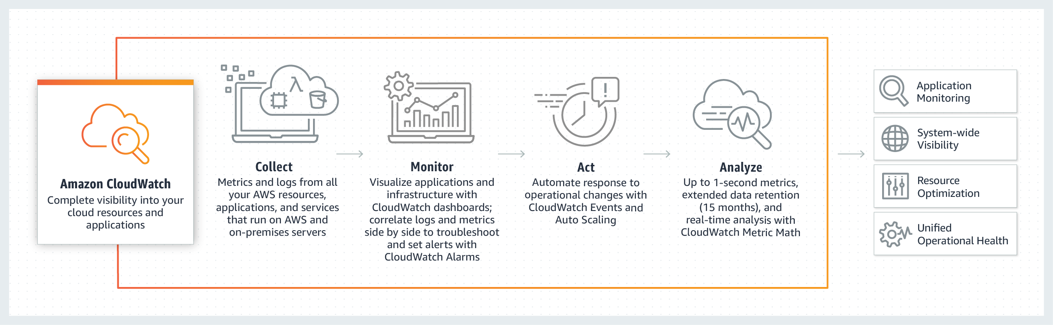

Amazon CloudWatch is a monitoring service for AWS cloud resources and the applications you run on AWS. CloudWatch is for performance monitoring (CloudTrail is for auditing).
It is used to collect and track metrics, collect and monitor log files, and set alarms. Basic monitoring collects metrics every 5 minutes whereas detailed monitoring collects metrics every 1 minute
AWS CloudTrail is a web service that records activity made on your account and delivers log files to an Amazon S3 bucket. CloudTrail is for auditing, whereas CloudWatch is for performance monitoring. CloudTrail is about logging and saves a history of API calls for your AWS account

🛡️ Domain 2: Security and Compliance

1. AWS Identity and Access Management (IAM)
- What: AWS IAM lets you securely manage access to AWS services and resources.
- Global or Regional: Global (configured once per account).
- Purpose: To control “who can do what” in your AWS account.
- Pricing: Free.
- Key Features:
  - Users, Groups, Roles, Policies
  - MFA (Multi-Factor Authentication) for extra security
  - Least Privilege principle (only give needed access)
- Integrations: Works with all AWS services.
- Limitations:
  - Hard to manage at scale manually (use AWS Organizations or IAM Identity Center).
- When to Use: Always—essential for managing security.
- When Not to Use: Never—it's foundational.

The IAM console provides information about when IAM users and roles last attempted to access AWS services. This information is called service last accessed data. This data can help you identify unnecessary permissions so that you can refine your IAM policies to better adhere to the principle of “least privilege.”
That means granting the minimum permissions required to perform a specific task. You can find the data on the Access Advisor tab in the IAM console by examining the detail view for any IAM user, group, role, or managed policy.

2. AWS IAM Identity Center (formerly AWS SSO)
- What: Central place to manage single sign-on (SSO) for multiple AWS accounts.
- Global or Regional: Regional.
- Purpose: For enterprises managing access to many AWS accounts.
- Pricing: Free.
- Integrations: AWS Organizations, IAM roles.
- Limitations: Only works with AWS Organizations.
- When to Use: Multiple accounts, federated identities.
- When Not to Use: Single-account, basic IAM use.

3. AWS Organizations
- What: Lets you group and manage multiple AWS accounts centrally.
- Global or Regional: Global.
- Purpose: Centralized billing, policy control (SCPs), and access management.
- Pricing: Free.
- Key Concepts:
  - OU (Organizational Units) – logical account groupings
  - SCP (Service Control Policies) – set limits on account permissions
- Integrations: IAM Identity Center, consolidated billing.
- When to Use: You have 2+ AWS accounts.
- When Not to Use: You have only one AWS account.

4. AWS Artifact
- What: Provides access to compliance reports and AWS certifications.
- Global or Regional: Global.
- Purpose: To help with regulatory and compliance audits.
- Pricing: Free.
- Use Case: Download SOC reports, ISO certifications, etc.
- When to Use: Compliance-heavy environments (e.g., finance, healthcare).

5. AWS Shield (Standard & Advanced)
- What: DDoS protection for AWS applications.
- Global or Regional: Global.
- Pricing:
  - Shield Standard: Free, basic DDoS protection.
  - Shield Advanced: Paid, enhanced protection + 24x7 DDoS Response Team.
- Protects:
  - Standard: CloudFront, Route 53, ALB.
  - Advanced: Also includes EC2, Elastic IPs, Global Accelerator.
- When to Use Shield Advanced:
  - If you run critical apps needing real-time DDoS support.

6. AWS WAF (Web Application Firewall)
- What: Protects web apps from common exploits (like SQL injection, XSS).
- Global or Regional: Regional, but can be used with global services like CloudFront.
- Pricing: Based on rules and number of requests.
- How It Works: Apply rules to filter web traffic.
- Integrations: CloudFront, ALB, API Gateway.
- When to Use: Public-facing web applications.
- When Not to Use: Private APIs or internal-only applications.

Comparison: AWS WAF vs Amazon Inspector vs Amazon GuardDuty

✅ 1. AWS WAF (Web Application Firewall)
🔸 Protects web applications from common web exploits (Layer 7 — Application Layer).
- What it does:
  - Filters/blocks traffic based on IPs, geo, HTTP headers, query strings, etc.
  - Blocks SQL Injection, XSS, etc.
  - Integrated with CloudFront, ALB, API Gateway, and App Runner.
- Use Case:
  - You are hosting a website or API and want to block malicious HTTP/S traffic.
  - You want to prevent OWASP Top 10 vulnerabilities.
- When to Use:
✅ For protecting web-facing applications from application-layer threats.

✅ 2. Amazon Inspector
🔸 Automated security assessment for EC2, Lambda, and container images (ECR).
- What it does:
  - Scans for vulnerabilities in software packages, libraries, OS, and app code.
  - Checks EC2, Lambda, and container images for known CVEs.
  - Produces detailed findings with severity scores.
- Use Case:
  - You want to continuously scan your workloads for software vulnerabilities.
  - You need CVE reports and compliance scanning.
- When to Use:
✅ For identifying software vulnerabilities in your compute resources.
✅ During CI/CD pipelines to catch security flaws early.

✅ 3. Amazon GuardDuty
🔸 Threat detection and monitoring using machine learning and AWS logs.
- What it does:
  - Analyzes VPC Flow Logs, CloudTrail logs, and DNS logs.
  - Detects suspicious behavior like port scans, brute force, compromised credentials, etc.
  - Sends alerts (findings) to the AWS console or via SNS.
- Use Case:
  - You want intelligent threat detection without deploying agents.
  - You want to be alerted about compromised resources or users.
- When to Use:
✅ For monitoring AWS accounts and workloads for unexpected, unauthorized, or malicious activity.
✅ For continuous security monitoring.

📊 Summary Comparison Table:
Feature | AWS WAF | Amazon Inspector | Amazon GuardDuty
Layer | Application Layer (Layer 7) | System/Package Level | Account & Network Activity Level
Protects Against | Web exploits (XSS, SQLi, etc.) | Vulnerabilities in OS, Lambda, ECR | Malware, brute force, data exfiltration
Input Type | HTTP/HTTPS traffic | EC2, Lambda, ECR | Logs (VPC, DNS, CloudTrail)
Active or Passive | Active (blocks traffic) | Passive (scans and reports) | Passive (monitors logs)
Agents Needed? | ❌ No | ✅ Yes (for EC2) | ❌ No
ML-based Detection? | ❌ No | ❌ No | ✅ Yes
Typical User | Web developers | DevSecOps, security auditors | Security teams, AWS account admins
Pricing | Based on rules and requests | Based on scanned resources | Based on volume of analyzed logs

🟢 When to Use Which:
- Use AWS WAF:
➤ When you want to actively block web traffic (like blocking bad IPs or malicious requests to your website/API).
- Use Amazon Inspector:
➤ When you want to scan your EC2, Lambda, and containers for vulnerabilities or CVEs to fix known issues.
- Use Amazon GuardDuty:
➤ When you want to monitor AWS resources continuously for threats like account compromise, data exfiltration, or suspicious behavior.
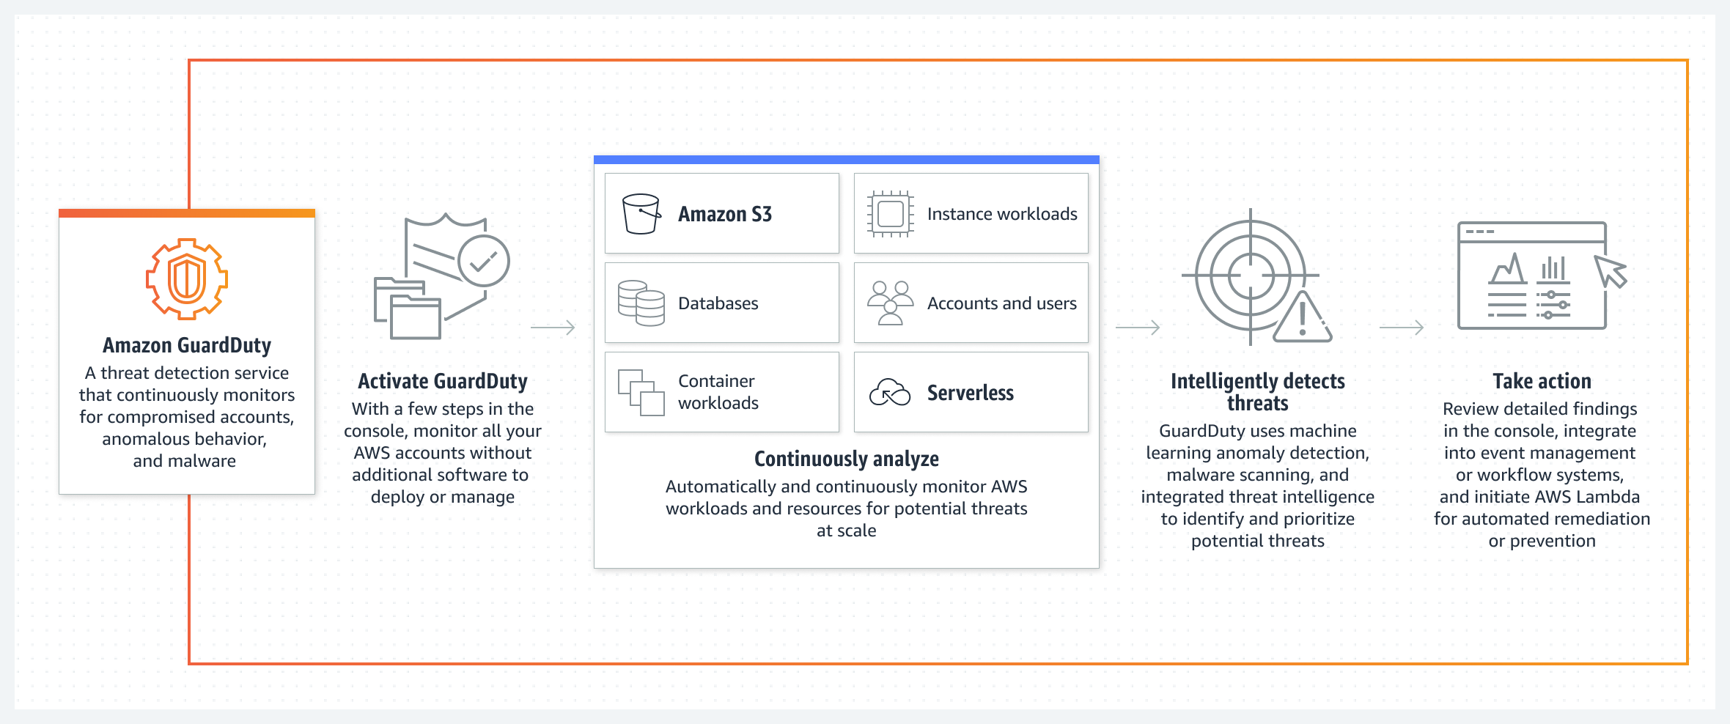

7. AWS Secrets Manager
- What: Securely stores, manages, and rotates secrets like API keys, passwords.
- Global or Regional: Regional.
- Pricing: $0.40/month per secret + API usage fees.
- Key Feature: Automatic rotation using AWS Lambda.
- When to Use: Dynamic apps needing high-security credential storage.
- When Not to Use: Small, static apps (consider Systems Manager Parameter Store).

8. AWS Key Management Service (KMS)
- What: Create and manage encryption keys used to encrypt your data.
- Global or Regional: Regional.
- Pricing: Free for default keys, usage fees apply for custom keys.
- Use Cases: Encrypt S3, EBS, RDS, Lambda environment variables.
- Integrations: Most AWS services.
- When to Use: Any service dealing with sensitive data.
- When Not to Use: Basic apps with no sensitive data.

9. Amazon Macie
- What: Uses ML to discover and protect sensitive data in S3.
- Global or Regional: Regional.
- Pricing: Based on number of S3 objects analyzed.
- Use Case: Data security, PII detection.
- When to Use: Large S3 datasets, compliance requirements.

Amazon Macie is a fully managed data security and data privacy service that uses Machine Learning and pattern matching to discover and protect your sensitive data in AWS.
Amazon Macie uses Machine Learning and pattern matching to cost-efficiently discover sensitive data at scale. Amazon Macie automatically detects a large and growing list of sensitive data types, including personally identifiable information (PII) such as names, addresses, and credit card numbers. It also gives you constant visibility of the data security and data privacy of your data stored in Amazon S3.
How Amazon Macie works:
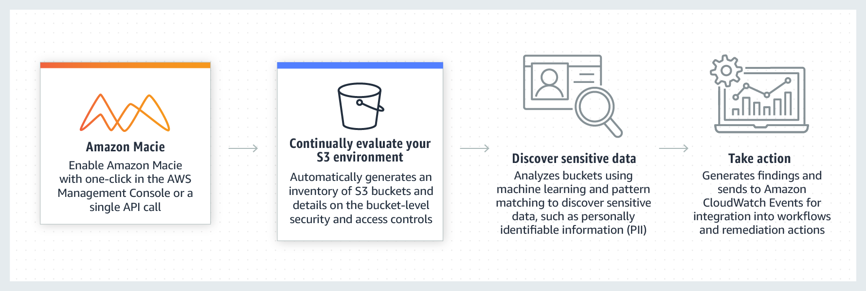
via - https://aws.amazon.com/macie/

10. Shared Responsibility Model
- What: AWS is responsible for security of the cloud, customers are responsible for security in the cloud.
- Examples:
  - AWS responsibility: hardware, data center, networking.
  - Your responsibility: user access, data encryption, app code.
Here is the continuation in Calibri font size 11 style — now moving to:

☁️ Domain 3: Cloud Technology and Services

1. Amazon EC2 (Elastic Compute Cloud)
- What: Virtual servers in the cloud (like renting computers).
- Global or Regional: Regional.
- Purpose: Run applications, websites, software.
- Pricing: Pay per second (on-demand), reserved, spot, or savings plan.
- Connects With: EBS (for storage), VPC (for networking), IAM (for access).
- Limitations:
  - You manage patching, scaling, etc.
- When to Use: Full control over the OS, software.
- When Not to Use: If you want serverless or managed platform (use Lambda or Elastic Beanstalk).

2. Amazon S3 (Simple Storage Service)
- What: Object storage for any type of data.
- Global or Regional: Regional, but bucket names are globally unique.
- Purpose: Store and retrieve files (documents, images, logs, backups).
- Pricing: Pay for storage + requests + transfer.
- Key Features:
  - Versioning, encryption, lifecycle policies, cross-region replication.
- Connects With: CloudFront, Lambda, Athena, Macie.
- Limitations:
  - Not suitable for structured relational data.
- When to Use: Static websites, backups, data lakes.
- When Not to Use: Need complex queries — use RDS/DynamoDB.

Amazon S3 Replication
Replication enables automatic, asynchronous copying of objects across Amazon S3 buckets. Buckets that are configured for object replication can be owned by the same AWS account or by different accounts. You can copy objects between different AWS Regions or within the same Region. You can use replication to make copies of your objects that retain all metadata, such as the original object creation time and version IDs. This capability is important if you need to ensure that your replica is identical to the source object.

Exam Alert:
Amazon S3 supports two types of replication: S3 cross-region replication (S3 CRR) vs S3 same-region replication (S3 SRR). Please review the differences between S3 SRR and S3 CRR:
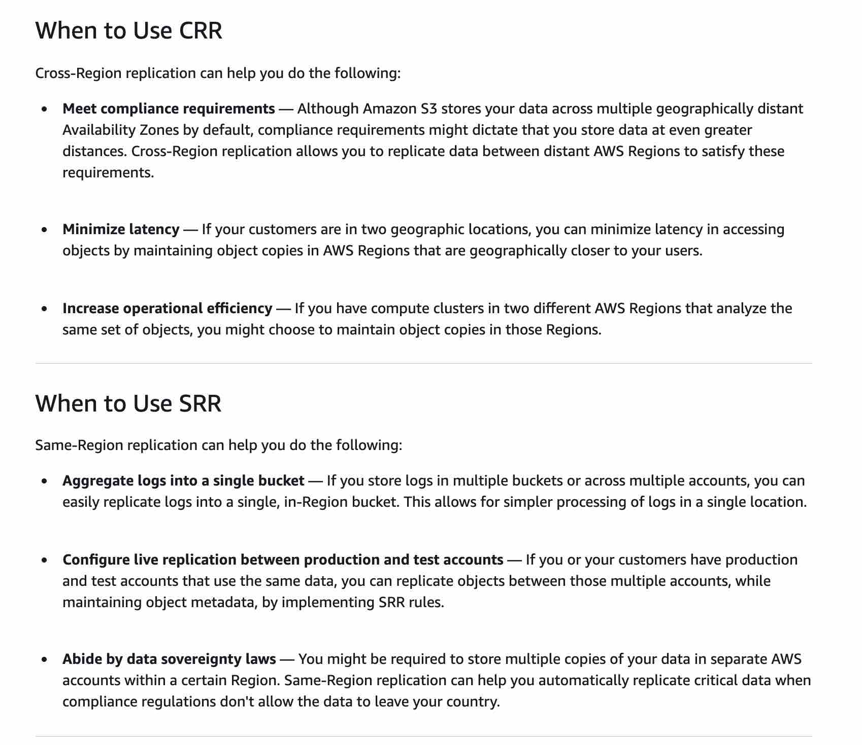

3. AWS Lambda
- What: Serverless compute — runs code without managing servers.
- Global or Regional: Regional.
- Purpose: Run backend functions, automation, triggers.
- Pricing: Pay per request and duration.
- Connects With: API Gateway, S3 (triggered by events), DynamoDB, EventBridge.
- Limitations:
  - Max timeout is 15 minutes.
- When to Use: Short-running functions, automation, microservices.
- When Not to Use: Long-running processes (use EC2/ECS).

4. Amazon RDS (Relational Database Service)
- What: Managed relational database (supports MySQL, PostgreSQL, Oracle, etc.).
- Global or Regional: Regional.
- Purpose: Store structured data using SQL.
- Pricing: Per hour + storage + I/O.
- Connects With: EC2, Lambda, App applications.
- Limitations:
  - Scaling vertically only (except Aurora), can be costly.
- When to Use: Structured data with strong consistency.
- When Not to Use: If using key-value or flexible schema (use DynamoDB).

5. Amazon DynamoDB
- What: NoSQL key-value and document database.
- Global or Regional: Regional.
- Purpose: Low-latency access to unstructured or semi-structured data.
- Pricing: On-demand or provisioned mode.
- Connects With: Lambda, API Gateway.
- Limitations:
  - Query flexibility limited (no joins).
- When to Use: Real-time applications (e.g., gaming, shopping carts).
- When Not to Use: Complex querying, relations (use RDS).

6. Amazon Aurora
- What: High-performance RDS database engine (compatible with MySQL/PostgreSQL).
- Global or Regional: Regional.
- Purpose: Enterprise-grade database with better performance than standard RDS.
- Pricing: More expensive than RDS, but faster.
- Connects With: All apps using JDBC/ODBC.
- Limitations: Only MySQL/PostgreSQL engines supported.
- When to Use: When you need high availability + better performance.
- When Not to Use: Small apps, or when not using SQL.

7. Amazon EBS (Elastic Block Store)
- What: Persistent block storage for EC2.
- Global or Regional: Regional.
- Purpose: Acts like a hard disk for EC2.
- Pricing: Based on provisioned size.
- Connects With: EC2 only.
- Limitations:
  - Bound to single AZ (use snapshots for backup).
- When to Use: OS disks, databases, logs.
- When Not to Use: Shared storage (use EFS or S3).

8. Amazon EFS (Elastic File System)
- What: Shared file storage across EC2 instances.
- Global or Regional: Regional.
- Purpose: Use like a shared network drive.
- Pricing: Based on usage + throughput.
- Connects With: EC2 in same region.
- Limitations:
  - Linux-only (for now), costlier than EBS.
- When to Use: Shared access, like home directories.
- When Not to Use: High-performance single-server access.

9. Amazon VPC (Virtual Private Cloud)
- What: Virtual network to launch AWS resources in.
- Global or Regional: Regional.
- Purpose: Network-level control (subnets, routing, security groups).
- Pricing: Mostly free, except for NAT Gateways, etc.
- Connects With: All services — EC2, RDS, Lambda.
- Limitations:
  - Can get complex.
- When to Use: Always — every AWS resource runs in a VPC.
- When Not to Use: N/A.

10. Amazon Route 53
- What: Scalable and highly available DNS and domain registration.
- Global or Regional: Global.
- Purpose: Manage domain names and routing traffic.
- Pricing: Based on number of hosted zones + queries.
- Connects With: CloudFront, ELB, EC2.
- When to Use: For all your domains hosted on AWS.

💰 Domain 4: Billing, Pricing & Support

1. AWS Pricing Models
Model | Description | When to Use
On-Demand | Pay only for what you use. No upfront. | Short-term, unpredictable workloads
Reserved Instances | 1 or 3-year commitment with huge discount (up to 75%) | Steady, long-term usage (e.g., databases, web apps)
Spot Instances | Spare capacity at up to 90% discount — can be interrupted anytime | Flexible, fault-tolerant workloads like batch jobs
Savings Plans | Commit to a specific $/hour for 1-3 years, flexible across services | Consistent usage, but with flexibility across compute

2. AWS Free Tier
- Always Free:
  - AWS IAM
  - AWS Lambda (1 million invocations/month)
  - Amazon DynamoDB (25 GB)
  - Amazon S3 (5 GB)
  - CloudWatch metrics (basic)
- 12-Month Free (after account creation):
  - EC2 (750 hrs/month – t2.micro or t3.micro)
  - RDS (750 hrs/month – db.t2.micro)
  - S3 (5 GB)
  - CloudFront (50 GB)
- Trials: Short-term free usage for services like Macie, Inspector.

3. AWS Budgets
- What: Set custom cost or usage budgets.
- Purpose: Alert when usage or cost exceeds threshold.
- Use Case: Avoid unexpected charges.

4. AWS Cost Explorer
- What: Visualize and analyze your cost over time.
- Purpose: Helps identify trends, unused resources.
- Use Case: Generate monthly reports.

5. AWS TCO Calculator
- What: Compares AWS cost vs. on-premise cost.
- Use Case: For migration planning and justification.

Server administration
Power/Cooling
- AWS Pricing Calculator lets you explore AWS services and create an estimate for the cost of your use cases on AWS. You can model your solutions before building them, explore the price points and calculations behind your estimate, and find the available instance types and contract terms that meet your needs. This enables you to make informed decisions about using AWS. You can plan your AWS costs and usage or price out by setting up a new set of instances and services. AWS Pricing Calculator can be accessed at https://calculator.aws/#/.
- AWS Pricing Calculator compares the cost of your applications in an on-premises or traditional hosting environment to AWS: server, storage, network, and IT labor. Therefore, you need to include every element relevant to these points of comparison.
- Server administration is included in the IT labor costs.
- Power/Cooling are included in the server, storage, and network cost.
Incorrect options:
Application advertising - The application advertising is not relevant for a Total Cost of Ownership (TCO) estimate.
Number of end-users - The number of end-users is not relevant for a Total Cost of Ownership (TCO) estimate.
Electronic equipment at office - The electronic equipment at the office is not relevant for a Total Cost of Ownership (TCO) estimate.
References:
https://calculator.aws/#/
https://aws.amazon.com/blogs/aws/new-cloud-tco-comparison-calculator-for-web-applications/

6. AWS Pricing Calculator
- What: Estimate monthly cost of AWS services.
- Use Case: Before launching, plan budget.

7. Consolidated Billing (AWS Organizations)
- What: Combine multiple AWS accounts to a single payer account.
- Benefits:
  - One bill
  - Share Reserved Instances
  - Volume discounts

8. AWS Support Plans
Plan | Tech Support | Response Time | Extras
Basic | None | None | Trusted Advisor (7 checks)
Developer | Email (Business hours) | 12–24 hrs | General guidance
Business | 24/7 email/chat/phone | 1 hr for urgent | All Trusted Advisor checks
Enterprise | 24/7 + TAM (dedicated) | 15 min for critical | Concierge + White-glove onboarding

9. Trusted Advisor
- What: Automated checks to optimize your AWS environment.
- Categories: Cost Optimization, Performance, Security, Fault Tolerance, Service Limits.
- Free Checks (Basic/Dev): 7 core checks.
- Full Checks: Business and Enterprise plans.

- AWS Trusted Advisor is a global service that provides real-time guidance to help you optimize your AWS environment across five key pillars:
  - Cost Optimization
  - Security
  - Fault Tolerance
  - Performance
  - Service Limits
- It runs checks on your AWS account to identify unused or underutilized resources, security gaps (like overly permissive security groups), and misconfigurations.
- There are two versions of Trusted Advisor:
  - With the Basic support plan, you get access to a limited set of checks (like S3 permissions, service limits).
  - With the Business or Enterprise support plans, you unlock full checks (including cost-saving recommendations, reserved instance optimization, and IAM usage).
- ✅ When to use it:
  - To proactively monitor your AWS usage and improve cost efficiency.
  - To ensure your environment follows AWS best practices.
  - To identify unused resources (e.g., idle EC2 instances) or security risks.
- ❌ When not to use it:
  - Not ideal for real-time monitoring or alerting — that’s what Amazon CloudWatch is for.
  - It doesn’t act automatically — it only gives suggestions; you must act on them manually.

AWS Trusted Advisor is an online resource to help you reduce cost, increase performance, and improve security by optimizing your AWS environment. AWS Trusted Advisor provides real-time guidance to help you provision your resources following AWS best practices.
How AWS Trusted Advisor works:
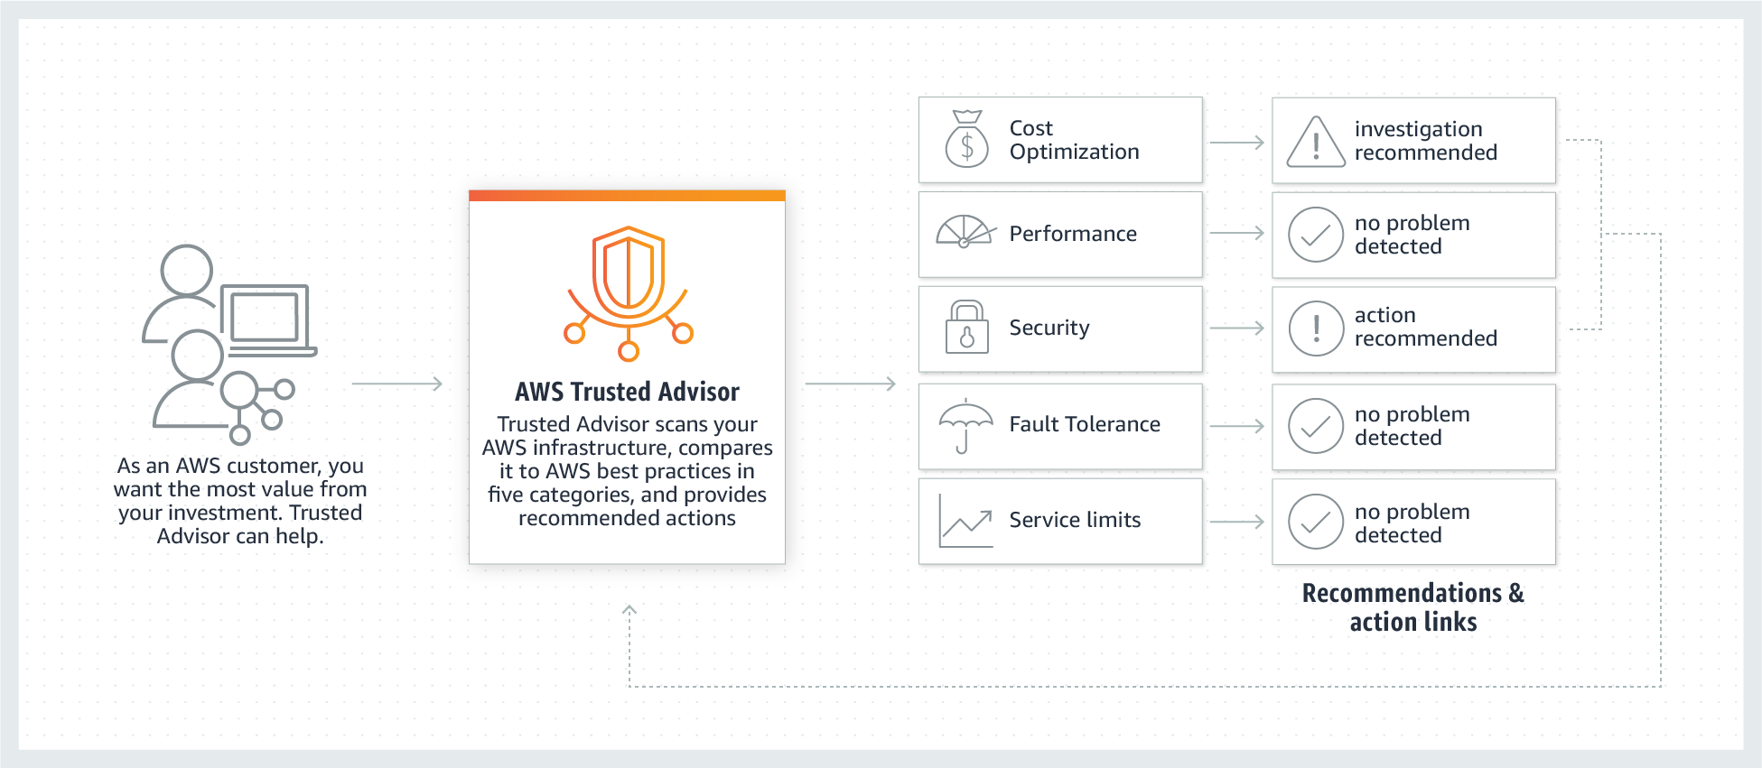
via - https://aws.amazon.com/premiumsupport/technology/trusted-advisor/

10. 📌 Amazon Pinpoint
Amazon Pinpoint is a regional AWS service that helps businesses engage customers by sending them messages via email, SMS, push notifications, and voice.
It is mainly used in marketing, transactional messaging, or user engagement scenarios. You can segment users, track user behavior, and send personalized messages at the right time.
You can use it to:
- Send a marketing email to users who abandoned their cart.
- Trigger an SMS alert when a user registers.
- Push a notification to mobile users about a new offer.
It supports analytics, campaign tracking, and event-based triggers using services like Amazon SNS, Lambda, and Kinesis.
✅ When to use it:
- When you want to target specific users with messages.
- When you need to build multi-channel communication workflows.
- For transactional messaging, like OTP, confirmation, or shipping updates.
❌ When not to use it:
- If you only need simple notifications (like service-to-service messages), Amazon SNS is easier.
- It is not ideal for internal infrastructure messaging.

How Amazon Pinpoint Works:

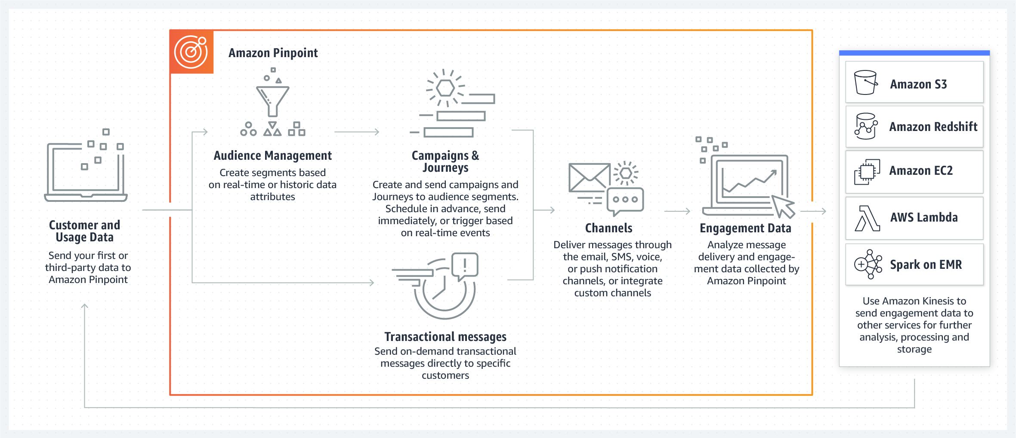

🖥️ Step 1: Customer and Usage Data
- You start by collecting customer data, like:
  - Email, phone numbers
  - Purchase history
  - Interaction behavior
- This can be first-party data (your app or website) or third-party data.
- The data is sent into Amazon Pinpoint using API or SDK.

🎯 Step 2: Audience Management
- Pinpoint uses the incoming data to create audience segments:
  - For example: “Users who haven’t logged in for 7 days” or “Users who added to cart but didn’t checkout”.
- Segments can be based on real-time events or historical data.
- This helps in targeting the right group of users.

📆 Step 3: Campaigns & Journeys
- You create Campaigns (single or scheduled messages) or Journeys (multi-step workflows like onboarding flows or nurture series).
- You can:
  - Send a one-time message.
  - Schedule campaigns for a future time.
  - Trigger messages automatically based on user behavior, like a sign-up or a cart abandon event.

✉️ Step 4: Channels
- Messages are sent through multi-channel communication:
  - Email
  - SMS
  - Voice messages
  - Push notifications
  - Or even custom channels
- You can choose the right channel depending on your user's preferences.

🔁 Step 5: Transactional Messages
- Apart from campaigns, you can also send real-time transactional messages:
  - E.g., OTP for login, payment confirmation, shipping status
- These are immediate and one-on-one messages targeted to a specific user.

📊 Step 6: Engagement Data
- Once messages are delivered, Amazon Pinpoint tracks and collects engagement metrics like:
  - Open rate
  - Click-through rate
  - Delivery status
  - Bounce or opt-out rates
- This helps you measure campaign effectiveness.

🔄 Step 7: Analytics & Integration
- The engagement data can be exported to other AWS services for deeper analysis and storage using:
  - Amazon S3 → for raw storage or reporting
  - Amazon Redshift → for running SQL-based analytics
  - Amazon EC2 / Spark on EMR → for heavy data processing
  - AWS Lambda → for triggering automated actions
- Amazon Kinesis is used to stream this engagement data in real time to these services for further analysis, processing, or storage.

✅ Key Benefits of This Setup
- Centralized user engagement across all channels.
- Real-time targeting and automation based on behavior.
- Scalable and serverless.
- Integrates well with other AWS services for advanced analytics.

10. Billing Tools Summary
Tool | Purpose
Budgets | Set alerts on cost/usage
Cost Explorer | Visualize and analyze AWS spend
Pricing Calculator | Estimate cost before using services
TCO Calculator | Compare on-prem vs. cloud cost
Consolidated Billing | Central billing across multiple accounts

📘 AWS Support Plans – Overview

🔹 1. AWS Developer Support Plan
- What it is: Entry-level support plan for developers experimenting or testing on AWS.
- Who it's for: Individual developers or small teams.
- Pricing: Starts at $29/month or 3% of monthly AWS usage, whichever is greater.
- Key Features:
  - Business hours support via email.
  - Response time: < 24 hours for general guidance, < 12 hours for system impaired.
  - Trusted Advisor: Access to 7 core checks only.
  - No access to AWS Support API.
When to use:
Use this if you are just getting started, experimenting, or running non-production workloads.

🔹 2. AWS Business Support Plan
- What it is: Production-level support for businesses.
- Who it's for: Organizations running production workloads.
- Pricing: Starts at $100/month or based on usage:
  - 10% of first $0–$10K
  - 7% of next $10K–$80K
  - 5% of next $80K–$250K
  - 3% over $250K
- Key Features:
  - 24/7 access to Cloud Support Engineers via email, phone, and chat.
  - Response time: < 1 hour for production system down.
  - Full access to all Trusted Advisor checks.
  - Access to AWS Support API and third-party software support.
  - Architectural guidance for use-cases.
When to use:
Use this plan when you’re running production workloads and need 24/7 fast access to engineers.

🔹 3. AWS Enterprise On-Ramp Support Plan
- What it is: Mid-tier between Business and Enterprise. Gives faster response times and some assigned guidance.
- Who it's for: Medium/large orgs getting started with mission-critical workloads on AWS.
- Pricing: Starts at $5,500/month.
- Key Features:
  - Access to Technical Account Manager (TAM) – light version.
  - Response time: < 30 mins for business-critical issues.
  - 24/7 support with architectural guidance.
  - Access to all Trusted Advisor checks, Support API, and Well-Architected Reviews.
When to use:
Use this if you’re starting to run mission-critical workloads and want faster, more proactive support than Business Plan, but not full Enterprise yet.

🔹 4. AWS Enterprise Support Plan
- What it is: The highest level of support from AWS for mission-critical, global applications.
- Who it's for: Large enterprises needing continuous support.
- Pricing: Starts at $15,000/month or based on usage:
  - Same tiered pricing as Business Support, minimum $15K
- Key Features:
  - Assigned Dedicated Technical Account Manager (TAM).
    - The Technical Account Manager provides expert monitoring and optimization for your environment and coordinates access to other programs and experts.
    - Included as part of the Enterprise Support plan, the Support Concierge Team are AWS billing and account experts that specialize in working with enterprise accounts.
  - < 15 mins response for business-critical system down.
  - Proactive support: Ops reviews, architecture reviews, cost optimization.
  - Access to AWS Concierge Team for billing/account help.
  - Event management support (e.g., product launches).
When to use:
Use this for mission-critical systems where zero downtime and proactive guidance are business priorities.

✅ Quick Comparison Table
Feature | Developer | Business | Enterprise On-Ramp | Enterprise
24/7 Support | No | Yes | Yes | Yes
Response Time (Critical) | N/A | < 1 hr | < 30 mins | < 15 mins
Trusted Advisor Checks | 7 Checks | All | All | All
TAM Assigned | No | No | Yes (limited) | Yes
Support API | No | Yes | Yes | Yes
Proactive Guidance | No | No | Some | Yes
Price (Starting) | $29/mo | $100/mo | $5,500/mo | $15,000/mo

🟦 AWS Support Plans Comparison Table
Feature | Developer | Business | Enterprise On-Ramp | Enterprise
Recommended for | Experimenting or testing in AWS | Production workloads | Business-critical workloads | Mission-critical workloads
Trusted Advisor Checks | Basic (Service Quota & Security) | Full set of checks | Full set of checks | Full set + Prioritized recommendations
Support Access | Business hours, 1 contact | 24×7 phone/chat/web, unlimited contacts | 24×7 phone/chat/web, unlimited contacts | 24×7 phone/chat/web, unlimited contacts + TAM
IAM Support for Cases | ❌ | ✅ | ✅ | ✅
Response Times | - General: < 24 hrs  - Impaired: < 12 hrs | - General: < 24 hrs  - Impaired: < 12 hrs  - Prod impaired: < 4 hrs  - Down: < 1 hr | Same as Business +  - Critical system down: < 30 mins | Same as On-Ramp +  - Mission-critical down: < 15 mins
Architectural Guidance | General | Contextual to use case | One consultative review/year | Ongoing reviews & guidance
AWS Support API | ❌ | ✅ | ✅ | ✅
AWS re:Post Priority | ✅ | ✅ | ✅ | ✅
Support App in Slack | ❌ | ✅ | ✅ | ✅
Third-Party Software Support | ❌ | ✅ | ✅ | ✅
Automation Workflows | ✅ (AWSsupport prefix) | ✅ (AWSsupport, AWSPremiumSupport) | ✅ (AWSsupport, AWSPremiumSupport) | ✅ (AWSsupport, AWSPremiumSupport)
Infrastructure Event Management (IEM) | ❌ | Paid add-on | One included per year | Fully included
Incident Detection & Response | ❌ | ❌ | Add-on | ✅ Included
Access to AMS (AWS Managed Services) | Paid add-on | Paid add-on | Paid add-on | Paid add-on
Training | ❌ | ❌ | ❌ | Self-paced labs access
Account Assistance | ❌ | Concierge team | Concierge team | Concierge team
Pricing | $29/month or 3% of usage | $100/month or:  10% ($0–$10K)  7% ($10K–$80K)  5% ($80K–$250K)  3% (> $250K) | $5,500/month or 10% of usage | $15,000/month or:  10% ($0–$150K)  7% ($150K–$500K)  5% ($500K–$1M)  3% (> $1M)

✅ Quick Summary – When to Use What
Use Case | Support Plan
Learning, testing, development | Developer
Running basic production apps | Business
Apps with high availability or cost of downtime | Enterprise On-Ramp
Business/mission-critical systems, 24/7 SLA, TAM | Enterprise

📊 AWS Cost & Usage Report (AWS CUR)
Category: 🧾 Support & Billing

What it is:
AWS Cost & Usage Report (CUR) is the most detailed billing report in AWS. It delivers comprehensive usage and cost data for your account(s) in a CSV or Parquet file format. This data includes every resource, usage type, cost allocation, and pricing model.

Global/Regional:
🌍 Global (Billing is a global function)

What it does:
- Tracks usage of every AWS service per hour/day/month
- Breaks down cost by account, service, usage type, region, etc.
- Sends detailed reports to an Amazon S3 bucket
- Can be integrated with Amazon Athena, Amazon Redshift, or AWS QuickSight for analytics

Why needed:
- Helps in cost transparency and budget forecasting
- Required for detailed chargeback or showback models in multi-account setups
- Supports cost optimization by identifying expensive resources
- Required for financial reporting or compliance in large organizations

Pricing:
✅ Free to use (but you pay for the S3 storage and any analytics tools you use like Athena or Redshift)

Integrations:
- Amazon S3 – stores CUR files
- AWS Organizations – aggregates CUR across linked accounts
- Amazon Athena – runs SQL queries on CUR data
- AWS Glue – creates tables in Athena to read CUR
- AWS QuickSight – visualize CUR for dashboards
- Amazon Redshift – for advanced analytics

Limitations:
- CUR files are large and complex
- Can have a delay of up to 24 hours
- Requires setup to parse and query using Athena or Redshift
- Not suitable for real-time billing – only historical data
- Cannot use directly in AWS Console (only available in S3)

When to use:
- You need the most detailed and accurate billing data
- You manage multiple AWS accounts using AWS Organizations
- You want to analyze costs per service, per account, per tag, or per region
- You’re building custom reports or financial dashboards

When not to use:
- You just want a simple view of monthly billing → use Cost Explorer
- You want real-time insights → use Budgets + CloudWatch Billing Alarms
- You’re not using Athena or Redshift → CUR can be overwhelming to analyze

Cloud Strategy & Management

🌐 AWS Cloud Adoption Framework (AWS CAF)
What is it?
AWS Cloud Adoption Framework (CAF) is a structured framework that helps organizations plan, guide, and manage their cloud adoption journey. It provides best practices, guidance, and perspectives to help build a comprehensive cloud migration and modernization strategy.

📚 Purpose
To help organizations:
- Understand how cloud adoption will impact business and technical processes.
- Identify gaps and create action plans.
- Align cloud strategies with business outcomes.
- Organize cloud adoption efforts across multiple departments.

🌍 Global or Regional?
- Not a service, so no regional scope. It's a strategic framework/tool used across organizations globally.

🧩 What It Does
CAF provides 6 Perspectives that cover different areas of an organization. Each perspective identifies roles, responsibilities, and capabilities needed for successful cloud adoption:
Perspective | Focus Area | Who is Involved
Business | Business goals, KPIs, value realization | Business Managers, Finance
People | Skills, training, organizational structure | HR, People Managers
Governance | Cloud policies, risk management, compliance | Legal, Risk, Audit
Platform | Cloud architecture, infrastructure, tools | IT Operations, Architects
Security | Identity, access, security controls, data protection | Security Teams
Operations | Monitoring, incident management, automation | Operations Team

💸 Pricing
- Free: AWS CAF is a framework — not a paid service.
- Often used during cloud readiness assessments or with AWS Professional Services/partners.

🔗 Integrations
- Integrates with cloud planning tools, AWS Well-Architected Framework, migration tools (e.g., AWS Migration Hub).
- Often used in combination with Cloud Readiness Assessments, CAF Tools, and AWS ProServe teams.

⚠️ Limitations
- Does not provide automation — it is a guidance tool, not a product.
- Needs experienced teams to implement the recommendations.

✅ When to Use
- When planning to migrate existing workloads to AWS.
- When aligning business goals with IT strategy.
- When evaluating organizational readiness for cloud.
- During transformation/migration projects.

❌ When to Avoid
- If already deeply cloud-native and have mature governance.
- If only looking for technical migration (CAF is more holistic and strategic).
- The AWS Cloud Adoption Framework (AWS CAF) leverages AWS experience and best practices to help you digitally transform and accelerate your business outcomes through innovative use of AWS. AWS CAF identifies specific organizational capabilities that underpin successful cloud transformations.
- AWS CAF groups its capabilities in six perspectives: Business, People, Governance, Platform, Security, and Operations.
- AWS Cloud Adoption Framework (CAF) Overview:
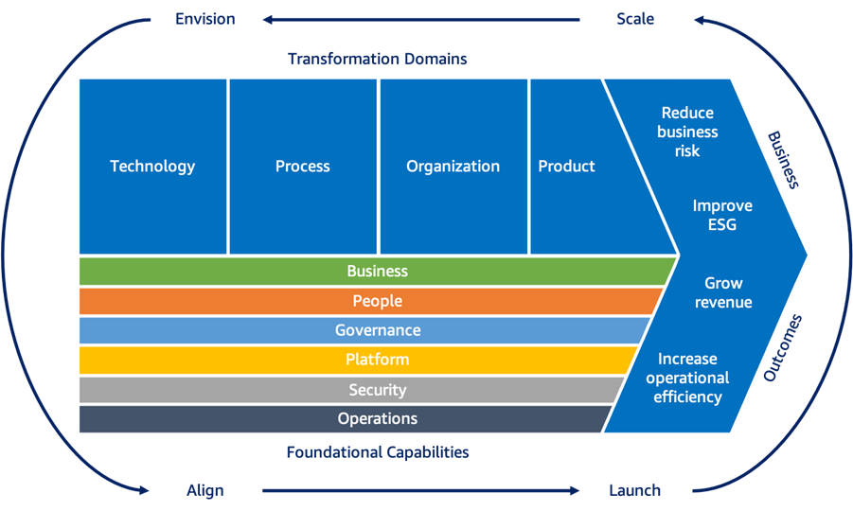

🌪️ Disaster Recovery (DR) Strategies
Category: ✅ Architecture & Reliability (new section)

What it is:
Disaster Recovery (DR) is the strategy for restoring systems, data, and applications after a failure, disaster, or outage. It ensures business continuity and minimizes downtime by defining how quickly and completely systems should recover.

⏱️ The 4 Common DR Strategies in AWS
Strategy Type | Recovery Time Objective (RTO) | Recovery Point Objective (RPO) | Cost 💰 | Description
Backup & Restore | High (hours to days) | High (hours to days) | 💸 Low | Take regular backups to Amazon S3 or Glacier. Restore when needed. Simple, low cost.
Pilot Light | Medium (tens of minutes) | Low (minutes) | 💰 Medium | Keep core components (like databases) always on; spin up the rest during disaster.
Warm Standby | Low (minutes) | Low (minutes) | 💰💰 Medium-High | A scaled-down version of the full environment is always running in another region.
Multi-Site (Hot-Hot) | Very Low (seconds) | Very Low (seconds) | 💰💰💰 High | Full production environments in multiple regions; traffic is load-balanced.

🧠 Key Terms:
- RTO (Recovery Time Objective):
How quickly the system must be restored after a failure.
- RPO (Recovery Point Objective):
The maximum acceptable amount of data loss measured in time (e.g., 5 minutes of data loss is okay).

🔄 DR Services to Know:
AWS Service | DR Use
Amazon S3 / Glacier | Backup storage
AWS Backup | Centralized backup management
Amazon RDS Snapshots | Backup/restore databases
Amazon Route 53 | DNS failover for multi-region setup
Amazon EC2 AMIs | Launch replacement instances quickly
CloudFormation | Recreate infrastructure from templates
AWS Elastic Disaster Recovery (DRS) | Service to automate and simplify DR (real-time replication of servers)

📌 When to Use Which Strategy:
Use Case | Recommended DR Strategy
Small business with limited budget | Backup & Restore
Need fast DB recovery but app can wait | Pilot Light
Always need core app up, but full scale not needed | Warm Standby
Banking, Healthcare, 24/7 mission critical systems | Multi-Site / Hot-Hot

Amazon Machine Image (AMI)
An Amazon Machine Image (AMI) provides the information required to launch an instance. You must specify an Amazon Machine Image (AMI) when you launch an instance. You can launch multiple instances from a single Amazon Machine Image (AMI) when you need multiple instances with the same configuration.
How to use an Amazon Machine Image (AMI):
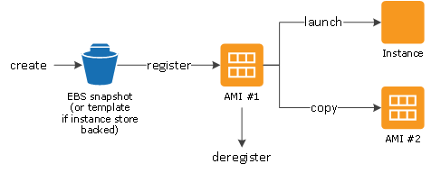

An Amazon EBS snapshot is a point-in-time copy of your Amazon EBS volume. EBS snapshots are one of the components of an AMI, but EBS snapshots alone cannot be used to deploy the same EC2 instances across different Availability Zones (AZs).

📝 Exam Tips:
- Pilot Light = Minimal infrastructure running (e.g., DB always on).
- Warm Standby = Partial environment always running.
- Multi-Site = Full infra live in multiple regions (most expensive).
- RPO/RTO questions help you identify which strategy fits.

Disaster recovery (DR) strategies:

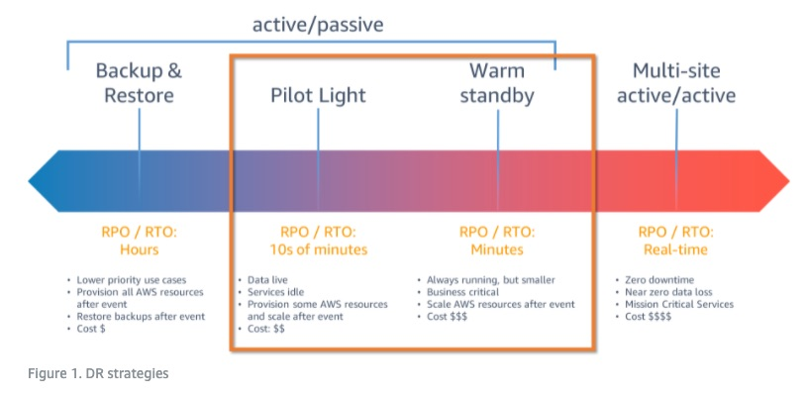

Warm Standby strategy
This strategy replicates data from the primary Region to data resources in the recovery Region, such as Amazon Relational Database Service (Amazon RDS) DB instances or Amazon DynamoDB tables. These data resources are ready to serve requests. In addition to replication, this strategy requires you to create a continuous backup in the recovery Region. This is because when "human action" type disasters occur, data can be deleted or corrupted, and replication will replicate the bad data. Backups are necessary to enable you to get back to the last known good state.
The warm standby strategy deploys a functional stack, but at reduced capacity. The DR endpoint can handle requests, but cannot handle production levels of traffic. It may be more, but is always less than the full production deployment for cost savings. If the passive stack is deployed to the recovery Region at full capacity, however, then this strategy is known as “hot standby.” Because warm standby deploys a functional stack to the recovery Region, this makes it easier to test Region readiness using synthetic transactions.

Multi-site active-active strategy - This strategy uses AWS Regions as your active sites, creating a multi-Region active/active architecture. Generally, two Regions are used. Each Region hosts a highly available, multi-Availability Zone (AZ) workload stack. In each Region, data is replicated live between the data stores and also backed up. This protects against disasters that include data deletion or corruption since the data backup can be restored to the last known good state. Each regional stack serves production traffic effectively. But, this strategy is cost involving and should only be used for mission-critical applications.

Pilot Light strategy - Pilot Light, like Warm Standby strategy, replicates data from the primary Region to data resources in the recovery Region, such as Amazon Relational Database Service (Amazon RDS) DB instances or Amazon DynamoDB tables. But, the DR Region in a pilot light strategy (unlike warm standby) cannot serve requests until additional steps are taken. A pilot light in a home furnace does not provide heat to the home. It provides a quick way to light the furnace burners that then provide heat.
Warm standby can handle traffic at reduced levels immediately. Pilot light requires you to first deploy infrastructure and then scale out resources before the workload can handle requests.

Backup & Restore strategy - Backup and Restore is associated with higher RTO (recovery time objective) and RPO (recovery point objective). This results in longer downtimes and greater loss of data between when the disaster event occurs and recovery. However, backup and restore can still be the right strategy for workloads because it is the easiest and least expensive strategy to implement.

🔒 Amazon Inspector
Category: ✅ Security Services

What it is:
Amazon Inspector is an automated security assessment service that helps you identify vulnerabilities and unintended network exposure in your Amazon EC2 instances, containers, and Lambda functions.

What it does:
- Scans workloads for known CVEs (Common Vulnerabilities and Exposures).
- Provides a security score and detailed findings.
- Continuously monitors EC2, ECR (container images), and Lambda.
- Integrates with Amazon EventBridge to trigger alerts or remediation.

Global or Regional:
🔁 Regional — Findings are scoped per region.

Why it's needed:
- Detect vulnerabilities in software packages.
- Ensure workloads comply with security best practices.
- Improve security posture automatically and continuously without manual checks.

Pricing:
- Pay for the number of resources scanned (EC2, container images, Lambda).
- No cost for initial activation; free tier available for some services.

Integrations:
- Amazon ECR: Scan container images for vulnerabilities.
  - Amazon Elastic Container Registry (ECR) is a fully-managed Docker container registry that makes it easy for developers to store, manage, and deploy Docker container images.
  - Amazon ECR is integrated with Amazon Elastic Container Service (ECS). Amazon ECR eliminates the need to operate your own container repositories or worry about scaling the underlying infrastructure.
  - 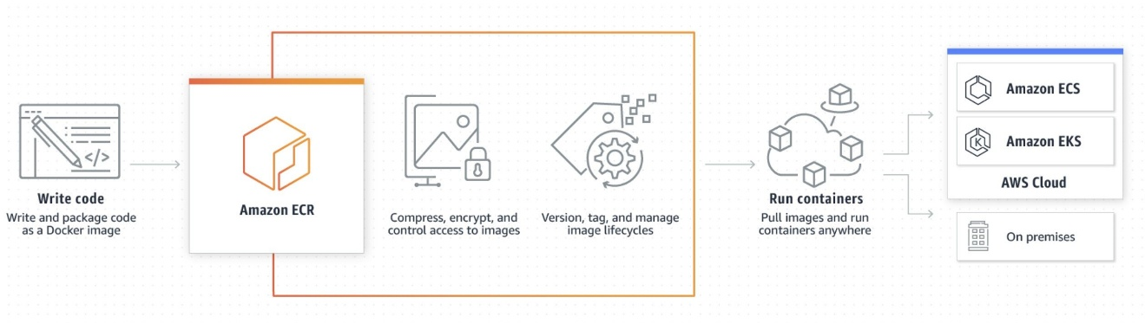

- AWS Lambda: Check code packages.
- AWS Security Hub: Centralized findings.
- Amazon EventBridge: Trigger automatic responses.

Limitations:
- Doesn't scan OS-level vulnerabilities inside managed services like RDS.
- Only supports specific operating systems and runtimes.

When to Use / Avoid:
✅ Use when:
- You need automated, continuous vulnerability detection.
- Your organization follows DevSecOps practices.
- You want integration with other AWS security services.
❌ Avoid when:
- You need compliance audits (use AWS Audit Manager instead).
- You want to scan on-premise servers (Inspector is AWS-native only).

AWS Config
AWS Config is a service that enables you to assess, audit, and evaluate the configurations of your AWS resources. AWS Config continuously monitors and records your AWS resource configurations and allows you to automate the evaluation of recorded configurations against desired configurations. With AWS Config, you can review changes in configurations and relationships between AWS resources, dive into detailed resource configuration histories, and determine your overall compliance against the configurations specified in your internal guidelines. This enables you to simplify compliance auditing, security analysis, change management, and operational troubleshooting.
How AWS Config works:
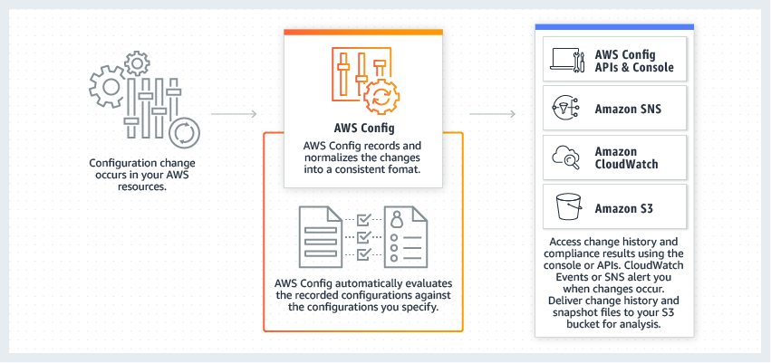
via - https://aws.amazon.com/config/

📄 AWS IAM Credentials Report
Category: ✅ Security / IAM Management

What it is:
The IAM Credentials Report is a downloadable CSV file that lists account-level security details for all IAM users in your AWS account.

What it does:
- Shows:
  - Whether MFA is enabled
  - When passwords were last used/rotated
  - When access keys were created, used, or rotated
  - If access keys are active or inactive
- Helps in auditing credential hygiene and security best practices.

Global or Regional:
🌍 Global — IAM is a global service.

Why it’s needed:
- Ensures you’re following least privilege and credential rotation policies.
- Useful for compliance and audit reviews.

Pricing:
✅ Free

Integrations:
- Use the report for automation scripts or with AWS Config/AWS Lambda for enforcement or alerting.

Limitations:
- Only for IAM users (not roles or federated identities).
- Must manually download the report or automate via CLI.

When to Use / Avoid:
✅ Use when:
- Performing security audits.
- Checking MFA status, unused users, or old credentials.
❌ Avoid when:
- You're managing only federated users or roles (use Access Analyzer or CloudTrail instead).

Amazon Translate
Amazon Translate is a neural machine translation service that delivers fast, high-quality, and affordable language translation. Amazon Translate allows you to localize content - such as websites and applications - for international users, and to easily translate large volumes of text efficiently.
Amazon Polly - You can use Amazon Polly to turn text into lifelike speech thereby allowing you to create applications that talk. Polly's Text-to-Speech (TTS) service uses advanced deep learning technologies to synthesize natural sounding human speech.
Amazon Transcribe - You can use Amazon Transcribe to add speech-to-text capability to your applications. Amazon Transcribe uses a deep learning process called automatic speech recognition (ASR) to convert speech to text quickly and accurately. Amazon Transcribe can be used to transcribe customer service calls, to automate closed captioning and subtitling, and to generate metadata for media assets.
Amazon Rekognition - With Amazon Rekognition, you can identify objects, people, text, scenes, and activities in images and videos, as well as to detect any inappropriate content. Amazon Rekognition also provides highly accurate facial analysis and facial search capabilities that you can use to detect, analyze, and compare faces for a wide variety of user verification, people counting, and public safety use cases.

Use AWS Key Management Service (AWS KMS) to encrypt data
The Security pillar includes the ability to protect information, systems, and assets while delivering business value through risk assessments and mitigation strategies.
Encrypting data is part of the design principle "Protect data in transit and at rest": Classify your data into sensitivity levels and use mechanisms, such as encryption, tokenization, and access control where appropriate.
AWS Key Management Service (AWS KMS) makes it easy for you to create and control keys used for encryption. It is a key service of the Security pillar.
The AWS Well-Architected Framework helps you understand the pros and cons of the decisions you make while building systems on AWS. By using the Framework you will learn architectural best practices for designing and operating reliable, secure, efficient, and cost-effective systems in the cloud. It provides a way for you to consistently measure your architectures against best practices and identify areas for improvement.
The AWS Well-Architected Framework is based on six pillars — Operational Excellence, Security, Reliability, Performance Efficiency, Cost Optimization, and Sustainability.
Overview of the six pillars of the AWS Well-Architected Framework:
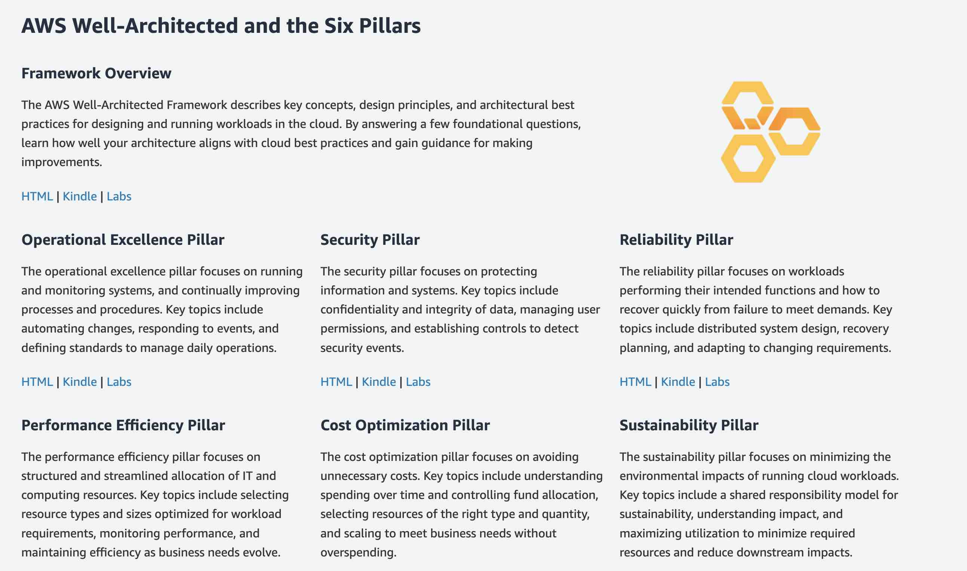
via - https://aws.amazon.com/architecture/well-architected/

The reliability pillar includes the ability of a system to recover from infrastructure or service disruptions, dynamically acquire computing resources to meet demand, and mitigate disruptions such as misconfigurations or transient network issues.
There are five design principles for reliability in the cloud:
– Test recovery procedures.
– Automatically recover from failure.
– Scale horizontally to increase aggregate system availability.
– Stop guessing capacity.
– Manage change in automation.

The performance efficiency pillar includes the ability to use computing resources efficiently to meet system requirements and to maintain that efficiency as demand changes and technologies evolve.
There are five design principles for performance efficiency in the cloud:
– Democratize advanced technologies.
– Go global in minutes.
– Use serverless architectures.
– Experiment more often.
– Mechanical sympathy.

The security pillar includes the ability to protect information, systems, and assets while delivering business value through risk assessments and mitigation strategies
There are six design principles for security in the cloud:
– Implement a strong identity foundation.
– Enable traceability.
– Apply security at all layers.
– Automate security best practices.
– Protect data in transit and at rest.
– Prepare for security events.

The cost optimization pillar includes the ability to avoid or eliminate unneeded cost or suboptimal resource.
There are five design principles for cost optimization in the cloud:
– Adopt a consumption model.
– Measure overall efficiency.
– Stop spending money on data center operations.
– Analyze and attribute expenditure.
– Use managed services to reduce cost of ownership.

References:
https://aws.amazon.com/blogs/apn/the-5-pillars-of-the-aws-well-architected-framework/
Save time with our exam-specific cheat sheets:
https://digitalcloud.training/certification-training/aws-certified-cloud-practitioner/architecting-for-the-cloud/

A customer gateway
A customer gateway device is a physical or software appliance on your side of a Site-to-Site VPN connection. You or your network administrator must configure the device to work with the Site-to-Site VPN connection.
You can enable access to your remote network from your VPC by creating an AWS Site-to-Site VPN (Site-to-Site VPN) connection, and configuring routing to pass traffic through the connection.
More on customer gateway device:
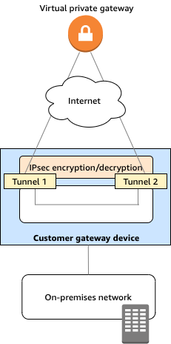
via - https://docs.aws.amazon.com/vpn/latest/s2svpn/your-cgw.html

AWS Security Token Service (AWS STS)
AWS Security Token Service (AWS STS) is a web service that enables you to request temporary, limited-privilege credentials for AWS Identity and Access Management (AWS IAM) users or for users that you authenticate (federated users).
You can use the AWS Security Token Service (AWS STS) to create and provide trusted users with temporary security credentials that can control access to your AWS resources. Temporary security credentials work almost identically to the long-term access key credentials that your IAM users can use, with the following differences:
- Temporary security credentials are short-term, as the name implies. They can be configured to last for anywhere from a few minutes to several hours. After the credentials expire, AWS no longer recognizes them or allows any kind of access from API requests made with them.
- Temporary security credentials are not stored with the user but are generated dynamically and provided to the user when requested. When (or even before) the temporary security credentials expire, the user can request new credentials, as long as the user requesting them still has permission to do so.
Temporary security credentials are generated by AWS Security Token Service (AWS STS). By default, AWS STS is a global service with a single endpoint at https://sts.amazonaws.com. However, you can also choose to make AWS STS API calls to endpoints in any other supported Region.

AWS Partner Solutions (formerly Quick Starts)
AWS Partner Solutions are automated reference deployments built by Amazon Web Services (AWS) solutions architects and AWS Partners. Partner Solutions help you deploy popular technologies to AWS according to AWS best practices. You can reduce hundreds of manual procedures to a few steps and start using your environment within minutes.
AWS Partner Solutions are automated reference deployments for key workloads on the AWS Cloud. Each Partner Solution launches, configures, and runs the AWS compute, network, storage, and other services required to deploy a specific workload on AWS, using AWS best practices for security and availability.

AWS Glue - AWS Glue is a fully managed extract, transform, and load (ETL) service that makes it easy for customers to prepare and load their data for analytics. AWS Glue job is meant to be used for batch ETL data processing. It cannot be used to take the load off the databases.
Amazon EMR - Amazon EMR provides a managed Hadoop framework that makes it easy, fast, and cost-effective to process vast amounts of data across dynamically scalable Amazon EC2 instances. It cannot be used to take the load off the databases.

Amazon Personalize
Amazon Personalize enables developers to build applications with the same machine learning (ML) technology used by Amazon.com for real-time personalized recommendations. Amazon Personalize can be used to personalize the end-user experience over any digital channel. Examples include product recommendations for e-commerce, news articles and content recommendation for publishing, media, and social networks, hotel recommendations for travel websites, credit card recommendations for banks, and match recommendations for dating sites. These recommendations and personalized experiences can be delivered over websites, mobile apps, or email/messaging. Amazon Personalize can also be used to customize the user experience when user interaction is over a physical channel, e.g., a meal delivery company could personalize weekly meals to users in a subscription plan.
Amazon Personalize supports the following key use cases:
- Personalized recommendations
- Similar items
- Personalized reranking i.e. rerank a list of items for a user
- Personalized promotions/notifications

Amazon SageMaker - Amazon SageMaker is a fully managed service that provides every developer and data scientist with the ability to build, train, and deploy machine learning (ML) models quickly. Amazon SageMaker removes the heavy lifting from each step of the machine learning process to make it easier to develop high-quality models.

Amazon Comprehend - Amazon Comprehend is a natural-language processing (NLP) service that uses machine learning to uncover information in unstructured data. Instead of combing through documents, the process is simplified and unseen information is easier to understand.
The service can identify critical elements in data, including references to language, people, and places, and the text files can be categorized by relevant topics. In real-time, you can automatically and accurately detect customer sentiment in your content.

Amazon Cognito
Amazon Cognito lets you add user sign-up, sign-in, and access control to your web and mobile apps quickly and easily. With Amazon Cognito, you also have the option to authenticate users through social identity providers such as Facebook, Twitter, or Amazon, with SAML identity solutions, or by using your own identity system.

Amazon CodeGuru
Amazon CodeGuru is a developer tool that provides intelligent recommendations to improve code quality and identify an application’s most expensive lines of code. Integrate Amazon CodeGuru into your existing software development workflow to automate code reviews during application development, continuously monitor application performance in production, provide recommendations and visual clues for improving code quality and application performance, and reduce overall cost.
Amazon CodeGuru Reviewer uses machine learning and automated reasoning to identify critical issues, security vulnerabilities, and hard-to-find bugs during application development and provides recommendations to improve code quality.
Amazon CodeGuru Profiler pinpoints an application’s most expensive lines of code by helping developers understand the runtime behavior of their applications, identify and remove code inefficiencies, improve performance, and significantly decrease compute costs.
How Amazon CodeGuru works:
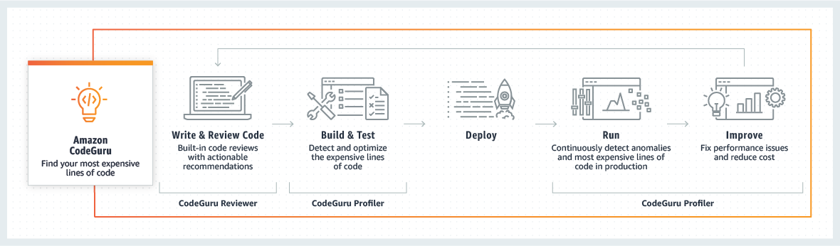
via - https://aws.amazon.com/codeguru/

Amazon Lex
Amazon Lex is a service for building conversational interfaces using voice and text. Powered by the same conversational engine as Amazon Alexa, Amazon Lex provides high-quality speech recognition and language understanding capabilities, enabling the addition of sophisticated, natural language ‘chatbots’ to new and existing applications.
Amazon Lex Use Cases:
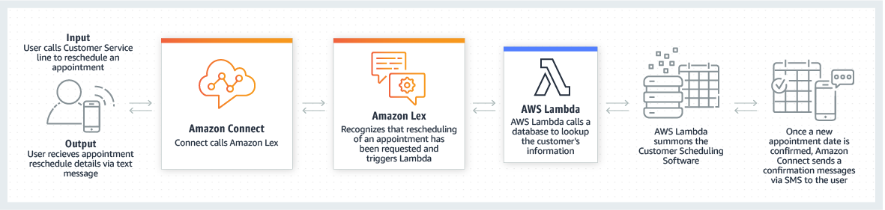
via - https://aws.amazon.com/lex/

AWS Fault Injection Simulator (AWS FIS)
AWS Fault Injection Simulator (AWS FIS) is a fully managed service for running fault injection experiments on AWS that makes it easier to improve an application’s performance, observability, and resiliency. Fault injection experiments are used in chaos engineering, which is the practice of stressing an application in testing or production environments by creating disruptive events, such as a sudden increase in CPU or memory consumption, observing how the system responds, and implementing improvements. Fault injection experiment helps teams create the real-world conditions needed to uncover the hidden bugs, and monitor blind spots, and performance bottlenecks that are difficult to find in distributed systems.
AWS Fault Injection Simulator (AWS FIS) simplifies the process of setting up and running controlled fault injection experiments across a range of AWS services so teams can build confidence in their application behavior. With AWS Fault Injection Simulator (AWS FIS), teams can quickly set up experiments using pre-built templates that generate the desired disruptions. AWS Fault Injection Simulator (AWS FIS) provides the controls and guardrails that teams need to run experiments in production, such as automatically rolling back or stopping the experiment if specific conditions are met. With a few clicks in the console, teams can run complex scenarios with common distributed system failures happening in parallel or building sequentially over time, enabling them to create the real-world conditions necessary to find hidden weaknesses.

You can use the consolidated billing feature in AWS Organizations to consolidate billing and payment for multiple AWS accounts or multiple Amazon Internet Services Pvt. Ltd (AISPL) accounts. Every organization in AWS Organizations has a master (payer) account that pays the charges of all the member (linked) accounts.
Consolidated billing has the following benefits:
• One bill – You get one bill for multiple accounts.
• Easy tracking – You can track the charges across multiple accounts and download the combined cost and usage data.
• Combined usage – You can combine the usage across all accounts in the organization to share the volume pricing discounts, Reserved Instance discounts, and Savings Plans. This can result in a lower charge for your project, department, or company than with individual standalone accounts.
• No extra fee – Consolidated billing is offered at no additional cost.

The AWS Storage Gateway service enables hybrid storage between on-premises environments and the AWS Cloud.
The Gateway Virtual Tape Library can be used with popular backup software such as NetBackup, Backup Exec and Veeam. Uses a virtual media changer and tape drives.
CORRECT: "Gateway Virtual Tape Library" is the correct answer.
INCORRECT: "File Gateway" is incorrect. File gateway provides a virtual on-premises file server, which enables you to store and retrieve files as objects in Amazon S3.
INCORRECT: "Volume Gateway" is incorrect. The volume gateway represents the family of gateways that support block-based volumes, previously referred to as gateway-cached and gateway-stored modes.

https://digitalcloud.training/certification-training/aws-certified-cloud-practitioner/architecting-for-the-cloud/

AWS customers are welcome to carry out security assessments or penetration tests against their AWS infrastructure without prior approval for the following eight services:
• Amazon EC2 instances, NAT Gateways, and Elastic Load Balancers.
• Amazon RDS.
• Amazon CloudFront.
• Amazon Aurora.
• Amazon API Gateways.
• AWS Lambda and Lambda Edge functions.
• Amazon LightSail resources.
• Amazon Elastic Beanstalk environments.
CORRECT: "Customers to carry out security assessments or penetration tests against their AWS infrastructure without prior approval for selected services" is the correct answer.
INCORRECT: "Customers to carry out security assessments or penetration tests against their AWS infrastructure after obtaining authorization from AWS" is incorrect as you do not need authorization.
INCORRECT: "AWS to perform penetration testing against customer resources without notification" is incorrect as AWS will not perform penetration testing on customer resources.
INCORRECT: "Authorized security assessors to perform penetration tests against any AWS customer without authorization" is incorrect. This is not something that is authorized
References:
https://aws.amazon.com/security/penetration-testing/
Save time with our exam-specific cheat sheets:
https://digitalcloud.training/certification-training/aws-certified-cloud-practitioner/cloud-security/

Amazon Detective automatically processes terabytes of event data records about IP traffic, AWS management operations, and malicious or unauthorized activity.

The AWS Policy Generator is a tool that enables you to create policies that control access to Amazon Web Services (AWS) products and resources.

Amazon AppStream 2.0 is a fully managed non-persistent application and desktop streaming service.

AWS Snowcone is used as an edge device for transferring data.

he Principal element specifies the user, account, service, or other entity that is allowed or denied access to a resource. The bucket policy below has a Principal element set to * which is a wildcard meaning any user. To grant access to a specific IAM user the following format can be used:
"Principal":{"AWS":"arn:aws:iam::AWSACCOUNTNUMBER:user/username"}
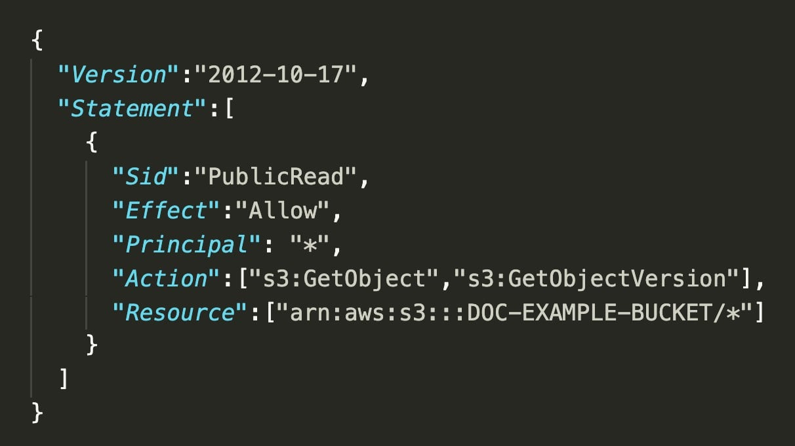
CORRECT: "Principal" is the correct answer.
INCORRECT: "Action" is incorrect. Actions are the permissions that you can specify in a policy.
INCORRECT: "Resource" is incorrect. Resources are the ARNs of resources you wish to specify permissions for.
INCORRECT: "Condition" is incorrect. Conditions define certain conditions to apply when granting permissions such as the source IP address of the caller.
References:
AWS cheat sheets:
https://digitalcloud.training/aws-storage-services/

Cost allocation tags can be used to tag and categorize your resources and then run view the billing in Cost Explorer and the cost allocation report. For example you can tag your resources by department or project and then view costs attributed to the resources used by those groups.
CORRECT: "Cost Allocation Tags" is the correct answer.
INCORRECT: "AWS Trusted Advisor" is incorrect. This service advises you on best practices for provisioning resources.
INCORRECT: "Consolidated billing" is incorrect. Consolidated billing will give you usage per account but not per project.
Amazon MSK (Managed Streaming for Kafka) is the correct choice as it is a fully managed service that facilitates building and running applications built on Apache Kafka without having to manage the underlying infrastructure. It would allow the financial services firm to focus on building their analytics platform without being concerned about Kafka’s infrastructure management, hence reducing the operational overhead.
Note: While the real AWS exam will often (but not always) expand the abbreviations, you must learn to recognize the services from their abbreviated names.

"Amazon Kinesis" is incorrect. Amazon Kinesis is incorrect as even though it is used for real-time streaming data and can technically be used to build a real-time analytics solution, it is not the best option when the requirement specifically mentions leveraging Apache Kafka. Kinesis has its own streaming data solution that is separate from Kafka.

AWS DataSync is used for replication and migrating data between storage systems and AWS.

The AWS Cloud Development Kit (AWS CDK) is an open source software development framework to define cloud application resources using familiar programming languages. With AWS CDK you can stick to using programming languages that are familiar to you and have infrastructure deployed using AWS CloudFormation.

Amazon CodeGuru is used to review code and provide intelligent recommendations for improvement.

AWS Outposts is a fully managed service that offers the same AWS infrastructure, AWS services, APIs, and tools to virtually any datacenter, co-location space, or on-premises facility for a truly consistent hybrid experience. With AWS Outposts you can extend your VPC into the on-premises data center as in the following diagram:
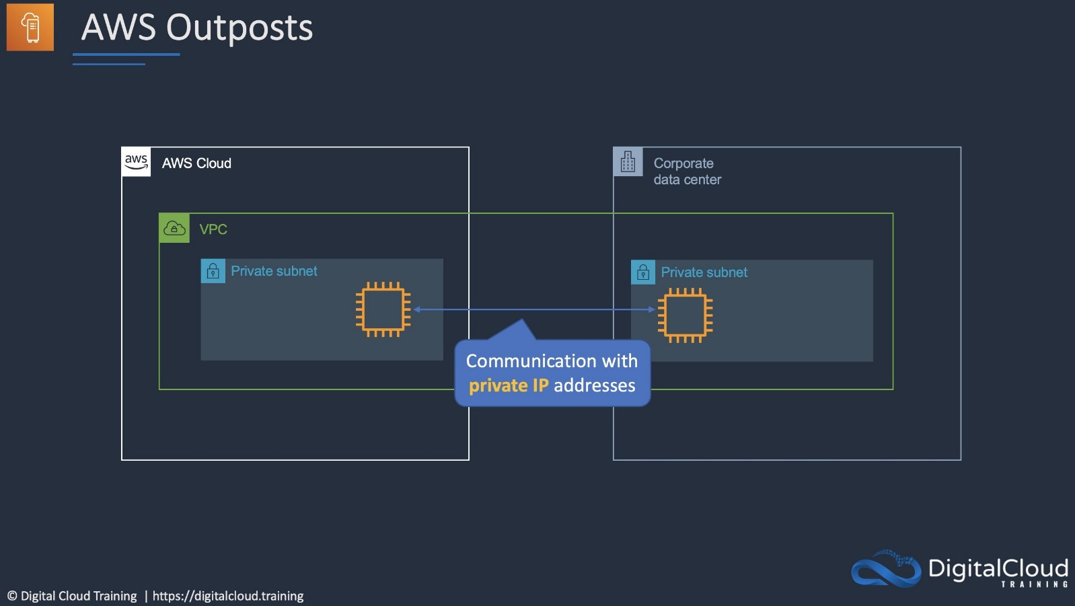

Amazon Connect provides a seamless omnichannel experience through a single unified contact center for voice, chat, and task management.
AWS Direct Connect is used for creating a low-latency private connection to an on-premises data center but it cannot be used to extend the VPC.
Amazon WorkSpaces is a managed, secure Desktop-as-a-Service (DaaS) solution.

AWS cheat sheets:
https://digitalcloud.training/aws-networking-services/

Amazon Elasticsearch Service is involved with operational analytics such as application monitoring, log analytics and clickstream analytics. Amazon Elasticsearch Service allows you to search, explore, filter, aggregate, and visualize your data in near real-time.
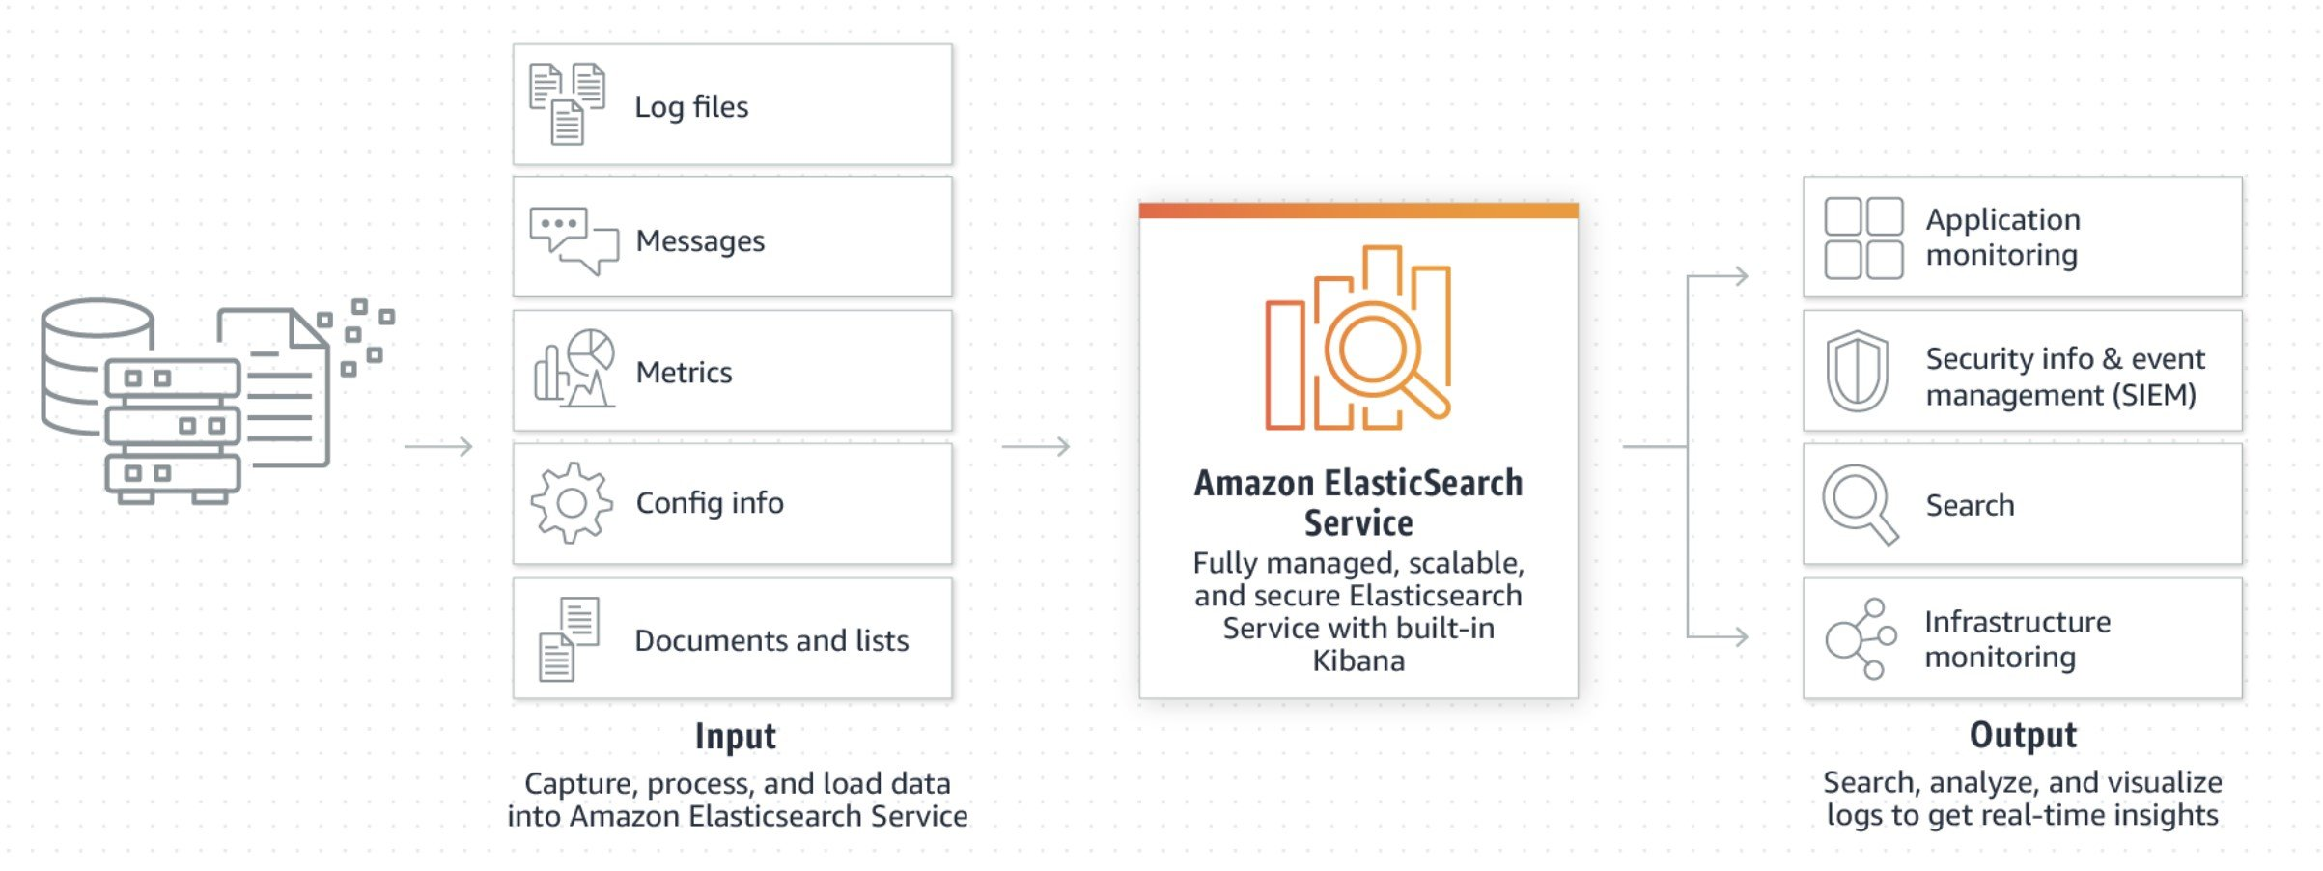
CORRECT: "Amazon Elasticsearch Service" is the correct answer.
INCORRECT: "Amazon EMR" is incorrect. For big data processing using the Spark and Hadoop frameworks, Amazon EMR provides a managed service for processing vast amounts data.
INCORRECT: "Amazon Athena" is incorrect. Amazon Athena is used to analyze data directly in S3 and Glacier using standard SQL queries.
INCORRECT: "Amazon QuickSight" is incorrect. Amazon QuickSight provides a fast, cloud-powered business analytics service, that that makes it easy to build stunning visualizations and rich dashboards that can be accessed from any browser or mobile device.

The performance efficiency pillar focused on selecting the appropriate resources and sizes based on workload requirements to ensure system efficiency and responsiveness. The reliability pillar is focused on system resilience and recovery, not on the selection of resources or optimization of specific workloads. The operational excellence pillar is concerned with running systems efficiently to deliver business value. The cost optimization pillar is focused on avoiding unnecessary costs, but it doesn't directly guide the selection of resources based on workload requirements.

