***Resume Parser using Spacy NLP Library with Stream lit Integrated***

Resume Analyses has been they’re for decades now, As, having well balanced and aesthetic resume can make or break your career. So, a personalized resume analyser helps us to evaluate and maintain a proper resume which might help us get a job in top MNC’s. In this project we explain you about the tools which helped us to analyse our resume and provide better feedback which can help us to increase the skills which we are lacking and also change the resume pattern which keeps us one step ahead of others.

***Base Paper***

1. <https://www.researchgate.net/publication/313851778_Resume_Parser_with_Natural_Language_Processing>

***Project Methodology***

***Streamlit:*** Stream lit is a small and easy web framework which helps us to build beautiful websites. The main reason for using stream lit is that it offers very user-friendly experience and we don’t need to have a prior knowledge of **HTML, CSS and JAVASCRIPT.** Streamlit is mostly used for deploying machine learning models without using any external cloud integrations. Some of the applications of Streamlit are it helps to deploy Machine learning and dee learning models, it can also help us to build a front end for a normal code. The output can be viewed as local server in your web browser.

**Resume Parser:** Resume parser is an NLP model which is used to get information from resumes such as details etc. then we have to train the NLP model according to dataset. Resume parsing helps recruiters to efficiently manage electronic resume documents sent electronically. Resume parsers are programs designed to scan the document, analyse it and extract information which are important to recruiters. They are extremely low-cost so that the data present in the resume can be searched, matched and can be displayed by recruiters.

***Installing SQLITE Database***

Ok, so as this project is integrated with database login support, we might need to install SQLite database in our system to make the code running. Trust me this will not take more than 5 min of your precious time, hang on.

1. Visit the given [link](https://sqlitebrowser.org/dl/) and download the SQLITE standard installer.

<https://sqlitebrowser.org/dl/>

1. After the download has ended, click on the .msi file and follow the all the necessary installation procedures.
2. Click on next and make sure to check the boxes for making the shortcuts.
3. Click on next and the installation procedures begins.
4. At last, click on finish to complete the setup procedure.

***Steps to Execute the Code!***

**Note:** Make sure you have added path while installing the software’s.

<https://techieyantechnologies.com/2022/07/how-to-install-anaconda/>

<https://techieyantechnologies.com/2022/06/get-started-with-creating-new-environment-in-anaconda-configuring-jupyter-notebook-and-installing-libraries-using-requirements-txt-2/>

1. Install the prerequisites/software’s required to execute the code from reading the above blog which is provided in the link above.
2. Press windows key and type in anaconda prompt a terminal opens up.
3. Go to the directory where your requirement.txt file is present, not just requirement.txt, if you want to execute any .py or .ipynb files, you need to go to that specific folder or path, where they are saved.

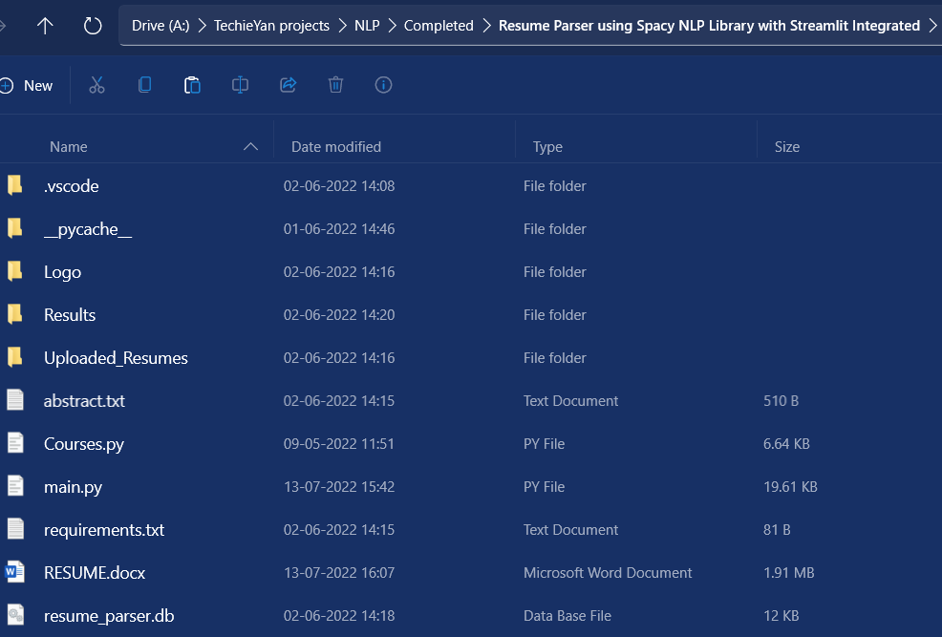

1. <<directory of your file:>>. E.g., If my file is in d drive, then
2. Type d:

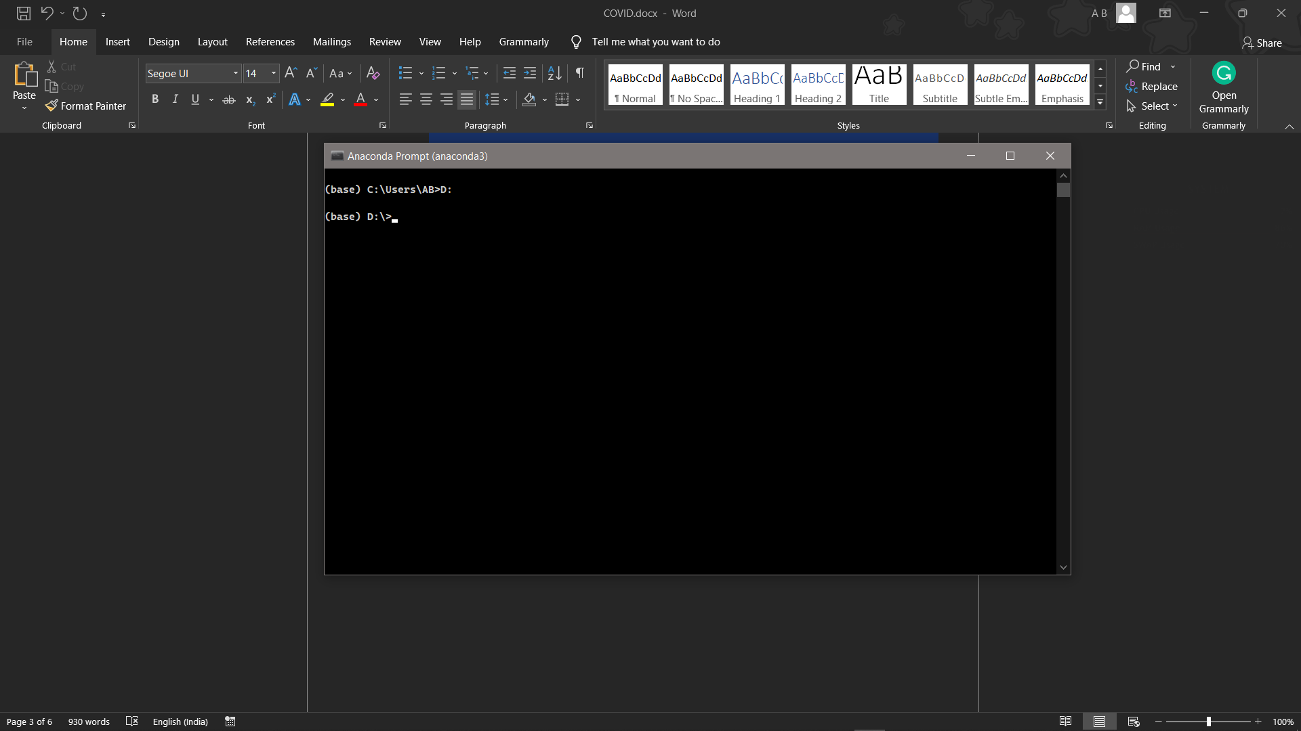

1. cd d:\License-Plate-Recognition-main #CHANGE PATH AS PER YOUR PROJECT, THIS IS JUST AN EXAMPLE

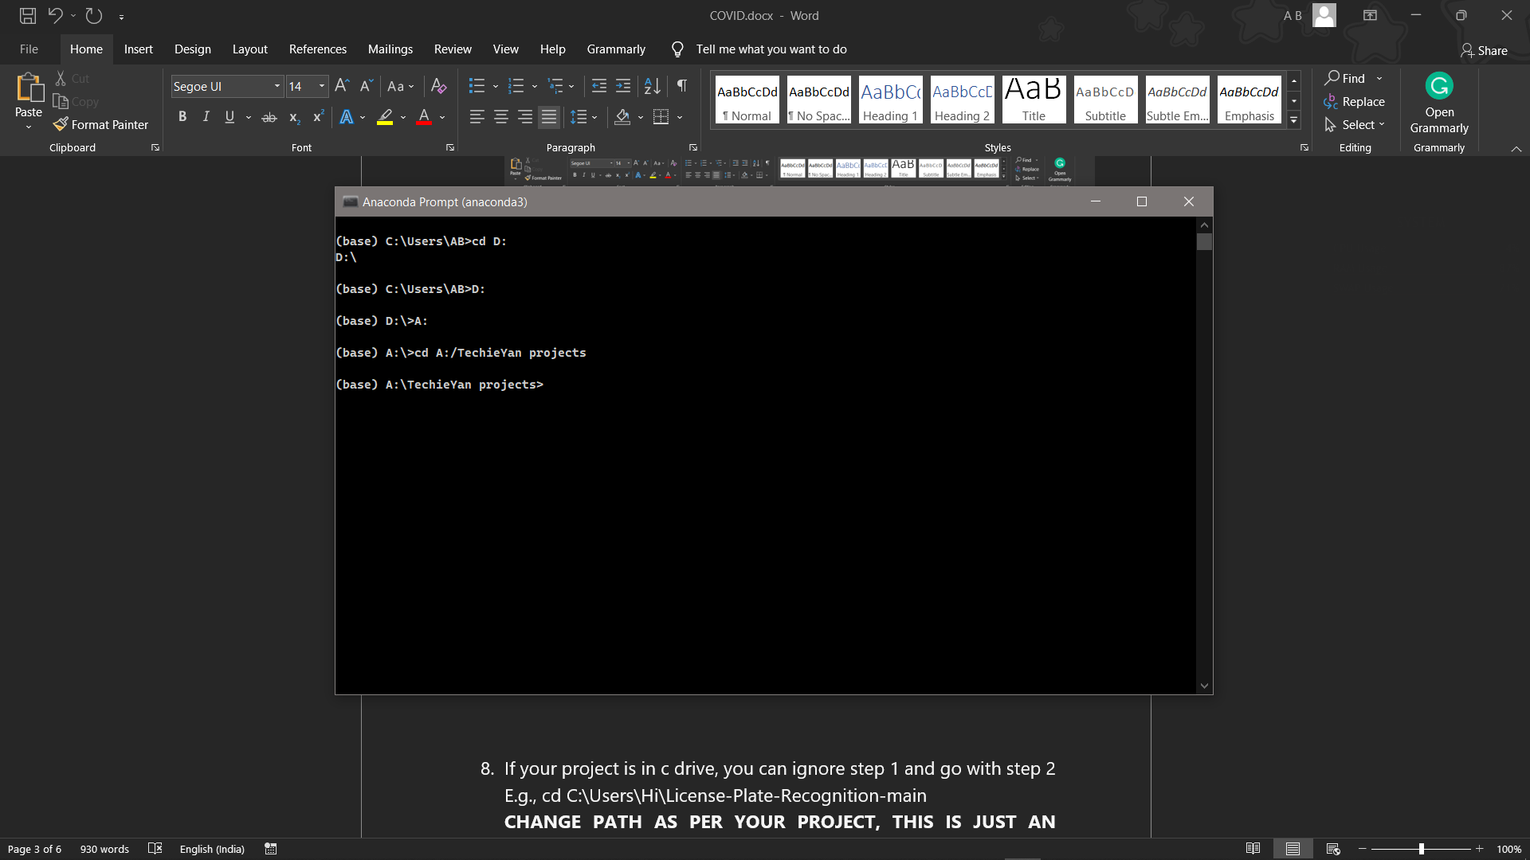

1. If your project is in c drive, you can ignore step 4 and go with step 5.

E.g., cd C:\Users\Hi\License-Plate-Recognition-main

**CHANGE PATH AS PER YOUR PROJECT, THIS IS JUST AN EXAMPLE**

1. Run pip install -r requirements.txt or conda install requirements.txt (Requirements.txt is a text file consisting of all the necessary libraries required for executing this python file. If it gives any error while installing libraries, you might need to install them individually.), example: pip install “module_name” i.e., pip install pandas

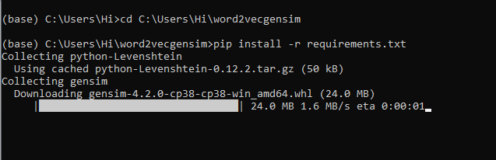

1. Type **python** **main.py** in your anaconda terminal and make sure to change the path where your executable files are located in the anaconda terminal.

(Please refer to the output images to understand how to login, On the right we have registration box and on the left we have Login Box)

***Dataset Description***

Specifically, no external dataset was used for this project. Some external links have been provided in the code to make a recommendation system which recommends courses to the people who use the application, based on their resume score.

***Issues Faced***

1. We might face an issue while installing specific libraries, in this case, you might need to install the libraires manually. Example: pip install “module_name/library” i.e., pip install pandas

2. Make sure you have the latest or specific version of python, since sometimes it might cause version mismatch.

3. Adding path to environment variables in order to run python files and anaconda environment in code editor, specifically in any code editor.

4. Make sure to change the **paths in the code** accordingly where your dataset/model is saved.

**Refer to the Below links to get more details on installing python and anaconda and how to configure it.**

<https://techieyantechnologies.com/2022/07/how-to-install-anaconda/>

<https://techieyantechnologies.com/2022/06/get-started-with-creating-new-environment-in-anaconda-configuring-jupyter-notebook-and-installing-libraries-using-requirements-txt-2/>

***Note:***

**All the required data has been provided over here. Please feel free to contact me for model weights and if you face any issues.**

<https://www.linkedin.com/in/abhinay-lingala-5a3ab7205/>

***Yes, you now have more knowledge than yesterday, Keep Going.***

***Results***

