



Math’s Coursework

Student Id : 2408573

Student Name : Kritish Dhakal

Section : L4CG20

Module : Computational Mathematics (4MM013)

Module Leader : Uttam Acharya

Tutor : Sulove Bhattarai

Submitted on : 20-05-2024

# Task 1

|  |  |  |  |
| --- | --- | --- | --- |
| For Function 1 | | | |
| Bisection Method | | Newton’s Method | |
| [𝑎, 𝑏]; #iterations; Root1 | [𝑎, 𝑏]; #iterations; Root2 | 𝑥0; #iterations; Root1 | 𝑥0; #iterations; Root2 |
| [-2, 0]; 100;  -0.6180 | [0, 2]; 100;  1.6180 | -1; 100;  -0.6180 | 1; 100;  1.6180 |
| SciPy Method | | | |
| x0;  Root1 | | x0;  Root2 | |
| 1;  -0.6180 | | 1;  1.6180 | |

Bisection Method Graph:

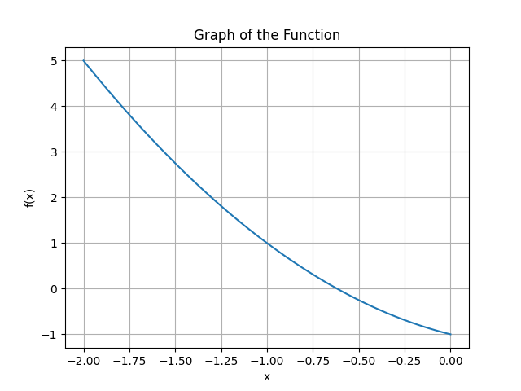

Newton Method Graph:

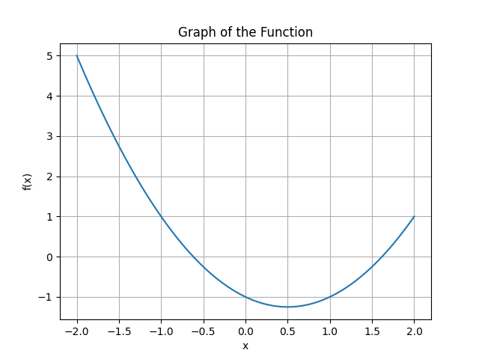

|  |  |  |  |  |  |
| --- | --- | --- | --- | --- | --- |
| For Function 2 | | | | | |
| Bisection Method | | | Newton’s Method | | |
| [𝑎, 𝑏]; #iterations; Root1 | [𝑎, 𝑏]; #iterations; Root2 | [𝑎, 𝑏]; #iterations; Root3 | 𝑥0; #iterations; Root1 | 𝑥0; #iterations; Root2 | 𝑥0; #iterations; Root3 |
| [-1, 1]; 100; 0.4450 | [-2,2]; 100; -1.2469 | [-3,3]; 100; -1.2469 | 1; 100;  0.4450 | -1;  100;  -1.2469 | -2;  100;  -1.2469 |
|  | SciPy Method | | | |  |
| x0;  Root1 | | x0;  Root2 | | x0;  Root3 | |
| 1;  0.4450 | | -1;  -1.2469 | | -2;  -1.2469 | |

Bisection Method:

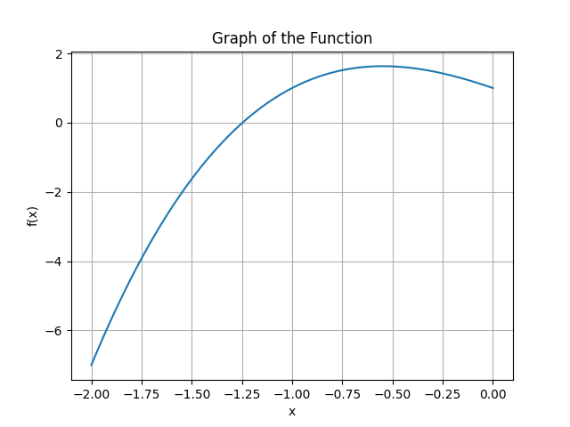

Newton Method:

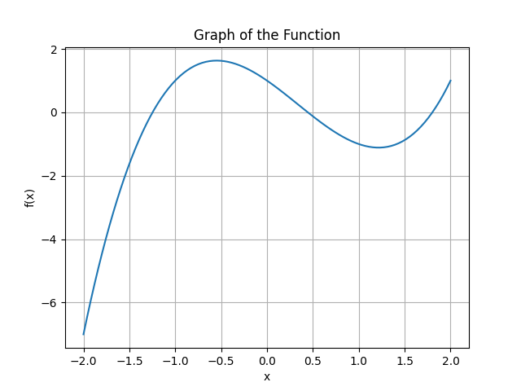

# Task 2

|  |  |  |  |  |  |
| --- | --- | --- | --- | --- | --- |
| N | Midpoint Approximation (MN) | Trapezoidal Rule  (TN) | Analytical  Method  (I) | Abs Error  |MN − I| | Abs Error  |TN − I| |
| For Function 1 | | | | | |
| 10 | 1.6403 | 1.606 | 1.6290 | 0.0113 | 0.022 |
| 30 | 1.6302 | 1.6266 | 1.6290 | 0.001 | 0.002 |
| 50 | 1.6294 | 1.6281 | 1.6290 | 0.0004 | 0.0008 |
| 100 | 1.6291 | 1.6288 | 1.6290 | 0.0001 | 0.0002 |
| 500 | 1.6290 | 1.6290 | 1.6290 | 0.000004 | 0.000008 |
| For Function 2 | | | | | |
| 10 | 145.88 | 150.47 | 147.41 | 1.5244 | 3.058 |
| 30 | 147.24 | 147.75 | 147.41 | 0.170 | 0.3410 |
| 50 | 147.35 | 147.53 | 147.41 | 0.0614 | 0.122 |
| 100 | 147.39 | 147.44 | 147.41 | 0.0153 | 0.030 |
| 500 | 147.41 | 147.41 | 147.41 | 0.0006 | 0.001 |

Midpoint Approx Graph (F1):

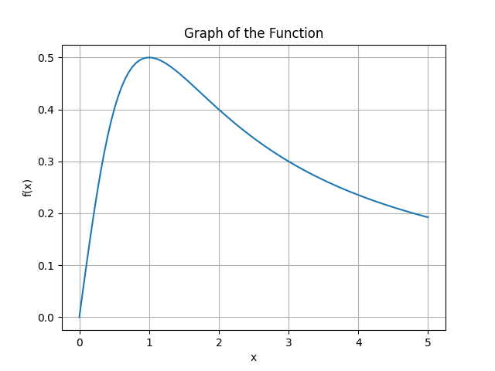

Midpoint Approx Graph (F2):

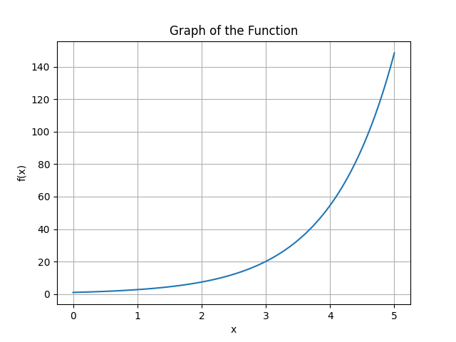

Trapezoidal Method (F1):



Trapezoidal Method (F2):

