**CHAPTER: 1**

**INTRODUCTION**

* 1. **Introduction:**

An online result management system is a digital platform designed to simplify the process of managing and publishing academic results. It is a modern and effective tool that helps educational institutions to streamline the result management process and improve their overall efficiency. The system is user-friendly and allows students, teachers, and administrators to access and manage results easily and securely from anywhere, at any time. It eliminates the need for tedious paperwork and manual data entry, reducing the risk of errors and making the process faster and more accurate.

One of the unique features of online result management systems is their ability to provide real-time updates on results. Students can receive their results as soon as they are published, without having to wait for days or weeks. This helps to reduce anxiety and allows students to plan their next steps accordingly. Another unique feature of online result management systems is the availability of detailed analytics and reports. This allows administrators to analyze the performance of individual students or groups and identify areas for improvement. It also helps to provide insights into the effectiveness of teaching methods and curriculum.

In conclusion, an online result management system is a game-changer in the education industry, providing a unique and efficient way to manage and publish academic results. It not only simplifies the process of result management but also provides real-time updates and detailed analytics, making it an indispensable tool for educational institutions.

* 1. **Problem Statement:**

Traditional result management systems in educational institutions often involve manual processes, which can be time-consuming, error-prone, and inefficient. The management of student results, including data entry, calculation, storage, and retrieval, can be a tedious task. Additionally, the manual process may lead to delays in result declaration and difficulty in tracking student performance over time. Therefore, there is a need for an automated system that can effectively manage and process student results.

**1.3 Objective:**

The objective of the proposed Online Doctor Appointment System is:

* + Providing a platform for teachers, students, and administrators to manage academic results and related information online. This includes features such as uploading and accessing grades, tracking student progress, and generating reports.
  + Allowing users to provide feedback on the system and its features. This feedback can help improve the system's usability, functionality, and overall effectiveness.

## 1.4 Scope

This system defines the description of the work that is required in delivering the Online Result Management System. The system will be developed using modern web technologies and will be designed to be scalable and customizable to meet the specific need of different Educational organization.

**CHAPTER: 2**

# BACKGROUND STUDY AND LITERATURE REVIEW

**2.1 Literature Review**

According to Freund et al. (2017), nowadays people interact directly with technology

in fields such as education, government, finance, retail, entertainment, health care,

science, travel, publishing, and manufacturing.

And they also state that, educators and teaching institutions use technology to

assist with education. Most equip labs and classrooms with laptops or desktops. Some

even provide computers or mobile devices to students. Many require students to have

a mobile computer or mobile device to access the school’s network or Internet

wirelessly, or to access digital-only content provided by a textbook publisher.

And educators may use a Course Management System (CMS), sometimes called

a Learning Management System (LMS), which is a software that contains tools for

class preparation, distribution, and management. For example, through the course

management system, students access course materials, grades, assessments, and a

variety of collaboration tools.

Many schools offer distance learning classes, where the delivery of education

occurs at one place while the learning occurs at other locations. Distance learning

courses provide time, distance, and place advantages for students who live far from a

campus or work full time.

Referencing Wallace (2015), the LMS is an information system used to track

student progress, and manage educational records. Many offer other features, such as

online registration, assessment tools, collaborative technologies, and payment

processing. They also offer tools for creating or importing content.

And she also states that, people are so accustomed to social networking and other

web applications that it is an easy step to build these tools into an online platform or

environment.

And referencing Wundenberg (2015), LMS characterizes a complex, often web

based software system which pools multiple task specific subprograms under a shared

User Interface (UI).

• Allocation and organization of learning content for different learning scenarios;

• School administration;

• Information management;

• Online school business related communication.

## 2.2 Study of Existing System

The study of existing systems for online result management provides valuable insights into their features, functionalities, and effectiveness. These systems, implemented in various institutions or organizations, exhibit different technical architectures, including database design and system components. The functionalities offered by these systems, such as result publication, student information management, grade calculation, report generation, and data analytics, are evaluated to determine their comprehensiveness and effectiveness in meeting educational institution needs. Additionally, the user interface design and user experience are assessed, considering factors such as ease of use, navigation, responsiveness, and user satisfaction. Security measures implemented in the systems to protect student data, prevent unauthorized access, and ensure data integrity are examined, along with privacy concerns and compliance with data protection regulations. The performance of the systems in terms of response time, concurrent user handling, and system availability is analyzed, and scalability is considered for future growth and increased usage. Overall, studying existing systems for online result management systems provides valuable insights into their functionalities, usability, security, and performance.

**CHAPTER: 3**

# SYSTEM ANALYSIS AND DESIGN

## 3.1 System Analysis

This system is designed with the series of processes starting with requirement analysis, design, implementation, testing and maintenance. During requirement analysis, all the functional and nonfunctional requirement are analyzed and system is developed according to the requirement then designing of the system is carried out. After the design process, coding and development part is started then after integrating the system there is testing of the system. If the testing is positive then system is implemented otherwise some maintenance is done and system come in operation.

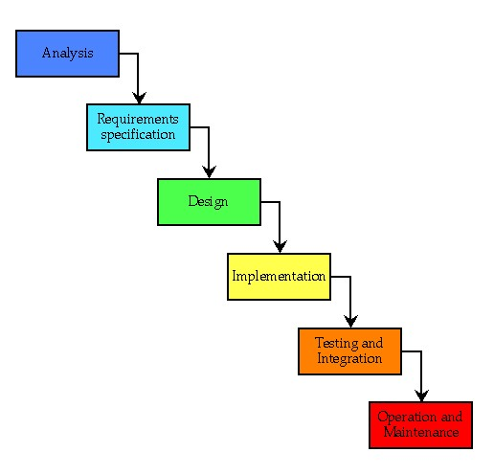

**Figure 3.1: Waterfall Methodology**

### 3.1.1 Requirement Analysis

The requirements are to be collected before starting projects’ development life cycle. To design and develop system, functional as well as non-functional requirement of the system has been studied.

• **Functional Requirements. Top of Form**

**1.Subject Information Management**: Maintain subject details like code, name, type,

semester, and credits.

**2.Student Information Management**: Manage student information including enrollment

number, name, and year of enrollment.

**3.Student's Subject Choice Information Management**: Track elective choices of students

in different semesters.

**4.Marks Information Management**: Store marks data with internal, external, total marks,

and credits.

**5.Mark Sheet Generation**: Automatically generate mark sheets for students in each

semester.

**6.Report Generation**: Create various reports, including student lists, subject choice lists,

semester-wise mark lists, and rank-wise lists.

**7.User Account Management**: Administer user accounts with usernames, IDs, passwords,

and roles.

• **Non- Functional Requirements.**

The system should be easy to use and navigate for Students and Teachers with minimal training.

### Availability

The system should be available 24/7 to ensure that Students can view results at any time.

### Performance

The system should be able to handle a large number of concurrent users and ensure fast response times.

### Security

### The system should be secure and protect Student data and privacy by implementing appropriate security measures.

### Scalability

The system should be designed to be scalable and able to handle increasing numbers of users as the system grows.

### Reliability

It should be reliable and ensure that data are handled correctly, and the system is available as per the specified uptime.

## Feasibility Study

The feasibility study concluded that the project is able to be implemented to success as it was carefully planned.

### i) Technical Feasibility Study

The system is technically feasible as the requirement for the development of the system is easily accessible. The necessary hardware and software required for the development and implementation of the system is available. The basic programming language which is suitable for project is available and the libraries required for project is capable of achieving the result that we are aiming for. All the existing resources can be used for the development and maintenance system.

### ii) Operational Feasibility Study

This system will include all the requirements used for Online result management system will be completely operational and can be successfully implemented and tenants and landlords will feel easy to use this system as it will be user-friendly

### iii) Economic Feasibility Study

The system is economically feasible and cost effective. As all the tools and resources required are either open sources or free. After the completion of the system organization didn’t need to deploy any new hardware and software as the required software and hardware. The existing resource of the system can be used.

### iv) Schedule Feasibility Study

The system which is going to be developed will be completed within scheduled time and will not exceed the scheduled time.

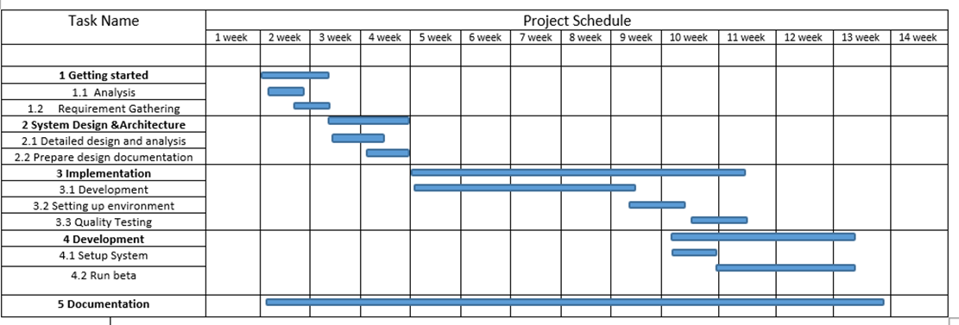

**Figure 3.2: Gantt chart for Online Result Management System**

### 3.1.2 Data Modeling (ER-Diagram)

In Entity-Relationship diagram are five entities named, appointment, patient, bill, prescription, admin, doctor, and schedules. Appointment has attributes like Appointment id, doc-name, time, date. Likewise patient has Patient id, name, email, phone-no, gender, address, and password. Bill has bill-id, date, description, and amount. Admin has admin-id, email, password, address and gender. Doctor has doc-id, name, email, password, gender, specialization, and experience. Schedules has sch-id, time, date, description. Appointments Doctor manages schedules according to the appointment time of the patient

**Fig 3.3: ER-DIAGRAM**

### 3.1.4 Process Modeling (DFD)

Data Flow Diagram of Online Doctor Appointment System consists of two levels of DFD Level 0 DFD and Level 1 DFD.

**Level 0 DFD:**

The Level 0 Data Flow Diagram (DFD) for the Online Result Management System provides an overview of the system's processes, data flow, and external entities. The main process in the system is the Result Management System, which includes result input, processing, and output. There are two external entities - Students and Teachers/Administrators - who interact with the system to access and manage result data. The system has two data stores - Student Result Database and User Database - which store result data and user information, respectively. The Level 0 DFD shows how the system is divided into sub-systems (processes), each of which deals with a specific aspect of result management..

**Level 1 DFD:**

The Level 1 Data Flow Diagram (DFD) for the Online Result Management System provides a more detailed view of the system's processes. The Result Management System process is divided into three sub-processes: Result Input, Result Processing, and Result Output. The Result Input sub-process receives input from Teachers/Administrators, such as uploading result files or manually entering result data. The input is then used to update the Student Result Database. The Result Processing sub-process performs calculations, such as grade point calculations, based on the input data from the Student Result Database. It also generates reports, such as result summaries or individual student reports. The Result Output sub-process provides output to both Students and Teachers/Administrators. Students can access their results through the system, while Teachers/Administrators can view and manage the result data. The Level 1 DFD shows how the system is divided into sub-processes, each of which deals with a specific aspect of result management.

## 3.2. System Design

**3.2.1. Architectural Design**

Architectural design is a process for identifying the sub-systems making up a system and the framework for sub-system control and communication.

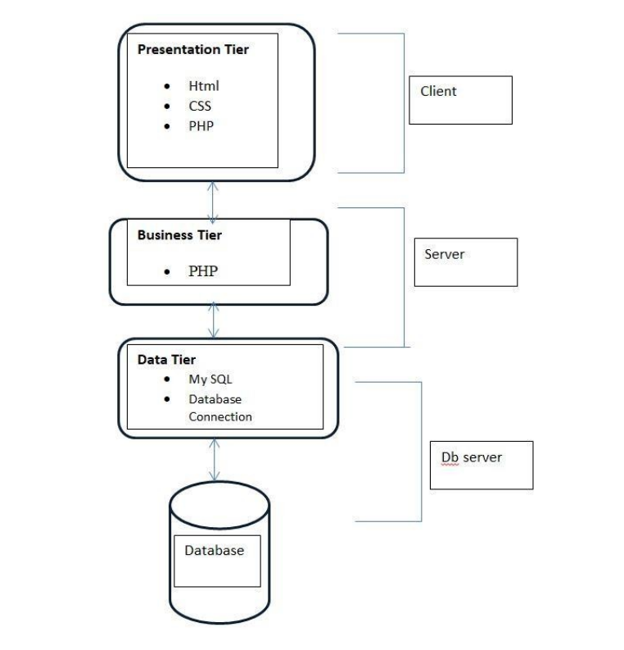

**3.2.2. Database Schema Design**

The database schema design section outlines the specific tables, attributes, and relationships required to implement the Online Result Management System. It involves designing an efficient and normalized database schema that can effectively store and retrieve student result data. The intended usage looks like this:

* an entry in 'users' for each person to use the tool
* the roles admin, student and user can be assigned to users
* an entry in 'persons' for every student, referencing a 'user'
* groups stays, time in school and days of leave defined in 'absences'
* all of the above (except for roles) should be confined to a department, which will be determined by the logged-in users department

**3.2.3. Interface Design (UI Interface / Interface Structure Diagrams)**

Interface design focuses on designing the user interface (UI) of the Online Result Management System. This section includes the creation of UI wireframes, interface structure diagrams, and navigation flows. It aims to create an intuitive and user-friendly interface that facilitates easy interaction with the system.

**Book References:**

* C. J. Date, A. Kannan and S. Swamynathan, An Introduction to Database Systems, Pearson Education, Eighth Edition, 2009.
* Abraham Silberschatz, Henry F. Korth and S. Sudarshan, Database System Concepts, McGraw-Hill Education (Asia), Fifth Edition, 2006.
* Shio Kumar Singh, Database Systems Concepts, Designs and Application, Pearson Education, Second Edition, 2011.

**Website References:**

* <http://junikhyatjournal.in/no_1_Online_21/63.pdf>
* <https://jespublication.com/upload/2021-V12I757>
* <https://uniprojecttopics.com/project/development-of-a-student-online-result-management-system/>
* <https://www.jetir.org/papers/JETIR2204722.pdf>