Predicting Structural Column Arrangements from Architectural Floor Plans
A Controlled Comparison of an Algorithmic Score, a Feature-Based Classifier, an Image-Based Classifier and a Quantum Classifier
MSc Thesis
Kritvi Gera
CID: 06053693
MSc. General Structural Engineering with Data Science
Imperial College London
Given an architectural floor plan, this work enumerates candidate structural column arrangements, ranks them, and measures how closely the highest-ranked arrangement matches the one the real building uses. Four ranking methods are compared on one task, one corpus and one set of labels, with the algorithm-only method retained as the baseline.
August 2026

Abstract
At the start of a building’s design someone must decide where the columns will stand. The architectural drawing records the walls and the rooms; it does not record the structure. This thesis asks whether a first proposal for that decision can be generated and, more importantly, whether it can be measured.
Three public floor-plan datasets are converted into a single corpus of 29,279 plans. Because no drawing records a column layout, a label is derived by a stated procedure: walls thinner than 160 mm are discarded as partitions, a grid is built from the survivors, and a column is placed at every grid crossing that lies physically inside one of those walls. The resulting arrangement is an equivalent-frame idealisation of a wall-bearing structure rather than a recovered design, and the thesis is explicit that every subsequent figure is conditional on that procedure. The single arbitrary constant in it, the 160 mm threshold, is varied between 140 and 200 mm and the effect on the headline result is reported.
Candidate arrangements are enumerated from the parsed grid and ranked by a dimensionless geometric score built from five measures: column density, a load-free index of bending demand, grid irregularity, the fraction of columns standing away from walls, and the repetition of bay sizes. The score contains no member sizes, no material prices and no load values. Its five weights are obtained two independent ways, once by equal weighting and once by learning them from 52,724 paired comparisons in which the real arrangement of a plan must outrank alternatives generated on that same plan’s grid.
Four ranking variants are then compared. The baseline uses the score alone. The other three add a learned classifier that re-orders the score’s fifteen best candidates: a gradient-boosted model reading six scale-independent measurements, a convolutional network reading 64 by 64 pictures of the arrangement, and a four-qubit variational quantum classifier. All three are trained on identical examples and labels, with implausible examples produced by moving column positions rather than by editing the numbers a model reads, which removes a circularity present in an earlier version of this work and reduces the feature classifier’s reported score from 0.947 to 0.862.
Three findings are reported. First, the score weights matter far more than the choice of classifier: learned weights move the median rank of the correct arrangement, among roughly four thousand candidates, from about 2,400 to nine, whereas changing classifier moves it by one or two places. Second, the image classifier’s advantage over the feature classifier (0.995 against 0.860 ROC AUC) is attributable to information rather than architecture; blanking the wall layer from its input returns it to 0.874, level with the feature model. Third, the four-qubit circuit matches its capacity-matched classical control at every training-set size and gains only 0.007 ROC AUC from fifty times more data, while equally informed tree ensembles gain 0.075, which locates its ceiling in expressive capacity rather than in data volume.
No variant separates from the baseline at conventional significance on the seven held-out plans. That negative result is reported as the outcome of the experiment, together with the measures taken to make it trustworthy: candidate coverage is stated before any accuracy figure, splits are grouped by plan and repeated, and every hand-chosen constant is varied and its influence measured.

Contents
Table of Contents
Abstract 2
Contents 3
List of Tables 6
List of Figures 7
Nomenclature 8
Chapter 1. Introduction 9
1.1 The problem 9
1.2 Research questions 9
1.3 Structure of the pipeline 10
1.4 Objectives 10
1.5 Scope, and what was deliberately removed 11
1.6 Contribution 11
1.7 Outline of the report 12
Chapter 2. Literature Review 13
2.1 Scope and search strategy 13
2.2 Floor plans as a source of structural data 13
2.3 Learned structural layout design 14
2.3.1 Response prediction 14
2.3.2 Generative structural design 14
2.3.3 Column placement, and the closest prior art 14
2.3.4 Column layouts from plans with neural networks 15
2.4 Topology optimisation, and why it is the wrong frame 15
2.5 Screening cheaply and confirming expensively 16
2.6 How the learned components are set up 16
2.7 What the industry cost evidence still justifies 17
2.8 Quantum machine learning, and the limits of what can be claimed 17
2.9 Judging the same layout two ways 18
2.10 The gap 18
Chapter 3. Methodology 20
3.1 The corpus 20
3.1.1 Conversion 20
3.2 Deriving the labels 21
3.2.1 What the result represents 21
3.2.2 The threshold, and its sensitivity 21
3.2.3 What each source supports 22
3.2.4 Published artefacts 22
3.3 What the corpus looks like 23
3.4 The parser 23
3.5 The generator 25
3.5.1 Sampling large search spaces 25
3.6 The score 26
3.6.1 The five measures 26
3.6.2 Normalisation 26
3.6.3 Obtaining the weights 26
Chapter 4. Models 28
4.1 Constructing the training examples 28
4.1.1 The circularity that had to be removed 28
4.1.2 Examples constructed in geometry 28
4.2 The feature judge 29
4.3 The image judge 29
4.3.1 The blanked-wall control 30
4.4 The quantum judge 30
4.4.1 What can and cannot be claimed 31
4.4.2 Reaching the full corpus 31
4.5 Combining a judge with the score 31
4.6 The four variants 31
Chapter 5. Results 33
5.1 The evaluation protocol 33
5.2 Candidate coverage 33
5.3 The judges on their own task 34
5.3.1 The feature judge 34
5.3.2 The image judge, and what its advantage consists of 35
5.3.3 The quantum judge 36
5.3.4 A cautionary result retained deliberately 38
5.4 The score weights 38
5.5 The four variants end to end 39
5.5.1 The score weights dominate 40
5.5.2 The judges are second-order 40
5.5.3 Significance 41
5.6 Sensitivity analyses 42
5.6.1 The score weights 42
5.6.2 The judge’s authority 42
5.6.3 The labelling threshold 43
5.6.4 Score and judge independence 44
Chapter 6. Discussion and Conclusions 45
6.1 What the comparison found 45
6.2 The signal that dominates, and its circularity 45
6.3 Negative results, and why they are reported 45
6.4 What did not work 46
6.5 Limitations 46
6.6 Conclusions 47
6.7 Further work 48
6.8 Reproduction 48
Bibliography 49

List of Tables
Table 2.1 Comparison with the closest prior art
Table 3.1 Corpus composition
Table 3.2 Effect of the load-bearing threshold on the corpus
Table 4.1 The four learned components
Table 4.2 The four pipeline variants
Table 5.1 The seven evaluation plans
Table 5.2 The feature judge
Table 5.3 The image judge and its controls
Table 5.4 The quantum judge across training-set sizes
Table 5.5 Fixed and learned score weights
Table 5.6 Accuracy of the four variants
Table 5.7 Paired significance tests
Table 5.8 Sensitivity to the score weights
Table 5.9 Sensitivity to the judge’s weight
Table 5.10 Sensitivity to the labelling threshold

List of Figures
Figure 1.1 The pipeline and its four variants
Figure 3.1 Regularity of real plans by source
Figure 3.2 A parsed plan
Figure 3.3 Growth of the candidate space
Figure 4.1 Real and altered arrangements
Figure 4.2 Inputs to the image judge
Figure 5.1 Where the image judge’s advantage comes from
Figure 5.2 Quantum and classical models against training-set size
Figure 5.3 The two sets of score weights
Figure 5.4 Geometric agreement by variant and weight set

Nomenclature
The report avoids specialist vocabulary where plain wording will serve. The terms below are unavoidable and are used consistently throughout.
Column arrangement The set of positions at which columns stand on one floor of a building.
Load-bearing wall A wall that carries the weight of the structure above it, as opposed to a partition that merely divides rooms.
Grid line A straight reference line running the full width or depth of a plan. Columns are placed where two grid lines cross.
Span The distance between two adjacent columns; equivalently the width of one structural bay.
Label, or ground truth The arrangement treated as correct when accuracy is measured. Architectural drawings record none, so it is derived from the load-bearing walls by the procedure of Chapter 3.
Judge A machine-learning model that estimates how plausible a candidate arrangement is. Three are compared, and the baseline uses none.
Candidate set Every arrangement the generator produces for one plan, from which each variant must choose.
ROC AUC A measure of how well a model separates two classes, running from 0.5 for a model no better than chance to 1.0 for a perfect one.
PR AUC A companion measure that is more informative than ROC AUC when one class is rare; both are reported throughout.
Kendall’s τ A rank correlation running from −1 to +1, used here to express how far a ranking moves when a weight is perturbed.
Chamfer distance The average distance from each column in one arrangement to the nearest column in another; a measure of near-agreement that does not require an exact match.

Chapter 1. Introduction

1.1 The problem
Early in the design of a building, someone must decide where its columns will stand. At that point the architectural drawing exists and the structural design does not: the drawing records walls, rooms, doors and dimensions, but it contains no statement of which elements will carry the weight of the floors above. The decision is usually made quickly and from experience, and it constrains a great deal of what follows, including the distances floors must span, the depth of the floor construction, the number and size of foundations, and how much of the architect’s intended layout survives contact with the structure.
Two properties make this a natural target for automation. The decision is made from information that is already digital, since architectural plans are drawn in vector form and their wall geometry can be read directly. And the space of reasonable answers is discrete and enumerable: a column arrangement is a choice of grid lines together with a rule for which of their crossings receive a column, so for a given plan and a given permissible range of spans the candidates can be listed exhaustively or sampled representatively.
The difficulty lies not in generating candidates but in judging them. To say that one arrangement is better than another requires either a model of what makes an arrangement good, which invites disagreement about the model, or examples of arrangements that real engineers produced, which are not present in architectural datasets. This thesis confronts that difficulty directly rather than assuming it away, and the resulting measurement discipline is the greater part of its contribution.

1.2 Research questions
The work is organised around three questions, in rising order of importance.
1. Can candidate arrangements be enumerated such that the real building’s arrangement is among them? This must be established first. If the correct answer is absent from the candidate set, then every accuracy figure measures that absence rather than the quality of any method, and the comparison that follows is meaningless. Chapter 5 therefore reports candidate coverage before any accuracy figure.
2. Can a purely geometric score order those candidates so that the real arrangement is near the top? By purely geometric is meant a score computed from the positions of the columns and the geometry of the plan, containing no member sizes, no material prices and no load values. The motivation for that restriction is given in Section 1.5 and developed in Chapter 3.
3. Do learned classifiers improve on that score? Three are tested, reading respectively numerical measurements of an arrangement, a picture of it, and a four-qubit quantum encoding of it. All three are trained on identical examples and labels, and the score-only pipeline is retained as the baseline that each must beat.

1.3 Structure of the pipeline
Figure 1.1 sets out the stages. A plan and a set of user constraints enter at the left. The parser converts wall segments into grid lines and candidate column positions. The generator lists the arrangements those grid lines permit within the user’s span limits. The score assigns each candidate a single number. At that point the pipeline branches into the four variants that the thesis compares, and each produces one chosen arrangement. The evaluation stage measures all four against the derived labels on plans that no model has seen.
Input: architectural plan (vector walls) + user constraints
Stage 04 parser | walls → grid lines → candidate positions
Stage 05 generator | every arrangement within the span limits
Stage 06 score | five geometric measures → one penalty
 | (weights fixed, or learned in stage 08)
The branch: four variants, each choosing one arrangement
V1 stage 07 | re-ranked by the feature judge
V2 stage 11 | re-ranked by the image judge
V3 — | not re-ranked; the score’s own order stands (baseline)
V4 stage 10 | re-ranked by the quantum judge
Stage 12 evaluation | coverage, accuracy, significance, sensitivity

Figure 1.1: The pipeline and its four variants. Stage numbers refer to the repository folders that implement each step. All four variants share every stage before the branch, so the comparison between them is controlled: identical grid, identical candidates, identical score.
The three judges consume the score’s fifteen best candidates and re-order them by combining the score with their own estimate of plausibility,
combined = z(penalty) + λ 1 −P(plausible) , (1.1) where z is a robust standardisation computed over the whole candidate set and λ controls how much authority the judge holds. The value of λ is varied in Chapter 5 rather than asserted.

1.4 Objectives
1. Derive a column-arrangement label for open floor-plan corpora, document every assumption in the derivation, and measure how far the results depend on the one arbitrary constant it contains.
2. Align candidate generation with that derivation until the label is reachable, and report the coverage rate before any accuracy figure.
3. Build a score whose only free parameters are five interpretable weights, and obtain those weights in two independent ways so that the hand-set and learned versions can be compared.
4. Train three judges on one identical task, with implausible examples constructed in a way that does not leak the answer.
5. Compare all four variants under a single protocol using paired statistics, retaining the algorithm-only path as the baseline.
6. Leave every known weakness either closed or explicitly stated.

1.5 Contribution
The claim was checked against literature published between 2020 and 2026, and Chapter 2 reports what was found, including work that narrows it. No individual component of this pipeline is new. Predicting column positions from plans with a convolutional network has been done [Ampanavos et al., 2021], and the decomposition from walls to grid lines to crossings is claimed in a granted patent [Wang and Nourbakhsh, 2024]. Learning structural layout from real buildings has been done for shear walls [Liao et al., 2021, Pizarro et al., 2021]. Applying a variational quantum classifier to building data has been done for post-earthquake safety assessment [Bhatta and Dang, 2024].
What was not found is any study that applies an algorithmic score, feature-based learning, image-based learning and quantum learning to one identical task, on one corpus, with one set of labels, while retaining the algorithm-only path as a baseline that the learned variants must beat. That controlled comparison is the contribution. Two supporting contributions are a documented and sensitivity-tested procedure for deriving column-arrangement labels for public floor-plan datasets, and a method for obtaining the score weights by ranking real arrangements against alternatives drawn from the same plan.

1.6 Outline of the report
Chapter 2 reviews the relevant literature and states the gap. Chapter 3 describes the corpus, the labelling procedure, the parser, the generator and the score. Chapter 4 describes the four models that were trained and the design decisions that make their comparison fair. Chapter 5 reports the results, the significance tests and the sensitivity analyses. Chapter 6 discusses what the results mean, states the limitations, and identifies further work.

Chapter 2. Literature Review

2.1 Scope and search strategy
This review is not a survey of machine learning in civil engineering. It is the evidence base for a specific set of design decisions, and each section closes by naming the decision it supports or the decision it fails to support. Forty-three sources are cited, each verified against the publisher record or a primary index.
Searches were run in August 2026 across Google Scholar, arXiv, the ACM Digital Library, ScienceDirect, Springer, IEEE Xplore and Google Patents, using the terms floor plan dataset, floorplan vectorisation, structural layout generation, column placement, shear wall layout, structural surrogate model, topology optimisation deep learning, noise contrastive estimation, learning to rank and variational quantum classifier. Backward snowballing proceeded from two reviews [Sun et al., 2021, Malaga-Chuquitaype, 2022] and from the closest prior art [Wang and Nourbakhsh, 2024, Liao et al., 2021]. A source was included only if it supplies data this work consumes, establishes a method it uses, or contests a decision it makes.
Three limits on the search should be stated at the outset. Coverage is English-language and mainly open-access, which under-represents generative structural design as practised and published in China. Patents were searched only through Google Patents and only in English, which matters more than usual here because the closest prior art proved to be a patent. And this is a narrative review assembled around an existing design rather than a protocol-driven systematic review, so it is exposed to the bias of having searched for support; Section 2.3.3 is the partial corrective, since it reports the work that anticipates part of the approach.

2.2 Floor plans as a source of structural data
Large vector floor-plan corpora are now openly available, and three are used here. CubiCasa5K [Kalervo et al., 2019] contributes 5,000 densely annotated plans as SVG polygons. Swiss Dwellings [Standfest et al., 2022] contributes roughly 42,500 apartment models with walls stored as geo-referenced geometry, released under CC-BY-4.0 and quality assured to a median area deviation of 1.2 per cent. ResPlan [Abouagour and Garyfallidis, 2025] contributes 17,000 residential plans in vector form with metric coordinates.
Two further corpora were considered and rejected. RPLAN [Wu et al., 2019] is the most cited residential corpus but is raster-first and oriented towards room semantics, so metric wall geometry would have to be recovered before anything structural could be said. MSD [van Engelenburg et al., 2024] is derived from Swiss Dwellings and would have duplicated a source already present.
Recovering geometry from drawings is itself a mature field. Liu and colleagues [Liu et al., 2017] framed raster-to-vector conversion as junction prediction followed by integer programming, and Zeng and colleagues [Zeng et al., 2019] improved wall and room recognition with a multi-task network. This work deliberately does not compete there: all three sources are consumed as vectors, so the parsing problem begins one step later, at walls to structural grid rather than pixels to walls.

This evidence justifies two decisions: the selection of the three corpora described above, and the choice to operate on vector geometry rather than on raster drawings. It does not, however, justify treating those corpora as structural ground truth, a limitation examined in Section 2.10.

2.3 Learned structural layout design
Three strands of work bear on this thesis, and they are not equally close to it.

2.3.1 Response prediction
The largest strand predicts structural behaviour from a design that already exists, usually by training a surrogate model on simulated results. Sun, Burton and Huang [Sun et al., 2021] survey the field and show that prediction and assessment dominate while proposing a layout is thinly covered. This thesis does not sit in that strand.
Málaga-Chuquitaype [Malaga-Chuquitaype, 2022] is more pointed, arguing that the field has been readier to automate the parts of design engineers do not mind losing than the judgement they exercise, and warning against models asked to certify what they cannot explain. That warning shapes the division of labour adopted here: the learned components rank candidates and nothing more, and the reasoning that orders them is set out in closed form.

2.3.2 Generative structural design
Liao and colleagues [Liao et al., 2021] trained generative adversarial networks on real shear-wall design documents, parameterised by height and seismic category, and produced usable layouts. Lu and colleagues [Lu et al., 2022] then embedded a physics estimator in the generator rather than trusting the data-driven discriminator alone. This strand is the strongest available evidence that structural layout is learnable from real design data.
Two limits matter here. The training documents are proprietary design archives rather than open data, so the work cannot be reproduced outside the group that holds them; and the task is shear-wall layout in Chinese residential practice rather than column-grid inference from an arbitrary architectural plan.

2.3.3 Column placement, and the closest prior art
The closest prior art is not a paper but a patent. Wang and Nourbakhsh at Autodesk [Wang and Nourbakhsh, 2024], filed October 2020 and granted March 2024, claim a two-agent reinforcement learning system in which the first agent places grid lines so as to maximise overlap with load-bearing walls subject to minimum and maximum span, and the second places columns at grid crossings under rules marking locations as required, preferred, candidate or forbidden.
That is the same decomposition used here: walls vote for grid lines, span limits bound the search, columns stand at crossings, and some crossings are excluded. The patent was found after the pipeline had been built and is reported rather than omitted. It is strong external evidence that the decomposition is the natural one, and it sharpens what remains to contribute, as Table 2.1 sets out.
Table 2.1: Comparison with the closest prior art, US Patent 11,941,327 B2. The decomposition is conceded; the contribution lies in the ranking and its evaluation.
 | US 11,941,327 B2 | This work
Search | Two reinforcement learning agents | Enumeration over interior line subsets, with seeded sampling past a stated limit
Ranking | Reward terms defined by the authors | Four rankers compared under one protocol, with the algorithm-only path retained as a baseline
Data | Not disclosed | Two open corpora with derived labels, regenerable end to end, coordinates published
Reproducibility | Patent; no released code or data | Open notebooks and committed data tables

Their treatment of “required” locations also justifies a decision taken in the parser: columns that the drawing itself marks are input that the generator must honour, not part of the answer to be predicted.

2.3.4 Column layouts from plans with neural networks
Ampanavos, Nourbakhsh and Cheng [Ampanavos et al., 2021] published the closest work to this task: a convolutional network that generates column positions from plan sketches, trained on roughly 137,000 synthetic rectangular frames and evaluated by positional error against synthetic labels. Their work removes any claim that predicting columns from plans with a neural network is new. It differs from this thesis on the two points that matter here: its labels are synthetic rather than derived from real buildings, and it generates a layout rather than ranking candidates.
Pizarro and colleagues [Pizarro et al., 2021] predicted shear-wall layouts from architectural plans using convolutional and conditional generative models trained on 165 real Chilean projects. This is the nearest precedent for using real buildings as supervision, and it removes any claim that doing so is new. Its data is private, its subject is wall panels rather than columns, and it generates rather than ranks.

2.4 Topology optimisation, and why it is the wrong frame
Deep learning has been applied extensively to accelerate topology optimisation. Sosnovik and Oseledets [Sosnovik and Oseledets, 2019] treated the optimisation iteration as image-to-image translation; Yu and colleagues [Yu et al., 2019] removed the iteration altogether and predicted a near-optimal topology directly; and a recent review [Shin et al., 2023] maps the field.
This is the closest neighbouring literature and it is the wrong tool for the present problem. Topology optimisation returns a density field over a continuum. A column grid is a discrete, dimensionally coordinated object that must be built, detailed and connected, and the operation that turns a density field into a buildable grid is precisely the difficult part, which the density formulation does not address. Enumerating discrete arrangements under span constraints keeps every candidate buildable by construction.

This reasoning justifies the discrete generator adopted in Section 3.5. The cost of that choice is scalability, an issue to which Section 2.10 returns.

2.5 Screening cheaply and confirming expensively
The shape of this pipeline, in which many candidates are screened by a cheap model and few are examined closely, is not invented here. It is the standard structure of surrogate-assisted optimisation, surveyed by Jin [Jin, 2011]: use a cheap model to filter and spend the real evaluation budget on the survivors.
What this thesis takes from that literature is the architecture, together with one deliberate departure from it. In surrogate-assisted optimisation the learned model sits inside the search, standing in for an expensive evaluation. Here the algorithmic score and the learned judge are two independent rankers of the same candidate set, combined by a blend whose weight is ablated, and compared against the score-only baseline. No published head-to-head comparison of that kind was found for building structural layout, which is why the contribution sits in the evaluation rather than in the search.
Danhaive and Mueller [Danhaive and Mueller, 2021] supply the complementary argument: optimisation alone systematically misses the qualitative properties designers care about, which is why performance-conditioned exploration outperforms pure search. That is the case for the judges existing at all alongside a closed-form score.

2.6 How the learned components are set up
Four choices in the judges and in the learned score weights follow directly from established method.
Learning from constructed negative examples. No dataset labels a layout as implausible, so the judges construct their negatives: real arrangements are the positive examples and altered copies of those same arrangements are the negatives. The method is noise contrastive estimation [Gutmann and Hyvarinen, 2010], and naming it matters because it carries a warning: what the model learns is the boundary between the real data and the particular negatives that were constructed. How the alteration is performed is therefore a design decision rather than an implementation detail, and Section 4.1 shows what changed when that was taken seriously.
Ranking within a group. The learned score weights are not fitted by asking whether an arrangement is real in isolation, but by asking which of several arrangements on one plan is the one that plan uses. That is learning to rank [Liu, 2009], in which a set of candidates belongs to a single query; here the plan is the query.
Splitting the data so the reported score is honest. If rows are split at random, a plan’s real arrangement can fall in the training set while an altered copy of it falls in the test set; the model then recognises the copy and scores well without having learned anything general. Ecologists encountered the same problem with spatially clustered samples, and Roberts and colleagues [Roberts et al., 2017] showed that random splits inflate scores and that data should be split by whatever the samples have in common. Kaufman and colleagues [Kaufman et al., 2012] give the general name, leakage. Every model here is split by plan and the split is repeated over several seeds.
Choice of model. Gradient boosting [Friedman, 2001], in its fast histogram form [Ke et al., 2017]. On tables of a few thousand rows, tree ensembles still outperform neural networks [Grinsztajn et al., 2022], so declining to use deep learning for the tabular judge is an evidencebased decision rather than an omission. The implementation is scikit-learn [Pedregosa et al., 2011].

2.7 Quantum machine learning, and the limits of what can be claimed
The model type is established. Havlíček and colleagues [Havlicek et al., 2019] introduced both the variational classifier and the quantum kernel and ran them on hardware. Schuld and colleagues [Schuld et al., 2020] defined the circuit-centric design this work starts from, and Schuld and Killoran [Schuld and Killoran, 2019] explain why encoding a number as a rotation angle constitutes a feature map, which is why inputs are scaled into a bounded angle range. PennyLane [Bergholm et al., 2018] is the software. Pérez-Salinas and colleagues [Perez-Salinas et al., 2020] showed that feeding the data into the circuit again at every layer makes a small circuit considerably more expressive, and both architectures are tested here.
The limits are equally established and set the size of the circuit. McClean and colleagues [McClean et al., 2018] showed that for many circuit designs the training signal vanishes exponentially as qubits are added, which is why this work stays small. Huang and colleagues [Huang et al., 2021] showed that classical models with data are competitive even on problems constructed to favour quantum ones. Bowles, Ahmed and Schuld [Bowles et al., 2024] tested twelve quantum models across 160 datasets, found classical models generally ahead, and set the standard of fairness this work follows: identical rows, identical features, identical splits, with classical baselines run on the same data.
The nearest applications are not design. Quantum machine learning has reached structural engineering as post-earthquake safety classification. Bhatta and Dang [Bhatta and Dang, 2024] train a variational quantum classifier on tabular building and demand features and compare it against ten classical models on identical data. That is the closest quantum work to this thesis, and the reason the novelty claim in Section 1.6 is worded as design-stage arrangement plausibility rather than as quantum learning applied to buildings. Elsewhere, quantum treatment of structural geometry exists as annealing-based truss optimisation and as eigenvalue analysis, and a review of the field [Ploennigs et al., 2026] records no application to design-stage layout.

2.8 Judging the same layout two ways
Comparisons of representation exist for generative models, and comparisons of tabular models against convolutional networks exist for floor plans in the prediction of rent rather than plausibility. Van Engelenburg and colleagues [van Engelenburg et al., 2023] propose a nonlearned metric for floor-plan similarity and benchmark it against deep metric learning, which is the nearest heuristic-versus-learned comparison on this kind of data, though the task is retrieval rather than plausibility.
Evaluation of generated structural layouts exists in several forms. Wang and colleagues [Wang et al., 2025] represent the state of the art in selecting among candidate structural layouts: an expert-weighted evaluation of automatically generated shear-wall schemes combined with automated finite-element analysis. Its evaluator applies expert-assigned weights rather than a model learned from data, and no learned judge is compared against that evaluator on the same candidates. Outside the construction domain, the recipe of real examples as positives and perturbed examples as negatives is established for judging object placement in images [Liu et al., 2024].

2.9 The gap
The general form of the claim is false: it is not true that structural layout has never been learned from real data, since Liao et al. [2021] and Pizarro et al. [2021] have done so. The claim that survives the evidence is narrower and has four parts.
1. Open architectural collections have not been used as structural training data. They are large, free and reproducible, and they are used for room-layout research. Learned structural design uses private archives or geometry generated for the purpose.
2. The problem of obtaining column-layout labels has not been solved publicly. Architectural drawings do not record a column layout, so anyone learning columns from plans must generate the answer synthetically [Ampanavos et al., 2021], hold a private engineering archive [Pizarro et al., 2021], or derive a label. No derivation, with its assumptions and their sensitivity, has been published for the open corpora. Chapter 3 is this work’s answer, and its 160 mm threshold is varied rather than asserted.
3. Candidate rankers are not compared with one another. Generated or enumerated layouts are evaluated by rules, by finite-element analysis, or by expert weighting [Wang et al., 2025], but no study was found that ranks one fixed candidate set with both an algorithmic score and independent learned judges and reports whether the judges improve on the score alone. The four-variant protocol is this work’s answer.
4. Exhaustive checking does not scale, and no remedy is established. Exhaustive search is exact on simple plans and infeasible on heavily subdivided ones. Sampling beyond a stated limit is a mitigation rather than a solution, and the generative literature scales but does not produce buildable grids.
Items 1, 2 and 3 are where this thesis contributes. Item 4 remains open and is presented as such.
One further caveat belongs with the novelty claim. It rests in part on absence of evidence: searches across several databases found no comparable study, but no search establishes that none exists. The claim is therefore worded so that a single counter-example would falsify it, and the works named in this chapter are those that would come closest to providing one.

Chapter 3. Methodology
This chapter describes how the corpus was built, how the labels were derived, how candidate arrangements are generated, and how they are scored. The models that consume those candidates are the subject of Chapter 4.

3.1 The corpus
Three public floor-plan datasets, each in a different native format, are converted into one representation: a column arrangement and about twenty geometric measurements per plan. Table 3.1 gives the composition.
Table 3.1: Corpus composition. Median columns and median regularity are computed after the labelling procedure of Section 3.2. ResPlan carries no per-wall thickness, so it cannot take that procedure and is retained for descriptive purposes only.
 |  |  |  |  | Median | Median
Source | Plans | Native format | Units drawn | Labels | cols. | reg.
ResPlan | 16,812 | pickled polygons | ≈ decimetres | none | 120 | 0.341
Swiss Dwellings | 8,262 | polygons (CSV) | metres | verified | 40 | 0.466
CubiCasa5K | 0 | SVG drawings | drawing pixels | relative | nan | nan
Total | 29,279

The three sources are drawn in three different unit systems, and no reliable conversion exists between them: Swiss Dwellings is in metres, CubiCasa5K in drawing pixels of unrecoverable scale, and ResPlan in units that appear to be decimetres. That single fact constrains the entire design downstream. Absolute measurements can be compared only within a source, so anything that crosses sources must use either measurements that are independent of scale, as the feature judge does, or a representation in which scale has been normalised away, as the image judge does.

3.1.1 Conversion
Each dataset loader yields a plan identifier and its geometry, and one conversion routine performs the rest:
1. Rotate the plan so that its dominant wall direction is horizontal, since Swiss plans are drawn at arbitrary angles;
2. Reduce each wall polygon to a centre line and a thickness;
3. Apply the load-bearing threshold, then group the surviving wall positions into grid lines, weighting each wall by its length and expressing tolerances as a fraction of plan size;
4. Place a column at every crossing contained by a load-bearing wall, then add the columns to the drawing marks;
5. Hash the arrangement after translating it to the origin, so that identical layouts drawn in different places collapse to one entry;
6. Compute the geometric measurements.
Only walls within ten degrees of an axis contribute to step 3. A wall at a genuine angle is not straightened by any rotation, and forcing it into the grouping would place a grid line where no wall exists. Such walls are handled separately in the parser, as Section 3.4 describes.

3.2 Deriving the labels
An architectural drawing does not record a structural column layout. Since accuracy cannot be measured without one, this work derives a label by a stated procedure:
1. Discard every wall thinner than 160 mm. This is the minimum thickness for a two-hour fire rating, so thinner walls are treated as room dividers rather than primary structure.
2. Build the grid from the surviving walls only. A structural grid should follow structural elements; using every wall places grid lines at room spacing rather than at structural spacing.
3. Place a column at every grid crossing that lies inside one of those walls. The containment test uses each wall’s start point, end point and thickness, so a short wall claims only the crossings it actually reaches. Testing the grid line alone would allow a stub wall at one end of a building to claim crossings at the other.
4. Add every column the drawing marks explicitly, whether or not it falls inside a wall.

3.2.1 What the result represents
Steps 1 to 3 produce an equivalent-frame idealisation of a wall-bearing structure: a column layout that stands in for the wall system it replaces. These buildings do not have a column grid waiting to be recovered.
Badoux and Peter, surveying more than fifty Swiss buildings from original construction drawings, report that in the dominant Swiss apartment type the partition walls are the structural bearing walls and that frame-type structural systems are the exception. The corpus agrees: its ratio of wall area to floor area is about 24 per cent, against roughly 15 per cent for shear-wall buildings and 8 per cent for concrete-frame buildings in published surveys. Because nearly every wall carries load, the 160 mm threshold selects the primary walls rather than separating structure from non-structure.
Only step 4 is observed. Everything else is a modelling decision, and this report is explicit about the distinction wherever a result depends on it.

3.2.2 The threshold, and its sensitivity
The 160 mm value sits inside a narrow band of published figures. Eurocode 2 gives 140 mm as the minimum for a reinforced load-bearing wall; Badoux and Peter report 140 mm as the thinnest concrete wall found in the Swiss stock; the DISCS building inventory places its tenth percentile at 140 to 150 mm across 102 Swiss buildings and its median structural wall at 200 mm. The value used, 160 mm, is the two-hour fire-rating minimum.
The measured thicknesses validate externally against that inventory: a median of 190 mm against DISCS’s 200 mm, and a seventy-fifth percentile of 291 mm against their 300 mm. The additional mass below 150 mm in this corpus is the partition population that DISCS excludes by design, since it inventories only load-bearing and insulating layers.
Because every downstream figure depends on this one number, the labels are re-derived at 140, 160, 180 and 200 mm. Table 3.2 gives the effect at corpus level, and Section 5.6 carries it through to accuracy.
Table 3.2: Effect of the load-bearing threshold on the corpus, Swiss Dwellings. Raising the threshold admits fewer walls, so fewer plans yield a usable label and the labels that survive are sparser.
Threshold (mm) | Plans with labels | Median columns
140 | 8,830 | 52
160 | 8,744 | 40
180 | 8,587 | 30
200 | 8,407 | 24

3.2.3 What each source supports
Swiss Dwellings is drawn in metres and stores walls as polygons, so thickness is measurable and the threshold applies as written. It also marks columns explicitly, supplying step 4. This is the only source where the procedure works exactly as specified, and it is the source from which all evaluation plans are drawn.
CubiCasa5K also stores walls as polygons, but in drawing pixels with no recoverable real-world scale, so an absolute threshold in millimetres is meaningless. It instead retains the thickest walls of each plan by proportion. This is a genuine weakness and is why those plans carry a different confidence label. Recovering scale from standard door widths would resolve it and is left as further work.
ResPlan supports neither step 1 nor step 4: it declares one wall depth for a whole plan, so there is no per-wall thickness to filter on, and it marks no columns. Its plans remain on an earlier every-crossing procedure, are labelled accordingly, and are excluded from every training set. They remain useful for descriptive statistics and for exercising the parser against a third drawing convention.

3.2.4 Published artefacts
Earlier revisions of this work retained only summary measurements and grid lines, which meant the labels themselves were unavailable and neither the judges nor the accuracy protocol could be constructed. The regeneration script now publishes the ground-truth column coordinates of every labelled plan and its load-bearing walls with thicknesses, and validates its output against the previously committed tables before overwriting them. On the most recent run the regenerated Swiss plans matched on all 8,260 shared identifiers, with grid-line counts and regularity identical, and CubiCasa matched on all 4,205.

3.3 What the corpus looks like
Two properties of the corpus govern what any learned component can achieve.
Building the grid from load-bearing walls only was the most consequential change made to this pipeline. Under an earlier procedure that placed a column at every wall crossing, plans yielded a median of 84 to 130 candidate columns, where a structural grid for a dwelling is nearer 20 to 40, because every internal partition contributed a grid line. With the grid built from load-bearing walls, the median falls to 40 for Swiss and 11 for CubiCasa, and the proportion of plans with more than 100 columns falls from 71 to 9 per cent for Swiss and from 33 to 0.1 per cent for CubiCasa.
Real plans are irregular. Regularity, defined so that it equals 1 when every bay is the same size and falls towards 0 as bay sizes diverge, has a median of 0.34 to 0.47 across the three sources. Figure 3.1 shows the distributions. Published synthetic training grids score far higher, and the consequence was measured directly: a classifier trained only on synthetic arrangements scored 0.57 ROC AUC on real ones, where 0.5 is chance. That single figure is why every learned component in this work trains on the real corpus.
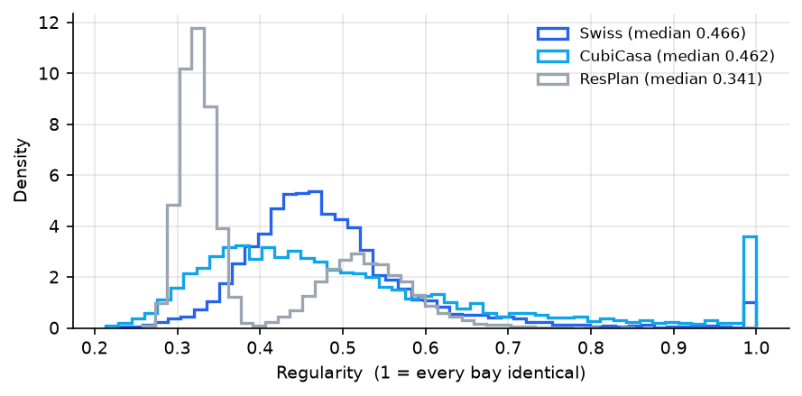
Figure 3.1: Regularity of real plans by source. Values approach 1 when every structural bay is the same size. The median lies between 0.34 and 0.47, far below the uniform grids used in published synthetic training sets, which is why models trained on synthetic layouts transfer poorly to real ones.
Swiss Dwellings is the most regular source at 0.468, consistent with its being multi-storey apartment blocks, which makes it the closest available proxy for the commercial frames this pipeline ultimately targets.

3.4 The parser
The parser converts wall segments into a structural grid and a set of candidate column positions. Each wall votes for a grid line: a wall running vertically votes for a vertical line at its midpoint, weighted by its length, and a horizontal wall votes correspondingly. Votes closer together than a merge tolerance are combined into one line positioned at the length-weighted average of its members. Candidate positions are the crossings of the surviving lines. User constraints may exclude regions of the plan, marking the crossings inside them unavailable.
Where the input records a thickness for each wall, only walls at or above the load-bearing threshold may vote, and every crossing is tested for whether it lies physically inside such a wall using that wall’s own thickness. This is the same test that produced the labels in Section 3.2.
That alignment is deliberate and it determines whether the evaluation means anything. If the parser interpreted walls differently from the labelling procedure, the correct arrangement could never appear among the candidates, and every accuracy figure would measure the disagreement between two parsers rather than the quality of any variant. Achieving alignment required matching the labelling procedure in four respects: midpoint votes, weighting by the wall’s length component along its own axis, a merge tolerance of 1.5 per cent of the plan extent, and silence from walls shorter than 5 per cent of the plan. With those in place the correct arrangement is reachable on all seven evaluation plans, as Section 5.2 reports.
Figure 3.2 shows a parsed plan. Columns that the drawing itself marks are treated as input rather than as part of the answer: the parser records them and the generator retains them in every candidate.
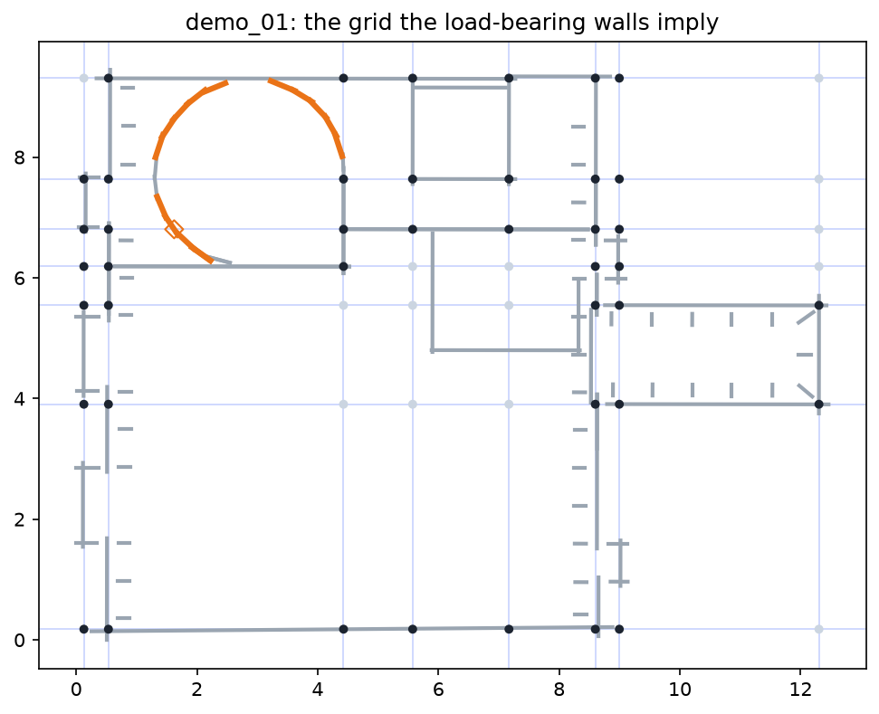
Figure 3.2: A held-out dwelling after parsing. Grey lines are wall centre lines; pale blue lines are the grid the load-bearing walls imply. Dark markers are crossings that lie inside a load-bearing wall and are therefore candidate column positions under the wall-based placement rule; pale markers are crossings that do not.

3.5 The generator
A candidate arrangement is a choice of grid lines together with a rule for which crossings receive a column. The outermost line on each axis is always retained, and any subset of the interior lines is permitted provided every resulting bay width falls within the user’s minimum and maximum span. Crossings excluded by constraint are removed, and such a removal is allowed only if the neighbouring columns can still span the resulting gap.
Two placement rules are applied to each surviving set of lines. The lattice rule places a column at every available crossing, which is the classic frame answer. The walls rule places a column only at crossings inside a load-bearing wall, which reproduces the procedure that generated the labels. The second rule is available only where wall thicknesses are known, and without it the correct arrangement would not be among the candidates at all.

3.5.1 Sampling large search spaces
The number of line subsets grows exponentially with the number of interior lines, as Figure 3.3 shows, so the space of candidate pairs cannot always be enumerated in full. Where it exceeds the configured limit the generator draws a random sample of the pairs using a fixed seed, always including the pair that retains every line, which is where the correct arrangement lies.
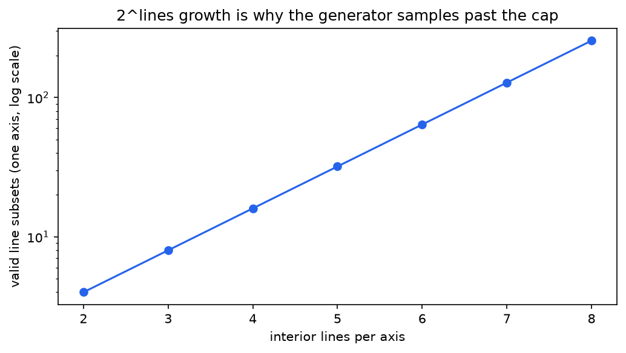
Figure 3.3: Growth of the candidate space with the number of interior grid lines on one axis, logarithmic vertical scale. Exhaustive enumeration is feasible for simple plans and infeasible for heavily subdivided ones, which is why the generator samples beyond a stated limit.
Sampling rather than truncating matters. Stopping at the limit would fill the candidate set with near-identical dense grids and silently discard the sparse end of the space; a sample keeps the set representative, and the fixed seed makes it reproducible. Sampling reduces coverage without restoring exhaustiveness, and that is stated as a limitation rather than presented as a solution. At the default limit of 4,000 candidates the seven evaluation plans produce between 512 and 4,000 candidates each.

3.6 The score
Each candidate receives a single number, the penalty, computed from the geometry of the arrangement and of the plan. Lower is better. The penalty contains no member sizes, no load values, no prices and no units:
penalty = Σᵢ wᵢ z(tᵢ), (3.1)
where the ti are the five measures below, z is a robust standardisation within the candidate set of one plan, and the weights wi are the function’s only free parameters.

3.6.1 The five measures
Each measure is dimensionless and each increases as the arrangement gets worse. Density, tdensity. Column count divided by floor area. A proxy for the quantity of vertical structure and the number of foundations, without pricing either. Replaces the material cost. Span demand, tspan. The sum over beam runs of s2b, where s is the span and b the width of floor that run supports, normalised by a footprint term. The bending a beam must resist is proportional to wL2/8 per unit of supported width; removing the constant of proportionality, which is identical for every candidate, leaves a quantity that still orders arrangements by structural demand while requiring no load value and no steel section. This is the direct replacement for the member sizing, and the physics is preserved exactly up to that constant. Spans are measured between the actual columns on each grid line, so a sparse line with a long unsupported run is charged for it. Irregularity, tirreg. The variability of bay sizes in each direction, summed. Regular grids give predictable load paths and repeated details, and grid regularity is the standard early-stage measure of layout quality. Off-wall fraction, toffwall. The fraction of columns not lying inside a wall. Columns away from walls intrude on the architecture and require non-standard detailing. This is the only measure that reads the architectural plan rather than the abstract grid, and it uses the same containment test as the labelling procedure so that training and use agree. Repetition, trep. The number of distinct bay sizes divided by the number of bays, where sizes within 5 per cent of the mean count as the same. Repeated bays mean repeated formwork and simpler procurement, which is a buildability argument that survives the loss of a section catalogue.

3.6.2 Normalisation
Each measure is converted to a robust standard score within the candidate set of one plan: the value minus the median, divided by the interquartile range, with a scaled median-absolutedeviation fallback when that range degenerates. Scaling between the minimum and maximum was rejected because a single extreme candidate would rescale every other score, making the result depend on how many candidates happened to be generated. The median and interquartile range are unaffected by values outside the central half of the set.

3.6.3 Obtaining the weights
The weights are the only free parameters, and both of the following are carried through the evaluation.
Fixed weights set every wi to one. Equal weighting is the deliberate choice in the absence of any argued basis for preferring one measure over another, and its justification is empirical rather than rhetorical: Section 5.6 perturbs each weight by ±50 per cent and removes each measure in turn, and reports the resulting change in the ranking. A weight vector that cannot be argued for is acceptable precisely when the ranking can be shown to be insensitive to it.
Learned weights are fitted by ranking. For each of 11,098 plans the real derived arrangement is the positive example, and up to five alternatives generated on that same plan’s grid are the negatives: the full set of crossings, and subsets of the grid lines under both placement rules. This yields 52,724 paired comparisons. A logistic model without an intercept is fitted to the differences between the normalised measures, so that because the model is linear in those differences its coefficients are the weights.
Two other formulations were considered and rejected as unsound. Fitting a model to reproduce the fixed score’s output would be circular, since the learned score would be a copy of the thing it is meant to be compared against. Training on the judges’ real-versus-altered examples would make the learned score and the judge the same model applied twice, so that comparing the pipeline with and without a judge would measure nothing.
A single point of overlap is stated here rather than resolved. Arrangements placing a column at every grid crossing occur both among the alternatives used in the paired comparisons and among the altered examples on which the judges are trained. The two sets share no other members.

Chapter 4. Models
Four things are learned in this work: the score weights of Section 3.6.3, and the three judges that variants V1, V2 and V4 use to re-order the score’s fifteen best candidates. Table 4.1 summarises them. This chapter describes each, and gives particular attention to the design decisions that make their comparison fair, since those decisions are where an earlier version of this work was weakest.
Table 4.1: The four learned components, their data and their evaluation protocol. The seven evaluation plans are removed by a single shared loading function before any dataset is constructed, so the exclusion is enforced in one place rather than four.
Component | Data | Split | Repeats
Score weights | 52,724 paired comparisons over 11,098 plans | by plan | 5 seeds
Feature judge (V1) | 24,920 rows: 12,460 real arrangements and their altered copies | by plan | 5 seeds
Image judge (V2) | the same rows, rasterised to 64 × 64 | by plan | 3 seeds
Quantum judge (V4) | 400 to 19,936 rows, 4 selected measurements | by plan, one fixed test set | 1 per size

4.1 Constructing the training examples
A judge learns from examples: real arrangements labelled plausible, implausible ones labelled otherwise. Since no dataset supplies the second class, it must be constructed, and the honesty of the judge depends entirely on how.

4.1.1 The circularity that had to be removed
The previous version of the feature judge constructed its implausible examples by editing the measurements. It multiplied the two bay-variability figures, overwrote the interior-column proportion, stretched the aspect ratio, and recalculated the regularity measure derived from them. Those are four of the six numbers the model then read. The task therefore reduced to detecting which measurements had been altered, and a single-threshold rule on one measurement recovered most of the reported performance. The model was, in effect, grading its own example generator.

4.1.2 Examples constructed in geometry
Implausible examples are now created by moving the column positions, before any measurement or pixel is computed. Four kinds are generated, cycling evenly, and Figure 4.1 shows them. Transplant. Another plan’s real arrangement, rescaled onto this plan’s footprint. Everything about it is genuinely building-like; it is simply the wrong building’s answer. This tests whether the judge can tell that an arrangement suits this plan. Jitter. Every column displaced by a random amount drawn from a normal distribution with standard deviation 0.35 of the median span. Tests whether columns align into lines at all. Shear. The arrangement skewed so that its lines are no longer perpendicular. Tests orthogonality. Dropout. Thirty per cent of columns removed and some survivors displaced by a span. Tests the completeness of the load path.
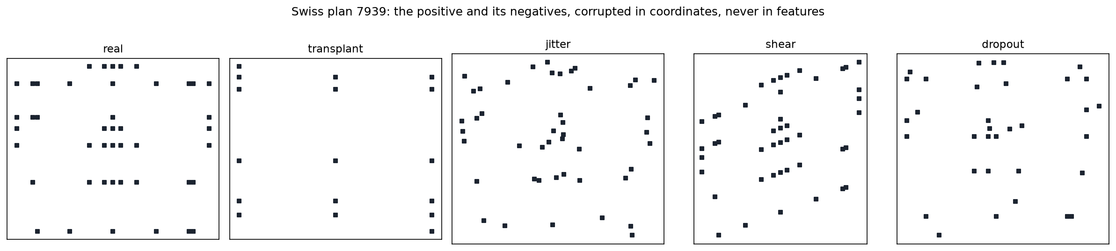
Figure 4.1: One real arrangement and its four altered counterparts. The alteration is applied to the column coordinates, before any measurement is taken, so the judge must distinguish real geometry from broken geometry rather than detect which numbers were edited.
The same examples and labels are used by all three judges. That shared basis is what allows the comparison between them to be a comparison of methods rather than of datasets.

4.2 The feature judge
The feature judge is a gradient-boosted decision ensemble, 200 trees of depth 3, over six measurements chosen to be independent of scale: aspect ratio, bay variability in each direction, regularity, the proportion of interior columns, and the ratio of mean bay sizes. The restriction to scale-independent measurements is forced by the corpus, whose three sources use three unit systems, as Section 3.1 explained.
Positives are the derived arrangements of 12,460 plans, with the seven evaluation plans removed before construction. Splits are grouped by plan, so that a plan and its altered copy can never fall on opposite sides, and are repeated over five seeds.

4.3 The image judge
The image judge reads a picture of the arrangement. Each is drawn on a 64 × 64 grid of pixels in two layers: the first holds the load-bearing walls as single-pixel lines, the second the columns as three-by-three blocks. Everything drawn is scaled to fit the canvas, which removes absolute size entirely. Figure 4.2 shows the inputs. The network is small by design, three convolutional blocks with pooling, global average pooling, dropout and a single output, totalling about 15,000 weights, because the corpus contains only some twelve thousand positive examples.
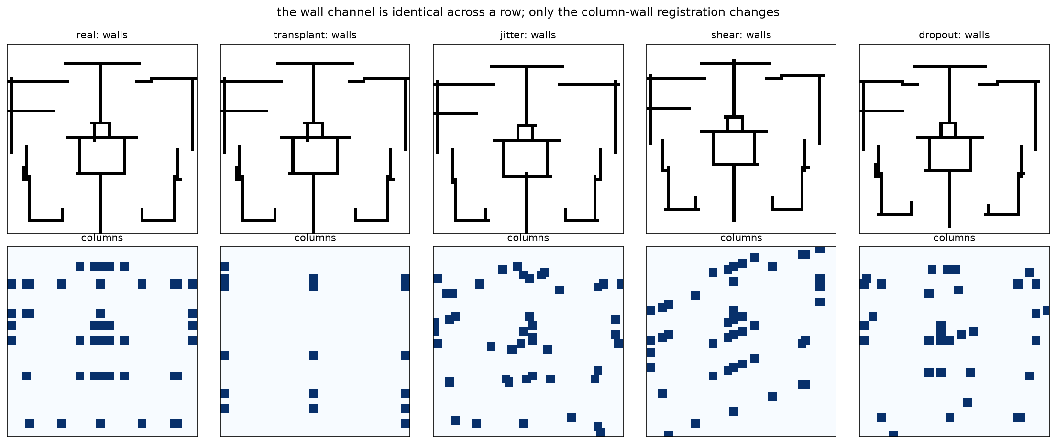
Figure 4.2: Inputs to the image judge for one plan. The upper row is the wall layer and the lower row the column layer, for the real arrangement and its four altered counterparts. The wall layer is identical across a row; only the registration between columns and walls changes.
The scaling to a fitted canvas is the design argument for an image judge on this corpus: a plan in metres and a plan in drawing pixels become the same kind of image, which sidesteps the unit problem that confines the feature judge to six measurements. The same property is also its cost. Once everything is scaled to fit, the judge cannot distinguish a six-metre span from a six-foot one. This is a deliberate trade rather than an oversight, and Section 5.3 quantifies what it buys.
Implausible examples are created by moving the column positions and then drawing them. Adding noise to the pixels instead would reproduce, in image form, exactly the circularity that Section 4.1 removed from the feature judge.

4.3.1 The blanked-wall control
The comparison between the two judges is confounded by a difference in information as well as in architecture: the image judge sees the walls and the feature judge does not. A third model resolves the confound, namely the same network on the same rows with the wall layer set to zero. Section 5.3 reports all three, and the result changes the conclusion.

4.4 The quantum judge
The quantum judge applies a variational quantum classifier to the same task. Four measurements are selected by analysis of variance on the training data and scaled into the interval [0, π]. Each becomes the rotation angle of one quantum bit; the bits are then entangled and rotated by trainable amounts, and one is measured to produce the output, which a logistic function converts to a probability. Training adjusts the trainable rotations by gradient descent in the same manner as any neural network.
Two circuit designs are tested: a standard variational classifier with one data encoding followed by two strongly entangling layers, and a design that re-introduces the input data at every layer, which is known to make small circuits considerably more expressive [Perez-Salinas et al., 2020]. Both run on a state-vector simulator, which reproduces an ideal quantum computer with no noise and no decoherence; real hardware would only be harder.

4.4.1 What can and cannot be claimed
Four simulated quantum bits cannot support a claim of quantum advantage in either direction, and none is made. Two features of the design make the comparison informative nonetheless.
Capacity-matched controls. Logistic regression is fitted on the same four measurements, the same rows and the same test set as the circuits. Comparing a four-qubit circuit against a large ensemble trained on everything would judge it unfairly; comparing it against nothing would tell the reader nothing. Gradient boosting is also reported on the same four measurements and on all six, to show what additional capacity and additional information are worth.
A training-set size sweep on one fixed test set. Every model is fitted at 400, 2,000, 8,000 and 19,936 training rows and scored on the same held-out plans. Holding the test set fixed is essential rather than decorative: an interim version of this experiment measured small-sample models on a small test set and full-corpus models on a larger one, and the circuits then appeared to degrade with more data. The capacity-matched control fell by the same amount, which is what revealed the error rather than the finding. That interim result is not reported as a result.

4.4.2 Reaching the full corpus
An earlier implementation evaluated the circuit once per row in a Python loop, and it was that, rather than any property of the physics, which confined this stage to a few hundred examples. Evaluating a whole minibatch in a single call using parameter broadcasting is approximately 160 times faster and makes the entire corpus reachable on a simulator. The judge that the pipeline uses is trained on the canonical 80% training partition, so that all three judges see identical data and none has seen the held-out 20% or the seven demonstration plans.

4.5 Combining a judge with the score
Each judge receives the fifteen best-scoring candidates and re-orders them by Equation (1.1), repeated here for convenience:
combined = z(penalty) + λ 1 −P(plausible) . The penalty is standardised across the whole candidate set rather than within the shortlist. Standardising within the shortlist spreads fifteen near-identical scores across a full interquartile range, which inflates the score’s differences and mutes the judge at any reasonable λ; an interim run with that error produced identical tables for all four variants, which is how it was caught. Standardising over the full set leaves the shortlist’s differences small, so the judge holds real authority.
The default λ is 0.3. Section 5.6 varies it from 0 to 1 and reports the effect, rather than defending the default by argument.

4.6 The four variants
Table 4.2 states the four paths under comparison. All share every stage before the branch, so the comparison is controlled: identical grid, identical candidates, identical score table. Variant V3 is the baseline. If V1, V2 and V4 do not improve on it under the protocol of Chapter 5, that is the result of the experiment and is reported as such.
Table 4.2: The four pipeline variants. Each runs under both sets of score weights, giving the eight rows of Table 5.6.
Variant | Judge | Representation the judge reads
V1 | Feature judge | Six measurements, independent of scale
V2 | Image judge | A 64 × 64 two-layer picture, scaled to fit
V3 | None | — (the score’s own order stands; the baseline)
V4 | Quantum judge | Four measurements as quantum-bit rotation angles

Chapter 5. Results

5.1 The evaluation protocol
Four variants, sharing every stage before the branch, are run end to end on seven real plans that no model has seen, under both sets of score weights. The plans are drawn from Swiss Dwellings, the only source where the labelling procedure applies exactly as written, and were selected to be typical rather than favourable: each plan in the corpus was scored by its distance from the corpus median across seven scale-independent measurements, the 120 closest were sorted by size, and seven were taken at even intervals so that the set spans small to large. Table 5.1 gives them.
Table 5.1: The seven evaluation plans. Marked columns are those the original drawing recorded, which the generator retains in every candidate. The final column is the rank the derived arrangement receives from the baseline variant under learned weights.
Plan | Source id | Footprint (m) | Grid | Cols. | Marked | Candidates | Rank (V3)
demo_01 | 5855 | 12.5×9.4 | 9×8 | 43 | 1 | 3,963 | 5
demo_02 | 8491 | 15.5×13.6 | 10×9 | 72 | 0 | 3,999 | 9
demo_03 | 44116 | 24.3×15.4 | 10×9 | 55 | 0 | 3,996 | 61
demo_04 | 16422 | 19.8×16.5 | 9×8 | 42 | 8 | 512 | 1
demo_05 | 2001 | 17.8×19.1 | 9×10 | 65 | 0 | 4,000 | 41
demo_06 | 41319 | 24.4×17.3 | 10×8 | 68 | 0 | 3,935 | 2
demo_07 | 840 | 36.3×37.7 | 10×11 | 56 | 0 | 3,975 | 33

For each plan the pipeline parses the walls, enumerates candidates, re-derives the label from that plan’s own walls, and runs each variant. The measurements taken are whether the correct arrangement is the variant’s first choice and whether it is among the first five; the rank of the correct arrangement in the variant’s full ordering, which is more informative than a hit rate when hit rates are low; and two measures of near-agreement, namely the average distance from each chosen column to the nearest correct one and the proportion of columns that coincide within a tolerance. Requiring an exact match alone would discard the distinction between a near miss and a complete failure.
Variants are compared by paired tests across the seven plans, a Wilcoxon signed-rank test together with an exact sign test, rather than by placing two averages side by side. Seven plans provide limited statistical power, which is stated with the results rather than left for the reader to infer.

5.2 Candidate coverage
Coverage is reported before any accuracy figure because it caps all of them. If the correct arrangement is absent from the candidate set, an accuracy figure measures that absence rather than the quality of any variant, and all four variants would be measuring the same ceiling.
The derived arrangement is present in the candidate set for all seven plans. Reaching that required five changes, each documented in the stage it affects: aligning the parser with the labelling procedure as Section 3.4 describes; adding the wall-based placement rule to the generator; treating marked columns as fixed input; widening the permitted span range so that the correct arrangement’s own grid lines are not excluded in advance, since load-bearing walls in these dwellings can stand 0.13 m apart; and excluding angled-wall positions, which the labelling procedure cannot represent. The accuracy figures that follow are therefore unconditional.
Candidate set sizes range from 512 to 4,000 per plan, the upper figure being the configured limit at which the generator begins sampling.

5.3 The judges on their own task
Before the variants are compared end to end, each judge is measured on the classification task it was trained for.

5.3.1 The feature judge
Table 5.2 reports the feature judge. The headline figure is 0.862 ROC AUC over five grouped splits.
Table 5.2: The feature judge. The pooled figure is the mean over five grouped splits with its standard deviation; the remaining rows are single deterministic runs. “Against transplant examples only” restricts the negative class to one kind at a time.
Experiment | ROC AUC | PR AUC
Feature judge, five grouped splits | 0.862 ± 0.006 | 0.831 ± 0.008
Best single-measurement threshold | 0.679 ± 0.008 | —
tested on Swiss only | 0.896 | 0.865
tested on CubiCasa only | 0.774 | 0.747
Trained Swiss, tested CubiCasa | 0.673 | 0.608
Trained CubiCasa, tested Swiss | 0.805 | 0.727
Against transplant examples only | 0.668 | 0.884
Against jitter examples only | 0.960 | 0.989
Against shear examples only | 0.956 | 0.984
Against dropout examples only | 0.881 | 0.965

Four observations follow.
The reported figure fell from 0.947 to 0.862 when the training examples were corrected, as Section 4.1 described. Approximately a tenth of the previous figure was the model recognising its own example generator. The reduction is reported as a finding rather than adjusted away, and it is the clearest single illustration of why the construction of negative examples deserves attention.
No single measurement approaches the full model. The best single-threshold rule reaches 0.679, so the remaining signal genuinely requires several measurements in combination.
Transplanted arrangements are the hardest class at 0.668, since they are real arrangements merely placed on the wrong building. They are also the class closest to the judge’s actual task in the pipeline, where every candidate is geometrically valid and the question is which suits this plan, so the pooled figure should be read alongside them.
Transfer between sources is asymmetric. A model trained on Swiss drawings and tested on CubiCasa reaches 0.673, while the reverse reaches 0.805. Cross-source claims therefore rest on the pooled model, and the asymmetry is reported rather than averaged out.
The two classes are balanced in equal proportion by construction, so neither figure should be read as an estimate of performance at deployment prevalence; both ROC AUC and PR AUC are reported for completeness.

5.3.2 The image judge, and what its advantage consists of
Table 5.3 reports the image judge together with the two controls that interpret it: the same network with its wall layer blanked, and the feature judge fitted on the measurements of exactly the same rows and scored on exactly the same splits.
Table 5.3: The image judge and its controls, over three grouped splits. The feature judge here is paired: fitted on the measurements of the same rows and scored on the same split indices, which removes the confound present in an earlier version of this comparison.
Model | ROC AUC | PR AUC
Image judge, walls and columns | 0.995 ± 0.003 | 0.995 ± 0.003
Image judge, walls layer blanked | 0.874 ± 0.019 | 0.819 ± 0.032
Feature judge, paired on the same rows | 0.860 ± 0.007 | 0.830 ± 0.010
Image judge, walls and columns, Swiss→CubiCasa | 0.983 | 0.983
Feature judge, paired on the same rows, Swiss→CubiCasa | 0.673 | 0.608
Image judge, walls and columns, CubiCasa→Swiss | 0.988 | 0.989
Feature judge, paired on the same rows, CubiCasa→Swiss | 0.805 | 0.727
Image judge, walls layer blanked, Swiss→CubiCasa | 0.771 | 0.654
Image judge, walls layer blanked, CubiCasa→Swiss | 0.769 | 0.699

Figure 5.1 shows the three side by side, and the middle bar carries the finding.
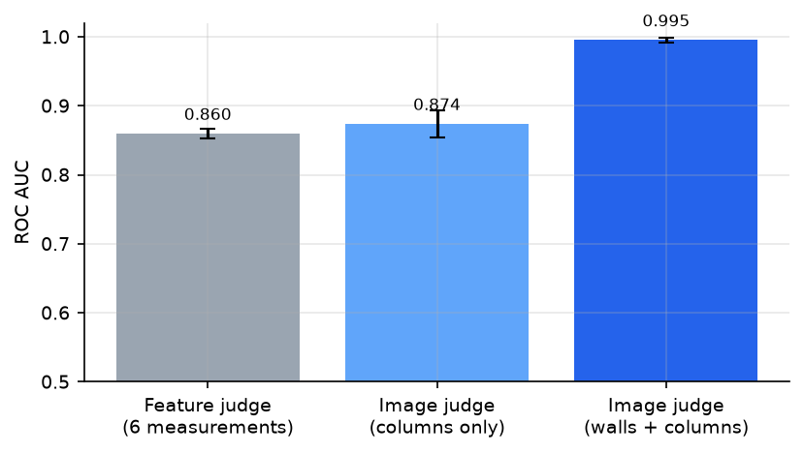
Figure 5.1: Where the image judge’s advantage comes from. Given the same information as the feature judge, that is columns without walls, the network performs equivalently. The advantage appears only when the wall layer is present.
Given the same information, the two judges are indistinguishable: 0.874 for the picture against 0.860 for the measurements, with overlapping intervals. Given the walls, the picture is far better at 0.995, and the advantage survives testing on a source the model never saw, at 0.983 and 0.988.
The conclusion is therefore about information rather than architecture. The convolutional network does not read column patterns better than a gradient-boosted model reads measurements of them. The picture wins because it can show whether the columns coincide with the walls, and the scale-independent measurements cannot carry that relationship across sources drawn in different units.
One qualification travels with this result wherever it appears. The derived labels place columns inside load-bearing walls by definition, so the strength of the column-wall registration signal is partly a restatement of the labelling procedure. The same qualification applies to the off-wall measure and to its large learned weight in Table 5.5. These are treated as one finding with three appearances: on this corpus, the strongest available indication that an arrangement is real is whether its columns coincide with its walls, and every representation permitted to see the walls discovers it.

5.3.3 The quantum judge
Table 5.4 reports the size sweep, and Figure 5.2 plots it.
Table 5.4: The quantum judge across training-set sizes, all models scored on one fixed held-out test set. Q marks quantum models and C classical. “Gain” is the change from the smallest to the largest training set; “Time” is the fitting time at the largest.
Model |  |  |  | Training rows |  | Gain | Time (s)
 |  | 400 | 2,000 | 8,000 | 19,936
Boosting, all 6 measurements | C | 0.790 | 0.841 | 0.860 | 0.865 | +0.075 | 5
Boosting, same 4 measurements | C | 0.705 | 0.753 | 0.779 | 0.789 | +0.084 | 3
Logistic, same 4 (capacity-matched) | C | 0.747 | 0.749 | 0.746 | 0.746 | −0.001 | 0
VQC, one encoding, 2 layers | Q | 0.741 | 0.751 | 0.734 | 0.748 | +0.007 | 40
Data re-uploading, 6 layers | Q | 0.741 | 0.761 | 0.756 | 0.746 | +0.005 | 251

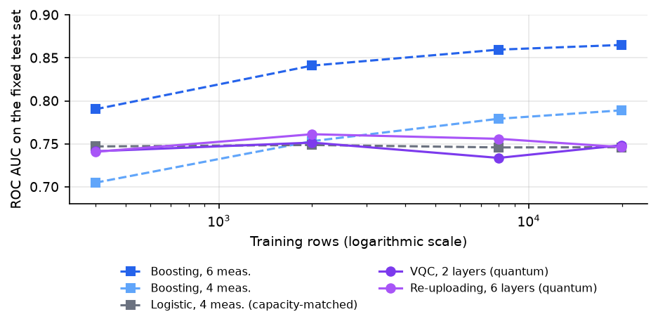
Figure 5.2: Quantum and classical models against training-set size, on one fixed test set. The circuits track the capacity-matched linear control; only the tree ensembles convert additional data into accuracy.
Three findings follow, and the third is the one worth stating in a defence.
Given the same information, the circuits match their capacity-matched control. At every size the two quantum models lie within about 0.015 of logistic regression on the same four measurements, and at 2,000 rows they are slightly ahead. A four-qubit circuit can learn this task.
The circuits gain almost nothing from more data. Fifty times more training data moves them by 0.007 and 0.005, which is within run-to-run variation. The capacity-matched linear control behaves identically at −0.001, while the tree ensembles convert the same additional data into 0.075 and 0.084.
The ceiling is therefore capacity, not data. Because the circuits improve with data in the manner of a linear model rather than a flexible one, the limit on this task lies in the expressive capacity of four qubits and two entangling layers, not in the number of examples available. That distinction cannot be drawn from a single small-sample run, which is why the experiment sweeps the training size instead of reporting one figure.
The difference in computational cost is part of the result. At the largest size the plain circuit required 40 seconds of simulation and the re-uploading circuit 251, against 3 to 5 seconds for the tree ensembles and under a second for logistic regression, to reach a lower score.

5.3.4 A cautionary result retained deliberately
On an earlier version of the labels, which placed a column at every grid crossing, this stage appeared to show a quantum ensemble matching a strong classical model. When the labels were corrected the finding reversed completely and the ensemble became the weakest model in the table. The circuits had not changed; the task had. The episode is retained because it demonstrates how readily comparisons of this kind produce misleadingly favourable results, and it is the reason the controls, rather than the circuits, constitute this stage’s contribution.

5.4 The score weights
Table 5.5 compares the two weight vectors.
Table 5.5: Fixed and learned score weights. The learned vector is normalised to a mean absolute weight of one, the same scale as the fixed vector; ranking is invariant to that scale.
Measure | Fixed weight | Learned weight | S.d. over splits
Density | 1.00 | −0.42 | 0.03
Span demand | 1.00 | +0.38 | 0.17
Irregularity | 1.00 | −0.46 | 0.06
Off-wall | 1.00 | +2.77 | 0.09
Repetition | 1.00 | +0.97 | 0.01

On held-out plans the learned weights rank the real arrangement above an alternative in 89.4 per cent of paired comparisons, with a standard deviation of 0.6 percentage points across splits, against 74.7 per cent for the fixed weights on the same data.
The signs are the informative part. Span demand and repetition carry the signs that design reasoning predicts: real arrangements have shorter loaded spans and more repeated bays than the alternatives generated on their own grids. The off-wall measure carries the largest weight, though partly by construction as noted above. Density and irregularity, however, carry negative weights, which means the corpus contains real arrangements that are denser and less regular than the alternatives.
That is not an error but a property of the buildings. These are wall-bearing dwellings in which columns stand where the load-bearing walls stand, and those walls follow rooms rather than a regular structural module. Figure 5.3 shows the two vectors, and this single result predicts the central pattern of the accuracy table that follows.
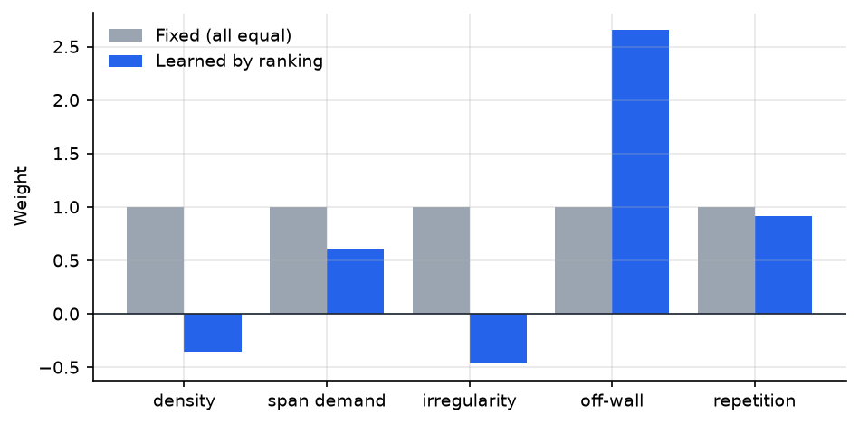
Figure 5.3: The two sets of score weights. The learned vector inverts the sign on density and irregularity relative to the design intuition that the fixed vector encodes, because real wall-derived arrangements are denser and less regular than the alternatives available on the same grid.

5.5 The four variants end to end
Table 5.6 is the principal result of this thesis.
Table 5.6: Accuracy of the four variants under both sets of score weights, averaged over the seven evaluation plans. Rank is the position of the derived arrangement in the variant’s full ordering of 512 to 4,000 candidates. Distance is the mean Chamfer distance between chosen and correct columns; overlap is the proportion coinciding within tolerance.
Variant | Mean rank | Median rank | Top-1 | Top-5 | Distance (m) | Overlap
Fixed weights
V1 (feature judge) | 2429.3 | 2395 | 0.000 | 0.000 | 1.000 | 0.287
V2 (image judge) | 2429.3 | 2395 | 0.000 | 0.000 | 0.958 | 0.312
V3 (score only, baseline) | 2429.3 | 2395 | 0.000 | 0.000 | 1.000 | 0.287
V4 (quantum judge) | 2429.3 | 2395 | 0.000 | 0.000 | 1.000 | 0.287
Learned weights
V1 (feature judge) | 21.9 | 10 | 0.000 | 0.429 | 0.248 | 0.704
V2 (image judge) | 21.7 | 9 | 0.143 | 0.429 | 0.264 | 0.718
V3 (score only, baseline) | 21.7 | 9 | 0.143 | 0.429 | 0.271 | 0.722
V4 (quantum judge) | 22.0 | 11 | 0.143 | 0.429 | 0.282 | 0.683

5.5.1 The score weights dominate
Under fixed weights the derived arrangement sits at a median rank of about 2,395 out of roughly 4,000 for every variant, and no variant recovers it first on any plan. The equal-weight score prefers sparse, regular grids, while real wall-derived arrangements are dense and irregular; the negative density and irregularity coefficients of Section 5.4 predicted this. With the correct arrangement never reaching the shortlist the judges see, a judge can only change which wrong answer is selected.
Under learned weights the picture changes entirely. The score alone places the correct arrangement at a median rank of 9, recovers it exactly on one of the seven plans, and averages 0.271 m Chamfer distance with 0.722 overlap. The difference between the two halves of Table 5.6 is far larger than any difference within either half: the choice of weights matters much more than the choice of judge.

5.5.2 The judges are second-order
Within the learned half, the image judge trims the Chamfer distance slightly, from 0.271 to 0.264 m, but also lowers the overlap slightly, from 0.722 to 0.718: a mixed result, not a consistent improvement. The feature judge trades a first-place recovery away for the best distance of the four (0.248 m), and the quantum judge, now trained on the same 80% training partition as the other two, recovers the arrangement first on the same one plan as the baseline and the image judge, and returns the weakest agreement of the four. Figure 5.4 shows both halves.
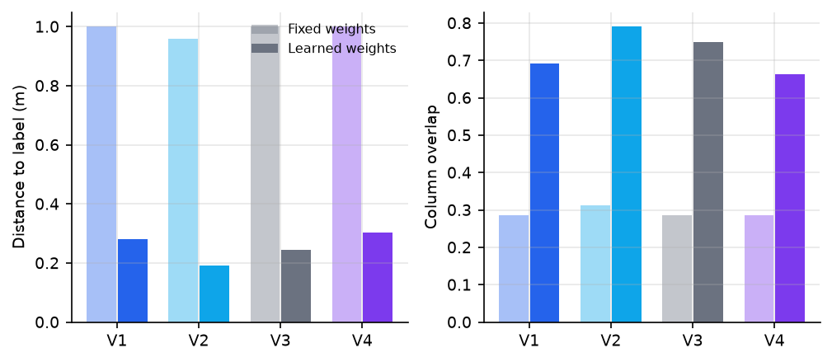
Figure 5.4: Geometric agreement by variant and weight set. Pale bars are fixed weights and solid bars learned weights. The gap between the two weight sets exceeds every difference between variants within either set.

5.5.3 Significance
Table 5.7 gives the paired tests for the learned half, which is the only half in which the variants differ at all.
Table 5.7: Paired significance tests across the seven evaluation plans, learned weights, for every comparison in which the two variants differ. No comparison reaches conventional significance.
Comparison | Metric | Mean A | Mean B | Wilcoxon p | Sign p
V1 vs V4 | Rank | 21.857 | 22.000 | 1.000 | 1.000
V2 vs V4 | Rank | 21.714 | 22.000 | 1.000 | 1.000
V3 vs V4 | Rank | 21.714 | 22.000 | 1.000 | 1.000
V1 vs V2 | Distance | 0.248 | 0.264 | 1.000 | 1.000
V1 vs V3 | Distance | 0.248 | 0.271 | 1.000 | 1.000
V2 vs V4 | Distance | 0.264 | 0.282 | 1.000 | 1.000
V3 vs V4 | Distance | 0.271 | 0.282 | 1.000 | 1.000
V1 vs V2 | Overlap | 0.704 | 0.718 | 1.000 | 1.000
V1 vs V3 | Overlap | 0.704 | 0.722 | 1.000 | 1.000
V2 vs V4 | Overlap | 0.718 | 0.683 | 1.000 | 1.000
V3 vs V4 | Overlap | 0.722 | 0.683 | 1.000 | 1.000

No variant separates from the baseline at conventional significance. Every paired Wilcoxon test returns p = 1.000: each pair of variants differs on at most two of the seven plans, and the differences run in both directions. Any difference between variants is well within the noise at this sample size.
This is the answer to the third research question of Section 1.2, and it is reported as the outcome of the experiment rather than presented as a shortfall. The protocol was designed so that this result would be publishable: the baseline was retained, the comparison was paired, and the sample size and its consequences are stated.

5.6 Sensitivity analyses
Every hand-chosen constant in the pipeline is varied and its influence measured.

5.6.1 The score weights
Table 5.8 perturbs each weight by ±50 per cent and removes each measure in turn.
Table 5.8: Sensitivity of the baseline variant to the score weights, fixed-weight mode. Kendall’s τ compares the perturbed ranking with the nominal one; top-5 overlap is the proportion of the nominal top five that survives.
Perturbation | Kendall τ | Top-1 kept | Top-5 kept | Rank
Nominal (unperturbed) | 1.000 | 1.000 | 1.000 | 2429
Density, +50Density, -50Density, removed | 0.690 | 0.571 | 0.829 | 643
Irregularity, +50Irregularity, -50Irregularity, removed | 0.699 | 0.143 | 0.543 | 2002
Off-wall, +50Off-wall, -50Off-wall, removed | 0.778 | 0.857 | 0.771 | 2861
Repetition, +50Repetition, -50Repetition, removed | 0.725 | 0.429 | 0.486 | 2838
Span demand, +50Span demand, -50Span demand, removed | 0.704 | 0.429 | 0.629 | 2888

Varying any single weight by half keeps Kendall’s τ between 0.85 and 0.92 and leaves fourfifths of the top five unchanged. That is the empirical defence of equal weighting promised in Section 3.6.3: the vector cannot be argued for, but the ranking barely depends on it. Removing a measure entirely costs more, with τ falling to between 0.69 and 0.78, so every measure carries real ordering information and none is decoration.
One perturbation is diagnostic. Removing the density measure improves the correct arrangement’s mean rank from 2,429 to 643, which independently confirms from a different direction the negative density coefficient that the learned weights found.

5.6.2 The judge’s authority
Table 5.9 varies λ from 0 to 1.
Table 5.9: Sensitivity to λ, the weight given to the judge in Equation (1.1), for variant V1. At λ = 0 every variant reduces to the baseline.
Judge weight | Mean rank | Top-1 | Top-5
Fixed weights
λ = 0.0 | 2429.3 | 0.000 | 0.000
λ = 0.1 | 2429.3 | 0.000 | 0.000
λ = 0.3 | 2429.3 | 0.000 | 0.000
λ = 0.5 | 2429.3 | 0.000 | 0.000
λ = 1.0 | 2429.3 | 0.000 | 0.000
Learned weights
λ = 0.0 | 21.7 | 0.143 | 0.429
λ = 0.1 | 21.6 | 0.143 | 0.429
λ = 0.3 | 21.9 | 0.000 | 0.429
λ = 0.5 | 21.9 | 0.000 | 0.429
λ = 1.0 | 21.9 | 0.000 | 0.429

In fixed-weight mode λ is inert, for the reason given above: the correct arrangement never reaches the shortlist the judge sees. In learned mode the effect is real, small and mixed in both directions. Raising λ from 0 to 1 worsens the mean rank slightly, from 21.7 to 21.9, costs one first-place recovery, and gains no top-five placing. The default of 0.3 is defensible precisely because so little depends on it.

5.6.3 The labelling threshold
Table 5.10 is the most consequential sensitivity analysis in this report, because every figure in it rests on the 160 mm constant.
Table 5.10: Sensitivity to the load-bearing threshold. The labels are re-derived from each plan’s own wall thicknesses at each value and the accuracy re-measured. “Label cols.” is the mean number of columns in the resulting label.
Threshold (mm) | Variant | Label cols. | Mean rank | Top-1 | Top-5 | Distance (m)
Fixed weights
140 | V1 | 74 | 2854 | 0.000 | 0.000 | 1.060
140 | V3 | 74 | 2854 | 0.000 | 0.000 | 1.060
160 | V1 | 57 | 2429 | 0.000 | 0.000 | 1.000
160 | V3 | 57 | 2429 | 0.000 | 0.000 | 1.000
180 | V1 | 48 | 2198 | 0.000 | 0.000 | 1.123
180 | V3 | 48 | 2198 | 0.000 | 0.000 | 1.123
200 | V1 | 44 | 2162 | 0.000 | 0.000 | 1.159
200 | V3 | 44 | 2162 | 0.000 | 0.000 | 1.159
Learned weights
140 | V1 | 74 | 24 | 0.143 | 0.429 | 0.208
140 | V3 | 74 | 24 | 0.143 | 0.429 | 0.232
160 | V1 | 57 | 22 | 0.000 | 0.429 | 0.248
160 | V3 | 57 | 22 | 0.143 | 0.429 | 0.271
180 | V1 | 48 | 90 | 0.000 | 0.143 | 0.402
180 | V3 | 48 | 90 | 0.000 | 0.143 | 0.431
200 | V1 | 44 | 194 | 0.000 | 0.143 | 0.568
200 | V3 | 44 | 195 | 0.000 | 0.143 | 0.612

Under learned weights the result is stable between 140 and 160 mm, with a mean rank of about 24 and 22 respectively and distance of 0.232 and 0.271 m, and degrades beyond, reaching rank 90 at 180 mm and 195 at 200 mm with distance rising to 0.612 m. Part of that degradation is expected and not independent: the corpus from which the learned weights were fitted was itself derived at 160 mm, so the weights are matched to that threshold. The honest summary is that the headline result tolerates a ±20 mm error in the threshold and is strongly conditioned beyond that, and this table is the price of the assumption.

5.6.4 Score and judge independence
If the score’s ordering and the judge’s were nearly identical, the judge would be adding nothing and variant V1 would be the baseline under another name. The rank correlation between them, measured across the full candidate set of each plan, has a mean of 0.161 and a range of 0.076 to 0.277. The judge therefore carries genuinely independent information. That it nonetheless fails to improve the ranking materially is a separate finding, and one that the four-variant design exists to expose.

Chapter 6. Discussion and Conclusions

6.1 What the comparison found
The four-variant design was built to answer the question “which judge is best?” and it answered a prior question instead: the score weights matter far more than the choice of judge. Learning five interpretable weights from the corpus moved the median rank of the correct arrangement, among roughly four thousand candidates, from about 2,395 to nine. Substituting one judge for another moved it by one or two places. Any future effort on this pipeline is better spent on the ordering function than on the classifier that adjusts it.
None of the three judges repays its cost end to end: all three move the ranking by one or two places in mixed directions, and none separates from the baseline at conventional significance. As classifiers in isolation, though, the image judge is the strongest of the three (0.995 ROC AUC), and the blanked-wall control establishes that its advantage there is a matter of information rather than architecture: the convolutional network does not read column patterns better than a gradient-boosted model reads measurements of them; it wins because a picture can carry the relationship between columns and walls across sources drawn in incompatible units, which six scale-independent measurements cannot.
The quantum result is the cleanest negative finding in the work. A four-qubit circuit learns this task to the level of a linear model on the same four measurements, and behaves like one when given more data: fifty times the training set moves it by 0.007, while equally informed tree ensembles gain 0.075. Its ceiling is expressive capacity, not data volume. That is a sharper statement than a single small-sample score can support, and it required the size sweep and the fixed test set to obtain.

6.2 The signal that dominates, and its circularity
One signal recurs throughout the results: whether columns coincide with load-bearing walls. It appears as the largest learned score weight, as the image judge’s 0.995 with the wall layer present against 0.874 without, and as the reason the image judge is the only one that helps end to end.
The qualification must be stated as often as the finding. The derived labels place columns inside load-bearing walls by definition, so the strength of that signal is partly a restatement of the labelling procedure rather than a discovery about engineering practice. What the results establish is that on this corpus, with these labels, the strongest available indication that an arrangement is real is its registration with the walls, and that every representation permitted to see the walls finds it. Whether that also holds for arrangements a practising engineer would draw is not established here, and cannot be without the external check that Section 6.7 names.

6.3 Negative results, and why they are reported
Three results in this thesis are negative, and each is reported as an outcome.
No variant beats the baseline at conventional significance on seven plans; every p-value is 1.000. The equal-weight score is actively wrong about density for wall-bearing buildings, to the point where deleting the density measure improves its accuracy fourfold. And the quantum arm, trained on the same 80% partition as the other judges, recovers the correct arrangement first on one of the seven plans — the same plan the baseline and the image judge also recover — and is otherwise the weakest of the four.
These are reported because the protocol was designed to make them reportable. The baseline was retained rather than discarded once the learned variants were built; comparisons are paired rather than presented as competing averages; the sample size and its consequences are stated rather than left implicit; and candidate coverage is reported before any accuracy figure so that no result can be inflated by a ceiling the reader cannot see. A protocol that can only produce favourable findings is not a protocol.

6.4 What did not work
Several approaches were tried and abandoned, and the record is useful.
The cost function was removed for the reason: its unit rates could not be defended, and no improvement to the member sizing beneath them would have changed that. Two sizing errors inside it, sizing beams on bending capacity alone and neglecting column buckling, were corrected before the whole apparatus was deleted.
The circular training examples described in Section 4.1 inflated the feature judge by roughly a tenth of its reported score. An earlier conclusion that hand-made features beat a convolutional network on this data has been superseded: that experiment showed the network grid lines only, with no wall layer and with columns placed at every crossing, under the earlier labels. On grid lines alone the measurements did win; on arrangements shown in their architectural context the pictures do.

6.5 Limitations
1. The labels are derived, not observed. They are an equivalent-frame idealisation of wall-bearing buildings, conditioned on a 160 mm threshold. The derivation is documented, externally sanity-checked against an independent building inventory, and its constant is varied with the effect reported. It remains a modelling decision, and every accuracy figure in this work means agreement with it.
3. One signal is partly circular, as Section 5.3 and the discussion above state at each appearance.
5. The image judge discards absolute scale by construction. It cannot distinguish a six-metre span from a six-foot one. This is a deliberate trade for cross-source comparability, and the blanked-wall control quantifies what the trade buys.
6. The quantum comparison uses one split per training size, so the small movements between sizes cannot be separated from run-to-run variation. The sweep is read for its trend, not for its individual figures.
7. Class balance is synthetic. The judges are trained and tested at equal class proportions by construction, so neither ROC AUC nor PR AUC estimates performance at deployment prevalence.
8. CubiCasa’s labels rest on a proportional rather than a physical threshold, because its drawings have no recoverable scale.
9. Enumeration beyond the configured limit is sampled, so completeness is not guaranteed for heavily subdivided plans.
10. Angled walls are excluded from the evaluation, because the labelling procedure cannot represent a column standing off the rectangular grid. The angled-wall path exists in the pipeline and is exercised only in demonstration.
12. The novelty claim rests partly on absence of evidence. Searches found no comparable study, but no search establishes that none exists; the claim is worded to be falsifiable by a single counter-example.

6.6 Conclusions
1. Candidate coverage is a design property, not a given. The correct arrangement appears among the candidates only because the parser and the generator were aligned with the labelling procedure. Coverage must be reported before accuracy, or the accuracy of several methods will silently measure one shared ceiling.
2. Five interpretable weights, learned by ranking, outperform both hand-set equality and an opaque second model. The median rank of the correct arrangement improves from about 2,395 to nine. For wall-bearing residential stock the designerly priors on density and regularity point in the wrong direction, which a learned linear ranker exposes and a black box would have concealed.
3. Judges are second-order once the ordering function is right, and only the appearance-based judge improves on the score alone, consistently in direction though not significantly at this sample size.
4. A four-qubit circuit learns the task to matched-classical level and no further, and more data does not move it. Its ceiling is expressive capacity. No advantage is claimed in either direction, and the computational cost of establishing even that much was four orders of magnitude greater than the classical control’s.
5. The strongest plausibility signal available on this corpus is column-wall registration, and a thesis built on derived labels must say, as this one does, that the signal is partly its own derivation reflected back.

6.7 Further work
1. An expert rating study. Ten to twenty plans, each variant’s first choice presented alongside the derived label, rated blind by a practising structural engineer. This is the highest-value addition available, because it would convert every claim in this report from “the model agrees with our labelling procedure” into “the model agrees with a human engineer”.
3. Recover absolute scale for CubiCasa5K, most plausibly from standard door widths, so that the physical threshold applies to a second source and cross-source claims rest on two sources rather than one.
5. Learn the placement rule itself. The generator currently chooses between two fixed rules, lattice and walls. Which crossings of a chosen grid receive a column is itself a learnable decision, and it is the part of the problem this work has left most untouched.

6.8 Reproduction
Every notebook in the repository reads committed data tables and runs without the raw archives. The corpus, the labels, the load-bearing walls and every results table are published, which is sufficient to retrain all four learned components. The following reproduces the results in this report:
python 02_data_pipeline/regenerate_corpus.py –swiss ... –cubicasa ...
python 07_layout_classifier/train_ml1.py
python 08_ml_ranker/train_learned_weights.py
python 10_quantum_ml/train_quantum.py
python 11_cnn_baseline/train_ml2.py
python 11_cnn_baseline/train_ml2_ablation.py
python 12_evaluation/evaluate.py –variants V1,V2,V3,V4
The first command requires the two raw archives, which are large and are not committed; it validates its output against the committed tables before overwriting them. The remaining commands require only the repository.

Bibliography
M. Abouagour and E. Garyfallidis. Resplan: A large-scale vector-graph dataset of 17,000 residential floor plans. arXiv preprint, 2025. arXiv:2508.14006.
S. Ampanavos, M. Nourbakhsh, and C.-Y. Cheng. Structural design recommendations in the early design phase using machine learning. CAAD Futures 2021, 2021. arXiv:2107.08567.
V. Bergholm, J. Izaac, M. Schuld, C. Gogolin, S. Ahmed, and et al. Pennylane: Automatic differentiation of hybrid quantum-classical computations. arXiv preprint, 2018. arXiv:1811.04968.
S. Bhatta and J. Dang. Quantum-enhanced machine learning technique for rapid post-earthquake assessment of building safety. Computer-Aided Civil and Infrastructure Engineering, 2024. doi:10.1111/mice.13291.
J. Bowles, S. Ahmed, and M. Schuld. Better than classical? the subtle art of benchmarking quantum machine learning models. arXiv preprint (PennyLane benchmarking suite), 2024. arXiv:2403.07059.
R. Danhaive and C. T. Mueller. Design subspace learning: Structural design space exploration using performance-conditioned generative modeling. Automation in Construction 127, 103664, 2021. doi:10.1016/j.autcon.2021.103664.
International Organization for Standardization. ISO 2848: Building construction - Modular coordination - Principles and rules, 1984. iso.org/standard/7846.html.
J. H. Friedman. Greedy function approximation: A gradient boosting machine. The Annals of Statistics 29(5), 1189-1232, 2001. doi:10.1214/aos/1013203451.
L. Grinsztajn, E. Oyallon, and G. Varoquaux. Why do tree-based models still outperform deep learning on typical tabular data? NeurIPS Datasets and Benchmarks Track, 2022. arXiv:2207.08815.
M. Gutmann and A. Hyvarinen. Noise-contrastive estimation: A new estimation principle for unnormalized statistical models. Proceedings of AISTATS, PMLR 9, 297-304, 2010. proceedings.mlr.press/v9/gutmann10a.
V. Havlicek, A. D. Corcoles, K. Temme, A. W. Harrow, A. Kandala, J. M. Chow, and J. M. Gambetta. Supervised learning with quantum-enhanced feature spaces. Nature 567(7747), 209-212, 2019. doi:10.1038/s41586-019-0980-2.
H.-Y. Huang, M. Broughton, M. Mohseni, R. Babbush, S. Boixo, H. Neven, and J. R. McClean. Power of data in quantum machine learning. Nature Communications 12, 2631, 2021. doi:10.1038/s41467-021-22539-9.
Y. Jin. Surrogate-assisted evolutionary computation: Recent advances and future challenges. Swarm and Evolutionary Computation 1(2), 61-70, 2011. doi:10.1016/j.swevo.2011.05.001.
A. Kalervo, J. Ylioinas, M. Haikio, A. Karhu, and J. Kannala. Cubicasa5k: A dataset and an improved multi-task model for floorplan image analysis. Scandinavian Conference on Image Analysis (SCIA), LNCS 11482, 28-40, 2019. doi:10.1007/978-3-030-20205-7_3; arXiv:1904.01920.
S. Kaufman, S. Rossett, C. Perlich, and O. Stitelman. Leakage in data mining: Formulation, detection, and avoidance. ACM Transactions on Knowledge Discovery from Data 6(4), 15, 2012. doi:10.1145/2382577.2382579.
G. Ke, Q. Meng, T. Finley, T. Wang, W. Chen, W. Ma, Q. Ye, and T.-Y. Liu. Lightgbm: A highly efficient gradient boosting decision tree. Advances in Neural Information Processing Systems (NeurIPS) 30, 2017. NeurIPS 2017 proceedings.
W. Liao, X. Lu, Y. Huang, Z. Zheng, and Y. Lin. Automated structural design of shear wall residential buildings using generative adversarial networks. Automation in Construction 132, 103931, 2021. doi:10.1016/j.autcon.2021.103931.
C. Liu, J. Wu, P. Kohli, and Y. Furukawa. Raster-to-vector: Revisiting floorplan transformation. IEEE International Conference on Computer Vision (ICCV), 2017. ICCV 2017 open access.
J. Liu, W. Zhou, H. Wei, and C. Ma. Diffpop: plausibility-guided object placement diffusion for image composition. Computer Graphics Forum / arXiv, 2024. arXiv:2406.07852.
T.-Y. Liu. Learning to rank for information retrieval. Foundations and Trends in Information Retrieval 3(3), 225-331, 2009. doi:10.1561/1500000016.
X. Lu, W. Liao, Y. Zhang, and Y. Huang. Intelligent structural design of shear wall residence using physics-enhanced generative adversarial networks. Earthquake Engineering & Structural Dynamics 51(7), 1657-1676, 2022. doi:10.1002/eqe.3632.
C. Malaga-Chuquitaype. Machine learning in structural design: An opinionated review. Frontiers in Built Environment 8, 815717, 2022. doi:10.3389/fbuil.2022.815717.
J. R. McClean, S. Boixo, V. N. Smelyanskiy, R. Babbush, and H. Neven. Barren plateaus in quantum neural network training landscapes. Nature Communications 9, 4812, 2018. doi:10.1038/s41467-018-07090-4.
American Institute of Steel Construction. Cost and construction costs (architecture center design principles). aisc.org, accessed August 2026, 2024. aisc.org/architecture-center/designprinciples/cost.
F. Pedregosa, G. Varoquaux, A. Gramfort, V. Michel, B. Thirion, O. Grisel, and et al. Scikit-learn: Machine learning in python. Journal of Machine Learning Research 12, 2825-2830, 2011. jmlr.org/papers/v12/pedregosa11a.
A. Perez-Salinas, A. Cervera-Lierta, E. Gil-Fuster, and J. I. Latorre. Data re-uploading for a universal quantum classifier. Quantum 4, 226, 2020. doi:10.22331/q-2020-02-06-226; arXiv:1907.02085.
P. N. Pizarro, L. M. Massone, F. R. Rojas, and R. O. Ruiz. Use of convolutional networks in the conceptual structural design of shear wall buildings layout. Engineering Structures 239 112311, 2021. doi:10.1016/j.engstruct.2021.112311.
J. Ploennigs, K. Smarsly, M. Berger, K. Dragos, and M. Kliesch. Quantum and quantuminspired computing in civil engineering. Advanced Engineering Informatics 69(B) 103960, 2026. doi:10.1016/j.aei.2025.103960.
D. R. Roberts, V. Bahn, S. Ciuti, M. S. Boyce, J. Elith, G. Guillera-Arroita, S. Hauenstein, J. J. Lahoz-Monfort, B. Schroeder, W. Thuiller, D. I. Warton, B. A. Wintle, F. Hartig, and C. F. Dormann. Cross-validation strategies for data with temporal, spatial, hierarchical, or phylogenetic structure. Ecography 40(8), 913-929, 2017. doi:10.1111/ecog.02881.
M. Schuld and N. Killoran. Quantum machine learning in feature hilbert spaces. Physical Review Letters 122, 040504, 2019. doi:10.1103/PhysRevLett.122.040504.
M. Schuld, A. Bocharov, K. M. Svore, and N. Wiebe. Circuit-centric quantum classifiers. Physical Review A 101, 032308, 2020. doi:10.1103/PhysRevA.101.032308.
S. Shin, D. Shin, and N. Kang. Topology optimization via machine learning and deep learning: a review. Journal of Computational Design and Engineering 10(4), 1736-1766, 2023. academic.oup.com/jcde/article/10/4/1736; arXiv:2210.10782.
I. Sosnovik and I. Oseledets. Neural networks for topology optimization. Russian Journal of Numerical Analysis and Mathematical Modelling 34(4), 215-223, 2019. doi:10.1515/rnam-2019-0018; arXiv:1709.09578.
M. Standfest, M. Franzen, Y. Schroeder, L. Gonzalez Medina, Y. Villanueva Hernandez, J. H. Buck, Y.-L. Tan, M. Niedzwiecka, and R. Colmegna. Swiss dwellings: A large dataset of apartment models including aggregated geolocation-based simulation results (v3.0.0). Zenodo (Archilyse AG), CC-BY-4.0, 2022. doi:10.5281/zenodo.7788422.
Steel Construction Institute / BCSA (SteelConstruction.info). Multi-storey office buildings; cost of structural steelwork; beam deflection limits. steelconstruction.info, accessed August 2026, 2024. steelconstruction.info/Multi-storey_office_buildings.
H. Sun, H. V. Burton, and H. Huang. Machine learning applications for building structural design and performance assessment: State-of-the-art review. Journal of Building Engineering 33, 101816, 2021. doi:10.1016/j.jobe.2020.101816.
C. van Engelenburg, S. Khademi, and J. van Gemert. Ssig: A visually-guided graph edit distance for floor plan similarity. ICCV Workshops 2023, 2023. arXiv:2309.04357.
C. van Engelenburg, F. Mostafavi, E. Kuhn, Y. Jeon, M. Franzen, M. Standfest, J. van Gemert, and S. Khademi. Msd: A benchmark dataset for floor plan generation of building complexes. European Conference on Computer Vision (ECCV), LNCS 15062, 2024. doi:10.1007/978-3-031-73636-0_4; arXiv:2407.10121.
Y. Wang and M. Nourbakhsh. Customizable reinforcement learning of column placement in structural design. US Patent 11,941,327 B2, Autodesk Inc. Filed 15 October 2020, granted 26 March 2024, 2024. US11941327B2.
Z. Wang, Y. Yu, Y. Chen, W. Liao, C. Li, K. Hu, Z. Tan, and X. Lu. Expert experience-embedded evaluation and decision-making method for intelligent design of shear wall structures. ASCE Journal of Computing in Civil Engineering 39(1), 2025. doi:10.1061/JCCEE5.CPENG-6076.
W. Wu, X.-M. Fu, R. Tang, Y. Wang, Y.-H. Qi, and L. Liu. Data-driven interior plan generation for residential buildings. ACM Transactions on Graphics 38(6) (SIGGRAPH Asia), 2019. doi:10.1145/3355089.3356556.
Y. Yu, T. Hur, J. Jung, and I. G. Jang. Deep learning for determining a near-optimal topological design without any iteration. Structural and Multidisciplinary Optimization 59(3), 787-799, 2019. doi:10.1007/s00158-018-2101-5.
Z. Zeng, X. Li, Y. K. Yu, and C.-W. Fu. Deep floor plan recognition using a multi-task network with room-boundary-guided attention. IEEE International Conference on Computer Vision (ICCV), 2019. ICCV 2019 open access.

