LAB 1 – MANUAL
Objective:
In this lab, you will learn how signals and systems are classified in communication systems. You will explore how different types of signals behave and how common system properties (linearity, time-invariance, causality, and stability) are evaluated.
Lab Outline:
- Classification of Signals
  - Continuous vs Discrete
  - Deterministic vs Random
  - Even vs Odd
  - Periodic vs Aperiodic
  - Energy vs Power
  - Time Shift & Time Scaling
- Classification of Systems
  - Linearity
  - Time-Invariance
  - Causality
Procedure:
Step 1 – Launch MATLAB
Open ‘MATLAB R2024b’ on your workstation
Step 2 – Load the Lab Script
Load the file Lab1.m into MATLAB. To run a block of code, use Run Section in the Editor panel (or press CTRL + ENTER).
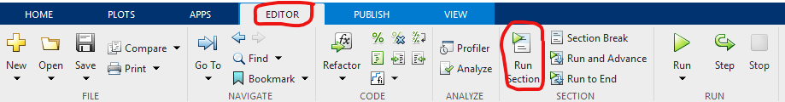
Part 1 – Classification of Signals
Signals represent information-bearing waveforms transmitted from a source to a receiver. In communication systems, it is essential to classify signals based on how they vary in time, energy and randomness.
- Pre-Lab Setup
Run the section labeled Pre-Lab Setup
This initializes:
- Base sample rate fs
- Sampling interval Ts
- Total simulation time T
- Random seed for reproducibility
Explain briefly what fs and Ts represent and why reproducibility is useful in simulation.
- Continuous-Time vs Discrete-Time (Sec 2.1)
Run the section labeled Continuous-Time vs Discrete-Time.
Observe how a 500 Hz cosine looks when sampled at:
- fs = 8 kHz (well above Nyquist)
- fs = 600 Hz (near Nyquist)
Question: Describe what you observe. What happens when fs < 2f0? (example, set fs=100 Hz).
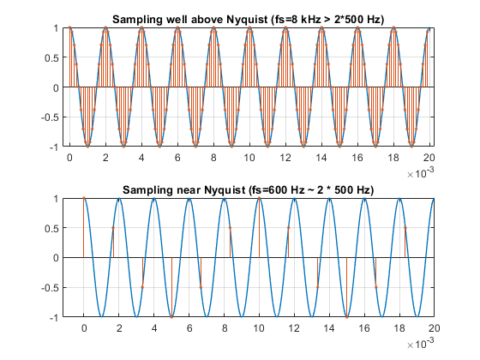
Figure 1. Continuous vs Discrete
- Deterministic vs Random (Sec 2.2)
Run the section Deterministic vs Random. The deterministic signal is fully predictable (cosine), while the random sequence varies unpredictably.
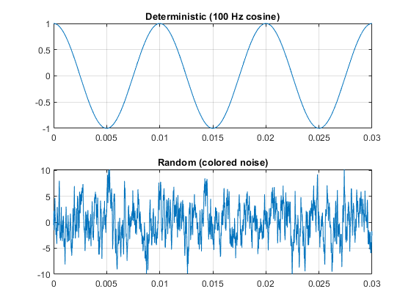
Figure 2. Deterministic vs Random
- Even/Odd Decomposition (Sec 2.3)
Run this section and observe how a signal can be decomposed into:
- An even component xe(t)
- An odd component x0(t)
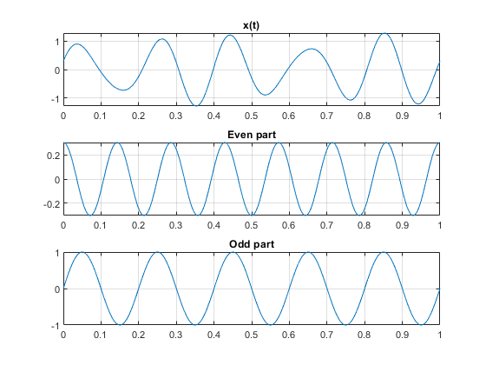
Figure 3. Even vs Odd Decomposition

- Periodic vs Aperiodic (Sec 2.4)
Run this section to compare signals that repeat over time vs signals localized in time.
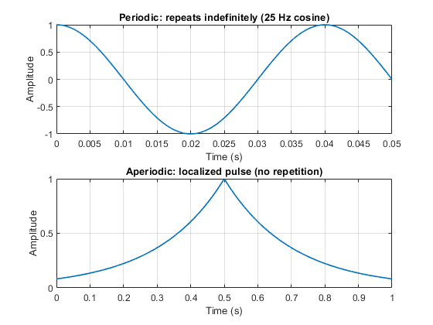
Figure 4. Periodic vs Aperiodic
Questions: Which subplot is periodic and how can you tell? Estimate the period from the plot and compute: T0, f0 = 1/T0, and ω0 = 2πf0
- Energy vs Power Signals (Sec 2.5)
Run this section and observe how:
- Decaying pulses are energy signals
- Persistent sinusoids are power signals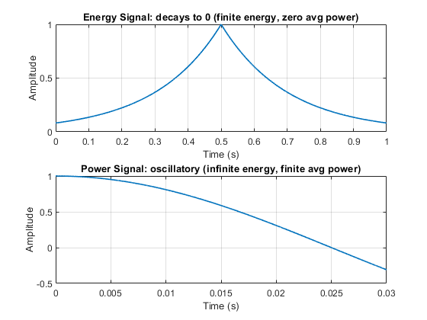
Figure 5. Energy vs Power Signal
Questions: Which signal has finite total energy and zero average power? Do energy signals typically look aperiodic? Why? Can a signal be both an energy and a power signal? Explain
- Time Shift & Time Scaling (Sec 2.6)
Run this section to visualize how shifting and scaling affect waveforms.
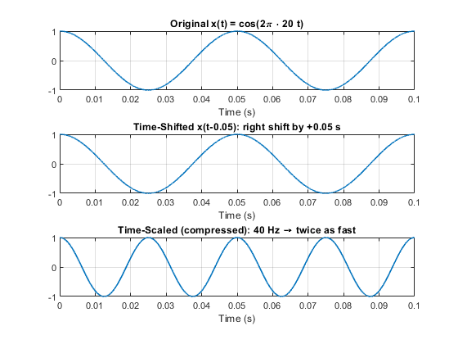
Figure 6. Time Shift & Scaling
Does x(t-0.05) shift left or right? Why? What is the period of the original and scaled signals? Which operation increases frequency and which affects phase? In communications, what does time compression correspond to?
Part 2 – Classification of Systems
In this section, we examine how systems respond to inputs and how to test basic properties. We investigate how systems respond to different inputs and how to evaluate common system properties. Many communication system blocks (filters, mixers, equalizers) are modeled as linear time-invariant (LTI) systems.
- Linearity Test
Run the section titled Linearity & Time-Invariance
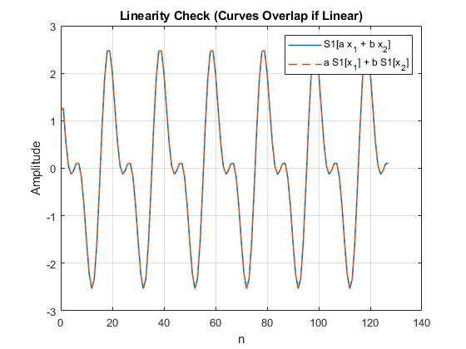
Figure 7. Linearity Test
From your observation; do the curves in the plot (lhs and rhs) overlap? What does that imply about linearity? Does shifting before vs after the system produce the same result? Based on these observations, how would you classify S1?
- Time-Invariance Test
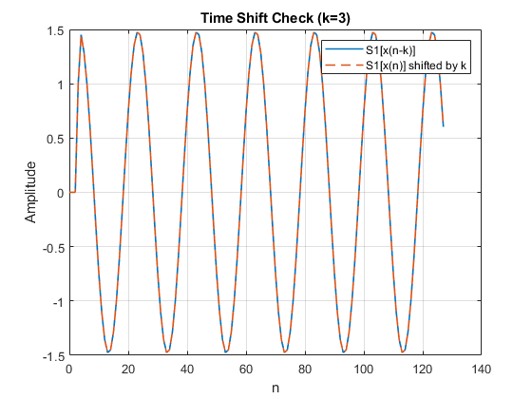
Figure 8. Time-Invariance Test
When the input is delayed by k samples, does the output also delay by k? Do the shifted waveforms align?
- Convolution Demo
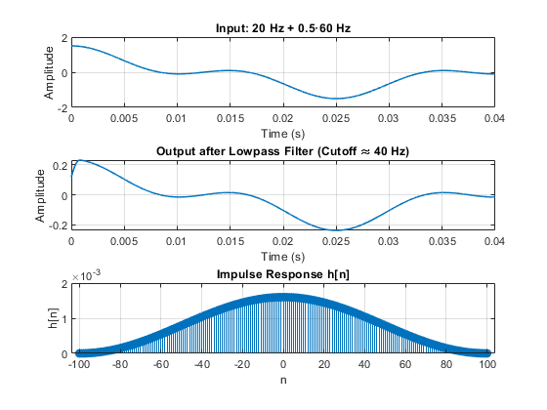
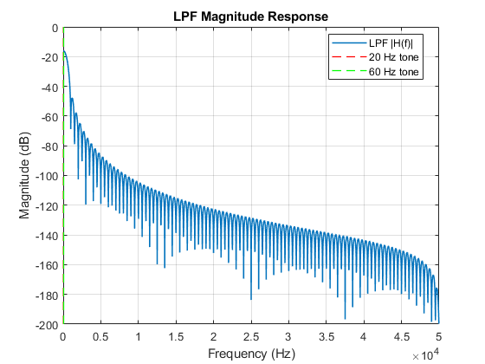
Which tone is attenuated more by the LPF and why? What happens if you move the cutoff below 20 Hz? What if you make the filter order smaller?
Part 3 — Signal Representation & Capacity
In this part of the lab, we introduce complex baseband representation (I/Q) and examine the effects of frequency conversion used in practical communication receivers. We also introduce Shannon capacity to build physical intuition for how SNR and bandwidth constrain data rate.
- Complex Baseband & Frequency Conversion
Run Section 4.1 (I/Q Baseband and Upconversion) and 4.2 (Downconversion) in the MATLAB file.
A 1 kHz baseband tone is mapped into complex I/Q components and then upconverted to a 20 kHz RF carrier. Downconversion with a local oscillator (LO) and lowpass filtering recovers the original I/Q signals.
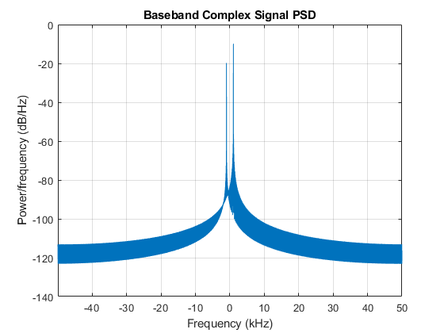
Figure 9. I(t): True vs Recovered
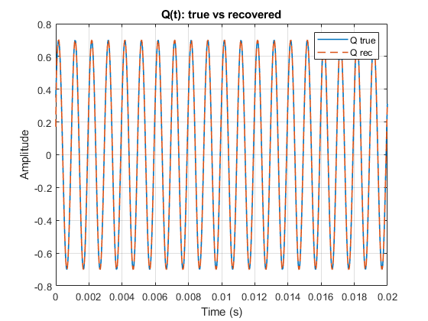
Figure 10. Q(t): True vs Recovered
Questions:
• How well does the recovered baseband match the original?
• What do the RMSE values indicate?
• Why can we apply a lowpass filter after mixing down to baseband?
- LO Phase Error Demonstration
Run Section 4.3 (LO Phase Error).
A small LO phase error rotates the recovered complex signal in the I/Q plane.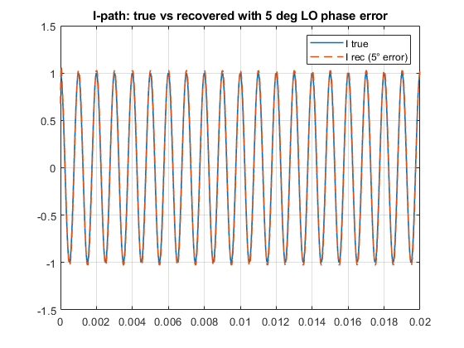
Figure 11. LO Phase Error Effect
Questions:
• How does a phase offset in the LO affect the recovered (I(t)) and (Q(t))?
• In a constellation view, what would this error correspond to?
- Capacity vs SNR
Run Section 5.1 (Capacity vs SNR).
Here we explore Shannon’s capacity formula:
Capacity is plotted versus SNR for a fixed bandwidth.
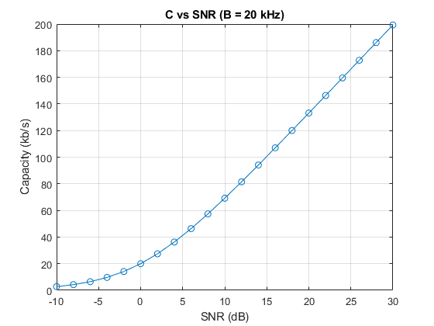
Figure 12. Capacity vs SNR
Questions:
• At very low SNR, which increases capacity more: +3 dB SNR or doubling bandwidth (B)?
• How does this relate to systems operating in noise-limited regimes?
(Hint: at low SNR, increases in B and SNR both give nearly linear gain)
- Capacity Heatmap: Bandwidth vs SNR
Run Section 5.2 (Capacity Heatmap).
The heatmap shows how data rate depends jointly on both SNR and bandwidth, revealing a region where capacity scales almost linearly with B.
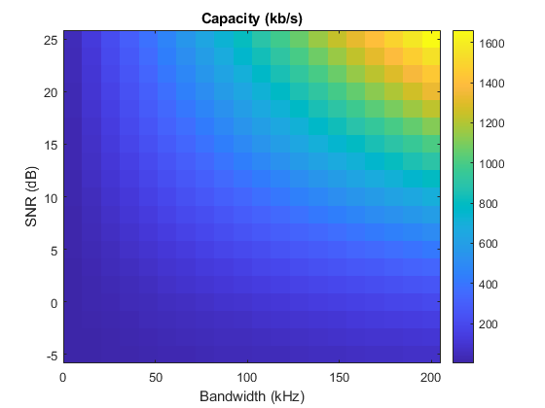
Figure 13. Capacity Heatmap
Questions:
• Why can capacity scale almost linearly with (B) at low SNR?
• How does this explain why ultra-wideband and spread-spectrum systems can operate with low spectral efficiency?
• What engineering tradeoffs limit bandwidth in practical systems?

