Lab 2 – Working with Audio signals

Introduction

1. Signals and Sampling
- A signal is a function that conveys information, often represented as a function of time. Examples include audio signals, temperature readings, or air pressure variations.
- Signals that repeat themselves after a period of time are known as periodic signals.
- The frequency, in Hertz, of a signal is the number of cycles per second and is the inverse of the period.
- The period is the duration of a cycle.
- In digital signal processing, continuous signals are converted into discrete signals by sampling.
  - Sampling Theorem: To avoid losing information, the sampling frequency $f_{s}$ must be at least twice the maximum frequency $f_{max}$ in the signal${ f}_{s}>2f_{max}$. This is known as the Nyquist Rate.
  - Aliasing: If the signal is sampled below the Nyquist rate, higher-frequency components appear as lower-frequency components. This leads to a distorted or incorrect representation of the original signal.

2. Frequency Representation
- Spectral decomposition is the idea that any signal can be expressed as the sum of sinusoids with diﬀerent frequencies.
- Signals can be decomposed into sinusoidal components using the Fourier Transform.
  - The Fourier Transform provides a frequency-domain representation of the signal.
  - The Discrete Fourier Transform (DFT), computed via the Fast Fourier Transform (FFT) algorithm, is essential for digital systems to analyze and process signals. You utilized this in Lab 1 to obtain the spectrum of the signal obtained from the dataset.
The frequency spectrum shows the amplitude and phase of the signal's components. The figure below shows an example of a frequency spectrum plot. The lowest frequency component is known as the fundamental frequency. In this plot, this is near 440 Hz. The fundamental frequency in this signal has the largest amplitude, so it is also the dominant frequency. The dominant frequency always has the largest amplitude. Again, from the plot, it can be observed that there are other spikes in the spectrum at the following frequencies: 880 Hz, 1320 Hz, 1760 Hz, and 2200 Hz. These spikes are integer multiples of the fundamental and are known as harmonics. 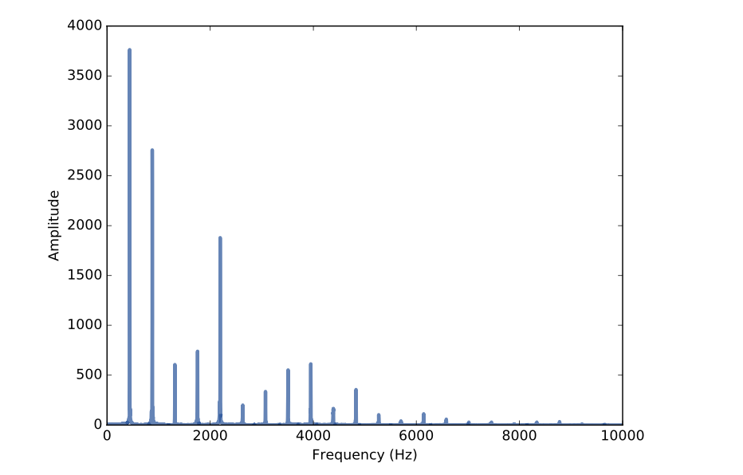
Given the harmonics and their amplitudes, it is possible to reconstruct the signal by adding up sinusoids. Harmonics are present when the signal is non-sinusoidal. E.g. (square or saw-tooth waves). Pure sinusoids do not contain harmonics. This is a key thing to note.

3. Convolution and Impulse response
- Convolution is a fundamental operation in DSP used to analyze and manipulate signals. It describes how an input signal interacts with a system to produce an output signal. For the mathematical representation and more details, refer to lecture 6.
- The impulse response of a system describes how the system reacts when given a unit impulse as input.
- Convolution is applied in many areas, such as signal, audio, and image processing. You can and should read more about some applications and the importance of convolution.

Lab Goals
- Understand Sampling: Explore aliasing by under-sampling audio signals and observing its effects.
- Fourier Analysis: Decompose signals into frequency components to observe noise or hum (e.g., 400 Hz interference).
- Convolution: Designing an impulse response and illustrating the convolution operation.
- Introduction to basic application design.
Part 1 – Sampling and Aliasing

Experiment 1
In a new Python project named Lab 2;
- Generate a signal with the following code;

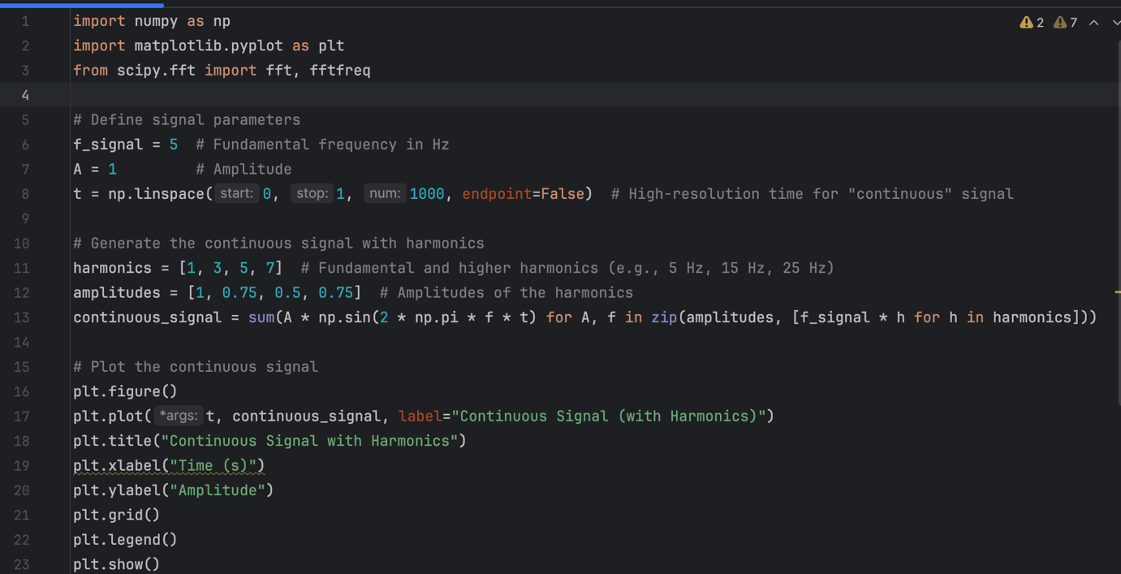

The libraries should be familiar as we have used them before. We use NumPy for numerical operations, such as generating time points and computing sinusoidal signals, and matplotlib for visualizing the signals in time and frequency domains.
Scipy.fft provides functions (fft and fftfreq) to compute the Fast Fourier Transform (FFT) and analyze the frequency components of the signal.
f_signal: The fundamental frequency of the signal is 5 Hz
A: The base amplitude of the signal is set to 1.
t: Generates 1000 evenly spaced time points in the interval [0,1), representing one second. This creates a high-resolution "continuous" signal.
harmonics: A list specifying the harmonic multipliers of the fundamental frequency.
amplitudes: Amplitudes of each harmonic. The higher the harmonic, the lower its amplitude

continuous_signal:
- Combines the fundamental frequency and its harmonics by summing sinusoidal components.
- Uses a generator expression where
  - np.sin(2 * np.pi * f * t): Generates the sine wave for a specific frequency and time points
  - A: Scales the amplitude of the sine wave.
  - zip(amplitudes, [f_signal * h for h in harmonics]): Combines the amplitude and frequency values for each harmonic.
- The result is a composite signal that includes the fundamental frequency and its harmonics. This will be displayed after writing out the associated plot functions as shown.
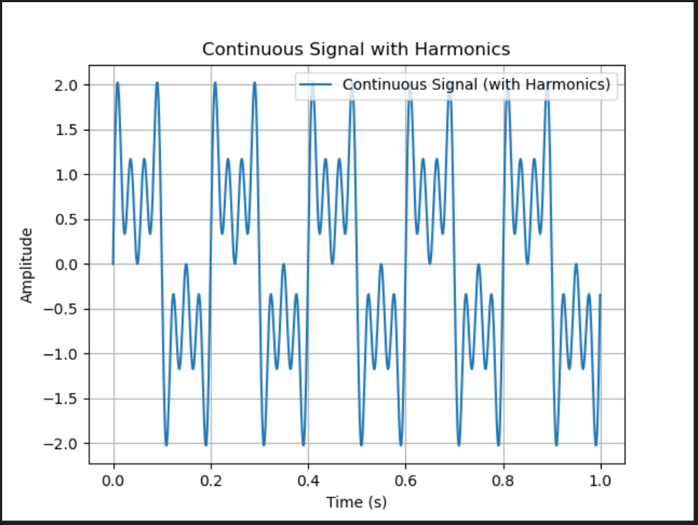

- Now, we obtain the frequency spectrum of the signal we just generated using the FFT. The code and the result should be as follows:
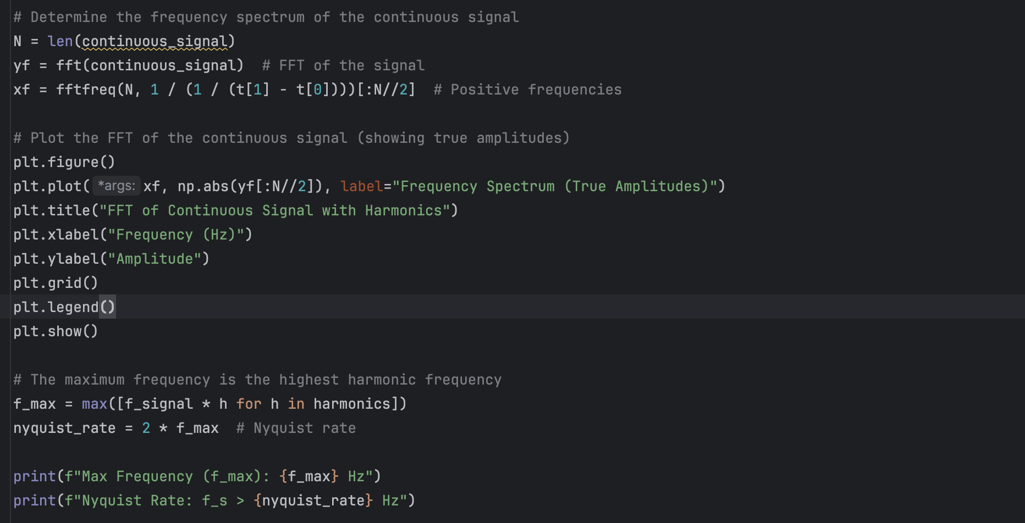
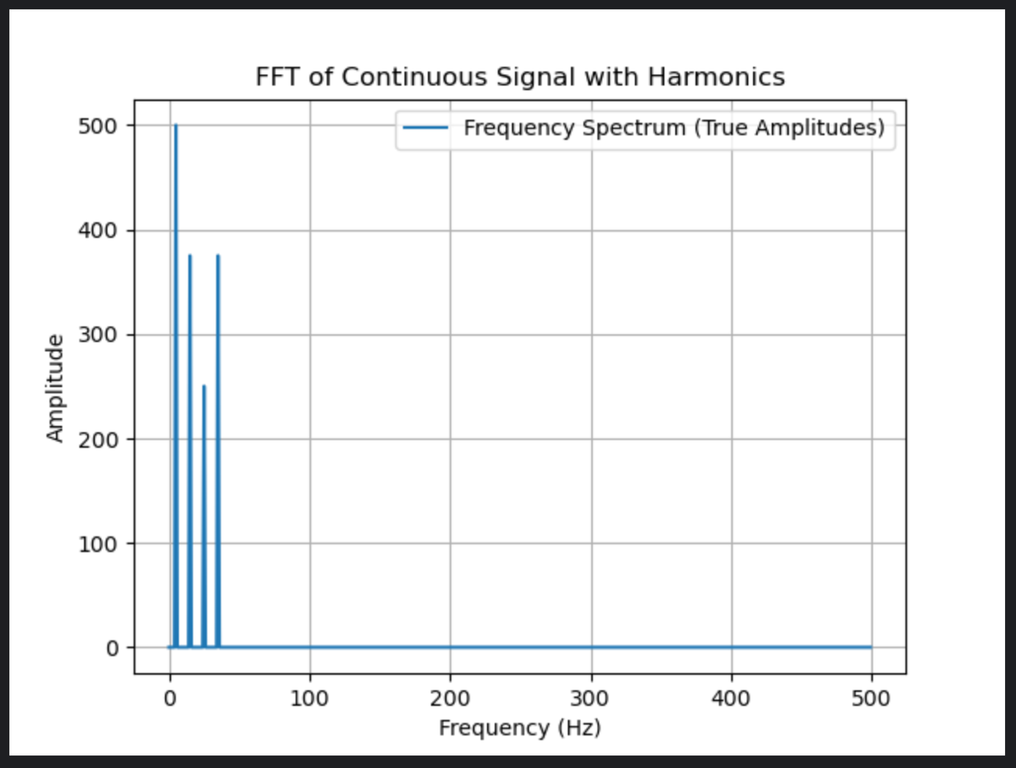

- Now we are going to illustrate the principle of sampling in this next step. To prevent loss of information, a key thing to remember is that the sampling rate must be greater than the Nyquist frequency. We first create a list to hold our sampling rates, new time points t_sampled, and finally the sampled signal at the given rates.
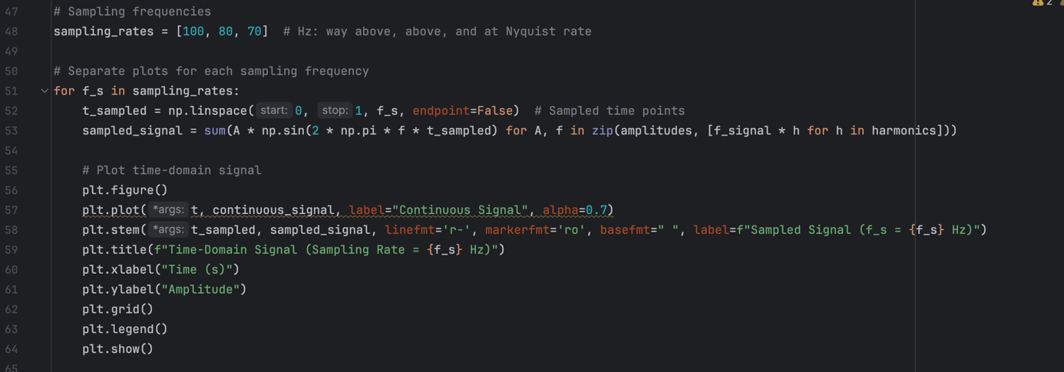

Assignment 1- Run the code from the experiment, answer the following, and attach the plots to your lab report.
1) What do you observe for the different sampling rates?
2) What is the implication of using higher sampling rates?
3) Modify the code to sample below the Nyquist frequency (at 50, 30, and 10Hz). What are your observations and the implications of sampling below this rate?
4) Another name for the Nyquist frequency is the folding frequency. Why is it called this?

Part 2 Audio Sampling and Filtering
We will now look at the effects of sampling and aliasing on audio signals. This practical example should help you better appreciate the applications of DSP in everyday life.

Experiment 2
    - Download the two .wav files and copy them to your project folder.
    - Create a new pure Python file and name it.
    - In the local terminal, type the following pip install sounddevice and press Enter. This installs the sound device library. We will be using this library to handle our audio files.
    - In your newly created file, type in the following code and run it. Use the audio file named without_hum.wav.
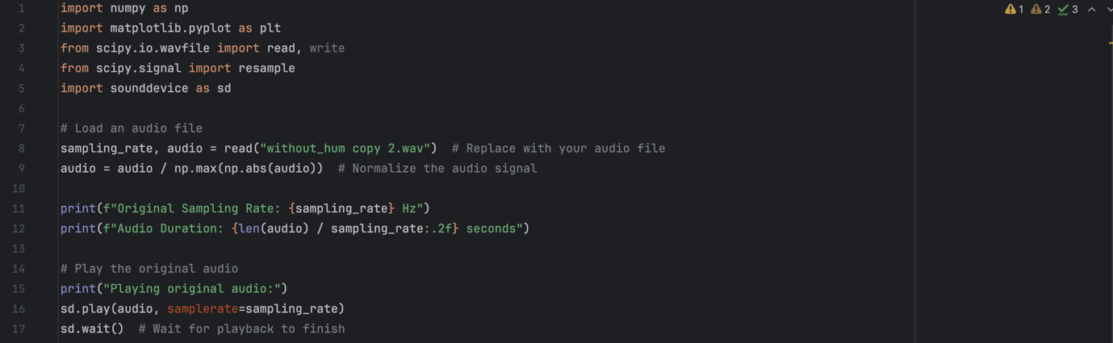
In the above code, we imported the various libraries we will be using from lines 1-5.
We load the audio file with lines 8-9 and with the help of read from the scipy.io.wavfile library, we can easily obtain the sampling rate of the audio file we are working with. We normalize this to make future computations easier.
To obtain the duration of the audio, we divide the audio length by the sampling rate.
Lines 15-17 play the audio.

    - Now we perform downsampling on the audio with the following lines of code.
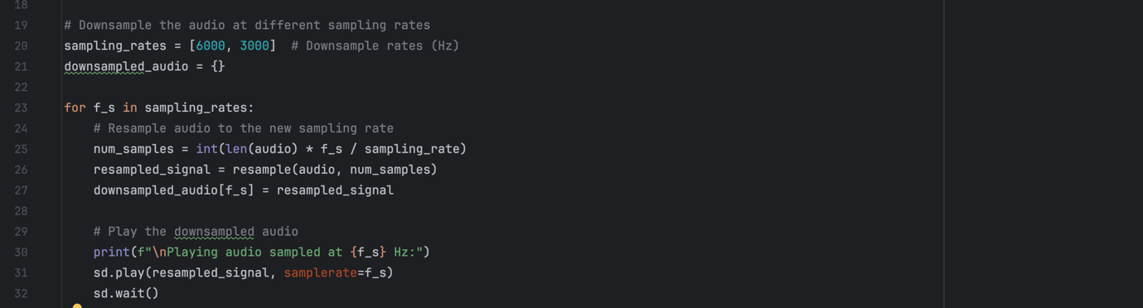
Line 20 contains the new sample rates in Hz, and line 21 creates an empty dictionary to store the downsampled_audios for later use. Take note of the syntax. {} is used in Python to create an empty dictionary. A dictionary is a data structure in Python that maps keys to values. Lines 29-32 play the newly downsampled audio files.

    - Can you observe any differences in the downsampled files?
    - We will now plot the time and frequency domains of the original and downsampled audio files at 6kHz and 3kHz and observe the effects of downsampling as earlier. Take time to understand the code and what each section does. Feel free to reach out to the TA if you need help understanding any portion of the new code.
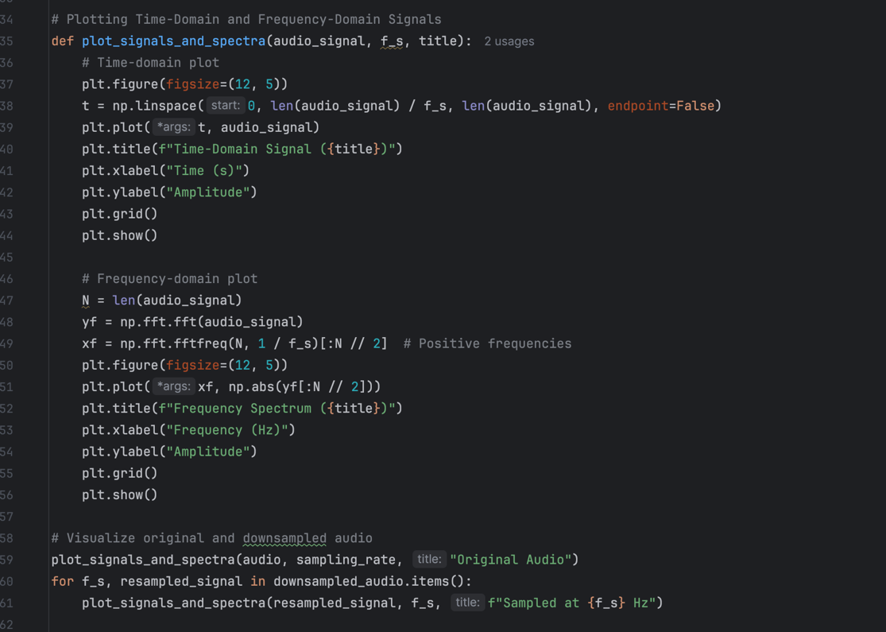

Assignment 2- Run the code from the experiment, answer the following, and attach the plots to your lab report.
    - What are your observations from step 6 in the experiment?
    - From the plots of the downsampled audio files do you think Aliasing occurred?
    - In what situations would downsampling and aliasing be beneficial?

Part 3 Convolution
This section deals with the convolution of signals. We will understand and visualize convolution using a manual approach and a built-in function from a Python library. We will compare the two approaches as well.

Experiment 3
- Import the necessary libraries needed for plotting and performing mathematical operations in Python.
- Generate a single sine wave with a sampling rate of 1000Hz and a frequency of 5Hz, an amplitude of 1, and a period of 1s.
- As the impulse response, we will use an impulse function defined as:
$$δ\left[n\right]=\left\{\begin{aligned}1, n=0 \\ 0 otherwise\end{aligned}\right.$$
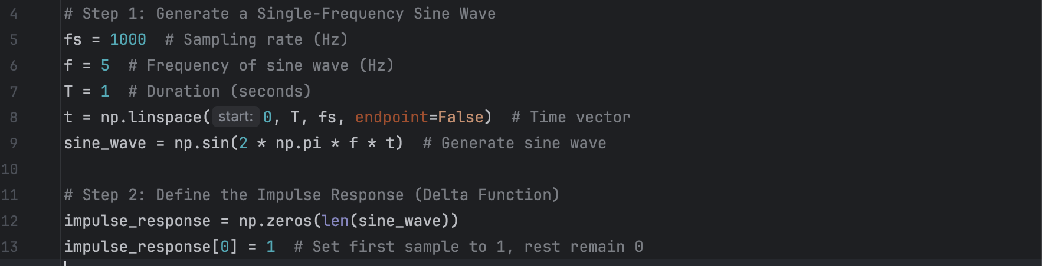
- We will now perform manual convolution using the following piece of code. We do so by first initializing an empty array for the result. The output length of the convolution will be the sum of the length of the input signal and the length of the impulse response minus 1. The outer loop corresponds to the shift of the impulse response over the input signal. The inner loop performs a weighted multiplication and summation while the “if condition” ensures valid indices to avoid out-of-bound errors. Refer to slide 38 of lecture 6 for the mathematical notation.
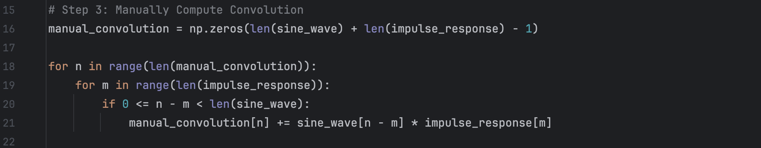

- We will now write the code to perform convolution using a library

Assignment 3 - Run the code from the experiment, answer the following, and attach the plots to your lab report.
- Plot the generated signal, the impulse response, the manually convoluted signal, and the numpy convoluted signal and attach them to your report.
- What do you observe about convolution with the impulse function?
- Given two sequences ;
$x\left[n\right]=\left\{\begin{aligned}1, 0≤n≤10 \\ 0 otherwise\end{aligned}\right.$ and $h\left[n\right]=\left\{\begin{aligned}2.6-0.5n, 0≤n≤10 \\ 0 otherwise\end{aligned}\right.$
Perform manual convolution only on these two sequences and plot your results. Results should include a plot of the two sequences and the convolution sum. Attach your code as well.
- How does the convolution result compare to the original signal? How does the length of the convolved signal relate to the lengths of x[n] and h[n]?
- What is the role of the impulse response in shaping the output?
- If the impulse sequence was causal, would the convoluted signal also be causal? If so, why?
- Name two applications you would use convolution and explain why convolution is essential in each context.

Building a basic DSP app in ANDROID APP

This portion will introduce you to basic concepts in building a simple DSP application in Android Studio using Jetpack Compose. We will design a simple app to generate and visualize a sine wave at various frequencies.
Let us begin by following the next steps:
- Open Android Studio and click on New Project.
- Select Empty Activity as the project template and click Next.
- Name the project as you want.
- Select Kotlin as the language of choice and set the minimum SDK as API 24.
- Click on finish.
- Check if the file activity_main.xml is in app/src/main/res/layout. If not, you will have to create this by;
  - Right-clicking on res and select New then Android Resource Directory
  - Set the directory's Resource Type to layout.
  - The folder name will automatically be set to layout.
  - Click on OK to create the folder.
  - Right-click on the newly created folder and select New > Layout Resource File
  - Name the file activity_main.xml and click OK.
- We are going to create a basic UI for the app using this portion of the code. Open the activity_main.xml file and make sure it is in code view. At the top of the editor, you should see two tabs: Code and Design. Click on Code (the three horizontal lines stacked vertically). Type in the code in the screenshot below.
LinearLayout acts as the parent layout, organizing its child views in a vertical orientation. orientation="vertical": Ensures all child views are stacked vertically; padding adds padding around the edges of the layout and layout_width and layout_height: specify that the layout fills the screen dimensions. We use TextView to display the current frequency value. In this, id assigns a unique identifier to this view; text shows the default text showing the frequency; textSize for the font, layout_gravity for positioning of the text and paddingBottom adds space below the text. SeekBar allows the user to adjust the frequency; max sets the maximum value to 50. View serves as a placeholder for rendering the sine wave visualization, which updates dynamically as the frequency changes. Background sets the background color and layout_marginTop adds spacing above this view. In your report, find out and indicate the meaning and use of dp and sp and how to obtain different colors for the background.
Save the file, and you can click the Design tab to see the layout rendered visually. You should see a simple layout with a text view displaying the frequency, a seekbar for the frequency, and a view to visualize the sine wave.
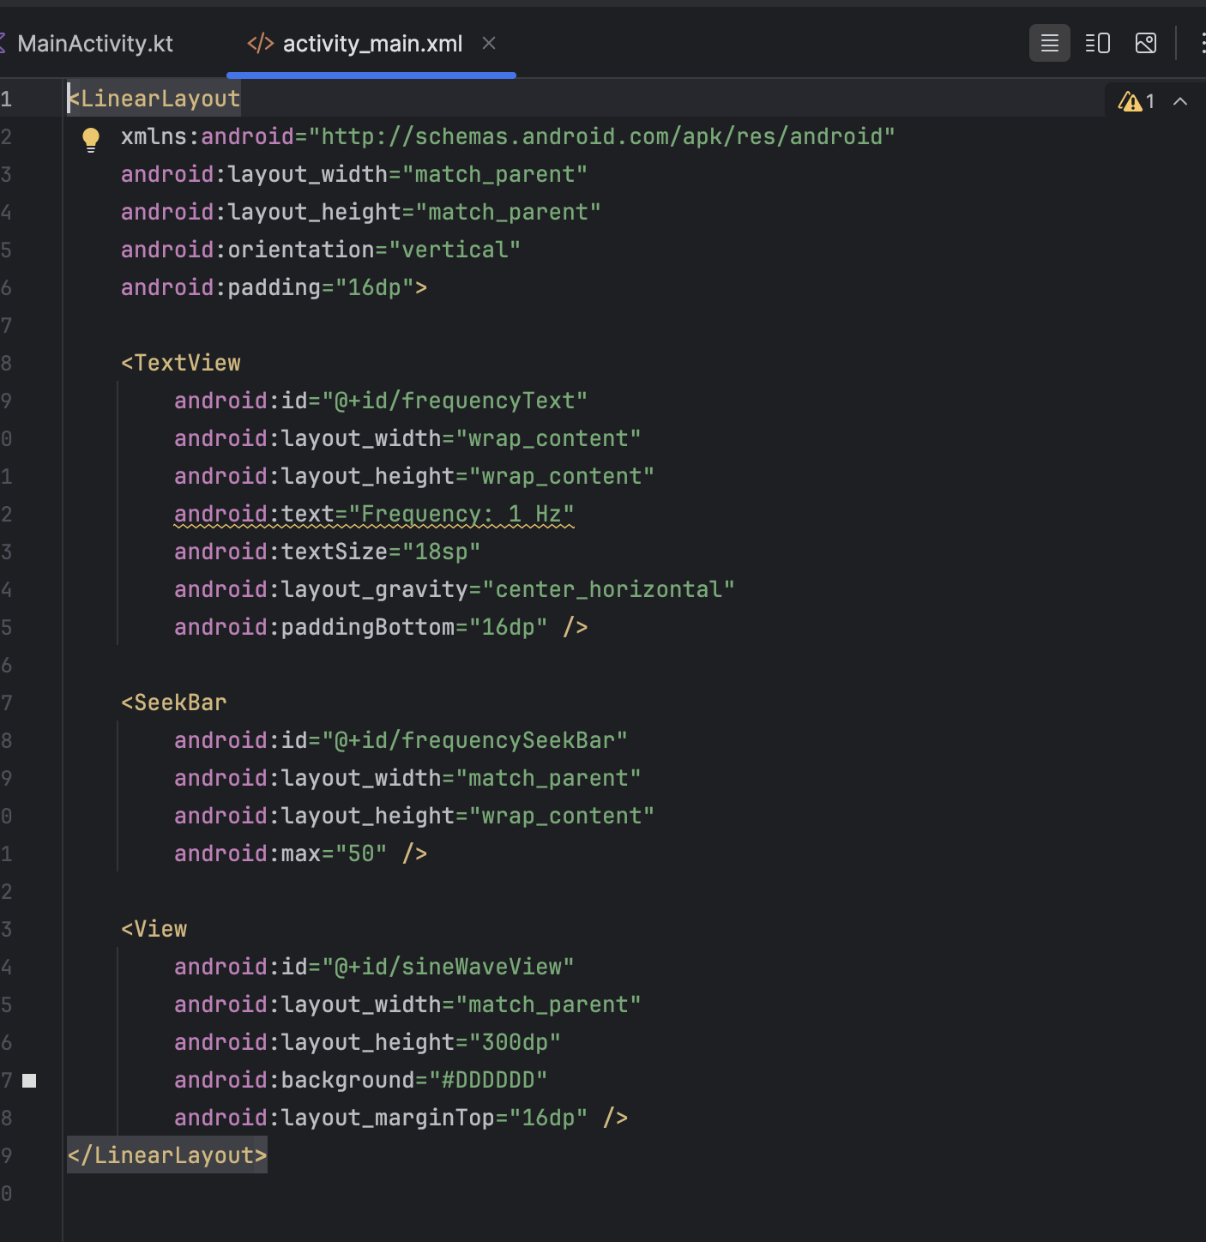
- Locate and open MainActivity.kt. This is where we will implement the logic to handle the user input in this case, the frequency adjustment, and visualize the sine wave.
- Type out the following code from the screenshot below. Package is used to specify the package name for the application. We use import to import the necessary libraries needed. Take time to read about them and what they can be used for.
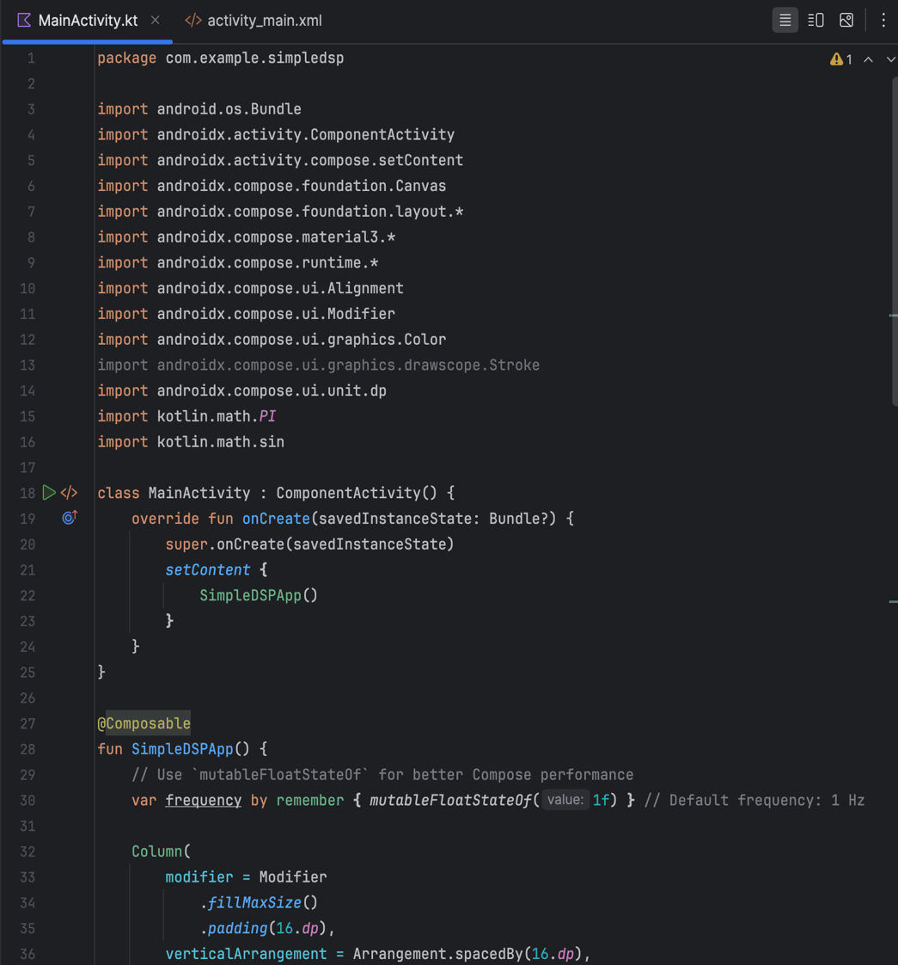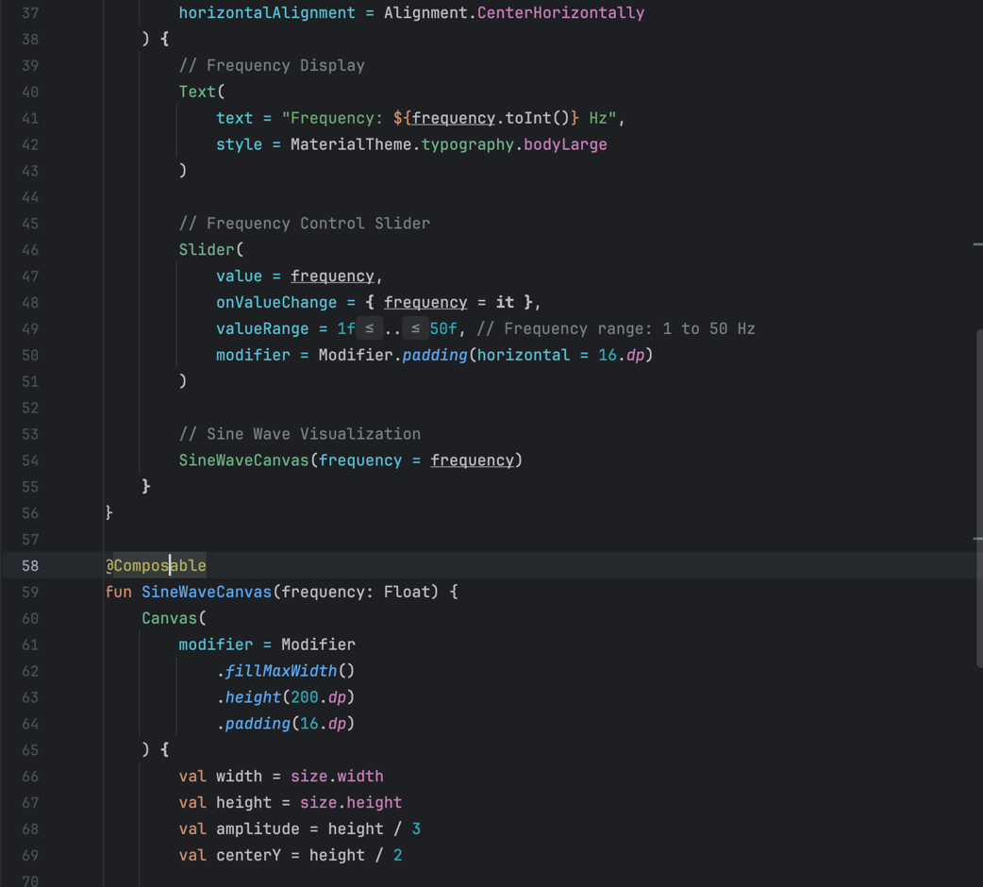
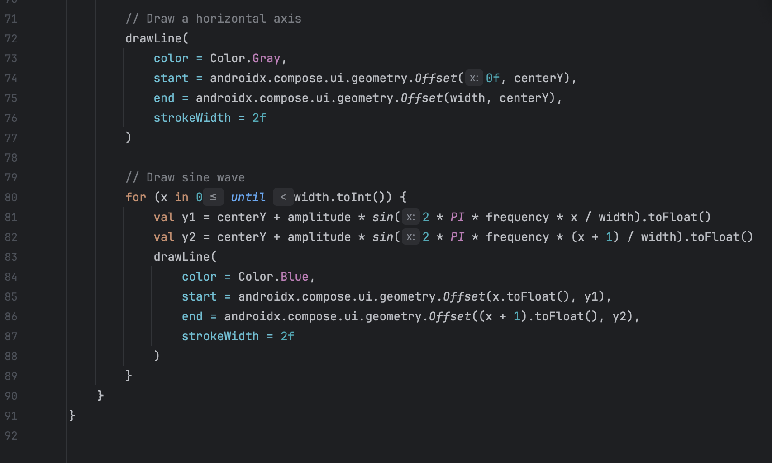

Assignment 4

- Build and run the project after typing in the code.
- Attach screenshots of the generated wave at 25Hz.
- With the help of any resources, understand and give a simple breakdown of the code, explaining it in your own words.
- Modify the application to also generate a variable cosine wave underneath the existing sine wave, this time with a range from 1 to 100Hz.
- Modify the existing application to visualize the sum of any two waves(sine, cosine, or triangular).
- Attach screenshots to the report.

Links
- https://en.wikipedia.org/wiki/Nyquist_frequency - Nyquist frequency
- https://en.wikipedia.org/wiki/Digital_filter - Digital filter
- https://en.wikipedia.org/wiki/Band-stop_filter - Notch/Bandstop filter description
- https://docs.scipy.org/doc/scipy/reference/generated/scipy.signal.butter.html -butter
- https://docs.scipy.org/doc/scipy/reference/generated/scipy.signal.freqz.html - freqz
- https://docs.scipy.org/doc/scipy/reference/generated/scipy.signal.firls.html#scipy.signal.firls – Scipy.signals.firls
- https://en.wikipedia.org/wiki/Finite_impulse_response - FIR filter
- https://en.wikipedia.org/wiki/Infinite_impulse_response - IIR filter

