EE 4162 – LAB 1 B– GETTING STARTED

- Download and install Android Studio. Choose “Standard Installation”.
- After installation, click on More Actions or Configure and select SDK Manager.
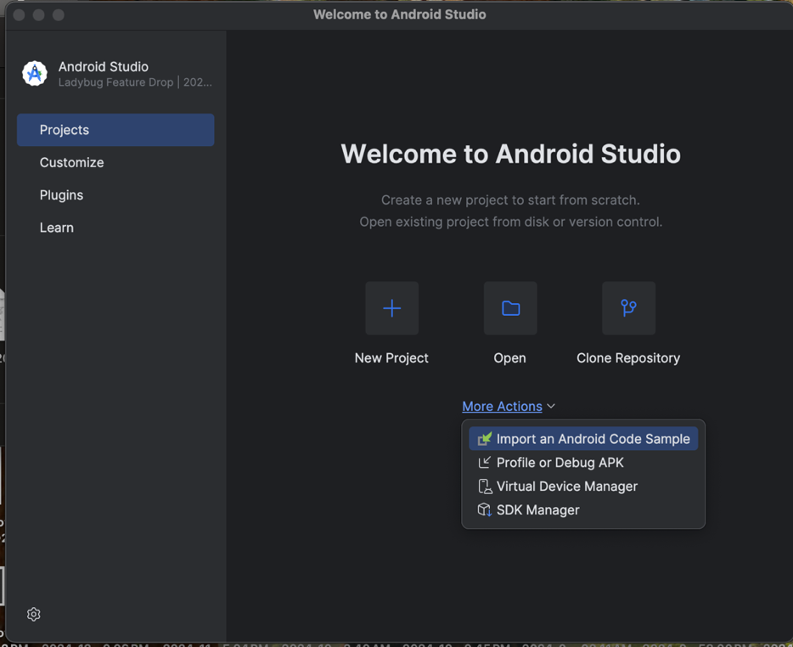

- Switch the tab to SDK tools, and check the boxes in the figure below. These will install the requisite Java SDK, C++ NDK, and debugging tools. Click OK to install.

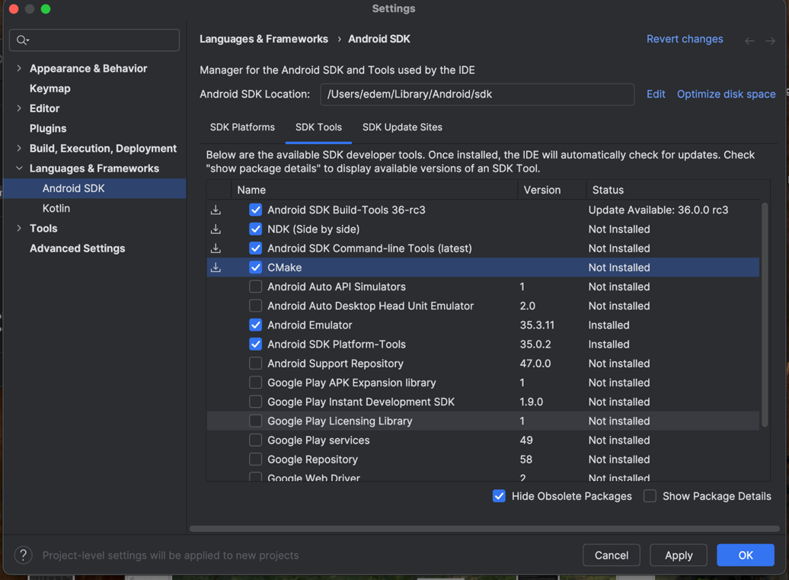

- Create a New Project: From the welcome screen, click on "New Project."
- Choose a Project Template: Select "Empty Activity" and Click "Next."
- Configure the Project:
  - Name the Project: Enter a name like HelloWorld.
  - Package Name: Accept the default or enter a unique identifier (e.g., com.example.helloworld).
  - Save Location: Choose a directory on your computer to save the project.
  - Minimum API Level: Choose a minimum API level (e.g., API 21 for better compatibility with most devices).
  - Language: Select Kotlin DSL. (Kotlin is now the recommended language for Android development, but Java can and is also widely used.)
  - Click "Finish."
- Wait for the Project to Load:
  - Android Studio will build and index the project. This may take a few moments.
  - Once the build finishes, the project interface will appear.

Understanding the Android Studio Interface
  - Toolbar: Includes buttons for building, running, and debugging the app and is located at the top.
  - Project Pane: This shows the file structure of the project and other folders related to the current work session.
  - Editor: Displays the open file for editing (e.g., Java/Kotlin code)
  - Logcat: Provides real-time logs for debugging when the app is running. (A cat face icon at the bottom left side of the window)

In the project pane, click on “Projects”. Use the figure below to find the following files and open them.
  - MainActivity.java or MainActivity.kt: The main code file where the app’s logic resides.
  - AndroidManifest.xml: Contains metadata about the app, including permissions and activity declaration.
  - 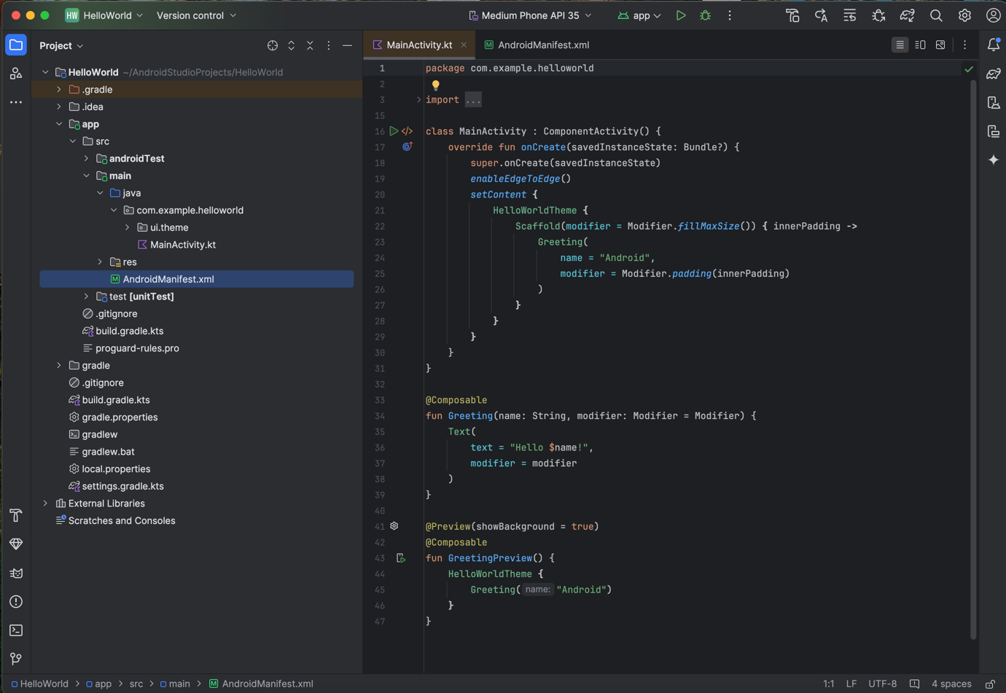

Running the Project
To run any project, it first needs to be built. This time around, the existing code from the template will be used.
Build the Project
  - Click "Build > Make Project" from the menu. You can also click on the hammer icon on the top right however this just builds the particular module you are working on and not the entire project.
  - Wait for Gradle to compile the project.
Run the App:
  - Click the green "Run" button or select "Run > Run App" from the menu.
  - A window will pop up asking for a deployment target (emulator or physical device). For now, select the emulator. It should automatically open up when no device is detected. (Note: With Android studios, you can also mirror Android devices to work on)
After running the app, the emulator should run and finally display a blank page with Hello Android at the top. Modify the display message as shown in the figure below.
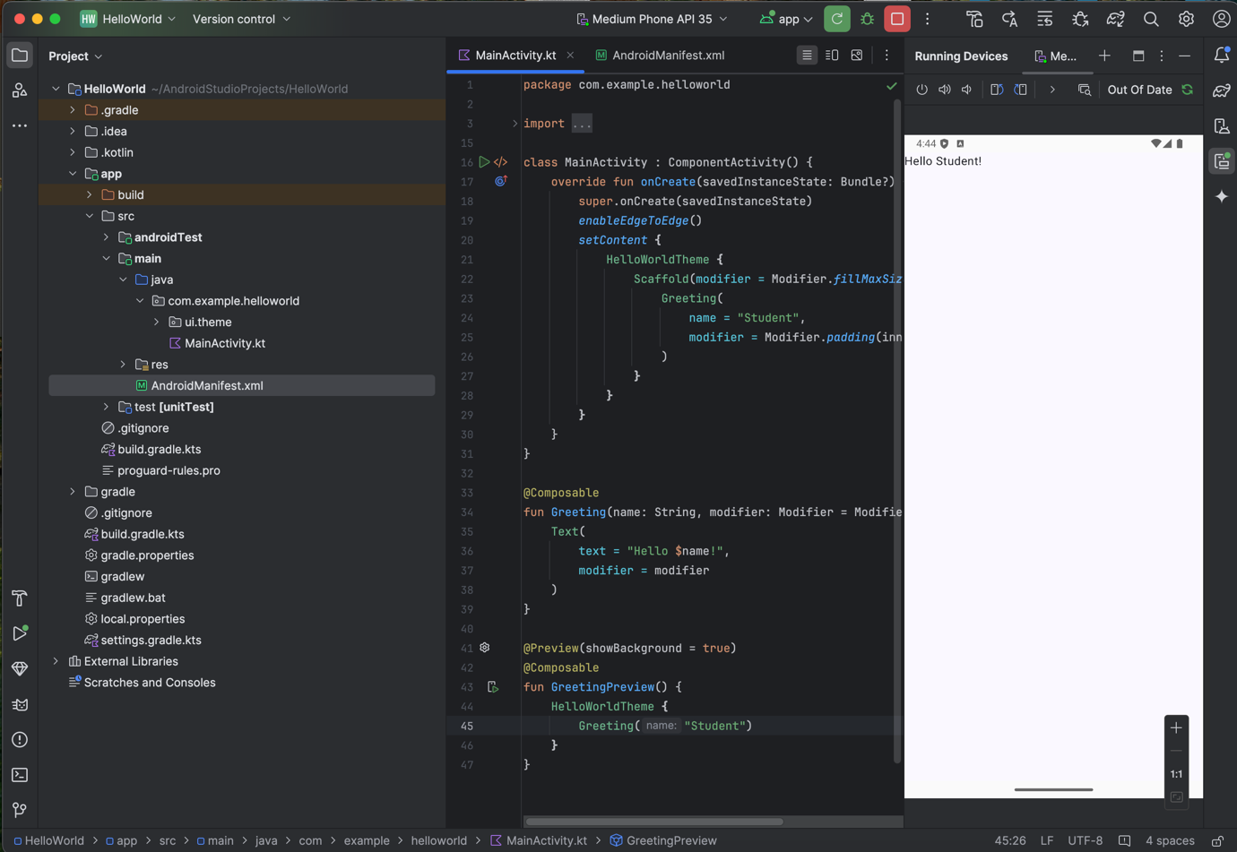

Gradle Build Process:
Gradle is a build automation tool that manages dependencies and creates APKs (Android application packages). It simplifies tasks like compiling code, managing dependencies, packaging the application, and preparing it for deployment.
It saves us a lot of time when it comes to application development and we do not need to know the full details of it. At your convenience, you can read more on it if you are interested.

Emulators
An emulator simulates an Android device on your computer, allowing you to test your app without a physical device. You can run tests here before actually deploying your code to the physical device. You can also use the virtual device's interface like a real tablet or phone. We will now add a new emulator.
- Open the Device Manager:
  - Click on Tools > Device Manager.
  - A window will appear showing the list of available virtual devices
- Create a Virtual Device:
  - Click on the "Create Device" button.
- Select a Device Profile:
  - Choose a device type from the list (e.g., Pixel 4 or Pixel 8).
  - Click Next.
- Select a System Image:
  - Choose the version of Android you want to emulate: Select the latest stable version (e.g., API Level 30 or 31).
  - If the system image isn’t downloaded, click the download link and wait for it to complete.
  - Click Next once the download finishes.
- Configure the Emulator Settings:
  - Device Orientation: Set to portrait or landscape as needed.
  - RAM/CPU: Accept the defaults or optimize based on your system's resources.
  - Graphics: Choose "Automatic" or "Hardware" for better performance.
- Finish the Setup:
  - Name the virtual device for easy identification (e.g., "Pixel 4 API 30").
  - Click Finish to create the emulator.
- Launch the Emulator:
  - In the Device Manager, click the green play button next to the virtual device.
  - Wait for the emulator to boot up (this might take a few minutes the first time).
- Deploy the App to the Emulator:
  - Go to your Android Studio project and click the Run button (green triangle).
  - When prompted to choose a deployment target, select your emulator from the list.
  - The app will install and run on the emulator.

Preparing the Lenovo Tablet
Before you do any Android development or run any of our labs, you need to enable the Developer Mode on your Android device and have USB Debugging enabled.
Here’s a detailed guide:
- Choose the “Settings” icon.
- Scroll down to “System”, tap on it, and scroll down to the “About Tablet” setting.
- Inside the About Tablet setting, find the “Build Number” item.
- Tap it 7 times in quick succession, and there will be notifications informing you how many taps you are away from being a developer.
- Go back to the main Settings menu and choose “Developer options”.
- Scroll to and Turn on the “USB debugging”.
- Connect the tablet to your computer via USB.
- Approve the connection by selecting “Allow”
If you are on Windows, you may need to install the OEM USB Drivers for your device. See this page for help if your device is not automatically recognized.

Test the Tablet with Android Studio
- Run the App on the Tablet:
  - Open your project in Android Studio.
  - Click Run > Run App or the green triangle button.
- Select the Tablet:
  - In the deployment target window, your tablet should appear as a connected device.
  - Select it and click OK.
  - The display on the tablet should be the same as the emulator.

Links
Learning Resources
- https://kotlinlang.org/docs/home.html
- https://play.kotlinlang.org/
- https://developer.android.com/courses/android-basics-kotlin/course
- https://www.youtube.com/playlist?list=PLlxmoA0rQ-Lw5k_QCqVl3rsoJOnb_00UV

Android Studio- https://developer.android.com/studio/index.html

