Zero-finding methods based on interval arithmetic and their applications to dynamical systems

1. Introduction

Chaotic systems form a subset of dynamical systems and are characterized by their high sensitivity to initial conditions. Even though these systems are deterministic (their future behaviour is fully determined by their initial conditions), small differences in initial conditions yield widely diverging outcomes, thus making long-term predictions generally impossible (see, e.g., textbook [1]). Study of chaotic systems has many practical applications in various fields of science, such as physics, engineering, meteorology, biology and economics [2 – 7]. Since chaotic systems are non-integrable, and perturbation methods work only in the cases of small deviations from the integrable system, numerical methods are generally necessary to study such systems.

Methods of computational error control based on order estimates of approximation errors are not rigorous and they do not take into account rounding error accumulation. In this study we use the numerical technique known as interval analysis (IA), interval arithmetic or interval computation. The first books on modern IA were published in 1966 [14, 15]. It has since then been successfully used to solve various problems [16, 17]. The essence of this technique is to compute enclosures (containing intervals) of the values instead of approximations. Simply put, it represents each value as a range of possibilities. Interval algorithms provide rigorous bounds on accumulated rounding errors, approximation errors and propagated uncertainties. Instead of working with a real (uncertain) value x, we work with the two ends of a closed interval [a, b] which contains x. After each operation, the output is an interval which reliably includes the true result [19, 20]. The size of the interval directly gives the rounding error estimate.

In order to develop the software with IA implemented to analyse chaotic systems, we used the programming language Julia [link to julia site], developed recently as a high-level open-source dynamic language for scientific and numerical computing with improved performance. Its performance is comparable to or exceeding (2 to 3 times the speed) that of the traditional programming languages like C/C++ due to its sophisticated type system. Using Julia, we created a software package with IA implemented which provides certain computational tools (such as automatic differentiation, interval Newton's method, interval Krawczyk method for one-dimensional and two-dimensional cases) which were applied to chaotic systems studied.

2. Interval analysis

Despite tremendous increase in the speed and performance of computers in the last decades, not much has changed in the way the actually perform their calculations. Due to the inherent limitations of any finite-state machine, the computations are almost never carried out in a mathematically precise manner. Thus, they do not produce exact results, but rather approximate values that are usually, but not always, near the true ones. To overcome this problem, computational models were developed in which approximate results are automatically provided with guaranteed error bounds. One of these models, interval analysis (IA) was developed by Ramon Moore in the 1960s [14]. We implement this technique following the definitions of W. Tucker [19].

In a nutshell, instead of real numbers, the elements in computations are real intervals (which we denote by bold italic letters)

(1)

which contain the value under consideration. The basic arithmetic operations over intervals are as follows:

(2)

(3)

(4)

(5)

To ensure that the true value is with certainty inside the interval, we always need to round down the lower end and round up the upper end of the interval at each operation. Also, we define certain properties of the interval, among which there are the following:

Radius and diameter:

(6)

Midpoint:

(7)

Mignitude:

(8)

Magnitude:

(9)

An interval whose radius is 0 is called a thin or degenerate interval.

In [file modules/IntervalArithmetic.jl] we implemented the basic definitions of the interval arithmetic.

3. Zero-finding methods

The general idea of a zero-finding (or root-finding) method is the solution to the following problem: given the function f(x), find a number ξ such that f(ξ) = 0. Numerous methods have been developed to solve this problem [ref]. In our study, we implemented the extended interval Newton method – an interval version of the Newton method for solving one-dimensional equations, which has advantages over the non-interval version [19]. This method uses the definition of an extended interval, a type of an interval [a, b] with b < a:

(10)

The operation of extended division is thus defined to make it possible to divide by intervals containing zero. Using this, it is possible to compute the Newton operator

(11)

(where F(x) is the natural interval extension of f(x) [19]) even when F'(x) contains zero. Starting from an arbitrary interval, after each step

(12)

we obtain an interval (normal or extended) containing the zeros. By repeating the process, it bisects the search domain in exactly the right places, thus finding all the zeros of the function in the given interval.

Another method, which avoids division by F'(x), is the Krawczyk method [8]. The interval Krawczyk operator, which is used in the same step procedure as N(x) in (12), is defined as follows:

(13)

where we define the finite constant C as

(14)

Applying the step procedure (12) with the Krawczyk operator, we bisect each existing intersection and after a number of iterations locate the zeros.

We extended the interval Krawczyk method into two dimensions, which enables us to solve the systems of two equations [20]. In this case, we work with two-dimensional intervals (rectangles) [a, b] × [c, d], where “×” denotes the Cartesian product. The two-dimensional Krawczyk operator has the following form:

(15)
where

(16)

In (15) and (16), is a two-dimensional function, is the Jacobian of with respect to , is a 2×2 unit matrix, and the function “mid” is defined as a two-dimensional vector consisting of the midpoints of each interval component of the two-dimensional interval. The bisection procedure therefore has four parts (two in each dimension).

We implemented the above-mentioned methods in Julia.

[file modules/NewtonMethod.jl]
[file modules/KrawczykMethod.jl]
[file modules/KrawczykMethod2D.jl]

4. Practical applications

Periodic points is an important topic in studying dynamical systems [28 – 31]. There is no general computational algorithm to the periodic point condition f^{t+T}(x) = f^{t}(x), T > 0; in chaotic systems, direct solution of this condition can be unstable. However, with interval arithmetic implemented, the resulting intervals will contain the periodic points with certainty.

4.1. The logistic map. The logistic map is one of the most studied chaotic systems (see, e.g., [21, 22] and book [23]). It is a polynomial mapping of degree 2. It has been used as a model for population dynamics. Mathematically, the logistic map is defined

(17)

and its behaviour changes dramatically as the parameter r varies from 0 to 4. Particularly, for r < 3, there is one stable point, while starting from r = 3 it exhibits the case of the period-doubling bifurcation which eventually leads to chaos at r ≈ 3.56995.

Our extended interval Newton method enables us to seek periodic points of the logistic map. Defining the logistic function

(18)

we can find the periodic point of period 1 by seeking solutions of the equation

(19)

The periodic points of period p will then be the solutions of the equation

(20)

where Tp(x) stands for the composition of the function T(x) with itself p times:

(21)

Using the interval Newton method, we could find p-periodic points for some values of r by seeking the zeros of the function

(22)

In Fig. 1 the graph of the logistic map is shown in blue, the abscissa containing the values of r and the ordinate axis the convergent values of x. The points found by using the interval Newton's method are shown in red: for example, for r ≤ 3 we found the points of period 1, for r = 3.2 there are two points of period 2, for r = 3.5 there are four points of period 4, and for r = 3.75 several points were found that are embedded in the chaotic region.

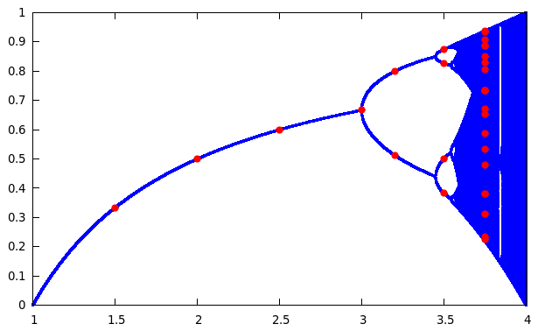
Fig. 1. The graph of the convergent points of the logistic map (20) with r along the abscissa and x along the ordinate axis, shown in blue, and the periodic points found by applying our extended interval Newton's method, shown in red.

4.2. The kicked rotor. The kicked rotor is a model for chaos studies, which describes a rotating rod which is kicked periodically by a homogeneous field. Its dynamics are described by the standard map [ref]

(23)

taken modulo 2π. The kicked rotor model is an approximation of systems studied in quantum mechanics [24], plasma physics [], solid state physics [] and particle physics [27].

Treating (23) as a two-dimensional function

(24)

we can seek the periodic points of period n with the help of our two-dimensional interval Krawczyk method by finding zeros of the function

(25)

where the superscript n denotes the n-composition as in (21). The results for points of period 1 to 4 are as follows.

1-periodic:
(0, 0)

2-periodic:
(1.32812164615400647499, 2.65624329230801270538 )
(3.1415926535897929937, 3.14159265358979299348 )
(4.95506366102558011696, 3.62694201487157351165)

3-periodic:
(0.806560442745249376478, 1.61312088549050729701 )
(1.76748900938308797098, 1.7674890093830876094 )
(4.51569629779649877807, 2.74820728841341117127)
(5.47662486443433212634, 2.33503221084453809028 )
(0.806560442745255646961, 3.94815309633504728909)
(1.76748900938308795797, 3.53497801876617509433 )
(4.515696297796499524, 4.51569629779649880409 )
(5.47662486443433730145, 4.67006442168907884207)

4-periodic:
(0.49205012902309243144, 0.984100258046184617634 )
(1.12061271550002283293, 1.12061271550002283185 )
(1.94858418114797580253, 1.45653405212488297558 )
(4.33460112603161137933, 2.38601694488363606458 )
(5.79113517815649389738, 1.45653405212488297373 )
(5.16257259168158489336, 2.02097993808812039277 )
(1.1206127154980039095, 4.26220536909146416197 )
(0.492050129023091697679, 4.82665125505470410557)
(1.94858418114797550947, 3.89716836229595025741 )
(4.33460112603161313617, 4.82665125505470410036 )
(5.16257259167956314384, 5.16257259167956295736 )
(5.79113517815649432412, 5.29908504913340143742)

In Fig. 2 the phase-space plot of the map (23) is presented for k = 1 with all the periodic points found.

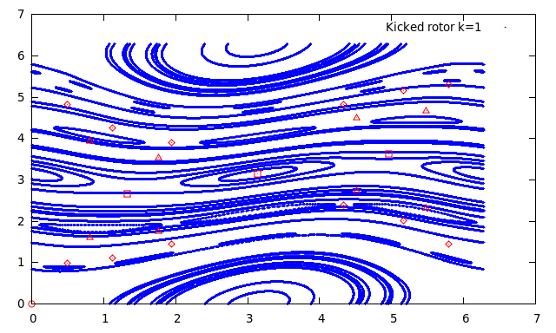
Fig. 2. The phase-space plot of the standard map (23), with the periodic points found by applying our two-dimensional interval Krawczyk method. 1-periodic points are shown as circles, 2-periodic as squares, 3-periodic as triangles and 4-periodic as rhombuses.

4.3. The Hénon map. The Hénon map is another well-studied two-dimensional map that exhibits chaotic behaviour [32]. Its dynamics are described by the following equations:

(26)

The classical set of the parameters of this map are a = 1.4, b = 0.3, for which the map is chaotic. Analogously to (24), we take the two-dimensional Hénon function and use our two-dimensional interval Krawczyk method to seek periodic points for the classical case. The results for the 1-, 2- and 4-periodic points are as follows (there were no 3-periodic points found).

1-periodic:

(–1.13135447708953442011e, –0.339406343126860313397)
(0.631354477089504723163e, 0.18940634312685140995)

2-periodic:

(–0.475800051175056966558, 0.292740015352516939591)
(0.975800051175056402475, –0.142740015352516985217 )

4-periodic:

(–0.706766777219408174151, 0.337520980960707702259 )
(0.638193992627155901628, –0.212030033165822425517 )
(0.217761765718631161359, 0.191458197788146763818 )
(1.12506993653569264653e, 0.0653285297155897614672)

In Fig. 3 we present these periodic points on the phase-space plot of the Hénon map.

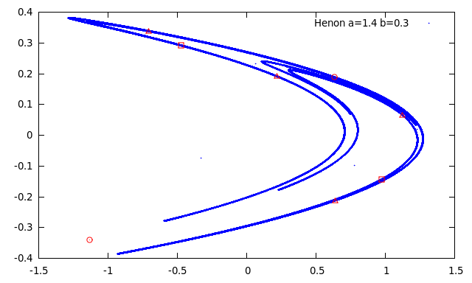
Fig. 3. The phase-space plot of the Hénon map with the periodic points found by applying our two-dimensional interval Krawczyk method. 1-periodic points are shown as circles, 2-periodic as squares and 4-periodic as triangles.

References

[1] H. Goldstein, C. Poole, J. Safko, Classical Mechanics (3rd ed.), Ch. 11, Addison-Wesley, 2001.
[2] A. A. Tsonis, J. B. Elsner, Bulletin of the American Meteorological Society, 70 (1), pp. 14 – 23.
[3] J. Shukla, Science 282 (5389) 1998, 728 – 731.
[4] D. Weixing, H. Wei, W. Xiaodong, C. X. Yu, Phys. Rev. Lett., 70 (2) 1993, pp. 170 – 173.
[5] L. Giuggioli, S. Pérez-Becker, D. P. Sanders, Phys. Rev. Lett. 110 (5), 058103 (2013).
[6] A. L. Fradkov, R. J. Evans, Annual Reviews in Control, 29 (1), 2005, pp. 33 – 56.
[7] M. Kopel, J. Evol. Econ. (1997) 7: 269 – 289.
[8] R. Krawczyk, Newton-Algorithmen zur Bestimmung von Nullstellen mit Fehlerschranken, Computing 4 (1969) 187 – 201.

[14] Moore. R. E. Interval Analysis. Prentice-Hall, Englewood Cliffs, NJ, USA, 1966.
[15] Cloud, Michael J.; Moore, Ramon E.; Kearfott, R. Baker (2009). Introduction to Interval Analysis. Philadelphia: Society for Industrial and Applied Mathematics.
[16] Shen Zuhe, A. Neumaier and M.C. Eiermann, Solving minimax problems by interval methods, BIT 30 (1990), 742 – 751.
[17] H. Schichl and A. Neumaier, Interval Analysis on Directed Acyclic Graphs for Global Optimization, J. Global Optimization 33 (2005), 541-562.

[19] W. Tucker, Validated Numerics, 2011
[20] R. Moore et al., Introduction to Interval Analysis, 2009
[21] W. Tucker, D. Wilczak, Physica D 238 (2009) 1923 – 1936
[22] E. Atlee Jackson, Alfred Hübler, Physica D 44 3 (1990) 407 – 420
[23] M. Ausloos, M. Dirickx, The logistic map and the route to chaos: From the beginnings to modern applications, Springer Berlin Heidelberg New York, 2006
[24] A. Altland, M. R. Zirnbauer, Phys. Rev. Lett. 77 4536 (1996)

[27] I. Sh. Averbukh and R. Arvieu, Phys. Rev. Lett. 87, 163601 (2001)
[28] M. Artin, B. Mazur, Annals of Mathematics, Second Series, Vol. 81, No. 1 (1965) 82 – 99
[29] Block, Louis, et al. "Periodic points and topological entropy of one dimensional maps." Global theory of dynamical systems. Springer Berlin Heidelberg, 1980. 18 – 34.
[30] S. E. Newhouse, Am. J. Math. Vol. 99, No. 5 (1977) 1061 – 1087
[31] V. Chothi, G. Everest, T. Ward, Journal für die reine und angewandte Mathematik (Crelles Journal), Vol. 1997, Issue 489, 99 – 132
[32] M. Hénon, Communications in Mathematical Physics 50 (1) 69–77 (1976)

