**Credit Risk Modeling of Financial Derivatives**

**KŘIVÁNKOVÁ Lenka and ZLATOŠOVÁ Silvie**

Lenka Křivánková, Department of Mathematics and Statistics, Faculty of Science, Masaryk University, Žerotínovo náměstí 617/9, 601 77 Brno, e-mail: 142474@mail.muni.cz

Silvie Zlatošová, Department of Finance, Faculty of Economics and Administration, Masaryk University, Žerotínovo náměstí 617/9, 601 77 Brno, e-mail: 175424@mail.muni.cz

**Abstract:** According to the Basel Committee's estimate three fourths of the counterparty credit risk losses during the financial crisis originate from Credit valuation adjustment's losses and not from actual defaults. Therefore Third Basel Accord has instructed banks to calculate capital requirement for risk of Credit valuation adjustment (CVA) from 2015. Banks are trying to model CVA to hold the prescribed standards and also reached the lowest possible impact on their profit. In this paper, we try to model CVA by using methods that are in compliance with the prescribed standards and also achieve the smallest possible impact on the bank's earnings. To do so, the data set of interest rate swaps from the year 2015 is used. The interest rate term structure is simulated by Hull-White one-factor model and Monte Carlo methods. Than the probability of default for each counterparty is constructed. Safe leval of CVA is reached in spite of calculated CVA achieves a lower level than CVA previously used by bank. This allows a reduction of capital requirements for banks. All claculations are computed in Matlab enviroment which contains packages of financial mathematics and stats with the function for the Hull-White model and the function for the estimation of probability of default which are necessary for the computation of the CVA.

**Keywords:** credit valuation adjustment, probability of default, interest rate swaps, yield curve, Hull-White model, Monte Carlo simulations, credit exposure

**Introduction**

The current situation in the banking market pressures banks to look for new opportunities to generate income. Common methods of making a profit are not as profitable as they were in the past. We can observe not only a negative inter bank offered rates, but also competitive fight for clients, which causes strong pressure to decrease bank fees and almost unprofitable lending. The banks, therefore, search for new possibilities how to decrease costs such as loan loss provission and credit valuation adjustment.One of the possibilities could be development of a new approach to CVA modeling respecting regulatory standards and simultaneously achieving maximal profit.

Banks often use proprietary parametric models, which are, although, very conservatively set due to risk vigilance. We suppose that a more sophisticated model would bring lower CVA as well as lower capital requirement for a bank.

A good introduction to pricing counter party credit risk can be found in a paper by Michael Pykhtin and Steven Zhu (2007). This paper discusses approaches to CVA calculation. A detailed review of counterparty credit risk modeling is given in Jon Gregory (2010). This book interestingly explains the rise of counterparty risk during the financial crisis. The quantification of credit exposure is presented as well as risk mitigation methods.

Under usual approaches CVA is measured at the counterparty level. Nevertheless, it can be sometimes required to determine contributions of individual trades to the CVA at the counterparty level. Pykhtin and Rosen (2010) thoroughly analyse the problem of allocating CVA to the individual trades. They explain how this problem can be simplified to calculating contributions of the trades to the expected exposure of the each counterparty where the expected exposure is conditioned by the default of counterparty.

K modelování úrokové míry budeme využívat Hull-White model. Hull a White publikují i o CVA v Hull and White (2012).

**Materials and Methods**

In this section, we developed the basic methodology to compute CVA and describe the basic terms.

**Components of credit valuation adjustment and terminology**

The basic concepts and notation for counterparty credit risk and CVA will be shown in this section. Counterparty credit risk (CCR) is the risk that the counterparty defaults before the final settlement of a transaction's cash flows. CVA can be explained as the difference between the portfolio's risk-free value and the portfolio's true value taking into account the possibility of default of the counterparty. In the next definition CVA is calculated as expectation of credit loss. *The credit valuation adjustment* is defined as

(1)

where is recovery rate, is the discounted expected exposure at time and is probability of default. In what follows, we specify the components of CVA. Recovery rate is the value of unity less *Loss given default (LGD)*, i.e. . The LGD is the percentage amount of the exposure expected to be lost if the counterparty defaults.

The counterparty credit exposure of the bank to a counterparty at time (hereafter simply exposure) is defined as the economic loss, incurred on all outstanding transactions with the counterparty if the counterparty defaults at . Denote the value of the -th instrument in the portfolio at time by . The value of the counterparty portfolio is given by

(2)

When netting is not allowed, the exposure E(t) is given by

(3)

For a counterparty portfolio with a netting agreement, the exposure is

(4)

Discounting is a financial mechanism in which a future value is being recalculated to the present value. The discount factor, , is the factor by which a future cash flow must be multiplied in order to obtain the present value. Consider the discount factor at time , defined as

(5)

where is risk-free rate of return and is the value of risk free asset at time . Hence, the discounted expected exposure at time conditional on the counterparty default at time is given by

(6)

Next component of the equation (1) is *Probability of Default*, which describes the creditworthiness of a counterparty. It provides an estimate of the likelihood that a borrower will be unable to meet its debt obligations. There are many alternatives for estimating the probability of default. The frequently used approach, taken by many banks, is to use external ratings agencies (such as S&P, Fitch or Moody's) for estimating PD from historical default experience.

**Results**

The numerical illustration of the calculation of CVA will be introduced in this section. We work with data set of interest rate swaps from the year 2015. An *interest rate swap (IRS)* is an agreement between two parties to exchange a interest rate cash flows on specified intervals and over a certain period of time. These data come from a bank operating in the Czech Republic. The data contains information about five vanilla interest rate swaps and each of them is associated with different counterparty.

Table I: Variables in a data set

|  |  |
| --- | --- |
| Notation | Name of Variable |
| ID | Counterparty ID |
| principal | Principal of swap |
| maturity | Maturity date of swap |
| LegRateReceiving | Interest rate received by bank |
| LegRatePaying | Interest rate paid by bank |
| period | Period of paying |

Source:

**Initial yield curve**

In order to evaluate the swaps, is necessary to describe a discount curve. The initial discount curve can be obtain by a linear interpolation of the risk free interest rates of different maturities. The initial rates were found at the web page of PATRIA (URLhttp://www.patria.cz/kurzy/CZK/5Y/irs/graf.html) and we can see them in the Tab. II. The interest rate shorter than one year were extracted from PRIBOR rates on October 30th, 2015. The Fig. 1 shows the initial yield curve at settlement date which was built from the initial rates in the Tab. II.

Table II: Initial rates

|  |  |
| --- | --- |
| Maturity (years) | Rate (%) |
| 0.25 | 0.14 |
| 0.5 | 0.16 |
| 1 | 0.21 |
| 2 | 0.25 |
| 3 | 0.28 |
| 4 | 0.33 |
| 5 | 0.40 |
| 6 | 0.47 |
| 7 | 0.56 |
| 8 | 0.65 |
| 9 | 0.75 |
| 10 | 0.83 |
| 12 | 0.99 |
| 15 | 1.16 |
| 20 | 1.27 |

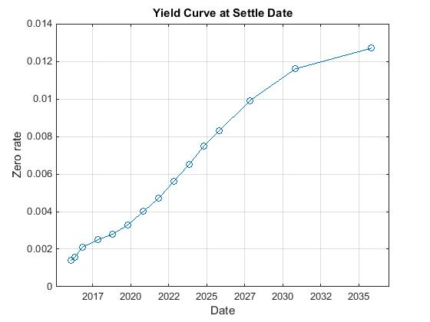

Figure 1: Yield Curve

**Interest rate simulation**

The interest rate simulation is based on historical data of the three month PRIBOR rate, from 2. 1. 2014 to 24. 11. 2015. The development of three month PRIBOR rate can be observed in the Fig. 2.

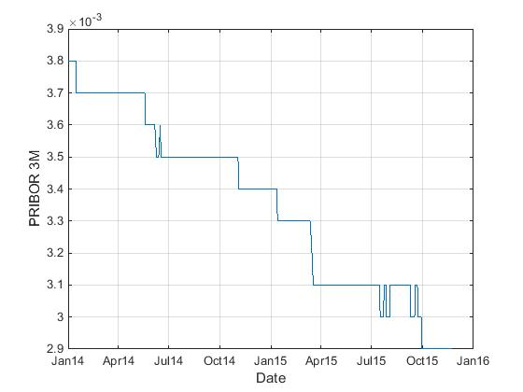

Figure 2: The three month PRIBOR rate

The well known interest rate evolution model, Hull-White one-factor model, will be used for modeling of the interest rate term structure. The model was first published by John Hull and Alan White (1990) and generalized later in Hull and White (2001). A general overview of the model can be found in Brigo, Capponi and Pallavicini (2014). The requirement for more accurate fit to the currently-observed yield curve, led Hull and White to the introduction of a time variable parameter in the Vasicek model. The model assumes that short rates have a normal distribution, and also that the short rates exhibit the mean reversion character. The Hull-White model extends the Vasicek and Cox-Ingersoll-Ross (CIR) models.

We can define this model by equation

(7)

where

The change in the interest rate after a small change in time, .

Constant reversion speed.

Volatility of the interest rate.

A Wiener process.

Drift function defined as

(8)

where

Instantaneous forward rate at time .

Instantaneous forward rate is defined as

(9)

where is price of a zero coupon bond at time with maturity at time .

The constants and are extracted from the historical three month PRIBOR rates. We use equation (7) to simulated the short interest rates. We can expand the entire interest rate curve from the short rate using

(10)

The large number of simulations was made. The example of yield surfaces obtained in one interest rate simulation is possible to observe in the Fig. 3.

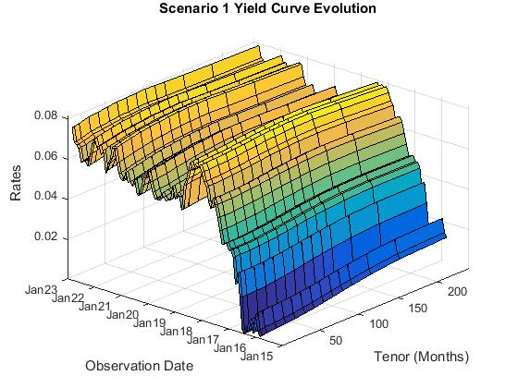

Figure 3: One Possible Scenario of Yield Curve Evolution

For each scenarios the swaps are priced at each future simulation date.

The main advantage of the Hull-White model is that it can be fitted exactly to the initial term structure of interest rates.

**Probability of default**

We assume that the wait time for default of a counterparty is a random variable with exponential distribution. Then the cumulative distribution function of this variable can be define as

(11)

where is the parameter of the distribution. Probability of default of the counterparty during one year we denote . Then

(12)

If we use value of PD from odkud bereme PD, Leni? could be estimate from (12)

(13)

Then we can construct probability curve for each counterparty. It is possible to observed them in the Fig. 4.

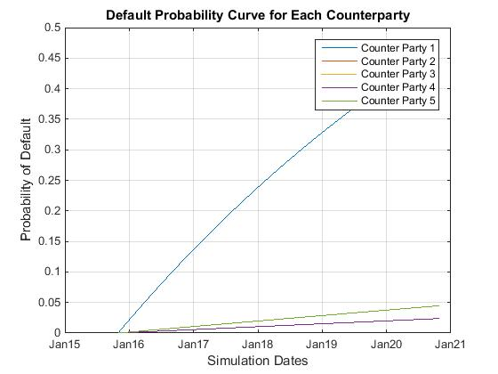

Figure 4: Default Probability Curves

**Computation of CVA**

Let consider the exposure is independent of default. Then total exposure of all contracts can be computed on the bases of equation (4). The bank has estimated recovery rate . Now we have everything for the CVA calculation according to the equation (1). The resulting values of CVA for each counterparty can be observed in the Tab. III.

|  |  |
| --- | --- |
| Counterparty | CVA (in CZK) |
|  | 1 056 075.83 |
|  | 265 290.14 |
|  | 369.19 |
|  | 1 045.54 |
|  | 103 319.55 |

Table III: Resulting CVA

**References**

ARORA, N., GANDHI, P. and LONGSTAFF, F. A. 2012. Counterparty credit risk and the credit default swap market. *Journal of Financial Economics*, 103(2):280-293.

BOUCHAUD, J.-P. and POTTERS, M. 2003. *Theory of financial risk and derivative pricing: from statistical physics to risk management*. edition. Cambridge: Cambridge University Press.

BRIGO, D., CAPPONI, A. and PALLAVICINI, A. 2014. Arbitrage-free bilateral counterparty risk valuation under collateralization and application to credit default swaps. *Mathematical Finance*, 24(1):125--146.

CANABARRO, E. and DUFFIE, D. 2003. Measuring and marking counterparty risk. *Asset/Liability Management for Financial Institutions, Institutional Investor Books*. Euromoney Institutional Investor PLC. [Online]. Available at: http://www.darrellduffie.com/uploads/surveys/duffiecanabarro2004.pdf. [Accessed: 2016, November 10]

DUFFIE, D. 2003. Intertemporal asset pricing theory. *Handbook of the Economics of Finance*, *1(2)*: 639-742.

ETHERIDGE, A. 2002. *A course in financial calculus*. New York: Cambridge University Press.

GREGORY, J. 2010. *Counterparty credit risk: the new challenge for global financial markets*, West Sussex: John Wiley & Sons.

HULL, J. 2012 *Options, futures, and other derivatives (8. ed., global ed.)*. Boston [u.a.] : Pearson.

HULL, J. and WHITE, A. 1990. Pricing interest-rate-derivative securities. *Review of financial studies*, 3(4): 573-592.

HULL, J. and WHITE, A. 2001. The general hull-white model and supercalibration. *Financial Analysts Journal*, 57(6): 34-43.

HULL, J. and WHITE, A. 2012. Cva and wrong-way risk. *Financial Analysts Journal*, 68(5): 58-69.

JÍLEK, J. 2000. *Finanční rizika*. 1. vyd. Praha: Grada.

PYKHTIN, M. and ROSEN, D. 2010. Pricing counterparty risk at the trade level and CVA allocations. [Online]. FEDS Working Paper No. 10. Available at: http://ssrn.com/abstract=1782063

PYKHTIN, M. and ZHU, S. H. 2007. A guide to modeling counterparty credit risk. *GARP Risk Review.*