Database
The Database layout was chosen to be in 3rd Normalform to minimize duplication of data and safeguard against data anomalies (update, insertion and deletion anomalies) . To still be able to use the database comfortable we decided to incorporate views which are temporary tables, thus do not use any space but still can be a lot more efficent than executing the same statement as the database engine is able to precalculate them.
Furthermore our design allows to enforce security measures such as storing the password table in a seperate database (only accessable for few) or providing reading allowances to endusers for the statistical views (which do not contain any privat or security relevant information).
The database user stored in our config.php has only the minimum rights necessary so can only insert datasets and issue select queries. This provides security in the case of security breach (sql-injection).

CREATE USER 'web'@'localhost' IDENTIFIED BY 'test';
GRANT SELECT,INSERT ON stss.* TO 'web'@'localhost';

CREATE VIEW availableseats AS
SELECT eventID, category, name, date, price, amount,
COUNT(purchases.seatID) AS sold,
(amount - COUNT(purchases.seatID)) AS available
FROM events NATURAL LEFT OUTER JOIN seats
NATURAL LEFT OUTER JOIN purchases
GROUP BY eventID, category;
-- --------------------------------------------------------
CREATE VIEW event_cat_stats AS
SELECT *,
((amount-sold)/amount*100) AS perc_unsold,
((sold)/amount*100) AS perc_sold,
(price * sold) AS revenue
FROM `availableseats`;
-- --------------------------------------------------------
CREATE VIEW event_stats AS
SELECT eventID, name, date,
SUM(amount) AS amount,
SUM(sold) AS sold,
SUM(available) AS available,
(SUM(available) / SUM(amount)*100) AS perc_unsold,
(SUM(sold) / SUM(amount)*100) AS perc_sold,
SUM(revenue) AS total_rev
FROM `event_cat_stats`
GROUP BY eventID;
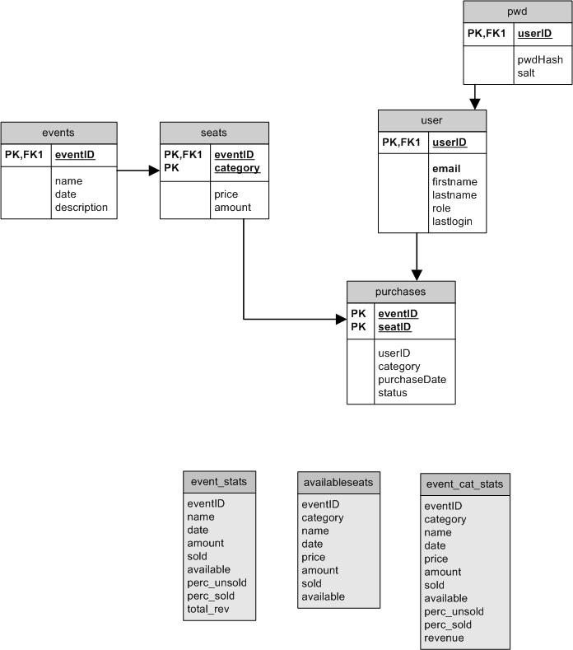

Framework
We decided to implement our own Model View Controller (MVC) Framework to use in this project. It proved to facilitate our work to the end because it allowed more independend changes (for instance one would be working on improving the look of the website in the view only and the other enforcing sql-injection protection in the model and simultaneous changes would not interfere with each other).
CONTROLLER
<?php

//requires ...

//initSession
...

//Resolved the required module and action from GET
//defaults to default action
...

//sets session language
...

// initialize file paths to be used for requested action
$actionFile = BASE_PATH.'/modules/'.$module.'/'.$action.'.model.php';
//select View based on action and language settings
$viewFile = BASE_PATH.'/views/'.$_SESSION['lang'].'/'.$module.'/'.$action.'.view.php';

//including model and view functions
...

//check if authenticated, included from model
if (authenticate()) {

//let the model do the work
$result = work();

//display the results with the view
display($result);
}
... no access

//if errors occured show here
...
?>
Our main component is the controller – index.php – which depending on the user request (as GET) selects a corrosponding module and action and their respective model.php and view.php.
The controller also initiates the session, selects the required language, includes commonly used resources and enforces security by requiering a authenticate() function to exist in every model.php and calling it.
MODEL:
<?php

function authenticate () {
//implement your own or call either
//authNO();
//or
//authUser();
//defined in Framework
}

function work() {
$result = array();
//Do your work and
//return $result = array();
//with the results
return $result;
}

?>

The model has to implement a authenticate() function with is called in the controller. The work() function does the actual model state changes and returns a result in the form of an array.

VIEW:
<?php

function display($data) {
showHeader(INDEX);

//output here page content generated out of results storend
//in array $data

showFooter();
}

?>

In the view there is only called display() function with the $result array as parameter. One then may display whatever output is requiered.

Five steps(copy&paste from wikipedia):
- The user interacts with the user interface in some way (e.g. presses a button).
- A controller handles the input event from the user interface, often via a registered handler or callback.
- The controller notifies the model of the user action, possibly resulting in a change in the model's state. (e.g. controller updates user's Shopping cart).[3]
- A view uses the model (indirectly) to generate an appropriate user interface (e.g. the view produces a screen listing the shopping cart contents). The view gets its own data from the model. The model has no direct knowledge of the view.
- The user interface waits for further user interactions, which begins the cycle anew.

- webroot/
  - includes/
  - modules/
    - buy/
      - add_ticket.model.php
      - buy_ticket.model.php
      - select_payment.model.php
      - view_cart.model.php
    - event/
    - user/
    - welcome/
  - views/
    - css/
    - de/
    - en/
      - buy/
        - add_ticket.view.php
        - buy_ticket.view.php
        - select_payment.view.php
        - view_cart.view.php
      - event/
      - user/
      - welcome/
    - images/
    - javascript/
    - common.php
    - language.php
    - menu.php
  - index.php
  - config.php

Full Database Layout
CREATE USER 'web'@'localhost' IDENTIFIED BY 'test';
GRANT SELECT,INSERT ON stss.* TO 'web'@'localhost';

CREATE TABLE `events` (
`eventID` int(11) NOT NULL auto_increment,
`name` varchar(40) NOT NULL,
`date` datetime NOT NULL,
`description` text NOT NULL,
PRIMARY KEY (`eventID`)
) ENGINE=InnoDB DEFAULT CHARSET=latin1;
-- --------------------------------------------------------
CREATE TABLE `purchases` (
`eventID` int(11) NOT NULL,
`userID` int(11) NOT NULL,
`seatID` int(11) NOT NULL,
`category` varchar(40) NOT NULL,
`purchaseDate` datetime NOT NULL,
`status` varchar(40) default NULL,
PRIMARY KEY (`eventID`,`seatID`)
) ENGINE=InnoDB DEFAULT CHARSET=latin1;
-- --------------------------------------------------------
CREATE TABLE `pwd` (
`userID` int(11) NOT NULL,
`pwdHash` varchar(256) NOT NULL,
`salt` varchar(128) NOT NULL,
PRIMARY KEY (`userID`)
) ENGINE=InnoDB DEFAULT CHARSET=latin1;
-- --------------------------------------------------------
CREATE TABLE `seats` (
`eventID` int(11) NOT NULL,
`category` varchar(40) NOT NULL,
`price` float NOT NULL,
`amount` int(11) NOT NULL,
PRIMARY KEY (`eventID`,`category`)
) ENGINE=InnoDB DEFAULT CHARSET=latin1;
-- --------------------------------------------------------
CREATE TABLE `user` (
`userID` int(11) NOT NULL auto_increment,
`email` varchar(40) NOT NULL,
`firstname` varchar(40) NOT NULL,
`lastname` varchar(40) NOT NULL,
`role` tinyint(4) NOT NULL,
`lastlogin` datetime NOT NULL,
PRIMARY KEY (`userID`),
UNIQUE KEY `email` (`email`)
) ENGINE=InnoDB;
-- --------------------------------------------------------
CREATE VIEW availableseats AS
SELECT eventID, category, name, date, price, amount,
COUNT(purchases.seatID) AS sold,
(amount - COUNT(purchases.seatID)) AS available
FROM events NATURAL LEFT OUTER JOIN seats
NATURAL LEFT OUTER JOIN purchases
GROUP BY eventID, category;
-- --------------------------------------------------------
CREATE VIEW event_cat_stats AS
SELECT *,
((amount-sold)/amount*100) AS perc_unsold,
((sold)/amount*100) AS perc_sold,
(price * sold) AS revenue
FROM `availableseats`;
-- --------------------------------------------------------
CREATE VIEW event_stats AS
SELECT eventID, name, date,
SUM(amount) AS amount,
SUM(sold) AS sold,
SUM(available) AS available,
(SUM(available) / SUM(amount)*100) AS perc_unsold,
(SUM(sold) / SUM(amount)*100) AS perc_sold,
SUM(revenue) AS total_rev
FROM `event_cat_stats`
GROUP BY eventID;

http://en.wikipedia.org/wiki/Database_normalization
http://en.wikipedia.org/wiki/Database_view

