**Group by** collapses groups of rows into a single result row

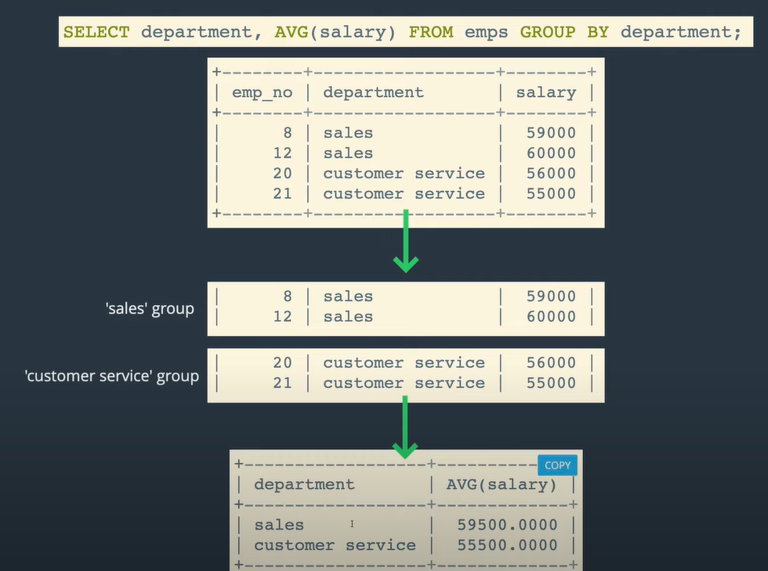

**Window functions** perform aggregate operations on groups of rows, but they produce a result for each row

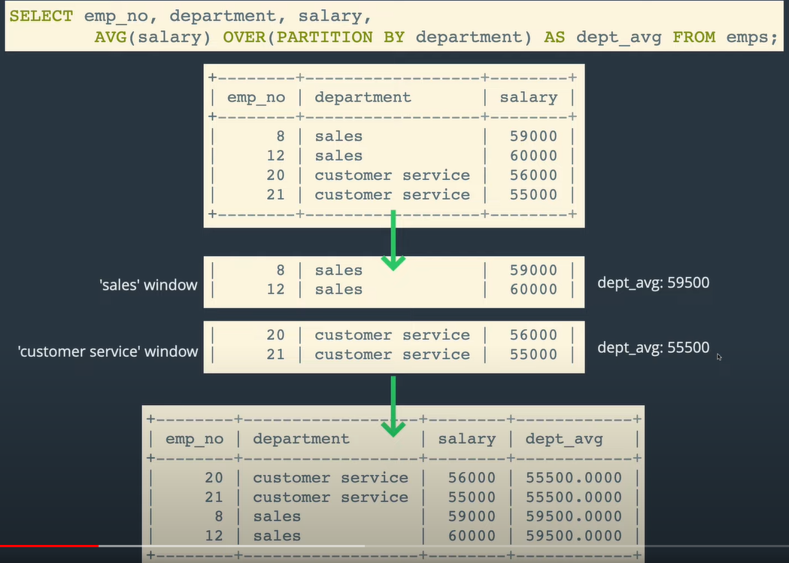

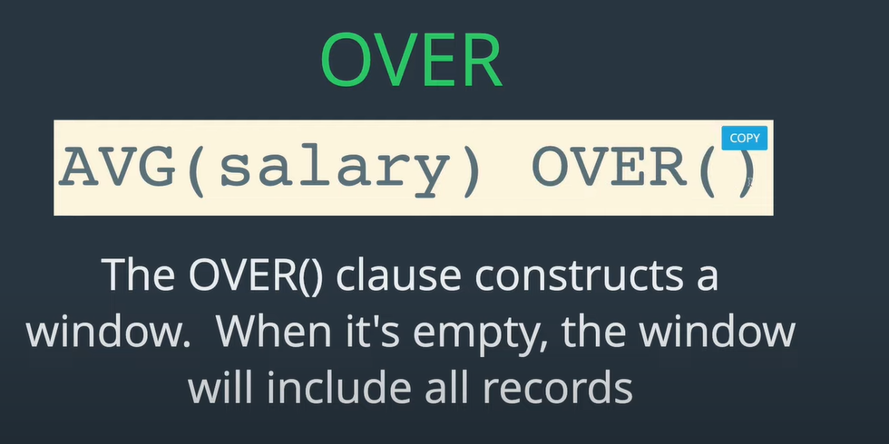

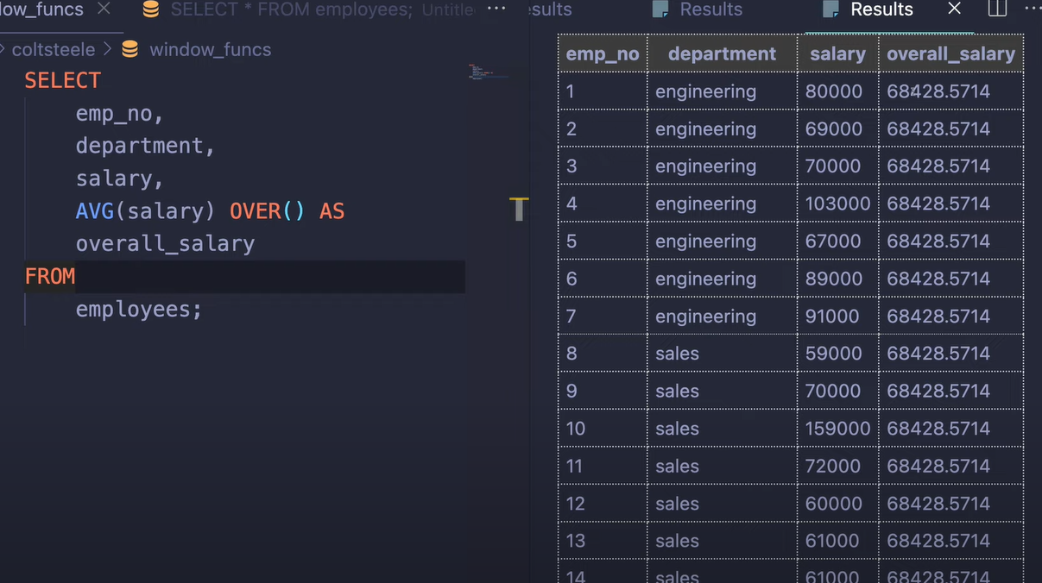

* I can see that now the overal salary is the same for all the rows

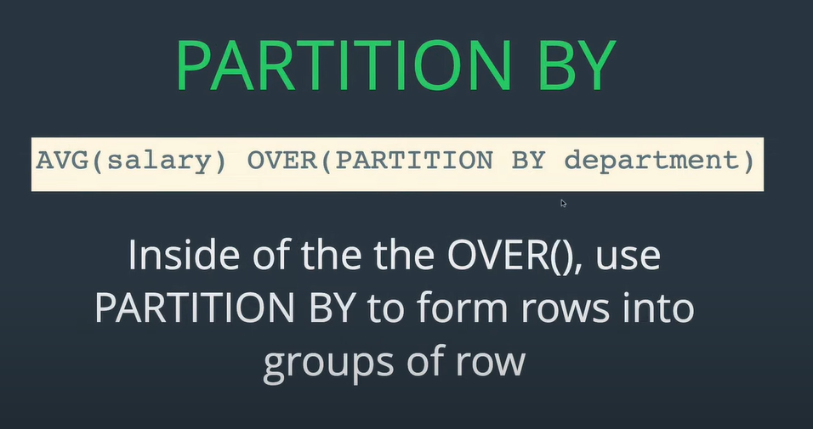

* Instead of one massive window with all the rows and calculating the mean for them, I want to calculate the average for all the rows in each window (basically window = group) partitioned by department

Some functins can only be used as a window functions:

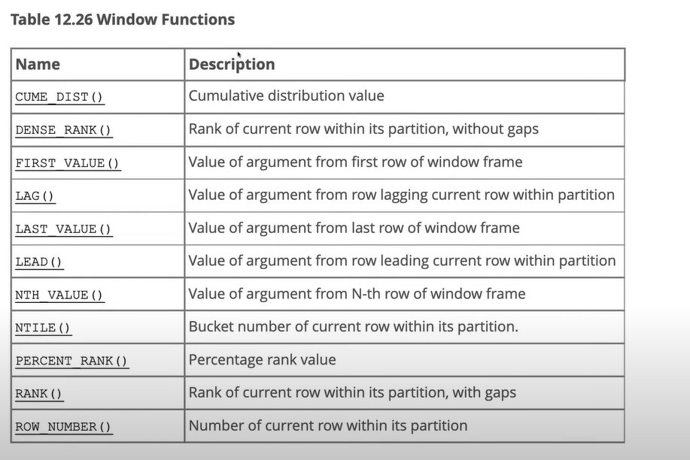

Funkce RANK() – chci vyjádřit pořadí salary within a window (group) – I need to include new piece of syntax

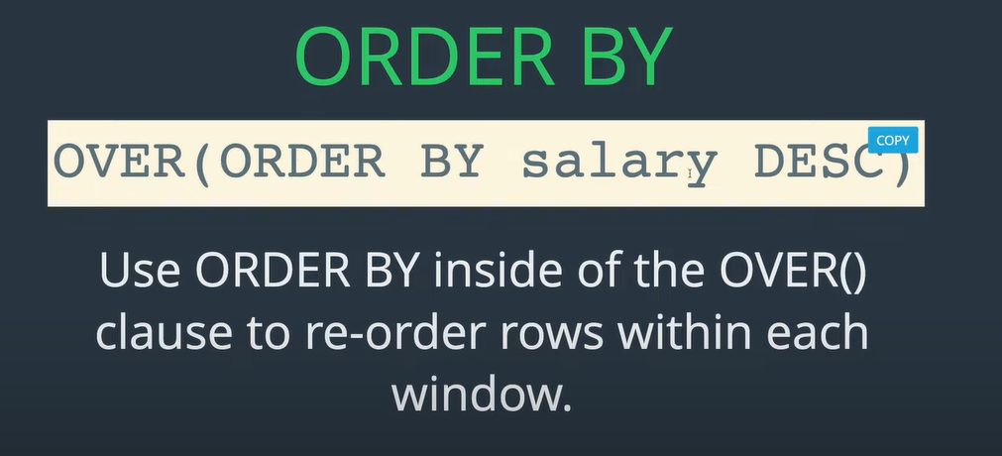

* This gives me just one big window ordered by salary

If I want to also get the order within windows (groups) – here for example based on department column

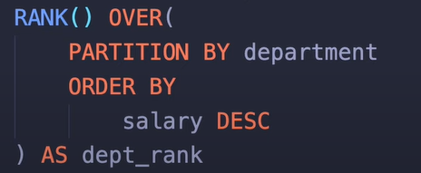

<https://youtu.be/y1KCM8vbYe4?feature=shared>