**Practical 4:**

**AIM: Exploring Router and VLAN security, setting up access lists using Cisco Packet tracer**

1. **Configure the router and apply ACL rules as follows:-**

* **192.168.1.2 deny**
* **Permit any**

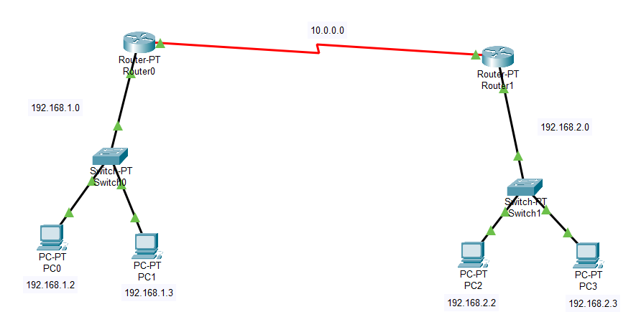

**ACL**

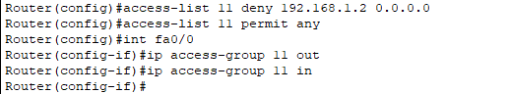

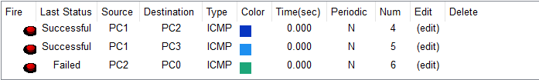

1. **Configure the router and apply ACL rules as follows: -**
2. **Deny the host 192.168.1.1 with the network 192.168.2.0**
3. **Deny the host 192.168.1.2 with the network 192.168.2.0**
4. **Deny the network 192.168.3.0 with the network 192.168.2.0**
5. **Permit all the remaining traffic**

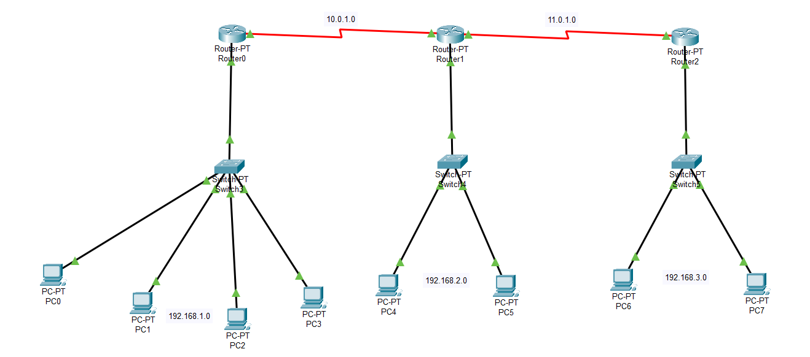

Blocking PC0 Having IP 192.168.1.2

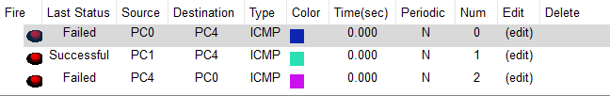

Blocking PC1 Having IP 192.168.1.3

