**Statistics Using Technology**

**Second Edition**

By Kathryn Kozak

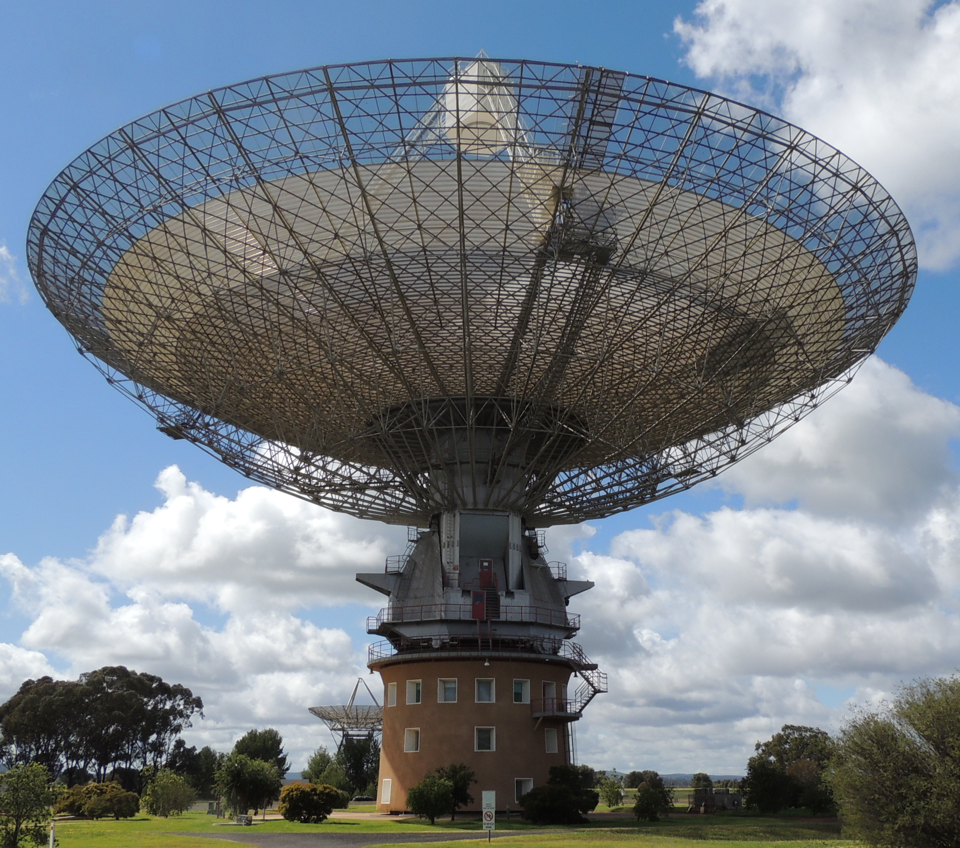

Photo taken by Richard Kozak at Parkes Observatory in Parkes, NSW, Australia

http://i.creativecommons.org/l/by-sa/3.0/88x31.png

**Creative Commons Attribution Sharealike**. This license is considered to be some to be the most open license. It allows reuse, remixing, and distribution (including commercial), but requires any remixes use the same license as the original. This limits where the content can be remixed into, but on the other hand ensures that no-one can remix the content then put the remix under a more restrictive license.

2015 Kathryn Kozak

**ISBN:** 978-1-329-75725-7

**Table of Content:**

**Preface iii**

**Chapter 1: Statistical Basics 1**

Section 1.1: What is Statistics? 1

Section 1.2: Sampling Methods 8

Section 1.3: Experimental Design 14

Section 1.4: How Not to Do Statistics 19

**Chapter 2: Graphical Descriptions of Data 25**

Section 2.1: Qualitative Data 25

Section 2.2: Quantitative Data 37

Section 2.3: Other Graphical Representations of Data 59

**Chapter 3: Numerical Descriptions of Data 75**

Section 3.1: Measures of Center 75

Section 3.2: Measures of Spread 90

Section 3.3: Ranking 107

**Chapter 4: Probability 121**

Section 4.1: Empirical Probability 121

Section 4.2: Theoretical Probability 124

Section 4.3: Conditional Probability 140

Section 4.4: Counting Techniques 152

**Chapter 5: Discrete Probability Distributions 157**

Section 5.1: Basics of Probability Distributions 157

Section 5.2: Binomial Probability Distribution 167

Section 5.3: Mean and Standard Deviation of Binomial Distribution 181

**Chapter 6: Continuous Probability Distributions 187**

Section 6.1: Uniform Distribution 187

Section 6.2: Graphs of the Normal Distribution 190

Section 6.3: Finding Probabilities for the Normal Distribution 193

Section 6.4: Assessing Normality 203

Section 6.5: Sampling Distribution and the Central Limit Theorem 216

**Chapter 7: One-Sample Inference 229**

Section 7.1: Basics of Hypothesis Testing 229

Section 7.2: One-Sample Proportion Test 242

Section 7.3: One-Sample Test for the Mean 249

**Chapter 8: Estimation 263**

Section 8.1: Basics of Confidence Intervals 263

Section 8.2: One-Sample Interval for the Proportion 267

Section 8.3: One-Sample Interval for the Mean 272

**Chapter 9: Two-Sample Inference 283**

Section 9.1: Two Proportions 283

Section 9.2: Paired Samples for Two Means 293

Section 9.3: Independent Samples for Two Means 313

Section 9.4: Which Analysis Should You Conduct? 339

**Chapter 10: Regression and Correlation 343**

Section 10.1: Regression 343

Section 10.2: Correlation 363

Section 10.3: Inference for Regression and Correlation 371

**Chapter 11: Chi-Square and ANOVA Tests 393**

Section 11.1: Chi-Square Test for Independence 393

Section 11.2: Chi-Square Goodness of Fit 411

Section 11.3: Analysis of Variance (ANOVA) 419

**Appendix: Critical Value Tables 433**

Table A.1: Normal Critical Values for Confidence Levels 434

Table A.2: Critical Values for t-Interval 435

**Answers to Odd Questions 439**

**Index 447**

**Preface:**

I hope you find this book useful in teaching statistics. When writing this book, I tried to follow the GAISE Standards (*GAISE recommendations*. (2014, January 05). Retrieved from <http://www.amstat.org/education/gaise/GAISECollege_Recommendations.pdf>

), which are

1. Emphasis statistical literacy and develop statistical understanding.
2. Use real data.
3. Stress conceptual understanding, rather than mere knowledge of procedure.
4. Foster active learning in the classroom.
5. Use technology for developing concepts and analyzing data.

To this end, I ask students to interpret the results of their calculations. I incorporated the use of technology for most calculations. Because of that you will not find me using any of the computational formulas for standard deviations or correlation and regression since I prefer students understand the concept of these quantities. Also, because I utilize technology you will not find the standard normal table, Student’s t-table, binomial table, chi-square distribution table, and F-distribution table in the book. The only tables I provided were for critical values for confidence intervals since they are more difficult to find using technology. Another difference between this book and other statistics books is the order of hypothesis testing and confidence intervals. Most books present confidence intervals first and then hypothesis tests. I find that presenting hypothesis testing first and then confidence intervals is more understandable for students. Lastly, I have de-emphasized the use of the z-test. In fact, I only use it to introduce hypothesis testing, and never utilize it again. You may also notice that when I introduced hypothesis testing and confidence intervals, proportions were introduced before means. However, when two sample tests and confidence intervals are introduced I switched this order. This is because usually many instructors do not discuss the proportions for two samples. However, you might try assigning problems for proportions without discussing it in class. After doing two samples for means, the proportions are similar. Lastly, to aid student understanding and interest, most of the homework and examples utilize real data. Again, I hope you find this book useful for your introductory statistics class.

I want to make a comment about the mathematical knowledge that I assumed the students possess. The course for which I wrote this book has a higher prerequisite than most introductory statistics books. However, I do feel that students can read and understand this book as long as they have had basic algebra and can substitute numbers into formulas. I do not show how to create most of the graphs, but most students should have been exposed to them in high school. So I hope the mathematical level is appropriate for your course.

The technology that I utilized for creating the graphs was Microsoft Excel, and I utilized the TI-83/84 graphing calculator for most calculations, including hypothesis testing, confidence intervals, and probability distributions. This is because these tools are readily available to my students. Please feel free to use any other technology that is more appropriate for your students. Do make sure that you use some technology.

**Acknowledgments:**

I would like to thank the following people for taking their valuable time to review the book. Their comments and insights improved this book immensely.

Jane Tanner, Onondaga Community College

Rob Farinelli, College of Southern Maryland

Carrie Kinnison, retired engineer

Sean Simpson, Westchester Community College

Kim Sonier, Coconino Community College

Jim Ham, Delta College

David Straayer, Tacoma Community College

Kendra Feinstein, Tacoma Community College

Students of Coconino Community College

Students Tacoma Community College

I also want to thank Coconino Community College for granting me a sabbatical so that I would have the time to write the book. Lastly, I want to thank my husband Rich and my son Dylan for supporting me in this project. Without their love and support, I would not have been able to complete the book.

**New to the Second Edition:**

The additions to this edition mostly involve adding the commands to create graphs, compute descriptive statistics, finding probabilities, and computing inferential analysis using the open source software R. Another change involve adding an example at the end of chapter 3 that shows analyzing a data set using graphical and numerical descriptions. Another major change was adding a section 9.4 that gives some insight into which inferential analysis should be completed based on a series of questions that should be asked. Lastly, minor explanations were made and corrections were made where necessary.

On a personal note, I wanted to thank my brother, John Matic, his wife Jenelle, and their children Hannah and Eli for their hospitality when writing the first edition. In addition to allowing my family access to their home, John provided numerous examples and data sets for business applications in this book. I inadvertently left this thank you out of the first edition of the book, and for that I apologize. His help and his family’s hospitality were invaluable to me.