Executing MapReduce code.

* Start eclipse, create new java project. 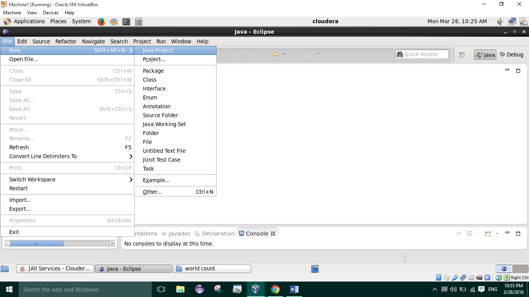
* Open ‘src’ and paste the mapper,reducer and job java files in default package. 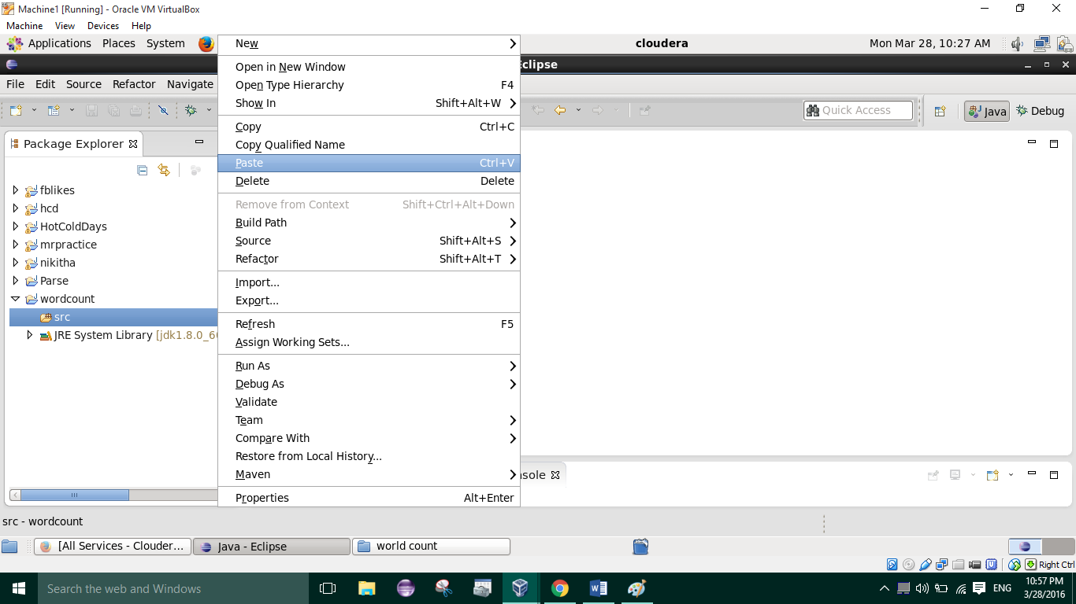
* Click on ‘project’ 🡪 ‘properties’ 🡪 Java build path 🡪 add external jars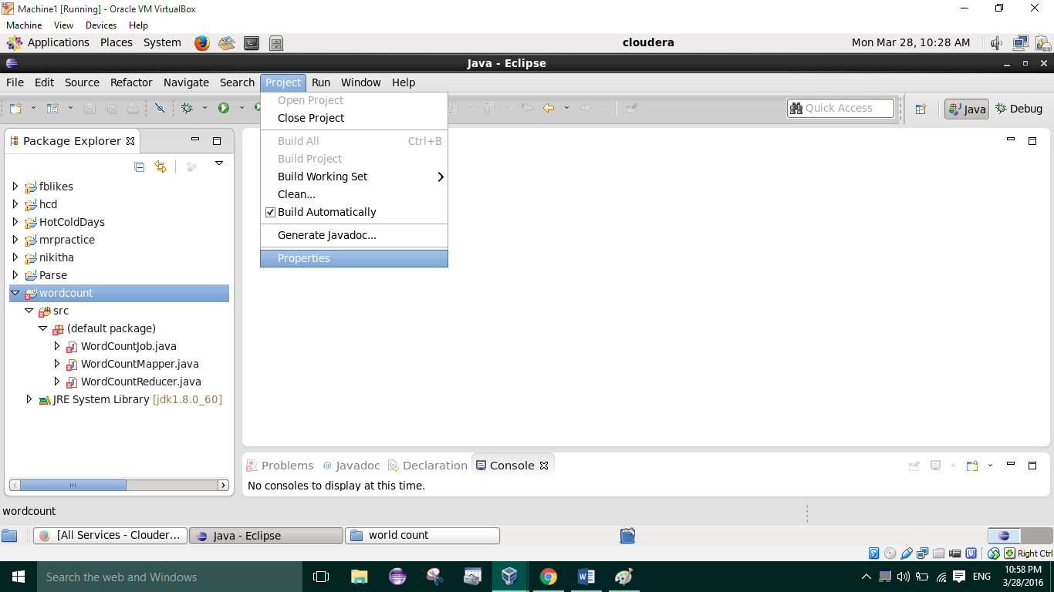
* Add the following jars
  + Usr/lib/Hadoop/Hadoop-common.jar
  + Usr/ lib/Hadoop/ client-0.20/ (all jars)
  + Usr/lib/Hadoop/lib/commons-code-1.4.jar

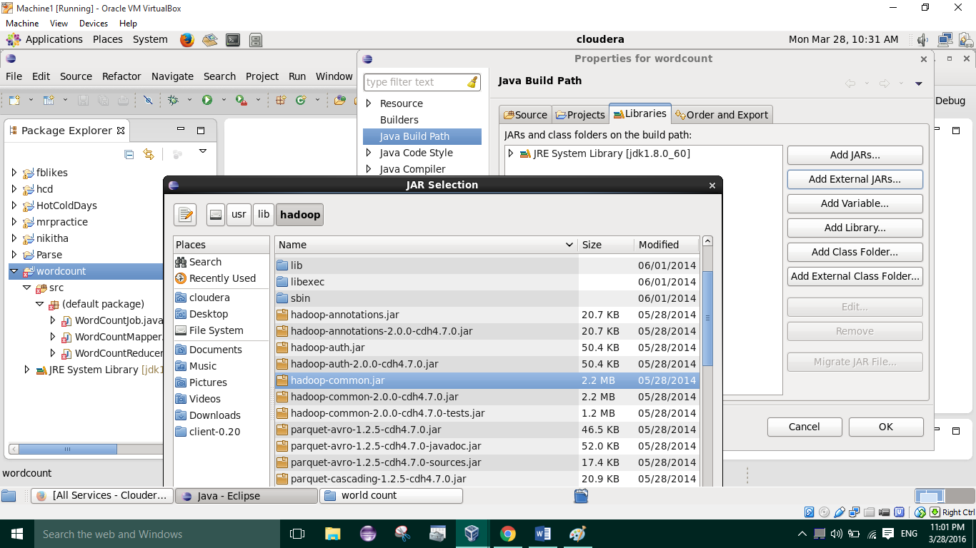

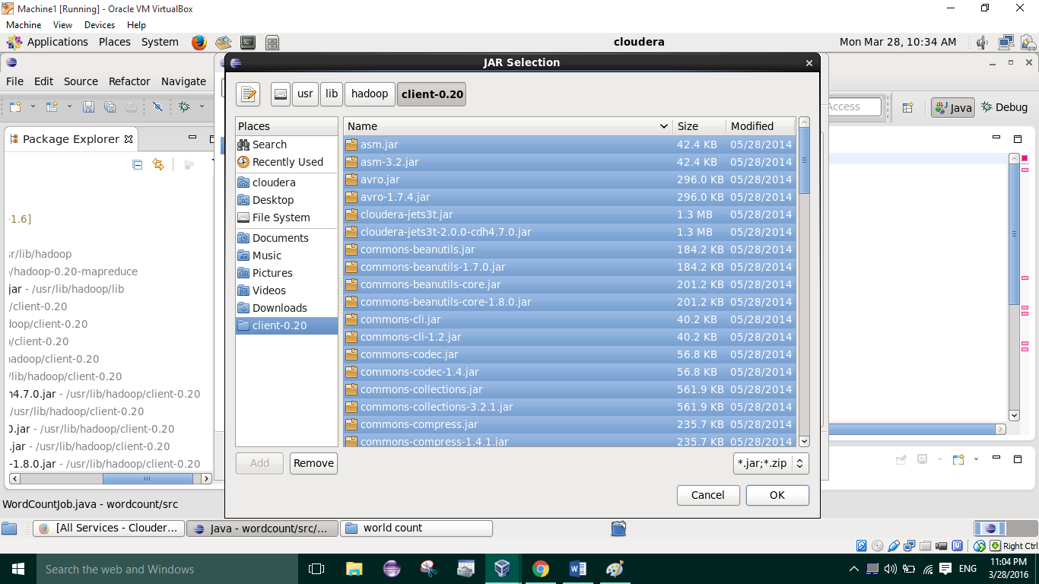

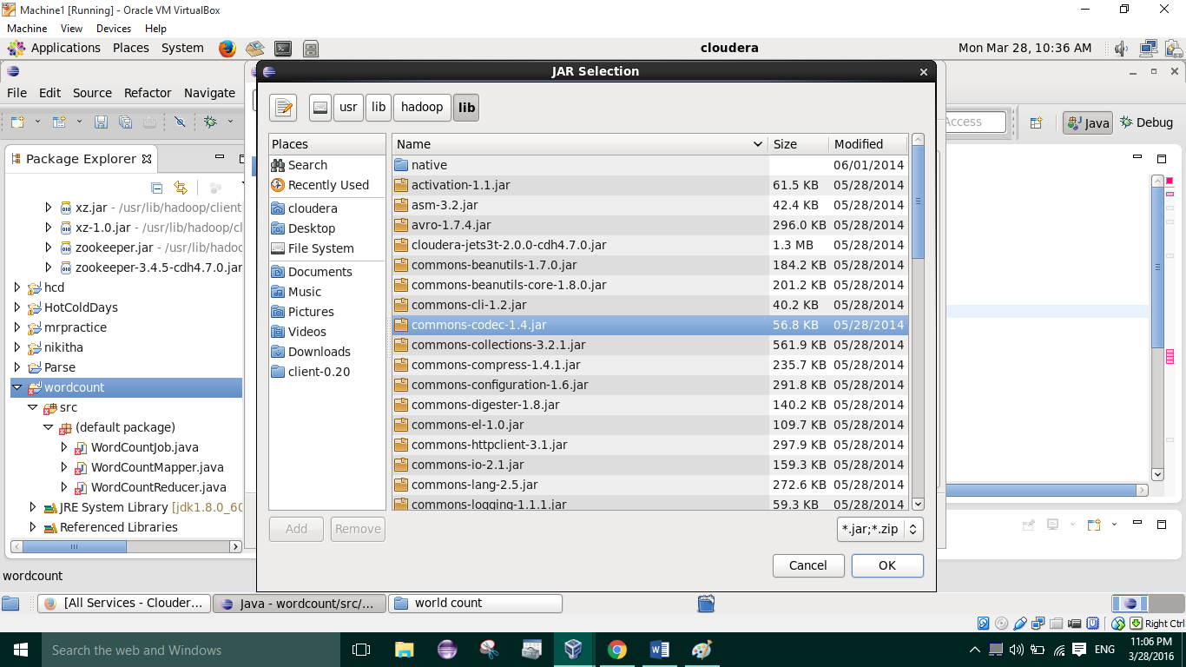

* Resave all .java files
* Click on file and export as jar file, give name and path where jar file can be stored(Ex: Desktop) 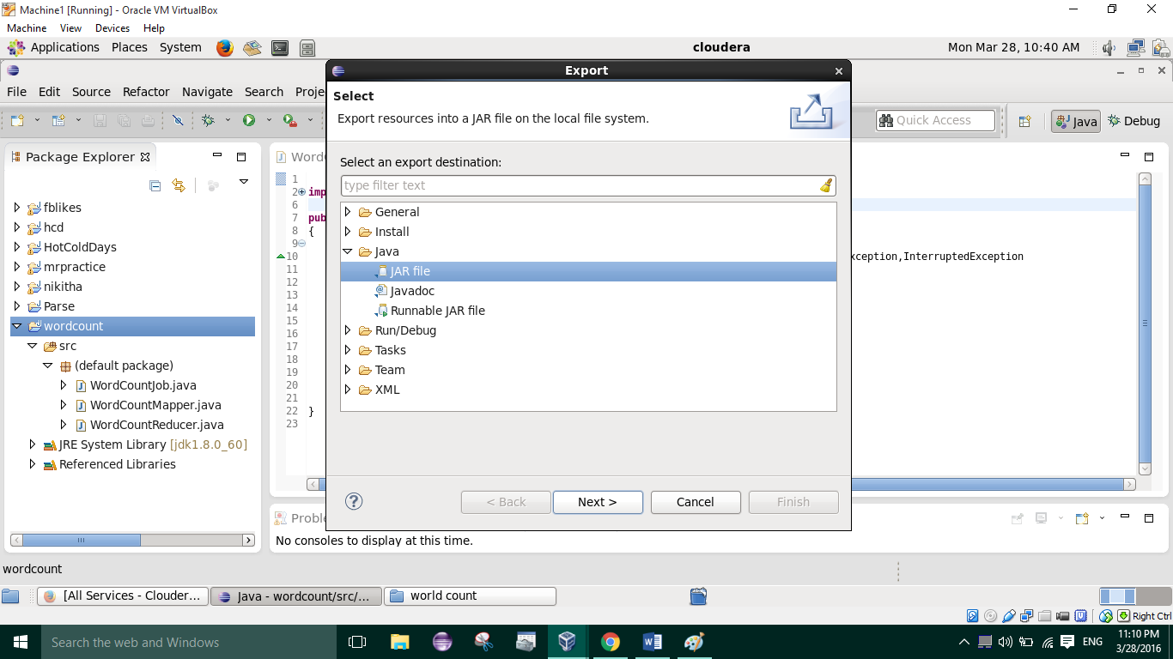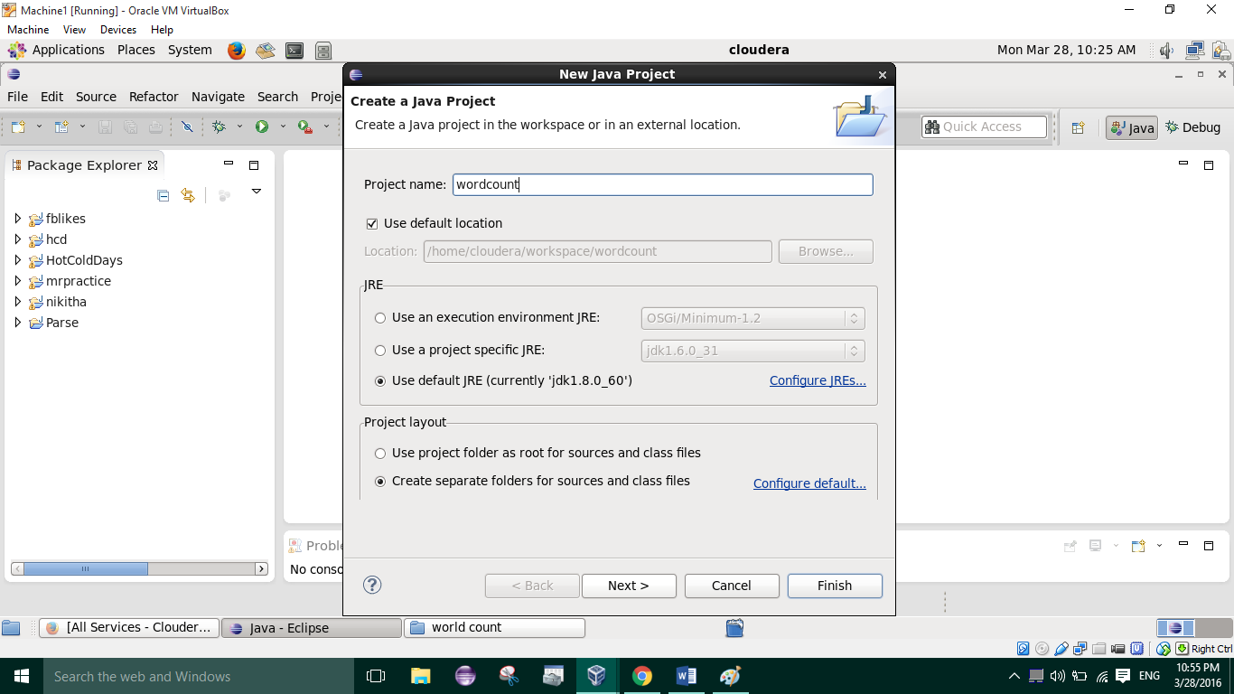
* Store test file in hdfs and run wordcount.jar on that file by using following command
  + Hadoop jar wordcount.jar [mainclassfilename] [input hdfs path] [output hdfs folder]

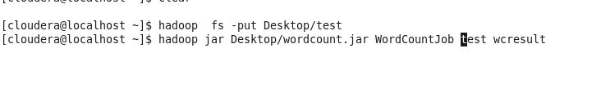

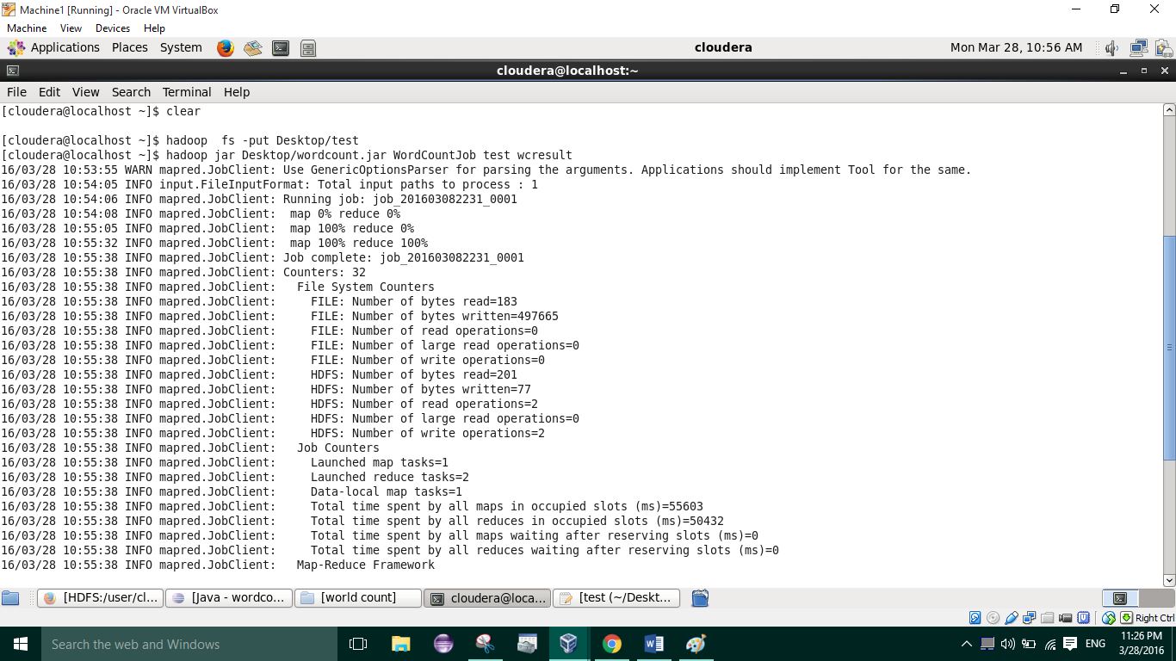

* Open hdfsNamenode in browser and browse created folder to view results

