Kenneth Luna

The data selected for this time series analysis is the stock price of Tesla Motors (ticker: TSLA) dating from June 29, 2010 to May 1, 2015. The dataset contains 1,219 observations, which are the closing stock price for each day. The source of the data is Google Finance[1].

TSLA was selected as the sample ticker for this project because it shows characteristics that are ideal for an ARMA-ARCH model. **Figure 1** highlights the daily stock price of TSLA for the last five years. The first half of the plot shows periods of relative calm in variance and price. The ticker is tethered around $25.00 and does not deviate much from the mean. The second half of the plot tells a different story; the price increases by several orders of magnitude and the variance spikes significantly.

To address this increase in volatility, the log of TSLA was taken (log.tsla). **Figure 2** shows the plot of log.tsla; as expected, the log of TSLA dampens the price variance over time. For the purpose of this exercise, we will continue to use log.tsla. The ACF and PACF for log.tsla are shown in **Figure 3** and **Figure 4** respectively. The behavior of the ACF and PACF plots show that tsla.log is a random walk, therefore will require differencing to adjust for this structure.

**Figure 5** is the 1st-Difference of log.tsla. Based on the plot, the daily changes of log.tsla do appear to be stationary minus a few shocks. The ACF and PACF plot in **Figure 6** and **Figure 7** further supports that the 1st-Difference is closer to stationary when compared to the original log.tsla plots. To make sure the data was differenced sufficiently, the 2nd-Difference is observed in **Figure 8.** Although the plot does appear to be stationary, the ACF and PACF in **Figure 9** and **Figure 10** do show signs of over-differencing. Lag-1 is approximately -0.5, a strong indicator of over-differencing. Based on this preliminary work, the ARIMA model that appears to best fit this data is the ARIMA(1, 0, 1).

To confirm which model is best, the AICC for all models with (p) and (q) in range 0 to 2 were observed. **Table 1** highlights the resulting AICC values; based on these observations, the best performing model is the mentioned ARIMA(0, 1, 0) with a constant. The summary of the best fitting model can be found in **Table 2.** The forecast model generates 95% confidence interval range of 5.353059 to 5.491966 as shown in **Table 3** and is the following formula:

x{t} = x{t-1} + .0018 + ε{t}

This formula makes sense for stocks as prices are never really predictable. If tomorrow’s prices were predictable, investors would buy the stock today, realizing tomorrow’s price already.

Next, the plot of the residuals is explored. One can still notice changes in variance sporadically in **Figure 11.** The ACF and PACF plots in **Figure 12** and **Figure 13** for the residuals also reveal increased volatility holding for small periods of time. The ACF and PACF of the squared residuals in **Figure 14** and **Figure 15** further confirm that the ARIMA model has not completely removed all periods of increased variance; there are signs of clusters around lag-10, lag-17 and lag-25. Although the residuals are not correlated, there are signs of conditional heteroskedasticity – where variance size characteristics are clustered throughout periods of time. ARIMA models do not capture those moments of continued shock so the ARCH model will be considered.

The AICC for the ARCH(q) and the GARCH(1,1,) models are then used to find the best fitting model. Values for (q) range from 0 to 10 for the ARCH model. The best fitting model based on the AICC values in **Table 4** and **Table 5** is the ARCH(5) model. Based on the p-values in **Table 6,** it appears that all of the coefficients are statistically significant except the last one, a5. If the one-step ahead forecast is constructed, the 95% confidence interval range is 5.354979 to 5.490047, which is slightly more compact then the ARIMA confidence interval.

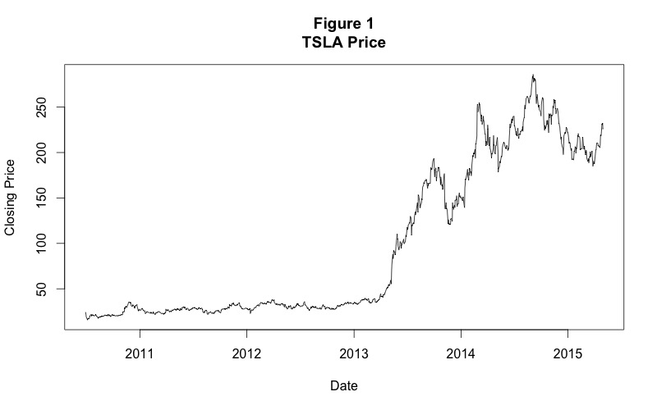

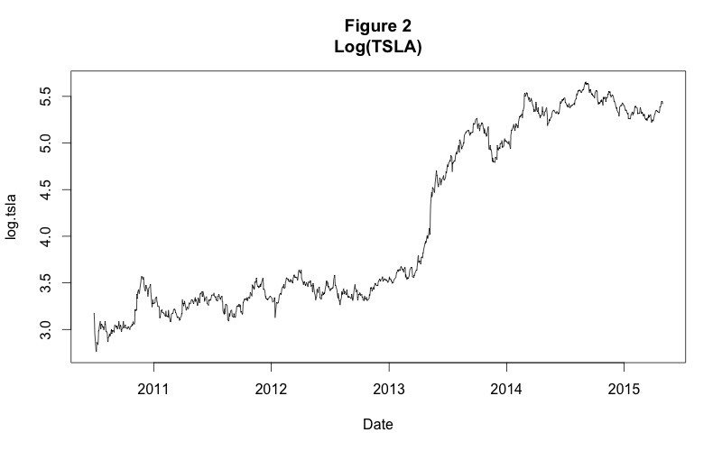

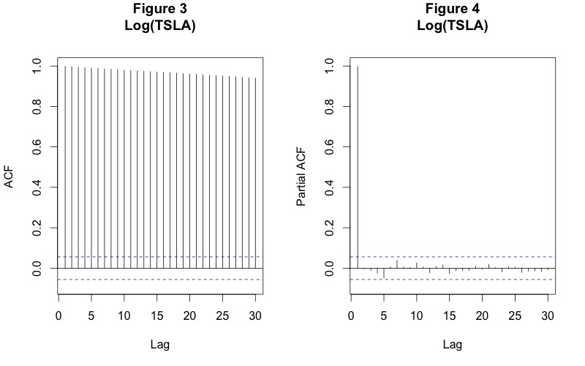

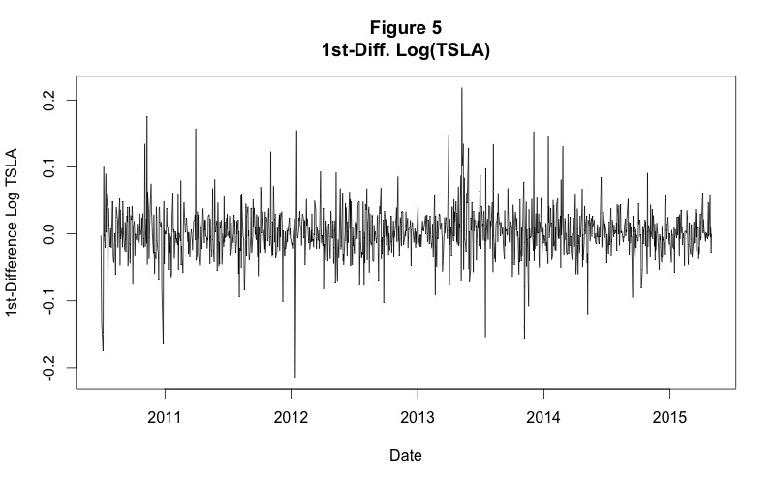

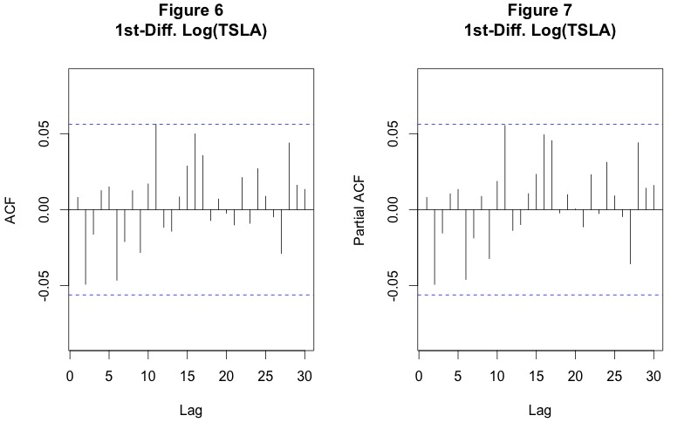

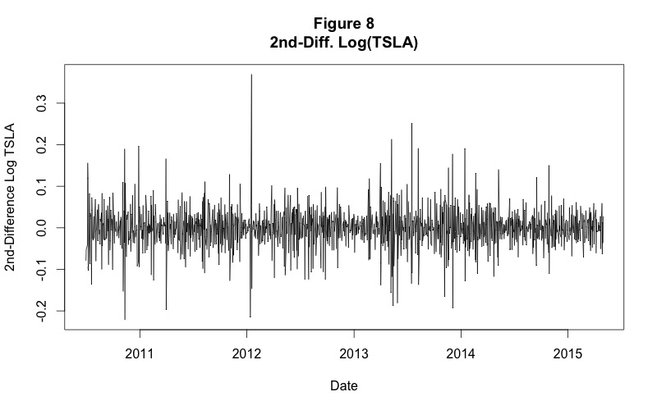

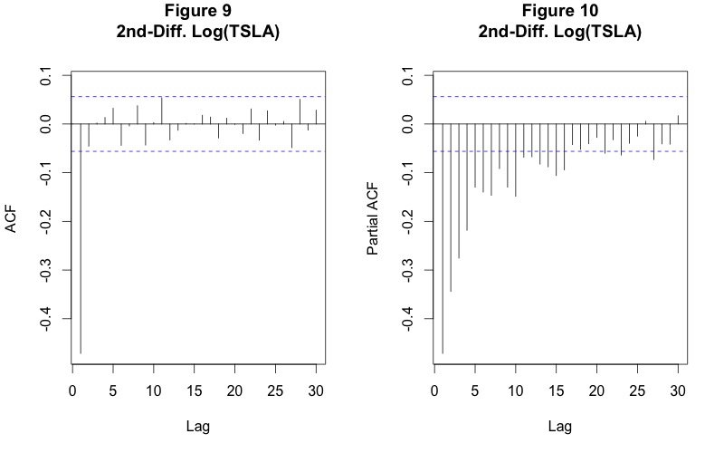

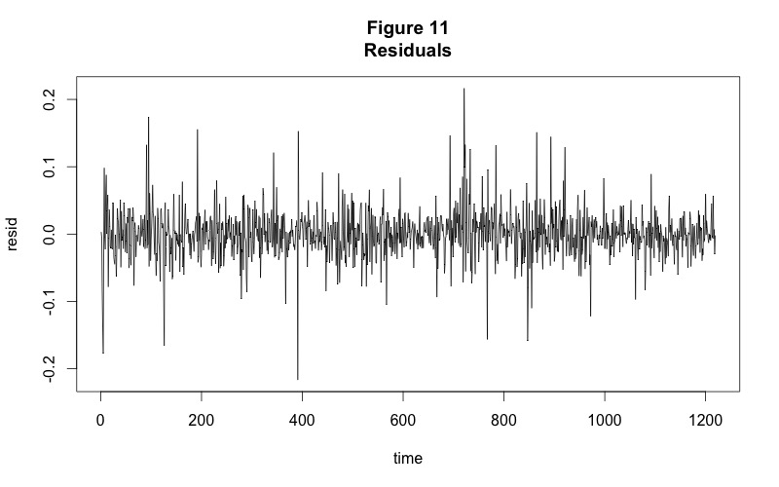

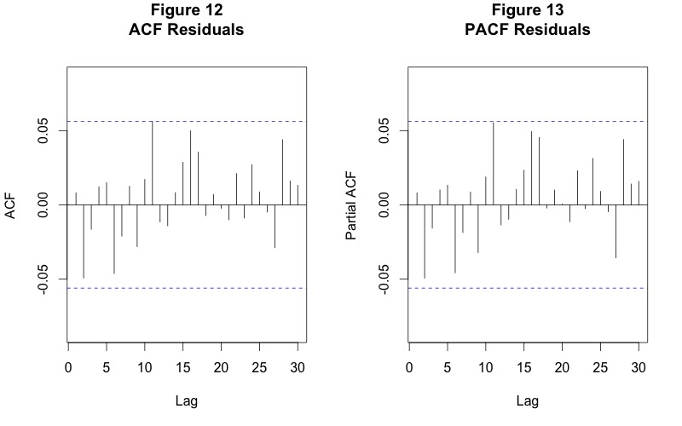

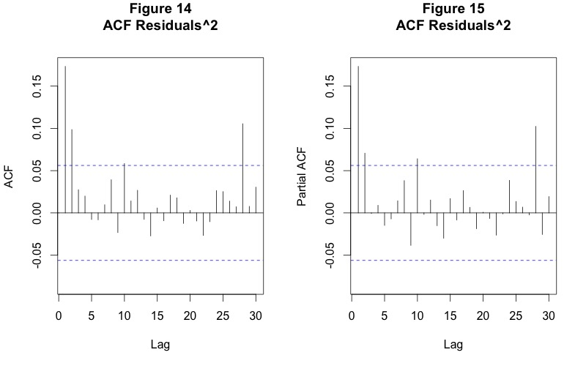

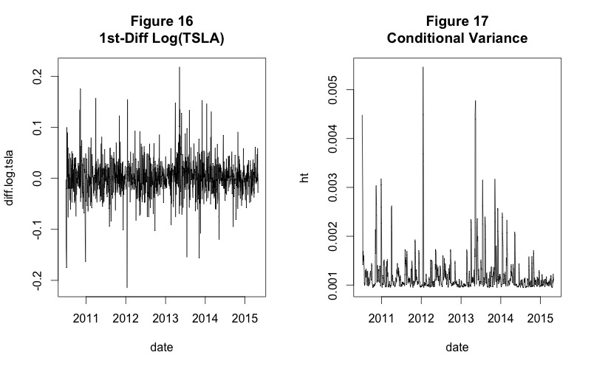

**TABLE 1**

|  |  |  |  |  |
| --- | --- | --- | --- | --- |
| **Model** | **AICC** |  | **Model** | **AICC** |
| ARIMA(0,1,0)(constant=FALSE) | -4675.46 |  | ARIMA(0,1,2)(constant=TRUE) | -4675.699 |
| ARIMA(0,1,1)(constant=FALSE) | -4673.609 |  | ARIMA(0,1,3)(constant=TRUE) | -4674.007 |
| ARIMA(0,1,2)(constant=FALSE) | -4674.117 |  | ARIMA(0,1,4)(constant=TRUE) | -4672.035 |
| ARIMA(0,1,3)(constant=FALSE) | -4672.306 |  | ARIMA(1,1,0)(constant=TRUE) | -4674.823 |
| ARIMA(0,1,4)(constant=FALSE) | -4670.419 |  | ARIMA(1,1,1)(constant=TRUE) | -4673.604 |
| ARIMA(1,1,0)(constant=FALSE) | -4673.594 |  | ARIMA(1,1,2)(constant=TRUE) | -4673.913 |
| ARIMA(1,1,1)(constant=FALSE) | -4672.374 |  | ARIMA(1,1,3)(constant=TRUE) | -4671.986 |
| ARIMA(1,1,2)(constant=FALSE) | -4672.227 |  | ARIMA(1,1,4)(constant=TRUE) | -4670.013 |
| ARIMA(1,1,3)(constant=FALSE) | -4670.287 |  | ARIMA(2,1,0)(constant=TRUE) | -4675.778 |
| ARIMA(1,1,4)(constant=FALSE) | -4668.402 |  | ARIMA(2,1,1)(constant=TRUE) | -4673.972 |
| ARIMA(2,1,0)(constant=FALSE) | -4674.209 |  | ARIMA(2,1,2)(constant=TRUE) | -4673.463 |
| ARIMA(2,1,1)(constant=FALSE) | -4672.312 |  | ARIMA(2,1,3)(constant=TRUE) | -4672.629 |
| ARIMA(2,1,2)(constant=FALSE) | -4674.613 |  | ARIMA(2,1,4)(constant=TRUE) | -4673.741 |
| ARIMA(2,1,3)(constant=FALSE) | -4672.587 |  | ARIMA(3,1,0)(constant=TRUE) | -4674.071 |
| ARIMA(2,1,4)(constant=FALSE) | -4667.371 |  | ARIMA(3,1,1)(constant=TRUE) | -4672.052 |
| ARIMA(3,1,0)(constant=FALSE) | -4672.39 |  | ARIMA(3,1,2)(constant=TRUE) | -4672.752 |
| ARIMA(3,1,1)(constant=FALSE) | -4670.375 |  | ARIMA(3,1,3)(constant=TRUE) | -4671.039 |
| ARIMA(3,1,2)(constant=FALSE) | -4674.05 |  | ARIMA(3,1,4)(constant=TRUE) | -4669.135 |
| ARIMA(3,1,3)(constant=FALSE) | -4669.173 |  | ARIMA(4,1,0)(constant=TRUE) | -4672.166 |
| ARIMA(3,1,4)(constant=FALSE) | -4668.003 |  | ARIMA(4,1,1)(constant=TRUE) | -4670.141 |
| ARIMA(4,1,0)(constant=FALSE) | -4670.592 |  | ARIMA(4,1,2)(constant=TRUE) | -4674.023 |
| ARIMA(4,1,1)(constant=FALSE) | -4668.569 |  | ARIMA(4,1,3)(constant=TRUE) | -4669.169 |
| ARIMA(4,1,2)(constant=FALSE) | -4670.169 |  | ARIMA(4,1,4)(constant=TRUE) | -4670.976 |
| ARIMA(4,1,3)(constant=FALSE) | -4667.985 |  |  |  |
| ARIMA(4,1,4)(constant=FALSE) | -4669.765 |  |  |  |
| ARIMA(0,1,0)(constant=TRUE) | -4676.754 |  |  |  |
| ARIMA(0,1,1)(constant=TRUE) | -4674.831 |  |  |  |

**TABLE 2**

Series: log.tsla

ARIMA(0,1,0) with drift

Coefficients:

drift

0.0018

s.e. 0.0010

sigma^2 estimated as 0.001256: log likelihood=2338.46

AIC=-4672.92 AICc=-4672.91 BIC=-4662.71

**TABLE 3**

Point Forecast Lo 95 Hi 95

1220 5.422513 5.353059 5.491966

**TABLE 4**

|  |  |  |  |  |
| --- | --- | --- | --- | --- |
| **q** |  | **loglik** |  | **aicc** |
| 0 |  | 2342.8 |  | -4683.6 |
| 1 |  | 2363.0 |  | -4722.0 |
| 2 |  | 2372.7 |  | -4739.5 |
| 3 |  | 2374.0 |  | -4739.9 |
| 4 |  | 2378.2 |  | -4746.3 |
| 5 |  | 2378.2 |  | -4744.3 |
| 6 |  | 2375.6 |  | -4737.1 |
| 7 |  | 2375.7 |  | -4735.3 |
| 8 |  | 2375.7 |  | -4733.2 |
| 9 |  | 2373.3 |  | -4726.3 |
| 10 |  | 2377.1 |  | -4732.0 |

**TABLE 5**

|  |  |  |
| --- | --- | --- |
| **loglik** |  | **aicc** |
| 2374.0 |  | -4744.0 |

**Table 6**

Call:

garch(x = resid, order = c(0, 5), trace = FALSE)

Model:

GARCH(0,5)

Residuals:

Min 1Q Median 3Q Max

-6.92825 -0.52208 -0.02419 0.52289 5.43753

Coefficient(s):

Estimate Std. Error t value Pr(>|t|)

a0 9.413e-04 3.012e-05 31.247 < 2e-16 ***

a1 6.543e-02 1.609e-02 4.067 4.75e-05 ***

a2 6.360e-02 1.830e-02 3.476 0.000509 ***

a3 4.403e-02 1.596e-02 2.758 0.005814 **

a4 3.639e-02 1.039e-02 3.504 0.000458 ***

a5 2.537e-14 1.898e-02 0.000 1.000000

---

1. https://www.google.com/finance/historical?q=NASDAQ%3ATSLA&ei=du9EVdGOKvTisQfXjYDwDw