Project Report

Web-based Movie Voting and Rating System

By Sunil K R

A2C7520331

MCA 3rd Year DLP

Madurai Kamaraj University

June 2008

Table of Contents

1.Introduction 4
2.Objectives 4
3.Assumptions 5
4.Technologies used 6
5.Database schema 6
6.Workflow chart 8
7.Algorithms 10
8.Screens 11
8.1.Introduction Screen 11
8.2.New User Registration screen 12
8.3.Finding a Movie Title 13
8.4.Search Results screen 14
8.5.Voting Option from Search Results 15
8.6.Voting Success screen (Normal Case) 16
8.7.Suggest Movie screen 17
8.8.Suggest screen Success 18
8.9.Reviewing the suggested list 19
8.10. Accepting a suggested movie title 20
8.11.Rejecting a suggested movie 21
8.12.Rejection of suggested movie Success 22
8.13.Adding a new cinema hall to Database 23
8.14.Cinema Hall Add success 24
9.Scope for enhancements 25

Introduction
This is a project undertaken by me as per the course requirements of the Master of Computer Applications program of Madurai Kamaraj University. This project reflects the technical skills learnt by me during the course.
The title of this project is: Movie Voting System. This application enables
- People in a city to express their demand to see any particular movie of their choice
- Theatre owners to gauge the mood of the public and screen the popular movies
Note: This application can be viewed from any internet enabled computer. The URL to access this application is:
http://members.lycos.co.uk/sunilr74

Objectives
There are many objectives that this project looks after, beside the main two objectives. Some are enumerated below:
- Authenticate users: Authentication is important. If we do not authenticate the people who are voting in the system, people will tend to keep on voting as they like. This will lead to uncountable number of duplicate votes. This will affect the credibility of the system.
- Set limit on number of choices: There are hundreds of good movies. If we allow a person to choose all his favorite movies, he may eventually forget how many movies he has voted for. This will affect his seriousness to see the movies he has selected. Cutting the number of choices will help the system maintain a pool of the strongest preferences, and keep it relatively fresh
- Always display the winning movies: Doing this will enable the application to force a clear cut result. Also, it will help in achieving harmony in the voters’ thoughts
- Enable people to suggest the movies that they don’t see in the list
- Enable theatre owners to filter the suggested movies according to the correctness of the title, their existence and availability

It will be seen that the objectives deal with a subtle kind of group psychology (if it may be called so). These objectives are geared toward the ultimate aim of making a useful and popular service that the masses can use.

Assumptions
It is assumed for this application, that
- a good majority of people has access to the internet
- people are comfortable with english

Technologies used
This application is a Web-based program. It utilizes the services of a web server. It is coded in a scripting language, which the web server executes. It maintains its data in a database. Therefore this calls for an integration of three different computer programs, namely,
- Apache Web Server Version 1.3.33
- PHP 4.3.0
- MySQL RDBMS Version 5.0

Database schema
The application uses a very simple schema. No relations have been implemented. The tables and their descriptions are as follows:
1. chall

Field | Type | Null | Key | Default
Hcode | char(4) | YES |  | NULL
Hname | char(30) | YES |  | NULL
hloc | char(64) | YES |  | NULL
hcity | char(30) | YES |  | NULL
hcountry | char(30) | YES |  | NULL
hpin | char(30) | YES |  | NULL

2. demand

Field | Type | Null | Key | Default
mcode | char(4) | YES |  | NULL
nvotes | int(11) | YES |  | NULL
oldestvote | Timestamp(14) | YES |  | NULL
newestvote | timestamp(14) | YES |  | NULL

3. movie

Field | Type | Null | Key | Default
mcode | char(4) | YES |  | NULL
mname | char(50) | YES |  | NULL
mpart | char(5) | YES |  | NULL
mtype | char(4) | YES |  | NULL
mlang | char(4) | YES |  | NULL

4. personvote

Field | Type | Null | Key | Default
personid | char(50) | YES |  | NULL
mcode | char(4) | YES |  | NULL
moviedate | date | YES |  | NULL
hcode | char(4) | YES |  | NULL

5. tmpmovie

Field | Type | Null | Key | Default
mname | char(50) | YES |  | NULL
mpart | char(5) | YES |  | NULL

6. users

Field | Type | Null | Key | Default
uname | char(30) | YES |  | NULL
uage | int(11) | YES |  | NULL
usex | char(1) | YES |  | NULL
ucity | char(20) | YES |  | NULL
ucountry | char(20) | YES |  | NULL
uemail | char(50) | YES |  | NULL
upass | char(50) | YES |  | NULL

Workflow chart
Suggestion list
Vote option
Register name
Find a movie
Suggest a movie
Review and ratify suggestions
Add a cinema hall
User initiates
System processes
Store User details to database
Search in database for supplied details
Found
Not found
Suggest option
Store suggestion to database
Display list of suggestions, along with close matches with movies already in available list
Selected movies
Available list
Store hall details to database

Delete an entry
Fresh vote option
Review votes option
See popular movies list
Vote a movie
Person has already voted for it
Update Timestamp
Person has exceeded voting limits
Review Votes
“un-vote” a movie, or “refresh” vote
Un-vote?
Update Timestamp
Query database for leading movies
Fresh entry
Normal case
Indicates Authenticated exchange
Indicates fresh screen display for new data
Notes

Algorithms
The major algorithms are self evident from the WorkFlow Diagram. However, there is one key algorithm that is worth mentioning in this document.
This pertains to the actual act of voting in the system. This algorithm is as follows:

Inputs to algorithm:
- Person’s ID,
- Movie ID for which the vote is to be registered

- Find out from personvote table, how many votes has the user cast
- If he has cast less than 5 votes, his present vote can be added to the list
- If he has cast more than (this should not be possible) or equal to 5 votes, take him to the Modify Votes screen; go to END
- If the vote he has cast already exists in the vote list, simply update the vote’s timestamp in the personvote table
- If it is a fresh vote, insert the details in the personvote table
- END

Screens
The screens are discussed below:

Introduction Screen
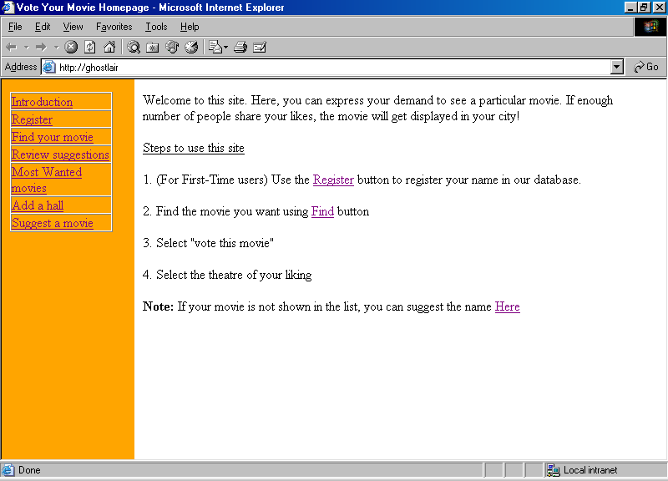
Figure 1

This is the starting screen. This screen attempts to explain the theme of the application, and also tries to get the user started off quickly without learning too much

New User Registration screen
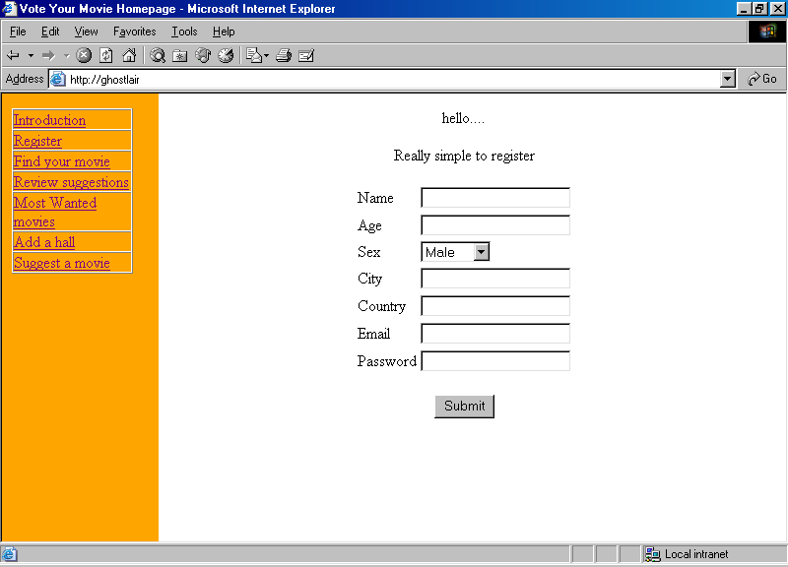
Figure 2

This is a simple form that asks a few questions about the user.
- The Email and Password are used to authenticate the user in voting related transactions
- The city and country may be used to set defaults while querying for available cinema halls
- The age and sex information may be of interest while user profiling and may interest movie makers in relating preferences to age and sex
- As an aside, the user profiling may also assist potential advertisers to make decisions about their campaign

Finding a Movie Title
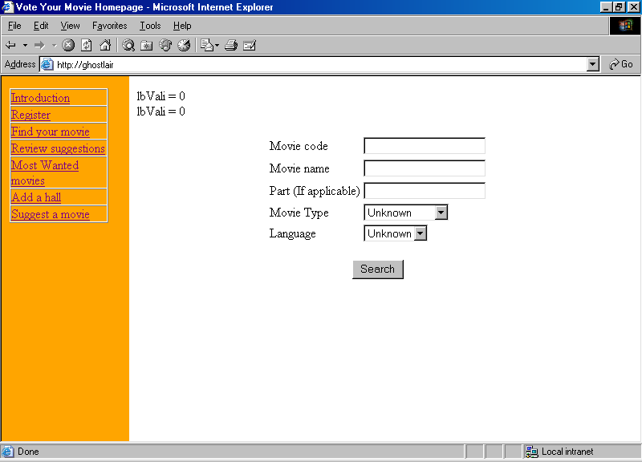
Figure 3

This is a Search form. All the fields in this form are optional.
- When any field is supplied, the search is narrowed to the matching rows
- When more than one field is supplied, the search criteria is joined by the OR directive. This means to say, that records matching any one criterion is selected for display
- When no field is specified, then the entire table is displayed

Search Results screen
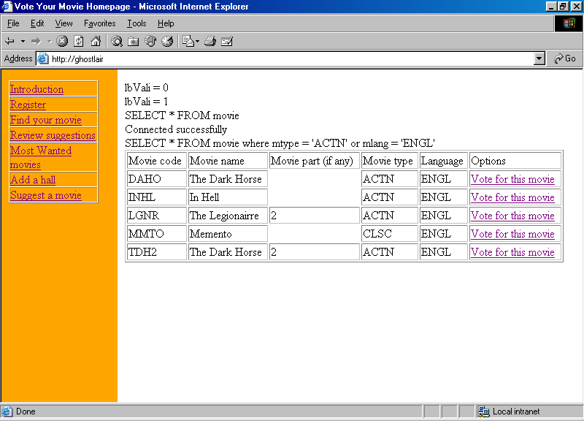
Figure 4

This screen displays the search results for movie.
- If there is no match found, an option is given to suggest the title.
- Else, for each match found, a voting option is displayed
- Selecting the voting option takes the user to the Voting screen

Voting Option from Search Results
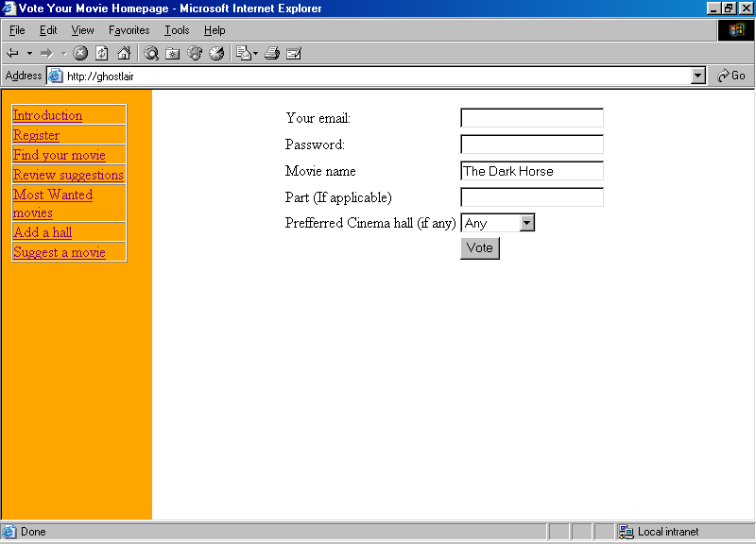
Figure 5

This is the voting screen.
- The User ID and password is used for authentication
- There is a chance to edit the preferred cinema hall

Voting Success screen (Normal Case)
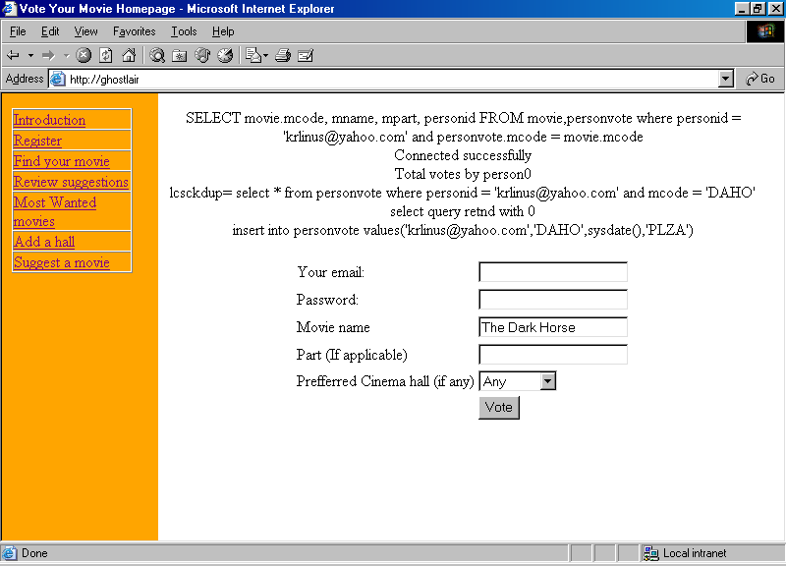
Figure 6

This is a Thank You screen when a vote is cast.
- When a vote is cast, an entry is made in the demand table,
- The count of such votes is used to rate the popularity of the film

Suggest Movie screen
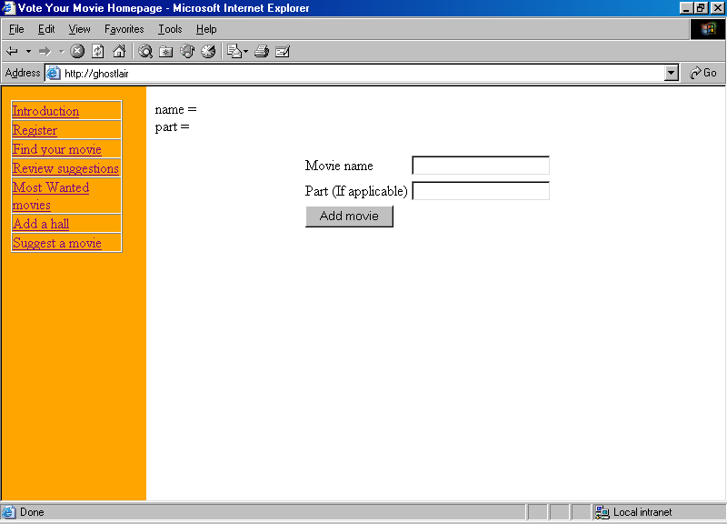
Figure 7

- The Suggest Movie form provides a quick way to take input from the public regarding any movie
- The suggested title is stored in a temporary table, and is later opened for review by an authorized person

Suggest screen Success
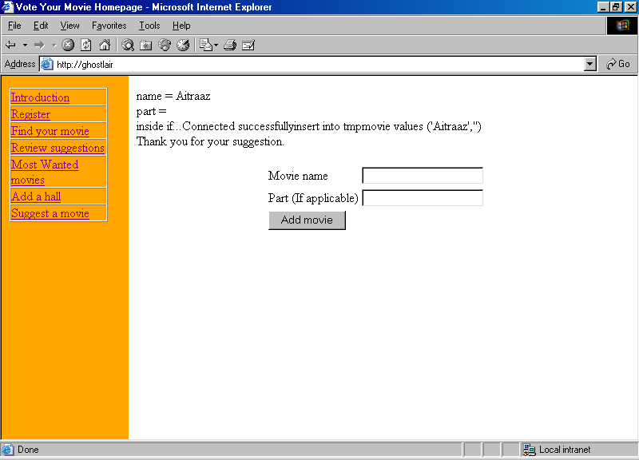
Figure 8

Reviewing the suggested list
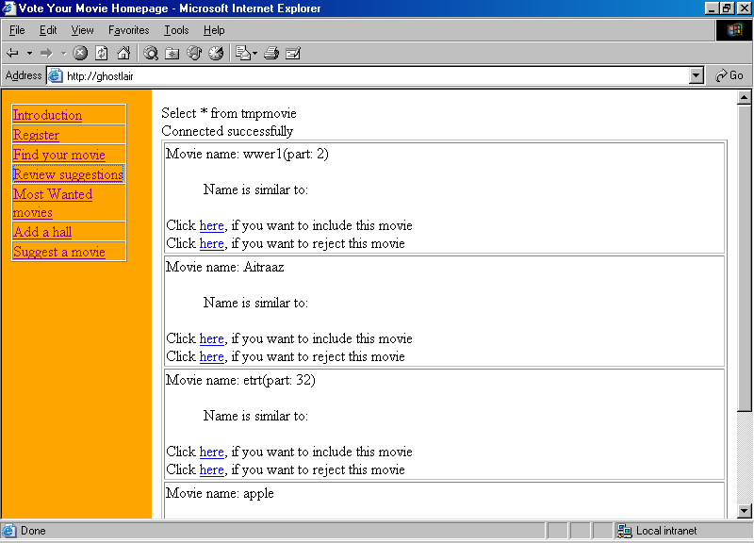
Figure 9

- This screen allows a user to see and analyse the suggested movie titles.
- The analysis would be with respect to movies already existing in the database.
- To help in eliminating duplicates, queries are run against the entries in the main movie table, and similar sounding names are presented for reference.
- Using the details provided, and using the market knowledge about the existence and availability of the movie, the authorized user moves the movie record to the available list.

Accepting a suggested movie title
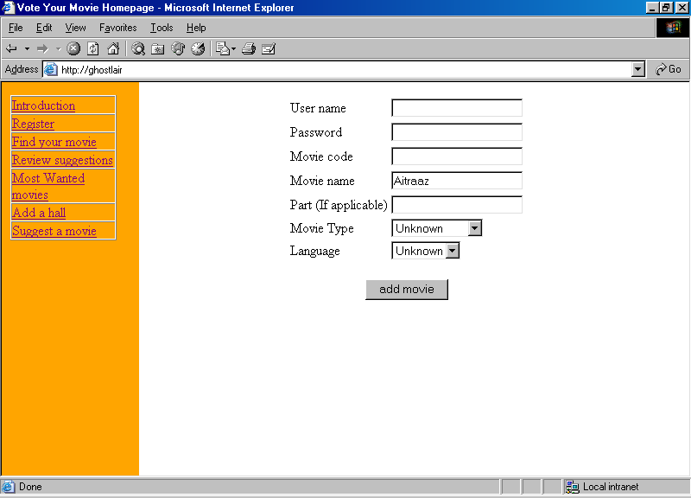
Figure 10

- This is the screen that help the authorized user to add a movie into the database.
- There is an opportunity given in this screen to correct the names and details of the movie

Rejecting a suggested movie
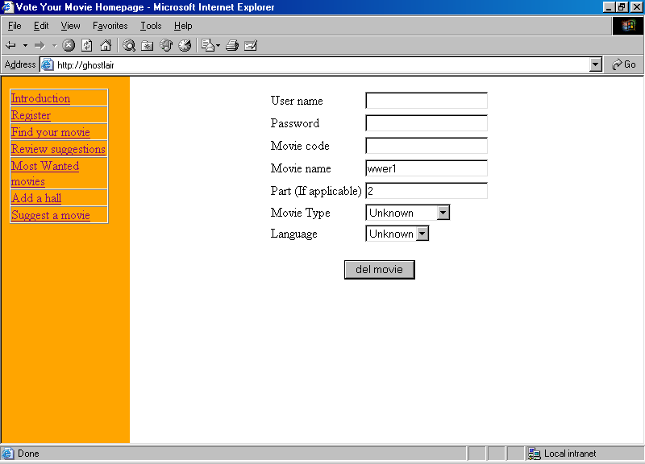
Figure 11

- This screen displays the details of the movie that is to be deleted from the Suggested list.

Rejection of suggested movie Success
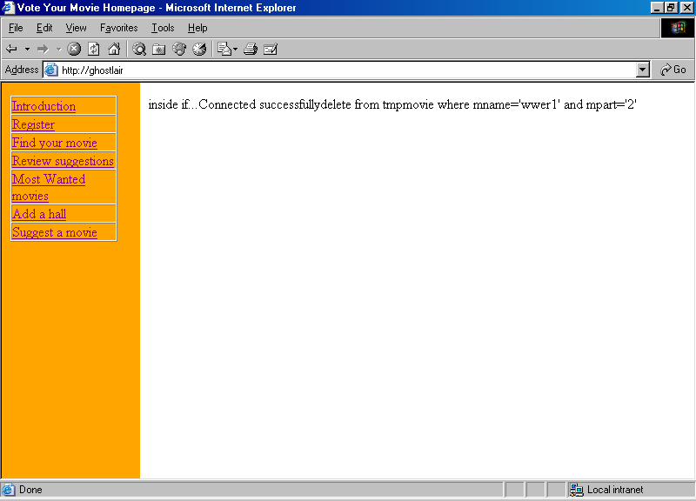
Figure 12

- This is the screen indicating the success of a rejection operation

Adding a new cinema hall to Database
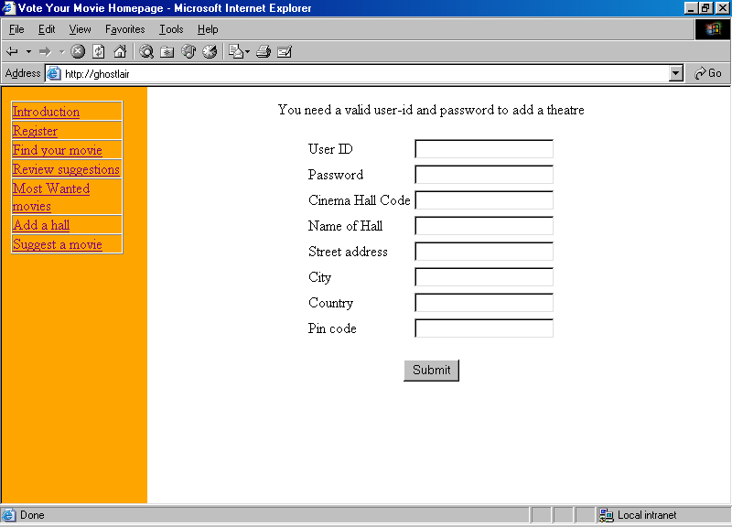
Figure 13

- Adding a cinema hall is the work of an authorized user.
- While adding he assigns a unique cinema hall code to the entry

Cinema Hall Add success
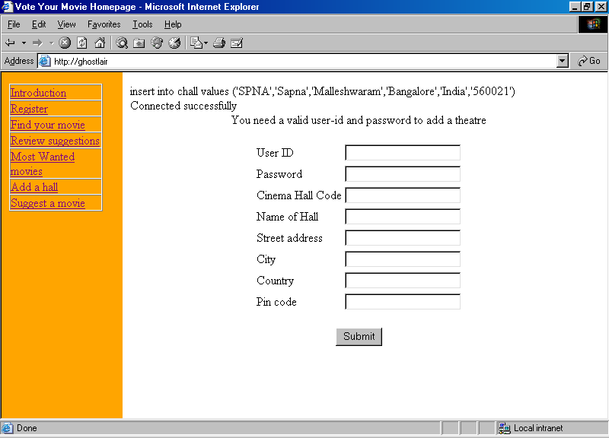

Scope for enhancements
This application is at best a version 1 release, meaning, there is lots of scope for improvement.
The Software Design can accommodate the following improvements with little or no additional effort:
- Displaying various user profile information to various interested parties
- Theatre owners can Invite Votes of a particular screening
- Enabling E-booking of tickets
- Discussion forum on various movie related topics
- Many others

