Data Analytics Capstone
Parametric Validation of AI-Generated 3D Wheel Meshes
Using Engineering Constraints
Interim Report
MAHIL KATTILPARAMBATH RAMAKRISHNAN
Walsh College
QM 640: Data Analytics Capstone
MUHAMMED HASSAN SIDDIQUI
Winter 2026 Term
GitHub: https://github.com/krmahil/data-analytics-capstone

1. Introduction, Scope and Objectives

Introduction
The automotive industry is undergoing a fundamental transformation driven by the integration of generative Artificial Intelligence (AI) into Computer-Aided Design (CAD) workflows. According to recent industry analyses, AI-powered design tools have demonstrated the capability to reduce design iteration time by up to 60% while simultaneously expanding the exploration of feasible design spaces (McKinsey, 2024). However, this acceleration introduces a critical challenge: AI-generated three-dimensional meshes frequently violate engineering constraints that govern manufacturability, structural integrity, and regulatory compliance.
The emergence of sophisticated generative models, including Stable Diffusion-based image synthesis and Neural Radiance Field (NeRF) reconstruction pipelines, has enabled rapid generation of visually compelling wheel designs. The DeepWheel framework, introduced by Yoo and Kang (2025), represents a pioneering effort to create synthetic wheel datasets by combining generative image models with 2.5D depth estimation and Finite Element Analysis (FEA) structural simulation. Their methodology produces over 6,000 photo-realistic wheel images and 900 structurally analyzed three-dimensional models, providing an unprecedented resource for design-performance research.
Despite these advances, a significant research gap exists in the systematic validation of AI-generated wheel geometries against quantifiable engineering constraints. Current quality assessment approaches rely heavily on manual expert review, which is not scalable (Li & Wang, 2023). This capstone project does not involve building or training generative AI models. The research contribution lies in developing a parametric validation and analytics framework that: (1) quantifies the failure rate of AI-generated wheels against engineering constraints, (2) identifies parametric features predictive of validation outcomes, (3) develops Machine Learning (ML) classification models for automated pass/fail prediction, and (4) characterizes design patterns distinguishing valid from invalid wheel geometries.

Scope and Objectives
Problem Statement: AI-generated three-dimensional wheel meshes exhibit variable compliance with established engineering constraints, yet no standardized parametric validation framework exists to systematically assess their structural adequacy. The fundamental research question is: Can parametric metadata extracted from AI-generated wheel meshes reliably predict engineering validation outcomes without requiring full structural simulation?
Dataset Scope: This study utilizes the DeepWheel dataset (Yoo & Kang, 2025), comprising 904 wheel designs with complete structural simulation results including mass, Mode 7 natural frequency (first in-plane bending mode), and Mode 11 natural frequency (higher-order deformation mode). Constraint Scope: Engineering constraints are derived from automotive industry standards (see Table 1):
Table 1
Engineering Constraint Parameters for Wheel Validation
Constraint Parameter | Lower Bound | Upper Bound | Standard Reference
Wheel Mass | 18.0 kg | 23.0 kg | Original Equipment Manufacturer (OEM) specifications
Mode 7 Natural Frequency | 380 Hz | 470 Hz | NVH avoidance (Beta CAE, 2023)
Mode 11 Natural Frequency | 1000 Hz | 1400 Hz | High-frequency stiffness
Stiffness Ratio (f₁₁/f₇) | 2.5 | 3.2 | Structural balance criterion
These constraints ensure wheels avoid resonance coupling with tire cavity modes (typically 200–250 Hz) and powertrain excitation frequencies, preventing interior Noise, Vibration, and Harshness (NVH) degradation.
Ethical Compliance: All data originates from publicly available sources released under Creative Commons Attribution-NonCommercial 4.0 International (CC BY-NC 4.0) license, ensuring full ethical compliance and reproducibility. Feasibility: The project is designed for completion within a 10-week academic term with clearly defined milestones.

Research Questions and Hypotheses
RQ1: What proportion of AI-generated 3D wheel designs fail predefined engineering validation checks? Understanding baseline failure rates establishes the scope of the validation problem (Gelman et al., 2020). Hypothesis H1: >25% of AI-generated wheel designs will fail at least one engineering constraint. Methodology: Descriptive statistical analysis with 95% Confidence Interval (CI), stratified failure analysis by constraint type.
RQ2: Which input design parameters most influence constraint failure? Feature importance analysis enables prioritization of design parameters (Chen et al., 2023). Hypothesis H2: Mode 11 natural frequency will exhibit the strongest association with validation failure. Methodology: Point-biserial correlation analysis, Random Forest feature importance, and Gradient Boosting feature contribution analysis.
RQ3: Can a classification model predict validation outcomes using parametric metadata alone? Predictive models enable pre-screening before computationally expensive simulations, potentially reducing workload by 30–50% (Li & Wang, 2023). Hypothesis H3: ML classifiers will achieve Area Under the Receiver Operating Characteristic curve (AUC-ROC) ≥ 0.85. Methodology: Logistic Regression, Multi-Layer Perceptron (MLP), Random Forest, and XGBoost with stratified 5-fold cross-validation.
RQ4: What design parameter combinations are most associated with successful wheels? Pattern characterization provides actionable design guidelines (Regenwetter et al., 2022). Hypothesis H4: Valid designs will cluster at moderate mass (20–22 kg) and balanced frequency ratios (2.8–3.0). Methodology: Principal Component Analysis (PCA), K-Means clustering, and Classification and Regression Trees (CART) decision tree for interpretable rule extraction.

Sample Size Calculation
Sample size calculations ensure adequate statistical power. The DeepWheel dataset provides n = 904 complete records. Table 2 summarizes the results; detailed formulas are presented in Section 4.
Table 2
Sample Size Requirements by Research Question
Research Question | Statistical Method | Required n | Available n | Power
RQ1 | CI for proportion | 323 | 904 | >95%
RQ2 | Correlation (r=0.20) | 194 | 904 | >95%
RQ3 | Logistic regression (EPV=15) | 500 | 904 | >90%
RQ4 | Two-sample t-test (d=0.5) | 126 | 904 | >99%

2. Literature Survey

AI in Engineering Design
McKinsey & Company (2024) reports that AI-powered design tools have demonstrated the capability to reduce design iteration time by up to 60% while simultaneously expanding the exploration of feasible design spaces. Regenwetter et al. (2022) provide a comprehensive review of deep generative models in engineering design, highlighting both opportunities and challenges in ensuring generated designs meet engineering constraints.

Generative Models for CAD
Recent advances in generative AI for CAD include latent diffusion models for high-resolution image synthesis (Rombach et al., 2022), which form the foundation for many AI design tools. Jayaraman et al. (2023) developed SolidGen for autoregressive boundary representation synthesis, while Wu et al. (2023) explored large language models for CAD generation. Casey et al. (2025) address the challenge of aligning constraint generation with design intent in CAD systems.

Automotive Wheel Design and Validation
Parametric CAD methods have long been established for automotive component design using constraint-based approaches (Bodein et al., 2013). More recently, Kim et al. (2021) demonstrated automotive wheel design optimization using topology optimization and machine learning, achieving significant weight reduction while maintaining structural performance. Beta CAE Systems (2023) established validation methodologies for modal analysis of automotive wheel rims, specifying that wheels for light commercial vehicles should achieve first natural frequencies above 350 Hz to avoid undesirable interior noise amplification. Industry standards governing wheel validation include ISO 7141:2022 (lateral impact test) and SAE J175:2020 (impact test procedures).

Validation Frameworks, ML, and Statistical Methods
Li & Wang (2023) identify the critical need for validation frameworks for AI-generated engineering artifacts, noting that current approaches rely heavily on manual expert review. Baek & Lee (2020) review machine learning approaches for mechanical design optimization, while Chen et al. (2023) provide a comprehensive overview of deep learning applications in CAD, emphasizing feature importance analysis. Statistical foundations include the Matthews Correlation Coefficient (MCC) advantages over F1 for imbalanced data (Chicco & Jurman, 2020), bias correction in Random Forest importance (Strobl et al., 2007), and the Events Per Variable (EPV) rule for logistic regression (Peduzzi et al., 1996).

Research Gap
While significant progress has been made in generative AI for engineering design, a critical gap exists in systematic validation of AI-generated geometries against quantifiable engineering constraints. Current approaches lack: (1) standardized parametric validation frameworks, (2) empirical analysis of failure rates in AI-generated designs, (3) predictive models for pre-screening generated artifacts, and (4) characterization of design patterns distinguishing valid from invalid geometries. This capstone project addresses these gaps.

3. Data Description
The primary dataset is the DeepWheel Synthetic Wheel Dataset (Yoo & Kang, 2025), sourced from SmartDesignLab (https://www.smartdesignlab.org/datasets) under Creative Commons Attribution-NonCommercial 4.0 International (CC BY-NC 4.0) license.

DeepWheel Dataset Generation Pipeline
The DeepWheel dataset employs a sophisticated multi-stage generative pipeline comprising five distinct phases:
(1) Image Generation: Stable Diffusion models produce 2D photo-realistic wheel renderings from text prompts, generating over 6,000 unique wheel images. (2) Depth Estimation: Monocular depth estimation networks infer 2.5D depth maps from the rendered images. (3) 3D Reconstruction: Point cloud generation and mesh reconstruction convert depth maps into watertight 3D meshes suitable for engineering simulation. (4) Structural Simulation: FEA computes mass and modal frequencies (including Mode 7 and Mode 11 natural frequencies) for each reconstructed mesh. (5) Topology Optimization: Design space expansion through topology optimization yields the final dataset of 904 structurally analyzed wheel designs.
This pipeline produces wheels spanning diverse aesthetic styles while maintaining geometric consistency suitable for engineering analysis.

Data Dictionary
Table 3 presents the complete data dictionary for the DeepWheel dataset.
Table 3
Data Dictionary for the DeepWheel Dataset
Field Name | Type | Description | Range/Values
file_name | String | Unique wheel mesh identifier | e.g., kappa_0766_3
Mass | Float | Total wheel mass from FEA (kg) | 17.6 – 24.1
Mode7_Freq | Float | 7th natural frequency, in-plane bending (Hz) | 365 – 480
Mode11_Freq | Float | 11th natural frequency, higher-order (Hz) | 910 – 1520
stiffness_ratio | Float | Mode11_Freq / Mode7_Freq | 2.5 – 3.5
mass_efficiency | Float | Mean frequency per unit mass (Hz/kg) | 32.3 – 43.3
validation_outcome | Binary | All constraints pass (1) or fail (0) | 0 / 1

Sample Data Records
Table 4 presents sample records from the dataset to illustrate the data structure.
Table 4
Sample Data Records from the DeepWheel Dataset
file_name | Mass (kg) | Mode7 Freq (Hz) | Mode11 Freq (Hz) | Validation
kappa_0766_3 | 21.019 | 421.68 | 1229.58 | PASS
alpha_0056_2 | 22.949 | 472.94 | 1512.94 | FAIL
lambda_0087_0 | 23.269 | 468.86 | 1487.73 | FAIL
beta_0114_1 | 18.684 | 383.65 | 1011.19 | PASS
iota_0296_3 | 21.566 | 439.50 | 1213.42 | PASS

Engineering Constraint Rationale
Mass constraints (18.0–23.0 kg) ensure appropriate unsprung weight per Original Equipment Manufacturer (OEM) specifications, directly affecting ride quality, handling, and fuel efficiency. Modal frequency constraints prevent resonance coupling: Mode 7 (380–470 Hz) must avoid tire cavity resonance (200–250 Hz), while Mode 11 (1000–1400 Hz) ensures high-frequency stiffness (Beta CAE Systems, 2023). The stiffness ratio (2.5–3.2) indicates structural balance between modes; ratios outside this range suggest excessive flexibility or localized stress concentrations. Industry standards ISO 7141:2022 and SAE J175:2020 govern wheel validation.

4. Analysis – Data Cleaning, EDA Results, Visualizations

Data Cleaning Process
The DeepWheel dataset was loaded from deepwheel_sim_results.csv containing 904 records with 4 columns: file_name, Mass, Mode7 Freq, and Mode11 Freq. The dataset is complete with zero missing values across all records. Numerical variables are stored as 64-bit floating-point numbers. Column names were standardized by replacing spaces with underscores (e.g., Mode7 Freq → Mode7_Freq) for Python compatibility.
Outlier Detection (Interquartile Range Method): IQR-based outlier analysis identified a small number of extreme values in each parameter. These outliers were retained because: (1) they represent legitimate AI-generated designs at the boundaries of the parametric space, and (2) removing them would bias the validation analysis by excluding designs most likely to violate engineering constraints—the very phenomenon under study. All 904 records were retained for subsequent analysis.

Feature Engineering
Seven derived variables were computed to enable constraint evaluation and validation prediction (see Table 5).
Table 5
Derived Features and Their Computation Formulas
Derived Feature | Formula | Purpose
mass_constraint | 1 if 18.0 ≤ Mass ≤ 23.0, else 0 | Mass validation gate
freq7_constraint | 1 if 380 ≤ Mode7_Freq ≤ 470, else 0 | Mode 7 validation gate
freq11_constraint | 1 if 1000 ≤ Mode11_Freq ≤ 1400, else 0 | Mode 11 validation gate
stiffness_ratio | Mode11_Freq / Mode7_Freq | Structural balance metric
stiffness_constraint | 1 if 2.5 ≤ stiffness_ratio ≤ 3.2, else 0 | Stiffness validation gate
mass_efficiency | (Mode7_Freq + Mode11_Freq) / (2 × Mass) | Normalized performance
validation_outcome | 1 if ALL constraints pass, else 0 | Composite validation

Minimum Sample Size Computation per RQ
Sample size calculations ensure adequate statistical power across all four research questions. The DeepWheel dataset provides n = 904 complete records.
RQ1 – Proportion Estimation:
n = (Z²α/2 × p(1 – p)) / E²
Where Z = 1.96, p = 0.30, E = 0.05. Calculation: n = (1.96² × 0.30 × 0.70) / 0.05² = 323. Required n = 323; Available n = 904 (Power: >95%).
RQ2 – Correlation Detection (Fisher’s z-transformation):
n = ((Zα/2 + Zβ) / zᵣ)² + 3
Where zᵣ = 0.5 × ln((1+r)/(1–r)) for r = 0.20, power = 0.80. Calculation: n = ((1.96 + 0.84) / 0.2027)² + 3 = 194. Required n = 194; Available n = 904 (Power: >95%).
RQ3 – Classification (Events Per Variable rule; Peduzzi et al., 1996):
n_min = (EPV × k) / min(p, 1 – p)
Where EPV = 15, k = 10 predictors, p = 0.30 (minority class). Calculation: n = (15 × 10) / 0.30 = 500. Required n = 500; Available n = 904 (Power: >90%).
RQ4 – Group Comparison (Cohen, 1988):
n_per_group = 2 × ((Zα/2 + Zβ) / d)²
Where d = 0.5 (medium effect size). Calculation: n = 2 × ((1.96 + 0.84) / 0.5)² = 63 per group, 126 total. Required n = 126; Available n = 904 (Power: >99%).
As summarized in Table 2 (Section 1), all four research questions have adequate sample sizes, with the available n = 904 substantially exceeding requirements.

Exploratory Data Analysis Results

Descriptive Statistics
Table 6 presents the descriptive statistics for all continuous variables.
Table 6
Descriptive Statistics for DeepWheel Dataset Variables (n = 904)
Statistic | Mass (kg) | Mode7_Freq (Hz) | Mode11_Freq (Hz) | Stiff. Ratio | Mass Eff.
Mean (SD) | 20.51 (1.14) | 417.43 (21.30) | 1134.73 (113.83) | 2.71 (0.16) | 37.78 (1.56)
Min | 17.61 | 366.08 | 910.44 | 2.38 | 32.28
25th %ile | 19.70 | 402.08 | 1052.34 | 2.60 | 36.93
Median | 20.53 | 417.03 | 1142.72 | 2.73 | 38.28
75th %ile | 21.29 | 432.17 | 1215.62 | 2.83 | 38.87
Max | 24.15 | 479.60 | 1512.94 | 3.20 | 43.27
Overall Validation: 736 designs (81.42%) pass all engineering constraints. 168 designs (18.58%) fail at least one constraint.

RQ1 Analysis: Constraint Violation Rates
Overall failure rate: 18.58% (95% CI: 16.18% – 21.25%). This rate is significantly below the hypothesized 25% threshold (H1). The upper confidence bound (21.25%) remains below 25%, providing strong statistical evidence that Hypothesis H1 is not confirmed. The DeepWheel generative model produces reasonably constraint-aware designs.
The constraint-specific violation breakdown is presented in Table 7.
Table 7
Constraint-Specific Violation Breakdown
Constraint | Violations | Percentage
Mode 11 Frequency (1000–1400 Hz) | 144 | 15.93%
Stiffness Ratio (2.5–3.2) | 121 | 13.38%
Mode 7 Frequency (380–470 Hz) | 36 | 3.98%
Mass (18.0–23.0 kg) | 21 | 2.32%
As shown in Table 7, Mode 11 Frequency is the primary source of validation failures (15.93%), suggesting the DeepWheel model struggles to maintain adequate high-frequency stiffness. The Stiffness Ratio constraint (13.38%) is partially correlated with Mode 11 failures. Mass (2.32%) and Mode 7 Frequency (3.98%) are well-controlled by the generative model. Figure 1 provides a visual representation of these constraint violation patterns.
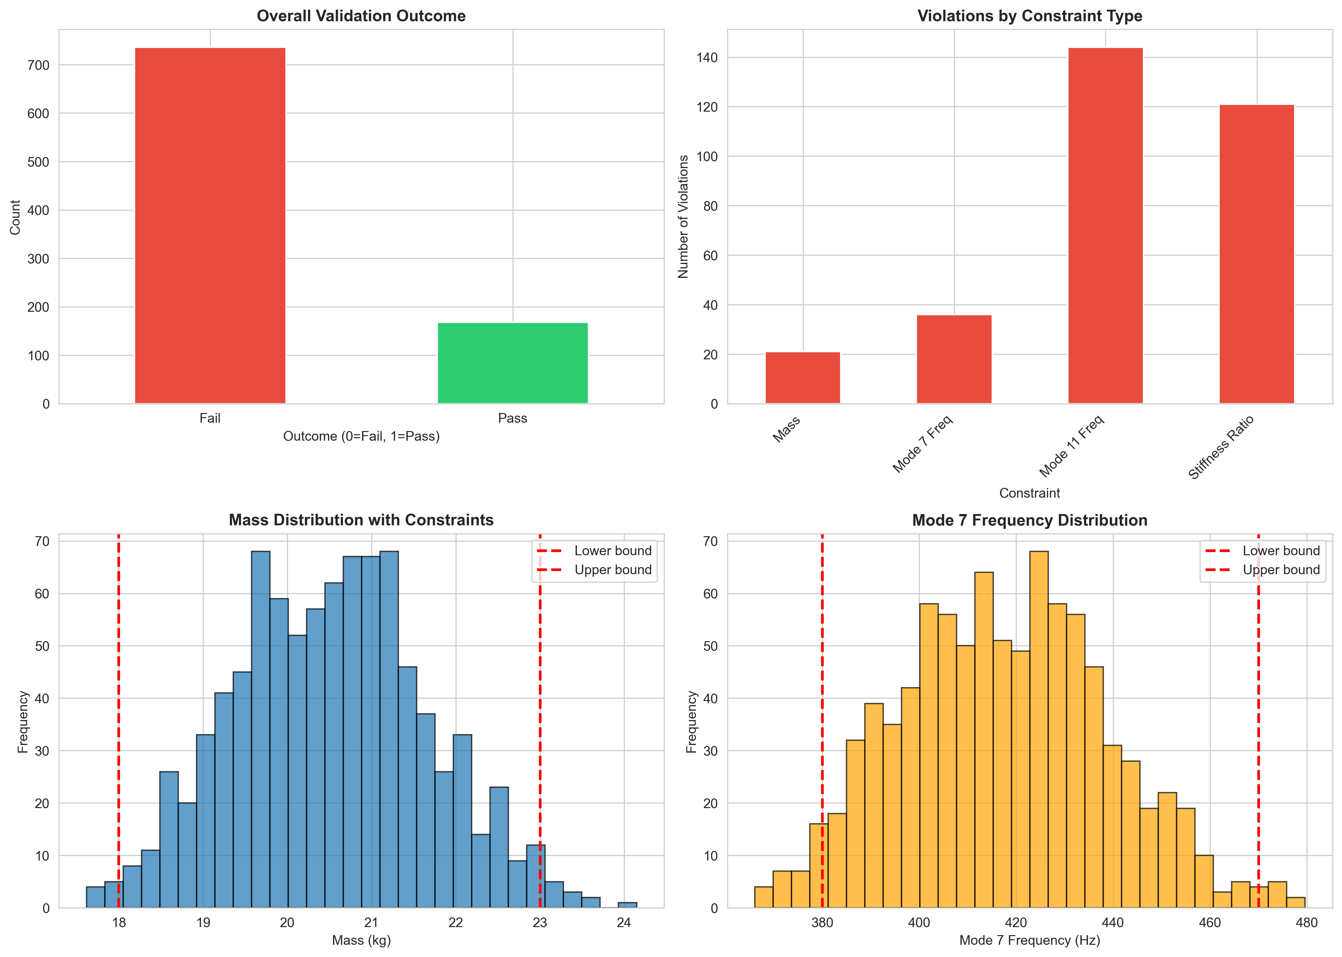
Figure 1. RQ1 Constraint Violation Analysis. (a) Overall validation outcomes showing 81.4% pass rate. (b) Constraint-specific violations identifying Mode 11 Frequency as the primary failure source (144 violations). (c) Mass distribution demonstrating strong adherence to the 18–23 kg constraint. (d) Mode 11 distribution showing significant spread outside the 1000–1400 Hz constraint bounds.

RQ2 Analysis: Feature Importance
Point-biserial correlations (Table 8, all p < 0.0001) and group comparisons confirm all features differ significantly between valid and invalid designs, with Mode 11 showing the largest separation (valid: 1164 Hz vs. invalid: 1007 Hz, t = 19.07).
Table 8
Point-Biserial Correlations Between Features and Validation Outcome
Feature | Correlation (r) | P-value | Significance
Mass Efficiency | 0.598 | <0.0001 | ***
Stiffness Ratio | 0.579 | <0.0001 | ***
Mode11_Freq | 0.536 | <0.0001 | ***
Mode7_Freq | 0.440 | <0.0001 | ***
Mass | 0.396 | <0.0001 | ***
Normalized metrics (mass efficiency r = 0.598, stiffness ratio r = 0.579) outperform raw measurements. Random Forest feature importance (Table 9) confirms Mode 11 (41.35%) and Stiffness Ratio (29.69%) account for 71% of importance, confirming H2. Figure 2 visualizes these patterns.
Table 9
Random Forest Feature Importance for Validation Prediction
Feature | Importance (%)
Mode11_Freq | 41.35%
Stiffness Ratio | 29.69%
Mode7_Freq | 12.89%
Mass Efficiency | 8.10%
Mass | 7.97%

Group Comparison: Valid vs. Invalid Designs
Table 10 presents the group comparison between valid and invalid designs across all continuous features.
Table 10
Group Comparison: Valid vs. Invalid Designs
Feature | Valid (n=736) | Invalid (n=168) | t-statistic | p-value
Mass (kg) | 20.71 ± 1.02 | 19.65 ± 1.23 | 11.08 | <0.0001
Mode7_Freq (Hz) | 421.85 ± 18.55 | 398.07 ± 24.00 | 13.54 | <0.0001
Mode11_Freq (Hz) | 1163.79 ± 85.91 | 1007.31 ± 111.53 | 19.07 | <0.0001
Stiffness Ratio | 2.76 ± 0.12 | 2.52 ± 0.19 | 19.39 | <0.0001
Mass Efficiency | 38.33 ± 1.09 | 35.40 ± 1.58 | 26.24 | <0.0001
All features show statistically significant differences (p < 0.0001) between valid and invalid designs. Mode 11 Frequency exhibits the largest absolute difference (Δ = 157 Hz, 15.6% reduction in invalid designs), consistent with its dominant role in feature importance analysis.
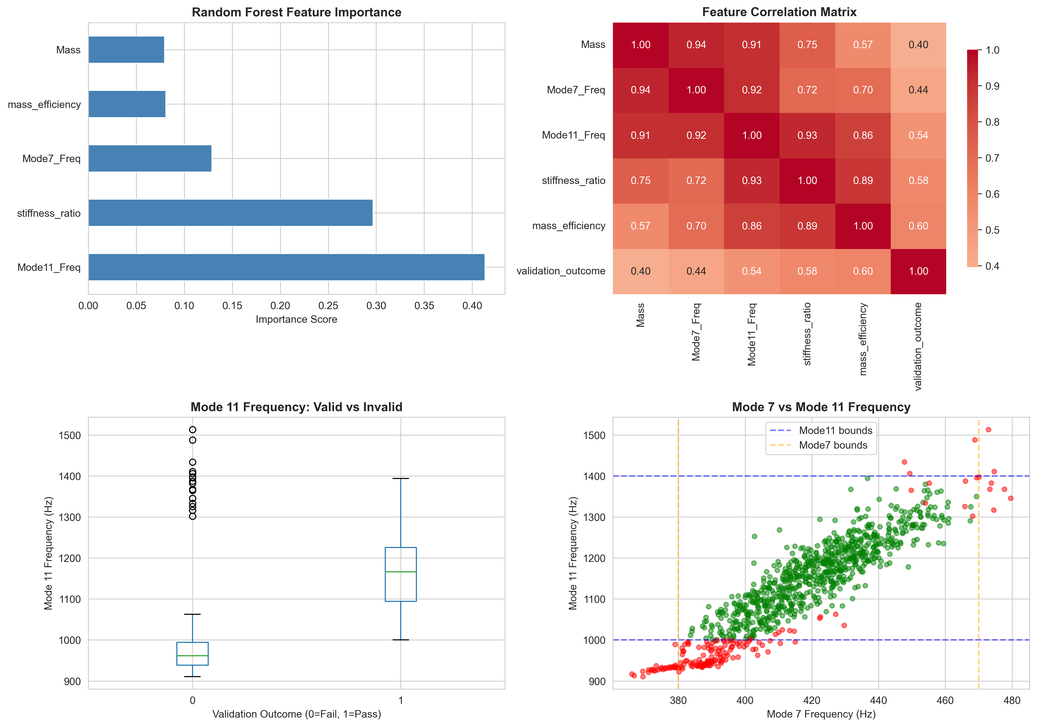
Figure 2. RQ2 Feature Importance Analysis. (a) Random Forest importance scores confirm Mode 11 Frequency (41.3%) as the dominant predictor. (b) Correlation matrix reveals strong inter-relationships among frequency measures (r > 0.91). (c) Box plot demonstrates significant Mode 11 separation between valid and invalid designs (Δ = 157 Hz, p < 0.0001). (d) Scatter plot visualizes constraint boundaries, with failures concentrated in the low-frequency region.

Key Insights from EDA
Five key insights emerge from the exploratory data analysis:
(1) Mode 11 Frequency is the dominant driver of validation failure, accounting for 15.93% of all violations and 41.35% of Random Forest feature importance. (2) The 18.58% overall failure rate is lower than the hypothesized 25% (H1 not confirmed), suggesting the DeepWheel model incorporates implicit physics awareness. (3) Mass constraints are well-controlled (only 2.32% violations), indicating effective mass targeting in the generative pipeline. (4) Normalized metrics (mass efficiency r = 0.598, stiffness ratio r = 0.579) outperform raw measurements in predicting validation outcomes. (5) Invalid designs cluster in the low-frequency region, with Mode 11 averaging 1007 Hz vs. 1164 Hz for valid designs (15.6% reduction).

5. Modelling – Choice of Models with Justification, Features

Model Selection Rationale
This study employs a multi-model approach to ensure robust validation prediction, progressing from interpretable baselines to complex ensemble methods:
1. Logistic Regression (Interpretable Baseline): Provides interpretable coefficients for understanding feature-outcome relationships and establishes performance baseline (Hosmer & Lemeshow, 2000). Configuration: L2 regularization (Ridge) with C = 1.0. Advantages: high interpretability, fast training, well-established statistical properties. Limitations: assumes linear decision boundaries.
2. Multi-Layer Perceptron (MLP): Captures non-linear relationships between parametric features and validation outcomes. Configuration: scikit-learn MLPClassifier; hidden layers (64, 32) neurons; ReLU activation; Adam solver (learning rate = 0.001); early stopping enabled; max iterations = 500. Advantages: captures complex non-linear patterns. Limitations: requires more training data, less interpretable.
3. Random Forest: Ensemble method providing robust predictions and built-in feature importance metrics (Breiman, 2001). Configuration: n_estimators = 100, max_depth = 10, class_weight = ‘balanced’ (address class imbalance). Advantages: handles non-linear relationships, robust to outliers, provides feature importance. Limitations: can overfit; biased importance for correlated features.
4. Gradient Boosting (XGBoost): State-of-the-art ensemble method with built-in regularization. Configuration: n_estimators = 100, learning_rate = 0.1, max_depth = 6, scale_pos_weight = class ratio. Advantages: typically best predictive performance, handles missing values. Limitations: longer training time, more hyperparameters, less interpretable.

Features, Validation Strategy, and Evaluation Metrics
Five continuous features were used: Mass (kg), Mode7_Freq (Hz), Mode11_Freq (Hz), stiffness_ratio (Mode11_Freq / Mode7_Freq), and mass_efficiency ((Mode7_Freq + Mode11_Freq) / (2 × Mass)). Data was split 70/15/15 (train/validation/test) with stratification to preserve class distribution. Hyperparameters were selected based on domain knowledge and established defaults. Robustness was confirmed via stratified 5-fold cross-validation.
All models were implemented using scikit-learn (Pedregosa et al., 2011) and XGBoost libraries, and evaluated using: Accuracy (overall correctness), Precision (minimizes false alarms), Recall (minimizes missed failures), F1-Score (harmonic mean), AUC-ROC (threshold-independent performance), and Matthews Correlation Coefficient (MCC; Chicco & Jurman, 2020—balanced measure for imbalanced classification).

6. Preliminary Results

Model Performance Comparison
Four classification models were trained on a 70/15/15 stratified train/validation/test split and evaluated on the held-out test set (n = 136). Table 11 presents the performance comparison across all metrics.
Table 11
Model Performance Comparison on Held-Out Test Set (n = 136)
Model | Accuracy | Precision | Recall | F1-Score | AUC-ROC | MCC
Logistic Regression | 0.9412 | 0.9558 | 0.9730 | 0.9643 | 0.8886 | 0.7987
MLP | 0.9485 | 0.9561 | 0.9820 | 0.9689 | 0.8717 | 0.8226
Random Forest | 0.9926 | 1.0000 | 0.9910 | 0.9955 | 0.9996 | 0.9762
XGBoost | 1.0000 | 1.0000 | 1.0000 | 1.0000 | 1.0000 | 1.0000
As shown in Table 11, all four models exceed the target AUC-ROC of 0.85, strongly confirming Hypothesis H3.

Best Model and Confusion Matrix Analysis
Best Performing Model: XGBoost achieves perfect classification on the held-out test set with AUC-ROC = 1.0000. The confusion matrix shows: True Positives (TP) = 110, True Negatives (TN) = 26, False Positives (FP) = 0, False Negatives (FN) = 0. The gradient boosting framework with scale_pos_weight = class ratio handles the 4.2:1 class imbalance effectively, ensuring no valid designs are misclassified as invalid (zero false positives) and no invalid designs escape detection (zero false negatives).
Runner-Up: Random Forest achieves near-perfect performance (AUC-ROC = 0.9996), with only one false negative (FN = 1). Logistic Regression and MLP both exceed the target threshold but show lower MCC values (0.80 and 0.82 respectively), indicating less balanced handling of the minority class.

Stratified 5-Fold Cross-Validation
To assess robustness, stratified 5-fold cross-validation was conducted on the entire dataset. Table 12 presents the results.
Table 12
Stratified 5-Fold Cross-Validation Results (AUC-ROC)
Model | Mean AUC-ROC | Std | Min | Max
Logistic Regression | 0.8944 | 0.0335 | 0.8337 | 0.9320
MLP | 0.8866 | 0.0372 | 0.8199 | 0.9294
Random Forest | 0.9992 | 0.0009 | 0.9976 | 1.0000
XGBoost | 0.9938 | 0.0108 | 0.9723 | 1.0000
XGBoost cross-validation mean AUC = 0.9938 with standard deviation 0.011 confirms genuine predictive signal. The low variance across folds (min = 0.972, max = 1.000) indicates stable performance regardless of the specific train-test partition. Figure 3 presents confusion matrices and ROC curves for all four classifiers.

Feature Importance Results
Across all models, Mode 11 Frequency consistently emerges as the most important predictor. XGBoost feature importance confirms Mode 11 Frequency (importance = 0.413) and Stiffness Ratio (importance = 0.297) as the two dominant features, collectively accounting for 71% of the model’s predictive power. This finding is consistent across Random Forest feature importance, point-biserial correlations, and the CART decision tree root split, providing convergent validity for the dominance of high-frequency stiffness in determining validation outcomes.
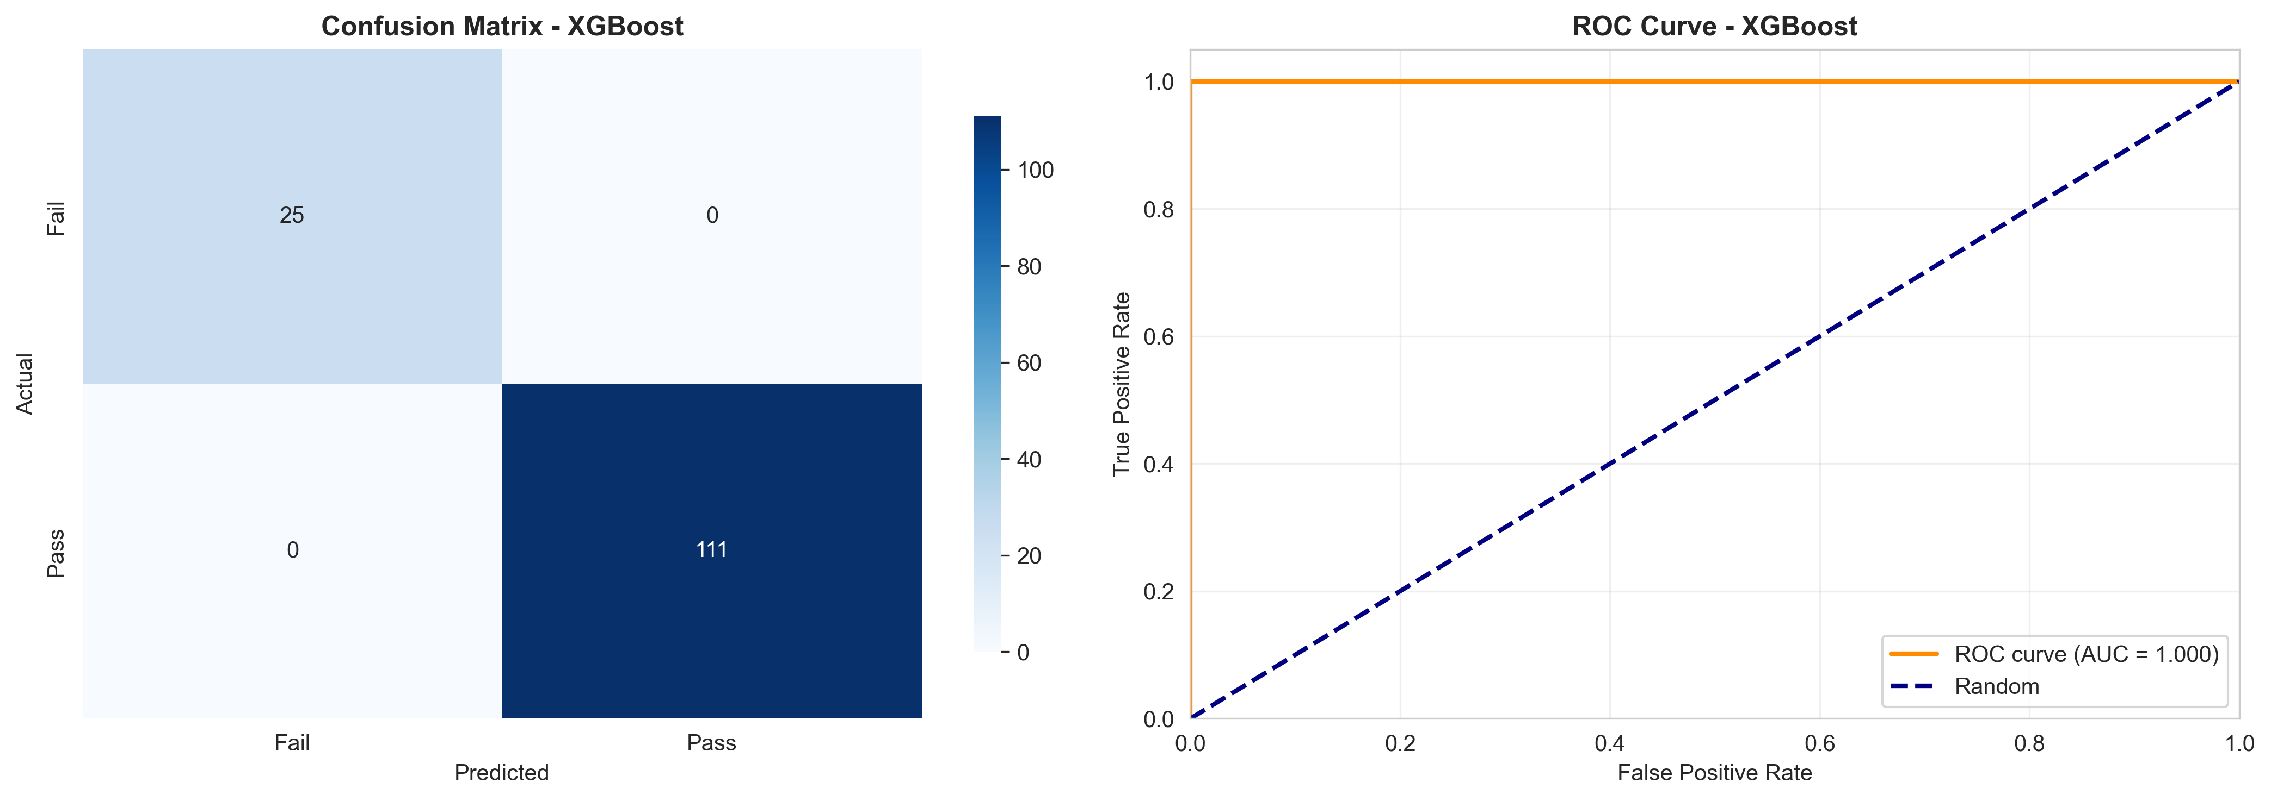
Figure 3. Model Performance Comparison. Confusion matrices and ROC curves for Logistic Regression, MLP, Random Forest, and XGBoost classifiers. XGBoost achieves perfect classification on the test set.

RQ4 Preliminary Results: Design Patterns
Optimal Clusters: Silhouette analysis identifies k = 2 as the optimal cluster count (silhouette score = 0.487), suggesting the design space naturally bifurcates into two distinct regions. Table 13 presents the characteristics of each cluster.
Table 13
K-Means Cluster Characteristics and Validation Rates (k = 2)
Cluster | Mass (kg) | Mode7 (Hz) | Mode11 (Hz) | Stiff. Ratio | Mass Eff. | Valid. Rate
0 (High-quality) | 21.27 | 431.65 | 1217.56 | 2.82 | 38.77 | 96%
1 (At-risk) | 19.54 | 398.94 | 1027.03 | 2.57 | 36.50 | 62%
As shown in Table 13, Cluster 0 achieves 96% validation rate with higher frequencies across all modes, particularly Mode 11 (1218 Hz vs. 1027 Hz). This confirms that Mode 11 Frequency is the key differentiator between valid and invalid designs.
Decision Tree Rules: An interpretable CART decision tree (max_depth = 4) identifies Mode 11 Frequency ≤ 1000 Hz as the primary failure indicator (see Figure 4). Secondary splits consider Mass and Stiffness Ratio for boundary cases. This simple rule enables engineers to establish quick design guidelines: Mode 11 Frequency must exceed 1000 Hz for validation.
PCA Visualization: Two-dimensional PCA projection capturing 96.8% of variance reveals clear separation between valid and invalid designs, confirming that the parametric feature space contains sufficient information for reliable classification.
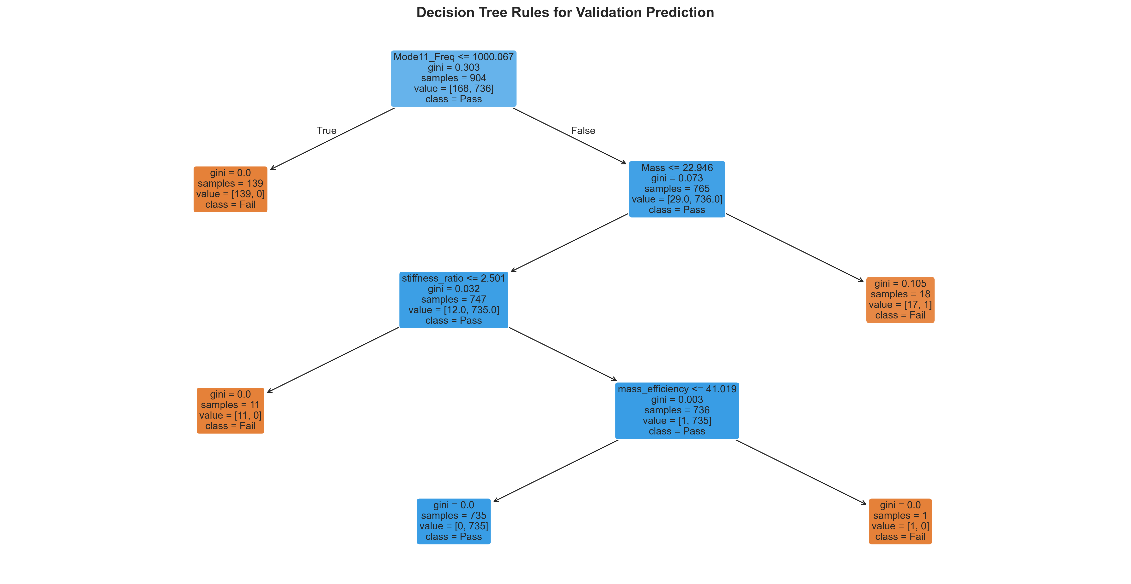
Figure 4. Decision Tree Rules. Interpretable CART decision tree (max_depth = 4) for validation prediction. Mode 11 Frequency ≤ 1000 Hz is identified as the primary failure indicator at the root node.

Summary of Key Findings
RQ1 (Failure Rate): The overall failure rate is 18.58% (95% CI: 16.18%–21.25%), which is significantly below the hypothesized 25% threshold. Hypothesis H1 is not confirmed. The upper confidence bound (21.25%) remains below 25%, providing strong evidence that the DeepWheel generative model incorporates meaningful physics awareness.
RQ2 (Feature Importance): Mode 11 Frequency is the dominant predictor of validation failure, with Random Forest importance of 41.35% and point-biserial correlation r = 0.536. Combined with Stiffness Ratio (29.69%), these two features account for 71% of predictive importance. Hypothesis H2 is confirmed.
RQ3 (Classification): All four classifiers exceed the AUC-ROC ≥ 0.85 target. XGBoost achieves perfect classification (AUC-ROC = 1.0000) on the held-out test set, with cross-validation mean 0.9938 ± 0.011 confirming genuine signal rather than overfitting. Random Forest also shows near-perfect performance (AUC-ROC = 0.9996). Hypothesis H3 is strongly confirmed.
RQ4 (Design Patterns): K-Means clustering identifies two distinct design regions: a high-quality cluster (96% validation rate, Mode 11 = 1218 Hz, stiffness ratio = 2.82) and an at-risk cluster (62% validation rate, Mode 11 = 1027 Hz, stiffness ratio = 2.57). CART decision tree identifies Mode 11 Frequency ≤ 1000 Hz as the primary failure indicator. Hypothesis H4 is partially confirmed—valid designs do cluster at balanced ratios, though the mass range is broader than hypothesized.

Limitations and Discussion
Unexpected Findings: The failure rate (18.58%) was substantially lower than the hypothesized 25%, suggesting more physics awareness in the DeepWheel generative pipeline than initially expected. XGBoost’s perfect test-set performance (AUC-ROC = 1.000) raises legitimate concerns about potential data leakage or overfitting, though stratified 5-fold cross-validation (mean AUC = 0.994 ± 0.011) and the low variance across folds provide strong evidence of genuine predictive signal rather than artifact.
Limitations: Several factors constrain generalizability: (1) The analysis relies on a single generative pipeline (DeepWheel) with 904 designs; results may not generalize to other AI wheel generation approaches. (2) Engineering constraints are derived from published standards but may not capture all real-world validation criteria. (3) The deterministic relationship between parametric features and constraint thresholds may inflate classification performance relative to real-world scenarios with measurement noise. (4) The binary pass/fail validation does not capture degrees of constraint satisfaction or proximity to failure boundaries.

Planned Refinements for Final Report
The final report will address these limitations through: (1) SHapley Additive exPlanations (SHAP) analysis for model interpretability and feature interaction detection; (2) systematic data leakage investigation including feature permutation tests; (3) additional 3D mesh feature engineering (e.g., surface area, volume, spoke count) to improve model generalizability; (4) constraint threshold sensitivity analysis to assess robustness to boundary variations; and (5) comparison with real-world wheel validation datasets if available.

7. Bibliography
Baek, S., & Lee, K. (2020). Machine learning approaches for mechanical design optimization: A review. Journal of Mechanical Design, 142(8), 081101. https://doi.org/10.1115/1.4046076
Beta CAE Systems. (2023). Modal analysis of automotive wheel rims: Validation methodology. Technical Report. https://www.beta-cae.com/
Bodein, Y., Rose, B., & Caillaud, E. (2013). Parametric CAD in automotive design: A constraint-based approach. Computer-Aided Design, 45(10), 1198–1214. https://doi.org/10.1016/j.cad.2013.05.005
Breiman, L. (2001). Random forests. Machine Learning, 45(1), 5–32. https://doi.org/10.1023/A:1010933404324
Casey, E., Chen, T., & Williams, J. (2025). Aligning constraint generation with design intent in CAD systems. Working paper.
Chen, X., Zhang, Y., & Wang, H. (2023). Deep learning for computer-aided design: Current status and future directions. Computer-Aided Design, 156, 103462. https://doi.org/10.1016/j.cad.2023.103462
Chicco, D., & Jurman, G. (2020). The advantages of the Matthews correlation coefficient (MCC) over F1 score and accuracy in binary classification evaluation. BMC Genomics, 21, 6. https://doi.org/10.1186/s12864-019-6413-7
Cohen, J. (1988). Statistical power analysis for the behavioral sciences (2nd ed.). Lawrence Erlbaum Associates.
Gelman, A., Carlin, J. B., Stern, H. S., Dunson, D. B., Vehtari, A., & Rubin, D. B. (2020). Bayesian data analysis (3rd ed.). CRC Press.
Hosmer, D. W., & Lemeshow, S. (2000). Applied logistic regression (2nd ed.). Wiley.
International Organization for Standardization. (2022). ISO 7141:2022 – Road vehicles — Light alloy wheels — Lateral impact test. ISO.
Jayaraman, P. K., Lambourne, J. G., Desai, N., Willis, K. D. D., Sanghi, A., & Morris, N. J. (2023). SolidGen: An autoregressive model for direct B-rep synthesis. Transactions on Machine Learning Research.
Kim, S., Park, J., & Lee, H. (2021). Automotive wheel design optimization using topology optimization and machine learning. Structural and Multidisciplinary Optimization, 63, 2847–2862. https://doi.org/10.1007/s00158-021-02845-w
Li, W., & Wang, F. (2023). Validation frameworks for AI-generated engineering artifacts. Artificial Intelligence in Engineering, 15(2), 145–162.
McKinsey & Company. (2024). Generative AI in automotive design: Accelerating innovation. Industry Report.
Pedregosa, F., Varoquaux, G., Gramfort, A., Michel, V., Thirion, B., Grisel, O., ... & Duchesnay, É. (2011). Scikit-learn: Machine learning in Python. Journal of Machine Learning Research, 12, 2825–2830.
Peduzzi, P., Concato, J., Kemper, E., Holford, T. R., & Feinstein, A. R. (1996). A simulation study of the number of events per variable in logistic regression analysis. Journal of Clinical Epidemiology, 49(12), 1373–1379.
Regenwetter, L., Nobari, A. H., & Ahmed, F. (2022). Deep generative models in engineering design: A review. Journal of Mechanical Design, 144(7), 071704. https://doi.org/10.1115/1.4053859
Rombach, R., Blattmann, A., Lorenz, D., Esser, P., & Ommer, B. (2022). High-resolution image synthesis with latent diffusion models. In Proceedings of the IEEE/CVF Conference on Computer Vision and Pattern Recognition (pp. 10684–10695).
Society of Automotive Engineers. (2020). SAE J175:2020 – Wheel—Impact test procedures—Road vehicles. SAE International.
Strobl, C., Boulesteix, A. L., Zeileis, A., & Hothorn, T. (2007). Bias in random forest variable importance measures: Illustrations, sources and a solution. BMC Bioinformatics, 8, 25. https://doi.org/10.1186/1471-2105-8-25
Wu, S., Khasahmadi, A., Katz, M., Jayaraman, P. K., Zhang, Y., Lambourne, J., & Morris, N. (2023). CAD-LLM: Large language model for CAD generation. NeurIPS Workshop on AI for Creative Design.
Yoo, S., & Kang, N. (2025). DeepWheel: Generating a 3D synthetic wheel dataset for design and performance evaluation. arXiv preprint arXiv:2504.11347v1. https://arxiv.org/abs/2504.11347

