**Following are the steps to bind the Sonar Lint plugin with SonarQube server for STS (IDE)**

Step 1: - Download the certificate.

Step 2: - Add the downloaded certificate in STS embedded JDK trust store.

Step 3: - Install the Sonar lint plugin and bind it with SonarQube server.

**Download the certificate**

Step 1.1:- Browse the URL https://sast.ap.toyota-asia.com, inspect and click on security tab

Step 1.2: - Click on view certificate than click on Details tab and click on Export button

Step:1.3 – Click on Export to download the certificate and save it in C:/tpex folder with name “sast.ap.toyota-asia.crt”  
  
**Add the downloaded certificate in STS embedded JDK trust store**

1. Navigate to STS extracted directory (Exp - D:\software\sts-4.17.2.RELEASE)
2. Open the configuration setting file name as "SpringToolSuite4"
3. Identify the embedded jdk directory (Exp - plugins/org.eclipse.justj.openjdk.hotspot.jre.full.win32.x86_64_17.0.6.v20230125-1136/jre/bin)
4. Open the command prompt with admin accesstifi
5. Navigate to embedded jdk directory ~/jre/lib/security folder (Exp - D:\software\sts-4.17.2.RELEASE\plugins\org.eclipse.justj.openjdk.hotspot.jre.full.win32.x86_64_17.0.6.v20230125-1136\jre\lib\security)
6. Execute the below command (password is - changeit): -  
   keytool -import -noprompt -trustcacerts -alias "sonar"  -file C:\tpex\sast.ap.toyota-asia.crt -keystore cacerts
7. Restart the system

**Install the Sonar lint plugin and bind it with SonarQube server**

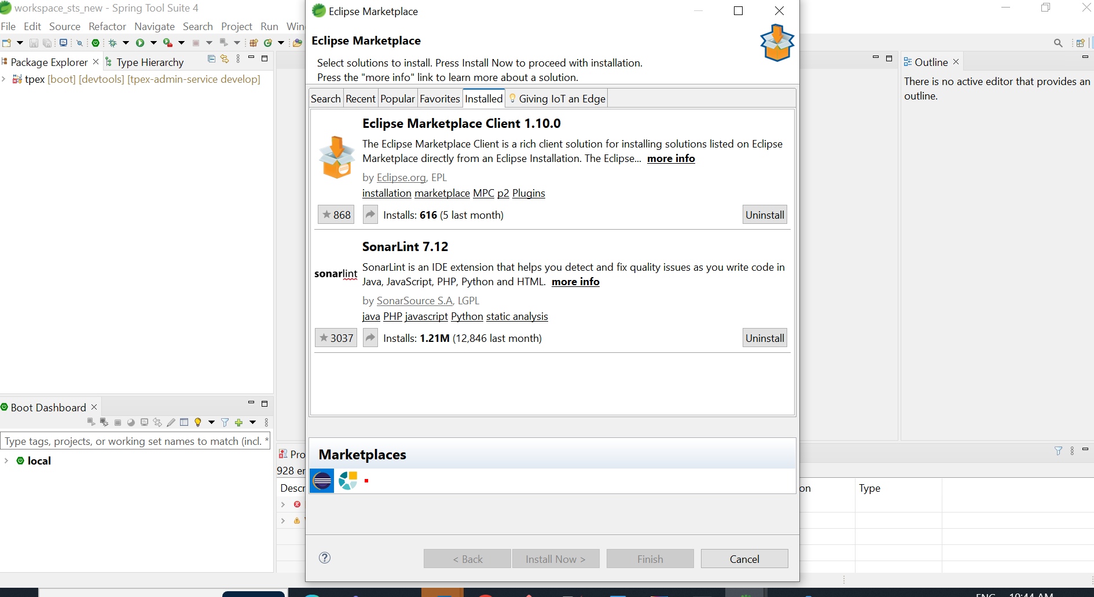

Binding with SonarQube server (https://sast.ap.toyota-asia.com)

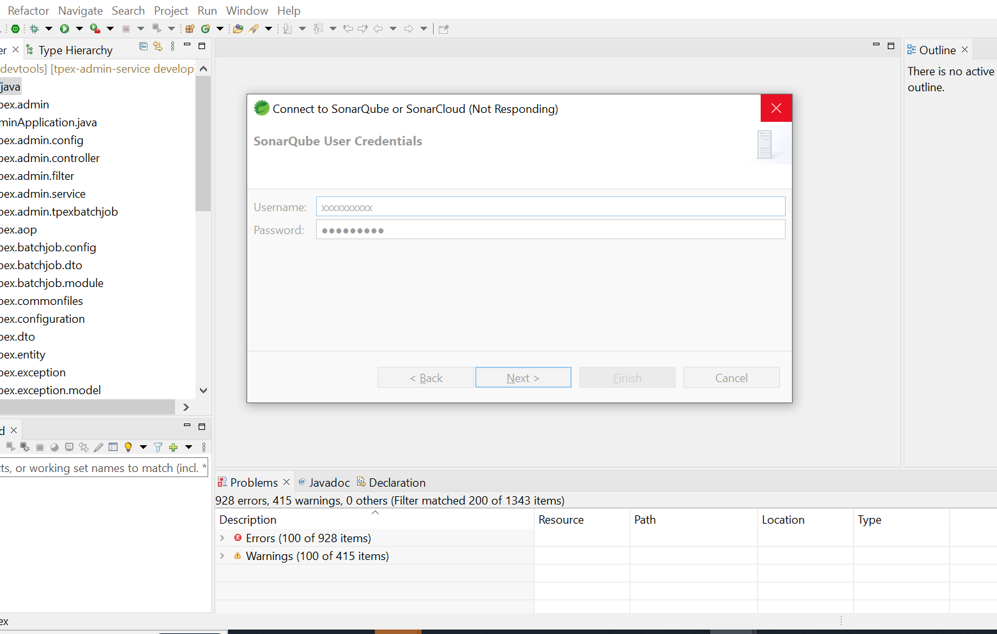5



