**Setup:**

**Step1>> Set your data root directory in the following way**

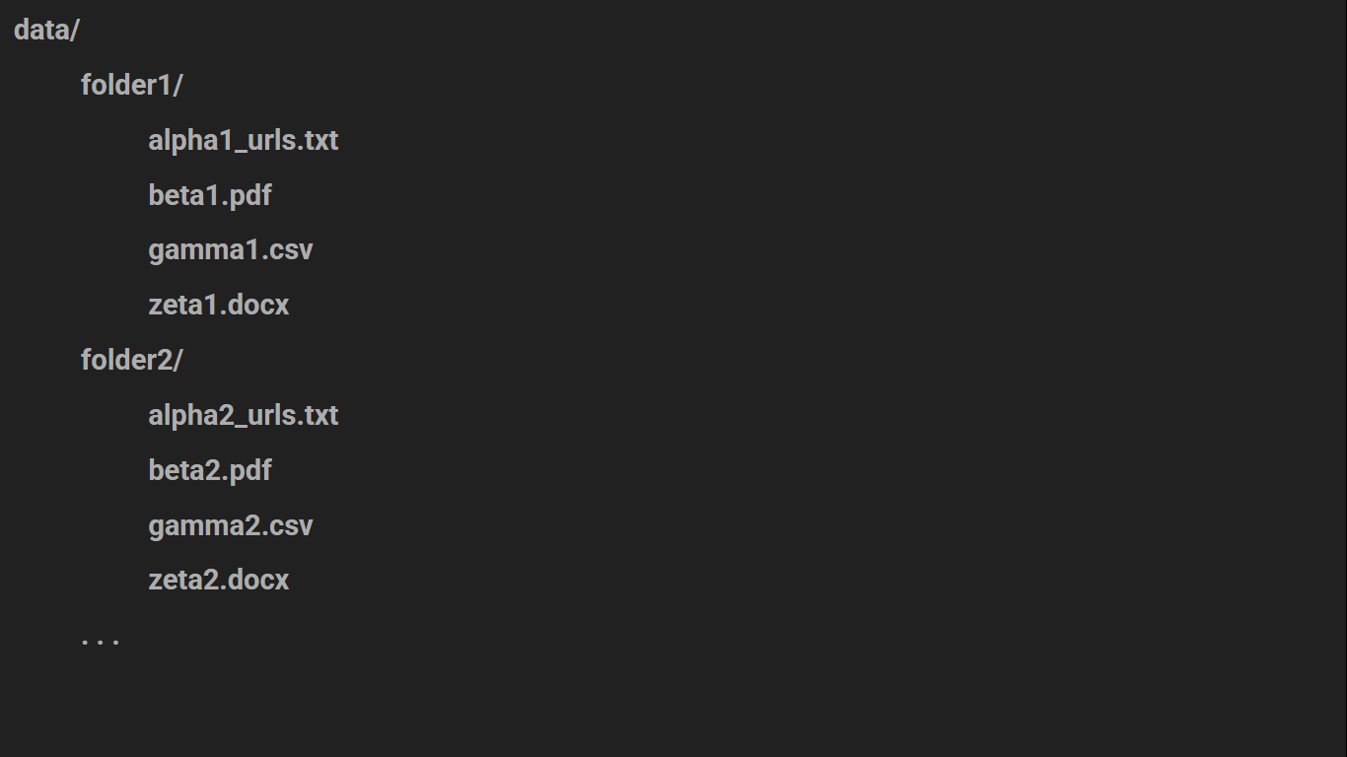

**Step2>> Follow the commands.txt file**

* **Setup your python environment**
* **Install the requirements.txt file**
* **Setup your LLM key in .env file**
* **Run your Streamlit app**

**Step3>> Redirect to HomePage**

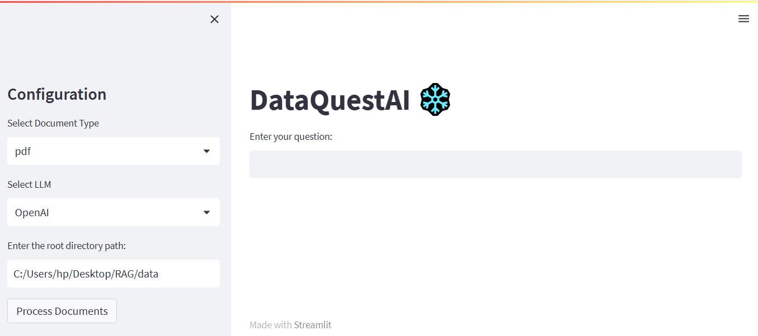

**Step4>> Select the file type and LLM you want to use and click on Process Documents.**

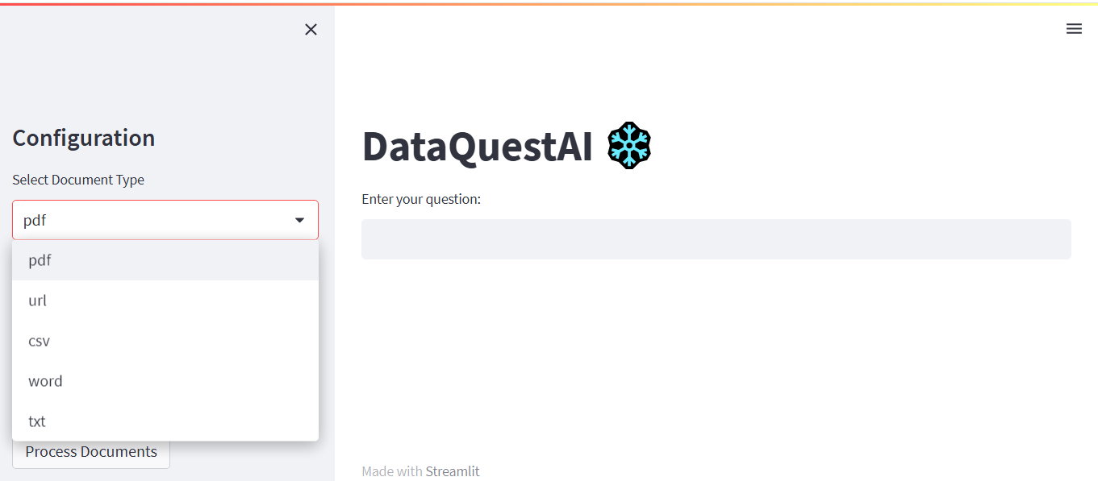

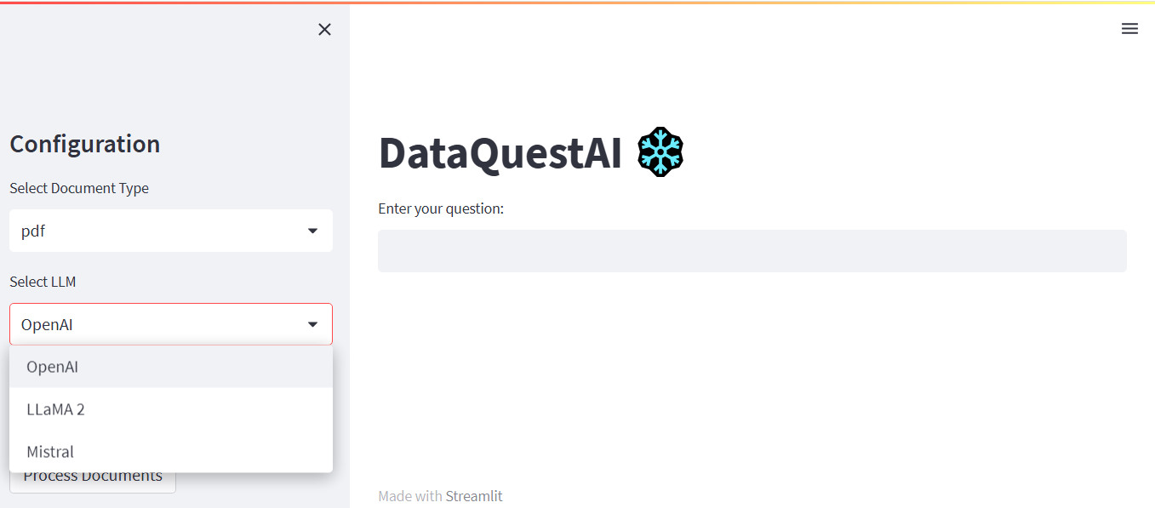

**Step5>> Once you select and configure all your settings, proceed to enter questions for query**