1. Link to the website: **krmariia.github.io**
2. Q3:

-The purpose of the site stayed the same – for my photo works and to promote myself, to encourage people. However, it will be difficult to maintain it and add new and new works as it requires too much time to write HTML and CSS codes.

- At first I planned to use it as storage for my works, but now I understood that is won’t be so simple. It was supposed to be used for future “clients” as well.

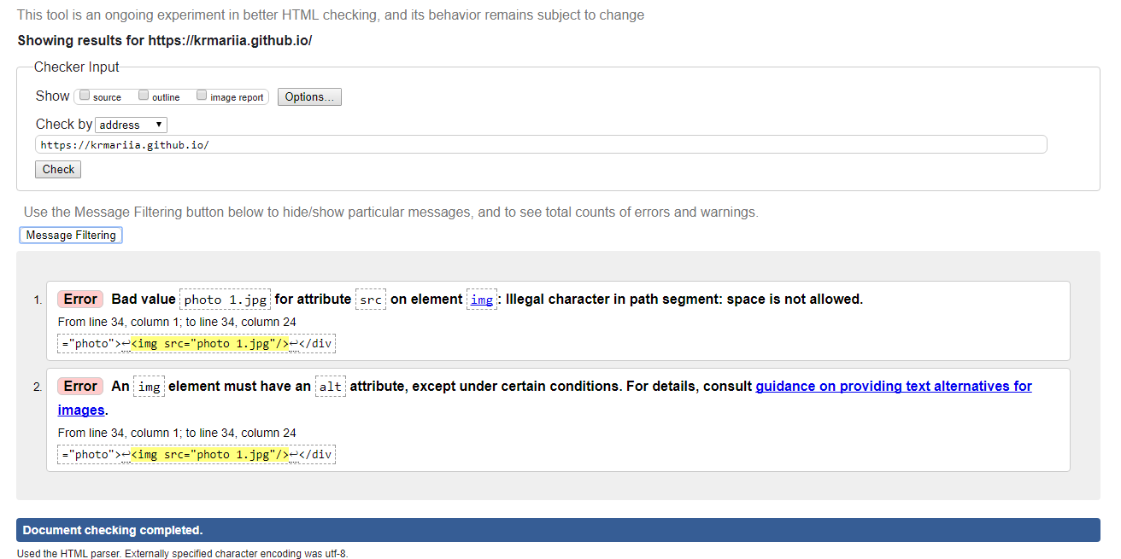- I was inspired by platform for professional photographers, namely <https://alexstoddard.format.com/#7> this one, which I chose as an example to follow.

3. Validator: