A STUDY OF AI-DRIVEN FINANCIAL PLANNING & ANALYSIS (FP&A) FOR STRATEGIC DECISION-MAKING IN INSIGHT CAPITAL ADVISORY PVT.LTD.,
Dissertation submitted in partial fulfillment of the requirements for the
award of the Degree of
POST GRADUATE DIPLOMA IN MANAGEMENT
of
ABBS SCHOOL OF MANAGEMENT

By
Nandan K R
Reg. No: 24PGDMR070
Under the guidance of
Bhagyamma.V
Assistant Professor
ABBS SCHOOL OF MANAGEMENT
2024-26

DECLARATION BY THE STUDENT

I hereby declare that “A STUDY OF AI-DRIVEN FINANCIAL PLANNING & ANALYSIS (FP&A) FOR STRATEGIC DECISION-MAKING IN INSIGHT CAPITAL ADVISORY PVT.LTD.,” is the result of the project work carried out by me under the guidance of the Bhagyamma. V in partial fulfillment for the award of Post Graduate Diploma in Management by ABBS School of Management.
I also declare that this project is the outcome of my own efforts and that it has not been submitted to any other university or Institute for the award of any other degree or Diploma or Certificate.

Place: Bengaluru | Name: Nandan K R
Date: 05-Sept-2026 | Reg No: 24PGDMR070

CERTIFICATE OF ORIGINALITY
Date: 05-Sept-2026

This is to certify that this Internship Report titled “AI-DRIVEN FINANCIAL PLANNING & ANALYSIS (FP&A) DASHBOARD FOR STRATEGIC DECISION-MAKING” submitted to ABBS School of Management, Bangalore in partial fulfillment of the requirement for the award of the Post Graduate Diploma in Management (PGDM) is a Bonafide work of Nandan K R, term VI PGDM, bearing Reg. No: 24PGDMR070 under the guidance and supervision of the Bhagyamma V Assistant Professor, ABBS School of Management, Bengaluru. This is to further certify that to the best of my knowledge and belief, this report has not been submitted earlier to any other University or Institution for the award of any Degree/Diploma/Certificate.
His/her character and conduct are satisfactory during the study and we wish him/her all the success in future endeavors.

SIGNATURE OF GUIDE | SIGNATURE OF DIRECTOR
Bhaghyamma.P | Dr. Madhumita Chatterji
Date: 05-Sept-2026 | Date: 05-Sept-2026

ACKNOWLEDGEMENT
I take this opportunity to offer my special thanks to Dr. Madhumita Chatterji, Director, ABBS School of Management, Bangalore, for providing me the necessary facilities in the campus to accelerate my academic activities in ABBS School of Management and for the moral support and care.
I would like to record my gratitude to Bhagyamma V, Assistant Professor, ABBS School of Management, Bangalore, who has guided me in my study. His/her able guidance has made me to complete this project work in the present shape and style.
I would like to thank my Rajesh Srinivasan (Human Resources & Administrative) and the team at Insight Capital Advisory Pvt. Ltd. for the support and guidance during the course of the project in the company.
Finally, I wish to express my deepest gratitude to my parents, the Almighty and my dear friends who have been the source of inspiration in my life all the time. My gratitude is also recorded here to those people who have directly or indirectly helped me during my project.

Place: Bengaluru | Name: Nandan K R
Date: 05-Sept-2026 | Reg No: 24PGDMR070

TABLE OF CONTENTS
CHAPTER NO. | PARTICULARS | PAGE NO.
CHAPTER 1 | INTRODUCTION | 01-04
CHAPTER 2 | PROFILE OF THE ORGANIZATION | 05-09
CHAPTER 3 | DESIGN OF THE DISSERTATION | 10-18
CHAPTER 4 | DATA ANALYSIS AND INTERPRETATION | 11-46
CHAPTER 5 | FINDINGS, SUGGESTIONS AND CONCLUSION | 47-54

LIST OF ABBREVIATIONS

ABBREVIATION | FULL FORM
AI | Artificial Intelligence
BI | Business Intelligence
BSE | Bombay Stock Exchange
CAGR | Compound Annual Growth Rate
D/E | Debt-Equity
DSS | Decision Support Systems
EBITDA | Earnings Before Interest, Taxes, Depreciation and Amortization
ERP | Enterprise Resource Planning
EPS | Earnings Per Share
FP&A | Financial Planning & Analysis
FY | Financial Year
HTML | Hypertext Markup Language
KPI | Key Performance Indicator
L&T | Larsen & Toubro
MIS | Management Information System
ML | Machine Learning
NSE | National Stock Exchange
PAT | Profit After Tax
PGDM | Post Graduate Diploma in Management
R | R statistical programming language
SQL | Structured Query Language

LIST OF TABLES
TABLE NO. | DESCRIPTION | PAGE NO.
4.1 | Overall Data Analysis Framework | 20
4.2 | Historical Growth Indicators | 20
4.3 | Comparative Profitability and Leverage Ratios | 22
4.4 | Driver-Based Forecast Summary | 23
4.5 | Driver-Based versus AI-Assisted Forecast Comparison Framework | 25
4.6 | Primary Data Methodology | 25
4.7 | Q1 Frequency Distribution | 26
4.8 | Q2 Frequency Distribution | 27
4.9 | Q3 Frequency Distribution | 28
4.10 | Q4 Frequency Distribution | 29
4.11 | Q5 Frequency Distribution | 30
4.12 | Q6 Frequency Distribution | 31
4.13 | Q7 Frequency Distribution | 32
4.14 | Q8 Frequency Distribution | 33
4.15 | Q9 Frequency Distribution | 34
4.16 | Q10 Frequency Distribution | 35
4.17 | Q11 Frequency Distribution | 36
4.18 | Q12. Dashboard-Building Confidence – Rating Distribution | 37
4.19 | Q13. MIS / Variance-Reporting Confidence – Rating Distribution | 38
4.20 | Q14. Importance of BI Skills for Finance Careers – Rating | 39
4.21 | Q15. Perceived PGDM Preparation for BI-Driven Roles – Rating | 40
4.22 | Summary of Primary Survey Mean Scores | 41
4.23 | Dashboard Confidence by Internship Experience | 42
4.24 | Dashboard Confidence by Excel Proficiency | 43

LIST OF FIGURES/GRAPHS
FIGURE NO. | DESCRIPTION | PAGE NO.
4.1 | Historical Revenue Trend of the Five Companies | 21
4.2 | EBITDA Margin Trend | 22
4.3 | Driver-Based Revenue Forecast | 24
4.4 | Forecast Revenue CAGR to FY2030-31 | 24
4.5 | Q1. Specialization | 26
4.6 | Q2. FP&A / Power BI internship experience | 27
4.7 | Q3. Excel proficiency | 28
4.8 | Q4. BI tools used or learned | 29
4.9 | Q5. BI training in PGDM coursework | 30
4.10 | Q6. Career likelihood | 31
4.11 | Q7. Recruiter-valued skills | 32
4.12 | Q8. Certification status | 33
4.13 | Q9. Placement impact | 34
4.14 | Q10. Curriculum improvement | 35
4.15 | Q11. Classroom–industry gap | 36
4.16 | Q12. Dashboard-Building Confidence | 37
4.17 | Q13. MIS / Variance-Reporting Confidence | 38
4.18 | Q14. Importance of BI Skills for Finance Careers | 39
4.19 | Q15. Perceived PGDM Preparation for BI-Driven Roles | 40
4.20 | Mean Dashboard Confidence by Internship Experience | 42
4.21 | Mean Dashboard Confidence by Excel Proficiency | 43

EXECUTIVE SUMMARY

The present dissertation, titled “AI-Driven Financial Planning & Analysis (FP&A) Dashboard for Strategic Decision-Making,” examines how Artificial Intelligence (AI), Business Intelligence (BI), financial modelling, budgeting, forecasting, variance analysis and dashboard analytics can be integrated into a practical Financial Planning & Analysis framework. The study is situated in the context of the internship exposure at Insight Capital Advisory Pvt. Ltd., Bengaluru, where activities included MIS reporting, budgeting and forecasting support, financial modelling, research and dashboard development.

The study addresses the problem of fragmented financial planning processes in which budgeting, forecasting, variance analysis and executive reporting may be handled separately through spreadsheets and different tools. To address this problem, the study develops an integrated, driver-based FP&A framework supported by an interactive dashboard. The framework combines historical financial analysis, driver-based projections, KPI monitoring, variance analysis and executive reporting.

The empirical financial analysis covers five NSE/BSE-listed Infrastructure & Construction companies: Larsen & Toubro (L&T), NCC Ltd, KNR Constructions, IRB Infrastructure Developers and HG Infra Engineering. Historical financial data covers FY2020-21 to FY2025-26, while driver-based projections extend to FY2030-31. The analysis includes Revenue, EBITDA, PAT, Cash Profit, Gross Block, Debt-Equity Ratio, Book Value per Share, Basic EPS and Order Book, together with profitability, growth and leverage indicators.

The historical analysis indicates that all five companies show an upward operating trajectory in the supplied dataset, although growth rates differ. NCC Ltd records the highest historical Revenue CAGR among the sample companies, while L&T maintains the largest revenue scale. Profitability margins generally improve over the historical period and Debt-Equity ratios decline across the companies, although IRB Infrastructure remains comparatively more leveraged. The driver-based forecast continues the broad historical scale hierarchy and projects further growth in revenue, PAT and EPS through FY2030-31.

The study also incorporates an anonymous primary survey of 113 PGDM students covering FP&A exposure, Excel proficiency, Business Intelligence tools, dashboarding, MIS/variance reporting, career relevance and curriculum preparedness. The survey indicates comparatively strong Excel capability but uneven BI exposure and practical FP&A experience. Mean dashboard-building confidence is 5.93/10, while mean MIS/variance-reporting confidence is 5.62/10. Respondents rate the importance of BI skills for finance careers at 5.89/10, compared with 5.45/10 for perceived program preparation for BI-driven finance roles.

The study concludes that an AI-driven FP&A dashboard can function as a Decision Support System by consolidating financial information, forecasts, KPIs and variances into a structured analytical environment. However, the dashboard should support rather than replace managerial judgement. Data quality, governance, forecasting assumptions, continuous validation and user capabilities remain critical to successful implementation. The study therefore recommends stronger integration of FP&A and BI skills, practical financial datasets, hands-on dashboard training, scenario-based planning and responsible use of AI in finance.
CHAPTER 1
INTRODUCTION

  - Introduction – AI-Driven Financial Planning & Analysis (FP&A) Dashboard for Strategic Decision-Making

This dissertation is based on the project “AI-Driven Financial Planning & Analysis (FP&A) Dashboard for Strategic Decision-Making: An Integrated Budgeting, Forecasting, Variance Analysis and Executive Reporting Framework,” undertaken in the context of the FP&A function, which has become one of the most strategic areas within modern corporate finance. As organizations operate in an increasingly competitive, data-driven environment, FP&A has evolved beyond preparing budgets and reports to become a strategic partner in business planning and organizational growth.
Financial Planning & Analysis integrates budgeting, forecasting, financial modelling, variance analysis, performance measurement, and executive reporting into a unified decision-support process focused on predicting future outcomes rather than merely analyzing historical performance. This study develops an integrated AI-driven FP&A Dashboard combining these functions into a comprehensive Business Intelligence platform that gives management real-time financial insights, monitors KPIs, and supports informed strategic decision-making.

1.2 Industry Scenario
1.2.1 Macro-Level Overview
The Financial Planning & Analysis industry has undergone a remarkable transformation over the past decade due to rapid technological advancements and the increasing adoption of Artificial Intelligence and Business Analytics. Rising business complexity, globalization, and volatile economic conditions have compelled organizations to strengthen budgeting, forecasting, and reporting capabilities, with AI-powered algorithms increasingly used to forecast revenues, detect anomalies, and optimize working capital.
The Business Intelligence market has also grown substantially, with platforms such as Microsoft Power BI, Tableau, and SAP Analytics Cloud enabling organizations to convert financial data into interactive, real-time dashboards. Across sectors such as Banking, IT, Manufacturing, and Retail, organizations are investing significantly in AI-driven FP&A solutions, and demand for integrated FP&A systems is expected to keep growing as finance functions shift from transaction processing to business partnering.

1.2.2 Micro-Level Overview
At the organizational level, the FP&A function serves as the financial intelligence center of an enterprise, supporting senior management with timely information and strategic recommendations rather than merely recording historical transactions. Core responsibilities include annual budgeting, rolling forecasts, financial modelling, variance analysis, and MIS reporting, with finance teams continuously monitoring actual performance against budgeted targets.
The integration of AI and Business Intelligence has significantly enhanced FP&A effectiveness, with organizations increasingly automating data collection, reporting, and dashboard generation, and predictive analytics allowing them to simulate scenarios and estimate future revenues and resource requirements. Consequently, the modern FP&A function has evolved into a strategic business partner combining financial expertise, automation, and data visualization to create sustainable competitive advantage.

1.3 Theoretical Background
The proposed study is grounded in the principles of Financial Planning & Analysis (FP&A), Management Accounting, Business Analytics, Artificial Intelligence, and Decision Support Systems. The following theoretical concepts provide the academic foundation for this dissertation.

1.3.1 Financial Planning & Analysis (FP&A)
Financial Planning & Analysis (FP&A) refers to the systematic process of planning, budgeting, forecasting, analyzing, and monitoring an organization's financial performance. It enables management to evaluate operational efficiency, allocate financial resources effectively, and support strategic decision-making. FP&A functions as a bridge between financial reporting and corporate strategy by providing forward-looking financial insights.
1.3.2 Budgeting and Forecasting Theory
Budgeting is the process of preparing detailed financial plans for future business activities, establishing performance targets and benchmarks; modern techniques include incremental, zero-based, activity-based, and driver-based budgeting. Forecasting extends this process by estimating future performance using historical trends and predictive analytics, with AI-powered techniques improving accuracy through machine learning.

1.3.3 Management Information Systems (MIS) and Variance Analysis
Management Information Systems (MIS) provide structured financial reports that support managerial planning, control, and decision-making by integrating financial and operational information into standardized dashboards. Variance analysis compares budgeted or forecasted performance with actual results to identify deviations — arising from sales volume, pricing, or cost changes — enabling organizations to implement corrective action.

1.3.4 Business Intelligence and Dashboard Analytics
Business Intelligence (BI) refers to the technologies and analytical processes used to transform raw data into meaningful information for decision-making; platforms such as Power BI and Tableau enable finance professionals to build interactive dashboards with charts, scorecards, and KPIs. These dashboards improve decision-making by giving executives real-time visibility into revenue, cash flow, and operational performance, and support drill-down and trend analysis.

1.3.5 Artificial Intelligence in FP&A
Artificial Intelligence enhances FP&A by automating repetitive processes, improving forecasting accuracy, and detecting anomalies and financial risks, enabling organizations to process large volumes of structured and unstructured data with less manual effort. Machine learning algorithms continuously learn from historical data to develop dynamic forecasting models, contributing to faster reporting and more effective strategic planning.
1.3.6 Decision Support Systems (DSS)
Decision Support Systems integrate financial models, analytical techniques, and visualization tools to assist managers in making informed decisions; an AI-driven FP&A dashboard functions as such a system by consolidating budgeting, forecasting, variance analysis, and reporting into a single platform that enables executives to evaluate scenarios and formulate evidence-based decisions.

1.3.7 Relevance to the Present Study
The concepts discussed above collectively provide the theoretical foundation for the present study: FP&A establishes the framework for budgeting and forecasting; MIS and variance analysis support performance evaluation; Business Intelligence enables visualization; AI enhances predictive analytics; and Decision Support Systems facilitate strategic decision-making. Accordingly, the proposed AI-Driven FP&A Dashboard integrates these concepts into a unified analytics framework designed to improve organizational planning and executive decision-making.
CHAPTER 2
PROFILE OF THE ORGANIZATION

2.1 Name of the Company and Its History
Company Name: Insight Capital Advisory Pvt. Ltd.
Insight Capital Advisory Pvt. Ltd. is a Bengaluru-based financial advisory and consulting company operating in the financial services sector. The company is registered with the Securities and Exchange Board of India (SEBI) as an Investment Adviser and provides professional financial advisory services to individuals, corporate clients, and institutional investors. Its registered office is located on Residency Road, Bengaluru, Karnataka.
The company was incorporated with the objective of providing transparent, research-driven, and client-centric financial advisory services. Over the years, Insight Capital Advisory has focused on helping clients make informed investment and business decisions through financial analysis, strategic planning, portfolio advisory, investment research, and corporate finance solutions.
The organization emphasizes evidence-based decision-making supported by financial modelling, market research, business analytics, and technology-enabled reporting systems. As financial markets become increasingly dynamic and data-intensive, the company has adopted modern analytical tools such as Microsoft Excel, Power BI, Tableau, and financial databases to enhance the quality and speed of financial analysis.
The Financial Planning & Analysis (FP&A) division plays an important role within the organization by supporting budgeting, forecasting, Management Information System (MIS) reporting, financial modelling, variance analysis, and executive reporting. During the internship, exposure to these activities provided the practical foundation for this dissertation, which focuses on developing an AI-driven FP&A Dashboard for strategic decision-making.

2.2 Vision and Mission Statements
Vision
To become one of India's most trusted financial advisory organizations by delivering innovative, technology-driven, and research-based financial solutions that create sustainable value for clients and stakeholders.
Mission
- To provide high-quality financial advisory and investment consulting services.
- To support informed financial decision-making through research and analytics.
- To promote transparency, integrity, and ethical business practices.
- To leverage Artificial Intelligence, Business Intelligence, and financial analytics to improve business performance.
- To deliver customized financial solutions that meet the evolving needs of clients.

2.3 Product and Service Profile
Insight Capital Advisory Pvt. Ltd. offers a range of financial advisory and consulting services across investment management and corporate finance. The major services include:
Investment Advisory
- Personalized investment planning
- Portfolio management support
- Equity and mutual fund research
- Asset allocation advisory
Financial Planning & Analysis (FP&A)
- Budget preparation
- Financial forecasting
- Variance analysis
- Management Information System (MIS) reporting
- Financial modelling
- KPI reporting

Corporate Finance Advisory
- Business valuation
- Financial due diligence support
- Strategic financial planning
- Performance analysis
Research and Analytics
- Sector and industry research
- Economic analysis
- Company financial analysis
- Market trend analysis
Business Intelligence
- Power BI dashboards
- Tableau reporting
- Executive dashboards
- Financial performance visualization
During the internship, work was primarily associated with the FP&A division, including preparation of MIS reports, budgeting and forecasting support, financial modelling, sector-level research, investor presentations, and dashboard development using Power BI and Tableau.

2.4 Competitors
Insight Capital Advisory operates in a competitive financial advisory market comprising investment advisory firms, consulting organizations, and wealth management companies.
Major competitors include:
- Motilal Oswal Financial Services
- Anand Rathi Wealth Limited
- 360 ONE Wealth (formerly IIFL Wealth)
- Nuvama Wealth Management
- ICICI Securities Wealth Management
- Kotak Wealth Management
- JM Financial
- Centrum Wealth
- ASK Investment Managers
- Fintech-based advisory platforms
The company differentiates itself through personalized advisory services, research-driven recommendations, financial modelling capabilities, and technology-enabled financial reporting.

2.5 Market Share
Insight Capital Advisory Pvt. Ltd. primarily operates as a boutique financial advisory firm serving a specialized client base. The internship documents do not provide quantitative information regarding the company's market share; therefore, an exact percentage cannot be stated.
Within its operating segment, the company competes by offering:
- Research-based advisory services
- Personalized client engagement
- Data-driven financial analysis
- FP&A support
- Business Intelligence solutions
- Executive financial reporting
Its competitive position is based on service quality, analytical capability, client relationships, and professional expertise rather than large-scale market coverage.

2.6 Milestones Achieved
The internship documents indicate the following organizational strengths and milestones:
- SEBI Registered Investment Adviser.
- Established FP&A division supporting budgeting, forecasting, MIS reporting, and financial modelling.
- Adoption of modern analytical tools such as Microsoft Excel, Power BI, Tableau, Bloomberg, and Capitaline.
- Development of investor presentation frameworks and executive financial reports.
- Focus on technology-enabled financial decision support and analytics.
No awards or recognitions are mentioned in the internship documents; therefore, they are not included here.
2.7 Corporate Social Responsibility (CSR)
The internship documents do not describe specific CSR initiatives undertaken by Insight Capital Advisory Pvt. Ltd.; this section should be updated if the company publishes an official CSR report in the future.

2.8 SWOT Assessment
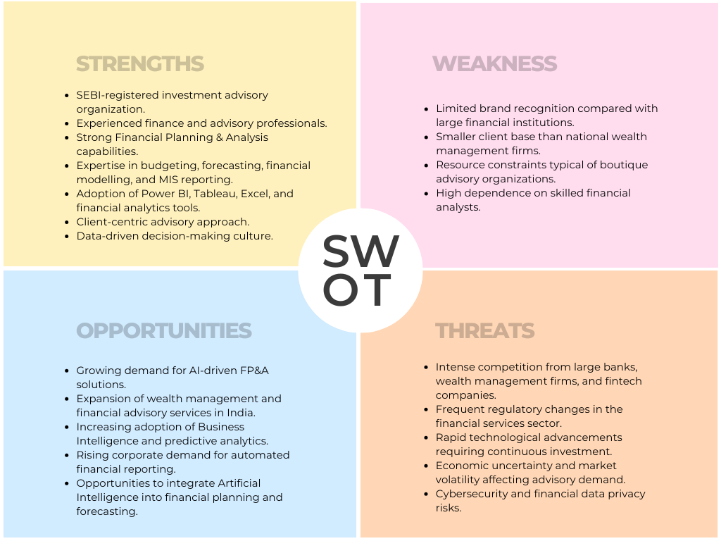

Company Profile Summary
Insight Capital Advisory Pvt. Ltd. is a technology-oriented financial advisory organization specializing in investment advisory, Financial Planning & Analysis, financial modelling, research, and Business Intelligence. The internship provided practical exposure to budgeting, forecasting, MIS reporting, financial modelling, and dashboard development, which directly support the objectives of this dissertation. The organization's emphasis on analytical decision-making and modern financial technologies provides an appropriate environment for developing an AI-driven FP&A Dashboard that integrates budgeting, forecasting, variance analysis, and executive reporting to enhance strategic business decision-making.
CHAPTER 3
DESIGN OF THE DISSERTATION

3.1 Review of Literature
Introduction
Financial Planning and Analysis (FP&A) has evolved from a traditional finance support function into a strategic component of organizational decision-making, driven by the growing availability of business data and advances in Artificial Intelligence (AI), Machine Learning (ML), Business Intelligence (BI), and cloud computing. This chapter reviews literature (2021–2026) on FP&A, AI, budgeting, forecasting, BI, dashboard analytics, and Decision Support Systems to identify current research trends and the gap that forms the basis of this study.

Evolution of Financial Planning and Analysis (FP&A)
Financial Planning and Analysis has traditionally focused on budgeting, financial reporting, and performance monitoring, but recent studies show FP&A has become a strategic business partner integrating budgeting, forecasting, financial modelling, and variance analysis into a unified management process. FP&A professionals are increasingly expected to possess analytical and technological skills alongside traditional accounting knowledge, reflecting the growing importance of data-driven decision-making in corporate finance.

Artificial Intelligence in Financial Planning and Analysis
Artificial Intelligence is widely described as an intelligent decision-support mechanism that processes large volumes of financial information, automates repetitive tasks, and generates predictive insights. Studies report that AI improves forecasting accuracy through machine learning algorithms and is increasingly used for anomaly detection, fraud identification, and cash-flow prediction — enhancing rather than replacing finance professionals, provided data quality and governance are maintained.
Budgeting, Forecasting, and Variance Analysis
Budgeting establishes financial targets, while forecasting continuously revises expected outcomes using historical trends and predictive analytics; recent literature favors driver-based budgeting and rolling forecasts over incremental approaches. Variance analysis remains a critical tool for comparing budgeted and actual performance, and AI-assisted variance analysis can now automatically identify the primary drivers of deviations, reducing reporting time while improving analytical quality.

Business Intelligence and Dashboard Analytics
Business Intelligence platforms such as Microsoft Power BI, Tableau, and SAP Analytics Cloud have become essential for transforming financial datasets into interactive dashboards that improve managerial understanding through real-time visibility into revenue, profitability, and other KPIs. Dashboard effectiveness depends on data quality and visualization design, and AI is increasingly used to enhance dashboards with automated insights and predictive recommendations.

Decision Support Systems in Corporate Finance
Decision Support Systems (DSS) integrate databases, financial models, and visualization tools to assist strategic decision-making, with FP&A dashboards identified as specialized DSS combining reporting, predictive analytics, and performance monitoring. Studies report that organizations implementing DSS experience improved planning efficiency and forecasting accuracy, though successful implementation depends on organizational readiness, data governance, and executive commitment as much as on the technology itself.

AI, Business Analytics, and Organizational Performance
The integration of AI and Business Analytics has improved operational efficiency, cost optimization, and forecasting accuracy across industries, with predictive analytics helping organizations identify financial risks and allocate resources more effectively. However, the literature also identifies implementation challenges data integration difficulties, cybersecurity concerns, and the need for continuous model validation leading researchers to recommend combining AI with human expertise rather than full automation.

Synthesis of the Literature
Overall, the literature demonstrates a clear transformation of FP&A from a traditional accounting function to a strategic decision-support capability, with AI, BI, and predictive analytics increasingly embedded in budgeting, forecasting, and reporting. However, most studies examine these components in isolation rather than as an integrated framework, and limited attention has been given to practical implementations combining AI-assisted forecasting, budgeting, variance analysis, KPI monitoring, and executive dashboards using widely accessible tools such as Microsoft Excel and Power BI — the gap that provides the foundation for the present study.

Chapter Summary
The literature reviewed indicates that AI-driven Financial Planning and Analysis has become a strategic capability for modern organizations, but comparatively few studies propose an integrated FP&A framework. The present study therefore aims to develop an AI-Driven FP&A Dashboard for Strategic Decision-Making that integrates budgeting, forecasting, variance analysis, KPI monitoring, and executive reporting into a comprehensive decision-support system.

3.2 Statement of the Problem / Need for the Study
Organizations across sectors continue to rely on fragmented financial planning processes — budgeting in static spreadsheets, forecasting through simple trend extrapolation, and variance analysis and executive reporting prepared manually and separately. Exposure gained during the internship at Insight Capital Advisory Pvt. Ltd. confirmed that even in a research-driven advisory environment, these activities are frequently handled as disconnected tasks using different tools, increasing turnaround time and limiting management's ability to obtain a real-time, unified view of financial performance.
Need and Significance of the Study
There is, therefore, a clear need for an integrated FP&A framework combining driver-based budgeting and forecasting, automated variance computation, KPI tracking, and an interactive executive dashboard into a single analytical workflow. The present study addresses this need by designing an AI-assisted, driver-based FP&A dashboard and demonstrating its application using the financial data of selected companies.
3.3 Objectives of the Study
- To study the existing budgeting, forecasting and MIS reporting practices observed at Insight Capital Advisory Pvt. Ltd. during the internship.
- To design an integrated, driver-based Financial Planning & Analysis framework that combines budgeting, forecasting, variance analysis and executive reporting.
- To apply the driver-based model and an AI-assisted time-series forecasting technique to the historical financial data of selected companies in order to project future financial performance.
- To compute and analyses key financial ratios and KPIs (EBITDA margin, PAT margin, Debt-Equity ratio, Book Value per Share, EPS, Cash Profit and Order Book growth) for the sample companies.
- To develop an interactive, web-based financial performance dashboard that visualizes historical and forecasted KPIs for comparative, cross-company analysis.
- To evaluate, based on the above, the extent to which an AI-driven, dashboard-based FP&A approach improves upon conventional, spreadsheet-based financial planning and reporting.

3.4 Hypothesis
This study is primarily descriptive, applied and developmental in nature — its core outcome is the design and demonstration of an AI-driven FP&A dashboard rather than the statistical testing of a hypothesis on primary survey data. Accordingly, no formal null/alternative hypotheses have been framed or statistically tested. The study is instead guided by the following working propositions, which are examined qualitatively and through the analytical outcomes of the dashboard:
- H1: A driver-based, AI-assisted forecasting approach provides a more consistent and interpretable estimate of future financial performance than simple, unstructured trend extrapolation.
- H2: An integrated, interactive dashboard improves the speed and clarity with which variances and KPI trends can be interpreted, compared with static, spreadsheet-based reporting.

3.5 Scope of the Study
The scope of the study is defined along the following dimensions:
- Functional scope: The study is limited to the budgeting, forecasting, variance analysis and executive/KPI reporting components of FP&A; it does not extend to taxation, statutory audit, or treasury/fund-management functions.
- Organizational scope: Organizational and functional context is drawn from the internship exposure at Insight Capital Advisory Pvt. Ltd., Bengaluru, particularly its FP&A division.
- Empirical/sectoral scope: The driver-based forecasting model and dashboard are demonstrated using the secondary financial data of five NSE/BSE-listed companies from the Infrastructure & Construction sector — Larsen & Toubro (L&T), NCC Ltd, KNR Constructions, IRB Infrastructure Developers, and HG Infra Engineering.
- Temporal scope: Historical (actual) data covers six financial years, FY2020-21 to FY2025-26, and the driver-based model projects five further financial years, FY2026-27 to FY2030-31.
- Geographic scope: The study is confined to Indian, exchange-listed companies and an Indian advisory-sector internship organization.
- Tool scope: The model and dashboard are built using MS Excel (driver-based assumptions and computations), R (read excel, dplyr, prophet and ggplot2 for time-series forecasting), and an HTML/Chart.js-based interactive web dashboard, with reference to Power BI and Tableau practices observed during the internship.
3.6 Operational Definition of the Concepts
- Financial Planning & Analysis (FP&A): The integrated process of budgeting, forecasting, financial modelling, variance analysis and performance reporting used to support management decision-making.
- Driver-based Forecasting: A forecasting approach in which future values of key financial line items are projected using explicit growth-rate assumptions (drivers) applied to a historical base, rather than by simple extrapolation.
- AI-Assisted Forecasting: The use of a machine-learning-based time-series algorithm (Prophet) to model trend and generate projected values from historical financial data.
- Variance Analysis: The comparison of budgeted/forecasted figures with actual or trend-based figures to identify and explain deviations.
- Key Performance Indicator (KPI): A quantifiable financial metric — such as EBITDA margin, PAT margin, Debt-Equity ratio, or EPS — used to monitor and evaluate business performance.
- Dashboard: An interactive visual interface that consolidates financial data, charts and KPIs to support real-time monitoring and executive decision-making.
- EBITDA / PAT / Cash Profit / Gross Block / Order Book: Standard financial statement line items, as reported in company annual/consolidated financial statements, used as the base data for ratio computation and forecasting in this study.

3.7 Methodology / Research Design
The study adopts a descriptive-cum-applied (developmental) research design. It is descriptive to the extent that it examines existing FP&A practices and the financial performance trends of the sample companies, and it is applied/developmental to the extent that its principal output is a working analytical artefact — a driver-based forecasting model and an interactive dashboard. The research approach is quantitative, based entirely on the analysis of secondary financial data using ratio analysis, time-series forecasting and dashboard visualization.

3.8 Data Collection
The study uses both primary and secondary data. Primary data was collected through an anonymous survey of 113 PGDM students covering FP&A, Excel, Business Intelligence tools, dashboarding, MIS/variance reporting, career relevance and curriculum preparedness. Secondary data was drawn from internship/company materials and published consolidated annual financial statements of the five selected companies for FY2020-21 to FY2025-26, with model projections extending to FY2030-31.

Research Instrument
The research instrument comprised an anonymous PGDM student survey containing 16 questions, including categorical and multiple-choice items and four 0–10 confidence/perception questions. The financial component of the study used a structured secondary-data schedule covering Revenue, EBITDA, EBITDA Margin, PAT, PAT Margin, Cash Profit, Gross Block, Debt-Equity Ratio, Book Value per Share, Basic EPS and Order Book for the selected companies.

3.9 Sampling Design
Purposive (judgmental) sampling was used for the financial-company sample, while the primary survey comprised 113 valid PGDM student responses. The financial sample consists of five NSE/BSE-listed Infrastructure & Construction companies selected for data availability and comparability: L&T, NCC Ltd, KNR Constructions, IRB Infrastructure Developers and HG Infra Engineering. The financial sampling unit is the consolidated annual financial statement for each company-year; the survey sampling unit is an individual PGDM respondent.
- Population: NSE/BSE-listed companies in the Indian Infrastructure & Construction sector.
- Sample: Five companies L&T, NCC Ltd, KNR Constructions, IRB Infrastructure Developers, and HG Infra Engineering selected for their listed status, availability of six years of consistent published financial data, and representation of large, mid-size and specialized players within the sector.
- Sampling unit: The consolidated annual financial statement of each sample company for each financial year.
- Sample size: Five companies across six historical financial years (30 company-year observations), extended through the driver-based model to five additional forecast years per company.

3.10 Plan of Analysis
The collected data was analyzed using the following techniques:
- Ratio Analysis: Computation of EBITDA margin, PAT margin, Debt-Equity ratio, Book Value per Share and Basic EPS for each company across all historical years.
- Driver-based Modelling: Application of explicit growth-rate assumptions (Revenue, EBITDA, PAT, Cash Profit, Gross Block, Debt, Book Value, EPS and Order Book growth) in MS Excel to project each line item for FY2026-27 to FY2030-31.
- AI-Assisted Time-Series Forecasting: Use of the Prophet forecasting library in R (with read excel for data import, dplyr for data preparation and ggplot2 for visualization) to model trend in historical financial data as a cross-check on the Excel-based driver assumptions.
- Variance Analysis: Comparison of forecasted/projected figures against the historical trend baseline to highlight companies and metrics showing the largest expected deviation.
- Cross-Company Comparative Analysis: Benchmarking the five companies against each other on each KPI, both historically and on a forecasted basis.
- Dashboard Visualization: Presentation of all of the above through an interactive, Chart.js-based HTML dashboard, enabling company-wise and metric-wise drill-down for executive reporting.

3.11 Limitations of the Study
- The study is based entirely on secondary, published financial data; its accuracy and reliability are dependent on the correctness of the underlying company disclosures.
- The empirical demonstration is restricted to five companies within a single sector (Infrastructure & Construction); findings and forecasts are therefore not generalizable to other sectors.
- The driver-based projections rely on fixed, assumption-based growth rates and do not explicitly model macroeconomic shocks, regulatory changes, or company-specific events that could alter actual future performance.
- The AI-assisted (Prophet) forecasting model is applied to a relatively short historical series (six annual data points per company), which can limit the statistical robustness of the trend it identifies.
- The duration of the internship limited the scope for primary validation of the dashboard's outputs with the internal finance/FP&A teams of the sample companies or the internship organization.

3.12 Chapter Scheme
This dissertation is organized into five chapters. Chapter One presents the introduction to the study, covering the industry scenario at the macro and micro levels and the theoretical background of Financial Planning & Analysis (FP&A), Business Intelligence, and AI-driven decision support. Chapter Two provides the profile of Insight Capital Advisory Pvt. Ltd., including its history, vision and mission, product and service profile, competitors, market position, milestones, CSR initiatives, and SWOT assessment. Chapter Three outlines the design of the dissertation, comprising the review of literature, statement of the problem, objectives, hypotheses, scope, operational definitions, methodology, data collection, sampling design, plan of analysis, and limitations of the study. Chapter Four presents the systematic analysis and interpretation of the secondary financial data (driver-based and AI-assisted forecasting for the five sample construction companies) and the primary survey data collected from PGDM students. Chapter Five summarizes the key findings, draws conclusions, offers suggestions for organizations, FP&A teams, and PGDM institutions, and presents the bibliography and annexures.
CHAPTER 4
DATA ANALYSIS AND INTERPRETATION

This chapter presents the systematic analysis and interpretation of both secondary and primary data used in the study. The chapter is intentionally divided into two major analytical streams. The first stream evaluates the historical and forecast financial performance of five selected Infrastructure & Construction companies. The second stream provides a detailed analysis of the primary survey conducted among 113 PGDM students. The primary survey is treated as a core research component because it provides first-hand evidence regarding students' exposure to Excel, Business Intelligence (BI) tools, dashboarding, MIS/variance reporting, career intentions and perceived gaps between classroom learning and industry expectations.
The financial analysis covers FY2020-21 to FY2025-26, with driver-based projections extending to FY2030-31. The primary survey consists of 113 valid anonymous responses and 16 questions, including categorical questions, multiple-choice questions and four 0–10 rating questions. The survey analysis uses frequency distributions, percentage interpretation, mean scores and selected cross-tabulations to provide a deeper interpretation of the primary evidence.

4.1 Secondary Data Analysis – Financial Performance
The secondary dataset contains historical financial observations for L&T, NCC Ltd, KNR Constructions, IRB Infrastructure and HG Infra Engineering. The principal variables are Revenue, EBITDA, EBITDA Margin, PAT, PAT Margin, Cash Profit, Gross Block, Debt-Equity Ratio, Book Value per Share, Basic EPS and Order Book. These variables support profitability, growth, leverage, shareholder-value and order-pipeline analysis.

Table 4.1: Overall Data Analysis Framework
Analytical component | Coverage | Purpose
Historical financial analysis | FY2020-21 to FY2025-26 | Assess historical performance
Driver-based forecasting | FY2026-27 to FY2030-31 | Estimate future financial trajectory
Primary survey | 113 PGDM respondents | Assess BI/FP&A skills and perceptions
Visualization | Financial + survey dashboards/charts | Communicate analytical findings
Source: Project (3).xlsx and Draft Report.docx

Table 4.2: Historical Growth Indicators
Company | Revenue CAGR (%) | EBITDA CAGR (%) | PAT CAGR (%) | Order Book CAGR (%)
L&T | 12.09 | 13.62 | 14.85 | 8.34
NCC Ltd | 17.20 | 19.67 | 25.14 | 13.23
KNR Constructions | 14.95 | 17.61 | 19.70 | 13.05
IRB Infrastructure | 10.76 | 12.28 | 18.27 | 8.71
HG Infra Engineering | 14.65 | 17.11 | 22.24 | 12.64
Source: Calculated from Project (3).xlsx – Financial Modeling
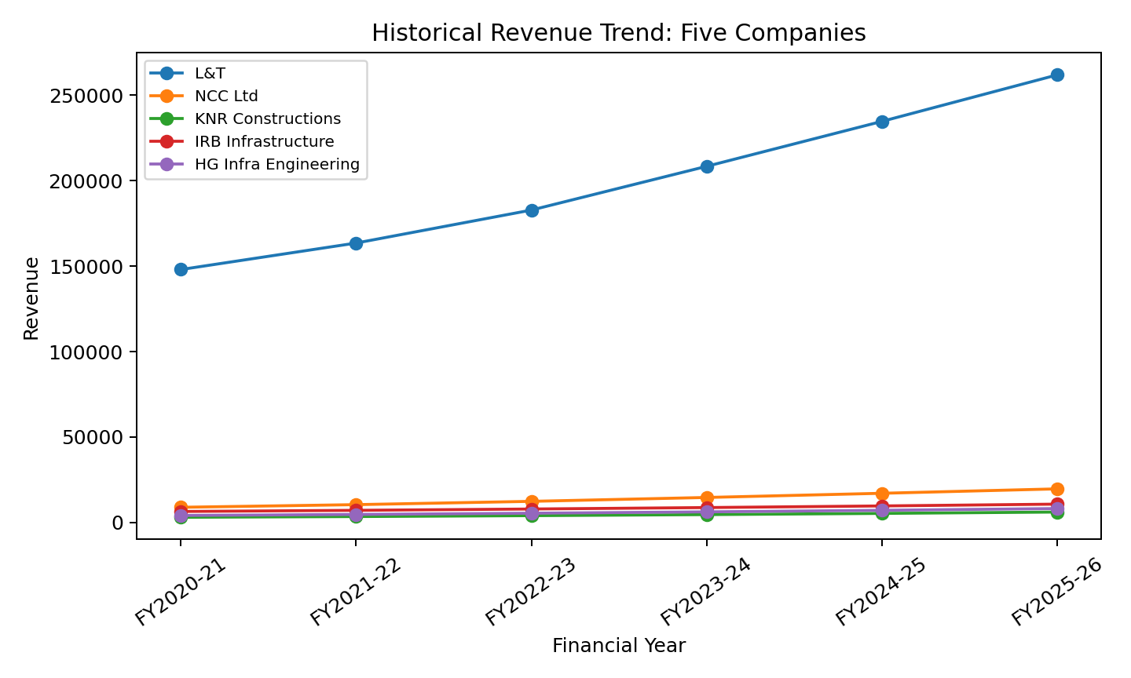
Figure 4.1: Historical Revenue Trend of the Five Companies
Source: Calculated from Project (3).xlsx – Financial Modeling

The historical revenue trend demonstrates the difference between absolute scale and growth rate. L&T maintains the largest revenue base throughout the period, while NCC Ltd records the highest revenue CAGR in the supplied dataset. The overall upward movement across the five companies indicates expansion in the operating scale of the sample during the historical period.
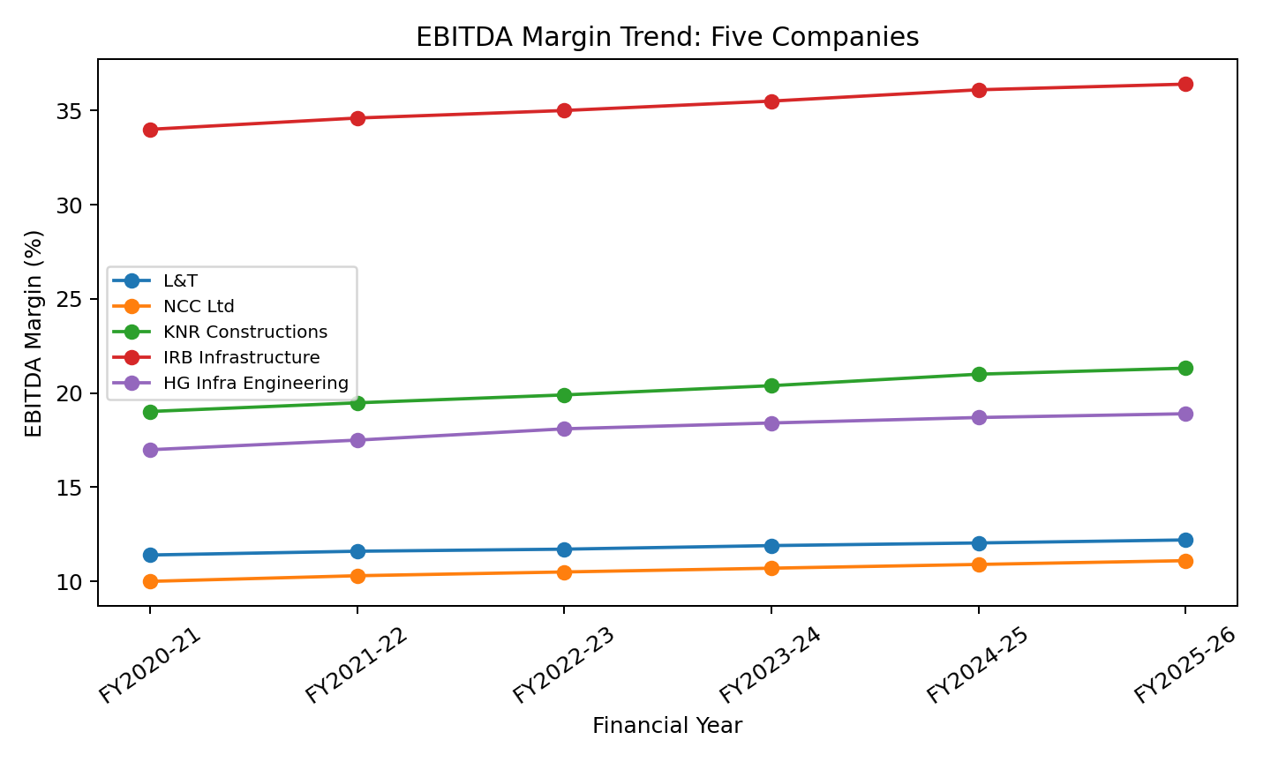
Figure 4.2: EBITDA Margin Trend
Source: Calculated from Project (3).xlsx – Financial Modeling
EBITDA margin is used to assess operating profitability independently of the absolute size of each company. The historical trend indicates improving operating profitability across the sample, although the level and rate of improvement differ by company. This reinforces the need to evaluate both growth and margin quality when comparing infrastructure companies.

4.2 Comparative Financial Ratio Interpretation
Table 4.3: Comparative Profitability and Leverage Ratios
Company | EBITDA Margin FY21 (%) | EBITDA Margin FY26 (%) | PAT Margin FY21 (%) | PAT Margin FY26 (%) | D/E FY21 | D/E FY26
L&T | 11.40 | 12.20 | 6.52 | 7.36 | 1.12 | 0.92
NCC Ltd | 10.00 | 11.10 | 4.04 | 5.62 | 0.42 | 0.25
KNR Constructions | 19.02 | 21.32 | 8.03 | 9.84 | 0.48 | 0.31
IRB Infrastructure | 34.00 | 36.40 | 8.14 | 11.30 | 1.65 | 1.22
HG Infra Engineering | 16.99 | 18.90 | 6.36 | 8.76 | 0.58 | 0.38

The comparative ratio analysis shows that profitability margins generally strengthen over the historical period. The Debt-Equity ratio also declines for the companies in the dataset, although IRB Infrastructure remains relatively more leveraged than the other firms. Therefore, profitability improvement should be considered alongside leverage and capital-structure risk.

4.3 Driver-Based Forecast Analysis
The supplied Financial Modeling worksheet extends the financial series through FY2030-31 using driver-based assumptions. The forecast provides a planning scenario for revenue, profitability, leverage and shareholder-value indicators. These values are interpreted as model outputs rather than guaranteed future results.

Table 4.4: Driver-Based Forecast Summary
Company | Revenue FY30-31 | Revenue CAGR (%) | PAT FY30-31 | PAT CAGR (%) | EBITDA Margin FY30-31 (%) | PAT Margin FY30-31 (%) | D/E FY30-31 | EPS FY30-31 (₹)
L&T | 461557.29 | 12.00 | 31050.63 | 10.00 | 11.15 | 6.73 | 1.07 | 221.93
NCC Ltd | 34682.88 | 12.00 | 1779.61 | 10.00 | 10.14 | 5.13 | 0.29 | 27.06
KNR Constructions | 10785.53 | 12.00 | 969.53 | 10.00 | 19.49 | 8.99 | 0.36 | 33.66
IRB Infrastructure | 18945.17 | 12.00 | 1956.77 | 10.00 | 33.26 | 10.33 | 1.41 | 15.78
HG Infra Engineering | 14380.71 | 12.00 | 1151.51 | 10.00 | 17.27 | 8.01 | 0.44 | 37.69
Source: Calculated from Project (3).xlsx – Financial Modeling

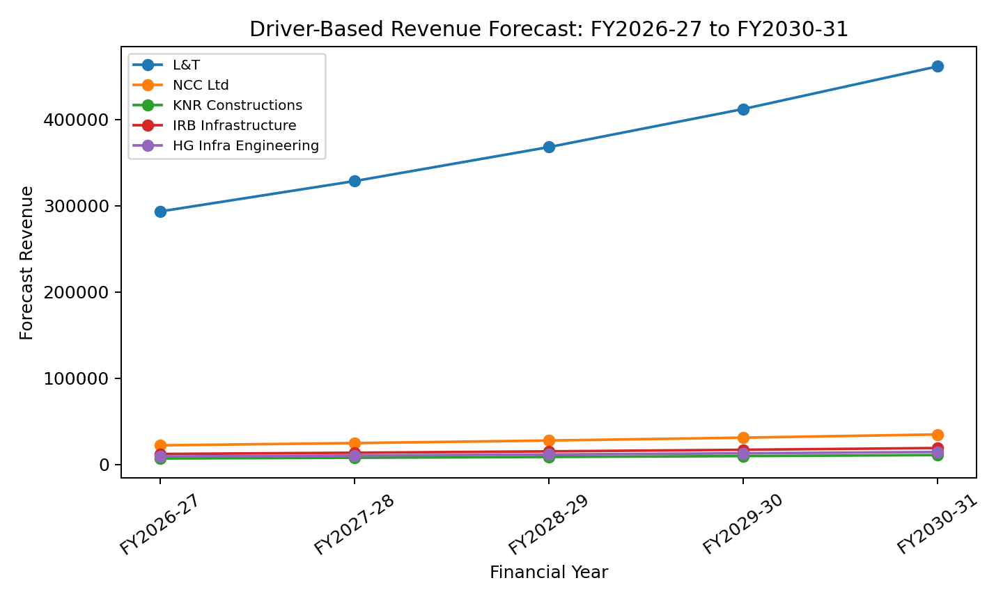
Figure 4.3: Driver-Based Revenue Forecast
Source: Calculated from Project (3).xlsx – Financial Modeling
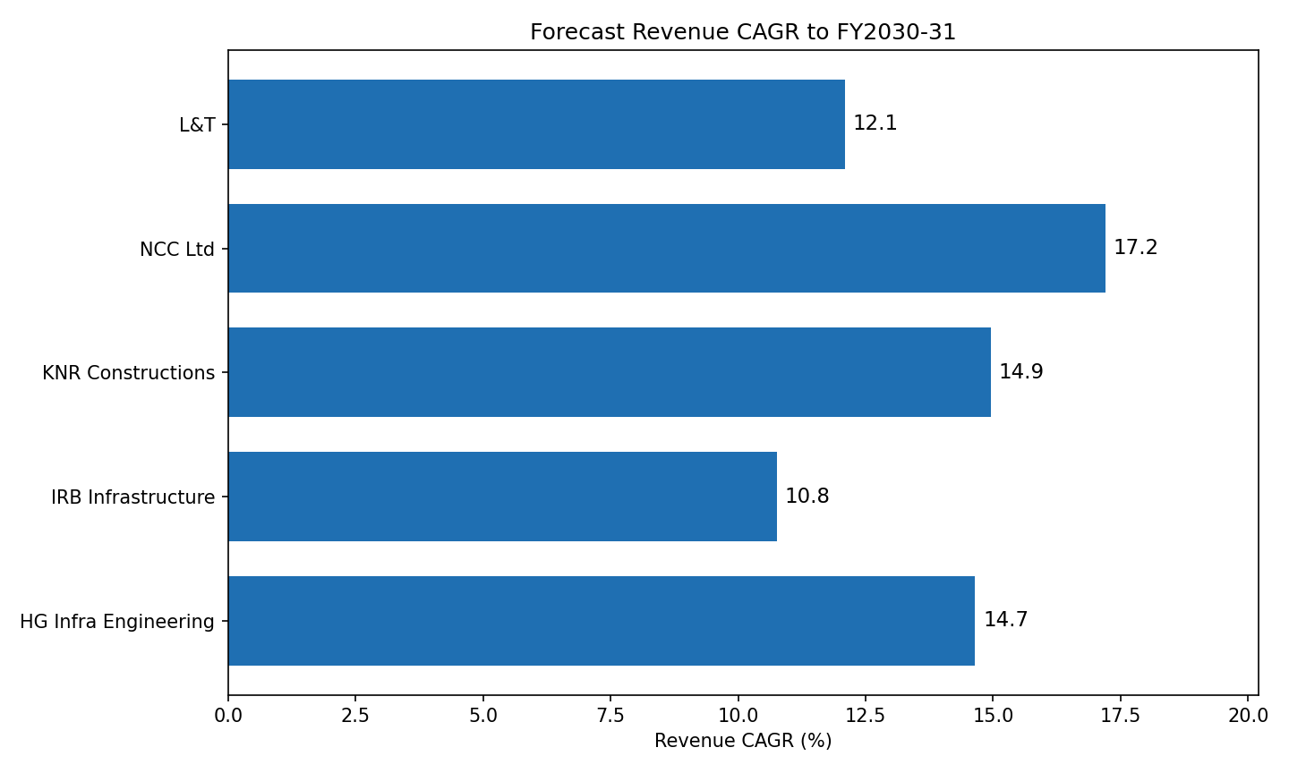
Figure 4.4: Forecast Revenue CAGR to FY2030-31
Source: Calculated from Project (3).xlsx – Financial Modeling

The forecast preserves the broad scale hierarchy observed historically, with L&T remaining the largest company by forecast revenue. The projected values also indicate continued growth in PAT and EPS across the sample. Forecast Debt-Equity ratios should be monitored because higher growth accompanied by excessive leverage could increase financial risk even when revenue and profit are expanding.

4.4 AI-Assisted Forecasting and Variance Analysis
The research methodology specifies an AI-assisted Prophet time-series model in R as a cross-check against the driver-based Excel forecast. The current workbook supplied for this revision contains the historical and driver-based forecast values, but does not contain the numerical Prophet output or forecast-accuracy diagnostics. Consequently, no Prophet values are invented in this chapter. Once the R output is available, the driver-based forecast and Prophet forecast can be compared using absolute difference, percentage difference and forecast-error measures.
Table 4.5: Driver-Based versus AI-Assisted Forecast Comparison Framework
Measure | Driver-based model | Prophet model | Variance %
Revenue | 87263.52 | 80709.63 | -5.29%
EBITDA | 10985.13 | 10970.71 | 0.83%
PAT | 6156.07 | 5941.03 | 0.28%
Order Book | 178648.17 | 157940.16 | -8.19%
Source: To be completed from the R/Prophet output

4.5 Primary Data Analysis – PGDM Student Survey
Primary data constitutes an important part of the present study. An anonymous survey was administered to PGDM students to understand their practical exposure to financial reporting, FP&A, Excel, BI tools and dashboarding, together with their perceptions of career relevance and curriculum preparedness. A total of 113 valid responses were analyzed. The survey instrument contained 16 questions: six background/categorical questions, five opinion or multiple-choice questions, and four questions measured on a 0–10 confidence/perception scale. The raw respondent-level data are retained in the source report for verification.
Table 4.6: Primary Data Methodology
Primary-data characteristic | Description
Sample size | 113 valid responses
Data collection | Anonymous PGDM student evaluation survey
Respondent identification | No respondent-identifying email data retained
Instrument | 16 questions
Analysis approach | Frequency, percentage, mean scores and cross-tabulation
Source: Draft Report.docx – Evaluation Survey Report
The primary survey is not merely supplementary background information. It directly contributes evidence to the study's focus on FP&A, BI and analytics readiness. The results help establish whether learners possess practical exposure to the tools required for modern FP&A work and whether they perceive a gap between academic preparation and industry expectations.
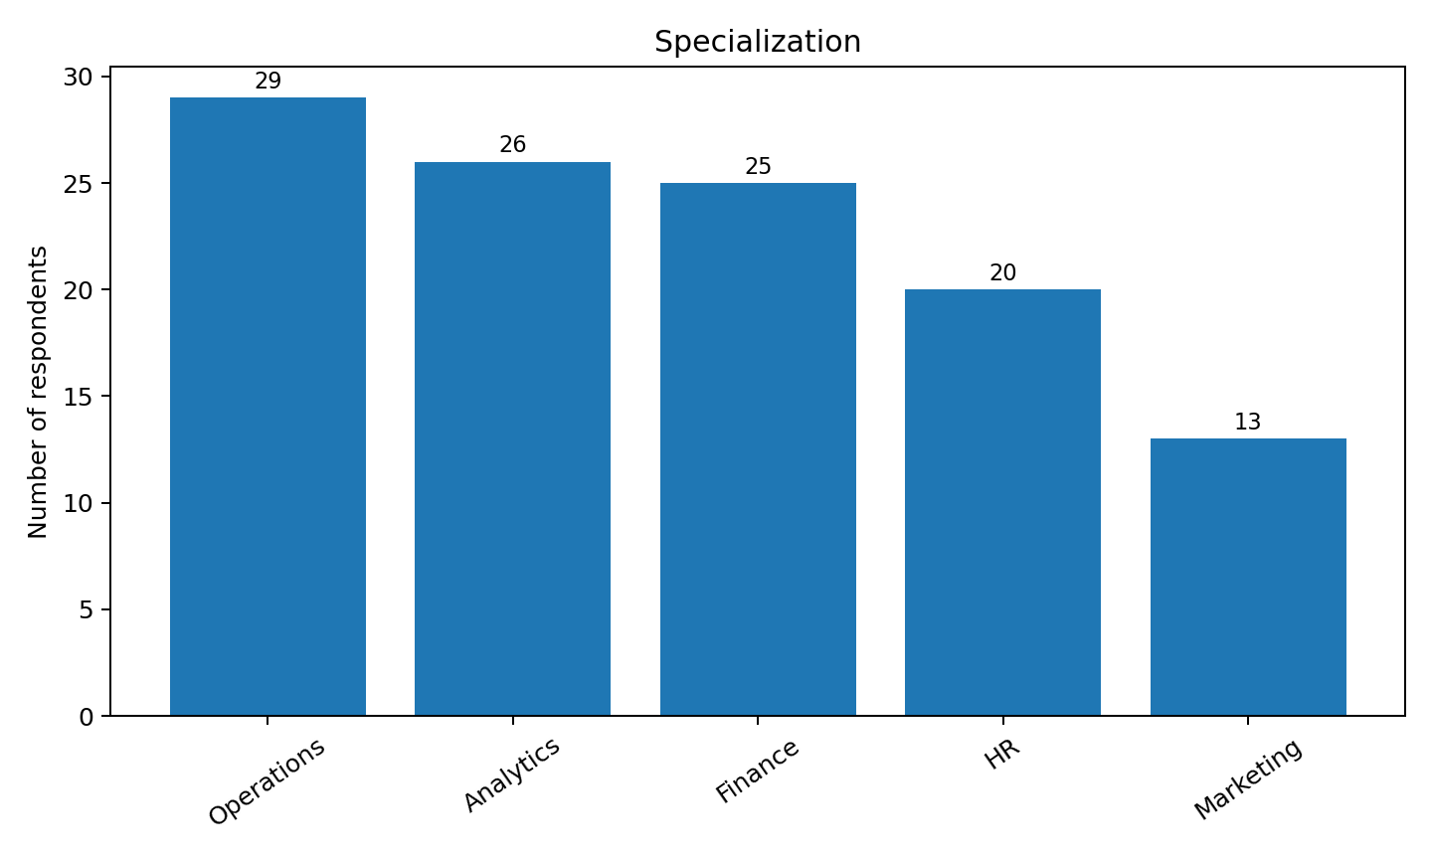
Figure 4.5: Q1. Specialization
Source: Primary survey – 113 valid responses

Table 4.7: Q1 Frequency Distribution
Response | Frequency | Percentage
Operations | 29 | 25.7
Analytics | 26 | 23.0
Finance | 25 | 22.1
HR | 20 | 17.7
Marketing | 13 | 11.5
Source: Primary survey – 113 valid responses
Interpretation: The respondents represent five specializations. Operations is the largest group with 29 respondents (26%), followed by Analytics with 26, Finance with 25, HR with 20 and Marketing with 13. The distribution provides representation across multiple PGDM functional areas.
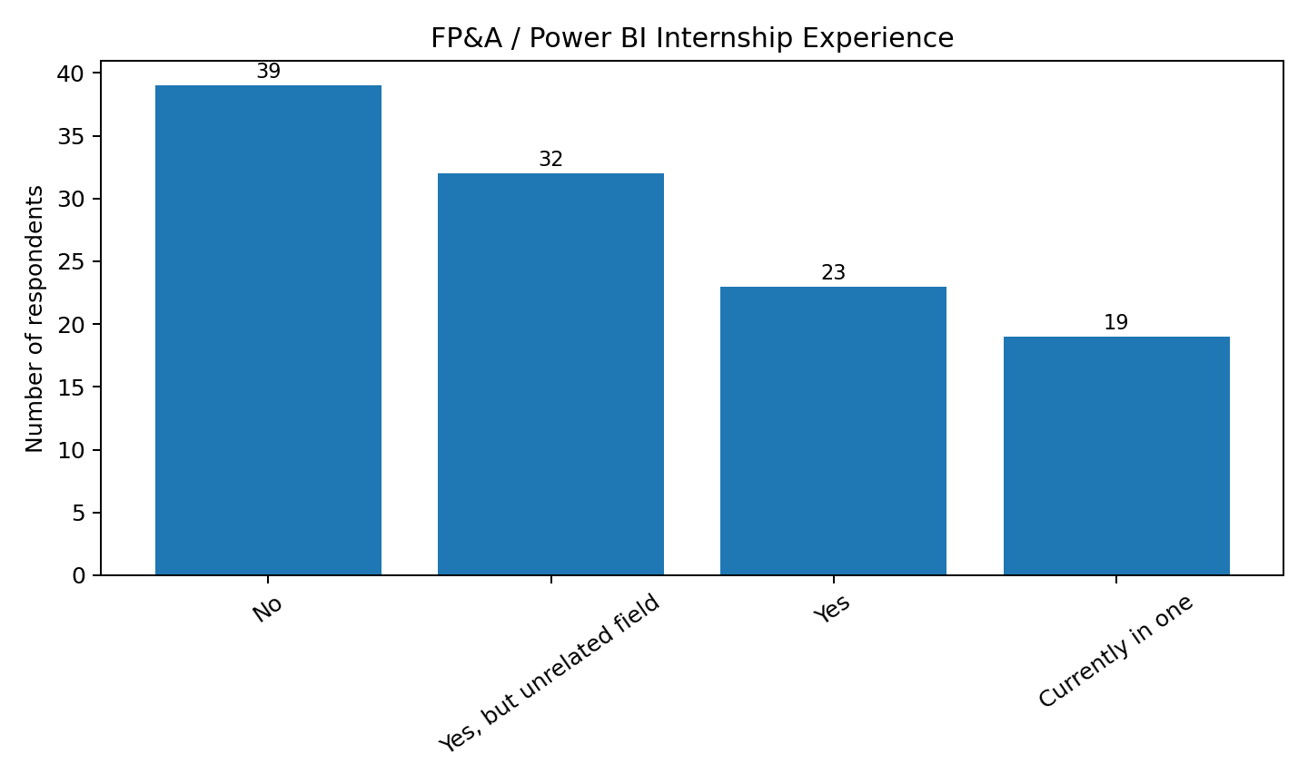
Figure 4.6: Q2. FP&A / Power BI internship experience
Source: Primary survey – 113 valid responses

Table 4.8: Q2 Frequency Distribution
Response | Frequency | Percentage
No | 39 | 34.5
Yes, but unrelated field | 32 | 28.3
Yes | 23 | 20.4
Currently in one | 19 | 16.8
Source: Primary survey – 113 valid responses
Interpretation: Thirty-nine respondents reported no relevant internship experience, while 23 had completed a relevant internship, 32 had internship experience in an unrelated field and 19 were currently in such an internship. Therefore, only a minority had completed directly relevant practical exposure at the time of the survey.
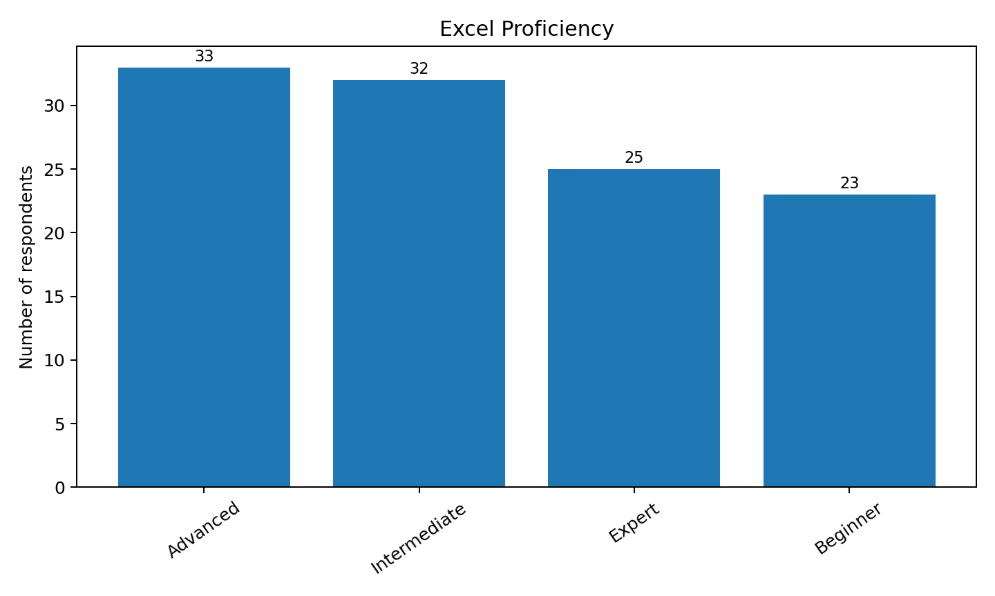
Figure 4.7: Q3. Excel proficiency
Source: Primary survey – 113 valid responses

Table 4.9: Q3 Frequency Distribution
Response | Frequency | Percentage
Advanced | 33 | 29.2
Intermediate | 32 | 28.3
Expert | 25 | 22.1
Beginner | 23 | 20.4
Source: Primary survey – 113 valid responses
Interpretation: Thirty-three respondents rated themselves Advanced and 25 Expert, meaning 58 respondents (51%) reported Advanced or Expert proficiency. Thirty-two were Intermediate and 23 Beginner. This indicates relatively strong spreadsheet capability within the sample.
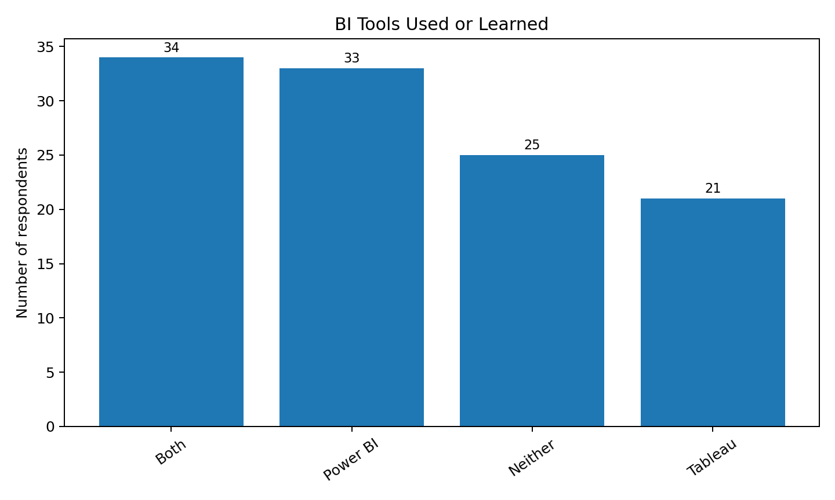
Figure 4.8: Q4. BI tools used or learned
Source: Primary survey – 113 valid responses

Table 4.10: Q4 Frequency Distribution
Response | Frequency | Percentage
Both | 34 | 30.1
Power BI | 33 | 29.2
Neither | 25 | 22.1
Tableau | 21 | 18.6
Source: Primary survey – 113 valid responses
Interpretation: Thirty-four respondents had used both Power BI and Tableau, 33 had used Power BI, 21 had used Tableau and 25 had used neither. The result indicates that Power BI exposure is widespread, but 25 respondents still reported no BI-tool exposure.
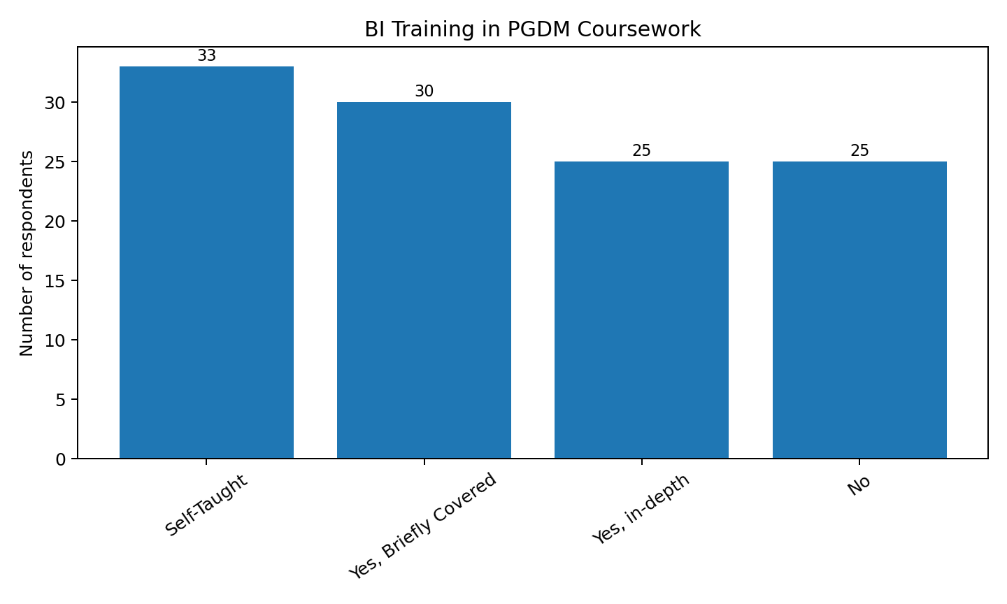
Figure 4.9: Q5. BI training in PGDM coursework
Source: Primary survey – 113 valid responses

Table 4.11: Q5 Frequency Distribution
Response | Frequency | Percentage
Self-Taught | 33 | 29.2
Yes, Briefly Covered | 30 | 26.5
Yes, in-depth | 25 | 22.1
No | 25 | 22.1
Source: Primary survey – 113 valid responses
Interpretation: Thirty-three respondents reported that BI training was self-taught, 30 reported brief coursework coverage, 25 reported in-depth coverage and 25 reported no such training. Thus, 58 respondents (51%) learned BI tools either entirely self-taught or without formal coursework coverage.
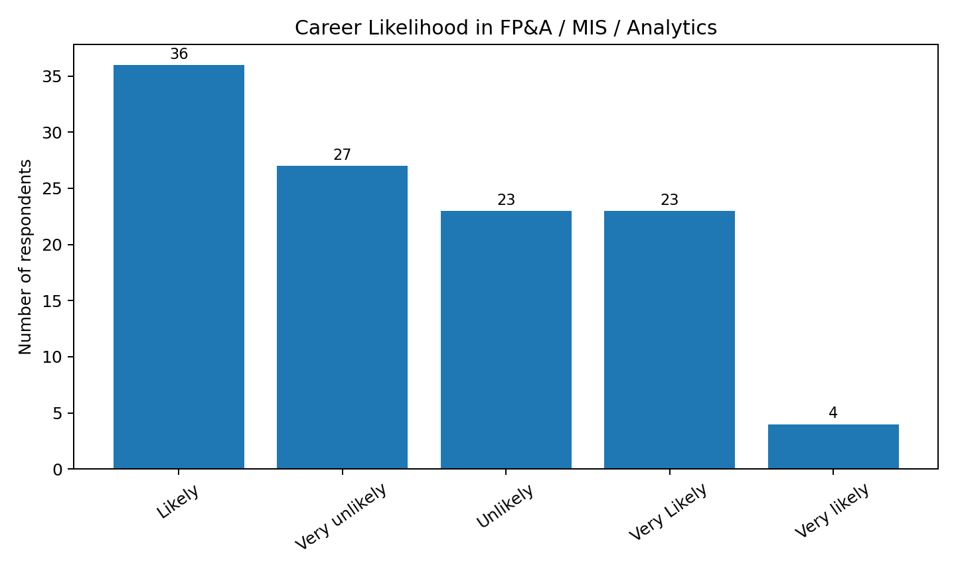
Figure 4.10: Q6. Career likelihood
Source: Primary survey – 113 valid responses

Table 4.12: Q6 Frequency Distribution
Response | Frequency | Percentage
Likely | 36 | 31.9
Very unlikely | 27 | 23.9
Unlikely | 23 | 20.4
Very Likely | 23 | 20.4
Very likely | 4 | 3.5
Source: Primary survey – 113 valid responses
Interpretation: The responses show a polarized career-intention pattern: 36 respondents selected Likely, 23 Very Likely, 23 Unlikely, 27 Very Unlikely and 4 Very likely. Combining the two positive variants gives 59 respondents with a positive likelihood response, while 50 selected an unlikely category.
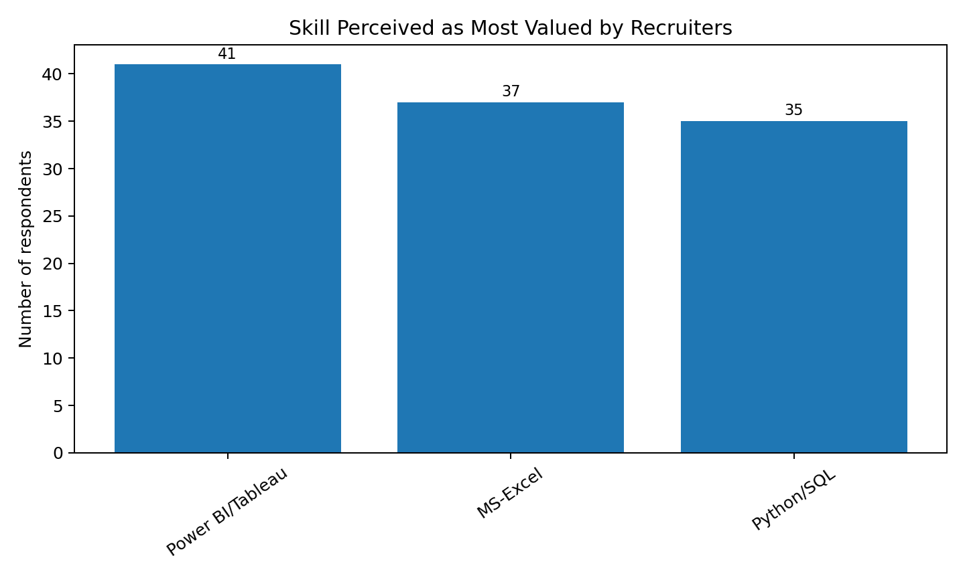
Figure 4.11: Q7. Recruiter-valued skills
Source: Primary survey – 113 valid responses

Table 4.13: Q7 Frequency Distribution
Response | Frequency | Percentage
Power BI/Tableau | 41 | 36.3
MS-Excel | 37 | 32.7
Python/SQL | 35 | 31.0
Source: Primary survey – 113 valid responses
Interpretation: Power BI/Tableau was selected by 41 respondents, MS-Excel by 37 and Python/SQL by 35. The responses show that recruiters are perceived to value a combination of spreadsheet, BI and programming/database skills rather than one isolated tool.
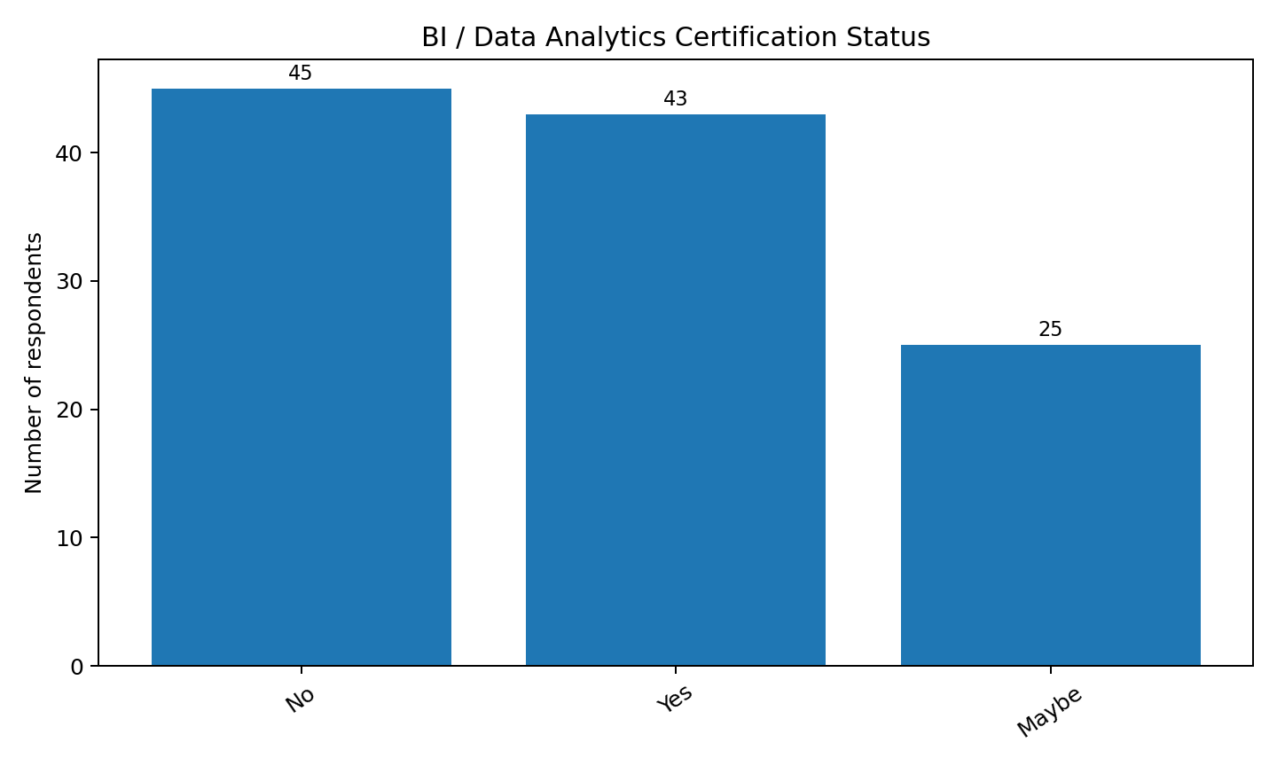
Figure 4.12: Q8. Certification status
Source: Primary survey – 113 valid responses

Table 4.14: Q8 Frequency Distribution
Response | Frequency | Percentage
No | 45 | 39.8
Yes | 43 | 38.1
Maybe | 25 | 22.1
Source: Primary survey – 113 valid responses
Interpretation: Forty-three respondents had completed or started a BI/data analytics certification, 45 had not, and 25 selected Maybe. This indicates moderate but inconsistent certification-based upskilling.
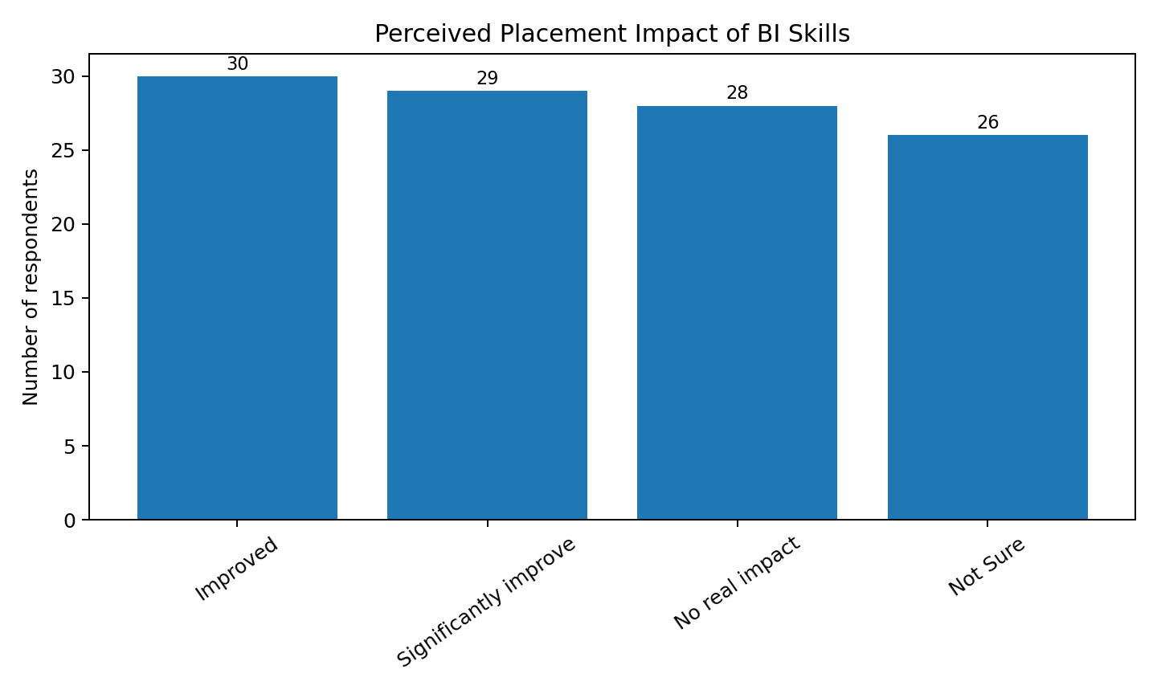
Figure 4.13: Q9. Placement impact
Source: Primary survey – 113 valid responses

Table 4.15: Q9 Frequency Distribution
Response | Frequency | Percentage
Improved | 30 | 26.5
Significantly improve | 29 | 25.7
No real impact | 28 | 24.8
Not Sure | 26 | 23.0
Source: Primary survey – 113 valid responses
Interpretation: Thirty respondents believed BI proficiency would improve placement prospects, 29 expected it to significantly improve prospects, 28 expected no real impact and 26 were not sure. Thus, 59 respondents (52.2%) expressed a positive placement effect, indicating that more than half of the sample links BI skills with employability.
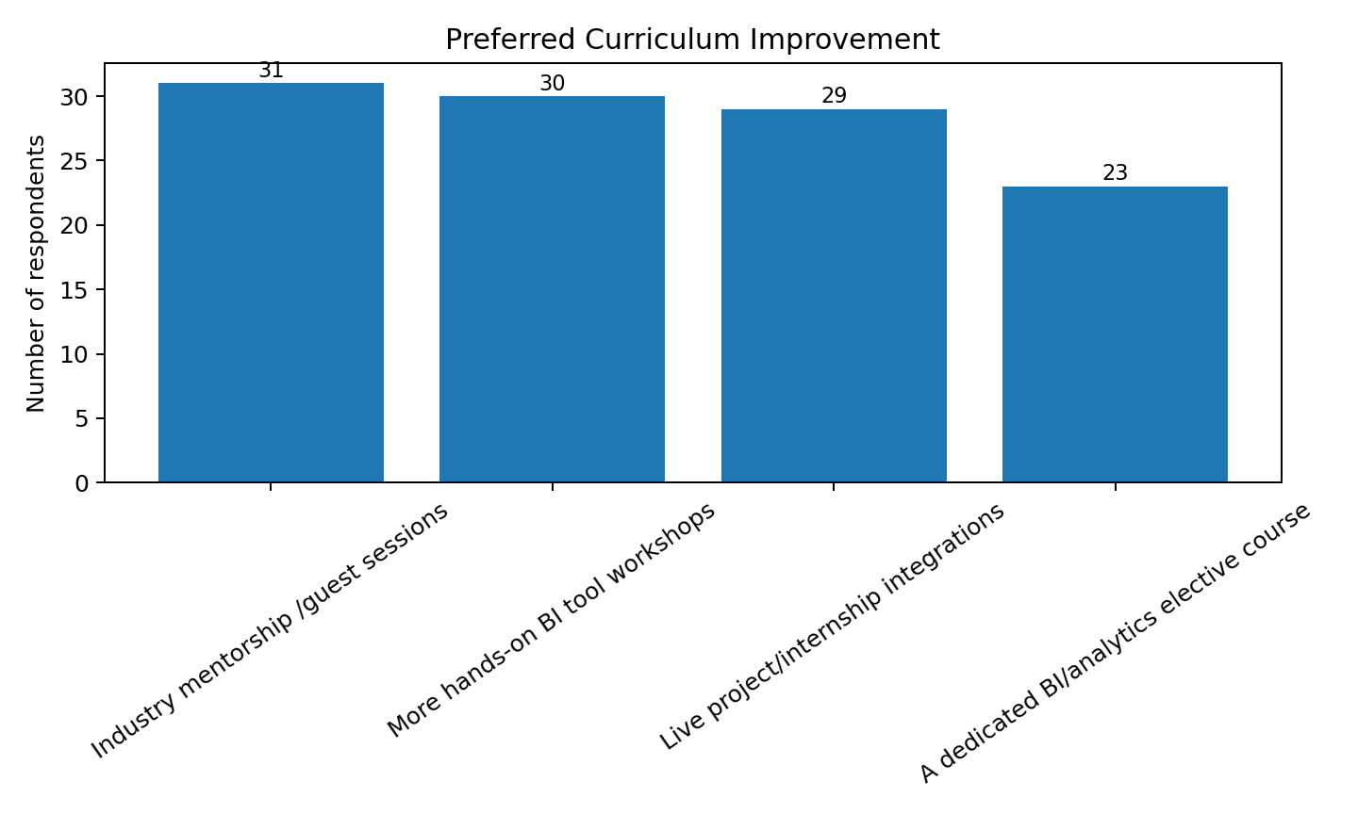
Figure 4.14: Q10. Curriculum improvement
Source: Primary survey – 113 valid responses

Table 4.16: Q10 Frequency Distribution
Response | Frequency | Percentage
Industry mentorship /guest sessions | 31 | 27.4
More hands-on BI tool workshops | 30 | 26.5
Live project/internship integrations | 29 | 25.7
A dedicated BI/analytics elective course | 23 | 20.4
Source: Primary survey – 113 valid responses
Interpretation: Industry mentorship/guest sessions was the most selected improvement with 31 responses, followed by more hands-on BI workshops with 30, live project/internship integration with 29 and a dedicated BI/analytics elective with 23. The responses show a strong preference for experiential learning.
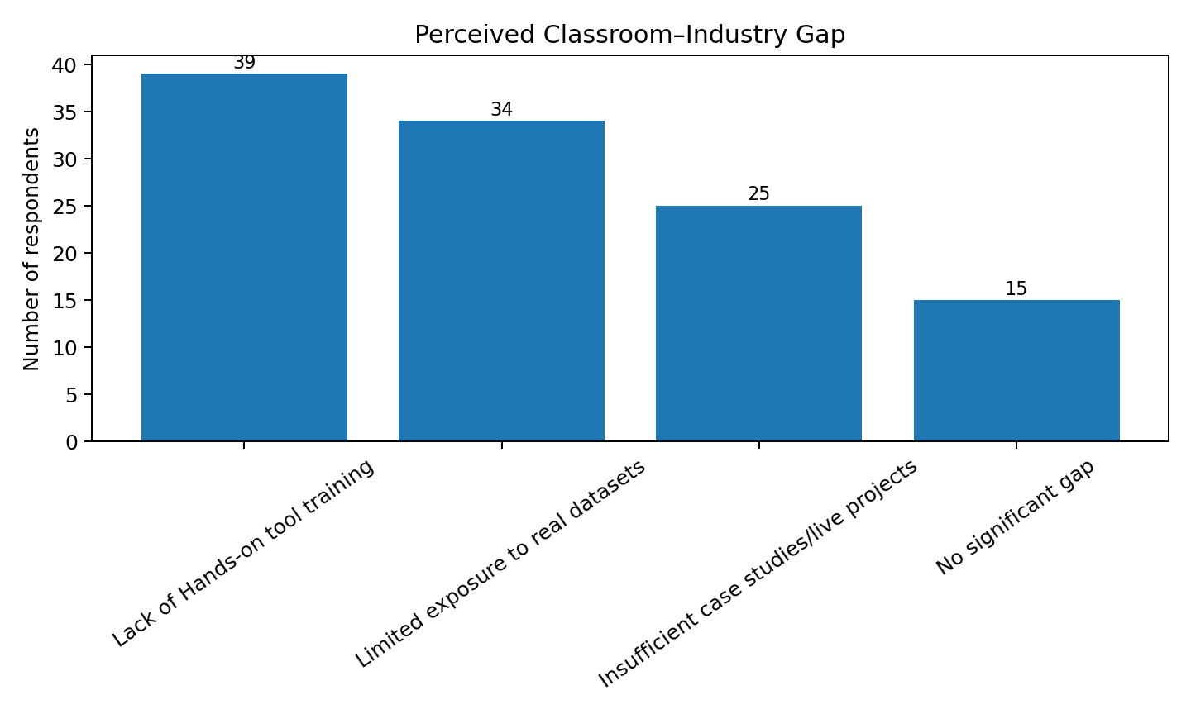
Figure 4.15: Q11. Classroom–industry gap
Source: Primary survey – 113 valid responses

Table 4.17: Q11 Frequency Distribution
Response | Frequency | Percentage
Lack of Hands-on tool training | 39 | 34.5
Limited exposure to real datasets | 34 | 30.1
Insufficient case studies/live projects | 25 | 22.1
No significant gap | 15 | 13.3
Source: Primary survey – 113 valid responses
Interpretation: Lack of hands-on tool training was the most cited gap with 39 responses, followed by limited exposure to real datasets with 34, insufficient case studies/live projects with 25 and no significant gap with 15. The first two categories alone account for 73 responses (64.6%).

4.6 Primary Data Analysis – Confidence and Perception Scores
Questions 12 to 15 measured respondents' confidence or perceptions on a 0–10 scale. Mean scores are used as the primary descriptive statistic. The four mean scores are 5.93 for dashboard-building confidence, 5.62 for MIS/variance-reporting confidence, 5.89 for the importance of BI/dashboarding skills and 5.45 for perceived PGDM preparation for BI-driven roles.
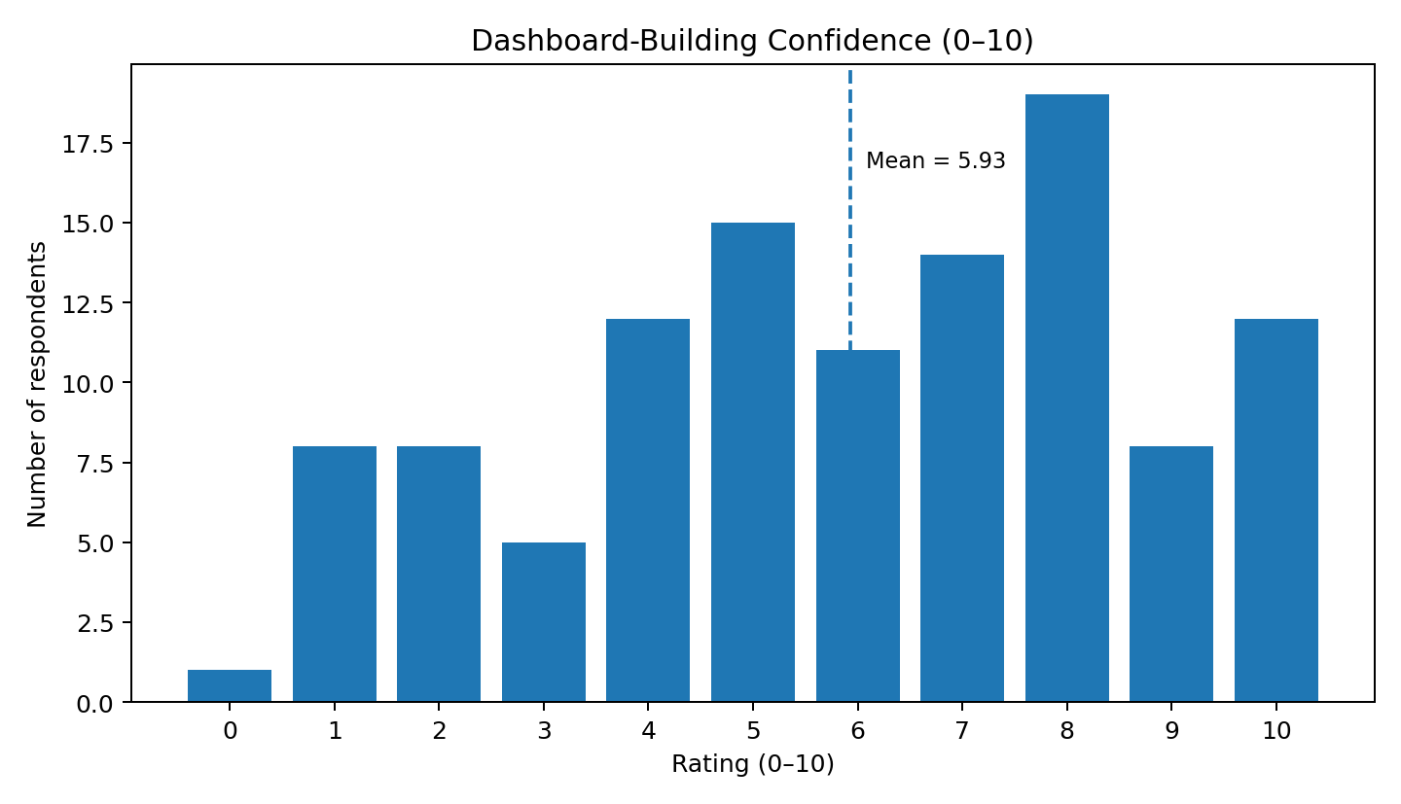
Figure 4.16: Q12. Dashboard-Building Confidence
Source: Primary survey – 113 valid responses

Table 4.18: Q12. Dashboard-Building Confidence – Rating Distribution
Rating | Frequency | Percentage
0.0 | 1.0 | 0.9
1.0 | 8.0 | 7.1
2.0 | 8.0 | 7.1
3.0 | 5.0 | 4.4
4.0 | 12.0 | 10.6
5.0 | 15.0 | 13.3
6.0 | 11.0 | 9.7
7.0 | 14.0 | 12.4
8.0 | 19.0 | 16.8
9.0 | 8.0 | 7.1
10.0 | 12.0 | 10.6
Source: Primary survey – 113 valid responses
Interpretation: The mean score for Dashboard is 5.93/10. The distribution shows substantial variation among respondents rather than a uniform level of confidence or agreement.
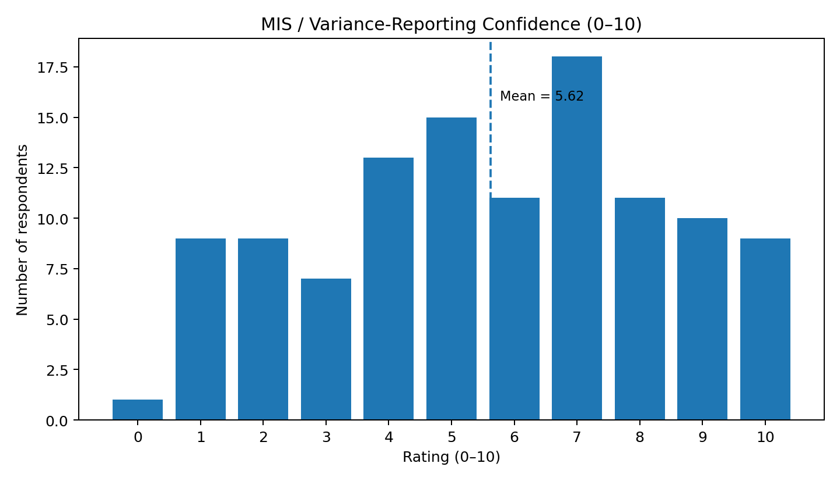
Figure 4.17: Q13. MIS / Variance-Reporting Confidence
Source: Primary survey – 113 valid responses

Table 4.19: Q13. MIS / Variance-Reporting Confidence – Rating Distribution
Rating | Frequency | Percentage
0.0 | 1.0 | 0.9
1.0 | 9.0 | 8.0
2.0 | 9.0 | 8.0
3.0 | 7.0 | 6.2
4.0 | 13.0 | 11.5
5.0 | 15.0 | 13.3
6.0 | 11.0 | 9.7
7.0 | 18.0 | 15.9
8.0 | 11.0 | 9.7
9.0 | 10.0 | 8.8
10.0 | 9.0 | 8.0
Source: Primary survey – 113 valid responses
Interpretation: The mean score for MIS Report is 5.62/10. The distribution shows substantial variation among respondents rather than a uniform level of confidence or agreement.
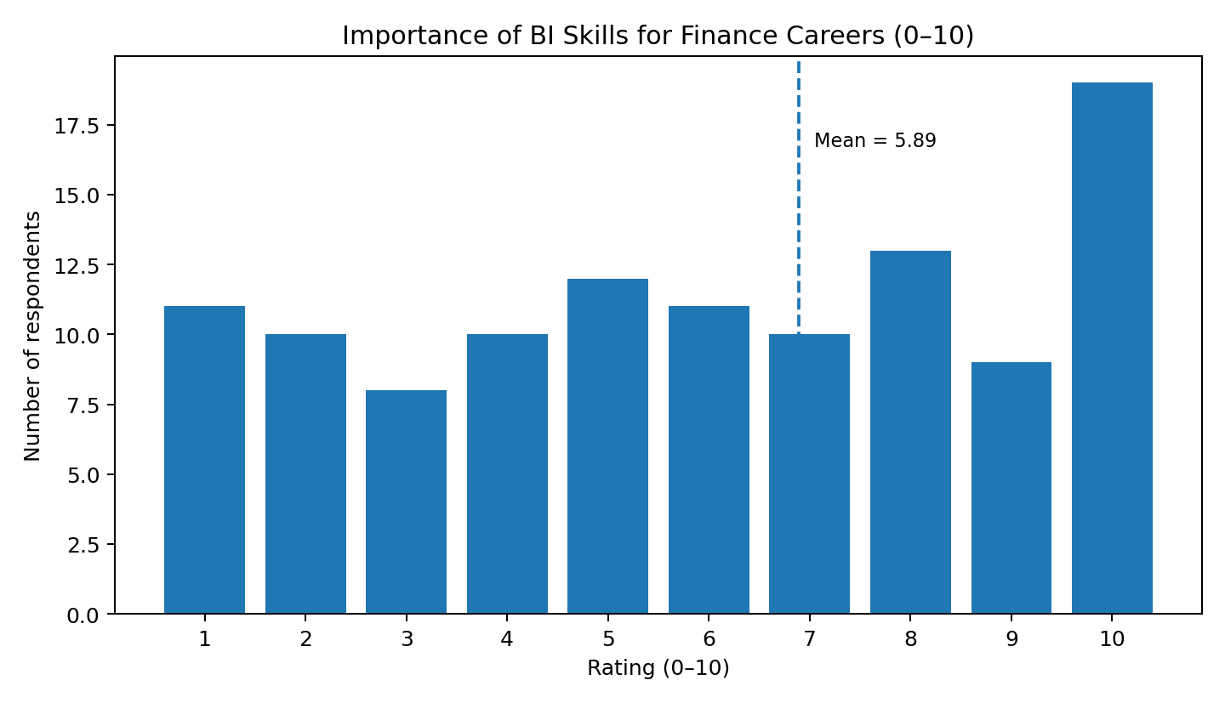
Figure 4.18: Q14. Importance of BI Skills for Finance Careers
Source: Primary survey – 113 valid responses

Table 4.20: Q14. Importance of BI Skills for Finance Careers – Rating Distribution
Rating | Frequency | Percentage
1.0 | 11.0 | 9.7
2.0 | 10.0 | 8.8
3.0 | 8.0 | 7.1
4.0 | 10.0 | 8.8
5.0 | 12.0 | 10.6
6.0 | 11.0 | 9.7
7.0 | 10.0 | 8.8
8.0 | 13.0 | 11.5
9.0 | 9.0 | 8.0
10.0 | 19.0 | 16.8
Source: Primary survey – 113 valid responses
Interpretation: The mean score for BI skills importance is 5.89/10. The distribution shows substantial variation among respondents rather than a uniform level of confidence or agreement.
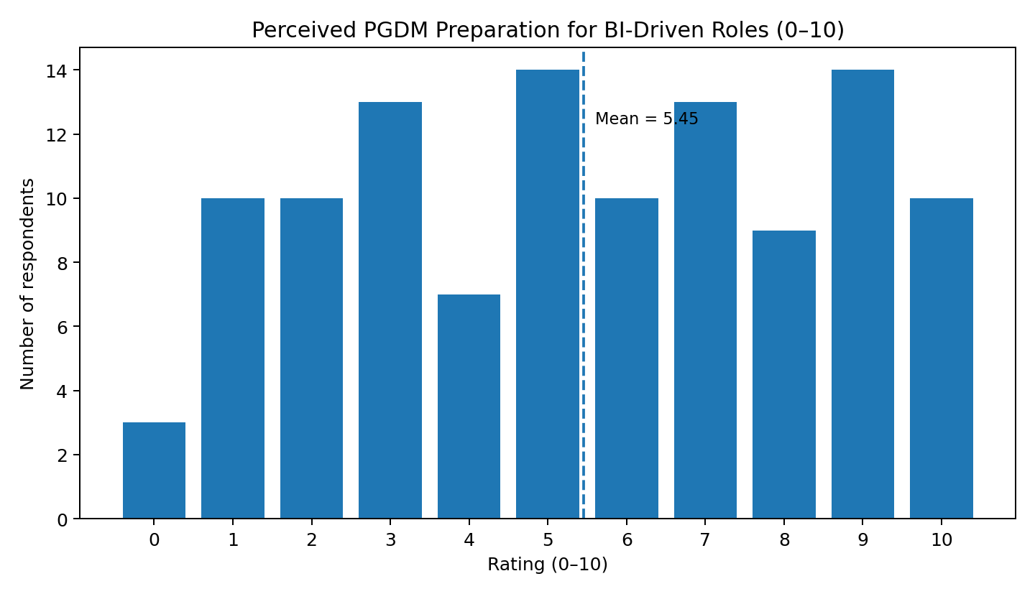
Figure 4.19: Q15. Perceived PGDM Preparation for BI-Driven Roles
Source: Primary survey – 113 valid responses

Table 4.21: Q15. Perceived PGDM Preparation for BI-Driven Roles – Rating Distribution
Rating | Frequency | Percentage
0.0 | 3.0 | 2.7
1.0 | 10.0 | 8.8
2.0 | 10.0 | 8.8
3.0 | 13.0 | 11.5
4.0 | 7.0 | 6.2
5.0 | 14.0 | 12.4
6.0 | 10.0 | 8.8
7.0 | 13.0 | 11.5
8.0 | 9.0 | 8.0
9.0 | 14.0 | 12.4
10.0 | 10.0 | 8.8
Source: Primary survey – 113 valid responses
Interpretation: The mean score for program preparedness is 5.45/10. The distribution shows substantial variation among respondents rather than a uniform level of confidence or agreement.

Table 4.22: Summary of Primary Survey Mean Scores
Measure | Mean (0–10)
Dashboard-building confidence | 5.93
MIS / variance-reporting confidence | 5.62
BI/dashboarding skills importance | 5.89
PGDM preparation for BI-driven finance roles | 5.45
Source: Primary survey – 113 valid responses
The most important result is the gap between perceived importance and perceived preparation. BI/dashboarding skills receive a mean importance score of 5.89/10, whereas perceived PGDM preparation for BI-driven roles is only 5.45/10. The difference of 0.44 points suggests that respondents recognize the labor-market relevance of BI skills more strongly than they believe the curriculum currently prepares them to apply those skills.

4.7 Primary Data Cross-Tabulation and Deeper Interpretation
To move beyond simple frequency analysis, selected cross-tabulations were performed using the raw 113-response dataset. These comparisons examine whether practical exposure and Excel proficiency are associated with differences in self-rated dashboard confidence. The results are descriptive and should not be interpreted as causal evidence.
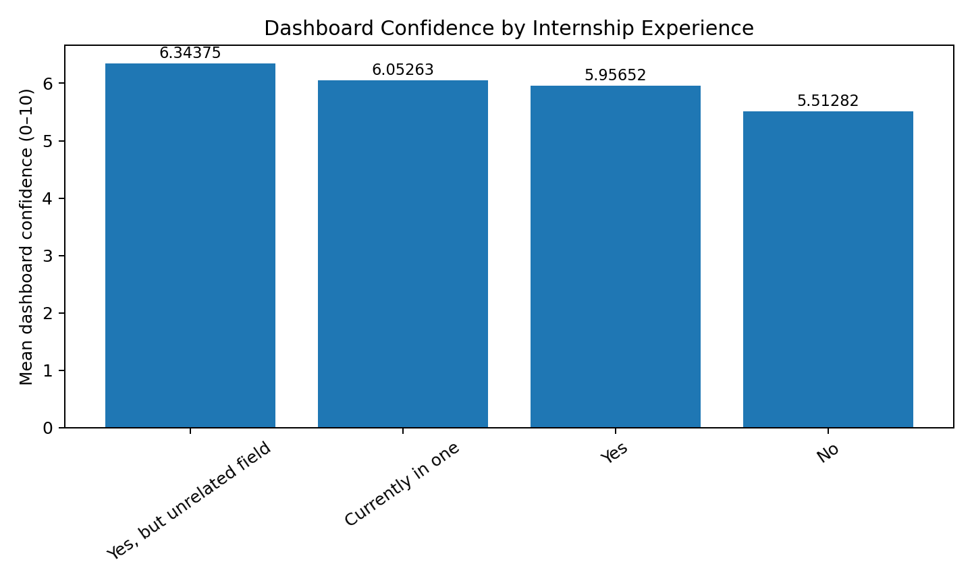
Figure 4.20: Mean Dashboard Confidence by Internship Experience
Source: Primary survey – calculated from 113 raw responses

Table 4.23: Dashboard Confidence by Internship Experience
Internship experience | Respondents | Mean dashboard confidence
Currently in one | 19 | 6.05
No | 39 | 5.51
Yes | 23 | 5.96
Yes, but unrelated field | 32 | 6.34
Source: Primary survey – calculated from 113 raw responses
Interpretation: respondents with no relevant internship experience have the lowest mean dashboard confidence at 5.51. The groups with completed or ongoing internship exposure report higher average dashboard confidence. This descriptive pattern supports the importance of practical exposure when developing applied FP&A and BI capabilities.
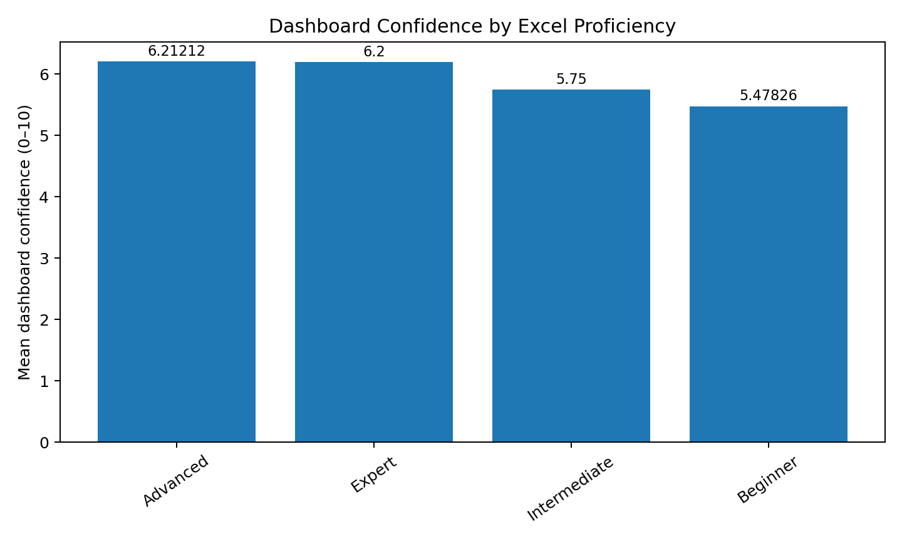
Figure 4.21: Mean Dashboard Confidence by Excel Proficiency
Source: Primary survey – calculated from 113 raw responses

Table 4.24: Dashboard Confidence by Excel Proficiency
Excel proficiency | Respondents | Mean dashboard confidence
Advanced | 33 | 6.21
Beginner | 23 | 5.48
Expert | 25 | 6.20
Intermediate | 32 | 5.75
Source: Primary survey – calculated from 113 raw responses
Interpretation: respondents classified as Advanced or Expert in Excel report higher mean dashboard confidence than respondents classified as Beginner or Intermediate. Advanced respondents report a mean of 6.21, while Beginner respondents report 5.48. This suggests a positive descriptive association between spreadsheet proficiency and confidence in building dashboards.

4.8 Consolidated Findings from Primary Data
- The primary dataset contains 113 valid anonymous PGDM responses and therefore provides a substantial respondent base for descriptive analysis.
- Operations is the largest specialization group with 29 respondents, followed by Analytics (26), Finance (25), HR (20) and Marketing (13).
- Thirty-nine respondents (35%) reported no internship involving financial reporting, FP&A or Power BI, indicating a meaningful practical-exposure gap.
- Fifty-eight respondents (51%) rated their Excel proficiency as Advanced or Expert, showing comparatively strong spreadsheet capability.
- Twenty-five respondents reported using neither Power BI nor Tableau, while 34 had experience with both tools.
- Fifty-eight respondents (51%) indicated that BI learning was self-taught or not covered through formal coursework, highlighting the importance of independent upskilling.
- Power BI/Tableau (41), MS-Excel (37) and Python/SQL (35) were the three leading skills perceived as valued by recruiters.
- Fifty-nine respondents (52.2%) believed BI proficiency would improve or significantly improve placement prospects.
- Industry mentorship/guest sessions, hands-on BI workshops and live project/internship integration were the three most preferred curriculum improvements.
- Lack of hands-on tool training (39) and limited exposure to real datasets (34) were the two most frequently cited classroom–industry gaps.
- Mean dashboard-building confidence was 5.93/10, while mean MIS/variance-reporting confidence was 5.62/10.
- BI/dashboarding skill importance received a mean score of 5.89/10, but perceived PGDM preparation for BI-driven roles was only 5.45/10.
- The cross-tabulation indicates higher dashboard confidence among respondents with relevant internship exposure and among respondents with Advanced/Expert Excel proficiency.

4.9 Integrated Interpretation of Secondary and Primary Data
The two data streams provide complementary evidence. The secondary financial analysis demonstrates the analytical need for integrated FP&A practices such as KPI monitoring, forecasting, variance analysis and executive reporting. The primary survey demonstrates the capability side of the same problem: students recognize the importance of BI and analytics but report only moderate confidence and identify practical training gaps.
The primary data therefore strengthens the justification for an AI-driven FP&A dashboard. A dashboard can consolidate financial KPIs, forecasts and variance indicators, but its effectiveness ultimately depends on users who can interpret financial information, manipulate Excel models, understand BI outputs and communicate managerial insights. The survey results indicate that practical exposure through internships, real datasets, workshops and live projects may help bridge this capability gap.

4.10 Chapter Summary
Chapter 4 analyzed the secondary financial dataset and the primary survey data separately and then interpreted their combined implications. The financial analysis identified historical growth, profitability, leverage and forecast trends across five Infrastructure & Construction companies. The primary-data analysis of 113 PGDM respondents examined specialization, internship experience, Excel proficiency, BI-tool exposure, coursework coverage, career intentions, recruiter-valued skills, certification, placement impact, curriculum preferences, classroom–industry gaps and four 0–10 confidence/perception measures.
The primary survey is particularly important to the study because it provides direct evidence from respondents about the practical readiness required for BI-enabled FP&A roles. The findings show moderate confidence in dashboarding and MIS reporting, strong recognition of BI's career importance, and a comparatively lower perception of curriculum preparedness. The results therefore support greater emphasis on hands-on BI workshops, real datasets, internships, industry interaction and live projects.
CHAPTER 5
SUMMARY OF FINDINGS, CONCLUSIONS AND SUGGESTIONS
This chapter presents the major findings of the study based on the secondary financial analysis and primary survey analysis. The findings are organized into financial findings, primary-data findings and integrated findings.
The study used two complementary sources of evidence. The first was secondary financial data relating to five listed Indian Infrastructure & Construction companies—Larsen & Toubro (L&T), NCC Ltd, KNR Constructions, IRB Infrastructure Developers and HG Infra Engineering. Historical financial performance was examined for FY2020-21 to FY2025-26, while driver-based projections were developed up to FY2030-31. The second source was primary data collected through an anonymous survey of 113 PGDM students covering Excel proficiency, BI-tool exposure, internship experience, dashboard confidence, MIS/variance-reporting capability, career relevance of BI skills and perceived gaps between classroom learning and industry expectations.
The combined findings demonstrate that modern FP&A requires both an integrated analytical system and users who possess adequate financial, spreadsheet, BI and analytical capabilities.

5.2 Findings
The secondary data shows steady financial growth across the five construction companies, with L&T leading in revenue, NCC Ltd posting the highest revenue CAGR, and most firms improving margins while reducing leverage — though IRB Infrastructure stays comparatively leveraged. Forecasts through FY2030-31 project continued growth in revenue, PAT, and EPS, underscoring the case for an integrated FP&A dashboard. The primary survey is the more striking part: about 35% of respondents had no internship exposure to financial reporting, FP&A, or Power BI, and 64.6% cited limited hands-on tool training and real-dataset exposure as the biggest classroom-industry gap. Despite strong Excel skills (51% rated Advanced/Expert), confidence in dashboard-building (5.93/10) and MIS/variance reporting (5.62/10) stayed only moderate, with internship exposure and Excel proficiency both linked to higher confidence. Together, the findings suggest an AI-driven FP&A dashboard meets a real business need, but its value depends on closing the skills and hands-on training gap identified among finance students.

5.3 Conclusion
The present study concludes that Financial Planning & Analysis is undergoing a significant transformation from a traditional reporting-oriented function into an integrated, technology-enabled decision-support capability.
The financial analysis of five selected Infrastructure & Construction companies demonstrates the usefulness of combining historical financial analysis, profitability measurement, leverage analysis, forecasting and KPI monitoring. The companies generally demonstrated positive historical growth and improving profitability, while the forecast model indicates continued expansion under the specified assumptions. However, the analysis also highlights the importance of monitoring leverage and financial risk alongside growth.
The study further demonstrates the relevance of an integrated FP&A dashboard. Combining budgeting, forecasting, variance analysis, financial ratios, KPIs and executive reporting can provide management with a more consolidated view of financial performance. Such a system can improve the accessibility and interpretation of financial information and support faster management review.
The primary survey of 113 PGDM students adds an important human-capability dimension to the study. Respondents demonstrated comparatively strong Excel capability, but BI exposure and practical FP&A experience were uneven. The mean dashboard confidence was 5.93/10 and MIS/variance-reporting confidence was 5.62/10. More importantly, respondents rated the importance of BI/dashboarding skills at 5.89/10 but perceived their programmer’s preparation for BI-driven finance roles at only 5.45/10.
The study therefore concludes that the future of FP&A depends on the integration of finance knowledge, analytical capability, AI-assisted forecasting and Business Intelligence. Technology can improve the speed and quality of financial analysis, but human judgement, data quality, governance and practical skills remain essential.
The proposed AI-driven FP&A dashboard should consequently be viewed as a Decision Support System rather than a fully automated decision-making system. Its greatest value lies in helping finance professionals move from manually compiling information toward interpreting trends, identifying risks, evaluating scenarios and providing strategic recommendations.
Overall, the study supports the proposition that an integrated FP&A framework can provide a more structured and decision-oriented approach to financial planning and reporting than fragmented spreadsheet-based processes. At the same time, the effectiveness of such systems depends on continuous improvement in data quality, analytical methods, technology adoption and user capabilities.

5.4 Suggestions for Organizations and FP&A Teams
- Implement integrated FP&A dashboards that combine budgeting, forecasting, variance analysis, KPI monitoring and executive reporting.
- Adopt driver-based forecasting using explicit business drivers such as revenue growth, EBITDA margin, PAT margin, order-book growth, capital expenditure and leverage assumptions.
- Introduce rolling forecasts so that financial expectations can be updated periodically based on actual performance and changing business conditions.
- Strengthen variance analysis by identifying the underlying drivers of significant favorable and unfavorable variances and communicating their managerial implications.
- Use AI as decision support rather than as a replacement for finance professionals. Financial decisions should incorporate human judgement, business knowledge, data validation and management review.
- Establish strong data governance to ensure consistency, accuracy, completeness and timeliness of financial data.
- Monitor financial risk alongside growth, particularly Debt-Equity ratios, cash flow and other leverage indicators.
- Develop scenario-based planning with base-case, optimistic and pessimistic scenarios.

5.5 Suggestions for PGDM Institutions
- Increase hands-on BI training in Power BI, Tableau, Excel dashboards and related analytical tools.
- Use actual or realistically structured financial datasets rather than relying primarily on simplified classroom examples.
- Integrate FP&A projects into the curriculum covering budgets, forecasts, variance analysis, financial models and executive dashboards.
- Strengthen industry interaction through workshops, guest lectures and practical case discussions.
- Expand live-project and internship integration so students work on real business problems involving financial reporting and BI.
- Promote multidisciplinary skill development covering Advanced MS Excel, financial modelling, Power BI/Tableau, SQL, Python or R, financial analysis, data visualization and business communication.
- Encourage relevant certifications and continuous learning in financial modelling, Power BI, analytics and SQL.

5.6 Limitations of the Study
- The financial analysis is restricted to five Infrastructure & Construction companies and therefore cannot automatically be generalized to other industries.
- The historical financial analysis covers six financial years, FY2020-21 to FY2025-26, which provides a useful trend period but remains relatively limited for sophisticated time-series modelling.
- The driver-based forecasts depend on predefined assumptions and therefore represent planning scenarios rather than guaranteed future outcomes.
- The current report does not contain numerical Prophet forecast outputs or forecast-accuracy diagnostics. Consequently, direct statistical comparison between the driver-based forecast and Prophet forecast has not been presented.
- The primary survey contains 113 respondents and uses self-reported measures of skills and confidence. Self-reported proficiency may differ from objectively tested proficiency.
- The primary survey is based on PGDM students and therefore its findings may not directly represent experienced finance professionals or corporate FP&A teams.
- The cross-tabulation findings are descriptive and should not be interpreted as evidence of causal relationships.
- The study had limited opportunity to validate the dashboard outputs with internal FP&A teams or senior management.
- The forecasts do not explicitly incorporate every possible macroeconomic shock, regulatory change, project-specific event or unexpected market development.

5.7 Scope for Future Research
- Expand the company sample to additional Infrastructure & Construction companies and other sectors such as Banking, Manufacturing, IT, FMCG, Healthcare and Telecommunications.
- Increase the historical dataset using quarterly or monthly financial data to improve the statistical robustness of AI-assisted forecasting models.
- Compare multiple AI forecasting algorithms such as Prophet, ARIMA, SARIMA, Boost, Random Forest and LSTM using MAE, RMSE and MAPE.
- Develop real-time FP&A dashboards connected directly to ERP, accounting or financial databases.
- Introduce scenario and sensitivity analysis for changes in revenue growth, EBITDA margins, interest rates, debt levels, inflation and project execution.
- Incorporate external economic variables such as inflation, interest rates, GDP growth, commodity prices and government infrastructure spending.
- Conduct longitudinal primary research among finance professionals before and after implementation of an AI-driven FP&A dashboard.
- Use inferential techniques such as correlation, regression, t-tests, ANOVA or structural equation modelling to examine relationships between Excel proficiency, internship exposure, BI training and dashboard confidence.
- Validate the system in an organizational environment by measuring reporting turnaround time, forecast accuracy, management satisfaction and decision-making quality.

5.8 REFERENCES
1. Annual Reports of Larsen & Toubro Limited, FY2020-21 to FY2025-26.
2. Annual Reports of NCC Limited, FY2020-21 to FY2025-26.
3. Annual Reports of KNR Constructions Limited, FY2020-21 to FY2025-26.
4. Annual Reports of IRB Infrastructure Developers Limited, FY2020-21 to FY2025-26.
5. Annual Reports of HG Infra Engineering Limited, FY2020-21 to FY2025-26.
6. Microsoft. Microsoft Excel Documentation and Financial Modelling Resources.
7. Microsoft. Microsoft Power BI Documentation and Business Intelligence Resources.
8. Taylor, S. J., & Letham, B. (2018). Forecasting at scale. The American Statistician, 72(1), 37–45.
9. Prophet Documentation. Meta Platforms / Prophet forecasting framework. Documentation relating to time-series forecasting and model implementation.
10. Screener.in. Financial statements and historical financial information of selected Indian listed companies.
11. Insight Capital Advisory Pvt. Ltd. Internship-related documents, financial analysis materials, MIS reports and organizational information.
12. Primary Survey Data. PGDM Student Survey on BI, FP&A, Excel, Dashboarding and Industry Readiness, 113 valid responses.
13. Project (3).xlsx. Financial Modelling dataset containing historical and projected financial information for the selected Infrastructure & Construction companies.
14. Draft Report. Research documentation, literature review, methodology, financial analysis and primary survey findings.

5.9 ANNEXURE

Annexure A – Primary Survey Questionnaire

The following questionnaire was administered to PGDM students to assess practical exposure, technical proficiency, confidence levels, and perceived curriculum readiness in relation to financial reporting, FP&A, and BI-tool usage.

Section 1: Respondent Profile

Current academic program (e.g., PGDM, MBA, other)

Specialization (Finance / Analytics / Other)

Have you completed or are you currently undergoing an internship involving financial reporting, FP&A, or Power BI?

Yes / No / Ongoing

Section 2: Technical Skill Proficiency

Rate your proficiency in MS Excel.

Beginner / Intermediate / Advanced / Expert

Have you used Power BI or Tableau?

Neither / Power BI only / Tableau only / Both

How did you primarily learn BI/dashboarding tools?

Formal coursework / Self-taught / Internship / Not learned yet

Which technical skills do you believe recruiters value most in finance/analytics roles? (Select or rank top 3)

Power BI/Tableau / MS-Excel / Python/SQL / Other

Section 3: Confidence & Preparedness

On a scale of 1–10, rate your confidence in building a financial dashboard.

On a scale of 1–10, rate your confidence in preparing MIS/variance reports.

On a scale of 1–10, how important do you consider BI/dashboarding skills for a finance career?

On a scale of 1–10, how well do you feel your PGDM curriculum has prepared you for BI-driven finance roles?

Section 4: Employability Perception

Do you believe BI proficiency will improve your placement prospects?

Significantly improve / Improve / No effect / Decrease

Section 5: Curriculum Gaps & Improvement Areas

What do you see as the biggest gap between classroom learning and industry requirements?

Lack of hands-on tool training / Limited exposure to real datasets / Lack of case studies / Other

Which curriculum improvements would you prefer?

Industry mentorship/guest sessions / Hands-on BI workshops / Live project/internship integration / Other

Any additional comments on improving BI/FP&A readiness in the PGDM program? (Open-ended, optional)

Annexure B – Financial Modelling and Dashboard Supporting Material

The financial modelling workbook and dashboard outputs referenced in the analysis form part of the supporting project material and may be attached with the final submission as required by the institute.

